2 – BOOK BANK PROCESS

1:USE CASE DIAGRAM

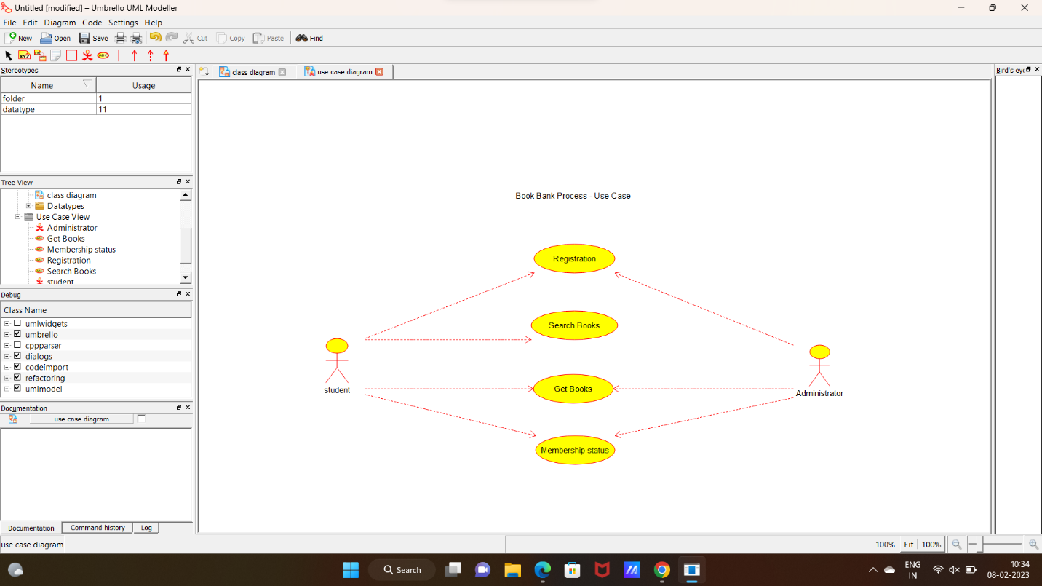

2- CLASS DIAGRAM

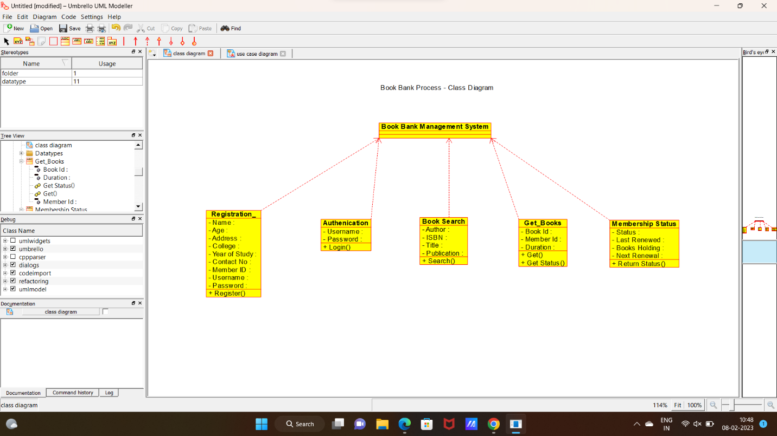

3:SEQUENCE DIAGRAM

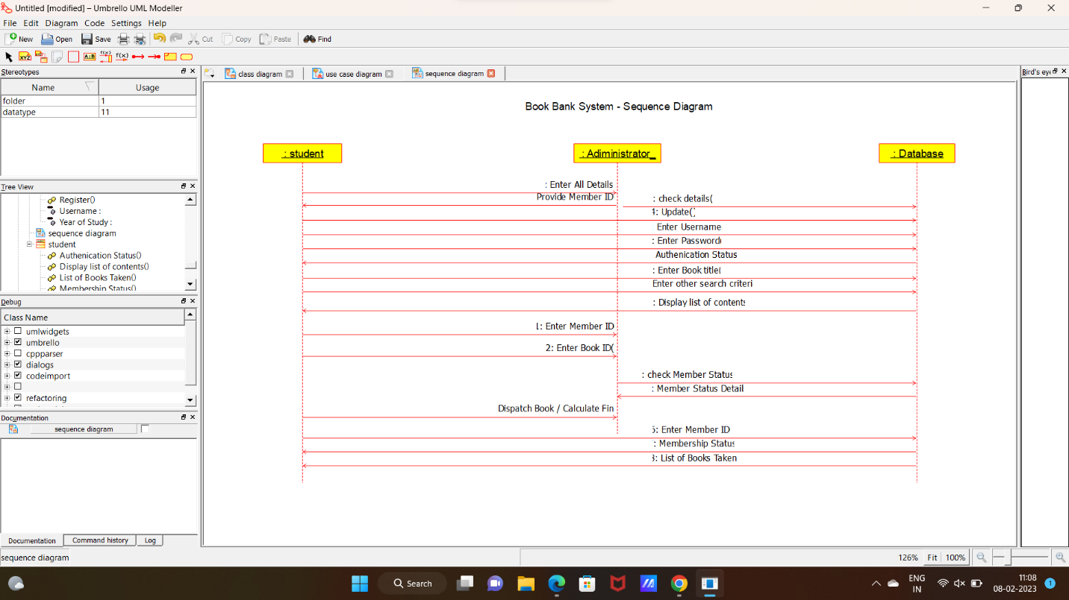

4:ACTIVITY DIAGRAM

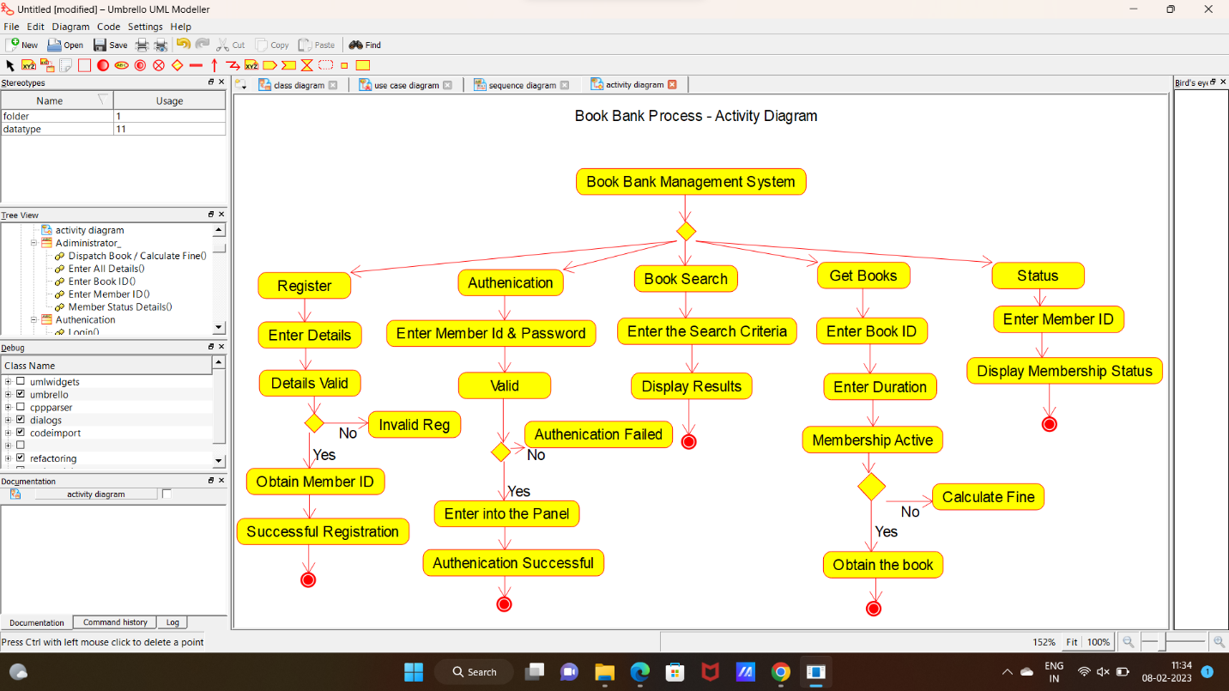

**CODE:**

ADMINISTRATOR:

#include "Adiministrator_.h"

// Constructors/Destructors

//

Adiministrator_::Adiministrator_ () {

}

Adiministrator_::~Adiministrator_ () { }

//

// Methods

//

// Accessor methods

//

// Other methods

//

AUTHENICATION:

#include "Authenication.h"

// Constructors/Destructors

//

Authenication::Authenication () {

initAttributes();

}

Authenication::~Authenication () { }

//

// Methods

//

// Accessor methods

//

// Other methods

//

void Authenication::initAttributes () {

}

BOOK BANK MANAGEMENT SYSTEM:

#include "Book_Bank_Management_System.h"

// Constructors/Destructors

//

Book_Bank_Management_System::Book_Bank_Management_System () {

}

Book_Bank_Management_System::~Book_Bank_Management_System () { }

//

// Methods

//

// Accessor methods

//

// Other methods

//

BOOK SEARCH:

#include "Book_Search.h"

// Constructors/Destructors

//

Book_Search::Book_Search () {

initAttributes();

}

Book_Search::~Book_Search () { }

//

// Methods

//

// Accessor methods

//

// Other methods

//

void Book_Search::initAttributes () {

}

DATABASE:

#include "Database.h"

// Constructors/Destructors

//

Database::Database () {

}

Database::~Database () { }

//

// Methods

//

// Accessor methods

//

// Other methods

//

GET BOOKS:

#include "Get_Books.h"

// Constructors/Destructors

//

Get_Books::Get_Books () {

initAttributes();

}

Get_Books::~Get_Books () { }

//

// Methods

//

// Accessor methods

//

// Other methods

//

void Get_Books::initAttributes () {

}

MEMBERSHIP STATUS:

#include "Membership_Status.h"

// Constructors/Destructors

//

Membership_Status::Membership_Status () {

initAttributes();

}

Membership_Status::~Membership_Status () { }

//

// Methods

//

// Accessor methods

//

// Other methods

//

void Membership_Status::initAttributes () {

}

REGISTRATION:

#include "Registration_.h"

// Constructors/Destructors

//

Registration_::Registration_ () {

initAttributes();

}

Registration_::~Registration_ () { }

//

// Methods

//

// Accessor methods

//

// Other methods

//

void Registration_::initAttributes () {

}

STUDENT:

#include "student.h"

// Constructors/Destructors

//

student::student () {

}

student::~student () { }

//

// Methods

//

// Accessor methods

//

// Other methods

//