3 – EXAM REGISTRATION PORTAL

1:ACTIVITY DIAGRAM

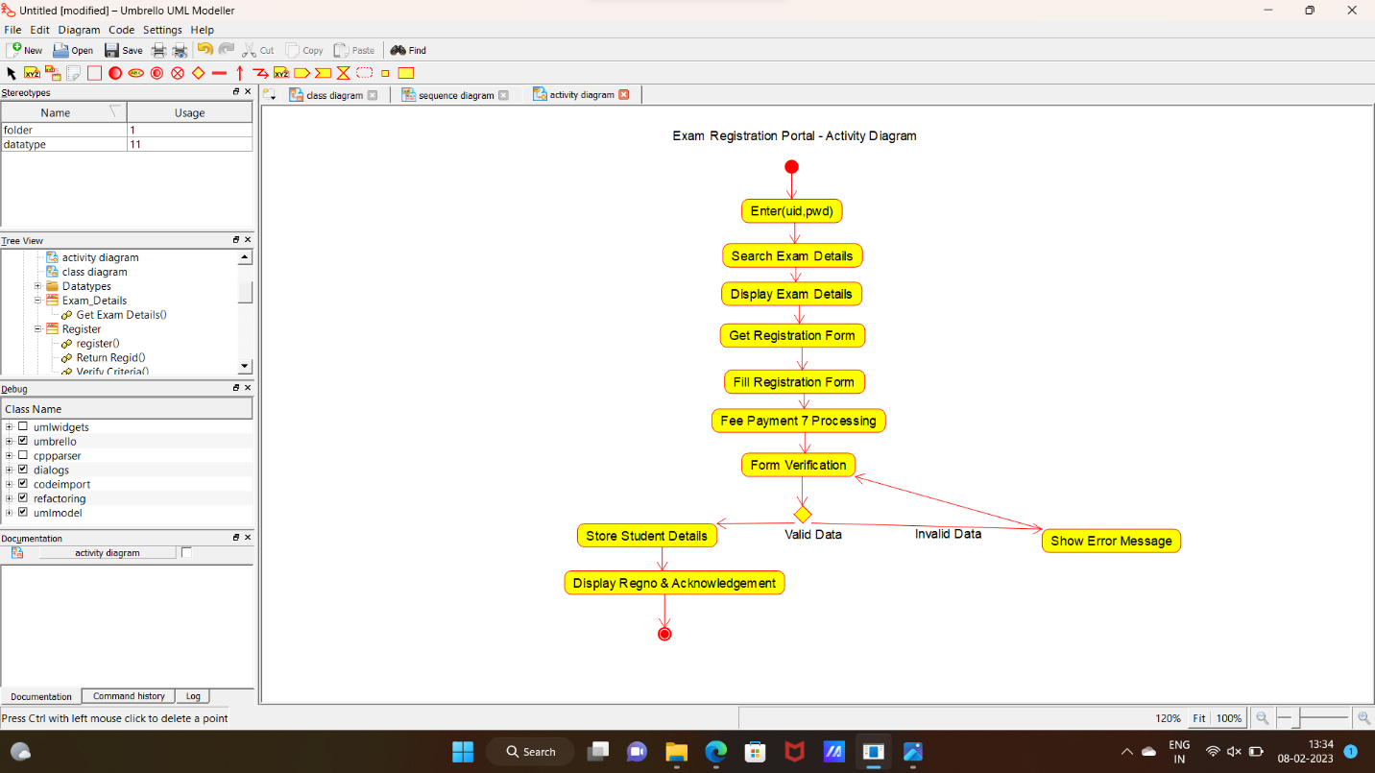

2:USE CASE DIAGRAM

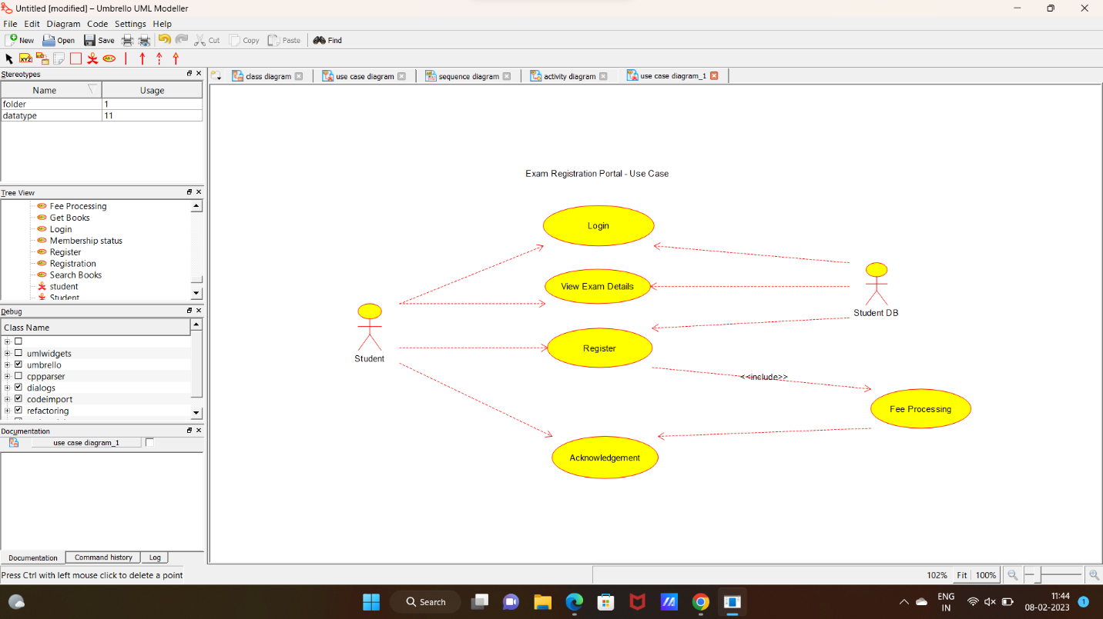

3:CLASS DIAGRAM

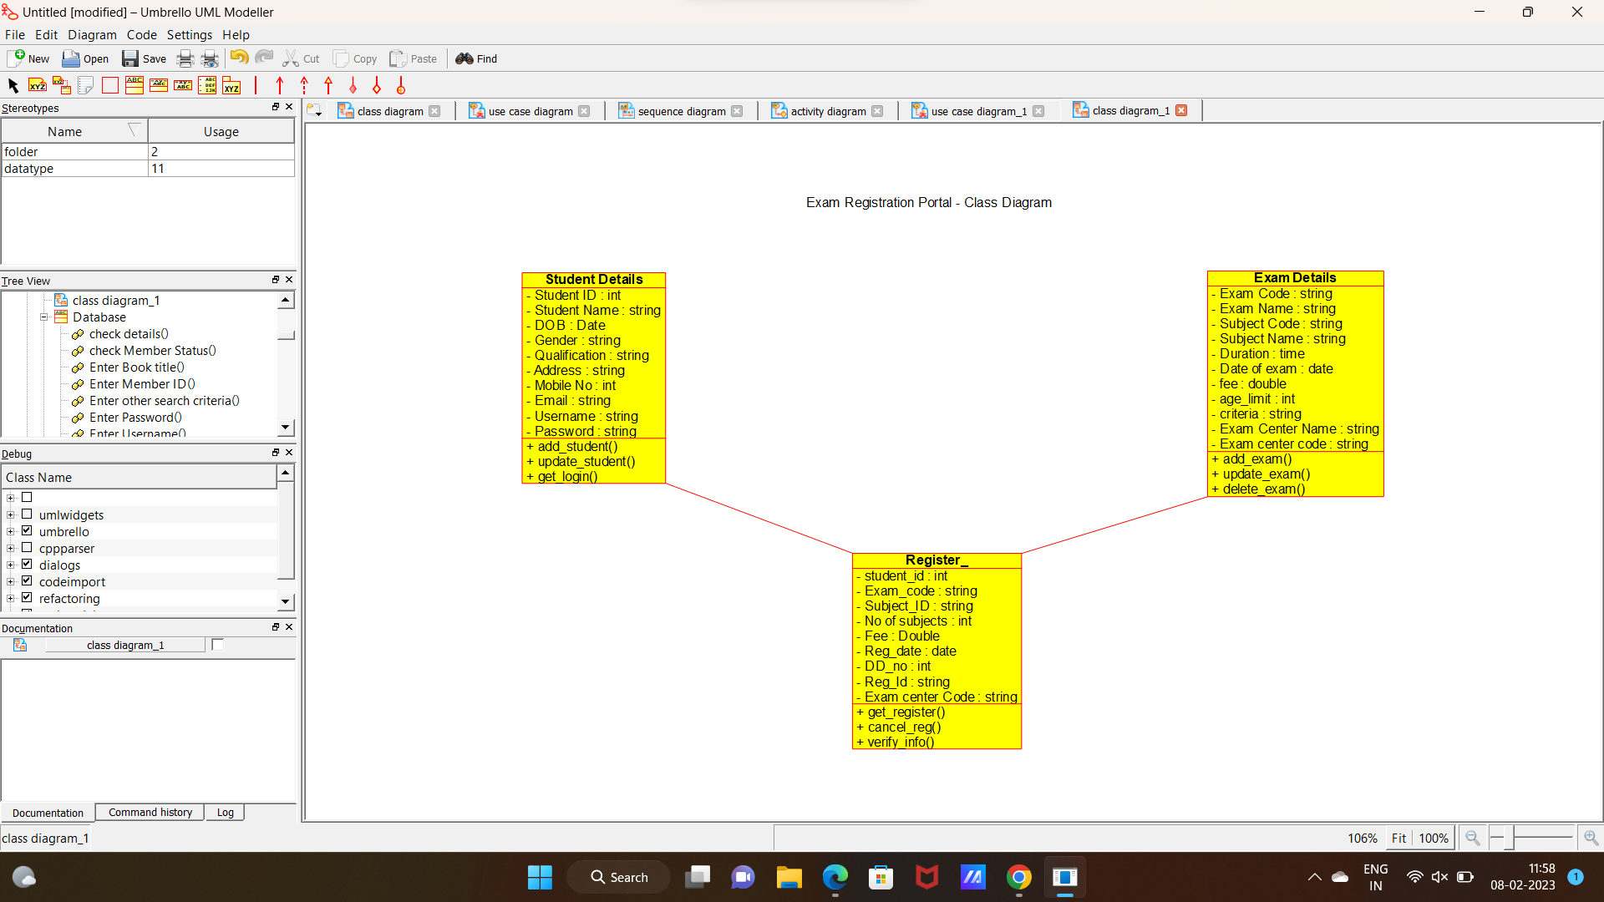

4:SEQUENCE DIAGRAM

