4 – STOCK MAINTANANCE SYSTEM

1:USE CASE DIAGRAM:  
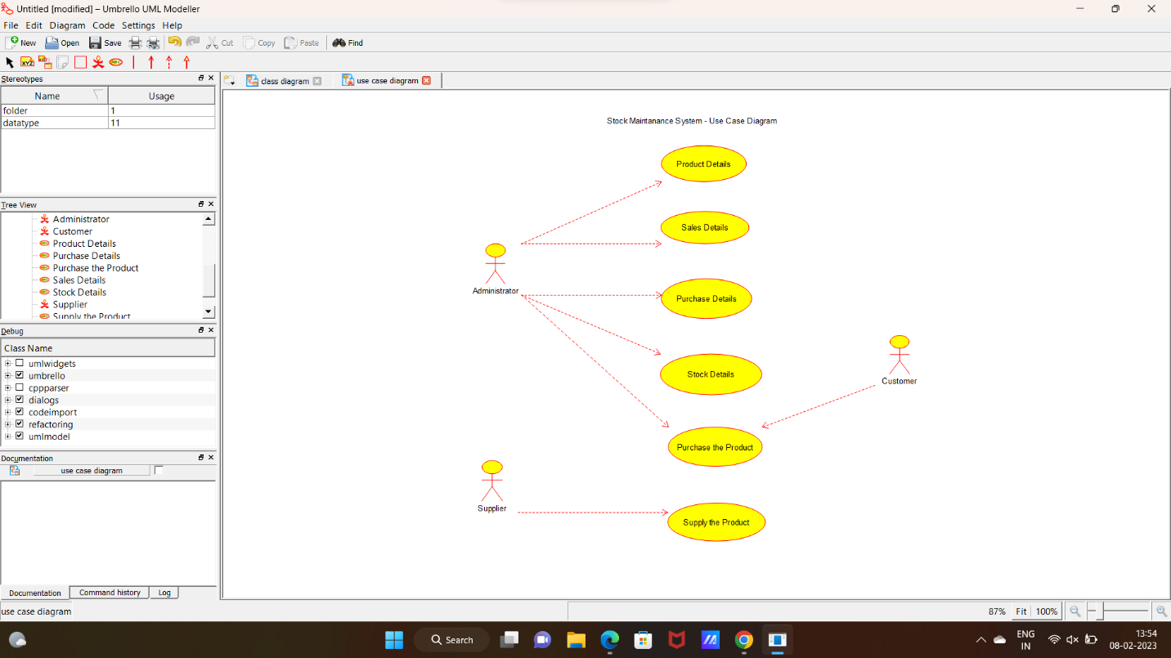

2:CLASS DIAGRAM:

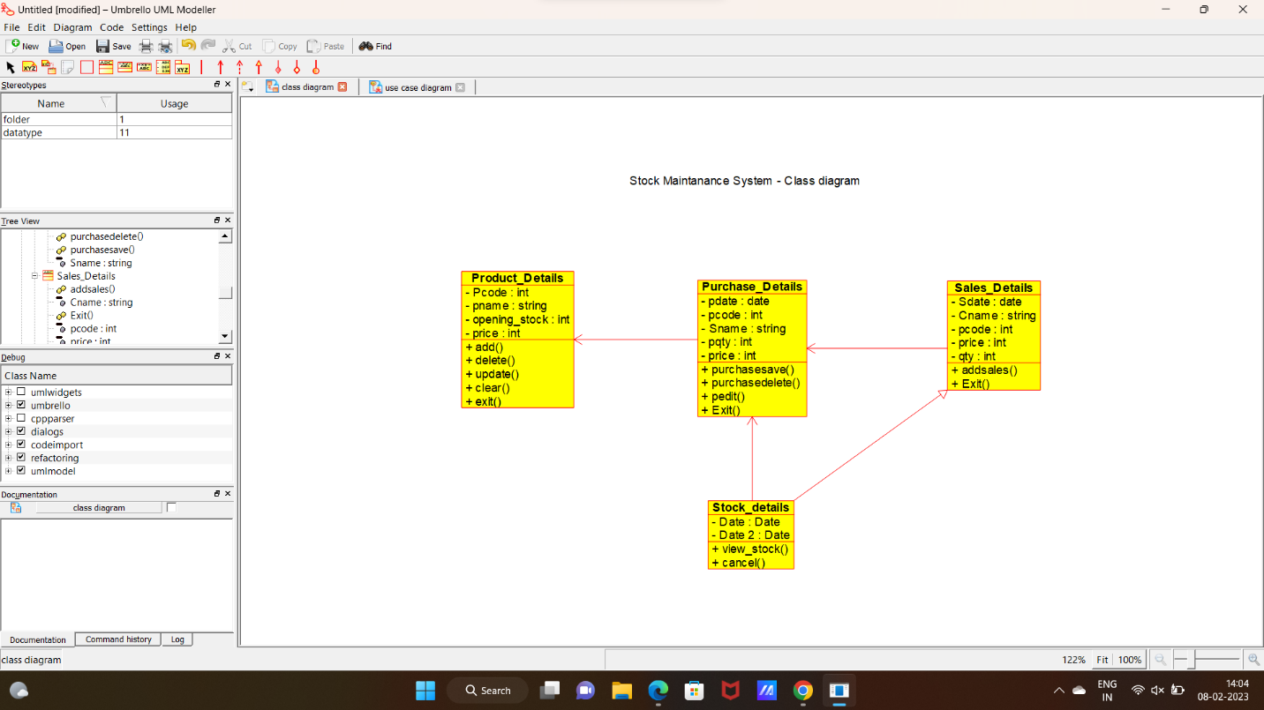

3:SEQUENCE DIAGRAM:

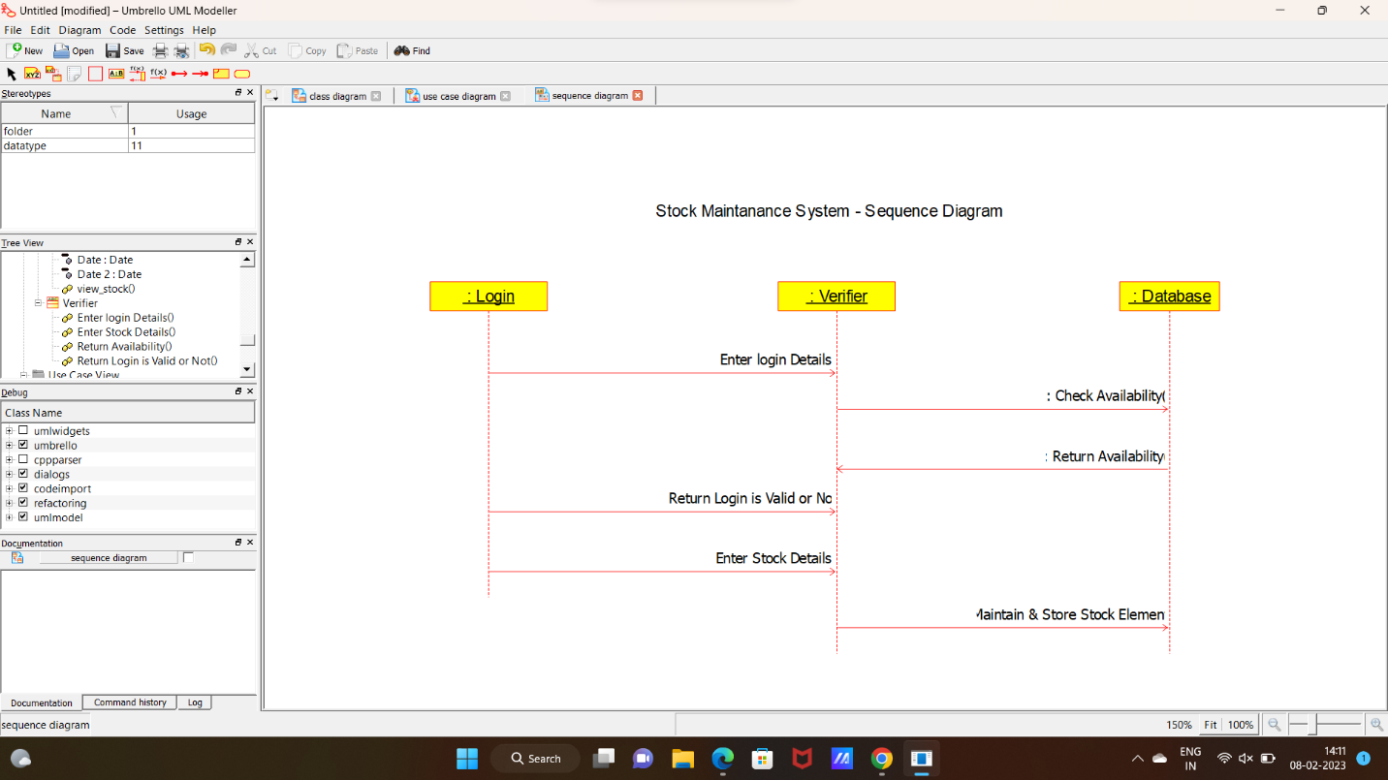

4:ACTIVITY DIAGRAM:

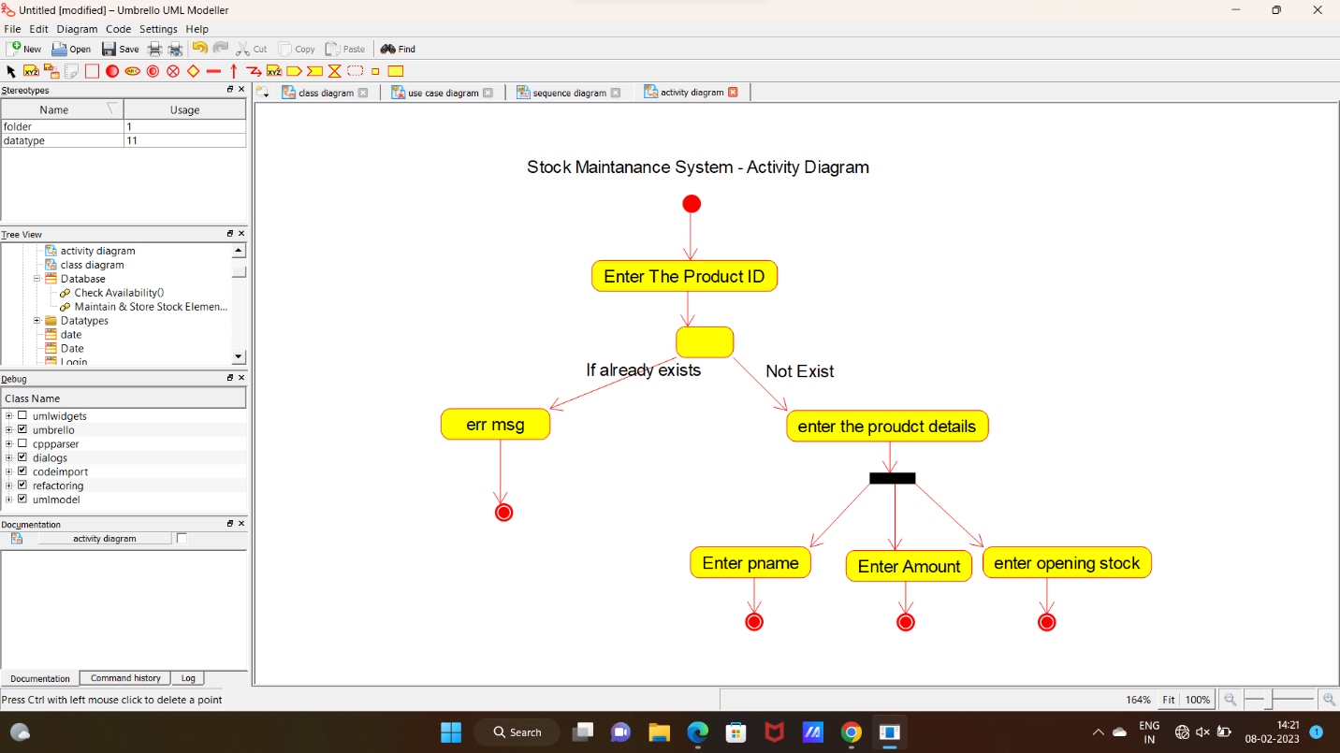

**CODE:**

DATE:

#include "Date.h"

// Constructors/Destructors

//

Date::Date () {

}

Date::~Date () { }

//

// Methods

//

// Accessor methods

//

// Other methods

//

PRODUCT DETAILS:

#include "Product_Details.h"

// Constructors/Destructors

//

Product_Details::Product_Details () {

initAttributes();

}

Product_Details::~Product_Details () { }

//

// Methods

//

// Accessor methods

//

// Other methods

//

void Product_Details::initAttributes () {

}

PURCHASE DETAILS:

#include "Purchase_Details.h"

// Constructors/Destructors

//

Purchase_Details::Purchase_Details () {

initAttributes();

}

Purchase_Details::~Purchase_Details () { }

//

// Methods

//

// Accessor methods

//

// Other methods

//

void Purchase_Details::initAttributes () {

}

SALES DETAILS:

#include "Sales_Details.h"

// Constructors/Destructors

//

Sales_Details::Sales_Details () {

initAttributes();

}

Sales_Details::~Sales_Details () { }

//

// Methods

//

// Accessor methods

//

// Other methods

//

void Sales_Details::initAttributes () {

}

STOCK DETAILS:

#include "Stock_details.h"

// Constructors/Destructors

//

Stock_details::Stock_details () {

initAttributes();

}

Stock_details::~Stock_details () { }

//

// Methods

//

// Accessor methods

//

// Other methods

//

void Stock_details::initAttributes () {

}