6 – E TICKETING SYSTEM

USE CASE DIAGRAM:

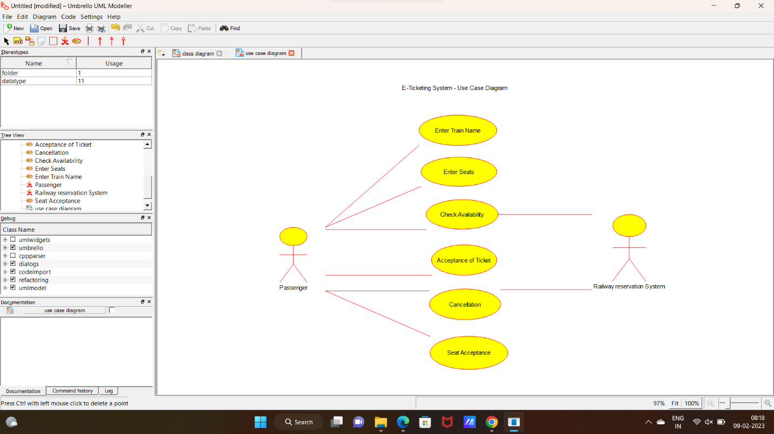

2:CLASS DIAGRAM:

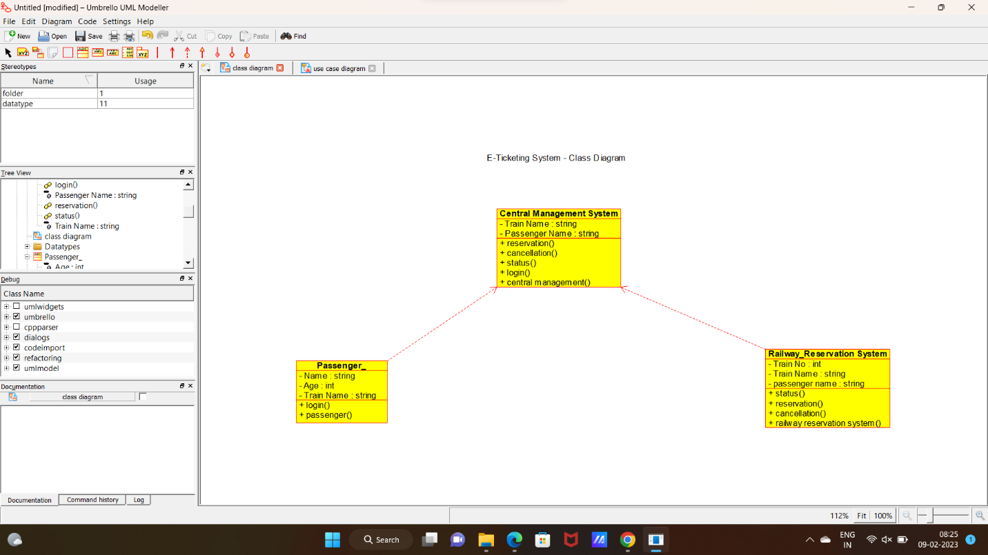

3:SEQUENCE DIAGRAM:

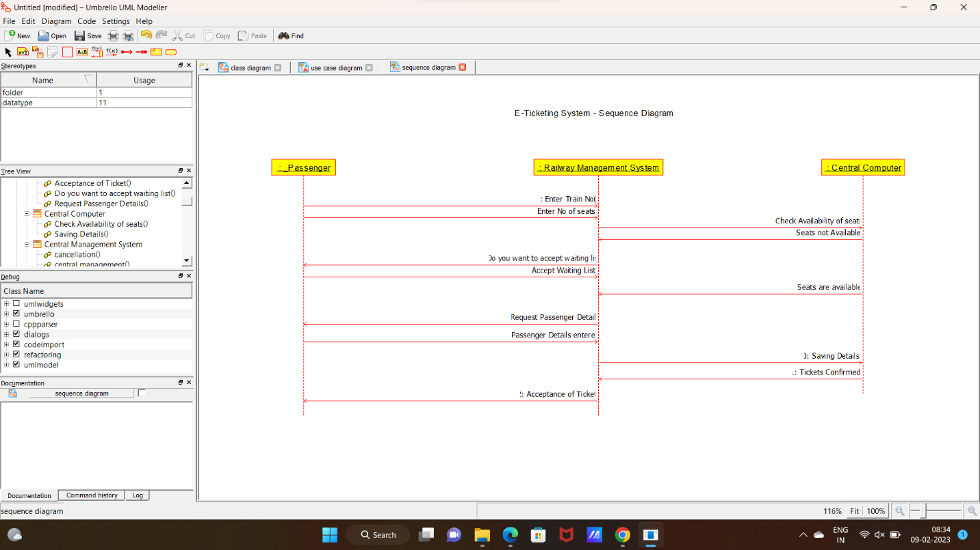

4:STATE DIAGRAM:

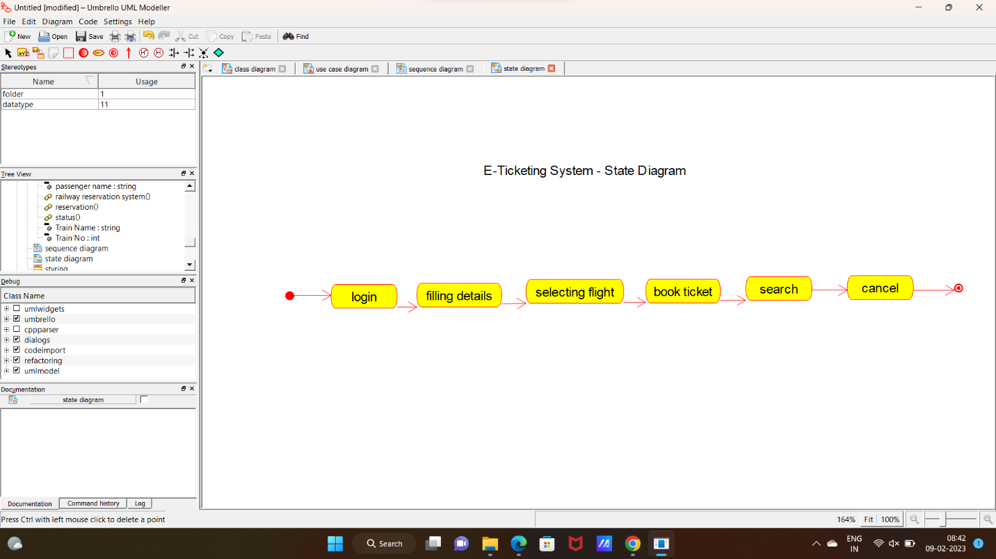

**CODE:**

CENTRAL MANAGEMENT SYSTEM:

#include "Central_Management_System.h"

// Constructors/Destructors

//

Central_Management_System::Central_Management_System () {

initAttributes();

}

Central_Management_System::~Central_Management_System () { }

//

// Methods

//

// Accessor methods

//

// Other methods

//

void Central_Management_System::initAttributes () {

}

PASSENGER:

#include "Passenger_.h"

// Constructors/Destructors

//

Passenger_::Passenger_ () {

initAttributes();

}

Passenger_::~Passenger_ () { }

//

// Methods

//

// Accessor methods

//

// Other methods

//

void Passenger_::initAttributes () {

}

RAILWAY RESERVATION SYSTEM:

#include "Railway_Reservation_System.h"

// Constructors/Destructors

//

Railway_Reservation_System::Railway_Reservation_System () {

initAttributes();

}

Railway_Reservation_System::~Railway_Reservation_System () { }

//

// Methods

//

// Accessor methods

//

// Other methods

//

void Railway_Reservation_System::initAttributes () {

}

STRING:

#include "string.h"

// Constructors/Destructors

//

string::string () {

}

string::~string () { }

//

// Methods

//

// Accessor methods

//

// Other methods

//