8 – SOFTWARE PERSONAL MANAGEMENT SYSTEM

USE CASE DIAGRAM:

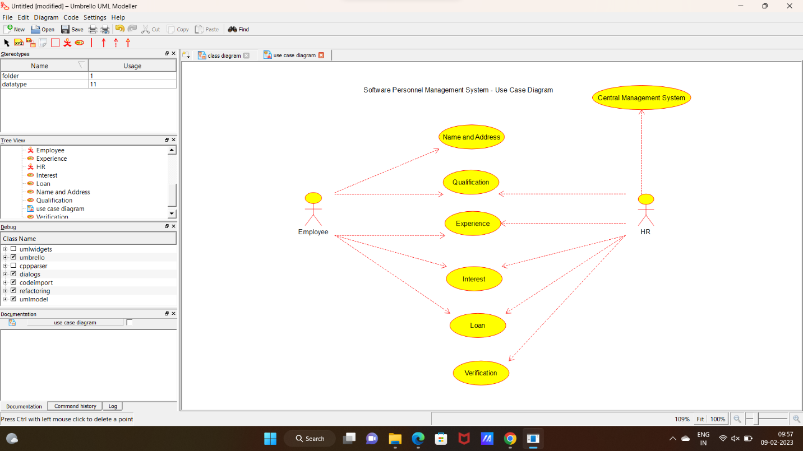

2:CLASS DIAGRAM

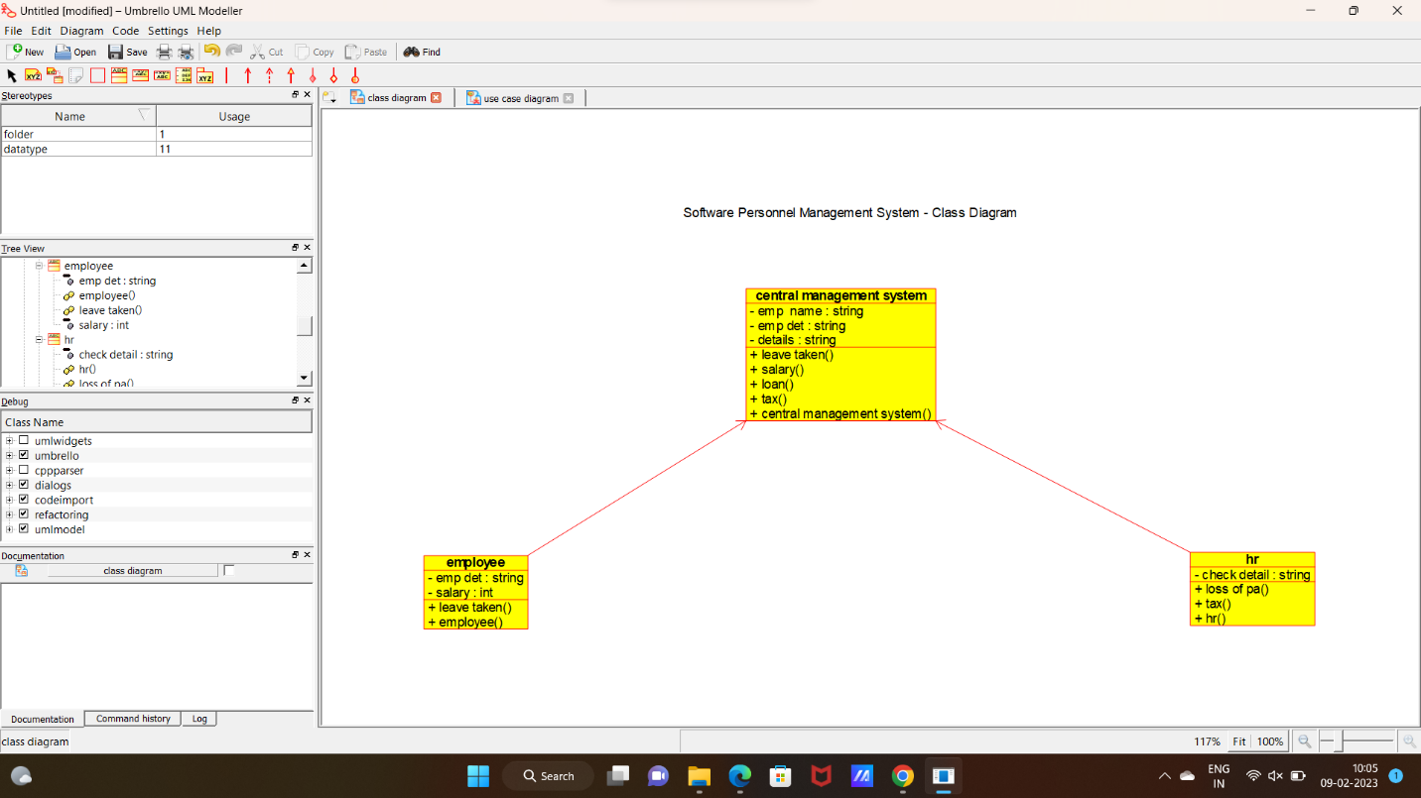

3:SEQUENCE DIAGRAM:

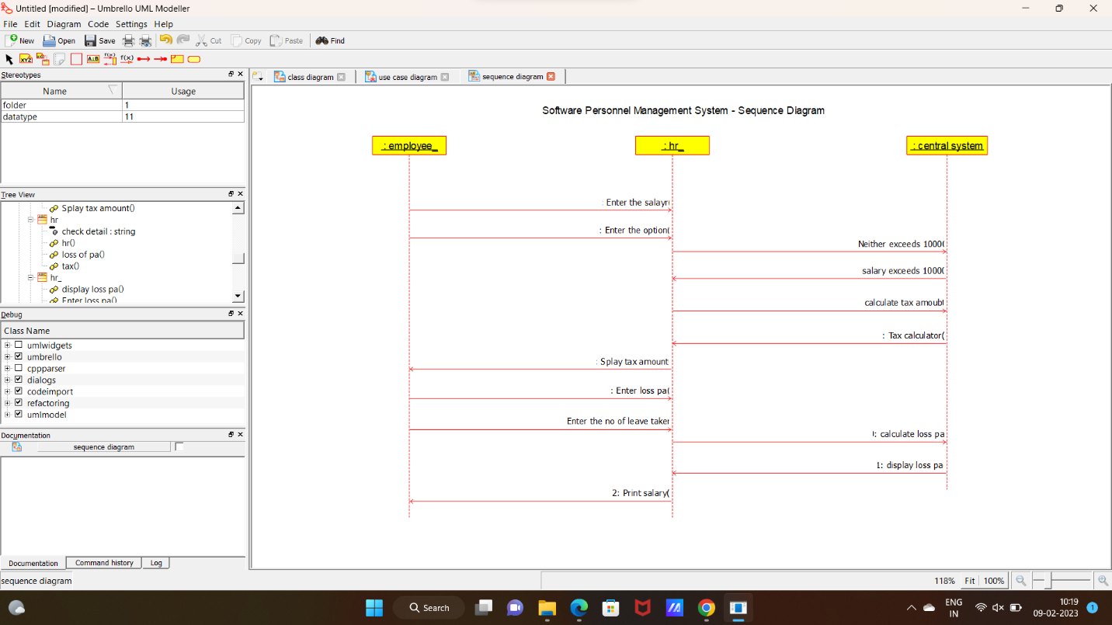

4:STATE DIAGRAM:

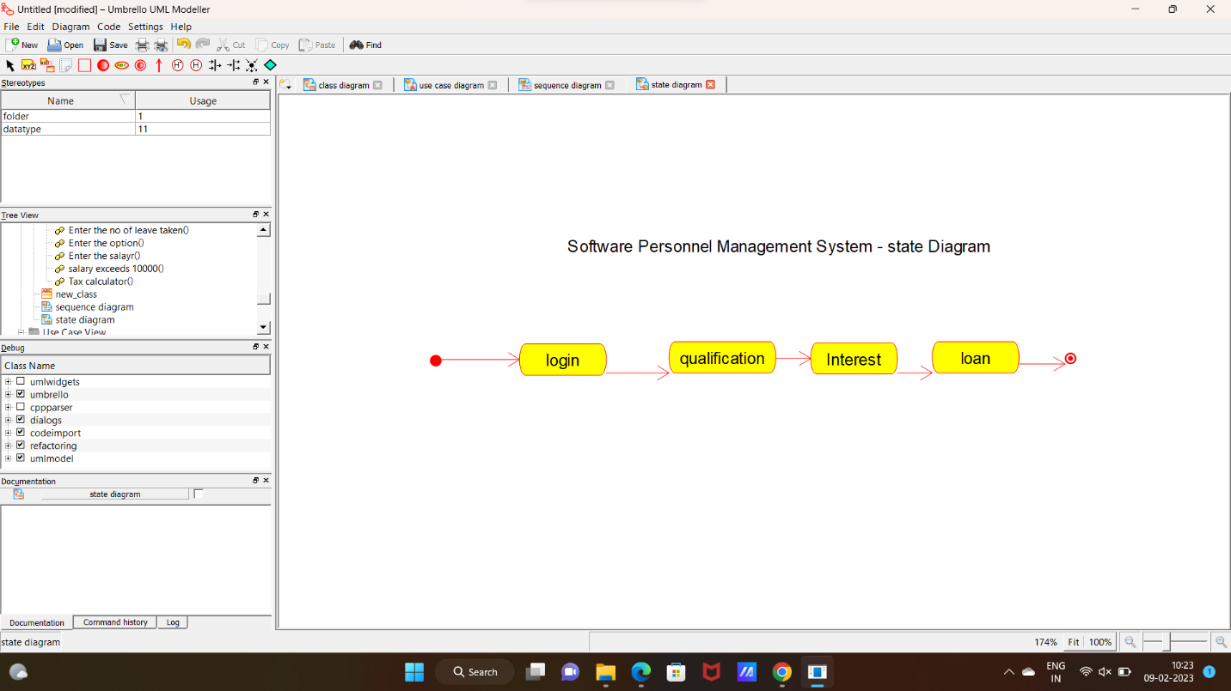

**CODE:**

CENTRAL MANAGEMENT SYSTEM:

#include "central_management_system.h"

// Constructors/Destructors

//

central_management_system::central_management_system () {

initAttributes();

}

central_management_system::~central_management_system () { }

//

// Methods

//

// Accessor methods

//

// Other methods

//

void central_management_system::initAttributes () {

}

EMPLOYEE:

#include "employee.h"

// Constructors/Destructors

//

employee::employee () {

initAttributes();

}

employee::~employee () { }

//

// Methods

//

// Accessor methods

//

// Other methods

//

void employee::initAttributes () {

}

HR:

#include "hr.h"

// Constructors/Destructors

//

hr::hr () {

initAttributes();

}

hr::~hr () { }

//

// Methods

//

// Accessor methods

//

// Other methods

//

void hr::initAttributes () {

}

NEW CLASS:

#include "new_class.h"

// Constructors/Destructors

//

new_class::new_class () {

}

new_class::~new_class () { }

//

// Methods

//

// Accessor methods

//

// Other methods

//