9 – E BOOK MANAGEMENT SYSTEM

USE CASE DIAGRAM:

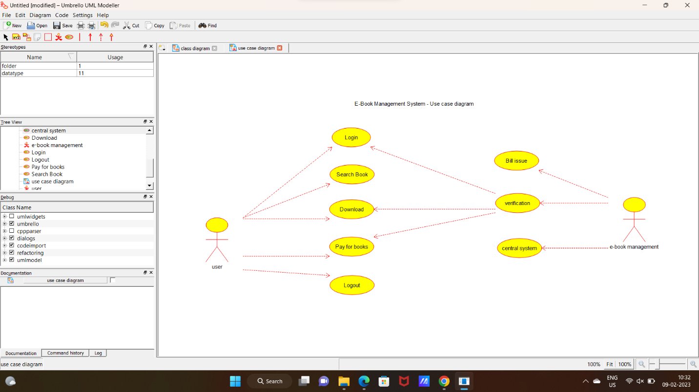

2:CLASS DIAGRAM:

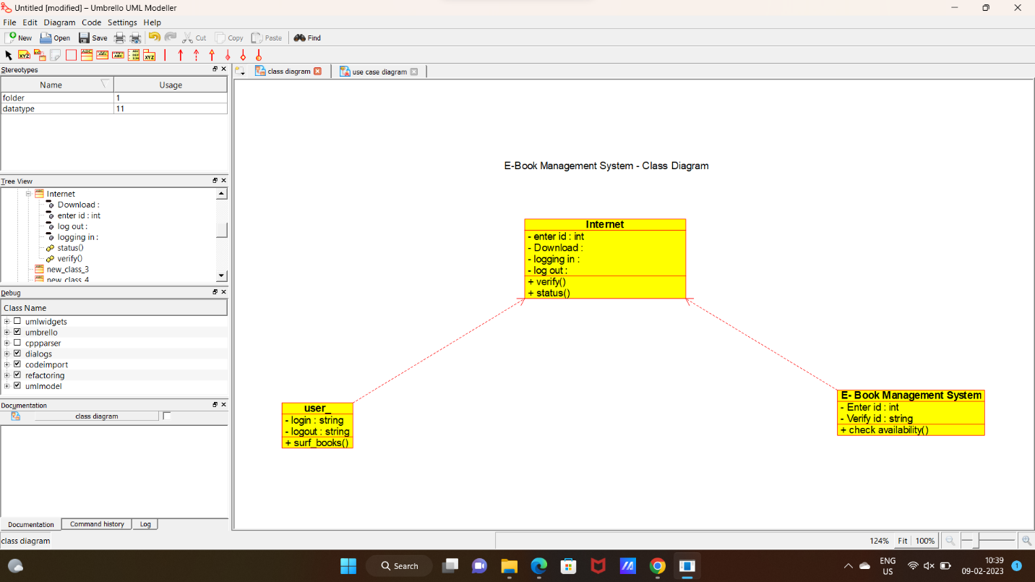

3:SEQUENCE DIAGRAM:

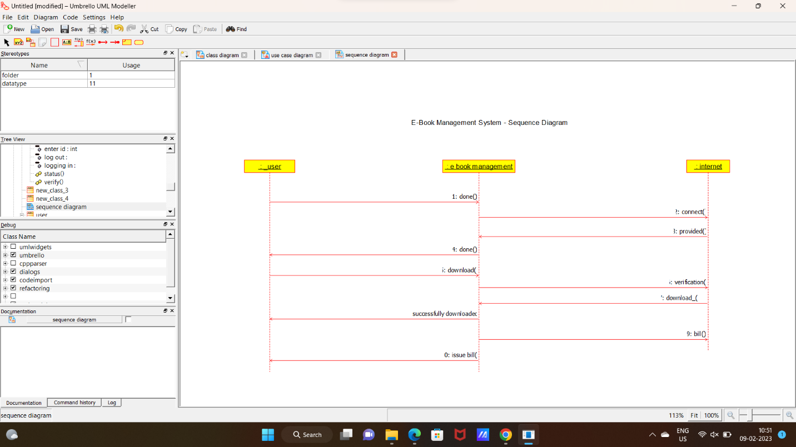

4:STATE DIAGRAM:

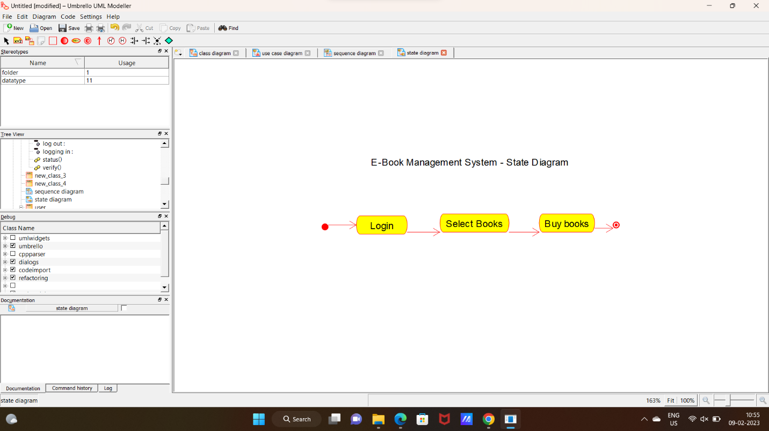

**CODE:**

E BOOK MANAGEMENT SYSTEM:

#include "E_Book_Management_System.h"

// Constructors/Destructors

//

E_Book_Management_System::E_Book_Management_System () {

initAttributes();

}

E_Book_Management_System::~E_Book_Management_System () { }

//

// Methods

//

// Accessor methods

//

// Other methods

//

void E_Book_Management_System::initAttributes () {

}

INTERNET:

#include "Internet.h"

// Constructors/Destructors

//

Internet::Internet () {

initAttributes();

}

Internet::~Internet () { }

//

// Methods

//

// Accessor methods

//

// Other methods

//

void Internet::initAttributes () {

}

NEW CLASS:

#include "new_class_3.h"

// Constructors/Destructors

//

new_class_3::new_class_3 () {

}

new_class_3::~new_class_3 () { }

//

// Methods

//

// Accessor methods

//

// Other methods

//

USER:

#include "user_.h"

// Constructors/Destructors

//

user_::user_ () {

initAttributes();

}

user_::~user_ () { }

//

// Methods

//

// Accessor methods

//

// Other methods

//

void user_::initAttributes () {

}