DRIVER INFORMATION SYSTEM

Introduction

The purpose of this system is track the multiple drivers location and current work situation and send this information to the owners company.

For example :

There is a truck driver which needs to carry woods from Zonguldak to Baghdat this dirver and needs to give information to the his own company owner about the job (i arrived , the put woods in to truck , i will move on tmorrow , i am currently here etc).

This software sends geolocation information to the company, takes register information for user and gives a verification , duty informations , add finished duty information.

In this app usege is splitted between driver and boss

This is the abilities of the BOSS and Driver

BOSS :

See all drivers current situation

Append a job to a ceratain driver

See detailed job of ceratain driver

Driver:

Find and send geolocation

Recive new dutys

The UML diagram below is explain the responsibilities of the target users

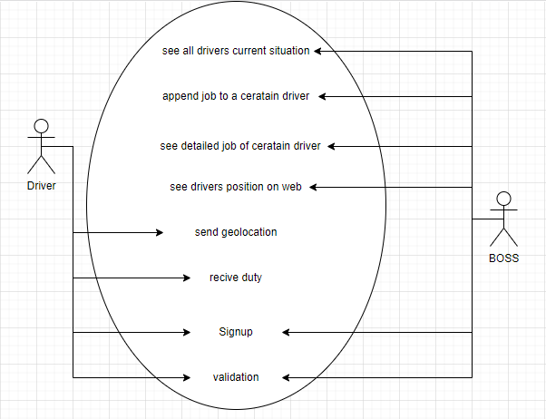

State Diagram:

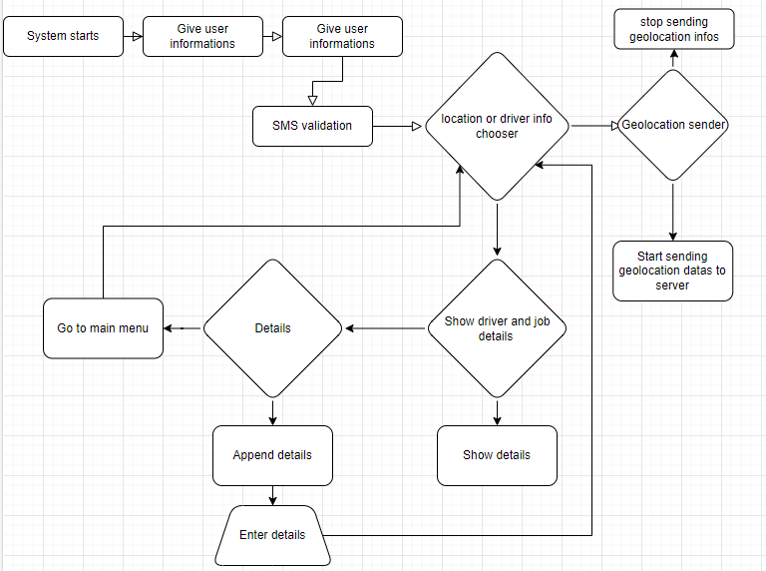

Class diagram

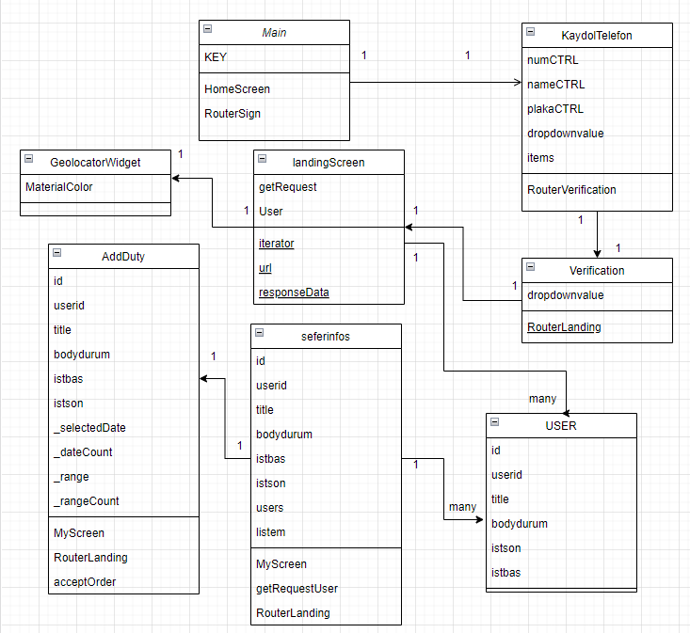

Usage:

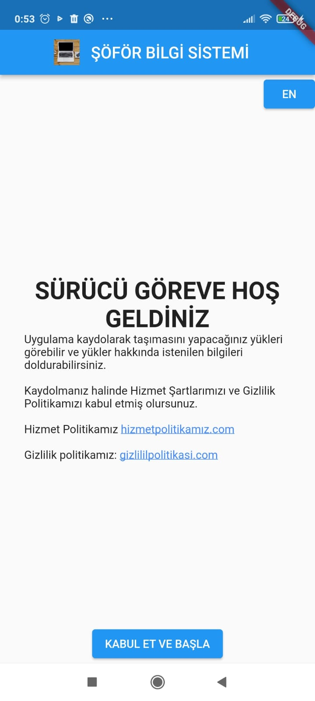

After we open our application this window will show up and it shows “hizmet politikası” and “gizlilik politikası” we need to agree that to contiune the program.

After we click the “KABUL ET VE BAŞLA” button program ask us to signup for use the program.

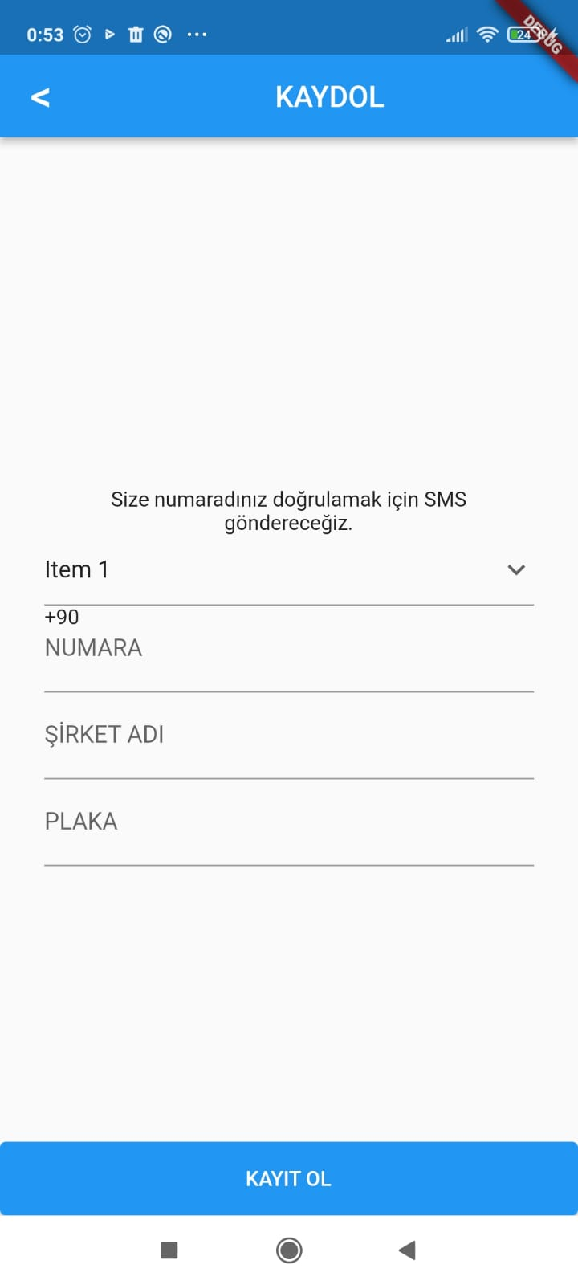

The dropdown menu shows the countries that we can select Numara part is Phone number part Şirket adı part is company name part.

After we give required informations we click “KAYIT OL” button.

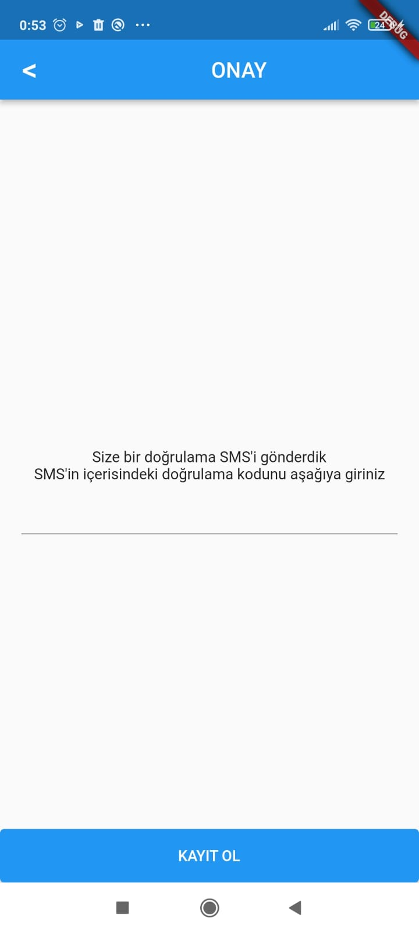

After we click KAYIT OL we recive a SMS code for validation. We give this validation code to the field we will contiune

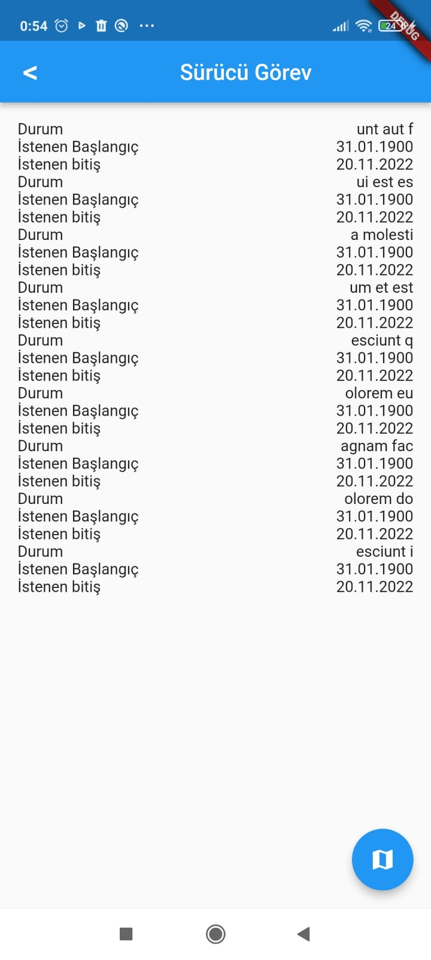

Now we are in the area of Driver Duty in this area we can click one of the



This bottom part to send our geolocation data to the main base(This part is for only drivers)

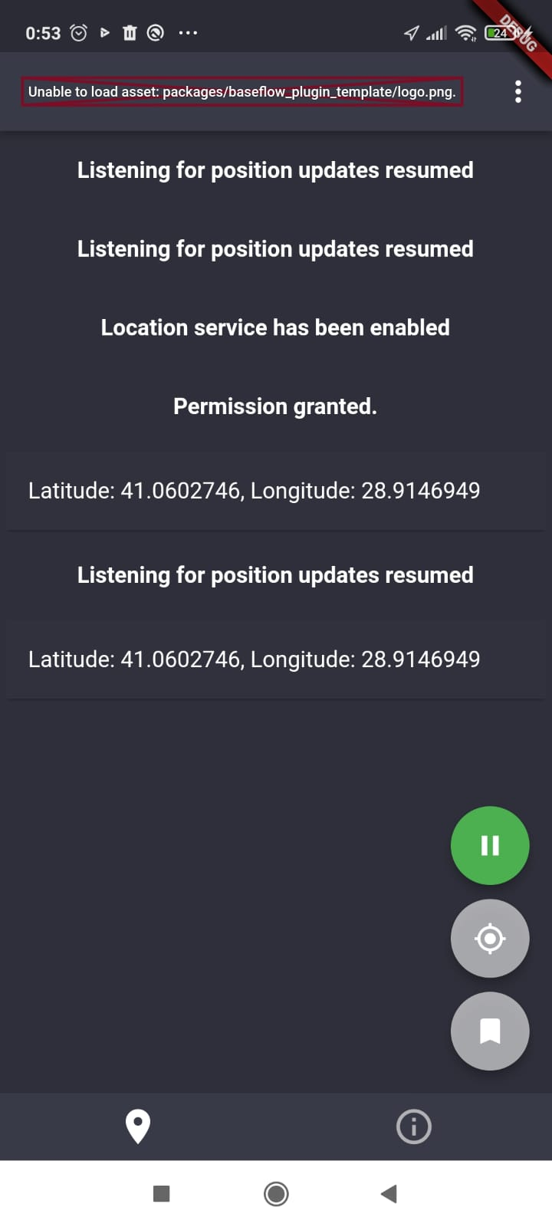

This page is geolocation page it takes the drivers geolocation and send to the company as realtime

Or we can click

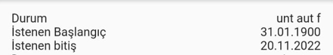

This parts this part currently showing the Drivers current situation required starting time and required job done time.(FOR BOSSES ONLY)

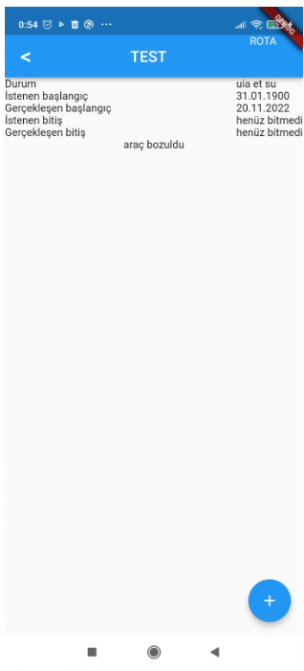

After we click that part we see a details of current work situation, required start date, required end date, occured start date, occured end date and drivers and viechales current situation.

At the bottom button we can apply new job for the driver

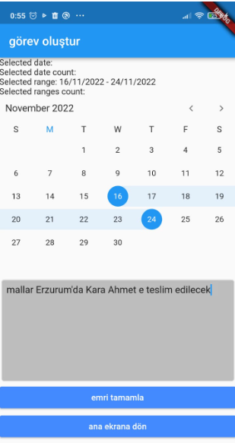

İn this part we choose the time range and Job description then we can compelate the order and return back to main.