# **Heroes of Pymoli Report**

**Data Trends:**

1. **Male players made more purchases compared to Female/Other/Non-disclosed players:**

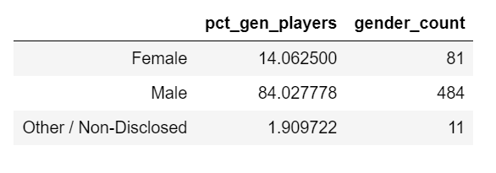

1. **Highest purchases were made by people in age group 20-24:**

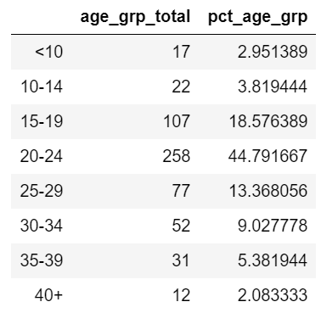

1. **Approximate price of most popular items were around $3-4**

