CURRICULUM VITAE
PERSONAL INFORMATION | Aditya Rachman Putra
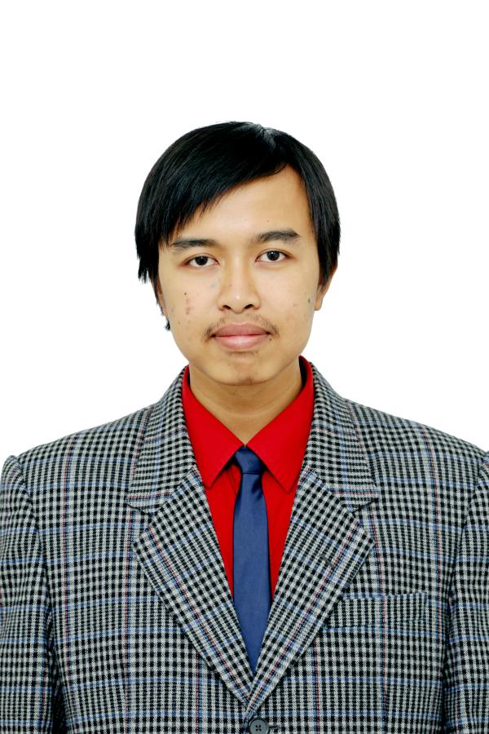 |   Number 83, Sarirasa III Street Block 09, Bandung, 40151, Indonesia

(+62)22 201 8182  (+62)811 229 8182

adityarputra@gmail.com

banditelol.github.io
 | Sex Male | Date of birth 16/08/1994 | Nationality Indonesia

EDUCATION

July 2012 - October 2016 | Bachelor of Engineering
July 2012 - October 2016 | Electrical Engineering, Institut Teknologi Bandung (Indonesia) https://stei.itb.ac.id/en
July 2012 - October 2016 | - CGPA 3.68 / 4.00 (151 Credits)  - Bachelor Thesis: “Implementation of Hazardous Chemical Gas Monitoring System Using Unmanned Aerial Vechicle (UAV)”
WORK EXPERIENCE

November 2017 - Present | Internal and Production Research Team
November 2017 - Present | Labtek Indie, Bandung, Indonesia  Jalan Titiran No 7 Bandung 40133 | www.labtekindie.com | ref: seterhen@labtekindie.com
November 2017 - Present | - Conducting regular research to explore new possibilities of technology or design method  - Conducting research to produce technology and method that supports production processes  - Publishing the result of research for public viewing  - Creating and continuously evaluate standardization of production method for agile development
November 2017 - Present | Business or sector Creative Research Partner
October 2016 – October 2017 | Freelance Embedded and Multimedia Developer
October 2016 – October 2017 | Various Employers, Bandung, Indonesia
October 2016 – October 2017 | - Designing embedded systems prototype for Fingerprint/ RFID-card based payment  - Designing controller for VR Golf game  - Designing hardware system for affordable and simple interactive-touch wall  - Working with a team of artist and engineer to create an art installation for Venice Art Biennale 2017  - Developing Interactive wall multimedia content together with a multi-disciplinary team  - Participated in several Design Thinking Sessions to help invented the best product for user.
February 2015 – June 2015 | Operational Volunteer
February 2015 – June 2015 | Fabrication Laboratory Bandung  78, Kopo Street, 40232 Bandung (Indonesia)
February 2015 – June 2015 | - Experimenting with available tools to enhance Fablab members’ cretaivity  - Aiding Fablab members in utilizing the machinery and provide training for new and prospective members

PERSONAL SKILLS

Language | - Bahasa Indonesia (Mother Tongue)  - English (IELTS Overall Score: 7.5; Reading: 8.5; Listening: 8.5; Speaking:6.5; Writing:7)

Communication skills | - Good communication skills gained through my experience in taking a role inside a company using holacracy structure  - Good coordination skills gained through participating in multiple projects with multidisciplinary background and various nationality to create an innovativa produts (I-Caps, d-Camp, E2Festa)  - Developing public speaking skills from multiple small presentation and co-facilitating training held by Labtek Indie  - Able to give workshop in English at Digital Design Weekend Bandung.

Organisational / managerial skills | - During my bachelor I organised a series of training for new Student Union Electrical Workshop members (October 2014 – February 2015)  - Event Organizing experience gained from being a coordinator of Ramadhan event in my University, involving 20 committees and 300 participants(June 2015 – July 2015)  - Leadership and lobbying skill was gained from being accommodation team manager in P3R (a City-wide Ramadhan Event held by a mosque near our Campus) (Mei 2013 – August 2013)  - Organizational and Bussiness skill gained from being the head of Lights and Sounds Department in Workshop Electrical Engineering Students ITB. I manage and expand the light and sound inventory and rent business inside Campus, and coordinate with other deparments (July 2015 – April 2016)  - Problem solving and design skill gained from multitudes of training and workshop abroad (Design Camp and TRIZ Camp).  - Design Thinking skill currently in development from several training, workshop, and real Co-Creation session with Labtek Indie

Technical Skill | - Exposure at using Python 3 (especially in Jupyter Notebook) for learning Machine Learning  - Exposure in Machine Learning, currently enrolled in auditing Andrew Ng Deep Learning Courses and participating in Fast.ai course to gain both practical and theoretical knowledge of Machine Learning  - Experience in C, C++, C#, Javascript, VHDL, Verilog, Octave, Matlab, openCV, HTML and CSS for several projects in University Classes and personal projects.  - Experience in Embedded microcontroller and Raspberry Pi development gained from several freelance projects  - Experience in TouchDesigner and Unity for interactive installation on several projects  - Familiarity in using Linux, command line environment, and git gained from daily usage

ADDITIONAL INFORMATION

Publications | - Aditya Rachman Putra, F. Mochammad and H. Herdian, "FPGA implementation of template matching using binary Sum of Absolute Difference," 2016 6th International Conference on System Engineering and Technology (ICSET), Bandung, 2016, pp. 13-17.  - F. Mochammad, A. R. Putra and B. R. Trilaksono, "Implementation of hazardous chemical gas monitoring system using unmanned aerial vehicle (UAV)," 2016 6th International Conference on System Engineering and Technology (ICSET), Bandung, 2016, pp. 163-168.
Training and Seminars | - Ideas to Action Training (Training Series for Design Thinking) by Labtek Indie in Bandung, Indonesia (2018)  - Insight for Innovation Training (Training Series for Design Thinking) by Labtek Indie in Bandung, Indonesia (2017)  - TRIZ Camp by Samsung Korea and Korea Innovation hub in Incheon, South Korea (2016)  - 8th International Students Multidisciplinary Design Camp (d-Camp) by Korean Innovation Hub in Incheon, South Korea (2016)  - 7th International Students Multidisciplinary Design Camp (d-Camp) by Universiti Kebangsaan Malaysia and Korean Innovation Hub in Langkawi, Malaysia (2016)  - 7 Habits of Highly Effective People by Stephen Covey in Bandung, Indonesia (2012)
Presentations | - Machine Learning for Stupidious, Introduction to Machine Learning for Artist using Wekinator at Digital Design Weekend Bandung, Indonesia (2017)  - Paper Presentation for "FPGA implementation of template matching using binary Sum of Absolute Difference," at International Conference on System Engineering and Technology (ICSET) Bandung, Indonesia. (2016)
Extra Courses | - Avionics System – School of Electrical Engineering and Informatics, Institut Teknologi Bandung  A semester of extra course taught by Prof. Adang Suwandi (Avionics expert in Indonesia)  - Neural Networks and Deep Learning (Audit) – Deeplearning.ai on Coursera  Online course on Coursera taught by Andrew Ng, part of deeplearning specialization
Projects | - “Mirror Painting” Installation, a passive-interactive installation using a 40” TV and a webcam to simulate mirror in which the reflected image is a stylized picture of the user, which makes the user feels like seeing themselves in famous painting (e.g. Van Gogh Starry Night). Project for Digital Design Weekend Bandung with Labtek Indie and British Council (2017)  - “River and People” Installation, an interactive installation using various medium and technology to retell the story of British children's imagination on how they will interact with river in the future. A project with Labtek Indie for British Council’s UKID Festival 2017 (2017)  - “Ultramimi“ Interactive Wall, a public installation using visual projection where people can interact and play with the wall using touch and sound. Project from PT Ultrajaya and Labtek Indie. (2017)  - “Tala”, a collaborative furniture product which explore how people interact with light. A collaborative project with Product Designer. (2017)  - “Raskin” Prototype, a prototype for how to pay for Raskin (subsidized rice for poor people) using fingerprint and NFC card as redundancy measure caused by memory deterioration. A project for initiating start-up (2017)  - “1001 Martian Homes”, 57th Venice Art Biennale Indonesia’s Pavilion, participating in several installation development, working together with Tintin Wulia as the artist. Project with Labtek Indie and BEKRAF. (2017)  - Google Singapore Exhibition Interactive Touch Wall. Project from Google and Labtek Indie. (2017)  - “Zurich VR Golf”, a VR golfing experience using mobile device and custom made controller for maximum immersion. Project with Zurich Insurance and Labtek Indie. (2016)  - “Oxytree”, a prototype of IoT-based autonomous urban city air purifier using microalgae technology. The system developed using Model Predictive Control (MPC) and can be monitored through Web and Application. Project for E2Festa. (2016)  - “FPGA Implementation of Template Matching Using Binary Sum of Absolute Difference”, a project for 2016 LSI Design Contest Okinawa, Japan.  - “Unmanned Aerial Vehicle for Hazardous Chemical Gas Monitoring System”, an integrated system for monitoring hazardous chemical gas using autonomous hexacopter where user can monitor and adjust mission scenario through Graphical User Interface in Ground Control Station. (2016)  - “FPGA Implementation of Far-Field Low-Cost Sound Source Localization Using 64-point Average Magnitude Difference Function (AMDF)”, a project developed using Altera Board and STM32F4 Board for 2015 Electronic Design Contest. (2015)  - Image-based Autonomous Boat, a project for National Autonomous Boat Competition. (2015)  - “LaMP”, Labtek Indie Music Player. A stand alone music player specifically build for pose-based control, aimed for fun and party events. A project implementing knowledge gained from internship programme at Labtek Indie. (2016)  - “Hit the Desk”, a differentiated distance-based digital musical instrument based on vibration phase differences. Final project for Microprocessor System Course.
Honours and awards | - Ganesha Karya Award for contributions and achievements in International competitions during bachelor study from Rector of Institut Teknologi Bandung. (August 2017)  - Grand Prize (1st) Award for International Session of Capstone Design Fair of Engineering Education Festa (E2Festa) 2016 by Korea Institute for Advancement of Technology (KIAT) in Seoul South Korea. (November 2016)  - Finalist on Bachelor Thesis Exhibition and Competition Institut Teknologi Bandung (ITB) by School of Electrical Engineering and Informatics ITB. (October 2016)  - Bronze (4th) Award of International Students Joint Caption Design (i-Caps) 2016 by Korea Innovation Hub in Incheon, South Korea. (August 2016)  - Participant of LSI Design Contest Okinawa, Japan with a topic Human Detection. (January 2016)  - 2nd Winner VLSI Category with topic of Sound Localization Device on Electronics Design Contest 2015 by Institute of Electrical and Electronics Engineers (IEEE) Solid State Circuit Society (SSCS) Indonesia Chapter. (December 2015)  - Best First Year Program Academic Students of School of Electrical Engineering and Informatics ITB from Rector of Institut Teknologi Bandung. (August 2013)
Organizations | - Electrical Engineering Institut Teknologi Bandung Students Association (HME ITB)  Member (April 2014 – October 2016) | Expert Staff of Community Service (April 2015 – March 2016)  - Electrical Engineering Workshop Institut Tekonlogi Bandung (Workshop HME ITB)  Member (October 2013 – October 2016)|Head of Lights and Sounds Dept (July 2015 – April 2016)  - Roboboat Team Institut Teknologi Bandung  Member of Electrical and Automation Division (February 2014 – March 2015)  - Komurindo Rocket Payload Team Institut Teknologi bandung  Member (February 2014 – October 2015)  - School of Electrical Engineering and Informatics Muslim Student Association ITB  Member (April 2013 – October 2016)|Vice Head (April 2015 - June 2016)

