PERSONAL INFORMATION | Aditya Rachman Putra
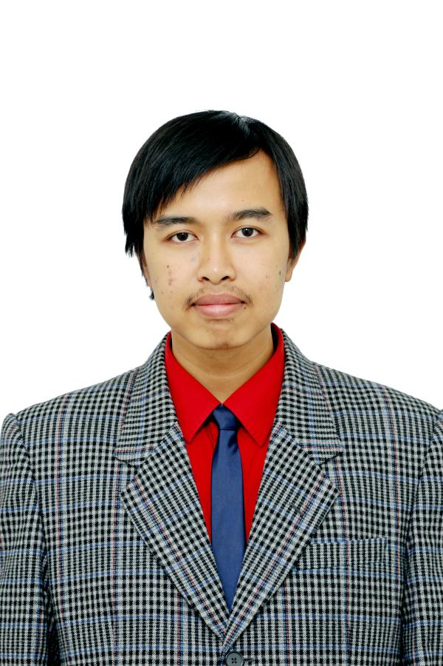 |   Number 83, Sarirasa III Street Block 09, Bandung, 40151, Indonesia

(+62)22 201 8182  (+62)811 229 8182

adityarputra@gmail.com

banditelol.github.io

Telegram banditelol
 | Sex Male | Date of birth 16/08/1994 | Nationality Indonesia

STUDIES APPLIED FOR | Artificial Intelligent Master Degree in University of Amsterdam

WORK EXPERIENCE

November 2017 - Present | Internal and Production Research Team
November 2017 - Present | Labtek Indie  7, 2nd floor, Titiran Street, 40151 Bandung (Indonesia)
November 2017 - Present | - Conducting regular research to explore new possibilities of technology or design method  - Conducting research to produce technology and method that supports production processes  - Publishing the result of research for public viewing  - Creating and continuously evaluate standardization of production method for agile development
November 2017 - Present | Business or sector Creative Research Partner
October 2016 – October 2017 | Embedded and Multimedia Freelancer
October 2016 – October 2017 | Various Employers, Bandung (Indonesia)
October 2016 – October 2017 | - Designing embedded systems prototype for Fingerprint/ RFID-card based payment  - Designing controller for VR Golf game  - Designing hardware system for affordable and simple interactive-touch wall  - Working with a team of artist and engineer to create an art installation for Venice Art Biennale 2017  - Developing Interactive wall multimedia content together with a multi-disciplinary team
February 2015 – June 2015 | Operational Volunteer
February 2015 – June 2015 | Fabrication Laboratory Bandung  78, Kopo Street, 40232 Bandung (Indonesia)
February 2015 – June 2015 | - Experimenting with available tools to enhance Fablab members’ cretaivity  - Aiding Fablab members in utilizing the machinery and provide training for new and prospective members

EDUCATION AND TRAINING

2012 - 2016 | Bachelor of Engineering in Electrical Engineering | Replace with EQF (or other) level if relevant
2012 - 2016 | Institut Teknologi Bandung, Bandung Indonesia
2012 - 2016 | - Fundamentals of Intelligent Sustems & Controls  - Fundamentals of Electrical Engineering and Microprocessor Systems  - Simple Analysis and Design of Digital IC  - Problem Solving with programming

PERSONAL SKILLS

Mother tongue(s) | Bahasa Indonesia
Other language(s) | UNDERSTANDING |  | SPEAKING | WRITING
Other language(s) | Listening | Reading
English | C1 | C1 | B2 | C1
 | IELTS
Levels: A1/A2: Basic user - B1/B2: Independent user - C1/C2 Proficient user
Common European Framework of Reference for Languages

Communication skills | - Good communication skills gained through my experience in taking a role inside a company using holacracy structure  - Good coordination skills gained through participating in multiple projects with multidisciplinary background and various nationality  - Developing public speaking skills from multiple small presentation, co-facilitating, and giving workshop.

Organisational / managerial skills | - During my bachelor I organised a series of training for new Student Union Electrical Workshop members  - Experience in delegating tasks to several teams, from being a coordinator of Ramadhan event in my University

Computer Skills | - Beginner – Intermediate experience in Python  - Beginner in Machine Learning, currently enrolled in auditing Andrew Ng Deep Learning Courses and participating in Fast.ai course

Driving licence | A , B

ADDITIONAL INFORMATION

Publications | - Aditya Rachman Putra, F. Mochammad and H. Herdian, "FPGA implementation of template matching using binary Sum of Absolute Difference," 2016 6th International Conference on System Engineering and Technology (ICSET), Bandung, 2016, pp. 13-17.  - F. Mochammad, A. R. Putra and B. R. Trilaksono, "Implementation of hazardous chemical gas monitoring system using unmanned aerial vehicle (UAV)," 2016 6th International Conference on System Engineering and Technology (ICSET), Bandung, 2016, pp. 163-168.
Presentations | - Machine Learning for Stupidious, Introduction to Machine Learning for Artist using Wekinator
Projects | - Venice Art Biennale 2017 Indonesia’s Pavilion , participating in several installation development
Honours and awards | - International Engineering Education Festa 2016 (Grand Prize)  - International Student Caption Design Contest 2016 in Korea (Bronze), working in a team of designers and engineers of Indonesia and South Korea to develop a prototype of smart shopping bag  - IEEE Indonesia Chapter, IEEE Electronic Design Contest (Second Place of VLSI Design Contest)

