Period: 4s

Duty Cycle: 25%

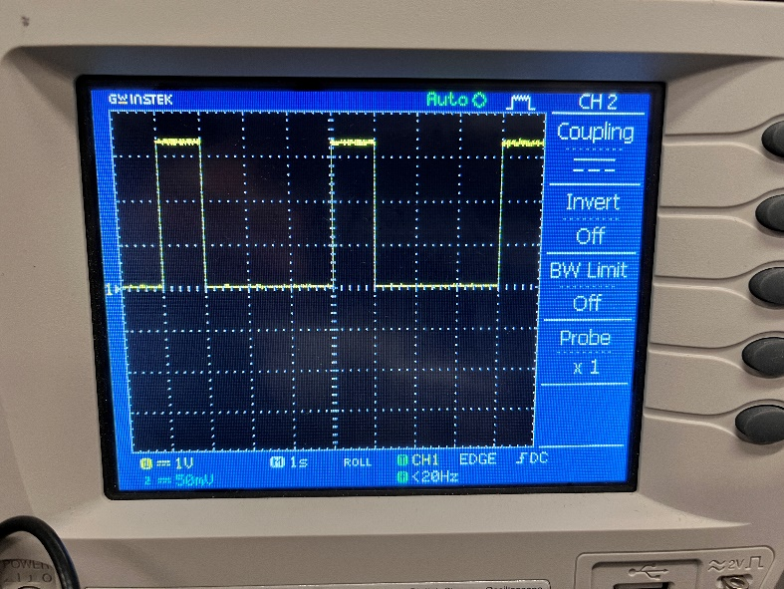

The fan won’t turn on when directly connected to the pico because the pico can’t supply enough power to the fan. It can’t offer enough voltage because the pico is capped at 5V.

The fan requires 12V at 0.93A which results in a power of 11.16W. Even if the pico could supply 12V, the USB is limited to only 0.5A which is half what is required from it (0.93A).