## Abstract : As digital distribution platforms have risen in popularity, board game classics are surprisingly still relevant in today’s society, but they have failed to adapt to the technological advances of today’s market. This points to an opportunity to adapt the classics that have stood the test of time with some innovative electronic based interfaces. We would like to implement an electronic medium to the classic game of Battleship. Acoustic Battleship innovates on the traditional Battleship game with acoustic localization technology, making accuracy part of the fun of the game.

## Introduction

[A] In the current era of electronic video gaming, one may ask, “where have the classic board games gone?” One may say that the classic board games such as Monopoly, Risk, Clue, and even Battleship have become outdated. Actually, within the past decade there has been an increasing rate of tabletop games, or board games, being sold each year, especially around the holiday season. What we are trying to do is add an electronic medium to the classic game of Battleship to enhance the entertainment amongst players. Although the classic game is actively being played today, we aren’t trying to solve a specific problem with the matter but instead create a better version of the game itself.

[B] This isn’t the first time someone thought of bringing electronics and classic board games together. Throughout the years, we have seen applications through our smart mobile devices such as Scrabble, Monopoly, and even Battleship. One of the critical viewpoints on these electronic board games is that it doesn’t bring people and families together at the same place as would a classical board game. So there are electronically developed board games such as Electronic Battleship: Advanced Mission which has special sound effect features that respond to the player’s imputed coordinates. Another product that has been electronically implemented is Monopoly, where you are now able to use a bank card to make transactions rather than using Monopoly dollars. Acoustic Battleship is different in terms of turning the classic board game into an electronically assembled accuracy based game that will be interactive and entertaining. We hope that this technology will be adaptive in terms of being implemented in other classic games such as darts, ping-pong, etc.

[C] We hope that Acoustic Battleship will make a social impact terms of bringing a more interactive community together to enjoy a new interface of the classic board games that we love. We hope to see this project be used in public settings such as arcades and game rooms, hopefully to one day be portable enough to be brought and played anywhere.

[D]

1. Design
   1. Overview

Our approach to this problem is to develop and deploy a robust sensor network on a playing surface much larger in area than the traditional BattleshipTM game. The sensor network will consist of 8 omni-directional microphones, a microcontroller, addressable LEDs, and a power supply. We considered the implementation of a sensor network consisting of infrared LEDs, though we felt that management of this system would be through brute force, and would be an unimpressive, highly wasteful, iteration of localization.

While the game rules will remain the same, ie, to win, you must eliminate your opponents battleships, the accuracy mechanism is now a projectile you will throw toward an intended coordinate on your opponent’s side of the playing surface. We have chosen to implement three blocks: Sensors, Microprocessor, and our User Interface (UI). This solution transforms the lackluster pace of a traditional marketplace into a more technologically mature space. By placing the accuracy of the game into the hand of the end-user, we anticipate a greater interest in the final product than the BattleshipTM of old.

Our microphone sensors will receive sound produced by a projectile striking the surface of our apparatus. Using Schmitt Triggers to convert our analog sound signals to 3.3 V digital signals, we can input these signals as triggers to our microcontroller in the Processing Unit. These digital inputs are representative of our Time Difference of Arrivals (TDOAs). By implementing polling in our microcontroller programming in the Processing Unit, we are able to accurately measure our TDOAs. These signals are then computed in our multilateration algorithm to produce the coordinate of the sound source. We then will light up the coordinate that is computed with byte addressable LEDs (i.e. WS2801 4-wire controlled by SPI) in the User Interface. The colour of the LED will be dependent on if that coordinate currently contained the position of a battleship (we anticipate using contrasting colors such as red and green to mark a “hit” or a “miss”). To position the battleship targets, we would like to implement a controller for each player, and an additional, smaller coordinate system that indicates the positions of a participants own battleships.

We would like to produce a responsive, accurate system, in which our sensors and processing unit produce coordinates within 5cm of accuracy and the processing unit and user interface have latency less than 500 milliseconds.

.

**INSERT FIGURE HERE**

* 1. Sensors

Our design implements 8 omni-directional microphones that are capturing the sounds produced on the playing board between the frequencies of 5kHz and 10kHz. We found that the distinct voltage signal of the projectile hitting the surface of the playing board is adequate for an Analog to Digital Conversion (ADC) by implementing a Schmitt Trigger (refer to appendix B). The voltage consistently reaches levels greater than **XX** volts. This allows us to implement a Schmitt Trigger with a supply voltage of 3.3 Volts that will consistently produce an ADC for our signal in all coordinates within our plane. After measuring TDOA versus theoretical TDOA values, we can confidently calculate the position of a sound source.

To achieve this solution, we have derived a two-dimensional planar algorithm for multilateration using TDOAs and energy waves of a known propagation speed (the speed of sound in dry air at 20°C, 343 m/sec). To comprehend the algorithm we will be implementing, it is useful to refer to Figure 1. As can be seen, our initial time of travel *a* (the red circle) to our first microphone is an unknown. This is evident, as we do not know when the projectile will strike the surface of our playing surface, we only can mark the arrival of the energy wave in time. We do know the *time difference of arrival* of that same energy wave to our second and third microphones, located at either end of the hypotenuse of our triangle in Figure 1. These are represented by *b* and *c* in Figure 1. It is then helpful to imagine TDOAs *b* and *c* as the radii of circles generated by the formula: d*b*,*c* (distance) = rate (the speed of sound in dry air at 20°C, 343 m/sec) x time (TDOA*b*,*c*).

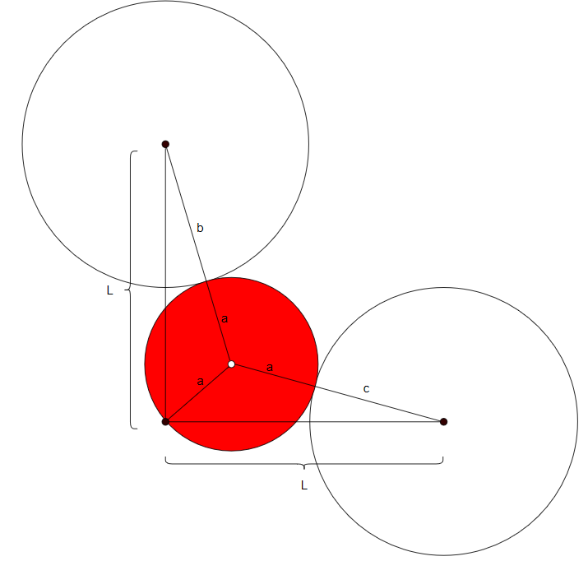

Figure 1. A visualization of multilateration utilizing an isosceles triangle.

These calculations produce two known radii (though without a known angle of arrival), we can produce the initial location of sound through the use of multilateration. For a comprehensive visual of our process, please refer to Figure 2.

Using multilateration algorithms derived on a 2D plane through analytical geometry, we can

* 1. Block 1
  2. Block 2
  3. Block 3

1. PROJECT MANAGEMENT

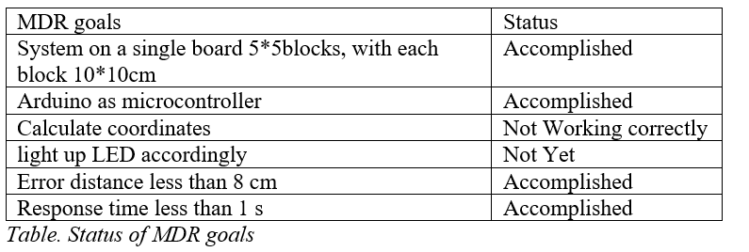

By MDR, our team have built a wood playboard whose dimension is 50cm*50cm. The board is divided into 5*5 blocks. We used Arduino Mega2560 as the microcontroller development board. We developed an algorithm that provides an analytical solution of calculating the coordinates of the positions of the sound source given an ideal input of the time of arrivals of all four microphone sensors. We simulated the algorithm in both Matlab and C++ and achieved 100% accuracy with ideal inputs which are generated from known dimensions of the board and the speed of sound in the air. We programmed our Arduino Mega2560 microcontroller to capture the time of arrivals; we then integrated our algorithm into the code for microcontroller to have it calculate the results of sound source coordinates based on the predefined coordinate plane.

However, the results generated by our system are incorrect. This might be caused by inaccurate time of arrivals captured by the system or the incompatibility of the algorithm used due to neglected conditions. We found that the biggest challenges come from making four registers of the microcontroller listen to four microphones independently and capture each time of arrival asynchronously.

We weren’t able to move on to displaying our results with LEDs because of failure to get accurate time of arrivals. We also could not calculate our error of distance for the same reason. However, our algorithm model makes it clear that as long as we manage to get the accurate time of arrivals, the error of distance should be negligible.

We did get a response time less than 1s. Actually, we had it under 500ms for our MDR prototype. There might be extra delay of time when LEDs are connected to the system, but the entire response time should still be reasonably small.

IV. Conclusion

We plan to keep working on the Arduino code to allow the microcontroller to capture the time of arrivals as accurately as possible, which will involve a lot of reading of datasheets, experiments of different approaches and testing of the accuracy. We also consider this as our biggest difficulty. Once we are able to obtain accurate time of arrivals and calculate the accurate coordinates, we will then move on to displaying the results in LEDs, scaling up the board and building a two-board system as required for the game.

ACKNOWLEDGMENT

APPENDIX

Sections A - D are required appendix sections. You may refer to these materials in the report body as needed. An appendix is a useful catchall when there is too much detail to include in the report body, but where this content is still useful to be communicated. Include such details in Section E, F, … and so on.

A. Design Alternatives

B. Testing Methods

C. Team Organization

D. Beyond the Classroom