Berkeley Andrus
Lab 1 Report – Fermat and Carmichael tests.

Part 1:
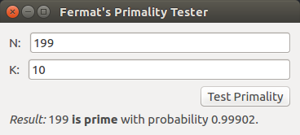

Screenshot 1: Demonstrates functionality with prime numbers.

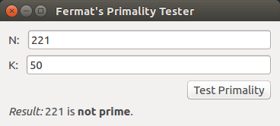

Screenshot 2:
Demonstrates functionality with composite numbers.

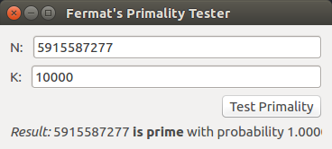

Screenshot 3:
Demonstrates functionality
with extremely large numbers.

Parts 2 and 3:

* I thought a screenshot of my development environment would be easier to read than code copied and pasted into a word processor. Sorry that it is small.

Working code with explanation of how it works:
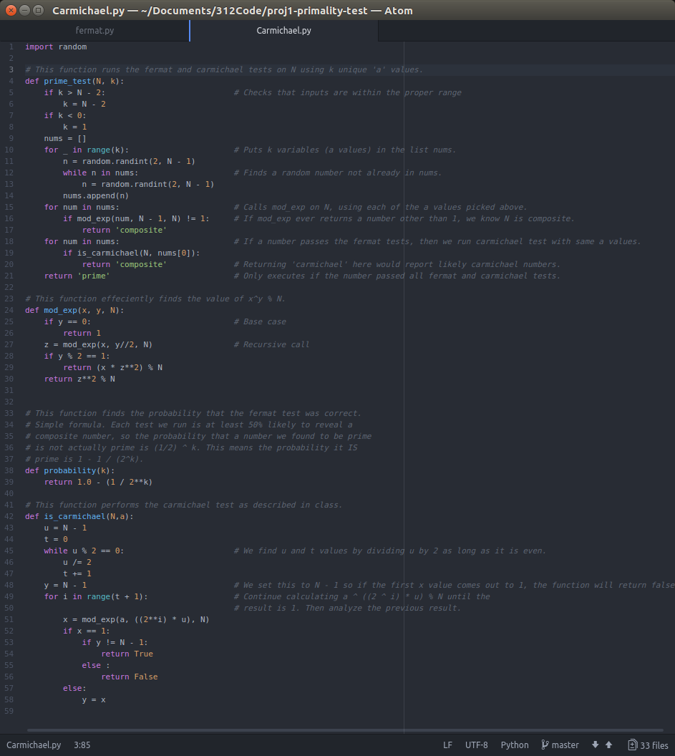

Code with time complexity analysis:
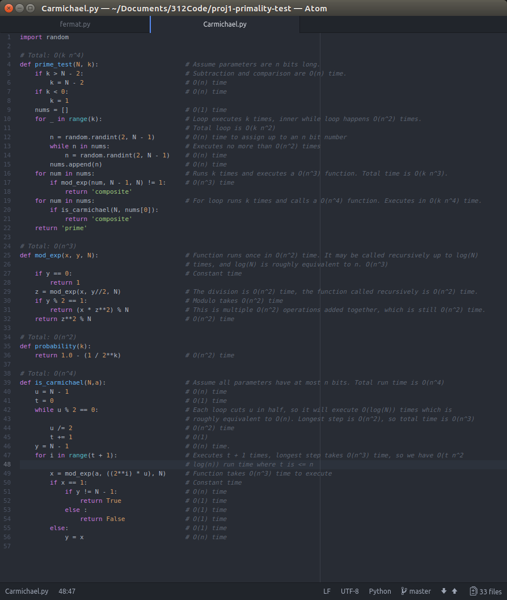

Code with Space completxity analysis:

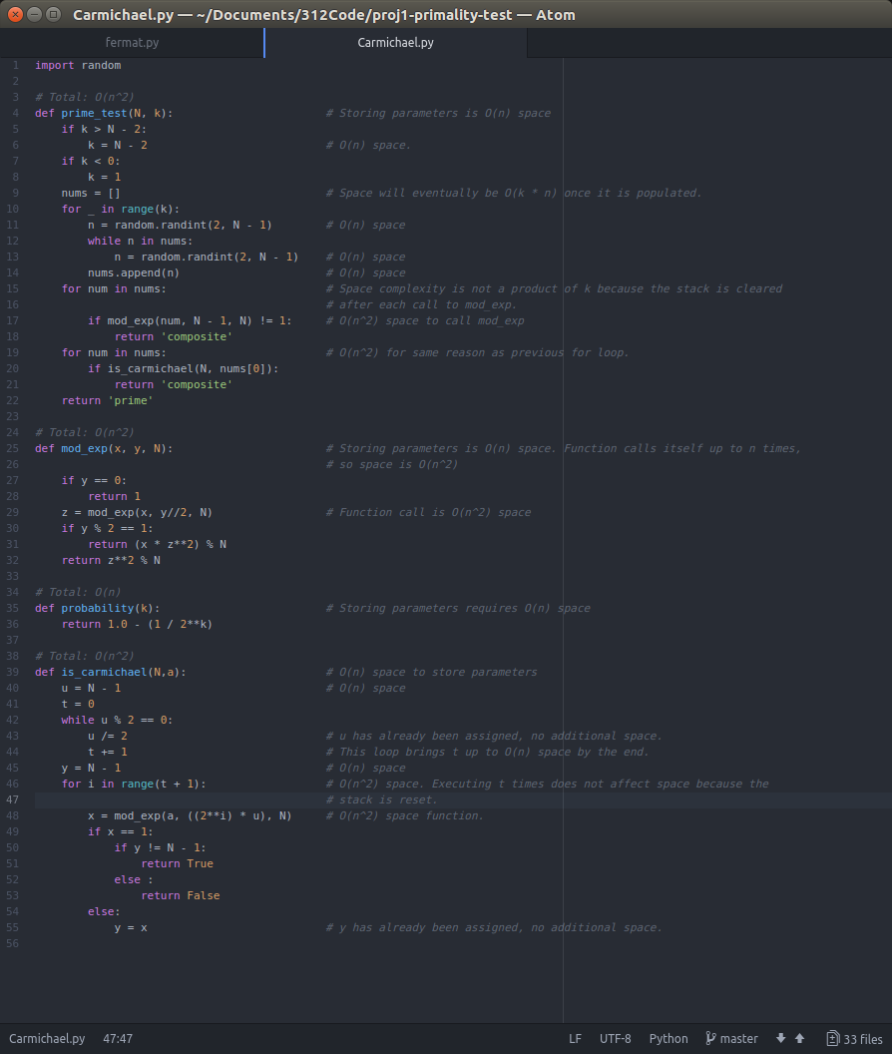

Part 4:

The probability equation was perhaps the easiest part of the project.

Each ‘a’ value that we use to test ‘N’ has at least a 50% chance of detecting a composite number. This means that if ‘k’ is the number of ‘a’ values you are using, you have a 0.5^{k} chance of missing a composite number, or a 1 – 0.5^{k} chance of detecting one. Thus, the probability that a number we have found is actually prime is 1 – 0.5^{k,}, or 1 – 1/2^{k}.

