Overview:
This scenario is intended for 6 players of moderate skill level and You should be able to play this scenario in one to two sessions of varying length. One player must play Jonathan Crown or the keeper must use Crown to begin the play. The assignment starts with Mr. Crown and he in turn hires the other players for specific jobs. Though everyone will have a specific part to play it may not be easy for the keeper to keep everyone together. Pre-generated characters are provided which match the various tasks Mr. Crown will require through the scenario. The scenario is written with the pre-gen characters in mind. If you would like to use different professions you can, but try to make them fit the skills that the pre-gen character you are replacing has. Also be aware that some of the scenario descriptions may have references to the pre-gen characters so you will need to change those accordingly.

If you are not using the pre-generated characters you should at the very least have a lawyer. The main hook in the scenario is a case that the lawyer receives which leads into the investigation. You will need a lawyer to start, if you can come up with another profession that will work you can however the entire scenario as written is based on one character being a lawyer.

Players Info:
You are a lawyer at the respected firm of Billings and Lafayette, you have worked here for five years and you are the top prospect to gain partnership with the firm. This is an incredibly significant occurrence being that firm, has not, as yet, ever taken a partner in all of its years of operation. It is the beginning of the year and many of your married colleagues have taken time off to be with their families. This has left you and Mrs. Edith Lampton, the office manager, to run the place during this, the slow season, for your firm. You, being a single individual, have no problem working extra hours as you are bucking for that partnership, which is to be announced soon.

The firm deals mostly in real estate law, estate management and inheritance. A particular file has come across your desk and you recognize the name instantly. The McGinley estate is the first and largest client the firm maintains and it behooves you to do your best with this case, as it is a very important one. It is Monday morning February 13th 1922 and you sit at your desk with the McGinley file in front of you. It almost feels like a test of some sort, to receive the firms most important clients file during a time when most of the office is away on vacation. You open the file…

Keepers Info:
Colton McGinley inherited his father’s fortune before he graduated Harvard University in 1852. He was not close with his father and never learned much about the business, which was the corner stone of the family’s fortune. The McGinley’s were in manufacturing, the McGinley Manufacturing Company was formed in 1823 by Milton McGinley, Colton’s father. Colton did not exactly know what to do with the company and so left it to the men his father had in place and took a hands off approach.

He spent his time, with another young man he met at Harvard named Abram Penkin. Penkin was a student of philosophy and had grand ideas about our world and that which he called the other side. He believed that there were alternate worlds or dimensions that paralleled our own, and this idea fascinated Colton McGinley. They became friends through this mutual interest in dimensional travel. They began to research the idea that one could pierce the fabric that exists between dimensions and travel freely between them. They traversed many avenues to reach their hypothesis, studying physics, mathematics, biology and finally finding what they were looking for in occult works.

It was in their final year at Harvard that Mr. Penkin made a great discovery. He found reference to a book, which was said to be the spell book of an ancient Russian sorcerer that contained formulas and rituals dealing with dimensional travel. Penkin convinced McGinley to put up the money for a trip to Denmark to find the alleged book. Once in Denmark they found the location of the grave, it was in a remote cemetery called De Beulen Huis (Danish translation The Executioners House). They procured the necessary equipment and proceed to rob the grave of the Russian sorcerer Maxim Utkin and carry off his book of shadows. Once back in the states Penkin began research in earnest.

Penkin became reclusive and solitary while he researched the book. It was written in Old East Slavic, an older Russian dialect and so Mr. Penkin, a fluent Russian speaker, was the best suited for the translation. It was during this time that Mr. McGinley met two other young men, Mr. Stewart Billings and Mr. Bernard Lafayette. Both of these men were students of law and endeared themselves to McGinley with their sharp wit and their intellectually clinical minds. It was a respite from the oppressive and sometimes dark conversation that he had been engaged in with Mr. Penkin for so long. He began to become more social and involved in the university community as a whole. He began attending parties and events, liberally spreading his family fortune around. He met another young man who was studying to be a doctor at Harvard Medical School at one such event, Mr. Wesley Lawton. They became friends and the four men became nearly inseparable.

Eventually the subject of the occult and specifically dimensional travel came up between McGinley and his new friends. They were skeptics but had an interest in delving into the dark arts as a means of amusement and wonder. They began to study magic and practice occult rituals, first as a curiosity and then more seriously as time went on. Eventually Mr. Penkin completed his translation of the ancient tome they pillaged from the detestable graveyard in Denmark. He produced an encrypted translation of the original, giving the cypher key to McGinley and keeping the encrypted translation himself. He told McGinley he was worried that the contents of the book would be found by others and that their research would be stolen. In truth he encrypted the book so that McGinley could not see the translation for what it was and discover Penkin’s diabolical intentions.

The author of the book, Maxim Utkin, was actually a descendant of Mr. Penkin. When his ancestors had migrated to the colonies they had changed their name from Utkin to Penkin attempting the flee the persecution that followed the family line. The Utkin / Penkin family had a long been worshipers of Yog-Sothoth, going back to the time of Maxim Utkin. When Penkin found the location of his ancestors grave he needed only to find others he could convince to help him perform the “Dedication to the Opener”. He found a willing participant in McGinley, however he never revealed his true intentions or his family history in fear that McGinley would sour on the whole affair. He needed to draw power from several individuals to perform the ritual, and he found them in McGinley’s new friends.

Penkin kept on with the group, performing small insignificant rituals and spells, to amuse them and increase their interest and abilities. Outwardly the men all seemed to be good friends, they formed a sort of secret club, which they called the Tenebris Circuli, Latin for the dark circle. McGinley bought a house outside of Boston on Waverly Oaks road so that the men had a location to practice their craft. Penkin finally convinced the men that he had a ritual that would send him to another dimension and he wanted them all to attempt it. They all agreed believing this to be research into dimensional travel and, if successful, would be a breakthrough that would gain them all considerable notoriety.

They went to the house on Waverly Oaks and performed the “Dedication to the Opener”. Mr. Penkin was transported to Yog-Sothoth where he was imbued with the dark gods power and horribly deformed then sent back, transformed into a servitor of the blasphemous god, bent on opening the way for his master to reign in our dimension. Upon returning, the others saw this corrupted version of Penkin and panicked. Mr. Lawton was the Penkin thing’s first victim, mesmerized by the power of the thing he rushed towards it. It pulled him in with writhing worm like appendages and the others watched in horror as the thing bit into Mr. Lawton’s neck and began to gorge on his blood. It was McGinley who, fearing trouble with the ritual, created a silver disc emblazoned with the Elder Sign. He ran forward and pressed the disk to the thing and it released Mr. Lawton. Calling for the others to get something to bind the thing as he held it fast with the disk, staring face to face with the abomination, which once was his friend Abram Penkin. They chained the thing up; fixing the disk to the chain to keep the thing at bay then proceeded to brick it up in the basement. They carved the Elder Sign on newly fashioned wall and performed the ritual to seal it. The body of Mr. Lawton was also walled up with the thing. They feared what would happen if anyone had found what they had done.

The three men, Colton McGinley, Stewart Billings and Bernard Lafayette told authorities that they had all be spelunking in some caverns in northern Massachusetts when a cave in claimed the lives of the other two men. They even went to the lengths of finding a cavern and causing a cave-in to legitimize their story. McGinley gave the two lawyers a large sum of money to begin handling his estate with specific stipulations, one of which was that the inheritors of the estate were never to sell or dismantle the house on Waverly Oaks road. This initial capital allowed Billings and Lafayette to start their firm before either had taken the Barr exam and so was blood money they could not pass up. The years went on and they pushed the memories as far down as they could.

A series of horrible incidents followed the McGinley family as they lived in the house, the thing in the basement ever calling for the inhabitants to release it. McGinley pushed his wife down the stairs in a fit of rage brought on by the thing. McGinley threw Penkin’s book into an empty well behind the house and sealed the “key” away in a safe deposit box at his bank. His son later fell in the empty well when the thing persuaded him to retrieve the book and use it to open its prison. Only his oldest son Christopher survived and eventually unable to resist the thing any longer, Colton McGinley shot himself so that he would not succumb to the will of the thing.

Christopher McGinley, found his fathers journal and realized the horrible truth. He attempted to right the wrong done by his father but the price was high. His wife, chased by the shadow of the thing, which it was able to project inside the house, jumped to her death. His daughter seeing the shadow went insane and was committed to the Roxbury Sanitarium. His son grew to manhood and left for college only to here a year later that his father had committed suicide by hanging.

Peter McGinley, the last descendant of the McGinley line, after finding his father and grandfathers journals also attempted to send the thing back to the hell it came from, but the things power was too strong. Fearing he would succumb to the things will, he also committed suicide just a week ago.

It is now Mr. Crown’s job as executor of the estate to facilitate the inheritance in accordance with the stipulations set forth in the estate documentation.

Setup:
It is best to setup the appointments, which Mr. Crown will have ahead of time so that the players will have definite connections at the beginning of the game. There is a note on the case file, which states that Mr. and Mrs. Lawton of Boston are the expected inheritors of the estate. It also makes some suggestions about services to contact. If you are using the pre-generated characters the following list will be useful however if you are using custom characters the list could be different.

Mr. / Mrs. Brooks – The accountant, Crown will want to setup a time to have the accountant begin looking through the company books. The company’s documentation is to be delivered to Mr. Crowns office at 9:00 AM Monday the 13th of February.

Mrs. Waterford or Mr. Pembrook – Antiquarian / Historian, it is best to have them either meet at the bank or the house to being appraising items that might be of particular value.

Mr. Stark – Architect, setup a time to meet at the house to check out its condition.

Mr. Elliot or Mrs. Witherspoon – Contractor / Interior Designer could be contacted by Crown or could be contacted by the inheritor of the house to have their own professional check out the house.

Mr. / Mrs. Lawton – Contact the Lawton’s to inform them about the inheritance.

Character descriptions and stats are included at the end of the scenario.

Note on the file:
handout #1
Mr. Crown,
This is the big one, so handle it with care.

Tracked down the last descendants of the Lawton family, see the stipulations for the inheritance.
The company records will be delivered, Monday 13th at 9 am, you may want to get an accountant or someone to look through them. You may also want to contact someone who can appraise items in the house to see what can be sold off. Get a hold of an architect or contractor to check the place out and see if there are any structural issues we will need to address.

Good luck Crown, I’ll see you when I return from vacation.
Danforth Billings

Billings and Lafayette:
Founded in 1852 Billings and Lafayette is one of the top firms in Boston dealing with real estate and inheritance law. Stewart Billings and Bernard Lafayette started the firm, the year of their graduation from Harvard Law School, and before either had even completed the Barr exam. Mr. Colton McGinley, who was a friend of both founders and the heir to the McGinley family fortune, provided the initial capital used to start the firm.

There is some intrigue to the founding of the firm, which is tied closely to the founders and their first client. A large sum, even for this time, was offered to begin the McGinley estate. This initial capital provided the means to create the firm before either of the two founders had taken the Barr and were accredited lawyers. Some say that this money was in some way tied to a tragedy which the three men were involved in that left two other men, Mr. Wesley Lawton and Mr. Abram Penkin, dead by a cave-in that occurred during a spelunking trip the men had taken after graduation.

Employees of Billings and Lafayette:
Danforth Billings – owner / founders grandson
Mr. Billings is a kind and compassionate man, and upstanding member of the community and an exceptional lawyer. Billings has taken Mr. Crown under his wing and is the reason that Crown is up for a partnership. Billings is on vacation for the week and will return Monday the 20th of February.

Walter Lafayette – owner / founders grandson
Mr. Lafayette is a shrewd and cunning businessman who is fastidious in both his business and personal life. He is an upstanding member of the community and has aspirations of becoming a judge. He recognizes Mr. Crown’s potential and his aptitude and although he will not say it outright, he believes Mr. Crown is a good choice for partnership. Lafayette is on vacation for an indeterminate amount of time. The keeper can decide if Lafayette returns during the scenario or not, but in most cases he should be on vacation.

Charles Monrow – lawyer
Charles is a decent lawyer but not as dedicated to the firm as one would hope. Charles has only been with the firm for two years and has proven capable but has been rumored to have entertained certain offers from other firms in the city. Mr. Monrow is out of town currently working with a client in New York. He will be back at the office Monday the 20th of February.

Edith Lampton – Office Manager / Secretary
Edith is a no nonsense woman with strong puritanical beliefs. She does not take any guff and is not keen on more liberal ideas about society. She keeps her opinions to herself unless asked but it quick to give disapproving looks when necessary. Mrs. Lampton is an efficient office manager and has the files and appointments in order. If there is anything that needs to be pulled up in the firm’s files she will do so in short order. She respects Mr. Crown, though she wonders why he is not married or looking to become so. She does not like Mr. Monrow and believes that he is a deviant that should be tossed out on his ear. She respects and admires Billings and Lafayette and has nothing but good things to say about them.

The Case File:
The file contains the accounting books of the estate as well as various assets and holdings. Much of this is trivial and can be passed over. Keepers may wish to put other assets in the file with possible connections to other scenarios of their choosing.

Important items:

The house at 1747 Waverly Oaks Rd. Waltham MA.
There is a stipulation in the file states the house can never be sold or torn down. It must remain as part of the estate until it either falls to ruin or is given over to a new inheritor.

Safe deposit box number 538 and key.

Empty envelope with the name Peter McGinley on it. Peter took the letter which was from his father and informed him of the whole story. He burned the letter.

Stipulation that if there were no members of the McGinley family that are of sound mind and body, the estate would go to the Lawton family. If the Lawton’s were not able to produce someone of sound mind and body the Penkin family would inherit. If there was no one left, the assets of the estate are to be liquidated and donated to the Harvard University. With the exception of the house. The house is to be raised and the basement filled with concrete, then the land donated to the state.

The note left by Peter, it is a single small sheet of paper folded in half, and written in a cramped disorganized hand. The note reads as follows

handout #2
“It wont be dismissed, let the Penkin line take on this burden, it was Penkin who cursed us to begin with”.

The Bank:
Eastern Bank 265 Franklin St. in the financial district.

Upon inquiring about the McGinley estate, anyone who is accompanied by or is Crown himself will be allowed access to the accounts and to the safe deposit box. If Crown is not present the bank employees will not allow any access. The bank manager Mr. Bromley Carrington is accommodating but unwavering in the security of the accounts entrusted to his bank. Any attempts to gain access to the account or safe deposit box without Mr. Crown will result in an escort out of the bank by security; if the investigators are persistent the police will be called.

The McGinley account has been depleted vastly by three generations of McGinley’s attempting to find the answer to sending back the thing in the basement. Many trips abroad and money spent on books and research material, not to mention neglect of the company that fuels the family fortune have left the coffers low. The total of accounts an investments left to the inheritor are in the sum of $270,000.

If asked about the safe deposit box a bank employee will take the investigators to the viewing room. The box number is 538 and the key is in the estate file. Once in the viewing room the bank employee will leave to allow privacy.

Safe Deposit Box 538:
The 12” by 12” metal box contains the following:
One leather bound book, one old key and a fist sized smooth white stone with an asymmetric five-pointed start carved into one side. In the center of the start is a flaming eye. This of course is an Elder Sign. The sign is fully functional and will repel lesser minions of the Mythos. If used on the thing in the basement it will render the beast immobile but will not stop it from using its mental powers.

A library use roll will turn up images of the symbol, which will then lead to more potent books. Another library use roll will be needed to track down a book said to contain the ritual needed to create an Elder Sign. The Oren Library at the Miskatonic University has a copy of Cthulhu in the Necronomicon by Dr. Laban Shrewsbury 1915 which contains the spell Create Elder Sign, this book is on the restricted list and only an admittance from Dr. Henry Armitage will gain the investigators access. The library also contains the Necronomicon itself but Armitage will not allow this book to be viewed.

The book is the cypher key for the translation created by Penkin, by itself it is completely useless. There are words in English, Latin, Hebrew and Russian sprinkled throughout without discernible connection. In addition there are various mathematical formulas and number patterns. A mathematics or know roll is required to determine that this is a decoder key for an encrypted document. Without the other book it is impossible to tell anything about the translation. If the other half of the pair is discovered in the dry well at the Waverly Oaks property, the mechanics needed to get the translated text appears at the end of the scenario. Briefly though, one must make a hard mathematics, or linguistics role to determine the pattern being used to encrypt the text. Once the pattern is discovered one must make two of either English, Hebrew, Latin or Russian to start piecing together the translation. Once this is achieved roll a 1d10 + 2 the result is the amount of days it will take to render a complete translation. The book can then be read in a day or two. The information contained in the book appears at the end of the scenario.

The key unlocks the hidden secret compartment in the master bedroom of the house on Waverly Oaks Rd. There is nothing else remarkable about the key other than its estimated age of around 80 plus years.

Research:

Research into the house on Waverly Oaks turns nothing up before the events directly involving the McGinleys. Colton McGinley purchased the house in 1852, before that the Dunlop family who originally built the house in 1783 owned it. The Dunlop family is unremarkable and there is no news worthy information about them.

Research into the other employees at the firm comes up with nothing useful.

Some avenues of research that would prove fruitful are the local papers or the Boston Public library, which would have back issues from the local papers. The Boston Globe has many articles of interest. The articles from the Waltham Examiner would be found at the Examiners offices in Waltham. The library however should have both so in the interest of time the Boston Public library would be the best choice.

Newspapers:

Billings, Lafayette, McGinley tell about deaths of Wesley Lampton and Abram Penkin.

handout #3
Boston Globe July 18th 1852
Tragedy befalls recreational cave explorers in upstate Massachusetts
A cave-in caused the death of two Harvard University graduates this Saturday July 17th while a group of armature spelunkers traversed an uncharted cave system in upstate Massachusetts. A group of five men all graduates from Harvard were on a camping trip in celebration of their recent graduation when the tragedy struck. Mr. Wesley Lawton and Mr. Abram Penkin where killed when a portion of the cave collapsed on them, the other men attempted to dig them out but realized the effort was futile and called authorities. The other three men Mr. Stewart Billings, Mr. Colton McGinley and Mr. Bernard Lafayette gave statements about the cave-in, which authorities deemed too extensive for there to be any chance of survivors.

Rescue crews were brought in to search the cave for the bodies but another cave-in, caused by structural weakening as a result the first, forced rescuers to abandon the effort. The cave, near Sutton Massachusetts, has been blocked off and is now off limits for curious cave explorers. This is a great tragedy for both the Lawton and Penkin families.

Death of McGinley’s wife Bethany.

handout #4
Waltham Examiner January 23rd 1864
Obituary:
Mrs. Bethany McGinley, wife of Colton McGinley, mother of Christopher and Charles McGinley died Wednesday January 20th 1864 after an accidental fall down the basements stairs in her home on Waverly Oaks road. Her distraught husband Mr. Colton McGinley told authorities that he came down for breakfast to find the door to the basement open. Upon investigating found his wife at the bottom of the stairs. Mr. McGinley stated that the stairs would often ice up on extremely cold night and she must have slipped on the ice. Funeral services will be held next Saturday the 30th of January.

Youngest Charles falls in well

Handout #5
Boston Globe August 7th 1867
Boy found in well after weeklong search
Search parties found the body of Charles McGinley, the young boy who had gone missing five days prior, in a dry well behind the McGinley home. Son of Colton McGinley owner of the prominent McGinley Manufacturing had been reported missing five days prior when he did not return for supper. The oldest boy Christopher stated that he had been playing in the woods behind the house but had lost track of his brother and could not find him. Mr. McGinley immediately set up a search party and a reward of $500 was offered.

After an exhaustive search of the woods and outlying areas the search party was beginning to lose hope. It was when one of the dogs caught scent of something in an old dry well that was covered with years of debris, that the searchers found the boy. A small holee had been uncovered and this was apparently the access, which the boy had found. The lifeless body of young Charles was found at the bottom of the 50-foot well. Another sad tragedy for the McGinley family coming only three years after the tragic death of Bethany McGinley, wife of Mr. McGinley and mother of young Charles.

Company starts downward spiral

Handout #6
Boston Globe October 4th 1867
McGinley Manufacturing stocks plummet
McGinley Manufacturing stock begins a downward trend as the owner Mr. Colton McGinley leaves on another trip abroad. Mr. McGinley who has not taken an active role in the company since his father’s death in 1851, continues with his globe trotting excursions while the company falls to ruin. Speculation on McGinley’s mental state after losing a wife and child have investors selling off as much stock as they can.

Back home mismanagement of the company has gone unchecked for years and it seems that Mr. McGinley is more interested in seeing the world than seeing his company succeed. It is rumored that several offers have been made to buy McGinley out but as yet the company rests firmly in the hands of the McGinley family.

Colton commits suicide

Handout #7
Waltham Examiner March 21st 1879
Tragedy at the McGinley residence
Mr. Colton McGinley was found dead in his home at 1747 Waverly Oaks Rd. yesterday morning when the mail carrier Stanley Knolls saw what looked like a body lying on the floor through the large bay windows of the home. When authorities arrived they received no answer and finally forced entry into the home. The body of Mr. McGinley was found lying on the floor of an apparent gunshot wound to the head. The home was searched and no evidence of foul play was discovered. Mr. McGinleys own .38 revolver was used and police stated that the injury was indeed self-inflicted.

Mr. McGinley had recently been seen in town in what was described as a bedraggled condition and ranting about his inability to stop his families curse. Mr. McGinley has become increasingly aloof in recent years, spending more and more time confined in his home, when he was not taking trips to exotic locations around the world. It is said that the loss of his wife and child and the decline of his company had played heavy on the mans mind.

His son Christopher McGinley who is currently away at the Miskatonic University in Arkham Massachusetts survives Mr. McGinley. Christophe is the sole inheritor of McGinley Manufacturing and the McGinley family fortune.

Christopher inherits company starts an upturn.

Handout #8
Boston Globe April 3rd 1888
McGinley Manufacturing takes an upward turn under new ownership
McGinley Manufacturing stock has taken a steep upturn under the new and capable ownership of Mr. Christopher McGinley. The son of Colton McGinley inherited the company and the family fortune in 1879. Since that time has taken a passive role in the company until now. It is reported that McGinley has cleaned house, letting go of many corrupt and inefficient managers who were pillaging the company due to that lack of a firm hand at the helm.

The woes of the company seem to now be in the past as the new McGinley is setting a course for success. We wish Mr. McGinley success in the future and we hope that the misfortune that has been a dark cloud over the McGinley family is now lifted.

Chirstopher’s wife Claudette falls from third story window dies, Agatha is sent to Roxbury.

Handout #9
Waltham Examiner October 16th 1897
Tragedy at the McGinley Home
Police were called to the McGinley house on Waverly Oaks road this Friday, responding to reports that the McGinley children were found wandering the road near the house. When police arrived Agatha McGinley, age four, was found with her two-year-old brother wandering the road a few blocks from the house. When officers asked the children where their parents were Agatha told an unbelievable tale, which sent the officers immediately to the home to discover the whereabouts of their mother Mrs. Claudette McGinley.

Agatha told officers that a beast had thrown her mother from the second story window of the home and that she was not moving. The police went to the home to find that Mrs. McGinley had indeed fallen to
death from the second story window. Her body was found at the foot of the large bay windows on the right corner of the house. The window above was open and the officers believed this must have been where she had fallen. A search of the house was conducted due to the assertion that a beast has pushed the children’s mother but the house was found to be empty.

Mr. McGinley, prominent owner of McGinley Manufacturing, was away on business but is now returning home from abroad. Agatha McGinley who seems to have suffered a mental break from witnessing her mother’s apparent suicide was taken to the Roxbury Sanitarium for evaluation. Peter McGinley has been taken to a family friends home until Mr. McGinley returns.

Agatha described a large creature that had to stoop down to fit in the confines of the house, it had dark green skin which glistened as if covered with some sort of mucus or slime. She saw it from behind and so did not get a look at the face of the thing but noted that it walked on two legs and had multiple appendages coming off the torso, which she took for arms. These arms however did not appear to be jointed as she described them as waving like hair in the wind. The thing had her mother tangled in its multiple appendages and was pulling her close to its body. She described a loud sucking sound and finally the sound of something ripping open. After that she stated that the thing flung her mother out the window and she had ran before it could turn to see her behind it. She grabbed the baby and ran from the house.
It is believed that Agatha has constructed this monster to justify in her mind the reason behind her mothers apparent suicide. When asked, neighbors stated that Mrs. McGinley had not seemed distraught or troubled in the weeks leading up to this grisly event, and that she had seemed happy and content. Mr. McGinley is expected to return home sometime in the coming week, he has received a telegram about the indecent and is returning home post haste.

Christopher hangs himself.

Handout #10
Boston Globe March 24th 1914
Head of McGinley Manufacturing Meets a Tragic End
The body of Mr. Christopher McGinley was found in his home this Monday evening as neighbors spotted something hanging in the large bay window that fronts the house. Upon closer inspection they realized it was the body of Mr. McGinley. Police responded to the call, searching the house but found no evidence of foul play. Mr. McGinley had hung himself, which was apparent from the condition of the body and the overturned chair beneath him. The family has suffered much loss through the years and it seems it has taken its toll on the manufacturing mogul.

His son Peter McGinley who will inherit the family fortune and the prosperous McGinley Manufacturing Company survives McGinley. The company has been on a downward trend since the death of McGinley’s wife but has recently taken a turn for the worst as McGinley stopped taking any hand in the day to day running of the company. There is speculation about the companies continued existence in the wake of this tragic event.

Peter’s suicide.

Handout #11
Waltham Examiner February 7th 1922
Another Tragic Death at The McGinley Home
Peter McGinley was found dead in the McGinley home today by a passing motorist seeing his body hanging in the large bay windows at the front of the house. Police were called and confirmed the suicide, ruling out any foul play.

Oddly enough the last of the McGinley line committed this heinous act in the exact fashion that his father before him had. Peter who had never taken any interest in the family business had recently returned home from abroad. It is speculated that the estate holders will now sell off the company, which bares the family name, and the family assets will be liquidated.

Journal of Colton McGinley:

Handout #12
Leather bound journal with no distinguishing marks on the outside cover. The inside front cover has an inscription “C McGinley”.

Entries begin in 1850 and detail the general college life of a young Harvard student. Being a history major the initial entries deal with trips to historical sites around Boston and musings about the cities past.

September 21st 1850
Today I met a philosophy major that had some very interesting things to say about the history of the greater New England area. Mr. Abram Penkin was his name. He spoke of the rich occult history of New England dating back to the original colonists. I of course have studied the witch trials but some of the events he brought up had eluded me. I found it intriguing that a philosophy student would have more interesting facts about the local area than I, a history major. We talked for several hours, he is a very interesting man.

October 17th 1850
Penkin and I are collaborating on some very exciting and unpopular ideas that I initially believed to just be a flight of fancy but the further we delve the more engrossed I have become in these theories. It is our belief that separate worlds or dimensions exists in parallel with our own. There are many references to this belief in the disciplines’ of religion, occult practices, physics and other fields. Though we do not claim that our ideas are original, we have dedicated ourselves to the pursuit of proving these beliefs to be true. I feel more excited by this research than I have been with anything I have experienced in my years so far at university.

January 23rd 1851
Penkin and I have gained a bit of unwanted notoriety around campus. It seems we are seen as strange and that our theories are fantasy at best and demonology at worst. We have been spending time studying any shreds that we can find about dimensional travel. Some interesting theories have been brought forth in the realm of physics but nothing as exciting as what we have uncovered in occult works.

June 27th 1851
My father has passed on, his health was failing for some time but somehow it comes as a shock. I can’t say that I feel all that much, he was never a kind man to me, he seemed less of a father and more of a benefactor. Still he is my father and so I grieve. I am to inherit the family business now as well as the entirety of the family fortune. I was content to simply fill my days with my studies and not think on our company or the estate. Now I have more responsibility than I have ever asked. It is less the sadness for my father and more the sadness of seeing my youth disappear before my eyes. Things will be forever different now. I will confide in Abram, it could be that he can provide some prospective. I wish I knew where he’d gone for the summer.

September 20th 1851
Penkin has come to me with some very intriguing news. He had been studying the notion of dimensional travel in occult reference works and had found mention of a book entitled Cabala of Saboth written in 1686. After some extensive inquiries he was able to locate a copy of the book in the Oren Library at the nearby Miskatonic University in Arkham. He had convinced the head librarian to allow him access to the book, which was on the restricted list and locked away in a private collection. The book hinted at some malevolent entity worshiped by witches and sorcerers who could grant its supplicants, through certain rituals, passage through dimensional rifts referred to as gates by the author.

Penkin told me of an old Russian tale told to frighten children which he believes had its roots in actual fact. He said that an ancient sorcerer named Maxim Utkin was said to have the ability to not only travel dimensions but to move forward and back in time at his whim. It was said that the man had a grimoire which contained the secret to such travel but that it was buried with him in an infamous graveyard in Denmark named “De Beulen Huis”

December 23rd 1851
We have returned from that terrible place “De Beulen Huis”, the executioner’s house as it is translated from the original Danish. It is akin to hell on earth. That place I will never forget how terrifying it was. We found the grave of Utkin and liberated the book from his cold dead grasp. I believe we may have gone too far. Penkin cannot be dissuaded, he means to translate the book from the Old East Slavic to his native Russian and finally to English. I am not so certain we should continue. That place, it was horrible.

January 14th 1851
Penkin is locked away in study of that horrible book. I have found this time away from him to be amicable to my state of mind. I am becoming more social and I have begun to be accepted in other social circles. Penkin for his work, has become sickly and gaunt, dark circles beneath his eyes and pale skin. I have told him to take a break but he is as a man possessed. There is no deterring him from his goal. I fear his body will break before he can achieve the final translation. For me it is a time of peace from the darkness we have been immersed in for so long.

March 18th 1851
I have made the acquaintance of two law students that I find particularly engaging. Mr. Stewart Billings and Mr. Bernard Lafayette have taken me under their wings socially and I find that I am enjoying the added distraction now that Penkin is looked up in his room studying every day. With the final months of this year upon us, I find myself looking forward to the summer, as I never had before.

July 4th 1851
I have reveled interest in the occult and the traveling of dimensions to Billings and Lafayette. To my surprise they did not rebuff me, instead we entered an in-depth discussion on the subject. I was surprised to find these men of law to be such mystics. For them I believe it is a passing fancy or novelty, Penkin and I will show them that it can be so much more. I haven’t seen Abram in days; I feel he is close to completing the translation. Wont he be happy to find that we have others who are of a like mind about our work.

November 13th 1851
I have purchased a house outside of Boston in the rural city of Waltham. The house is at 1747 Waverly Oaks road. It is secluded but not so much that we would have to travel far if we needed anything. The neighboring houses are at a decent distance to not be disturbed by our nightly activities. The others have come on board fully and we are beginning to head to the house on weekends to perform our experiments. We have even taken to calling ourselves Tenebris Circuli, Latin for The Dark Circle. It has been thrilling and I feel that we are on the verge of something very big.

February 6th 1852
Our research is coming along; we have been spending many weekends at the house experimenting with various rituals. I believe we are ready but the translation is still to be completed. The others know now what we are working towards and they are on board. We are met another who I believe will be a good fit for the group. He is a medical student and is very skeptical. I believe he will keep us grounded as we continue to progress. His name is Wesley Lawton, his seems a fine man with a solid mind, but can he be discreet until we are ready to reveal our findings.

May 21st 1852
I spoke with Penkin and he is ready. He gave me a portion of the translation that he calls the key. He has encrypted the text so that only he and I with our separate portions of the book can create the full translation. We are ready. We will so go to the house and perform the final ritual. This will be a momentous day.

July 18th 1852
What have we done, what have be brought into this world? We completed the ritual and it worked, god help us it worked. The group met at the house on a Friday evening and had what seemed to be a nice night discussing the specifics of the coming ritual. All seemed in order and the next day we set about getting things ready for the nights festivities. From all accounts the ritual was a complete success, a gate was drawn on the floor in the great room of the house, the proper incantations and rituals were preformed, and finally Mr. Penkin stepped into the circular symbol we had created as the gate. To our amazement he then vanished. We were astonished and could not believe what we had seen. We all stood before the gate gazing in wonder, but then, the abomination crossed back over the threshold. The thing that came back through the gate was not Abram Penkin though it bore his face. It was a figure standing on two legs, which were bent in awkward places and from its torso extended several writhing pseudo-pods that undulated with some sort of unheard rhythm. The skin of the thing was dark and wet with some sort of mucus, which constantly ran down the thing. Atop that blasphemous torso was the visage of my friend Penkin, but bloated with puss filled tumors bulging from random locations around his head. It turned to us and we could only stare frozen in fear as it exhibited what appeared to be a victorious smile.
At that Billings crumpled to the floor in terror and began to shriek, Lawton, apparently mesmerized by the creature stepped forward and was engulfed in the undulating grasp of the multiple appendages then pulled closer into the thing where the face that bore Penkin’s visage bit deeply into the neck of Lawton and began to devour the lifeless body. I had prepared for trouble and had created a single silver disc baring the symbol of a five pointed star emblazoned with a flaming eye in its center. I rushed to the thing pressing the disk to its skin; it dropped the limp form of Lawton to the ground and shrank back staring wildly at me. I called for Lafayette to bring something to bind the foul beast with and Lafayette rushed off, returning with a length of rope, which, they hastily tied around the abomination. With the symbol subduing the thing we quickly found a chain that was used to secure the outside basement doors and bound the thing with it affixing the disk to the chain. Then dragged the thing and Mr. Lawton’s body down into the basement. On through the night, until morning we worked at bricking the thing and Lawton’s corpse into the center wall of the basement. All the while we worked the thing stared at us and made no sound. Once finished we carved the symbol on the freshly made brick wall and set about carving the same symbol into each of the entry ways and windows of the home. With our grisly work completed Lafayette and I sat on the couch in the great room and succumbed to exhaustion as the shrieking of Mr. Billings began to subside.
It is in Gods hands now, have mercy on us.
July 19th 1852
We have come up with a story that the authorities are willing to believe. We told the tale of a cave-in that claimed Mr. Lawton and Mr. Penkin’s lives. For now there seem to be no further inquiries into the incident. We were able to fake the cave-in convincingly with some explosives that we used to collapse an old cavern we knew of in Sutton. What have we become in all of this.
I have offered a large sum of money to the two lawyers for them to handle my family estate. With it they should be able to being a firm of their own, which I have suggested to them. I can only hope that this will be enough to keep them quiet about the incident.
The journal does not have another entry for several years.
November 3rd 1863
It has started again, that calling. I thought that after so many years it would be dead. Starved in its tomb, but it calls. I can hear it in the back of my mind calling tirelessly, beckoning for release. Had I only worked harder to keep the company afloat, I would not have had to sell the family home and move back here. Now with Bethany and the children, I should have never come back, I am a fool.
January 23rd 1864
I came to at the top of the stairs with my Bethany lying at the bottom, neck broken. My god, how could this have happened? I pushed her, it was me, spurred on by that voice calling, ever present, that horrible voice. I killed her, my God, my love what have I done. I must hide this journal, no one must ever know. What have I done?
January 30th 1864
I cast Penkin’s portion of the translation into the dry well behind the house and covered it. Let it rot there never to be seen again. I have made a vow to send that thing back, send it to the hell it came from. I will search the world over to end this curse that I have brought upon my family, this curse that killed Bethany, by my own hands. I will end this.

Entries after this point begin to speak of travels abroad in search of a way to send the Penkin thing back to the dark realm it came from and stop the constant clawing at his mind to release the thing. There are references to his return to “De Beulen Huis” the horrid graveyard in Denmark in an attempt to retrace the lineage of Maxim Utkin. The search leads him to Arkhangelisk Russian where Utkin was born. The trail went cold there.
August 3rd 1867
Charles is missing; I know it has something to do with that thing. Something horrible has happened I just know it. I have put forth a reward and created a search party, my poor son, I just know something horrible has happened. I am sick with worry.
August 6th 1867
They found him in the well. The well I through that cursed book into. I know it was that thing in the basement, poisoning his mind to do it’s bidding. Calling to him to retrieve its evil book. No, I must end this. I must stop it, my son, sweet little Charles. What have I done to you my sweet boy?
March 19th 1879
It is too much to bear, the calling the beckoning. I can no longer hold myself against it. I have traveled the world over and I have not found a way to stop it. It cannot be stopped, it will call until I release it and then it will bring forth its horrible master. This is more than just me and mine, the fate of mankind rests on keeping that thing at bay. I cannot hold any longer, so I will remove from it that which gives it power. I have created a secret space in which to hide the key and this journal. Never should it see the light of day. I will leave the means to continue my research however, if one so desires. I will lock this all away and then put an end to my retched life. I do not deserve the forgiveness of God, I am doomed to hell for what I have done.

Journal of Christopher McGinley:
Handout #13
Mundane entries dealing with day-to-day affairs, there is an inordinate amount of references to horrible dreams as a child and on through young adulthood. These dreams seem to have stopped entirely once Christopher left his home for college.
March 21st 1879
Father took his own life, how could this be, he seemed so strong. After mother’s death I know there was something driving him, something he was not telling anyone. I imagined that father had some secret that he was protecting the family from. So horrible, I wish I were at home with him, if I hadn’t gone away to school maybe I could have helped. I am the last now. I love you father.

There are more entries dealing with Christopher’s college life and life in Arkham. There is some mention to not wanting to return to his family home. Christopher writes that the horrible dreams have stopped and he feels better than he has in his entire life. Leaving home was the best thing for him.
Entries in 1890 speak of Claudette and the subsequent marriage, after which their first child is born in 1893, Agatha McGinley. Two years later, Peter McGinley is born and the family moves to the house on Waverly Oaks. At this point the entries begin to take on a similar tone to Christopher’s fathers journal.
April 2nd 1897
We have move back to this house, which has cause my family so much grief. I still feel the oppressive feeling I has as a child here, Claudette loves the place and so I cannot deny it to her. She and the children seem happy here. I wish I could say the same.
May 4th 1897
Claudette has gone to the bank and opened the safe deposit box left by my father before his death. There was nothing in it save a single key. What it could be for is beyond me. I do not remember that key in all of my time here in this house. Claudette believes it to be some sort of fantastic mystery, which she has set herself to solve. Not harm I suppose.
May 18th 1897
The search for the mate to that confounded key is becoming an obsession for Claudette. I worry about her, she seems so preoccupied by this search that she has begun to neglect other duties around the house. The dreams are back too, I thought I had grown out of them but maybe it is just being back here at the house that is bringing them on. I am having a difficult time sleeping now and the fatigue is wearying on me.
June 25th 1897
Claudette is having the dreams too; she describes the same visions I have been seeing for years. She told me she has found herself in the basement and had no recollection of coming down. I am convinced it is this damn house. I have begun hearing whispers as well. I need to see a doctor and check my ears. The children seem to be unaffected it could be just the lack of sleep.
July 7th 1897
The most horrifying event happened in the small hours of the morning. I woke to find Claudette was not beside me in bed. I went downstairs to find her when I noticed the basement door was open. I could hear noises down there and so I went to investigate. When I reached the bottom of the stairs I was horrified to see that Claudette was there kneeling before a section of brick wall to the south side of the basement. She had moved old furniture and boxes away from the wall to expose a section that was of a different brick then the rest of the basement. There was also a strange star shape chiseled into the brick with what looked like a flaming eye in the center.
Claudette was kneeling in front of this wall murmuring to herself quietly so that I could not here her. I called to her to see what was the matter and that is when she turned to me and I nearly fell backward from shock. Her eyes were white and rolled back into their sockets and the veins stood out on her neck as she said in a horrifying guttural voice, which was not her own, “set me free”. After this exchange she fell unconscious and has been so ever since. I knew we should not have come to this place. I know it is this house; some evil that my father knew of but never spoke. I had to find out what my father knew, I had to help my dear Claudette.
July 23rd 1897
I found it, while fixing a floorboard in the master bedroom I noticed something in the heating register, which hung down from above. To my surprise when pulled an audible click sound was heard to my left. I noticed a section of wall had come open a slight bit and once opened revealed a steal safe door with a handle and a large keyhole. I rushed to get the mysterious key, which fit perfectly into the hole. With a turn it opened to reveal its contents.
It contained a two leather bound books one which was obviously my father’s journal and the other which was illegible gibberish. The odd book seemed to be a mix of English, Latin, Hebrew and another language which I do not recognize but appears to be some Cyrillic style language, maybe Russian. In addition to these there are various mathematical formulas which I do not understand. I will have to have the thing looked into. I will begin on my father’s journal tonight.
August 4th 1897
I read my father’s journal and I know what I must do. I must stop the thing that lurks in the basement wall. This is what is causing the coma that dear Claudette is in. This is what has been drawing her down to that horrible wall in the basement and this is the thing that took from me my father’s affection all those years and my brother. I must find a way to send it back, for our family. I will leave immediately for Russia to pick up the cold trail my father left there. I only hope I am not too late. I have hired the appropriate caregivers for my wife and children. I must do this for the sake of my family.
October 18th 1897
I have received a telegram informing me of my wifes apparent suicide and my daughters mental break. This can not be, I am too late. Oh my poor dear wife, how can this be, how can I go on. I have found what I was searching for here in Arkhangelisk, the sorcerer Utkin’s family left Russia on a ship bound for the Colonies, I found the manifest and I will research where it landed in America when I get home. Oh dear Claudette I will avenge your death, I will end this.

November 3rd 1897
The Utkin’s ship landed in Boston but the family changed their name once they got here. I was terrified to see it in print before me as I stared at the documents I had uncovered in the Hall of Records. The Utkin line who had traveled to the new world, fearing persecution for the worship of that vile God, which was part of their family since the time of Maxim Utkin, had changed their name to Penkin upon arrival. I found in the blasphemous Unaussprechliche Kulte, which was in the restricted section of the Oren Library, the name of that horrible malevolent entity, it is named Yog-Sothoth.

February 6th 1899
I have learned much from this and other books, I have fashioned a ward, that same ward which my father carved into the door and windows of the house and sealed that thing up with. I have also learned the ability to create a portal to other worlds. It may be my undoing but I must try. I will send it back, using one of these so called gates, to where I do not know, I do not care. I must only gain the power to do so, it beckons ceaselessly in my mind, ever to set it free. I will grant it’s wish, but not into our world, God help those who dwell in the land of its destination.

The entries trail off here with some occasional entries dealing with Christopher’s struggle against the constant beckoning of the thing in the basement.

March 21st 1914
I will put the ward and the others in the safe deposit box for any who wish to combat this thing. I have not been able to generate enough power myself to create the gate required to send it away. I found my self in the basement last night with a pick attempting to break down the wall. It is now controlling my actions, I can not let it free.

Journal of Peter McGinley:

The journal of Peter McGinley is sparse and uninformative for the most part. Much of it is from his childhood and speaks of terrible dreams and his mother’s obsession with finding the lock to which the key would fit. He speaks of Agatha and how much he wished he could have helped her and the guilt he felt at visiting her less and less. He too saw the skulking specter of the beast in the home but unlike Agatha he realized it was only a shadow not a physical manifestation. It was a projection of some horrible evil thing that Peter believed lived in the basement and that this is why his mother was so obsessed with that part of the house. He knew that it was also the subject of his fathers many trips and long nights of study with old and dusty books. It was also the reason he choose Anthropology as his major in school. He hoped that he could study various peoples around the world looking for signs in their legends and traditions that would somehow relate to the thing he had seen in the house. After school his travels aimed at the same goal and as his father and grandfather before him he searched for a way to send the thing back.

Company Documents:
A large collection of documents is delivered to Jonathan Crown’s office at 9:00 AM on Monday morning. If Mr. Crown has secured the services of an accountant he can have that person begin wading through the unorganized boxes, file folders, ledger books and loose papers that are now piled in the corner of his cramped office. The paperwork is disorganized after 1852 when Colton McGinley inherited the company. Before that the books are tidy and in order.

The company was founded in 1821 and is based in Boston. Besides the news articles about the McGinley family, starting with Colton in 1852, there are no other intriguing stories about the company or Colton’s father. At the time Colton inherited the company and family fortune, the entire holdings and assets totaled around 2 million. This included several office buildings, a family Mansion in Boston, a factory in Boston and other assets related to the operation of a company. Keepers can decide what assets and resources still exist that have not been sold off.

Points of interest:
Accounting rolls should be made for each. Each roll constitutes 2 hours of research.
No roll is needed to uncover the obvious fact that after inheriting the company in 1852, Colton McGinley did not take an active roll in the management and the company began a downturn. The other pieces of information require successful accounting rolls.

#1 Colton books passage for Mr. Abram Penkin and himself to Denmark in 1851 arriving in the town of Ebeltoft. Once in Denmark he procured a large amount of excavation equipment.

#2 Colton purchased the house at 1747 Waverley Oaks Road during his final year of Harvard 1852. The house was reasonably prices and it was a sound investment.

#3 1863 Colton sells the family mansion to pay debts and infuse the now failing company with capital and moves into the house on Waverly Oaks.

#4 1864 Colton begins to travel extensively, most notably he makes several trips to Arkhangelisk Russia.

#5 Christopher McGinley inherits the estate and does well at putting the company back on course. He moves his family into the house on Waverly Oaks.

#6 1897 Christopher commits his daughter Agatha to the Roxbury Sanitarium.

#7 1897 Christopher begins to travel extensively abroad to the same places his father had, specifically he makes trips to Denmark and Arkhangelisk Russian.

#8 1897 Christopher hires genealogist to find descendants of a Maxim Utkin. The result is that the Utkin family changed their name to Penkin when coming to the new world.

#9 Several inquires to purchase rare books: Unaussprechliche Kulten, Cthulhu in the Necronomicon, Necronomicon, De Vermis Mysteris. Was not able to find sellers for any of these books.

#10 Peter McGinley inherits the estate.

Researching the strange stone found in the safe deposit box:

A successful appraise or history roll will remind the investigator that they may have seen a representation of the symbol in occult works. A successful library use roll after that will lead them to renderings of the symbol and references to an ancient and rare tome called the Necronomicon. There are other works that are less rare which are reference works for the original such as Shrewsbury’s Cthulhu in the Necronomicon. Another library use roll or by speaking with the librarian the investigators can discover that the closest location which would house either of these tomes would the the Oren Library at the Miskatonic University in Arkham. If the investigator works for the university or lives in Arkham have them make a luck roll to see if they remember mention of the books being at the Oren Library.

If they travel to the Oren Library they will have to get past Dr. Henry Armitage to gain access to the books. He will grant access to Cthulhu in the Necronomicon by way of a persuade, credit rating or charm roll but will not, under any circumstance, allow access to the Necronomicon itself. He does not yet know the terrible things in that book, as the Dunwich horror has not yet happened at the time, but he knows enough to keep it safe from prying eyes.

Allow the investigators to study and learn the Elder Sign spell if they wish, the time lines for how long that will take is up to the keeper.

Agatha McGinley, Roxbury Sanitarium

If the investigator is an alienist or doctor of some sort there will be no issue getting in to see Agatha. If Mr. Crown is present and is inquiring about Agatha’s mental state in relation to the inheritance, he and his associates will be granted access as well. If, however, Crown is not present the the investigator is not a doctor of some sort, the investigators will need a persuade or fast talk roll to be granted admittance to see Agatha.

Agatha is not in the violent patients ward but is in a secured ward for her own safety. She is quite mad as she is a sensitive person to the powers of the spirit realm as well as the forces of the mythos. She can see through the veil as they say. She knows of the thing in the basement and has seen the shadow that it can manifest. She can hear it in her mind and she knows its goals. She knows that it is attempting to bring its master into this world, she does not know who its master is but knows it is a powerful dark god. Use Agatha to ramp up the tension if the investigators already have suspicions of the case of the McGinley family misfortunes. She can also be used to give clues if the investigators are having trouble.

The spiral symbol she draws is a symbol associated with Yog-Sothoth. The symbol is also present in the “Lock” portion of the “Lock and Key” translation created by Penkin. If the investigators posses the “Lock” an idea roll will alert them that this symbol appears in the book. Mythos rolls can identify the symbol as having a connection to Yog-Sothoth “The Opener of Ways”.

Agatha will say things about the thing in the basement but will be cryptic and insane. You can use short phrases when she is speaking but she will not be able to hold a normal rational conversation.
Examples:
"It will call to you", "it can’t be stopped", "it will destroy us all", "it will control you", "Don’t let it out"

When the investigators leave Agatha will scream at them one final time. “You will be next, it will call to you, don’t let it out”.

1747 Waverly Oaks Road
Waltham Massachusetts is not far from Boston, being some 14 miles away. By 1922, the town has grown up into an industrial center with, most notably the Boston Manufacturing Company and the Waltham Watch Company. With a population of around 30 thousand, Waltham is a decently sized town, which has a downtown area where the investigators can find just about anything they can in Boston. The people in the town are either hard working folks or scholarly types; they are friendly and not suspicions of outsiders. Locals can relate some basic information about the McGinley home and the tragedies that have occurred there but will direct inquirers to the Waltham Examiner or the public library for more information. Older folks around town may have knows the McGinley family and would consider them a kind and generous family. Locals believe it is a series of sad and unfortunate incidents that have plagued the McGinley family, up to this final blow, the suicide of Peter McGinley.

Anyone in town can direct the investigators to Waverly Oaks Rd. and can give the location of the McGinley home. Waverly Oaks meanders through town then begins to get a bit more rural. 1747 Waverly Oaks is a bit out of the town center but not far. The woods begin to thicken around that area and the houses begin to be dispersed farther apart. The road is well maintained but the shoulders become dirt and gravel at this point.

The house is a two story victorian with a drive way and a path that leads to the porch. The front of the house is dominated by a large bay window to the left and a large porch to the right that wraps the remainder of the front and continues on the right side of the house. The grounds are overgrown slightly and from the road one can see the forest extend behind the house. The house it self seems to be in good repair and there are no noticeable damages to the exterior. As the investigators approach the house they get a feeling of unease as if their clothes don’t exactly fit right, not a feeling of dread but just that something is off.

Once inside the feeling is much stronger, there is heaviness to the air, an oppressive feeling like humidity all around but it is not hot it is cold. Once the investigators enter the house the clock starts ticking. See the explanation below for details of the Penkin things ability. A spot hidden roll will reveal that the elder sign has been carved above all doorways and windows of the house. These keep the Penkin thing from manifesting its shadow outside of the house. They do not stop it from exiting if it is free however but they keep its influence inside the confines of the house. Once outside the house the thing cannot affect a person unless they are already under its suggestion. Attempt to use the suggestive power to keep investigators in the house, unless of course it is sending them out to retrieve the “Lock” from the dry well.

Each hour a person is in the house they must make a POW check with the appropriate penalty or bonus die. Failing the POW roll will result in one of the affects listed on the table, or the keeper can choose one that seems appropriate. All investigators start the process with 2 bonus die, each hour in the house decreases that bonus by one. It will decrease into penalty die up to the point when 2 penalty die have been reached, this would be 5 hours. At this point the affects of the thing in the basement occur each hour without the ability to resist. When the thing makes a suggestion to a player who fails to resist they must make a CON roll, if they fail, they slip into a dream state in which they will perform actions given to them by the Penkin thing in the basement. Each time a player succumbs to the will of the thing and performs an action they will lose 1 magic point, as it begins to suck magic points from the investigators. With enough magic points (40 total) it will be able to free itself from its prison in the basement. This accumulation can be stopped however by leaving the house for 24 hours. The thing will attempt to have someone get the “Lock” book form the well, knowing that the investigators have or have access to the “Key”. It will also attempt to have someone release it from the wall and then remove the chains and elder sign that binds it. It will attempt to make investigators fight each other if it thinks it is being threatened. It is not concerned about physical damage, but attempts to send it though a gate or to use the banishing ritual in the “Lock and Key” will cause it to try and control individuals to attack each other. If it manages to be released or releases itself the game will soon be over. It is a powerful thing, which will most likely kill all of the investigators, however, if they do significant damage to it, it will flee into the woods and disappear.

Try to keep the atmosphere creepy as the investigators search the house. It may seem that there is a haunting here, so play that up. Make the mental suggestion from the thing seem like a ghost. You can also use the shadow manifestation of the thing, which it can do once per 2 hours. If the investigators believe it is a haunting the reveal that the thing exists in the basement will have more impact. Below is a table of possible manifestations of the thing, use them as you see fit or create your own, do not make the manifestations affect the investigators physically, there will be enough for them to deal with once they see the thing or it escapes its prison.

The architect, designer or contractor will attempt to begin measuring the place after several hours at the minimum of 4 they will discover that there is a section of the basement that seems to be missing or walled off. This is the section with the symbol. If the wall is removed it will reveal the Penkin thing, which is really, really bad.

In the basement the wall with the symbol has a different style of brick than the rest of the walls. This can be noticed by laymen with a hard idea roll or if the character is an architect, contractor, designer or applicable profession they can use one of their profession specific skills to identify this. It can also be gleaned by a professional that the wall was constructed after the rest of the walls in the basement. Extreme rolls will uncover the fact that the construction is around 80 years old.

If the investigators go check, or are compelled to check, the dry well they will find it uncovered. It was exposed to extract the body of Charles McGinley after he was found. There have been some branches and other debris strewn across the opening but it is for the most part accessible. A rope is required to get to the bottom and a successful climb roll. At the bottom a spot hidden must be succeeded to find a cloth wrapped book. The cover of the book is badly damaged but the pages are intact. The clay mud managed to preserve it rather than destroy it, if the investigators still have the “Key” portion they now have the two pieces required to decode the translation. The books together are referred to as the “Lock and Key”. A climb roll is also required to get out of the well.

At some point while inspecting the house the investigators will hear loud crash from outside which will shake the entire house. If they go outside to investigate they will see that a tree has fallen against the house. The thing in the basement used its power to dislodge the dirt beneath the basement enough to cause the tree to shift in the soil. The weight of the tree topples the tree due to its lose roots. This is a great expenditure of power so you should give the investigators a free hour without affect from the Penkin thing. The cause of this tree colliding with the house is that the wall of the basement has cracked and the oddly inconsistent brick wall has also cracked and lost some mortar between some of the bricks. This cracking will progress until mortar and eventually bricks begin to dislodge. It will take several hours for this to occur. If anyone attempts to fix this they will need to remove a few bricks and the mortar to replace them. This will reveal Penkin.

In the area marked with an "S" in the master bedroom is the secret hiding place that Colton McGinley created to keep his journal and the translation. A spot hidden roll focused on the north west corner of the room is needed to reveal a small metal lever hanging down inside of the heating grate. Reaching a finger in and pulling forward will unlatch a portion of the wood paneling which will come away from the wall with an audible click. Pulling open the paneling will reveal a metal door with a handle and key hole. The old key from the safe deposit box will open this door to reveal the contents. Inside are 3 leather bound books with no markings on the covers. Inside the front covers reveals the names of the journals authors. "C McGinley", "Christopher McGinley" and "Peter McGinley". The contents of the journal are in the handouts section.

First Floor

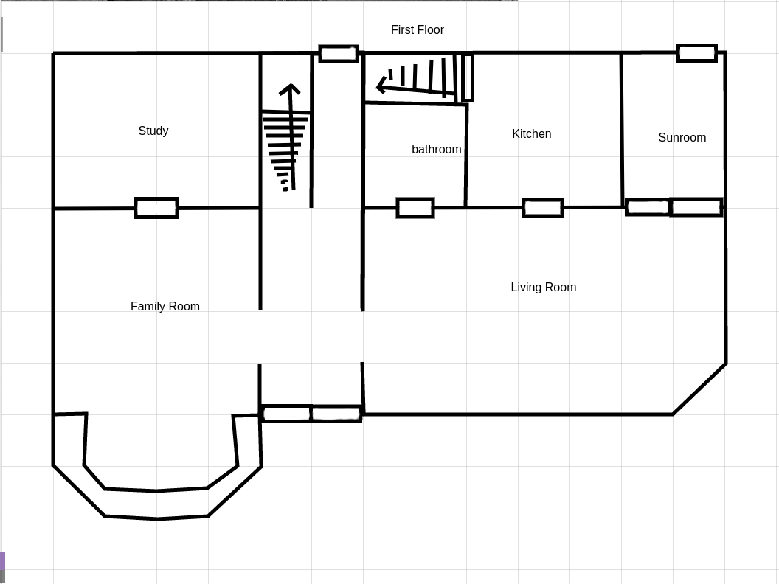

Second Floor

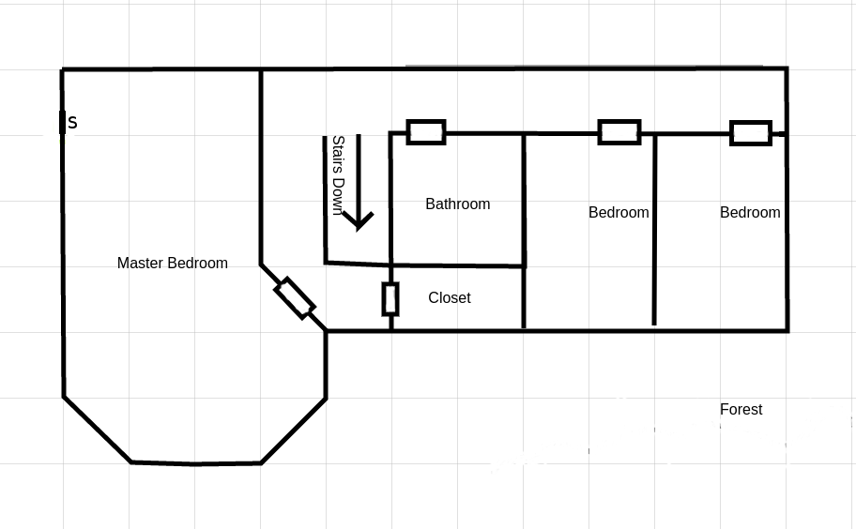

Basement

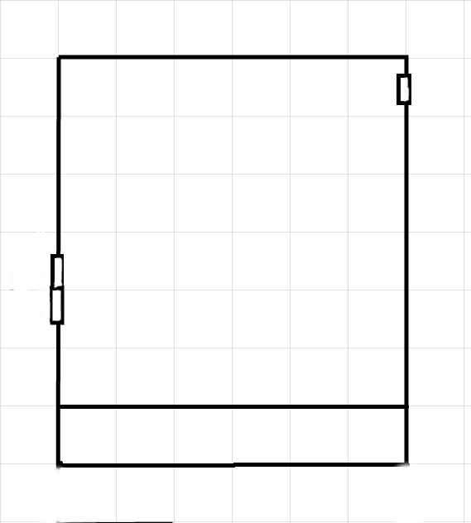
Wall with Symbol

Outside House

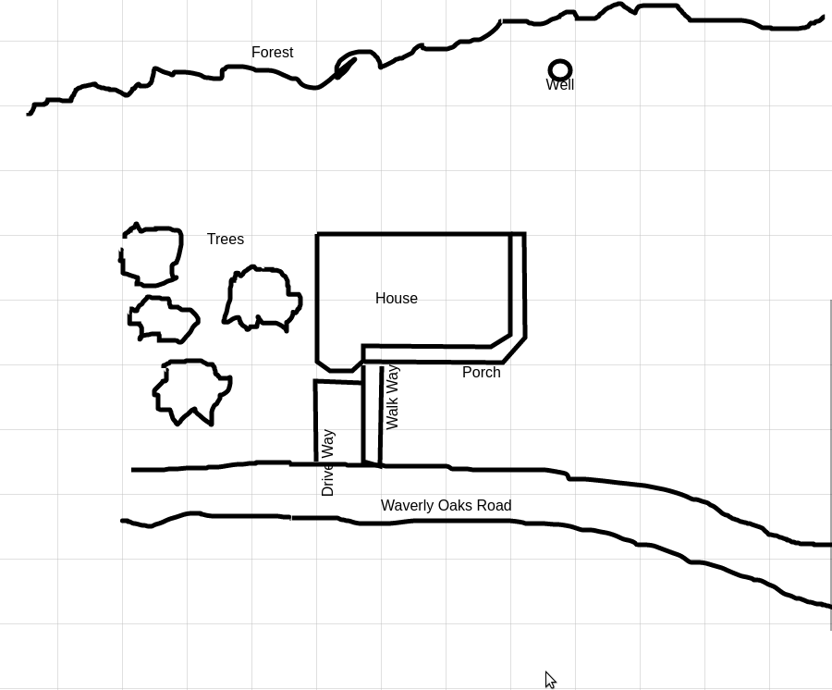

Manifestations
Roll (1d10) Action
- Investigator feels as if something is watching them.
- Investigator hears what sounds like footsteps in the next room.
- Investigator catches a glimpse of a large shadow moving in a reflective surface.
- Investigator hears “release me” in a very low whisper.
- Investigator is struck with a bout of nausea.
- Investigator smells a horrible smell, which dissipates within moments.
- Investigator hears a voice in their ear, “Let me out”.
- Investigator sees a door creak open or shut slowly.
- Investigator is paralyzed for a moment, can’t speak or move, and then it is gone.
- Investigator sees a large 9 to 10 foot tall shadow which seems to be a bi-pedal creature with several thin whip like appendages extending from the torso which seem to writhe in unison. Then it is gone.

Suggestions
Roll (1d10) Action
- Retrieve the “Lock” book from the dry well behind the house.
- Retrieve the “Key” book.
- Come to the basement.
- Kneel before the wall in the basement and allow the thing to sap magic points. (1 per 20 minutes remaining before the wall kneeling. Roll CON each 20 minutes to break the hypnotic power)
- Break down the wall in the basement.
- Divert another named investigator from their current action.
- Attack named investigator.
- Remove Elder Sings from the house.
- Dream (Keepers can create any dream or day dream they would like)
- Free the thing in the basement. This includes all remaining steps at the time to release the monster.

The Penkin Thing:
STR: 120 DEX: 140 POW: 100
CON: 130 APP: 10 EDU: 75
SIZ: 90 INT: 90 Move 10
HP 22 Luck 60 SAN: 0
MP 20
DB: 1d6 Build 2

Appendages 1d4 + DB 60%*
Claw 1d6 + DB 60%
Bite 1d10 60%

* can attack with 5 separate appendages at a time if not using a claw or bite attack
ARMOR: All non magical weapons do minimum damage, regenerate 1d6 hp per round.

Special abilities: If the thing can lock its gaze with you, there is an immediate 2 penalty die to resist its suggestions.
It can also manifest a shadow of itself within a range of 100 feet from its location.

Spells: Call Yog-Sothoth, Contact Yog-Sothoth, Fist of Yog-Sothoth, Create Gate, Send Dreams, Shriveling, Mind Blast, Dominate, Dedication to the Opener

The Lock and Key:

Language: Encrypted (Can be deciphered with the use of the Key, once deciphered, the text is a mix of English, Hebrew, Latin and Russian. Rolls for each of these languages must be made). To decipher the text one must know how the key works, this information can be obtained from Dr. Stanton Pellegrin, Henry Armitage or other individuals determined by the keeper. Keepers can create custom mechanics for deciphering the text but as a base a roll in Mathematics, Linguistics or combination of the languages used in the encryption should be made. After the text is decrypted the keeper should ask for additional language rolls to understand the text. This may seem overly difficult but it should. The original book of shadows that this translation comes from is a very potent book written in Old East Slavic, which contains very specific spells and rituals pertaining to Yog-Sothoth and dimensional travel. The original was taken back to "De Beulen Huis" and re-buried with it's author by Christopher McGinley after discovering the book and it's terrible connection to his family. You can find the McGinley story here
Sanity Loss: 1d4/1d8
Mythos Rating: 25
Cthulhu Mythos: +3/+6
Study: 30 weeks
Spells: Call/Dismiss Yog-Sothoth, Contact Deity: Yog-Sothoth, Create Gate, Voorish Sign, Summon/Bind Servitor of the Outer Gods, Dedication to the Opener, Dismiss Servitor of the Opener (This spell will dismiss the thing in the basement)
New Spell:
Dedication to the Opener: Upon casting the spell the caster is transported to Yog-Sothoth who will imbue the caster with his essences and transform the caster into a servitor of Yog-Sothoth. Once this transformation is complete the caster is transported back to his/her original location. The caster will have powers granted by the deity but is now a slave to Yog-Sothoth and will be driven by the desire to bring Yog-Sothoth into the casters plane of existence.
The caster gains the ability to, send dreams, dominate and manifest themselves as a shadow which can exist up to 100 feet from the casters location.
The caster is also horribly deformed by the transformation, the extent of this deformation is at the keepers discretion.
Casting:
The caster spends 1d8 sanity and 1d8 magic points, they must also successfully cast a Create Gate spell. A symbol is drawn on the ground and once cast the caster steps into the symbol and is transported to Yog-Sothoth.

Dismiss Servitor of the Opener: Once cast this spell will dismiss a servitor or Yog-Sothoth.

Casting:
The caster spends 1d6 + 1 sanity and 5 points of POW. The caster must then spend 10 MP, this gives them a 20% chance of success. If the caster wishes to add aditional MP from artifacts or other participants they can at this time giving an additional 5% per MP added. If successful, a gate will open swallowing the servitor and closing after.

