

Branislav Radovanovic 31/22

ExoGems JavaScript site

Contents

Uvod 4

Uvod u kod 4

Korisceni programski jezici: 4

Koriscene biblioteke: 4

Funkcionalnosti sajta 4

Dinamicki ispis sadrzaja 4

Loader / Spinner 5

Obrada Forme 5

Provera podataka forme 5

Submit Forme 6

Animacije uradjene preko waypoints JQuery biblioteke 7

Sortiranje 7

Filtriranje 7

Pretraga proizvoda 7

Korpa (Upotreba LocalStorage) 8

Organizacija 9

Organizaciona sema 9

Mapa sajta 9

Template 11

Template link: 11

Uvod u template 12

Struktura fajlova 12

Sadrzaj Sajta. 14

Index 14

Shop 16

Contact 18

Cart 19

Kodovi 20

HTML 20

INDEX HTML 20

SHOP 26

Contact 34

Cart 40

JSON 44

Products.json 44

topSellers.json 51

trendingProducts.json 52

# Uvod

## Uvod u kod

Za svaki html file na sajtu se nalazi poseban js file u kome se nalazi logika samo za tu stranicu.  
U main js se nalazi logika koja je prisutna na svim stranicama.

## Korisceni programski jezici:

* HTML
* CSS
* JavaScript

## Koriscene biblioteke:

* JQuery
* Bootstrap

# Funkcionalnosti sajta

## Dinamicki ispis sadrzaja

U zavisnosti od stranice, dohvata se jedan ili vise JSON fajlova i potom se prikaze na stranici.  
Korisceni su promisi za dohvatanje i obradu izuzetka.

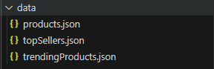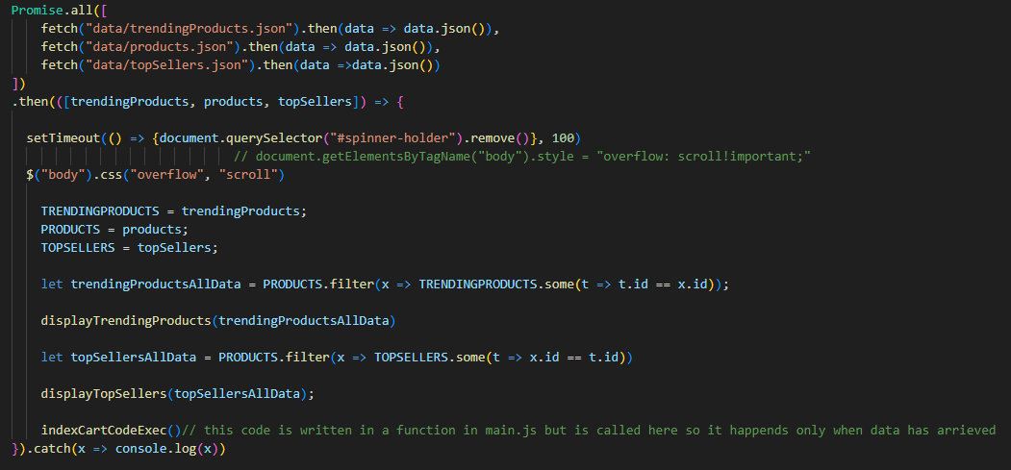

## Loader / Spinner

Spinner ostaje na sajtu sve dok se promise ne ispuni.  
Kada se ispuni on se brise iz html-a

## Obrada Forme

### Provera podataka forme

Podaci se proveravaju regex-om na dogadjaj ‘blur I keyup radi boljeg korisnickog iskustva.

I ispisuje se greska praznog polja kada ga obrisemo.

Ukoliko je polje dobro uneseno border ce biti zelen.

Kada kliknemo na blur, ako je polje prazno greske ce se obrisati.

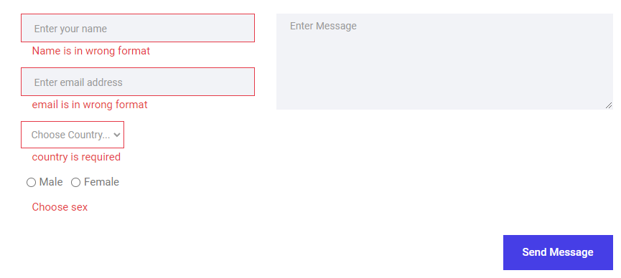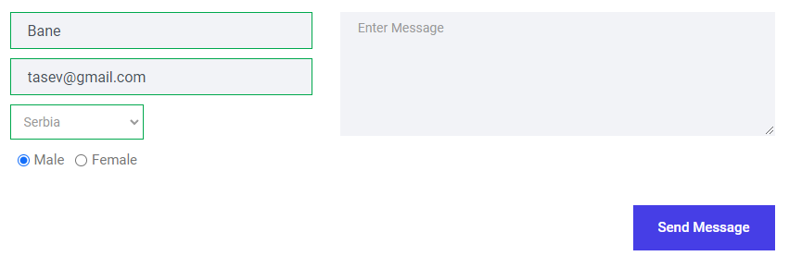

### Submit Forme

Samo ukoliko su svi podaci validni isti ce se poslati na server, u suprotnom bice ispisane greske ispod odgovarajucis polja.

## Sortiranje

Logika za sort se nalazi u shop.js file.

Nakon izabranog kriterijuma se za taj kriterijum sortiraju i ponovno prikazu proizvodi.

## Filtriranje

Logika za filter se nalazi na shop.js file.

Nakon cekiranog radio btn se izvrsi filter funkcija sa prilagodjenim filterom. I potom se prikazu .proizvodi  
Nakon drugog izabranog filtera u slucaju da nema proizvoda prikazace se poseban region.

## Pretraga proizvoda

Logika za pretragu se nalazi u shop.js file.

Pretraga se vrsi po keywords svojstvu u products.json file.

Vrsi se na keyup dogadjaj.

## Korpa (Upotreba LocalStorage)

Za korpu je koriscen local storage.

Kada dodamo proizvode u korpu dodaju se u local storage. Mozemo obrisati, menjati kolicinu I obrisati pojedinacan proizvod iz korpe. Proceed to checkout dugme nas samo vraca nazad na tu istu stranicu.

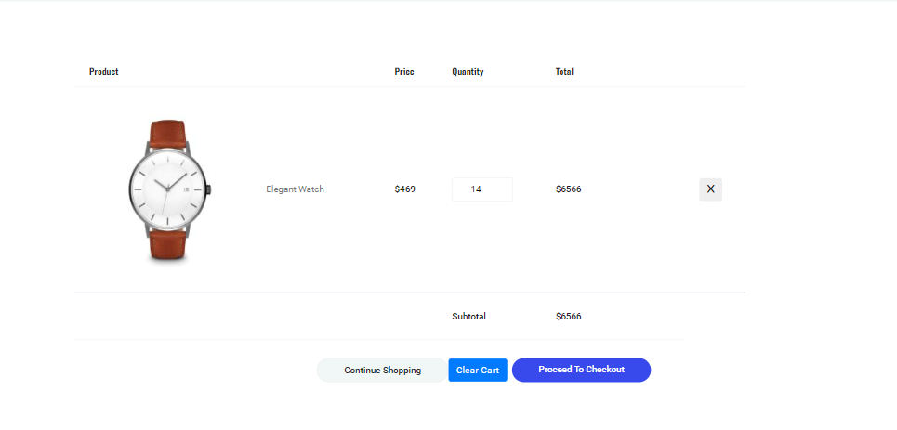

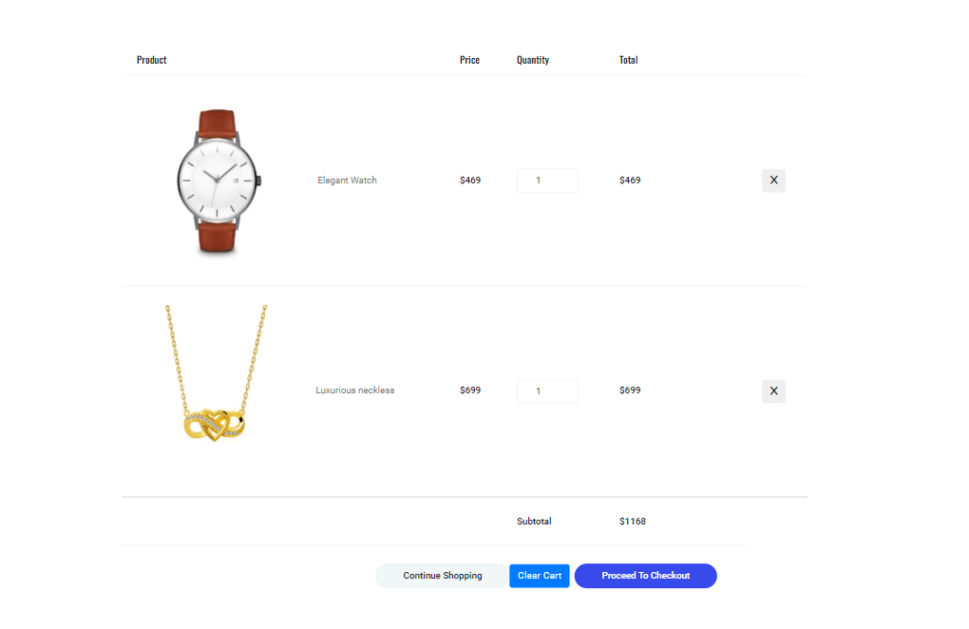

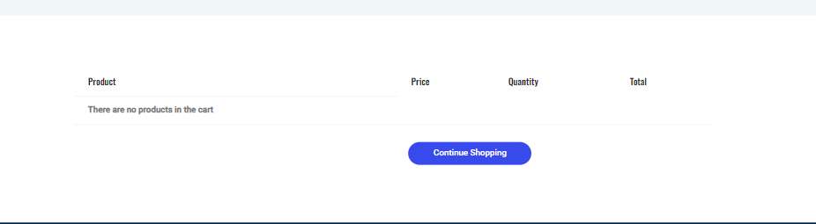

# Organizacija

## Organizaciona sema

shop

Contact

Index

About

Cart

## Mapa sajta

<?xml version="1.0" encoding="UTF-8"?>

<urlset xmlns ="http://www.sitemaps.org/schemas/sitemap/0.9">

<url>

    <loc>https://bane159.github.io/ExoGems/index.html</loc>

    <lastmod>2024-02-25</lastmod>

    <changefreq>weekly</changefreq>

    <priority>0.7</priority>

</url>

<url>

    <loc>https://bane159.github.io/ExoGems/cart.html</loc>

    <lastmod>2024-02-24</lastmod>

    <changefreq>daily</changefreq>

    <priority>0.8</priority>

</url>

<url>

    <loc>https://bane159.github.io/ExoGems/category.html</loc>

    <lastmod>2024-02-25</lastmod>

    <changefreq>weekly</changefreq>

    <priority>0.7</priority>

</url>

<url>

    <loc>https://bane159.github.io/ExoGems/contact.html</loc>

    <lastmod>2024-02-25</lastmod>

    <changefreq>yearly</changefreq>

    <priority>0.5</priority>

</url>

<url>

    <loc>https://bane159.github.io/ExoGems/about.html</loc>

    <lastmod>2024-02-25</lastmod>

    <changefreq>yearly</changefreq>

    <priority>0.5</priority>

</url>

</urlset>

# Template

## Template link:

https://themewagon.com/themes/free-bootstrap-4-html5-online-shopping-website-template-aroma/

## Uvod u template

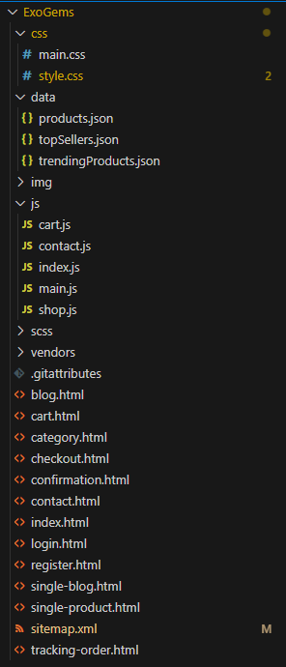

Design templata je izmenjen.

Sav javascript kod I sve biblioteke sa templata su obrisane.

### Struktura fajlova

#### Style.scss:

Nalazi se minifikovan template css, sve do linije 2.

Od druge linije koda sledi sopstveni css.

#### main.css

Template minifikovan kod

#### Img:

**Putanja: /img/**

Nalaze se slike iz template

**Putanja:/img/non-template**

Nalaze se sve custom slike koje su koriscene za modifikovan template

#### Main.js

Ovde se nalazi kod koji je zajednicki za sve stranice sajta. Obrada gresaka za subscribe field.

ka

#### Shop.js

Ovde se nalazi logika sort filter i search, kao i koriscenje promisa kao i dinamicki ispis

#### Index.js

Ovde se nalazi rad sa vise poziva ka json fajlovima i dinamicki ispis iz svih fajlova

#### Contact.js

Ovde se nalazi obrada forme kao i obrada gresaka prilikom unosenja pogresnih podataka u formu.

#### Cart.js

Ovde se nalazi logika za korpu dinamicki ispis korpe iz lokal storgae

# Sadrzaj Sajta.

U ovom poglavlju su slike sajta oznacene po regionama i njihovim funkcionalnostima

## Index

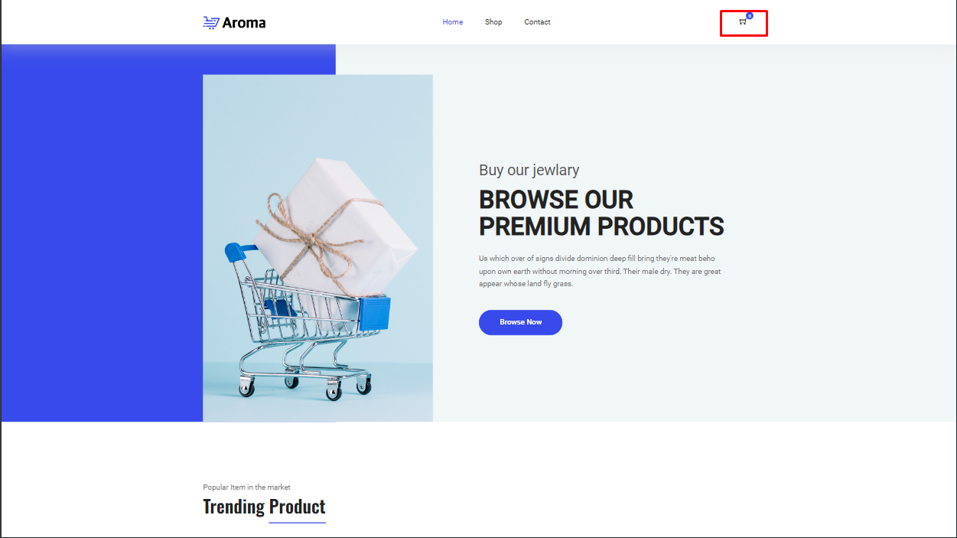

Broj stavki koji se nalaze u korpi

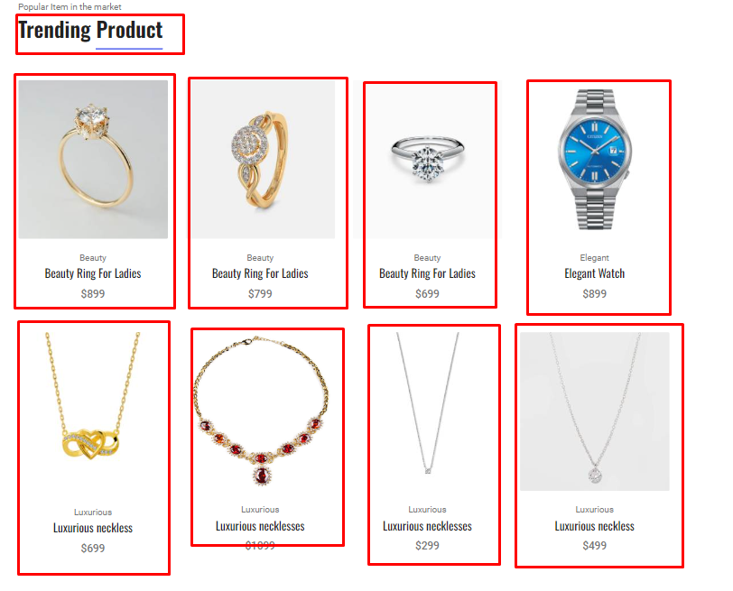

Dohvatanje i dinamicki ispis samo onih proizvoda koji imaju trending flag

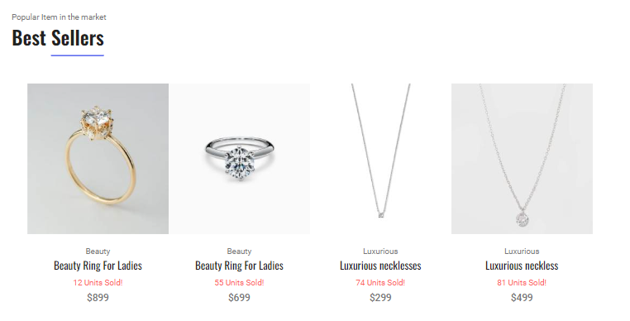

Dohvatanje i dinamicki ispis samo onih proizvoda koji imaju best seller flag

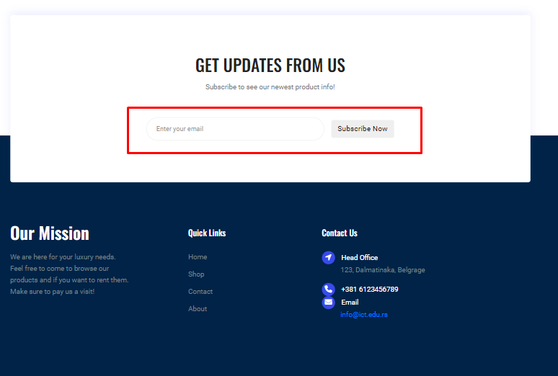

Provera subscribe polja

## Shop

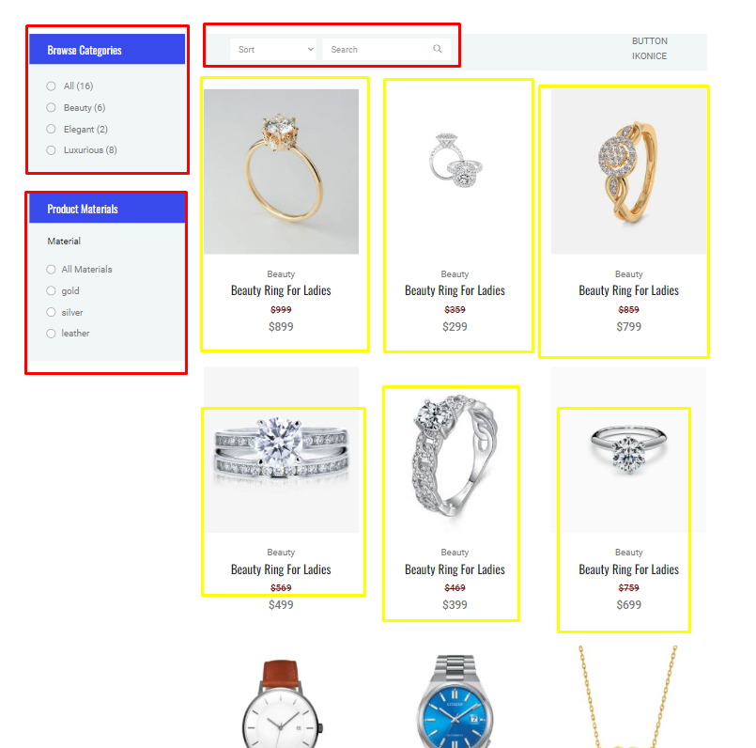

Filter sort i search

Dinamicki ispis proizvoda iz json fajla

## Contact

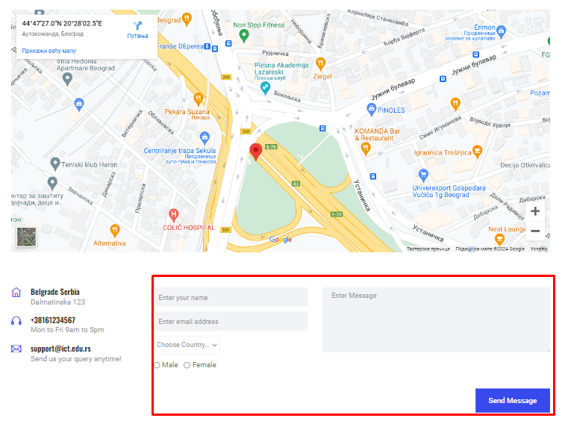

## Cart

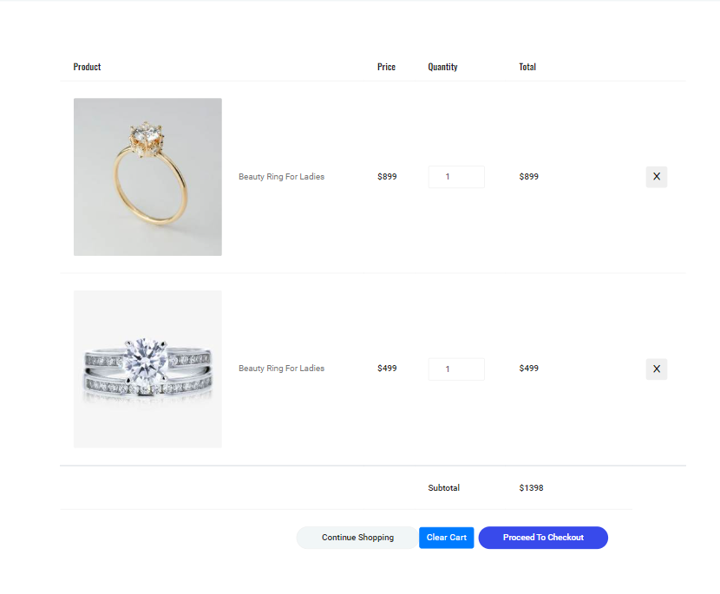

Dinamicki ispis iz local storage kao i dugmad za brisanje korpe, brisanje posebne stavke iz korpe i povecavanje i smanjivanje kolicine proizvoda.Obrada forme.

# Kodovi

## HTML

### INDEX HTML

<!DOCTYPE html>

<html lang="en">

<head>

  <meta charset="UTF-8" />

  <meta name="viewport" content="width=device-width, initial-scale=1.0" />

  <meta http-equiv="X-UA-Compatible" content="ie=edge" />

  <title>ExoGems Home</title>

  <link rel="icon" href="img/Fevicon.png" type="image/png" />

  <link rel="stylesheet" href="vendors/bootstrap/bootstrap.min.css" />

  <link rel="stylesheet" href="vendors/fontawesome/css/all.min.css" />

  <link rel="stylesheet" href="vendors/themify-icons/themify-icons.css" />

  <link rel="stylesheet" href="vendors/nice-select/nice-select.css" />

  <link rel="stylesheet" href="vendors/owl-carousel/owl.theme.default.min.css" />

  <link rel="stylesheet" href="vendors/owl-carousel/owl.carousel.min.css" />

  <link rel="stylesheet" href="css/style.css" />

</head>

<body>

  <!--================ Start Header Menu Area =================-->

  <div id="spinner-holder">

    <div id="spinner"><i class="fa-solid fa-spinner br-icon"></i></div>

  </div>

  <header class="header_area">

    <div class="main_menu">

      <nav class="navbar navbar-expand-lg navbar-light">

        <div class="container">

          <a class="navbar-brand logo_h" href="index.html"><img src="img/logo.png" alt=""></a>

          <button class="navbar-toggler" type="button" data-toggle="collapse" data-target="#navbarSupportedContent"

            aria-controls="navbarSupportedContent" aria-expanded="false" aria-label="Toggle navigation">

            <span class="icon-bar"></span>

            <span class="icon-bar"></span>

            <span class="icon-bar"></span>

          </button>

          <div class="collapse navbar-collapse offset" id="navbarSupportedContent">

            <ul class="nav navbar-nav menu_nav ml-auto mr-auto">

              <li class="nav-item active"><a class="nav-link" href="index.html">Home</a></li>

              <li class="nav-item"><a class="nav-link" href="category.html">Shop</a></li>

              <li class="nav-item"><a class="nav-link" href="contact.html">Contact</a></li>

            </ul>

            <ul class="nav-shop d-flex justify-content-center my-3">

              <li class="nav-item"><button id="cartButton"><i class="ti-shopping-cart"></i><span class="nav-shop__circle" id="cartNumberOfProducts">   </span></button></li>

            </ul>

          </div>

        </div>

      </nav>

    </div>

  </header>

  <!--================ End Header Menu Area =================-->

  <main class="site-main">

    <!--================ Hero banner start =================-->

    <section class="hero-banner">

      <div class="container">

        <div class="row no-gutters align-items-center pt-60px">

          <div class="col-5 d-none d-sm-block">

            <div class="hero-banner__img">

              <img class="img-fluid" src="img/home/hero-banner.png" alt="banner" />

            </div>

          </div>

          <div class="col-sm-7 col-lg-6 offset-lg-1 pl-4 pl-md-5 pl-lg-0">

            <div class="hero-banner__content">

              <h4>Buy our jewlary</h4>

              <h1>Browse Our Premium Products</h1>

              <p>Us which over of signs divide dominion deep fill bring they're meat beho upon own earth without morning over third. Their male dry. They are great appear whose land fly grass.</p>

              <a class="button button-hero" href="category.html">Browse Now</a>

            </div>

          </div>

        </div>

      </div>

    </section>

    <!--================ Hero banner start =================-->

    <!--================ Hero Carousel start =================-->

    <section class="section-margin mt-0">

      <div class="owl-carousel owl-theme hero-carousel">

        <div class="hero-carousel__slide">

          <img src="img/home/hero-slide1.png" alt="" class="img-fluid">

          <a href="#" class="hero-carousel__slideOverlay">

            <h3>Wireless Headphone</h3>

            <p>Accessories Item</p>

          </a>

        </div>

        <div class="hero-carousel__slide">

          <img src="img/home/hero-slide2.png" alt="" class="img-fluid">

          <a href="#" class="hero-carousel__slideOverlay">

            <h3>Wireless Headphone</h3>

            <p>Accessories Item</p>

          </a>

        </div>

        <div class="hero-carousel__slide">

          <img src="img/home/hero-slide3.png" alt="" class="img-fluid">

          <a href="#" class="hero-carousel__slideOverlay">

            <h3>Wireless Headphone</h3>

            <p>Accessories Item</p>

          </a>

        </div>

      </div>

    </section>

    <!--================ Hero Carousel end =================-->

    <!-- ================ trending product section start ================= -->

    <section class="section-margin calc-60px">

      <div class="container">

        <div class="section-intro pb-60px">

          <p>Popular Item in the market</p>

          <h2>Trending <span class="section-intro__style">Product</span></h2>

        </div>

        <div class="row" id="trendingProducts">

          <!-- dynamis js  -->

        </div>

      </div>

    </section>

    <!-- ================ trending product section end ================= -->

    <!-- ================ offer section start ================= -->

    <!-- <section class="offer" id="parallax-1" data-anchor-target="#parallax-1" data-300-top="background-position: 20px 30px" data-top-bottom="background-position: 0 20px">

      <div class="container">

        <div class="row">

          <div class="col-xl-5">

            <div class="offer__content text-center">

              <h3>Up To 50% Off</h3>

              <h4>Winter Sale</h4>

              <p>Him she'd let them sixth saw light</p>

              <a class="button button--active mt-3 mt-xl-4" href="category.html">Shop Now</a>

            </div>

          </div>

        </div>

      </div>

    </section> -->

    <!-- ================ offer section end ================= -->

    <!-- ================ Best Selling item  carousel ================= -->

    <section class="section-margin calc-60px">

      <div class="container">

        <div class="section-intro pb-60px">

          <p>Popular Item in the market</p>

          <h2>Best <span class="section-intro__style">Sellers</span></h2>

        </div>

        <div class="d-flex justify-content-center flex-wrap align-items-center" id="bestSellersHolder">

          <div class="card text-center card-product my-1">

            <div class="card-product__img">

              <img class="img-fluid" src="img/product/product1.png" alt="" />

              <ul class="card-product__imgOverlay">

                <!-- <li><button><i class="ti-search"></i></button></li> -->

                <li><button><i class="ti-shopping-cart"></i></button></li>

                <!-- <li><button><i class="ti-heart"></i></button></li> -->

              </ul>

            </div>

            <div class="card-body">

              <p>Accessories</p>

              <h4 class="card-product__title"><a href="single-product.html">Quartz Belt Watch</a></h4>

              <p class=" br-sm-text-sellers">125 sold!</p>

              <p class="card-product__price">$150.00</p>

            </div>

          </div>

        </div>

        <!-- </div> -->

      </div>

    </section>

    <!-- ================ Best Selling item  carousel end ================= -->

    <!-- ================ Subscribe section start ================= -->

    <section class="subscribe-position">

      <div class="container">

        <div class="subscribe text-center">

          <h3 class="subscribe__title">Get Updates From Us</h3>

          <p>Subscribe to see our newest product info!</p>

          <div id="mc_embed_signup">

            <form  class="subscribe-form form-inline mt-5 pt-1">

              <div class="form-group ml-sm-auto">

                <input class="form-control mb-1" type="email" name="email" id="email-subscribe" placeholder="Enter your email"  />

              <div class="info"> <span id="email-subscribe-error"></span></div>

              </div>

              <button class="btn mr-auto mb-1" id="email-subscribe-success">Subscribe Now</button>

            </form>

          </div>

        </div>

      </div>

    </section>

    <!-- ================ Subscribe section end ================= -->

  </main>

  <!--================ Start footer Area  =================-->

  <footer class="footer">

    <div class="footer-area">

      <div class="container">

        <div class="row section_gap">

          <div class="col-lg-3 col-md-6 col-sm-6">

            <div class="single-footer-widget tp_widgets">

              <h4 class="footer_title large_title">Our Mission</h4>

              <p>

                We are here for your luxury needs.

                Feel free to come to browse our products and if you want to rent them.

                Make sure to pay us a visit!

              </p>

            </div>

          </div>

          <div class="offset-lg-1 col-lg-2 col-md-6 col-sm-6">

            <div class="single-footer-widget tp_widgets">

              <h4 class="footer_title">Quick Links</h4>

              <ul class="list">

                <li><a href="#">Home</a></li>

                <li><a href="category.html">Shop</a></li>

                <li><a href="contact.html">Contact</a></li>

                <li><a href="about.html">About</a></li>

              </ul>

            </div>

          </div>

          <div class="offset-lg-1 col-lg-3 col-md-6 col-sm-6">

            <div class="single-footer-widget tp_widgets">

              <h4 class="footer_title">Contact Us</h4>

              <div class="ml-40">

                <p class="sm-head">

                  <span class="fa fa-location-arrow"></span>

                  Head Office

                </p>

                <p>123, Dalmatinska, Belgrage</p>

                <p class="sm-head">

                  <span class="fa fa-phone"></span>

                  +381 6123456789

                <p class="sm-head">

                  <span class="fa fa-envelope"></span>

                  Email

                </p>

                <p>

                  <a href="mailto:info@ict.edu.rs">info@ict.edu.rs</a>

                </p>

              </div>

            </div>

          </div>

        </div>

      </div>

    </div>

    <div class="footer-bottom">

      <div class="container">

        <div class="row d-flex">

          <p class="col-lg-12 footer-text text-center">

            <!-- Link back to Colorlib can't be removed. Template is licensed under CC BY 3.0. -->

Copyright &copy;<script>document.write(new Date().getFullYear());</script> All rights reserved | This template is made with <i class="fa fa-heart" aria-hidden="true"></i> by <a href="https://colorlib.com" target="_blank">Colorlib</a>

<!-- Link back to Colorlib can't be removed. Template is licensed under CC BY 3.0. --></p>

        </div>

      </div>

    </div>

  </footer>

  <!--================ End footer Area  =================-->

  <script src="https://kit.fontawesome.com/b982b959fc.js" crossorigin="anonymous"></script>

  <script src="vendors/jquery/jquery-3.2.1.min.js"></script>

  <script src="vendors/bootstrap/bootstrap.bundle.min.js"></script>

  <script src="vendors/jquery.ajaxchimp.min.js"></script>

  <script src="js/index.js"></script>

  <script src="js/main.js"></script>

</body>

</html>

### SHOP

<!DOCTYPE html>

<html lang="en">

<head>

  <meta charset="UTF-8">

  <meta name="viewport" content="width=device-width, initial-scale=1.0">

  <meta http-equiv="X-UA-Compatible" content="ie=edge">

  <title>Aroma Shop - Category</title>

  <link rel="icon" href="img/Fevicon.png" type="image/png">

  <link rel="stylesheet" href="vendors/bootstrap/bootstrap.min.css">

  <link rel="stylesheet" href="vendors/fontawesome/css/all.min.css">

  <link rel="stylesheet" href="vendors/themify-icons/themify-icons.css">

  <link rel="stylesheet" href="vendors/linericon/style.css">

  <link rel="stylesheet" href="vendors/owl-carousel/owl.theme.default.min.css">

  <link rel="stylesheet" href="vendors/owl-carousel/owl.carousel.min.css">

  <link rel="stylesheet" href="vendors/nice-select/nice-select.css">

  <link rel="stylesheet" href="vendors/nouislider/nouislider.min.css">

  <link rel="stylesheet" href="css/style.css">

</head>

<body>

  <div class="br-modal" id="br-appear-modal">

    <p>Added To Cart!</p>

  </div>

  <div id="spinner-holder">

    <div id="spinner"><i class="fa-solid fa-spinner br-icon"></i></div>

  </div>

  <!--================ Start Header Menu Area =================-->

  <header class="header_area">

    <div class="main_menu">

      <nav class="navbar navbar-expand-lg navbar-light">

        <div class="container">

          <a class="navbar-brand logo_h" href="index.html"><img src="img/logo.png" alt=""></a>

          <button class="navbar-toggler" type="button" data-toggle="collapse" data-target="#navbarSupportedContent"

            aria-controls="navbarSupportedContent" aria-expanded="false" aria-label="Toggle navigation">

            <span class="icon-bar"></span>

            <span class="icon-bar"></span>

            <span class="icon-bar"></span>

          </button>

          <div class="collapse navbar-collapse offset" id="navbarSupportedContent">

            <ul class="nav navbar-nav menu_nav ml-auto mr-auto">

              <li class="nav-item"><a class="nav-link" href="index.html">Home</a></li>

              <li class="nav-item active"><a class="nav-link" href="category.html">Shop</a></li>

              <li class="nav-item"><a class="nav-link" href="contact.html">Contact</a></li>

            </ul>

            <ul class="nav-shop d-flex justify-content-center  my-3">

              <!-- <li class="nav-item"><button><i class="ti-search"></i></button></li> -->

              <li class="nav-item"><button id="cartButton"><i class="ti-shopping-cart"></i><span class="nav-shop__circle" id="cartNumberOfProducts">   </span></button></li>

              <!-- <li class="nav-item"><a class="button button-header" href="#">Buy Now</a></li> -->

            </ul>

          </div>

        </div>

      </nav>

    </div>

  </header>

  <!--================ End Header Menu Area =================-->

  <!-- ================ start banner area ================= -->

  <section class="blog-banner-area" id="category">

    <div class="container h-100">

      <div class="blog-banner">

        <div class="text-center">

          <h1>Shop Category</h1>

          <nav aria-label="breadcrumb" class="banner-breadcrumb">

            <ol class="breadcrumb">

              <li class="breadcrumb-item"><a href="#">Home</a></li>

              <li class="breadcrumb-item active" aria-current="page">Shop Category</li>

            </ol>

          </nav>

        </div>

      </div>

    </div>

  </section>

  <!-- ================ end banner area ================= -->

  <!-- ================ category section start ================= -->

  <section class="section-margin--small mb-5">

    <div class="container">

      <div class="row">

        <div class="col-xl-3 col-lg-4 col-md-5">

          <div class="sidebar-categories">

            <div class="head">Browse Categories</div>

            <ul class="main-categories">

              <li class="common-filter">

                <!-- <form action="#"> -->

                  <ul>

                    <li class="filter-list">

                      <input class="pixel-radio" type="radio" id="All" name="category" value="All"/>

                      <label for="All">All <span id="AllNumber"> </span></label>

                    </li>

                    <li class="filter-list">

                      <input class="pixel-radio" type="radio" id="Beauty" name="category" value="Beauty"/>

                      <label for="Beauty">Beauty

                        <span id="BeautyNumber"> </span>

                      </label>

                    </li>

                    <li class="filter-list">

                      <input class="pixel-radio" type="radio" id="Elegant" name="category" value="Elegant" />

                      <label for="Elegant">Elegant

                        <span id="ElegantNumber"> </span>

                      </label>

                    </li>

                    <li class="filter-list"><input class="pixel-radio" type="radio" id="Luxurious" name="category" value="Luxurious" />

                      <label for="Luxurious">Luxurious

                        <span id="LuxuriousNumber"> </span>

                      </label>

                    </li>

                  </ul>

                <!-- </form> -->

              </li>

            </ul>

          </div>

          <div class="sidebar-filter">

            <div class="top-filter-head">Product Materials</div>

            <div class="common-filter">

              <div class="head">Material</div>

                <ul>

                  <li class="filter-list"><input class="pixel-radio" type="radio" id="AllMat" name="material" value="AllMat"/><label for="gold">All Materials

                    <span id="AllMatNumber"></span></label></li>

                  <li class="filter-list"><input class="pixel-radio" type="radio" id="gold" name="material" value="gold"/><label for="gold">gold

                    <span id="goldNumber"></span></label></li>

                  <li class="filter-list"><input class="pixel-radio" type="radio" id="silver" name="material" value="silver"/><label for="silver">silver

                    <span id="silverNumber"></span>

                  </label></li>

                  <li class="filter-list"><input class="pixel-radio" type="radio" id="leather" name="material" value="leather"/><label for="leather">leather

                    <span id="leatherNumber"></span>

                  </label></li>

                </ul>

            </div>

          </div>

        </div>

        <div class="col-xl-9 col-lg-8 col-md-7">

          <!-- Start Filter Bar -->

          <div class="filter-bar d-flex flex-column flex-md-row align-items-center justify-content-between">

          <div class="container d-flex flex-wrap align-items-center">

            <div class="mx-2 bg-light-subtle">

              <select class="br-filter" aria-label="Default select example" name="sort" id="sortCriterium">

                <option selected>Sort</option>

                <option value="popularity">Popularity</option>

                <option value="priceAsc">Price Ascending</option>

                <option value="priceDesc">Price Descending</option>

              </select>

            </div>

            <!-- <div class=" mr-auto">

              <select class="form-select p-2" aria-label="Default select example">

                <option selected>Open this select menu</option>

                <option value="1">One</option>

                <option value="2">Two</option>

                <option value="3">Three</option>

              </select>

            </div> -->

            <div>

              <div class="input-group filter-bar-search">

                <input type="text" placeholder="Search" id="searchBar"/>

                <div class="input-group-append">

                  <button type="button" id="initSeatchBtn"><i class="ti-search"></i></button>

                </div>

              </div>

            </div>

          </div>

          <!--Ovde idu ikonice za redosled-->

          <div class="my-3 my-md-0">

              BUTTON IKONICE

          </div>

        </div>

          <!-- End Filter Bar -->

          <!-- Start Best Seller -->

          <section class="lattest-product-area pb-40 category-list">

            <div class="row d-flex justify-content-center" id="shop-products">

            </div>

          </section>

          <!-- End Best Seller -->

        </div>

      </div>

    </div>

  </section>

  <!-- ================ category section end ================= -->

  <!-- ================ Subscribe section start ================= -->

  <section class="subscribe-position">

    <div class="container">

      <div class="subscribe text-center">

        <h3 class="subscribe__title">Get Updates From Us</h3>

        <p>Subscribe to see our newest product info!</p>

        <div id="mc_embed_signup">

          <form  class="subscribe-form form-inline mt-5 pt-1">

            <div class="form-group ml-sm-auto">

              <input class="form-control mb-1" type="email" name="email" id="email-subscribe" placeholder="Enter your email"  />

            <div class="info"> <span id="email-subscribe-error"></span></div>

            </div>

            <button class="btn mr-auto mb-1" id="email-subscribe-success">Subscribe Now</button>

          </form>

        </div>

      </div>

    </div>

  </section>

  <!-- ================ Subscribe section end ================= -->

  <!--================ Start footer Area  =================-->

  <footer class="footer">

    <div class="footer-area">

      <div class="container">

        <div class="row section_gap">

          <div class="col-lg-3 col-md-6 col-sm-6">

            <div class="single-footer-widget tp_widgets">

              <h4 class="footer_title large_title">Our Mission</h4>

              <p>

                So seed seed green that winged cattle in. Gathering thing made fly you're no

                divided deep moved us lan Gathering thing us land years living.

              </p>

              <p>

                So seed seed green that winged cattle in. Gathering thing made fly you're no divided deep moved

              </p>

            </div>

          </div>

          <div class="offset-lg-1 col-lg-2 col-md-6 col-sm-6">

            <div class="single-footer-widget tp_widgets">

              <h4 class="footer_title">Quick Links</h4>

              <ul class="list">

                <li><a href="#">Home</a></li>

                <li><a href="#">Shop</a></li>

                <li><a href="#">Contact</a></li>

                <li><a href="#">About</a></li>

              </ul>

            </div>

          </div>

          <div class="offset-lg-1 col-lg-3 col-md-6 col-sm-6">

            <div class="single-footer-widget tp_widgets">

              <h4 class="footer_title">Contact Us</h4>

              <div class="ml-40">

                <p class="sm-head">

                  <span class="fa fa-location-arrow"></span>

                  Head Office

                </p>

                <p>123, Main Street, Your City</p>

                <p class="sm-head">

                  <span class="fa fa-phone"></span>

                  Phone Number

                </p>

                <p>

                  +123 456 7890 <br>

                  +123 456 7890

                </p>

                <p class="sm-head">

                  <span class="fa fa-envelope"></span>

                  Email

                </p>

                <p>

                  free@infoexample.com <br>

                  www.infoexample.com

                </p>

              </div>

            </div>

          </div>

        </div>

      </div>

    </div>

    <div class="footer-bottom">

      <div class="container">

        <div class="row d-flex">

          <p class="col-lg-12 footer-text text-center">

            <!-- Link back to Colorlib can't be removed. Template is licensed under CC BY 3.0. -->

Copyright &copy;<script>document.write(new Date().getFullYear());</script> All rights reserved | This template is made with <i class="fa fa-heart" aria-hidden="true"></i> by <a href="https://colorlib.com" target="_blank">Colorlib</a>

<!-- Link back to Colorlib can't be removed. Template is licensed under CC BY 3.0. --></p>

        </div>

      </div>

    </div>

  </footer>

  <!--================ End footer Area  =================-->

  <script src="https://kit.fontawesome.com/b982b959fc.js" crossorigin="anonymous"></script>

  <script src="vendors/jquery/jquery-3.2.1.min.js"></script>

  <script src="vendors/bootstrap/bootstrap.bundle.min.js"></script>

  <script src="vendors/jquery.ajaxchimp.min.js"></script>

  <script src="js/shop.js"></script>

  <script src="js/main.js"></script>

</body>

</html>

### Contact

<!DOCTYPE html>

<html lang="en">

<head>

  <meta charset="UTF-8" />

  <meta name="viewport" content="width=device-width, initial-scale=1.0" />

  <meta http-equiv="X-UA-Compatible" content="ie=edge" />

  <title>Aroma Shop - Contact</title>

  <link rel="icon" href="img/Fevicon.png" type="image/png" />

  <link rel="stylesheet" href="vendors/bootstrap/bootstrap.min.css" />

  <link rel="stylesheet" href="vendors/fontawesome/css/all.min.css" />

  <link rel="stylesheet" href="vendors/themify-icons/themify-icons.css" />

  <link rel="stylesheet" href="vendors/linericon/style.css" />

  <link rel="stylesheet" href="vendors/owl-carousel/owl.theme.default.min.css" />

  <link rel="stylesheet" href="vendors/owl-carousel/owl.carousel.min.css" />

  <link rel="stylesheet" href="css/style.css" />

</head>

<body>

  <!--================ Start Header Menu Area =================-->

  <header class="header_area">

    <div class="main_menu">

      <nav class="navbar navbar-expand-lg navbar-light">

        <div class="container">

          <a class="navbar-brand logo_h" href="index.html"><img src="img/logo.png" alt=""></a>

          <button class="navbar-toggler" type="button" data-toggle="collapse" data-target="#navbarSupportedContent"

            aria-controls="navbarSupportedContent" aria-expanded="false" aria-label="Toggle navigation">

            <span class="icon-bar"></span>

            <span class="icon-bar"></span>

            <span class="icon-bar"></span>

          </button>

          <div class="collapse navbar-collapse offset" id="navbarSupportedContent">

            <ul class="nav navbar-nav menu_nav ml-auto mr-auto">

              <li class="nav-item"><a class="nav-link" href="index.html">Home</a></li>

              <li class="nav-item"><a class="nav-link" href="category.html">Shop</a></li>

              <li class="nav-item"><a class="nav-link active" href="contact.html">Contact</a></li>

            </ul>

            <ul class="nav-shop d-flex justify-content-center  my-3">

              <li class="nav-item"><button id="cartButton"><i class="ti-shopping-cart"></i><span class="nav-shop__circle" id="cartNumberOfProducts">   </span></button></li>

            </ul>

          </div>

        </div>

      </nav>

    </div>

  </header>

  <!--================ End Header Menu Area =================-->

  <!-- ================ start banner area ================= -->

  <section class="blog-banner-area" id="contact">

    <div class="container h-100">

      <div class="blog-banner">

        <div class="text-center">

          <h1>Contact Us</h1>

          <nav aria-label="breadcrumb" class="banner-breadcrumb">

            <ol class="breadcrumb">

              <li class="breadcrumb-item"><a href="index.html">Home</a></li>

              <li class="breadcrumb-item active" aria-current="page">Contact Us</li>

            </ol>

          </nav>

        </div>

      </div>

    </div>

  </section>

  <!-- ================ end banner area ================= -->

  <!-- ================ contact section start ================= -->

  <section class="section-margin--small">

    <div class="container">

      <div class="d-none d-sm-block mb-5 pb-4">

        <div id="map" style="height: 500px;">

          <iframe src="https://www.google.com/maps/embed?pb=!1m17!1m12!1m3!1d2002.1625906535073!2d20.46790548609919!3d44.79129366738908!2m3!1f0!2f0!3f0!3m2!1i1024!2i768!4f13.1!3m2!1m1!2zNDTCsDQ3JzI3LjAiTiAyMMKwMjgnMDIuNSJF!5e0!3m2!1ssr!2srs!4v1708022133747!5m2!1ssr!2srs" allowfullscreen="" loading="lazy" referrerpolicy="no-referrer-when-downgrade" style="height: 100%; width: 100%; border: none;" >

          </iframe>

        </div>

      </div>

      <div class="row">

        <div class="col-md-4 col-lg-3 mb-4 mb-md-0">

          <div class="media contact-info">

            <span class="contact-info__icon"><i class="ti-home"></i></span>

            <div class="media-body">

              <h3>Belgrade Serbia</h3>

              <p>Dalmatinska 123</p>

            </div>

          </div>

          <div class="media contact-info">

            <span class="contact-info__icon"><i class="ti-headphone"></i></span>

            <div class="media-body">

              <h3><a href="tel:454545654">+38161234567</a></h3>

              <p>Mon to Fri 9am to 5pm</p>

            </div>

          </div>

          <div class="media contact-info">

            <span class="contact-info__icon"><i class="ti-email"></i></span>

            <div class="media-body">

              <h3><a href="mailto:support@ict.edu.rs">support@ict.edu.rs</a></h3>

              <p>Send us your query anytime!</p>

            </div>

          </div>

        </div>

        <div class="col-md-8 col-lg-9">

          <form action="index.html" class="form-contact contact_form"  method="post" id="contactForm" >

            <div class="row">

              <div class="col-lg-5">

                <div class="form-group">

                  <input class="form-control" name="name" id="name" type="text" placeholder="Enter your name" />

                  <span class="text-danger mx-3 d-none" id="nameError"> Name is entered increctly</span>

                </div>

                <div class="form-group">

                  <input class="form-control" name="email" id="email" type="email" placeholder="Enter email address" />

                  <span class="text-danger mx-3 d-none"  id="emailError"> Invalid Email adress</span>

                </div>

                <div class="form-group">

                  <!-- <input class="form-control" name="subject" id="subject" type="text" placeholder="Enter Subject" /> -->

                  <select class="form-select br-filter " aria-label="Default select example" id="country">

                    <option value="Choose"> Choose Country...</option>

                    <option value="Serbia"> Serbia</option>

                    <option value="Croatia"> Croatia</option>

                    <option value="Romania">Romania</option>

                    <option value="Germany">Germany</option>

                    <option value="Ukraine">Ukraine</option>

                  </select>

                  <span class="text-danger mx-3 d-none" id="countryError">Chose atleast one option</span>

                </div>

                <div class="form-check form-group form-check-inline mx-2">

                  <input class="form-check-input" type="radio" id="maleSex" value="M" name="sex"/>

                  <label class="form-check-label" for="maleSex">Male</label>

                </div>

                <div class="form-check form-group form-check-inline">

                  <input class="form-check-input" type="radio" id="femaleSex" value="F"  name="sex"/>

                  <label class="form-check-label" for="femaleSex">Female</label>

                </div>

                <div class="form-group">

                  <span class="text-danger mx-3 d-none" id="sexError">Choose sex ( ͡° ͜ʖ ͡°)</span>

                </div>

              </div>

              <div class="col-lg-7">

                <div class="form-group">

                    <textarea class="form-control different-control w-100" name="message" id="message" cols="30" rows="5" placeholder="Enter Message"></textarea>

                </div>

              </div>

            </div>

            <div class="form-group text-center text-md-right mt-3">

              <button type="submit" id="submitBtn" class="button button--active button-contactForm">Send Message</button>

            </div>

          </form>

        </div>

      </div>

    </div>

  </section>

  <!-- ================ contact section end ================= -->

  <!--================ Start footer Area  =================-->

  <footer class="footer">

    <div class="footer-area">

      <div class="container">

        <div class="row section_gap">

          <div class="col-lg-3 col-md-6 col-sm-6">

            <div class="single-footer-widget tp_widgets">

              <h4 class="footer_title large_title">Our Mission</h4>

              <p>

                We are here for your luxury needs.

                Feel free to come to browse our products and if you want to rent them.

                Make sure to pay us a visit!

              </p>

            </div>

          </div>

          <div class="offset-lg-1 col-lg-2 col-md-6 col-sm-6">

            <div class="single-footer-widget tp_widgets">

              <h4 class="footer_title">Quick Links</h4>

              <ul class="list">

                <li><a href="#">Home</a></li>

                <li><a href="category.html">Shop</a></li>

                <li><a href="contact.html">Contact</a></li>

                <li><a href="about.html">About</a></li>

              </ul>

            </div>

          </div>

          <div class="offset-lg-1 col-lg-3 col-md-6 col-sm-6">

            <div class="single-footer-widget tp_widgets">

              <h4 class="footer_title">Contact Us</h4>

              <div class="ml-40">

                <p class="sm-head">

                  <span class="fa fa-location-arrow"></span>

                  Head Office

                </p>

                <p>123, Dalmatinska, Belgrage</p>

                <p class="sm-head">

                  <span class="fa fa-phone"></span>

                  +381 6123456789

                <p class="sm-head">

                  <span class="fa fa-envelope"></span>

                  Email

                </p>

                <p>

                  <a href="mailto:info@ict.edu.rs">info@ict.edu.rs</a>

                </p>

              </div>

            </div>

          </div>

        </div>

      </div>

    </div>

    <div class="footer-bottom">

      <div class="container">

        <div class="row d-flex">

          <p class="col-lg-12 footer-text text-center">

            <!-- Link back to Colorlib can't be removed. Template is licensed under CC BY 3.0. -->

Copyright &copy;<script>document.write(new Date().getFullYear());</script> All rights reserved | This template is made with <i class="fa fa-heart" aria-hidden="true"></i> by <a href="https://colorlib.com" target="_blank">Colorlib</a>

<!-- Link back to Colorlib can't be removed. Template is licensed under CC BY 3.0. --></p>

        </div>

      </div>

    </div>

  </footer>

  <!--================ End footer Area  =================-->

  <script src="https://kit.fontawesome.com/b982b959fc.js" crossorigin="anonymous"></script>

  <script src="vendors/jquery/jquery-3.2.1.min.js"></script>

  <script src="vendors/bootstrap/bootstrap.bundle.min.js"></script>

  <script src="vendors/jquery.form.js"></script>

  <script src="vendors/jquery.validate.min.js"></script>

  <script src="vendors/jquery.ajaxchimp.min.js"></script>

  <script src="js/contact.js"></script>

  <script src="js/main.js"></script>

</body>

</html>

### Cart

<!DOCTYPE html>

<html lang="en">

<head>

  <meta charset="UTF-8" />

  <meta name="viewport" content="width=device-width, initial-scale=1.0" />

  <meta http-equiv="X-UA-Compatible" content="ie=edge"  />

  <title>Aroma Shop - Cart</title>

    <link rel="icon" href="img/Fevicon.png" type="image/png" />

  <link rel="stylesheet" href="vendors/bootstrap/bootstrap.min.css" />

  <link rel="stylesheet" href="vendors/fontawesome/css/all.min.css" />

    <link rel="stylesheet" href="vendors/themify-icons/themify-icons.css" />

    <link rel="stylesheet" href="vendors/linericon/style.css" />

  <link rel="stylesheet" href="vendors/owl-carousel/owl.theme.default.min.css" />

  <link rel="stylesheet" href="vendors/owl-carousel/owl.carousel.min.css" />

  <link rel="stylesheet" href="vendors/nice-select/nice-select.css" />

  <link rel="stylesheet" href="vendors/nouislider/nouislider.min.css" />

  <link rel="stylesheet" href="css/style.css">

</head>

<body>

  <div id="spinner-holder">

    <div id="spinner"><i class="fa-solid fa-spinner br-icon"></i></div>

  </div>

  <!--================ Start Header Menu Area =================-->

  <header class="header_area">

    <div class="main_menu">

      <nav class="navbar navbar-expand-lg navbar-light">

        <div class="container">

          <a class="navbar-brand logo_h" href="index.html"><img src="img/logo.png" alt=""></a>

          <button class="navbar-toggler" type="button" data-toggle="collapse" data-target="#navbarSupportedContent"

            aria-controls="navbarSupportedContent" aria-expanded="false" aria-label="Toggle navigation">

            <span class="icon-bar"></span>

            <span class="icon-bar"></span>

            <span class="icon-bar"></span>

          </button>

          <div class="collapse navbar-collapse offset" id="navbarSupportedContent">

            <ul class="nav navbar-nav menu_nav ml-auto mr-auto">

              <li class="nav-item"><a class="nav-link" href="index.html">Home</a></li>

              <li class="nav-item"><a class="nav-link" href="category.html">Shop</a></li>

              <li class="nav-item"><a class="nav-link" href="contact.html">Contact</a></li>

            </ul>

            <ul class="nav-shop d-flex justify-content-center  my-3">

              <li class="nav-item"><button id="cartButton"><i class="ti-shopping-cart"></i><span class="nav-shop__circle" id="cartNumberOfProducts">   </span></button></li>

            </ul>

          </div>

        </div>

      </nav>

    </div>

  </header>

    <!--================ End Header Menu Area =================-->

    <!-- ================ start banner area ================= -->

    <section class="blog-banner-area" id="category">

        <div class="container h-100">

            <div class="blog-banner">

                <div class="text-center">

                    <h1>Shopping Cart</h1>

                    <nav aria-label="breadcrumb" class="banner-breadcrumb">

            <ol class="breadcrumb">

              <li class="breadcrumb-item"><a href="#">Home</a></li>

              <li class="breadcrumb-item active" aria-current="page">Shopping Cart</li>

            </ol>

          </nav>

                </div>

            </div>

    </div>

    </section>

    <!-- ================ end banner area ================= -->

  <!--================Cart Area =================-->

  <section class="cart_area">

      <div class="container">

          <div class="cart_inner">

              <div class="table-responsive">

                  <table class="table" id="cartItemsHolder">

                      </tbody>

                  </table>

              </div>

          </div>

      </div>

  </section>

  <!--================End Cart Area =================-->

  <!--================ Start footer Area  =================-->

  <footer class="footer">

        <div class="footer-area">

            <div class="container">

                <div class="row section_gap">

                    <div class="col-lg-3 col-md-6 col-sm-6">

                        <div class="single-footer-widget tp_widgets">

                            <h4 class="footer_title large_title">Our Mission</h4>

                            <p>

                                We are here for your luxury needs.

                Feel free to come to browse our products and if you want to rent them.

                Make sure to pay us a visit!

                            </p>

                        </div>

                    </div>

                    <div class="offset-lg-1 col-lg-2 col-md-6 col-sm-6">

                        <div class="single-footer-widget tp_widgets">

                            <h4 class="footer_title">Quick Links</h4>

                            <ul class="list">

                                <li><a href="#">Home</a></li>

                                <li><a href="category.html">Shop</a></li>

                                <li><a href="contact.html">Contact</a></li>

                <li><a href="about.html">About</a></li>

                            </ul>

                        </div>

                    </div>

                    <div class="offset-lg-1 col-lg-3 col-md-6 col-sm-6">

                        <div class="single-footer-widget tp_widgets">

                            <h4 class="footer_title">Contact Us</h4>

                            <div class="ml-40">

                                <p class="sm-head">

                                    <span class="fa fa-location-arrow"></span>

                                    Head Office

                                </p>

                                <p>123, Dalmatinska, Belgrage</p>

                                <p class="sm-head">

                                    <span class="fa fa-phone"></span>

                                    +381 6123456789

                                <p class="sm-head">

                                    <span class="fa fa-envelope"></span>

                                    Email

                                </p>

                                <p>

                                    <a href="mailto:info@ict.edu.rs">info@ict.edu.rs</a>

                                </p>

                            </div>

                        </div>

                    </div>

                </div>

            </div>

        </div>

        <div class="footer-bottom">

            <div class="container">

                <div class="row d-flex">

                    <p class="col-lg-12 footer-text text-center">

                        <!-- Link back to Colorlib can't be removed. Template is licensed under CC BY 3.0. -->

Copyright &copy;<script>document.write(new Date().getFullYear());</script> All rights reserved | This template is made with <i class="fa fa-heart" aria-hidden="true"></i> by <a href="https://colorlib.com" target="_blank">Colorlib</a>

<!-- Link back to Colorlib can't be removed. Template is licensed under CC BY 3.0. --></p>

                </div>

            </div>

        </div>

    </footer>

    <!--================ End footer Area  =================-->

  <script src="vendors/jquery/jquery-3.2.1.min.js"></script>

  <script src="vendors/bootstrap/bootstrap.bundle.min.js"></script>

  <script src="https://kit.fontawesome.com/b982b959fc.js" crossorigin="anonymous"></script>

  <script src="vendors/jquery.ajaxchimp.min.js"></script>

  <script src="js/cart.js"></script>

  <script src="js/main.js"></script>

</body>

</html>

## JSON

### Products.json

[

    {

        "id": 1,

        "img": {

            "src": "img/non-template/product-images/ring1.jpg",

            "alt": "Ring 1"

        },

        "keywords": "golden diamond rings",

        "name": "Ring",

        "category": "Beauty",

        "text": "Beauty Ring For Ladies",

        "price": 899,

        "old_price": 999,

        "material": "gold",

        "unitsSold": 12,

        "dates": {

            "dateAdded": "2020-04-23",

            "datePriceExpireing": "2024-04-23"

        }

    },

    {

        "id": 2,

        "img": {

            "src": "img/non-template/product-images/ring2.jpg",

            "alt": "Ring 2"

        },

        "keywords": "silver diamond rings",

        "name": "Ring",

        "category": "Beauty",

        "text": "Beauty Ring For Ladies",

        "price": 299,

        "old_price": 359,

        "material": "silver",

        "unitsSold": 42,

        "dates": {

            "dateAdded": "2021-07-21",

            "datePriceExpireing": "2024-04-20"

        }

    },

    {

        "id": 3,

        "img": {

            "src": "img/non-template/product-images/ring3.jpg",

            "alt": "Ring 3"

        },

        "keywords": "golden diamond rings",

        "name": "Ring",

        "category": "Beauty",

        "text": "Beauty Ring For Ladies",

        "price": 799,

        "old_price": 859,

        "material": "gold",

        "unitsSold": 27,

        "dates": {

            "dateAdded": "2021-01-26",

            "datePriceExpireing": "2024-08-10"

        }

    },

    {

        "id": 4,

        "img": {

            "src": "img/non-template/product-images/ring4.jpg",

            "alt": "Ring 4"

        },

        "keywords": "silver precious stone rings",

        "name": "Ring",

        "category": "Beauty",

        "text": "Beauty Ring For Ladies",

        "price": 499,

        "old_price": 569,

        "material": "silver",

        "unitsSold": 37,

        "dates": {

            "dateAdded": "2023-11-19",

            "datePriceExpireing": "2024-08-10"

        }

    },

    {

        "id": 5,

        "img": {

            "src": "img/non-template/product-images/ring5.jpg",

            "alt": "Ring 5"

        },

        "keywords": "silver diamond rings",

        "name": "Ring",

        "category": "Beauty",

        "text": "Beauty Ring For Ladies",

        "price": 399,

        "old_price": 469,

        "material": "silver",

        "unitsSold": 33,

        "dates": {

            "dateAdded": "2023-11-19",

            "datePriceExpireing": "2024-08-10"

        }

    },

    {

        "id": 6,

        "img": {

            "src": "img/non-template/product-images/ring6.jpg",

            "alt": "Ring 6"

        },

        "keywords": "silver diamond rings",

        "name": "Ring",

        "category": "Beauty",

        "text": "Beauty Ring For Ladies",

        "price": 699,

        "old_price": 759,

        "material": "silver",

        "unitsSold": 55,

        "dates": {

            "dateAdded": "2023-11-19",

            "datePriceExpireing": "2024-08-10"

        }

    },

    {

        "id": 7,

        "img": {

            "src": "img/non-template/product-images/w1.jpg",

            "alt": "Watch 1"

        },

        "keywords": "leather watches watchs",

        "name": "Watch",

        "category": "Elegant",

        "text": "Elegant Watch",

        "price": 469,

        "old_price": 539,

        "material": "leather",

        "unitsSold": 59,

        "dates": {

            "dateAdded": "2023-08-05",

            "datePriceExpireing": "2024-08-10"

        }

    },

    {

        "id": 8,

        "img": {

            "src": "img/non-template/product-images/w2.jpg",

            "alt": "Watch 2"

        },

        "keywords": "silver watches watchs ",

        "name": "Watch",

        "category": "Elegant",

        "text": "Elegant Watch",

        "price": 899,

        "old_price": 999,

        "material": "silver",

        "unitsSold": 46,

        "dates": {

            "dateAdded": "2023-06-02",

            "datePriceExpireing": "2024-07-10"

        }

    },

    {

        "id": 9,

        "img": {

            "src": "img/non-template/product-images/n1.jpg",

            "alt": "Neckless"

        },

        "keywords": "golden neckless with silver details infinity love",

        "name": "Neckless",

        "category": "Luxurious",

        "text": "Luxurious neckless",

        "price": 699,

        "old_price": 799,

        "material": "gold",

        "unitsSold": 62,

        "dates": {

            "dateAdded": "2022-12-07",

            "datePriceExpireing": "2024-07-10"

        }

    },

    {

        "id": 10,

        "img": {

            "src": "img/non-template/product-images/n3.jpg",

            "alt": "Neckless"

        },

        "keywords": "golden luxurious neckless",

        "name": "Neckless",

        "category": "Luxurious",

        "text": "Luxurious necklesses",

        "price": 1199,

        "old_price": 1299,

        "material": "gold",

        "unitsSold": 58,

        "dates": {

            "dateAdded": "2024-01-02",

            "datePriceExpireing": "2025-01-07"

        }

    },

    {

        "id": 11,

        "img": {

            "src": "img/non-template/product-images/n4.png",

            "alt": "Neckless 4"

        },

        "keywords": "golden precious red stone neckless gift girlfriend",

        "name": "Neckless",

        "category": "Luxurious",

        "text": "Luxurious necklesses",

        "price": 1099,

        "old_price": 1199,

        "material": "gold",

        "unitsSold": 17,

        "dates": {

            "dateAdded": "2023-10-24",

            "datePriceExpireing": "2024-06-18"

        }

    },

    {

        "id": 12,

        "img": {

            "src": "img/non-template/product-images/n5.jpg",

            "alt": "Neckless 5"

        },

        "keywords": "silver neckless",

        "name": "Neckless",

        "category": "Luxurious",

        "text": "Luxurious necklesses",

        "price": 399,

        "old_price": 459,

        "material": "silver",

        "unitsSold": 72,

        "dates": {

            "dateAdded": "2023-08-07",

            "datePriceExpireing": "2024-04-18"

        }

    },

    {

        "id": 13,

        "img": {

            "src": "img/non-template/product-images/n6.jpg",

            "alt": "Neckless 6"

        },

        "keywords": "silver necklesses",

        "name": "Neckless",

        "category": "Luxurious",

        "text": "Luxurious necklesses",

        "price": 299,

        "old_price": 369,

        "material": "silver",

        "unitsSold": 74,

        "dates": {

            "dateAdded": "2023-10-19",

            "datePriceExpireing": "2024-04-18"

        }

    },

    {

        "id": 14,

        "img": {

            "src": "img/non-template/product-images/n7.jpg",

            "alt": "Neckless 7"

        },

        "keywords": "silver necklesses",

        "name": "Neckless",

        "category": "Luxurious",

        "text": "Luxurious neckless",

        "price": 499,

        "old_price": 569,

        "material": "silver",

        "unitsSold": 81,

        "dates": {

            "dateAdded": "2023-10-10",

            "datePriceExpireing": "2024-08-18"

        }

    },

    {

        "id": 15,

        "img": {

            "src": "img/non-template/product-images/n8.jpg",

            "alt": "Neckless 8"

        },

        "keywords": "silver necklesses with diamonds for girls girlfriend",

        "name": "Neckless",

        "category": "Luxurious",

        "text": "Luxurious neckless",

        "price": 459,

        "old_price": 539,

        "material": "silver",

        "unitsSold": 81,

        "dates": {

            "dateAdded": "2023-09-07",

            "datePriceExpireing": "2024-05-18"

        }

    },

    {

        "id": 16,

        "img": {

            "src": "img/non-template/product-images/n9.jpg",

            "alt": "Neckless 9"

        },

        "keywords": "silver neckless with precious stones for ladies girls girlfriends",

        "name": "Neckless",

        "category": "Luxurious",

        "text": "Luxurious neckless",

        "price": 459,

        "old_price": 539,

        "material": "silver",

        "unitsSold": 24,

        "dates": {

            "dateAdded": "2023-10-11",

            "datePriceExpireing": "2024-07-29"

        }

    }

]

### topSellers.json

[

    {

        "id": 1,

        "name": "Ring",

        "dates": {

            "dateAdded": "2020-04-23",

            "datePriceExpireing": "2024-04-23"

        }

    },

    {

        "id": 6,

        "name": "Ring",

        "dates": {

            "dateAdded": "2023-11-19",

            "datePriceExpireing": "2024-08-10"

        }

    },

    {

        "id": 13,

        "name": "Neckless",

        "dates": {

            "dateAdded": "2023-11-19",

            "datePriceExpireing": "2024-08-10"

        }

    },

    {

        "id": 14,

        "name": "Neckless",

        "dates": {

            "dateAdded": "2023-10-10",

            "datePriceExpireing": "2024-08-18"

        }

    }

]

### trendingProducts.json

[

    {

        "id": 1,

        "name": "Ring",

        "dates": {

            "dateAdded": "2020-04-23",

            "datePriceExpireing": "2024-04-23"

        }

    },

    {

        "id": 3,

        "name": "Ring",

        "dates": {

            "dateAdded": "2021-01-26",

            "datePriceExpireing": "2024-08-10"

        }

    },

    {

        "id": 6,

        "name": "Ring",

        "dates": {

            "dateAdded": "2023-11-19",

            "datePriceExpireing": "2024-08-10"

        }

    },

    {

        "id": 8,

        "name": "Watch",

        "dates": {

            "dateAdded": "2023-06-02",

            "datePriceExpireing": "2024-07-10"

        }

    },

    {

        "id": 9,

        "name": "Neckless",

        "dates": {

            "dateAdded": "2022-12-07",

            "datePriceExpireing": "2024-07-10"

        }

    },

    {

        "id": 11,

        "name": "Neckless",

        "dates": {

            "dateAdded": "2023-10-24",

            "datePriceExpireing": "2024-06-18"

        }

    },

    {

        "id": 13,

        "name": "Neckless",

        "dates": {

            "dateAdded": "2023-11-19",

            "datePriceExpireing": "2024-08-10"

        }

    },

    {

        "id": 14,

        "name": "Neckless",

        "dates": {

            "dateAdded": "2023-10-10",

            "datePriceExpireing": "2024-08-18"

        }

    }

]