It also connects to the things we discussed earlier. A calibrated differentiable simulator is a data engine for surrogates and foundation models, supplying physically consistent training data with gradients. Further out, chaining process gradients to device simulation would let design-technology co-optimisation pass derivatives from transistor performance all the way back to etch recipes.
FRACTAL SEMICONDUCTOR
M2 Lesson Plan
Zero to hero on the differentiable geometry core: what it does, why it is built the way it is, and enough implementation detail to argue with the PRD.

Audience anyone joining M2. Assumes you know how an etch chamber works and can read Python. Assumes nothing about level sets, adjoints or automatic differentiation. Effort ~40 hours. Six modules plus a capstone.

Contents

Figure 1 — How the missions compose
Where M2 sits. Read the chain downward: a recipe becomes flux at the wafer (M6), crosses the interface (M7), becomes flux at each point inside the trench (M3), becomes a local etch speed (M5), moves the shape (M2), and becomes a number (M4). Then one backward pass returns the derivative of that number with respect to everything above it. Lesson 0.2 refers to this figure.
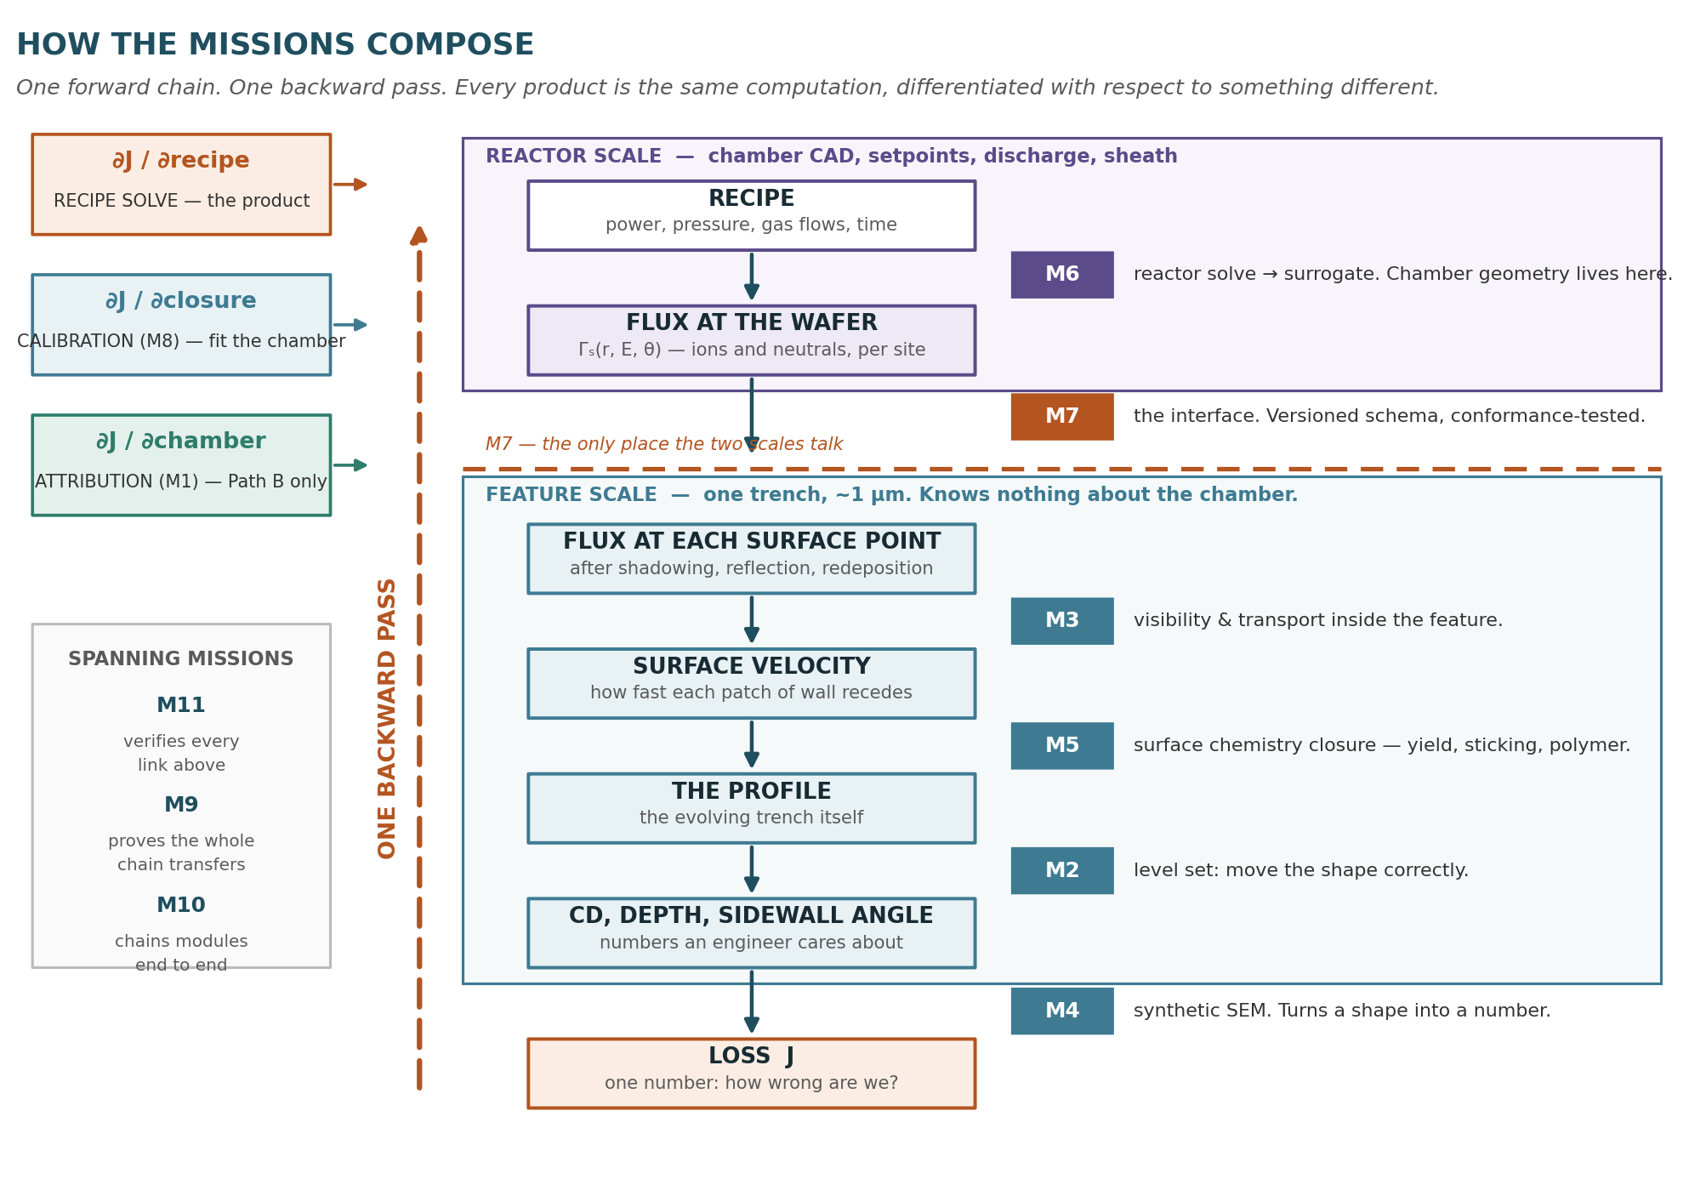

How to use this
Do the exercises. Reading about level sets does not stick; writing forty lines of NumPy does. Every lesson has a small piece of code you can finish in under an hour, and the pieces accumulate into the capstone.
The capstone is a scale model of the mission. By the end you will have built a 2D differentiable level-set etch simulator in roughly 200 lines, with a passing gradient test. That is M2.1 through M2.3 in miniature. If a competent engineer can do it in a week, M2 is twenty-two weeks of the same thing at scale and the plan is sound. If they cannot, that is information worth having in week one rather than week twelve.
Each lesson ends with a self-check. If you cannot answer it in your own words, do not move on — the later modules assume the earlier ones tightly.
Cross-references to the M2 PRD are given as section numbers, so you can read the requirement immediately after learning why it exists.

What you already know that helps
- An etch chamber: plasma, sheath, ions arriving with an energy and an angle, neutrals arriving roughly isotropically, a mask, a film, a stop layer.
- What CD, depth, sidewall angle, bowing and faceting mean, and why an engineer cares.
- Python and NumPy at a working level.

What you do not need
- Any prior exposure to level sets, computational geometry or PDE solvers.
- Any prior exposure to automatic differentiation, adjoints or JAX.
- Graduate numerical analysis. Where we need a result, we state it and cite it.

The curriculum at a glance

Module | Subject | Effort | What you can do afterwards
0 | Orientation — what M2 is for | 2 h | Explain to a process engineer why a differentiable simulator is a different thing from a fast one
1 | Representing a moving shape | 8 h | Write a working 2D level-set etch simulator
2 | Making it behave — reinitialisation, extension, stability | 7 h | Diagnose why a level-set profile is drifting, distorting or blowing up
3 | Derivatives of programs | 9 h | Explain forward vs reverse mode, and why the adjoint costs one extra solve rather than twenty
4 | Where derivatives die | 6 h | Read the PRD’s anti-requirements list and know why every item is there
5 | Shape to numbers, and verification | 6 h | Run and interpret a Taylor-remainder test; localise a gradient bug
— | Capstone — 200-line differentiable etcher | 8 h | Everything above, working, with a passing gradient test

Module 0 — Orientation

0.1 The two questions
45 min · M2 PRD: §1, §2
An etch simulator answers: "here is my recipe, what shape do I get?" Call that the forward question. Every commercial TCAD tool answers it.
M2 exists for the backward question: "here is the shape I want, which knob do I turn, in which direction, and by how much?" That is a derivative, and the whole architecture follows from wanting it.
Why you cannot just run it forward a lot
You could estimate the derivative by finite differences: run the simulation, nudge power by 1%, run again, subtract. With twenty knobs that is twenty extra simulations, every time you want to know which way to move, and you would do that hundreds of times inside an optimiser.
The adjoint gives you all twenty sensitivities in roughly one extra simulation, regardless of how many knobs there are. That is the entire economic argument for the architecture, and it is why so much of the PRD is about protecting gradient correctness rather than about physics.
Self-check
You are done when you can explain, without notes, why a simulator that is 100× faster would not remove the need for the adjoint.

0.2 Where M2 sits
45 min · M2 PRD: §1, §3
Read Figure 1 at the front of this document. M2 is one link in a chain: M6 turns a recipe into flux at the wafer, M3 turns that into flux at each point inside the trench, M5 turns flux into a local etch speed, and M2 moves the shape given those speeds.
The scope boundary that matters most. M2 does not compute velocity. It consumes velocity through a fixed contract. This is not tidiness — it is so M2 and M3 can fail independently. If M2 shipped its own flux model, every M3 bug would look like an M2 bug and vice versa.
Exercise
Write two paragraphs: one describing what M2 would need if it also computed flux, and one describing why the PRD forbids it (§11). Keep them; you will revisit this at Module 4.

0.3 Read the PRD once, badly
30 min · M2 PRD: all
Read the whole M2 PRD now, quickly, and do not worry about what you do not understand. The point is to build a map of unfamiliar words so that when you meet them in the lessons you recognise where they came from. Write down every term you could not define. That list is your progress bar.

Module 1 — Representing a moving shape

1.1 Why not just track the surface?
1 h · M2 PRD: §5.1
The obvious representation of a trench wall is a list of points connected by segments, moved inward each timestep. This is called an explicit or Lagrangian representation, and it works beautifully until it does not.
The three ways it breaks
- Topology change. Two etch fronts meet and merge; a mask undercuts and a piece detaches. Your list of connected points is now wrong and there is no local rule that fixes it. Someone has to write surgery code that detects and repairs every case.
- Point crowding and starvation. Points bunch up in concave corners and spread out in convex ones. You need continuous re-meshing.
- Self-intersection. A front moving inward under normal speed will cross itself at a corner. Physically it should form a sharp facet; numerically you get a loop that must be detected and clipped.
Feature-scale etch does all three routinely. That is why the field moved to implicit representations.

1.2 Signed distance functions
1.5 h · M2 PRD: §5.1
Instead of storing the surface, store a scalar field φ on a fixed grid. At every grid point, φ is the distance to the nearest surface, signed: negative inside the solid, positive in open space. The surface is wherever φ = 0.
It sounds indirect and wasteful — you are storing a whole 3D array to represent a 2D surface. Three things pay for it:
- Topology change happens automatically. A number crossing zero has no opinion about whether that merges two holes.
- Geometric quantities are easy. The outward normal is ∇φ/|∇φ|. Curvature is ∇·(∇φ/|∇φ|).
- The grid is fixed. No re-meshing, ever.
Exercise
import numpy as np

n, dx = 128, 1.0 (128x128 grid of points, 1 unit apart, centered on zero)
x = (np.arange(n) - n/2) * dx
X, Y = np.meshgrid(x, x, indexing="ij")

# a circle of radius 30: phi < 0 inside
phi = np.sqrt(X**2 + Y**2) - 30.0
- Anything that is inside the circle becomes negative
- Nothing on the circle becomes 0
- Anything outside the circle is positive

# check: |grad phi| should be 1 everywhere for a true SDF
gy, gx = np.gradient(phi, dx)
print(np.abs(np.sqrt(gx**2 + gy**2) - 1).max())
- Printing the worst deviation found
Now build φ for a rectangle. You will find the exact signed distance to a rectangle is fiddly at the corners — that difficulty is exactly why reinitialisation (Lesson 2.1) exists.
a, b = 40.0, 20.0 # half-width, half-height
qx, qy = np.abs(X) - a, np.abs(Y) - b # signed distance to each pair of faces (split between the x and y)
outside = np.sqrt(np.maximum(qx, 0)**2 + np.maximum(qy, 0)**2)
- Qx = how far past left or right face am I?
- Qy = how far past top or bottom face am I?
- Maximum function only keeps the positive parts (AKA when you’re past the wall, not inside it)
- Only is pythagoras when you’re offset @ both sides, and now the closest distance might be to a corner
inside = np.minimum(np.maximum(qx, qy), 0)
- Choosing the less negative out of qx and qy (AKA the closer face)
- Np.minimum returns 0 when the term is outside the triangle, as max(qx,qy) would be positive (keeping only negative values)
phi = outside + inside
- One of these terms is going to be zero always
Convention. The PRD fixes negative-inside-solid and asserts it in tests (§5.1). A sign error here inverts every gradient in the system and is the most common single bug in level-set code. Pick the convention once and test it.
Self-check
Why does |∇φ| = 1 characterise a signed distance function, and what does it mean physically when |∇φ| drifts to 1.4 in some region?
- Phi = distance from surface (countour = 0)
- Gradient = arrow at each point (the direction that phi increases fastest) AKA away from circle
- |gradient| = length of the gradient; how much distance goes up for every 1nm you step in the gradient’s direction (should be 1 AKA true distance)
- Contour = all points that share the same phi (distance) value
  - Everything inside the contour = 0 (AKA surface, phi = 0) is negative phi
- Outward normal → purely directional aspect of the gradient (gradient/|gradient|)
  - In a perfect SDF, gradient is already the normal
  - |gradient|!=1 means that the thing drifted
- Curvature = slope of outward normal (AKA how quickly normal changes direction as you slide along the wall)
  - Flat wall: curvature = 0
  - Divergence of normals → are arrows spreading apart or crowding together
    - Bulge outward → positive curvature
    - Scooped in → negative curvature (like bottom corner of trench)
- When length fo gradient drifts, that means that the distance function can not be trusted
  - Doesnt’ change the shape (wall is where distance - 0)
  - Fix = reinitialization (code resets distance so the slope is 1 again, recalibrating the ruler)

1.3 The level set equation
2 h · M2 PRD: §5.2
The surface moves with speed V along its own normal — that is what etching is. The field that represents it must then satisfy
∂φ/∂t + V |∇φ| = 0
Derive this for yourself: a point on the surface has φ = 0 for all time, so dφ/dt = 0 along its trajectory. Expand with the chain rule, substitute the normal velocity, and the |∇φ| appears. Do the derivation on paper; it takes five lines and it is the difference between using the equation and understanding it.
- Level set equation becomes an update rule
  - This rule determines which way to calculate the differences
Osher & Sethian introduced this in 1988. Adalsteinsson & Sethian applied it specifically to etching, deposition and lithography in 1995, which is the paper the PRD cites and the one worth reading first.

1.4 Why central differences explode
2 h · M2 PRD: §5.2
You now want to discretise |∇φ|. The obvious choice — central differences — produces a scheme that oscillates and then diverges. Understanding why is the single most useful piece of numerical intuition in this module.
- Discretise = estimating it from grid values alone (since computer doesn’t have formula for distance)
  - Change in distance is gradient; magnitude of that is length of gradient
  - Central difference = replacing derivative with difference between neighboring grid values, divided by the distance between them (calculus → arithmetic on a grid)
- Time is also discretized
The level set equation is a Hamilton–Jacobi equation: information propagates in a definite direction, from the surface outward along characteristics. A central difference looks upstream and downstream equally, so it happily lets information travel the wrong way. The fix is upwinding: choose the one-sided difference that looks in the direction the information is actually coming from.
- Hamilton-Jacobi equation → a first-order, non-linear partial differential equation in classical mechanics that links a system's energy (the Hamiltonian) to the action (the time-integral of its Lagrangian)
  - Hamilton–Jacobi equation: a PDE of the form ∂φ/∂t + H(∇φ) = 0, where H is a function of the gradient. Here H = V|∇φ|.
- Information only arrives from one side
  - Upwinding → use the side that the information is coming from; costs accuracy, but stops errors from growing
    - Everytime the grid point takes one time step, the new value is what whatever value was a distance V*dt to it’s left a moment ago (no relevance in the right neighbor)
      - Upstream is decided by the direction of motion, not by whether the point is in solid or open space
        - Moving left; upstream is right (as in the case with etching)
        - Moving right; upstream is left
      - Characteristics → path along which values travel
For |∇φ| under normal motion the correct choice is the Godunov Hamiltonian, which picks forward or backward differences per direction based on the sign of V.
- Trivial on 1D
  - Real profile: slope’s sign changes → “upwind” direction decided per point, axis, every step
- Von Neumann stability analysis → break grid pattern into waves, check whether one step multiplies any wave’s size by > 1 (if so, the scheme is unbstable)
- First-order / second-order → halving dx roughly halves / quarters the error
  - Making grid finer (AKA smaller dx) → error shrinks
  - Higher order → shrinking more
  - error ≈ C × dxᵖ
    - C represents everything in the error that doesn’t depend on dx
      - Depends on (1) scheme you use and (2) how curved/wiggly the function is at that point
        - Corners of the trench has large derivatives; errors are large even with fine grid (upwind smears sharp corners more than flat walls)
        - Asymptotic regime → range of dx small enough that the leading error term dominates
          - Leading error term → largest term in the truncation error (less prominent in coarser environments)
      - As a scheme central difference has a higher C term (but it is higher order)
        - We use Godunov as scheme for space
        - Use forward Euler for time
          - Forward is first order
- Numerical diffusion → smearing rounds off sharp features (causes issues with CD and sidewall angle)
  - Diffusion term → smooths out bumps, as in the heat equation
  - Size of rounding depends on grid spacing and step size instead of physics
  - Cost of upwinding’s stability
    - Higher order upwind schemes like ENO and WENO exist to solve this
Exercise
def godunov_grad_mag(phi, dx, V):
dxm = (phi - np.roll(phi, 1, 0)) / dx # backward
dxp = (np.roll(phi, -1, 0) - phi) / dx # forward
dym = (phi - np.roll(phi, 1, 1)) / dx
dyp = (np.roll(phi, -1, 1) - phi) / dx
if_pos = (np.maximum(dxm, 0)**2 + np.minimum(dxp, 0)**2 +
np.maximum(dym, 0)**2 + np.minimum(dyp, 0)**2)
if_neg = (np.minimum(dxm, 0)**2 + np.maximum(dxp, 0)**2 +
np.minimum(dym, 0)**2 + np.maximum(dyp, 0)**2)
return np.sqrt(np.where(V > 0, if_pos, if_neg))

# then: phi_new = phi - dt * V * godunov_grad_mag(phi, dx, V)
Run it with V constant on your circle. The radius should shrink linearly. Now replace the Godunov function with a plain central difference and watch it fail. Keep both; the failure is instructive.
Note for later. Look at the maximum and minimum calls in that snippet. Every one of them is a place a derivative can silently die. Module 4 comes back to this — it is the reason §11 forbids bare abs, max and sign near the interface.

1.5 Timestepping and the CFL condition
1.5 h · M2 PRD: §5.2
An explicit scheme is only stable if information does not travel more than about one cell per step. That is the CFL condition: V·dt/dx must stay below a constant of order one. Violate it and the solution oscillates and blows up, usually within a few dozen steps.
- CFL (courant-friedrichs-lewy) → explicit scheme si oly stable if true information travels no further per step than the scheme’s stencil can see
  - Courant number v=V*(dt/dx) → how many cells the information travels per step
    - v=1 exactly → true value comes from exactly the upstream neighbor; scheme copies it perfectly; bump moves with no error at all
    - v<1 → stable but bump smears a bit (numerical diffusion), but height never grows
    - v>1 → true source past neighbor, wiggles grow each step; “blew up” within a few dozen steps
    - You can not easily make dt tiny → costs more compute
      - Smearing also becomes larger per unit time
        - Diffusion coefficient contains (1-v)
  - Explicit scheme → computes new values directly from old values (e.g., forward Euler)
    - Cheap per step, but subject to CFL limit
  - Implicit scheme → system of equations each step and avoids limit, but much higher cost
    - You don’t compute new values directly; you write an equation that new values must satisfy and you solve it
      - DIFFERENT vs implicit representation (AKA storing the shape)
    - 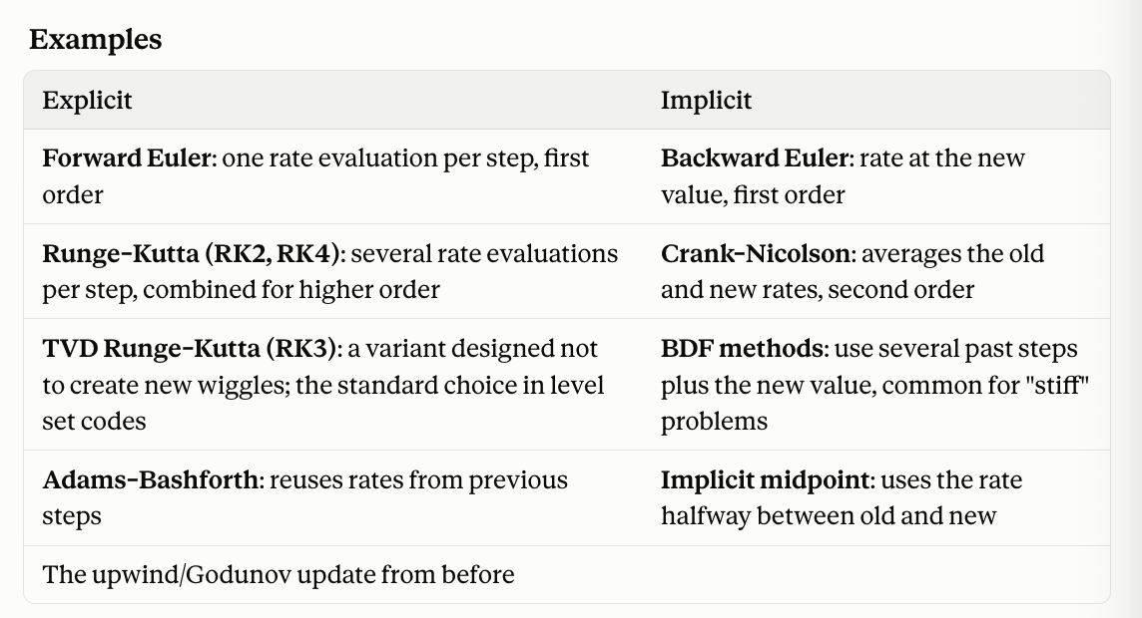
      - Implicit schemes work well in stiff problems → where some parts change much faster than others, forcing explicit schemes to take tiny steps
        - Semi-implicit → treats stiff part implicitly and the rest explicitly
The natural response is to compute dt from the current maximum velocity each step. The PRD forbids this, for a reason that has nothing to do with stability, and Module 4 explains it. For now, note the requirement: fixed step count N from config, dt = T/N, and an assertion that CFL stays under 0.5.
- Limit of 1 is for 1D → limit tightens with 2D and 3D
  - 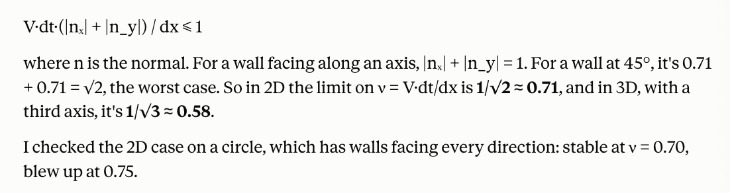
    - V can vary with etching speed though
      - Can’t choose dt form current velocity
        - Data-dependent loop counts: Number of steps depends on V, V depends on recipe, nudging recipe can add or remove a whole step → jump in output → breaks gradients
    - Fixed dt is troublesome; code can’t shrink dt when velocities get large; drifts would become unstable silently
Self-check
If you halve dx and keep dt fixed, what happens, and why?
- Dx = grid spacing (distance between neighboring grid shapes)
  - Resolution fo shape
  - Smaller dx = finer grid and more detail
- Dt = time step (how much simulated time passes in one update)
- Both of these terms are in the courant number
  - Cells are now half as big (same distance, 2x as many cells)
  - Information outruns what the scheme can see = CFL violation
    - Made grid finer, but broke the simulation
      - In explicit schemes, you should shrink dt in proportion to stay within the CFL limit
      - Implicit schemes might fix the stability issue but not eh accuracy issue

Module 2 — Making it behave

2.1 Reinitialisation — why φ goes bad
2 h · M2 PRD: §5.3
Advect your circle for a few hundred steps and re-measure |∇φ|. It will no longer be 1. The level set equation only guarantees the motion of the zero contour; it says nothing about keeping the rest of the field a distance function. Where |∇φ| becomes very large the field is steep and the interface position becomes sensitive to noise; where it becomes very small the interface is smeared over many cells.
The standard fix is to periodically re-impose the distance property by iterating a second PDE to steady state:
∂φ/∂τ + sign(φ₀)(|∇φ| − 1) = 0
- Tau is pseudo-time → no etching, just nudging phi until it settles
  - Each step in tau = one “iteration”
- Phi 0 represents start of reinitilaization cycle
- Sign phi 0 is computed once and doesn’t change during the iterations
  - -1 in solid
  - +1 in open space
  - 0 exactly on the wall
- |gradient|-1 = error
  - How far slope is from what a distance function needs
- Iterating until nothing changes means partial derivative of phi wrt t = 0
  - When sign (phi 0) != 0, the way to get there is to reduce error to 0
  - When iteration settles, phi becomes the distance function again
- Same concept of the level set equation
  - ∂φ/∂τ + sign(φ₀)·|∇φ| = sign(φ₀)
  - Wall acts as fixed boundary, with correct distance values spread out from it like a wave
  - Needs Codunov upwinding
  - Speed is 1, so CFL requires dτ ≲ 0.5·dx.
    - 5 iterations at dτ = 0.5·dx → correction wave only travels 2.5 cells from wall (which is fine; proximity matters most)
This is Sussman, Smereka & Osher (1994). It drives |∇φ| toward 1 while, in principle, leaving the zero contour where it was.
The failure mode nobody checks
"In principle" is doing work in that sentence. Discretised reinitialisation moves the interface slightly, a little each cycle, always in the same direction. Over five hundred steps that becomes a systematic etch-rate bias. It looks exactly like physics. It will be absorbed into the calibrated chemistry parameters at M8, and then it will fail to transfer at M9.
- Interface = wall (boundary between solid and open space; AKA phi = 0 contour)
  - Level set is basically implicit representation
- The wall is usually never exactly on a grid point (interpolate based on phi values of neighbors)
  - For example, if one cell has φ = −0.4 and the next has +0.6, the wall is 40% of the way from the first to the second.
  - Those neighbouring cells aren't on the wall, so sign(φ₀) ≠ 0 there and they do get updated. If the update changes −0.4 to −0.45 and +0.6 to +0.58, the interpolated crossing shifts, even though nothing etched. That's the interface moving.
    - The discrete |∇φ| near the wall is never exactly 1, because of curvature and truncation error, so these updates always happen. The error has a consistent sign set by the shape, so the wall creeps the same way every cycle rather than jittering back and forth. That's what makes it dangerous.
This is check V12 in the PRD (§8.3): measure enclosed area before and after a reinitialisation cycle with no advection, and require drift below 0.1% per cycle. It is described there as the most commonly missed check in level-set codes, and that is not rhetoric.
- Every reinitialization cycle nudges the wall a little, always in teh same direction
- M8 (calibration) → fit chemistry parameters (e.g., yield or sticking) to match measured SEM profiles
  - Can’t tell numerical drift from chemistry, so it absorbs the drift; chemistry parameters shift to compensate
- M9 (transfer) → different conditions (etch time, grid/geometry, curvature) → drift depends on numerical settings, but chemistry parameters contain old compensation
- V12 tests it with no advection (V=0) → numerical changes only
  - 0.1% * expected cycle count → how does this compare to etch-rate accuracy needed in M8?
Exercise
Implement reinitialisation with a fixed five iterations. Measure area drift per cycle for the smoothed sign function φ₀/√(φ₀² + dx²) versus the exact np.sign. Report both numbers.
Did this in Colab notebook
Takeaways:
- Go with the smoothed sign → passed V12, but we need to check for accumulated drift over realistic run length
  - Sign → acts as update speed in the reinitialization equation
  - Smoothed sign → slows cells near the wall to fraction of full speed, reaching nearly full speed only a few cells out
    - Updates cells near the interpolated zero crossing gently → less drift
    - Behaves close to the same as exact sign away from the wall
  - Exact sign → updates a cell a quarter-cell from the wall at full speed
  - 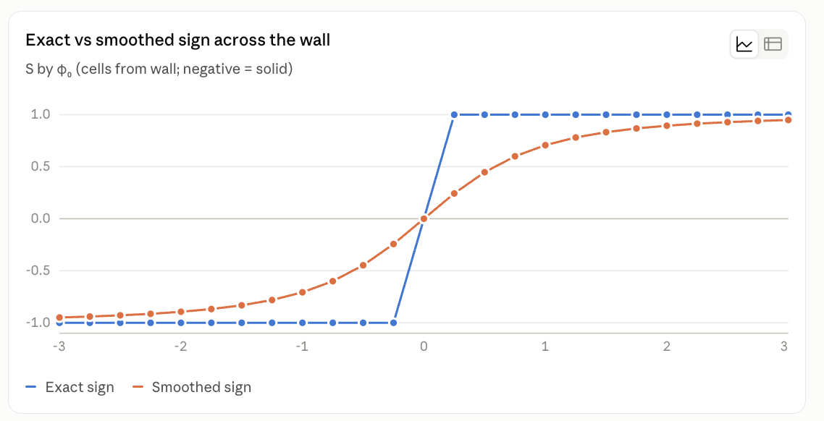

2.2 Velocity extension
1.5 h · M2 PRD: §5.4
The etch speed is physically defined only on the surface — that is where the ions land. But the advection step needs a velocity at every grid point in the band. So you extend it off the interface, either by solving a transport equation that carries values along the normal direction, or by simply having each cell look up the velocity at its closest point on the surface.
- Two methods
  - Define velocity for each grid point by looking at closest point on the surface (floor, sidewall, or ambiguous; v=1.0, 0.2, tie/corner)
    - These are arbitrary values for example → based on the capstone’s velocity model
    - V = v_iso + v_dir · max(0, n·ẑ)ᵖ
      - V_iso → isotropic etch from neutrals
      - v_dir · max(0, n·ẑ)ᵖ term is the directional etch from ions → arrive nearly straight down
        - n·ẑ measures how much the surface faces up toward them
          - 1 for a surface facing straight up (floor)
          - 0 for vertical one (straight sidewall)
          - max() terms switches it off for downward facing surfaces the ions can’t reach
    - Depends on phi being a good distance function (tradeoff between this and transport PDE)
  - Transport PDE → equation that carries V outward along the normals (like reinitialization for phi)
    - ∂V/∂τ + sign(φ) (n · ∇V) = 0
    - Better when phi has drifted
    - When it settles, n · ∇V = 0, which is the "constant along the normal" condition. Information spreads outward from the wall about one cell per iteration, with the same upwinding logic as before. It's iterative and only fills a band a few cells wide per fixed number of iterations, but it copes better when φ has drifted.
      - Only uses phi for its sign (to tell you side and direction) → stretched or squeezed phi doesn’t mislead it
A poor extension shows up as a spurious drift in |∇φ| and as artifacts near concave corners. A good one is boring, which is the goal.
- Artifacts near concave corners
  - Along the diagonal, points are equally close tof loor and sidewall (jump of 5x between neighboring grid points)
  - Trench bottom corners → where you measure CD and sidewall angle
    - Can’t really remove the jump since floor and sidewall etch @ different speeds
- These are the things you should watch for during verification

2.3 Narrow bands, and why M2 does not use one
1.5 h · M2 PRD: §4
The classical optimisation is to update only cells within a few of the interface — the narrow band (Adalsteinsson & Sethian 1995; Peng et al. 1999). Cost then scales with surface area rather than volume, which for a large domain is an enormous saving.
- Narrow band = set of grids close to the wall
  - band = { cells where |φ| < β }
    - Makes sure we cover negative and positive β (distance from wall)
  - β = k·dx → stands for the band’s half-wifth → actual distance
    - k = count of cells
    - Dx = size of one cell
    - 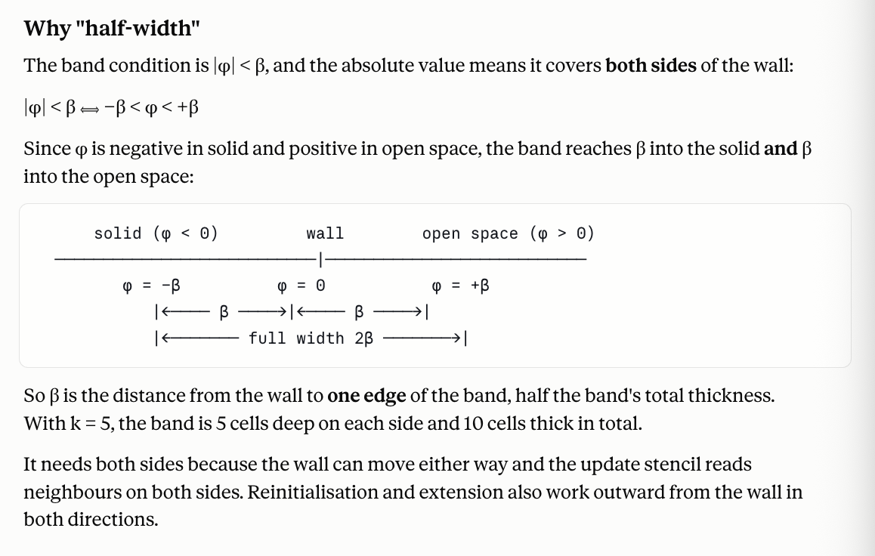
- Band needs to be rebuilt periodically
  - Adalsteinsson and Sethian → when wall gets close to band’s edge
  - Peng et al. use two nested bands with a smooth cutoff so values fade out at the edge instead of being abruptly frozen
    - Reduces computational effort by one order of magnitude (BUT that’s not really an issue in this case here)
The PRD deliberately does not do this, and §4 is worth reading closely because it is the largest architectural decision in the mission. The argument: a single feature with periodic lateral boundaries is small. 512 × 128 × 128 at 2 nm is 34 MB per field. Dense is affordable, and going dense removes three of the four hardest gradient problems at a stroke — static shapes, no data-dependent active set, and reinitialisation becomes ordinary differentiable code rather than requiring a hand-derived adjoint.
- Dense can be made affordable:
  - One field is small
  - Use checkpointing to make one backward pass fit comfortably on one GPU
    - Checkpointing: storing only some intermediate states during the forward pass and recomputing the others during the backward pass, trading extra compute for less memory.
- Gradient problems
- Static shapes
  - JAX compiles step function for fixed array sizes
    - Narrow band’s list of active cells changes length every step (wall’s area grows with trench deepening) → need ot either recompile or pad + checkpointing stores different shape each time
  - Identical shapes with dense arrays → one compiled step function → looped with lax.scan → checkpointed with one decorator
- No data-dependent active set
  - Under narrow bad, which cells are in the band is defined by |φ| < β
    - φ depends on recipe parameters → some cells might be in band under one recipe but not under another
  - Kinks (not jumps) in dense → continuous (more in module 4)
- Reinitialization
  - Narrow band codes usually reinitialize with fast marching → computes distances cell by cell in order of increasing distance, using priority queue
    - Processing order chosen from data → can’t be traced cleanly by autodiff
    - Need to derive adjoint by hand to get gradients (big failure mode here is drift)
- Ordinary differentiable code is a forward simulation written entirely from operations the autodiff system understands (array arithmetic, fixed loops, smooth functions) so that jax.grad builds the backward pass automatically by applying the chain rule to every operation. You write the forward code only. The gradient is correct by construction for whatever the forward code computes, and it stays correct when you change the forward code.
- A hand-derived adjoint is a backward pass that a person works out mathematically and implements as separate code, plugged in with jax.custom_vjp. It's needed when the forward algorithm can't be traced (heaps, sorting, dynamic structures) or when tracing it would be wasteful.
- 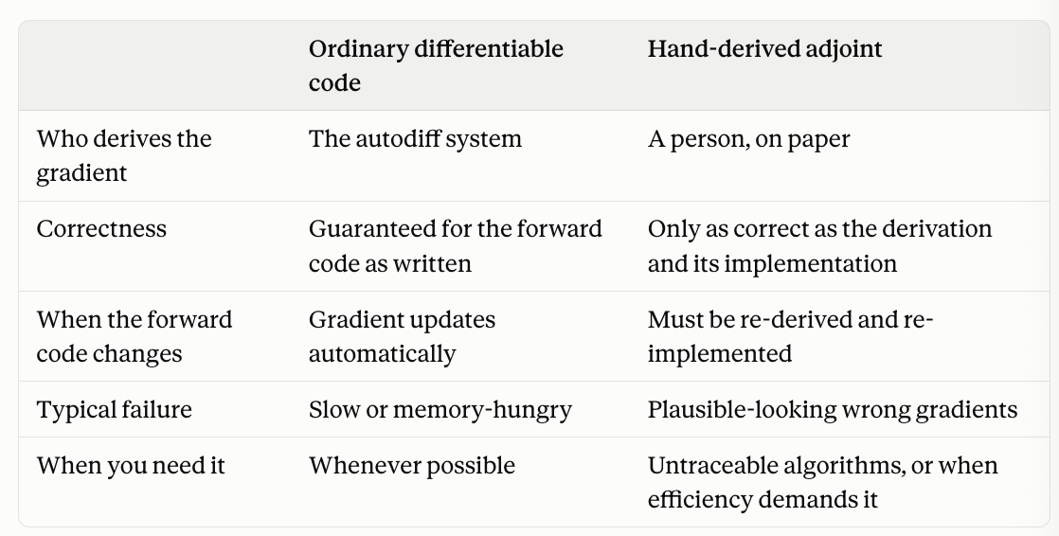
Self-check
At what domain size does the dense choice stop being reasonable, and what would you do then?
- "Dense stops fitting on one GPU at roughly 10⁸ cells, about 8–16× the baseline domain (1 nm grids, several-µm-deep features, or multi-feature boxes), and run time per gradient becomes a problem even sooner. First I'd try options that keep static shapes: stronger checkpointing or offloading, symmetry reduction if the feature allows it, and splitting the dense grid across GPUs. I'd go sparse only if the domain is mostly far from any wall, since that's the only case where it saves a lot, and then I'd prefer fixed-capacity block sparsity to keep shapes static. That brings back the data-dependent active set and possibly a hand-derived reinit adjoint, so it needs its own gradient verification."
- Could use Taichi → narrow band speed without hand writing sparse data structures
- Reasonable
  - Memory
    - peak ≈ M × (cells × 8 bytes) (fp64)
  - Time
    - one gradient has to be fast enough to run the hundreds or thousands of times that calibration (M8) needs.
    - Fitting works by gradient descent, repeated many times:
- Run the simulation with the current parameters (forward pass).
- Compare the result with the measured profiles to get J.
- Run the backward pass to get the gradient: how J changes with each parameter.
- Nudge every parameter a little in the direction that reduces J.
- Go back to step 1 with the new parameters.
    - One gradient means one trip through steps 1–3: one forward pass plus one backward pass. Thanks to the adjoint, that gives the sensitivity to all parameters at once, at a cost of roughly 2–4 forward runs, including the checkpointing recompute.
- 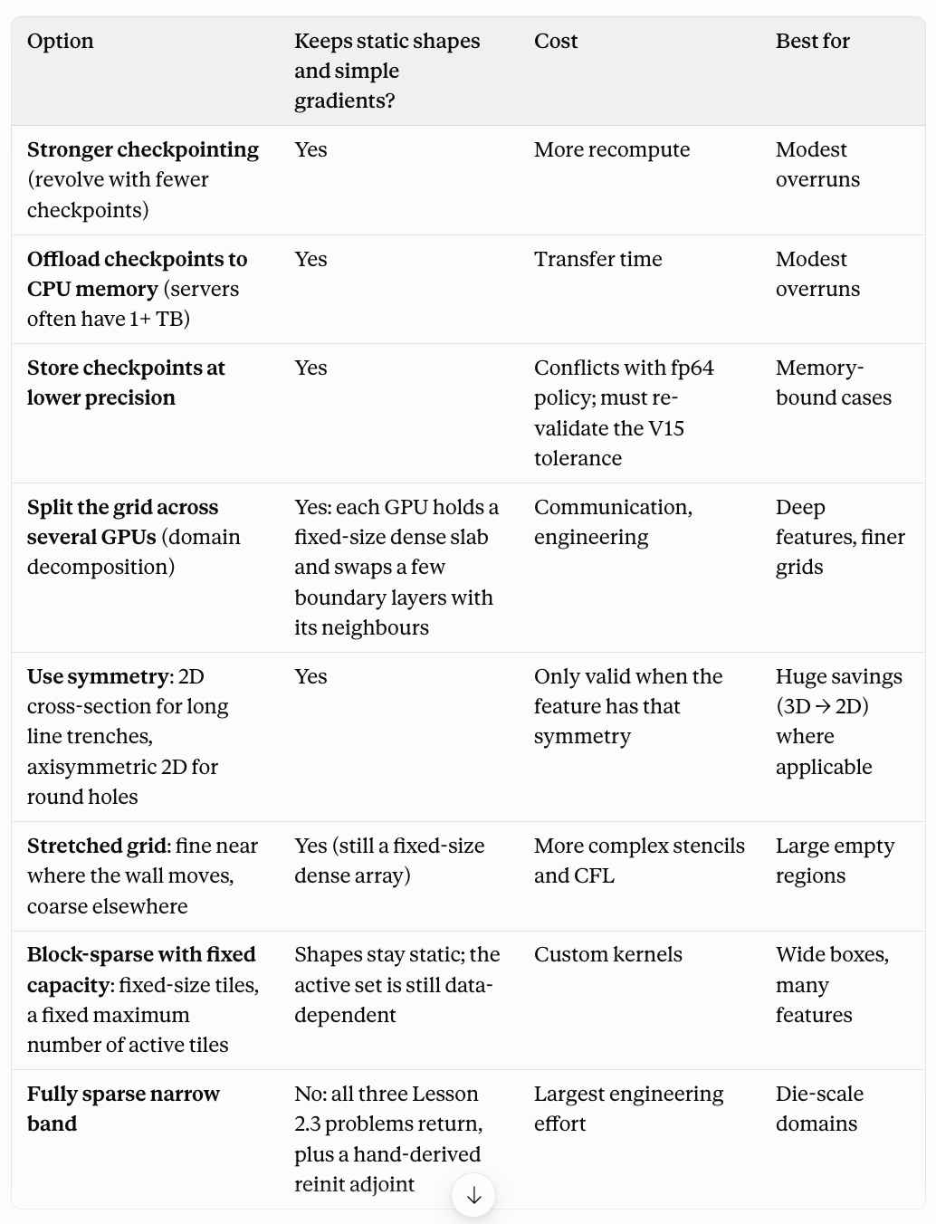

2.4 Verification you can do today
2 h · M2 PRD: §8.1–§8.3
You now have enough to run four of the PRD’s checks. Do them on your own code; they take an afternoon and they build the habit the mission depends on.

ID | Check | What it catches
V1 | Isotropic growth: circle under constant V, radius must be r₀ + Vt | Almost everything, cheaply. Your first alarm.
V2 | Plane translation: a flat interface moves at exactly V | Boundary-condition and upwinding errors. Should be nearly exact.
V9 | Reversibility: advect forward N steps, then backward N steps | Accumulated advection error that V1 hides. Needs no analytic solution.
V10 | Grid isotropy: rotate the initial circle 45°, growth must stay isotropic | Grid anisotropy, which later masquerades as a sidewall-angle dependence.

Module 3 — Derivatives of programs

3.1 What it means to differentiate a program
1.5 h · M2 PRD: §7
There are three ways to get a derivative of a computer program, and only one of them is right here.
- Symbolic. Differentiate the formula by hand or with a computer algebra system. Fine for a formula; impossible for a five-hundred-step loop.
- Numerical (finite differences). Nudge an input, rerun, subtract. Simple, and it is what we test against — but it costs one rerun per parameter and it suffers from cancellation error, so it is never accurate to more than about half machine precision. → this is the manual version
  - Cancellation error → loss of significant digits when subtracting two nearly equal numbers (magnified round-off errors)
  - Truncation error → error from approximating derivative within finite step, from the neglected Taylor terms
  - Round-off error → error form storing a number with finite digits
- Automatic differentiation. Apply the chain rule mechanically to every elementary operation the program performs. Exact to machine precision, and — in reverse mode — costs a small constant multiple of one forward run regardless of parameter count.
  - 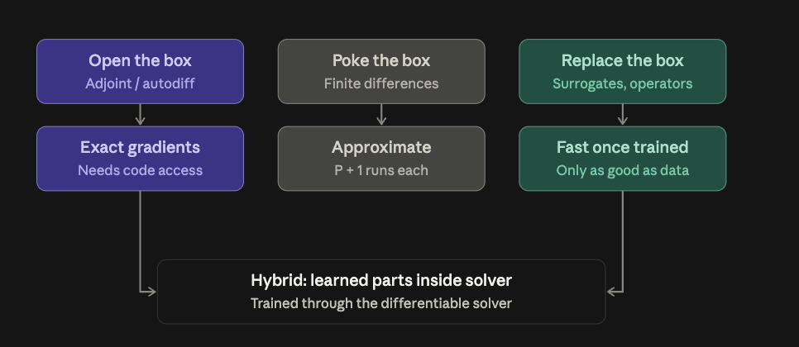

- Replacing the box:
  - Surrogate → cheap model, fitted to many simulator runs, mapping inputs (recipe knobs, closure parameters, mask geometry: vector of 10-50 numbers) to outputs
    - Classically: polynomial response surfaces and Gaussian processes
    - Modern: neural networks
    - Once trained, evaluating and differentiating it are basically free
    - 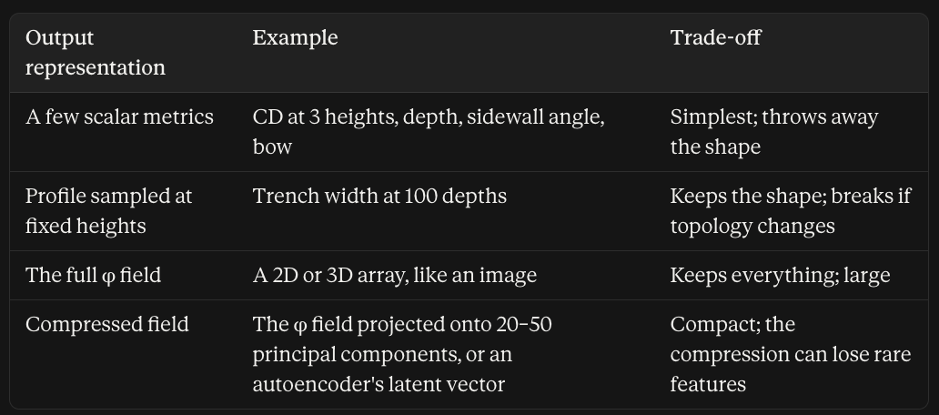
    - Making it smarter: build in symmetries, penalise violations of the governing equations during training, train on gradients as well as values (next section), or keep part of the physics solver inside the model (a hybrid).
  - Neural operator → AKA surrogates for whole fields rather than a few numbers
    - Learns map from one function to another
      - Example: initial profile + recipe → final profile
      - Replaces entire time stepping solver
      - Best known: FNO, DeepONet
    - DINOs (O’Leary-Roseberry et al. (2024)) → derivative-informed neural operators → adding derivative information to training improves function accuracy
      - Gradients must be right if surrogate is to be used inside optimizer; training on values along isn’t good enough
    - Solver-in-the-loop → learned correction can be learned through backpropagating thru differentiable solver over many time steps
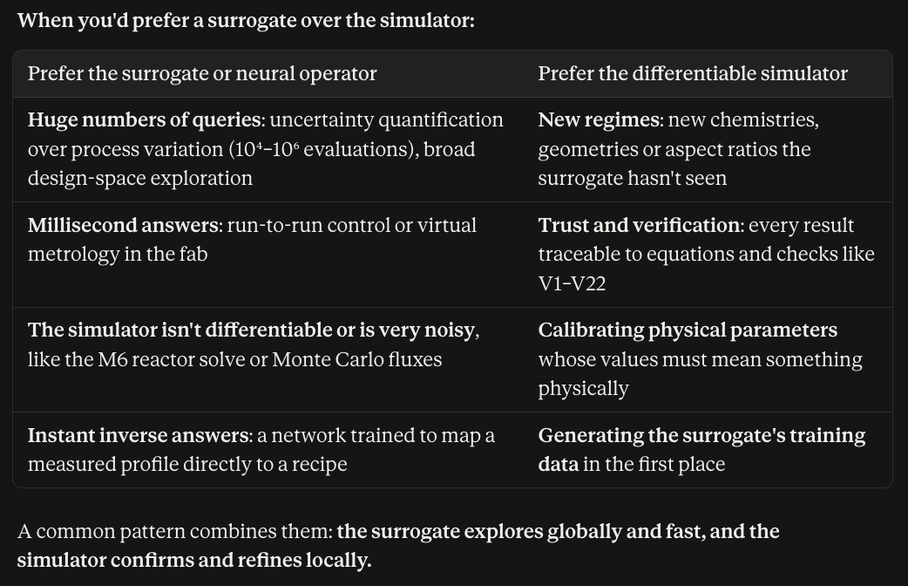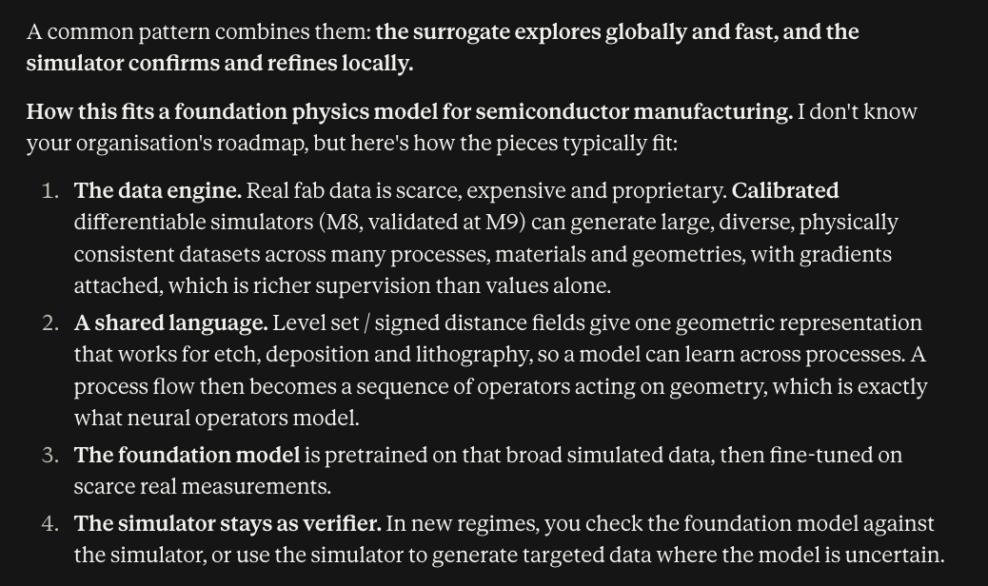
Baydin et al. (2018) is the readable survey. Read the first ten pages.

3.2 Forward mode versus reverse mode
2 h · M2 PRD: §7.1, §8.5
Both apply the chain rule; they differ in the order of multiplication, and the order decides the cost.
Forward mode carries a derivative alongside each value as it computes forward. One pass gives you the derivative of every output with respect to one input. Cost: one pass per input.
Reverse mode runs the program forward, records what it did, then walks backward accumulating sensitivities. One backward pass gives you the derivative of one output with respect to every input. Cost: one pass per output.
- The forward pass runs the simulation and computes J, the one number. The backward pass gives ∇J, all 30 derivatives at once.
  - Backward pass:
    - ∇J = (∂J/∂metrics) × (∂metrics/∂parameters)
    - = (a row of 10 numbers) × (the 10 × 30 Jacobian)
The rule of thumb. Many inputs, one output → reverse mode. That is exactly our situation: dozens of recipe and closure parameters, one scalar loss J. It is also exactly the situation in neural network training, which is why the tooling exists and is good.
- This is about the shape of the function (not whether it is one-to-one)
- Jacobian → table of how every output changes with every input
- Chain ends at the loss J
  - Gradient is what hte backward pass computers → how much J changes when you nudge the parameter
    - In this case, this is still technically a jacobian, but it is that of a function with only one output (so there is only one row) → that row = the gradient
- 3D field is the intermediate (like hidden layer in neural network)
  - Reverse mode's cost depends on the number of final outputs
  - Memory is the bigger issue here for size of the field
    - The backward pass carries a sensitivity for every grid cell at every step, "how much does J care about φ here?", and those are field-sized arrays. That's the 17 GB problem and why checkpointing exists.
- 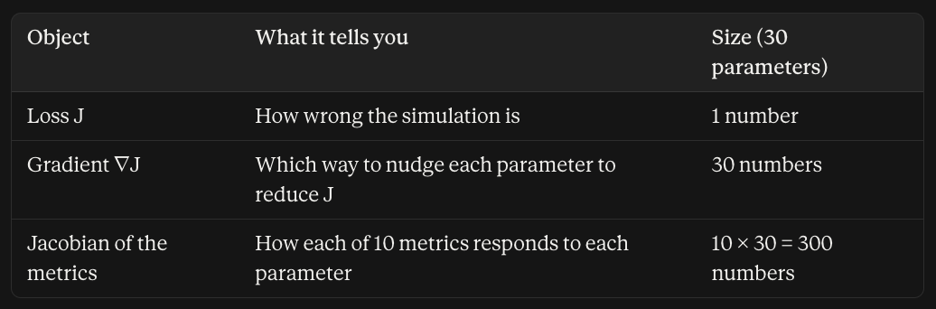
Exercise
import jax, jax.numpy as jnp

def f(p):
x = p[0]*p[1] + jnp.sin(p[2])
return jnp.sum(x**2)

p = jnp.array([1.0, 2.0, 0.5])

g_rev = jax.grad(f)(p) # one pass, all three
g_fwd = jnp.array([jax.jvp(f, (p,), (e,))[1] # one pass each
for e in jnp.eye(3)])
print(g_rev, g_fwd) # must agree
That last comparison is check V15 in the PRD, and the PRD calls it the highest value-per-line check in the whole suite. The reason: JAX implements forward and reverse mode as separate code paths, so agreement between them is real evidence rather than a tautology.

3.3 The adjoint of a timestepper
2.5 h · M2 PRD: §7.4
Now apply reverse mode to a loop of five hundred timesteps. Conceptually it is the same chain rule, but the practical consequence is memory: to walk backward through step k you need the state at step k, so a naive implementation stores every intermediate state.
- Adjoint → linear map going backwards
- Timestepper → function that advancesw the simulation one step in time
  - φₖ₊₁ = S(φₖ, θ)
    - Here φₖ is the state at step k (the whole level set field)
    - θ is the parameters (recipe and closure)
    - S is the step function
    - In M2, S does one explicit update: extend the velocity, apply the Godunov update, and reinitialise if it's due
At 34 MB per field and 500 steps that is 17 GB, which is why the PRD treats this as a first-class design problem rather than an implementation detail.
Checkpointing
Store only a few states — checkpoints — and recompute the rest on the way back. With √N checkpoints you get roughly √N memory and a factor of two in recompute. Griewank and Walther worked out the optimal schedule (the "revolve" algorithm); in JAX you get most of the benefit from jax.checkpoint applied to the step function.
- Jax.checkpoint → uniform scheme, evenly space checkpoints
- Revolve = optimal schedule given N steps and memory budget
  - Most likely won’t use this right now
  - When memory becomes a binding constraint, this would become helpful
750 MB and 2× compute instead of 17 GB. This is the trade the PRD specifies in §7.4.
- 2x compute = more time, rather than more data (trade-off)
  - Backward pass has own cost that doesn’t double (usually 1-3x a forward step) → so total time is not doubled
- 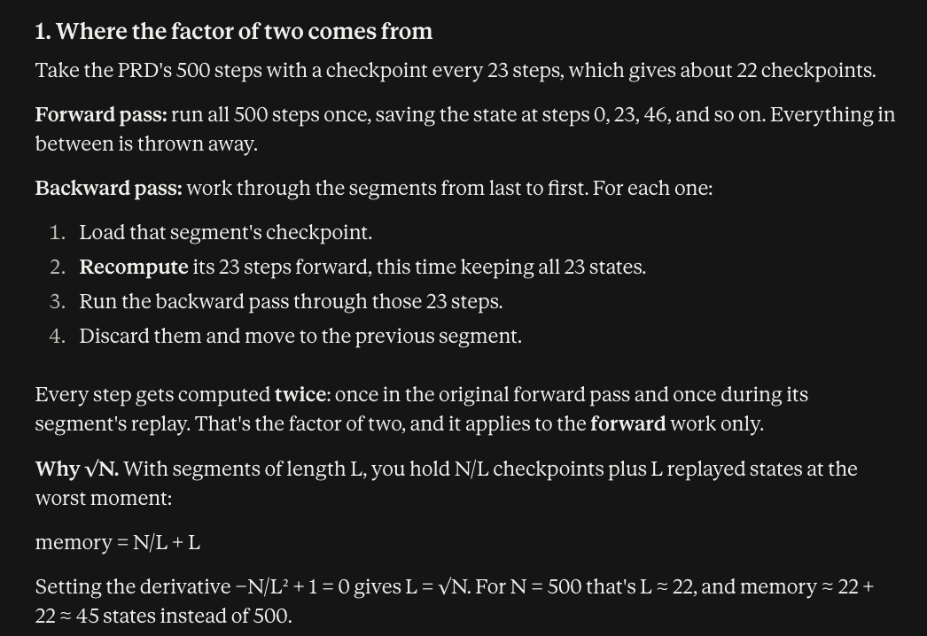
Self-check
Why does checkpointing help at all — what exactly is being traded for what?
- Memory is being traded for compute time

3.4 The adjoint in physics language
1.5 h · M2 PRD: §1
If you find the automatic-differentiation framing abstract, here is the same thing from the PDE side. The adjoint equation is a second PDE, run backward in time, whose solution is the sensitivity of your objective to a perturbation at each point and time. Weather forecasting has used this since the 1980s under the name 4D-Var; shape optimisation in aerospace and photonics uses it; Allaire, Jouve & Toader (2004) is the standard reference for the level-set case specifically.
- 4D-Var → auto-diff adjoint in weather forecasting
Automatic differentiation and the hand-derived adjoint compute the same object. AD derives it mechanically, which is less elegant and much less error-prone. M2 uses AD; knowing the adjoint framing helps when you read the literature, because most of it predates usable AD tooling.
- This was before jax.gradient became the shit

3.5 JAX in practice
1.5 h · M2 PRD: §10, §7.3
Enough JAX to work in the codebase: pure functions, jit, grad, jvp, vjp, pytrees, and the two rules that will otherwise cost you a day each.
- Static shapes. Array shapes must be known at trace time. This is why the dense representation of §4 fits JAX and a sparse narrow band fights it.
- Nothing differentiable in a closure. A parameter captured in a closure rather than passed in the parameter pytree is invisible to jax.grad, and produces a silently zero gradient column rather than an error. §7.3 requires a test that every declared parameter has a nonzero gradient somewhere, precisely to catch this
- Closure → function that uses variable from outside itself via surrounding code, instead of receiving it as an argument
  - Captured in closure → k grabbed from surroundings rather than passed in
    - JAX only differentiates wrt to function’s arguments → closure treated as fixed constant (parameter’s gradient entry becomes zero)
      - Test is to compute gradient for each parameter → make sure zero does not pu
        - Nonzero somewhere under some condition (some zero parameters are legit)
  - Cause trouble with differentiating
- Pytree → nested container → JAX treats as one structured input
  - Parameter pytree → holds every parameter you want to fit

Module 4 — Where derivatives die
This module is the intellectual core of the mission. Every item in the PRD’s anti-requirements list (§11) is here, and each one has produced a real bug in somebody’s code.

4.1 Data-dependent loop counts
1.5 h · M2 PRD: §5.2, §5.3
The natural timestep is dt = CFL·dx / max|V|, integrating to a fixed final time T. But max|V| depends on the parameters. So dt depends on the parameters. So N = ceil(T/dt) depends on the parameters — and it is an integer, so it changes in jumps.
- Since N changes, that threatens the differentiability
- N = ceil(T/dt) → rounding up to the next whole number
The derivative of the output with respect to a parameter now has a discontinuity every time N ticks over. Nothing crashes. The gradient is simply wrong near those points, and it looks like noise rather than like a bug, so you will blame the Monte Carlo, or the grid, or precision.
The fix is the one in §5.2: fix N, set dt = T/N, assert CFL. Same reasoning forbids convergence-based stopping in reinitialisation and velocity extension — all iteration counts are fixed and come from config.
Generalise the lesson. Anything that makes the shape of the computation depend on the value of a parameter is a gradient hazard: adaptive steps, convergence loops, sorting, if-statements on parameter values, dynamic array sizes. A differentiable program wants a fixed computational graph.

4.2 Kinks, jumps and mollification
2 h · M2 PRD: §5.3, §5.6
Three different pathologies get confused. Learn to tell them apart.

Kind | Example | Consequence for the gradient
Kink (C⁰, not C¹) | abs(x), max(x, 0) at zero  - V-shaped valley with sharp bottom | Derivative exists almost everywhere but is discontinuous. Usually survivable; can stall an optimiser.  - Slope flips suddenly → optimizer may zigzag but usually gets there
Jump (discontinuous) | sign(x), an integer material ID changing | Derivative is zero everywhere and undefined at one point. The signal is destroyed, not degraded.  - All change happens at cliff edge, where slope is undef  - AD reports zero, says the information doesn’t matter → info is destroyed
Quantisation  - Might appear when we are measuring CD | CD extracted by counting cells  - Staircase of many small steps (zero slope everywhere between steps) | Piecewise constant. Derivative is exactly zero. Looks like the parameter has no effect. (even if it does)

The general remedy is mollification: replace the sharp function with a smoothed version over a width w. The smoothed sign in reinitialisation, φ/√(φ² + dx²), is exactly this. So is the smoothed Heaviside in the volumetric functional, and the material blending of §5.6.
- Small nudge near the wall causes small, visible change → gradient becomes nonzero and finite (below are some use cases in M2)
  - Smoothed sign in reinitialisation, which you've tested: it also moved the wall far less.
  - Smoothed Heaviside (a soft 0-to-1 step) for measuring areas and volumes, so they change continuously as the wall moves.
  - Material blending (§5.6): near an interface, a cell is treated as a gradual mix of materials instead of being fully one or the other, so moving the interface changes properties smoothly rather than flipping an integer material ID.
    - So everything is about making things smooth rather than jumps
The honest cost
Mollification buys differentiability by changing the physics slightly. §5.6 requires reporting how much the gradient depends on the smoothing width w_mat at 1, 2, 4 and 8 cells — and states that if the gradient depends strongly on a purely numerical parameter, that is a finding and must be reported, not tuned away. Sit with that requirement for a minute; it is the difference between engineering and wishful thinking.
- This is not the workaround for quantised CD; this is the secondary option
- Mollification changes the problem slightly → physics + blur (not perfectly sharp interface)
- W_mat is arbitrarily chosen and not necessarily in physics → we did it for the gradients
  - Gradient at different w values should be roughly the same (trustworthy answer shouldn’t be too dependent on w_mat)
  - 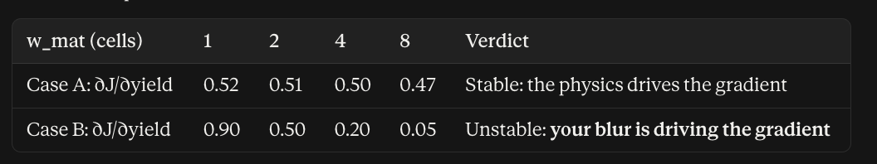
  - 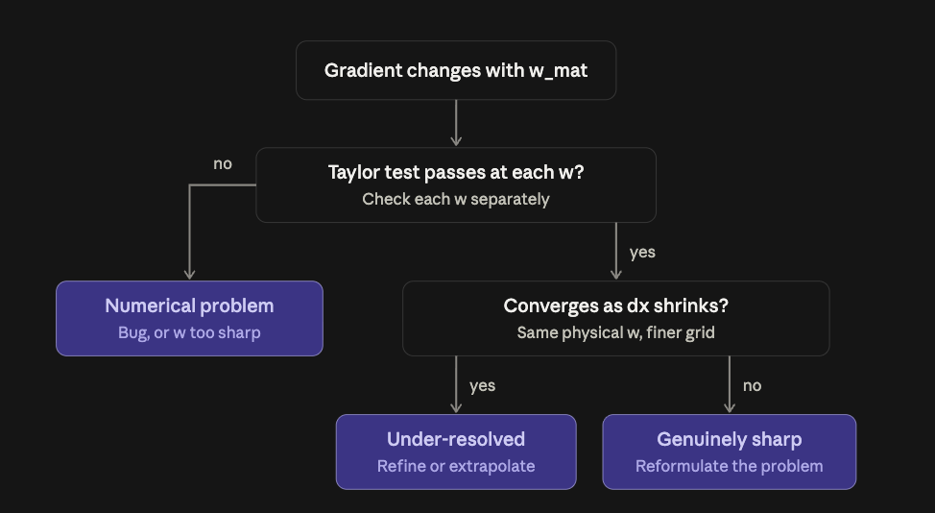

4.3 The stop-gradient temptation
1 h · M2 PRD: §5.3, §11
When a piece of the computation is awkward to differentiate, every framework offers an escape hatch that tells the autodiff to treat it as a constant. It always makes the error go away. It is almost always wrong.
Applying it to reinitialisation, for example, asserts that reinitialisation has no effect on the output — which is false, since reinitialisation is a real part of the forward map. The result is a biased gradient that points in a slightly wrong direction, forever, with no error message.
§11 forbids stop-gradient on reinitialisation, extension and material blending, and instructs you to stop and ask if you think you need one. Treat that as literal.
- Stop-gradient → operation that passes a value through unchanged in the forward pass, but tells autodiff to treat it as constant in the backward pass
  - Tells JAX not to differentiate through thais
  - This is tempting during awkward parts to differentiate
    - It is telling the model that this specific value has no effect on the output
      - For reintialization, that causes a butterfly effect to change the phi values in the wrong direction

4.4 Stochastic forward passes
1.5 h · M2 PRD: §7.6
M3 will supply a Monte Carlo velocity: random rays, random scattering. M2 has to be built so that this does not break the adjoint, and the trap is subtle enough to be worth a lesson of its own.
- Stochastic = random (opposite of deterministic)
Under checkpointing, the forward pass is recomputed during the backward pass. If the velocity model draws fresh randomness on recompute, the recomputed forward differs from the original one — and the adjoint is then differentiating a trajectory that never happened. Nothing crashes. The gradient is plausible and wrong.
The fix: the RNG key must be a deterministic function of step index and a run-level seed, both passed through the velocity request. Never global, never stateful. Check V18 verifies that a checkpointed recompute reproduces the forward trajectory bitwise.
Self-check
Why is "use a fixed global seed at the start of the run" not sufficient?
- Fixed global seed makes the whole run repeatable from the beginning
  - Doesn’t make any single step repeatable on its own → which is needed for checkpointing
- Stateful random generator → keeps internal position, advances it with every draw (each result depends on all previous draws)
- Stateless → counter-based random generator → result is a pure function of key and index (e.g., jax.random)

Module 5 — Shape to numbers, and verification

5.1 Sub-cell extraction
2 h · M2 PRD: §5.7, §8.4
You have φ on a grid; you need CD, depth and sidewall angle. Marching squares in 2D (marching cubes in 3D) walks the grid, finds cells where φ changes sign, and locates the crossing by linear interpolation between the two corner values. That interpolation is the whole point.
- Marching squares / marching cubes:
  - Look at one square, with its four corner values of φ.
  - Mark each corner as inside (φ < 0) or outside (φ > 0).
  - If all four agree, the wall doesn't pass through this square. Move on.
  - Otherwise, the wall crosses every edge whose two ends disagree. On each such edge, place a point by linear interpolation.
  - Join those points with a line segment inside the square.
  - March to the next square. The segments link up into the full contour.
- This is about how the computer reads measurements off the shape that it has etched
  - The computer only stores phi (one number per grid point)
  - Extraction → getting CD (width), depth, sidewall angle from the shape
- 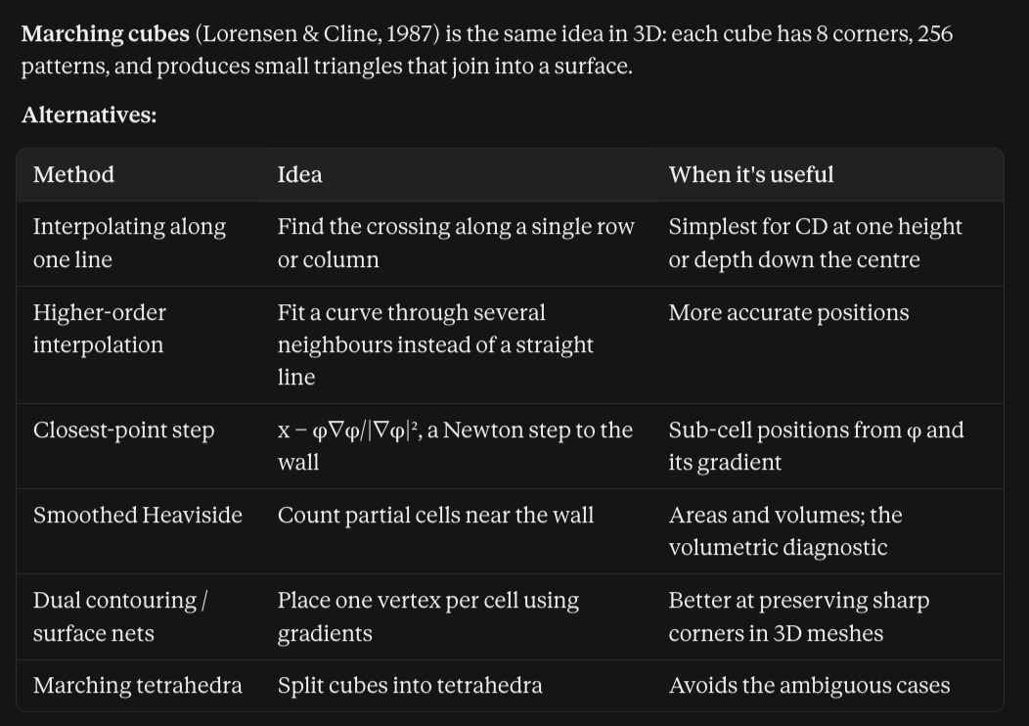
If instead you count cells with φ < 0, your CD is quantised to the grid spacing. It changes in steps of dx and is constant in between, so its derivative with respect to any parameter is exactly zero almost everywhere. The optimiser sees a flat landscape and concludes nothing matters.
- Origin of the quantised CD issue
Exercise
Take your circle, sweep its centre by 0.1 dx increments across one cell, and plot extracted diameter versus offset. With marching squares you get a smooth line. With cell counting you get a staircase. That plot is check V13 and it is worth pinning to a wall.
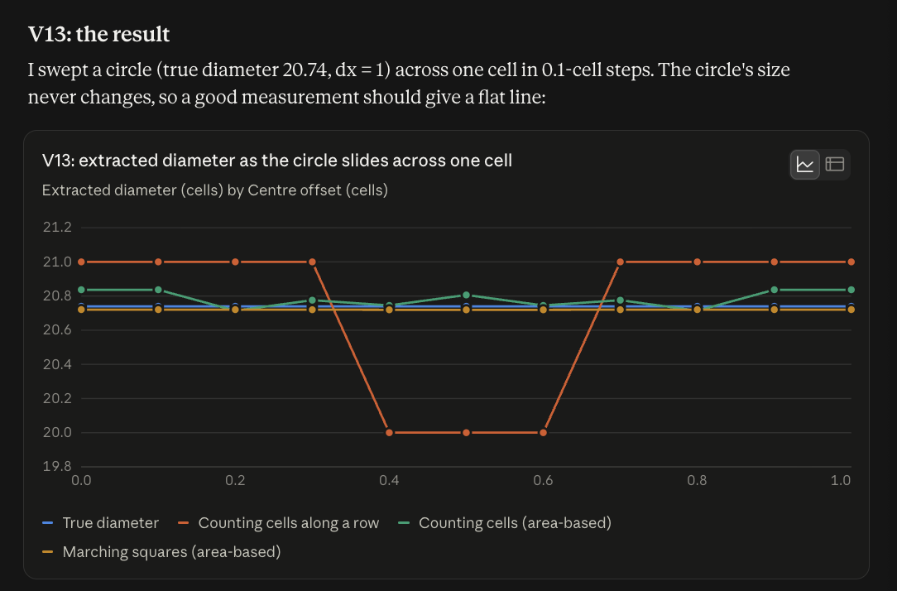

5.2 The smooth functional, and why it exists
1 h · M2 PRD: §5.7, §8.7
The PRD also requires a purely volumetric objective, the etched volume computed with a mollified Heaviside. No product uses it (they only care about the SEM measurements). It exists as a diagnostic instrument.
- Volumetric objective → volume of material removed (volume of open space) @ the end of the simulation
  - Sum over every cell: V = Σ over all cells of H_w(φᵢ) × dx³
    - H_w(φ) says how much of that cell counts as open space: 0 in solid, 1 in open space, in between near the wall. The etched volume is V at the end minus V at the start. Since the starting shape doesn't depend on the parameters, both have the same gradient.
- What is a mollified Heaviside?
  - The Heaviside function is the sharp on/off step: H(z) = 0 for z < 0 and 1 for z > 0. Using it to measure volume would be exactly cell counting: each cell is fully in or fully out, and the total jumps.
    - Mollified version replaces step with smooth ramp of width w on each side of zero
      - H_w(z) = ½ (1 + z/w + sin(πz/w)/π) for |z| < w, 0 below −w, 1 above +w
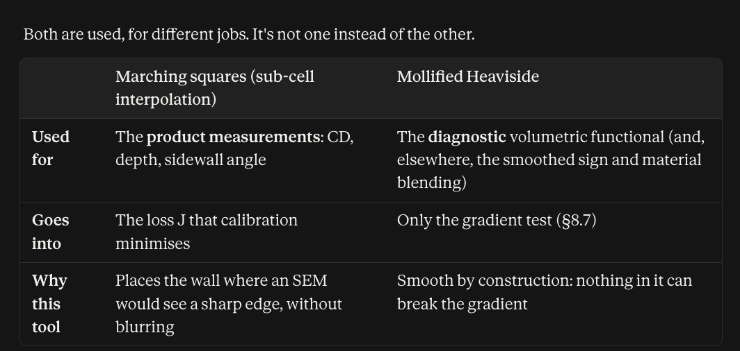
Because it is smooth by construction, running the gradient test on both it and the extracted CD localises failures immediately: if volume passes and CD fails, the bug is in extraction; if both fail, it is in the advection, reinitialisation or checkpointing. That is §8.7, and it turns a multi-day hunt into a ten-minute triage.
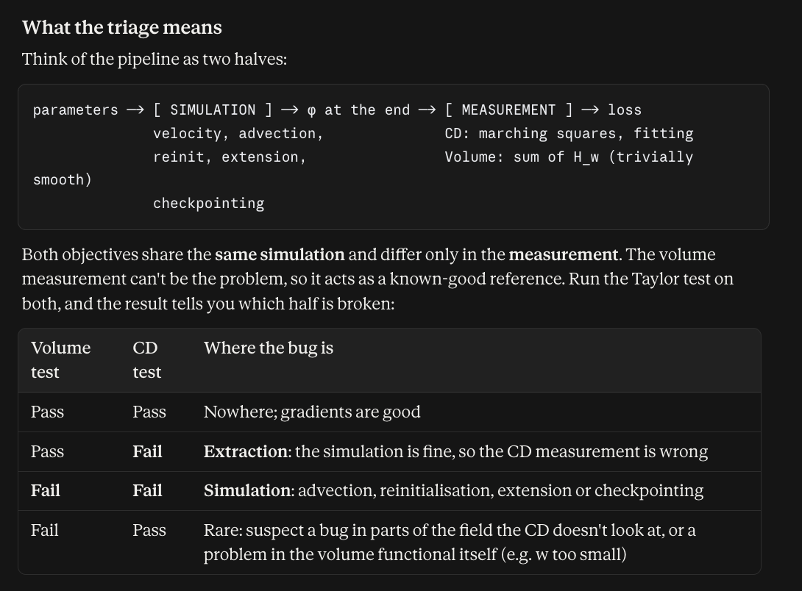

5.3 The Taylor-remainder test
2 h · M2 PRD: §7.1, §8.5
Taylor remainder (R(h)) → difference between actual change in J and the change predicted by the gradient, for a step of size h
- If h is too small, the rounding noise takes over and the remainder stops shrinking
- Direction δ: the combination of parameters being nudged; a random δ tests all of them at once.
- O(h²): terms that shrink at least as fast as h².
This is the gate the whole mission turns on, and it is worth understanding rather than copying.
- Code produces gradient → showing how J changes wrt each parameter
- Taylor remainder test confirms that they re “right”
  - Trust the forward simulator: J @ any parameter values you choose, already checked against physics by the other verification tests
    - Forward physics checks that the simulation is right; Taylor test establishes that the gradient matches the simulation
    - On benchmarking against solvers:
      - Solvers still have to be calibrated against machine
    - 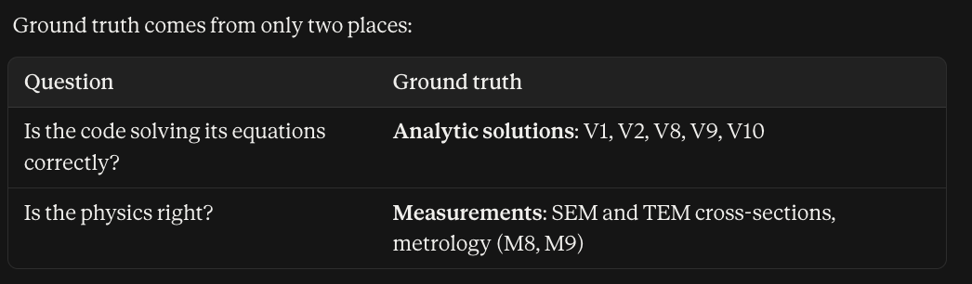
- TRT tests gradient’s defining property: is is the best straight-line prediction of how J changes for small nudges
- Predict the change for a nudge of size h, using your gradient g: ΔJ ≈ h (g · δ).
- Run the simulation at the nudged parameters and see the real change.
- Measure the miss: R(h) = |actual change − predicted change|.
- Repeat with smaller h and watch how fast the miss shrinks.
Taylor’s theorem says J(θ + hδ) = J(θ) + h∇J·δ + O(h²). So if your gradient is correct, the residual R(h) = |J(θ+hδ) − J(θ) − h∇J·δ| must shrink like h². Halve h, the residual drops by four.
- Taylor remainder R(h): the gap between the actual change in J and the change predicted by the gradient, for a step of size h.
- Direction δ: the mix of parameters being nudged together; a random δ tests the whole gradient at once.
- Curvature term c = ½ δᵀHδ: how much J bends along δ; it sets the size of the h² term.
- Hessian H: the table of second derivatives of J.
- Rounding floor: the smallest remainder measurable, set by floating-point error in J, about 10⁻¹⁵ relative in fp64.
- Log-log slope: the exponent p in R ∝ hᵖ, read off as the steepness of a straight line on log-log axes.
- V14: the PRD's Taylor-test requirement, a slope between 1.8 and 2.2 on both the volume and CD objectives.
If the gradient is wrong, the first-order term does not cancel and the residual shrinks only like h. On a log-log plot you are reading a slope: 2 means correct, 1 means wrong. That distinction is why a plain finite-difference comparison is not sufficient — a gradient can agree to first order and still be wrong.
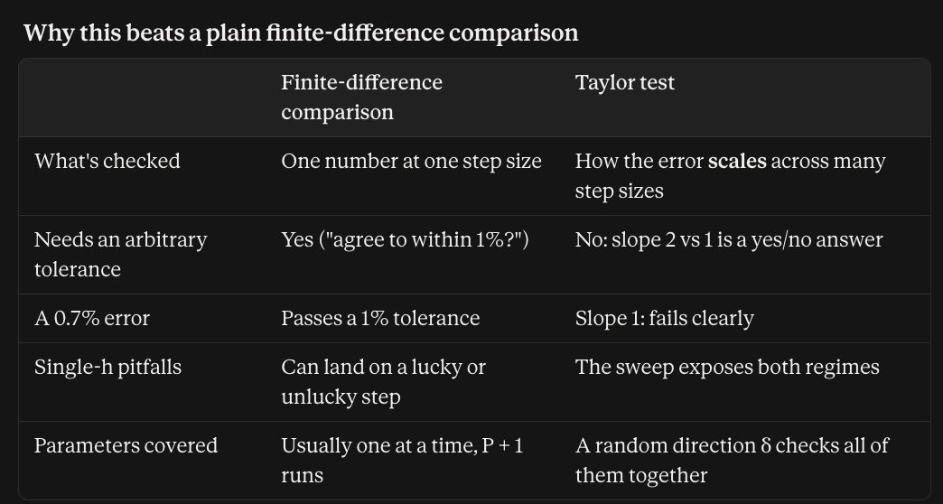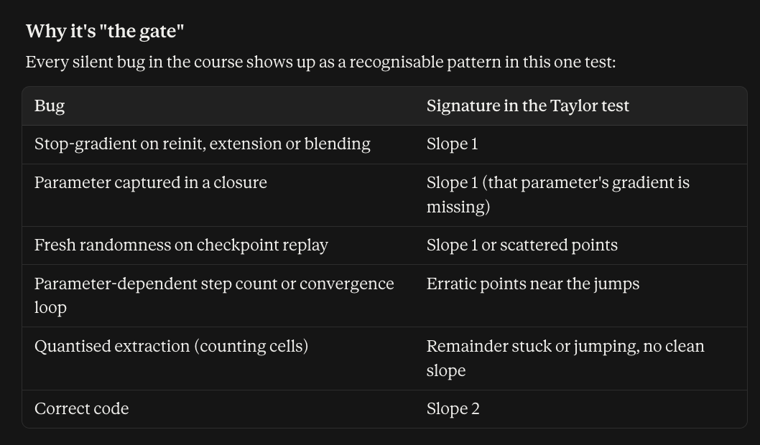
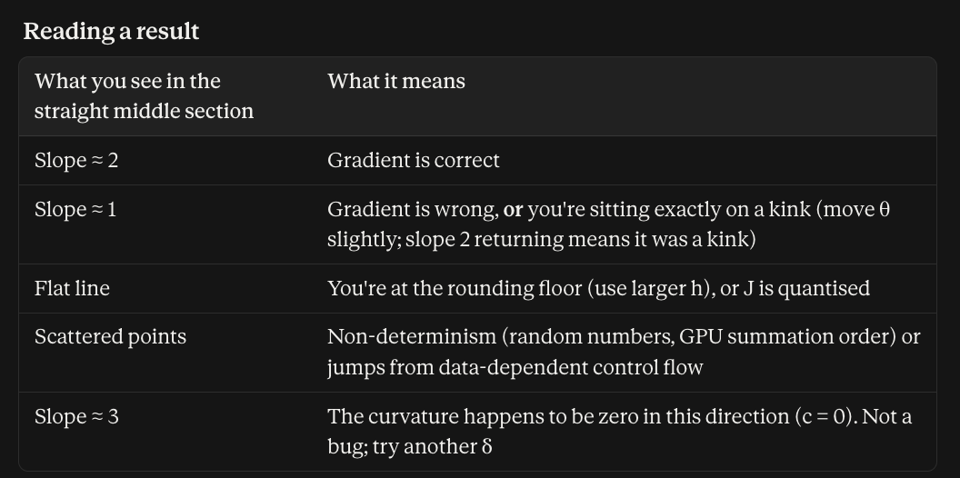
Exercise
def taylor_test(J, grad_J, theta, delta, hs):
J0, g = J(theta), jnp.vdot(grad_J(theta), delta)
return [abs(J(theta + h*delta) - J0 - h*g) for h in hs]

hs = [1e-1, 1e-2, 1e-3, 1e-4, 1e-5]
R = taylor_test(J, jax.grad(J), theta, delta, hs)
# fit slope of log R vs log h; require 1.8 <= slope <= 2.2

# now deliberately corrupt the gradient and confirm the test FAILS
bad = lambda t: jax.grad(J)(t).at[0].multiply(1.05)
Test the test. That last two lines are check V19, and §7.2 makes it a gate at the very first milestone. A verification suite that has never been shown to fail has not been verified. Run it before you trust anything else.

5.4 The rest of the verification suite
1 h · M2 PRD: §8
Read §8 of the PRD end to end. You now have the background for all twenty-two checks. Pay particular attention to the cadence table in §8.0 — fast tier under three minutes on every commit, nightly, and gate-only — and to §8.9, which states plainly what M2 does not verify. A green M2 suite means the equations are solved correctly. It says nothing about whether they are the right equations, because the velocity is prescribed.

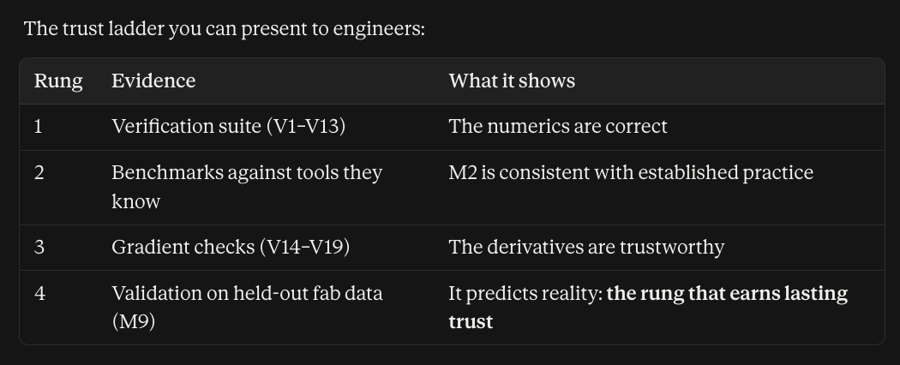

Capstone — a 200-line differentiable etcher
Build, in JAX, a 2D differentiable level-set etch simulator. Roughly 200 lines. Budget one week.

Specification
- Domain 256 × 256, periodic laterally, Neumann top and bottom. φ initialised to a flat film under a mask with an opening.
- Velocity model: V = v_iso + v_dir · max(0, n·ẑ)^p, with v_iso, v_dir and p as the differentiable parameters. This is a crude stand-in for isotropic neutral etch plus directional ion etch, and it is deliberately the shape of what M3 will eventually supply.
- Fixed N = 300 steps, dt = T/N, CFL assertion. Godunov Hamiltonian, TVD-RK2.
- Reinitialisation every 5 steps, 5 fixed iterations, smoothed sign.
- Extract depth and CD at mid-depth by sub-cell interpolation.
- Objective J = (CD − CD_target)² + (depth − depth_target)².
- Gradient by jax.grad, with jax.checkpoint on the step function.

Acceptance — mirror the real gates
- V1 isotropic growth, V2 plane translation, V9 reversibility, V12 reinitialisation area drift under 0.1% per cycle.
- V13 sub-cell smoothness sweep — produce the staircase-versus-smooth plot.
- V14 Taylor remainder, slope between 1.8 and 2.2, on both the volumetric functional and extracted CD.
- V15 forward mode agrees with reverse mode to 1e-10 in fp64.
- V19 the corrupted-gradient canary is caught by V14 and V15.
- V17 gradient with checkpointing equals gradient without, at small N.

The finale
Pick a target CD and depth. Start from wrong parameters. Run gradient descent and recover them.
That is recipe inversion, in miniature, and it is the first time the whole idea will feel real rather than theoretical.

What the capstone tells you about the mission. It is M2.1 through M2.3 at 1/50 scale. If a competent engineer completes it in a week with all checks passing, the mission plan’s twenty-two weeks for the full 3D multi-material version is credible. If it takes three weeks and the Taylor test will not hold slope 2, that is the single most valuable schedule signal you will get all year — and you will have it in week one.

Reading list

Read these
- Adalsteinsson & Sethian, J. Comput. Phys. 118 (1995), "A level set approach to a unified model for etching, deposition, and lithography." The paper this whole mission descends from. Read first.
- Osher & Sethian, J. Comput. Phys. 79 (1988). The original level-set paper. Short.
- Baydin, Pearlmutter, Radul & Siskind, JMLR 18 (2018), "Automatic differentiation in machine learning: a survey." First ten pages cover forward vs reverse mode better than anything else.
- The JAX Autodiff Cookbook. Official docs. Work through it at a keyboard, not in an armchair.

Read when you hit the relevant lesson
- Sussman, Smereka & Osher, J. Comput. Phys. 114 (1994). Reinitialisation. → Lesson 2.1
- Peng, Merriman, Osher, Zhao & Kang, J. Comput. Phys. 155 (1999). Narrow-band methods. → Lesson 2.3
- Griewank & Walther, Evaluating Derivatives (2nd ed., SIAM 2008), chapters on reverse mode and checkpointing. → Lesson 3.3
- Allaire, Jouve & Toader, J. Comput. Phys. 194 (2004). Level sets plus shape sensitivity, the classical-adjoint view. → Lesson 3.4
- Zalesak, J. Comput. Phys. 31 (1979). Origin of the rotating-disk test. → check V8

Reference, not reading
- Osher & Fedkiw, Level Set Methods and Dynamic Implicit Surfaces (Springer 2003). The standard text. Keep it on the desk; do not read it cover to cover.
- Sethian, Level Set Methods and Fast Marching Methods (CUP 1999). Stronger on fast marching and on applications including microfabrication.
- ViennaPS documentation and source. An independent implementation of much of what M2 builds. GPL-3.0 — read for understanding only, never copy, and observe the clean-room rule in §8.8 of the PRD.

You are ready for M2 when you can
- Explain to a process engineer why a differentiable simulator differs from a fast one, without using the word "gradient" more than once.
- Derive the level set equation from dφ/dt = 0 on the interface, on a whiteboard.
- Say why central differencing fails and what upwinding fixes.
- Explain why reverse mode is the right choice here, and what it costs in memory.
- Name three ways a derivative can silently become zero or wrong, and give the remedy for each.
- Read a Taylor-remainder plot and say whether the gradient is correct.
- Argue with at least one decision in the M2 PRD and defend your position.

That last one is not a joke. The PRD contains judgement calls — dense over sparse, mollified material transitions, fixed step counts, fp64 throughout — and each has a cost. Someone who has finished this curriculum and agrees with all of them has probably not finished it.

