FRACTAL SEMICONDUCTOR
M3 Lesson Plan
Feature-scale transport and flux: the rendering equation in a trench, Monte Carlo estimation of it, and the differentiation of integrals whose integrands jump.

Audience engineers who have completed the M2 curriculum. Assumes level sets, reverse-mode autodiff, and the Taylor-remainder test. Assumes no rendering, no radiative transfer, no Monte Carlo theory. Effort ~65 hours over eight modules plus a capstone. Companion M3 PRD — read §2 and §4 before Module 0, then section by section as cited.

Relationship to the PRD. Every lesson cites the section of the M3 PRD it explains, so you can read the requirement immediately after learning why it exists. The PRD states decisions; this document derives them. Where the PRD says "warped-area sampling, unbiased, no silhouette detection", §5.6 here proves it. Read them together.

Contents

How to use this
M3 is the least conventional mission in the plan. The machinery it needs — unbiased differentiation of discontinuous integrals — exists in computer graphics and, as far as I am aware, has never been applied to feature-scale process simulation. There is no textbook chapter to read. The derivations below are therefore given in full rather than cited, because you will need to reproduce and modify them rather than invoke them.
- What does this phrase mean exactly?
Notation is fixed in §0.3 and used consistently throughout. Sign conventions for directions and normals are the single most common source of error in this material; the convention is stated once and never varied.
Every module ends with exercises that are derivations, not reading. Do them on paper. The capstone couples a 2D differentiable flux solver to the M2 capstone, producing the first object in the project that is recognisably a process simulator.

Prerequisites
- M2 curriculum complete: level sets, signed distance functions, reverse-mode automatic differentiation, checkpointing, the Taylor-remainder test.
- Multivariable calculus: divergence theorem, change of variables, Leibniz integral rule.
- Elementary probability: expectation, variance, unbiased estimators, law of large numbers, central limit theorem.
- Etch chamber physics at a working level: sheath, ion energy, neutral flux, mask and film.

Curriculum map

Module | Subject | Effort | Central result
0 | Orientation and notation | 3 h | M3 computes a functional of the geometry, not a field on it
1 | The transport regime | 6 h | Kn ≫ 1 ⇒ collisionless ⇒ the problem is a rendering problem
2 | The integral equation | 9.5 h | Rendering equation; Neumann series at rate (1−s); the redeposition fixed point
3 | Monte Carlo estimation | 8 h | Unbiasedness; NEE and Russian roulette; variance scaling
4 | Ray–surface intersection on an SDF | 6 h | ∂t/∂θ = −(∂φ/∂θ)/(∇φ·ω), singular exactly at the silhouette
5 | Differentiating discontinuous integrals | 12 h | The boundary term; naive pathwise AD is biased; warped-area sampling
6 | Variance, noise floor and the optimiser | 10 h | Common random numbers; L-BFGS vs MC gradients; flux lagging and why remat is mandatory
7 | Verification | 5 h | Analytic view factors; the furnace test; ARDE
— | Capstone | 10 h | A 2D differentiable flux solver coupled to the M2 capstone

Module 0 — Orientation and notation

0.1 What M3 computes
1 h · M3 PRD §1, §5.0; M2 PRD §5.5
M2 evolves a surface given a velocity field. M3 supplies that velocity field. Formally, M3 implements a map
Γ : (S, θ) ↦ {Γₛ(x)}ₛ for all x ∈ S (0.1)
from the current surface S and parameters θ to the per-species particle flux arriving at each point of that surface. M5 then converts flux to speed through the surface chemistry closure, and M2 advects.
- M3: converts current surface S and parameters θ → per-species particle flux @ each point on surface S
  - S, the current surface, which is the zero level set of φ. It is a curve in 2D and a surface in 3D.
  - θ, the parameters: source parameters (e.g. ion angular spread σ), sticking coefficients, scattering parameters.
  - X standing for each point
  - Flux Γₛ(x): Particles of species s arriving per unit surface area per unit time at x
  - Gives you arriving flux but only if someone tells you the surface
- M5: flux → speed through surface chemistry closure
  - Tells you chemistry at the surface (what do they do when they land → stick or bounce?)
  - This tells you what the speed is
  - This gives you the real chemistry; M3 and M2 right now only assume that ions come straight down and a tilted surface etches slower (using stand-in shape to verify gradients while chemistry is not written yet)
- M2 → advects (tells you the surface but only if you get the speed)
  - Advection → transport by bulk motion
    - Thing being carried is phi field
      - Surface: where phi = 0 (store phi and read surface off of it)
    - What carries it: surface velocity
- 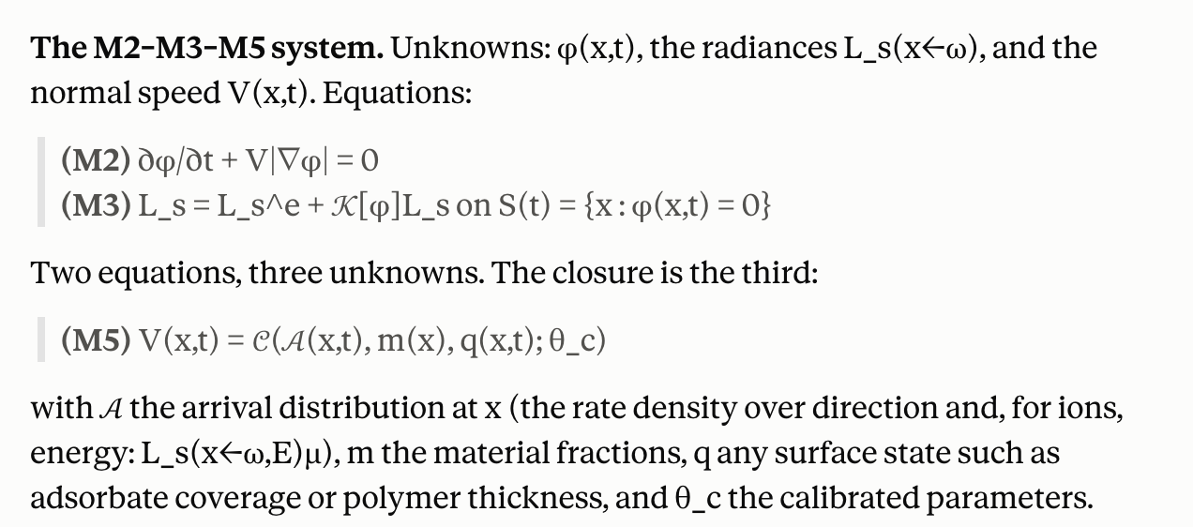
The essential structural fact: Γₛ(x) depends on the entire surface, not on a neighbourhood of x. A point deep in a trench receives less flux because the rest of the trench is in the way. This nonlocality is what separates M3 from every other term in the chain and it is why the mission is hard: the derivative ∂Γₛ(x)/∂θ has contributions from geometry changes arbitrarily far away.

0.2 Why this is a rendering problem
1 h · M3 PRD §1, §4.1
Consider what determines the flux at a point on a trench sidewall. Particles arrive from the plasma above, but only from the portion of the sky that point can see; the rest is occluded by the mask and the opposite wall. Particles also arrive having bounced off other surfaces. Some species stick on arrival, some re-emit, some sputter material that lands elsewhere.
Replace "particle" with "photon", "sticks" with "absorbed", "re-emits" with "reflected", and "the plasma above" with "an area light source", and this is verbatim the problem computer graphics solves to render an image. The governing equation is the same equation. The estimation technique — Monte Carlo path tracing — is the same technique. The differentiation difficulty — visibility is discontinuous — is the same difficulty, and it was solved in graphics between 2018 and 2020.
Where this claim is and is not established. The physical equivalence is exact and uncontroversial: both are linear transport of non-interacting particles in a vacuum with surface interactions. The transfer of the differentiable-rendering machinery to feature-scale etch is, to my knowledge, unpublished. That is the main technical risk in M3 and the main reason the mission plan flags it as the most likely to overrun.

0.3 Notation — fixed for the whole document
1 h · M3 PRD §14
See this for a visual explanation of everything
Symbol | Meaning
S ⊂ ℝ³ | The surface, the zero level set of φ: S = {x : φ(x) = 0}. φ < 0 inside solid (M2 convention).  - x  - Not stored, but read off of phi
n(x) | Outward unit normal at x ∈ S, pointing into the void. n = ∇φ/|∇φ|.  - Pointing to faster increase  - Flat surface → points up  - Right sidewall → points to the left
ω ∈ S² | A unit direction. Always points AWAY from the surface point under discussion.  - Integrand → should always be opposite of physical velocity  - If a particle’s flight directio (d) came in at 45 degrees (-0.707, 0, 0.707) → then w = -d  - Name arrival by opposite arrow
H(x) | The upper hemisphere at x: H(x) = {ω ∈ S² : ω·n(x) > 0}.  - Set of directions that point out of the surface at x  - At verical wall of trench, the dome (hemisphere) would be on its side, pointing int he trench  - Under mask overhand, it would hang downward  - Each point on surface has own dome, oriented by the normal  - Half of all possible directions → solid (half is inside the material)  - V(P,w) → tells you which parts of the dome are actually open to the plasma
μ = ω·n(x) | Cosine of the angle between ω and the normal. μ ∈ (0,1] on H(x).  - Beam can smear across more area → particles spred out  - Represents spreading factor → slanted projection  - AKA sidewalls barely etch  - Count of particles per unit of wall → determines how fast the wall recedes  - Radiance → defined per unit area across beam  - This is in the flux integral  - 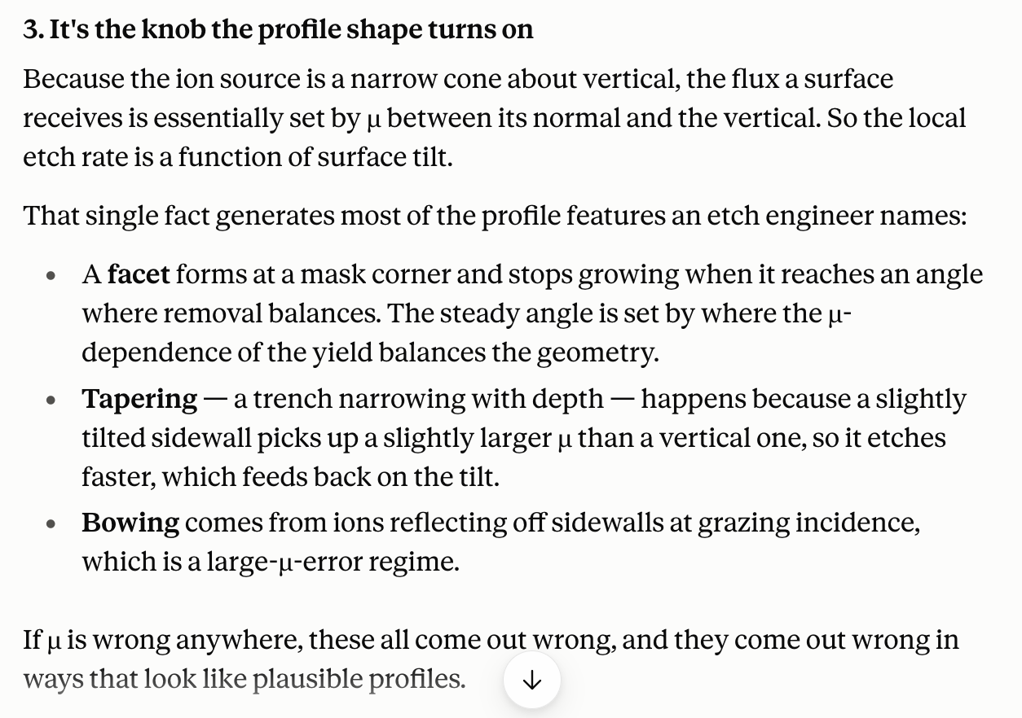
Lₛ(x ← ω)  Radiance | Arrival rate density of species s at x from direction ω, per unit solid angle per unit area perpendicular to ω. The analogue of radiance.  - Analogue → plays the same role of radiance did in computer graphics  - How much stuff is flying in a particular direction (nothing to do with where the surface is hit)  - Constant along an unobstructed ray
Γₛ(x) | Total flux of species s at x, particles per unit area per unit time.  - Sum over directions  - Each direction: (how much comes from it) * (how much that direction gets spread)
fₛ(y, ωᵢ → ωₒ)  - Incoming  - Outgoing | Surface scattering distribution: fraction of species s arriving at y from ωᵢ that departs toward ωₒ, per unit solid angle. The analogue of the BRDF.  - Bidirectional Reflectance Distribution Function (BRDF) is a mathematical formula that defines how light reflects off a surface in computer graphics  - Why does this turn into y?  - Describes what the surface x does to new surface y (not the other way around)  - X = query point  - Y = hit point  - Y = r(x,w)  - Y is the “origin” of the ray that hits X  - Order  - Particle into trench  - Bounces off floor, hitting right sidewall  - When on right sidewall (X), the Y is the floor  - Bounces off right sidewall, hitting left sidewall (end)  - When on left sidewall (X), the Y is the right sidewall
sₛ(y, ωᵢ)  - Should add up to 1 with fs | Sticking coefficient: probability that an arriving particle is absorbed rather than re-emitted.  - Using omega i because it depends on moment of arrival  - If it does not stick, then we proceed with f
r(x, ω) | Ray-cast: the first intersection of the ray {x + tω : t > 0} with S, or ∅ if the ray escapes.
V(x, ω) | Visibility: 1 if r(x,ω) = ∅ (the ray escapes to the plasma), 0 otherwise.
Lₛᵘ(ω) | Source distribution at the top boundary — the IEADF handed over by M6 through the M7 interface.
θ | The differentiable parameter vector: recipe, closure parameters, and — crucially — anything the surface depends on.

Sign convention. ω always points away from the point being discussed. So Lₛ(x ← ω) is what arrives at x travelling in direction −ω. This is the standard graphics convention and it is chosen so that μ = ω·n is positive on the visible hemisphere. Half the errors in this material are sign errors from mixing conventions; fix this one and never vary it.

Module 1 — The transport regime

1.1 The Knudsen number, computed
2 h · M3 PRD §4.1; open question Q1
The claim that the feature interior is collisionless is not an approximation of convenience; it is a statement about a dimensionless number, and you should compute it yourself.
- The smaller the feature, the higher the knudsen number → collisions become more negligible at smaller features
  - Making the knudsen number bigger doesn’t really help atp → >1 is already the satisfied requirement
The mean free path of a hard-sphere gas:
λ = kʙT / (√2 π d² p) (1.1)
with d the molecular diameter, p the pressure, T the gas temperature. For a fluorocarbon etch at p = 20 mTorr = 2.67 Pa, T = 300 K, d ≈ 4 × 10⁻¹⁰ m:
λ = (1.38×10⁻²³ × 300) / (1.414 × 3.1416 × 1.6×10⁻¹⁹ × 2.67) ≈ 2.2 × 10⁻³ m
Two millimetres. The feature is of order one micron. The Knudsen number is
Kn = λ / L ≈ 2.2×10⁻³ / 10⁻⁶ ≈ 2 × 10³ (1.2)
Kn ≫ 1 is the free-molecular limit. A particle entering the trench will, with overwhelming probability, travel in a perfectly straight line until it hits a wall. There is no gas-phase chemistry inside the feature, no collisions, no pressure gradient, no continuum.
- Meaning: inside the feature, particles fly in perfectly straight lines and only ever interact with walls. No gas chemistry, no collisions, no pressure gradients, no fluid behaviour.
This is what licenses the entire approach. The Boltzmann equation, whose collision integral makes it intractable, degenerates to free streaming plus boundary conditions — which is the rendering equation.
- Free streaming: between walls, particles go in straight lines at constant speed. Nothing happens to them. No collisions, no forces, no deflection. If you know where a particle is and where it's headed, you know its whole future until it meets a wall.
- Boundary conditions: something interesting happens @ the walls: arrival → absorb or bounce?
Exercise
- Compute Kn for the highest pressure your target process uses. At what pressure and feature size does Kn approach 10, and what would you have to do then?
  - Yeah, no pressure in a semi manufacturing environment would get us close to 10
- Estimate the probability that a particle crossing a 1 µm trench suffers a collision. Use P(collision) = 1 − exp(−L/λ) and confirm it is below 10⁻³.
  - Probability = 1/Kn
  - Saturation → crossing contains at least one collision on average

1.2 The source distribution: what M6 hands you (AKA the sheath)
1.5 h · M3 PRD §5.1
The source term Lₛᵘ(ω) is the ion energy and angular distribution function evaluated at the wafer plane. Its structure differs qualitatively between species (ions vs neutrals) and that difference drives the physics.
- Above wafer: plasma is continuum problem
- Below mask: rendering problem
Ions
Ions are accelerated across the sheath by a field normal to the wafer. Their angular spread is set by the ratio of thermal transverse velocity to the acceleration:
- There is s small sideways thermal wobble when the ions enter the sheath, which doens’t grow or shrink
  - Only downward velocity grows
  - Angular spread collapses to about 1 degree → ions arrive as needle (makes etching possible)
⟨Δθ²⟩¹ᶠ² ≈ √(Tᵢ / (2 e Vₛ)) (1.3)
with Tᵢ the ion temperature entering the sheath and Vₛ the sheath potential. For Tᵢ ~ 0.05 eV and Vₛ ~ 200 V this is of order 1°. Ions arrive nearly collimated, which is why anisotropic etching is possible at all.
- Collimated → arriving in parallel lines
- M3 currently represents a narrow cone for ions (to prepare for what M6 is going to handoff)
In energy, the RF sheath produces the characteristic bimodal distribution: the ion transit time across the sheath is comparable to the RF period, so ions sample different phases of the oscillating potential and pile up at the two turning points. The separation scales as the inverse of the ion transit time.
- Two humped distribution straddling
  - This is also why people run dual-frequency chambers
    - A high-frequency source sets how many ions there are
    - Low-frequency bias sets their energy spread
  - Peaks at low eV and high eV
Neutrals
Neutrals are not accelerated. They arrive with a cosine distribution, which is the equilibrium flux distribution from an isotropic gas:
Lₙᵉᵘᵗ(ω) ∝ μ ⇒ Γ = ∫_H L μ dω = L₀ ∫₀^(2π)∫₀^(π/2) μ² sinθ dθ dφ = (2π/3) L₀ (1.4)
- M3 currently represents neutrals via a cosine
- Fixing the seed → fixes the randomness problem with MC
  - The table might be the right way to hand things off
  - The other stuff like the narrow cone and cosine are not the right ways to represent this (simply a stand-in for M3 without having M6 as an input)
Exercise — derive the cosine law
Take an isotropic Maxwellian gas of density n and mean speed v̄. Show the flux crossing a plane in one direction is n v̄ /4, and that its angular distribution is proportional to cosθ. This is Knudsen’s cosine law and it will appear again as the re-emission distribution in §2.2.
- Radiance is constant with no cosine
- Cosine belongs to the arrivals

1.3 Sticking, re-emission, and why ARDE is transport
2.5 h · M3 PRD §5.6, §7.3; check V39
The sticking coefficient sₛ ∈ [0,1] is the probability an arriving particle is consumed. Its value controls how deep into a feature a species penetrates, and this single number produces one of the most important observable phenomena in etch.
- How do we get the sticking coefficient? Is this something that we fit, or is this something that is defined in the literature?
  - M8 calibrates the sticking coefficient
    - Underlying constraints that M5 owns and M8 fits + local state that the simulation computes
A one-dimensional model of aspect-ratio-dependent etching
Consider a trench of width w and depth h, aspect ratio A = h/w. Treat it as a tube and let a particle entering the mouth have probability s of sticking at each wall encounter. The Clausing-type transmission probability through a long tube scales asymptotically (approaching a value or line but never reaching it → asymptote) as
- Transmission → fraction of what goes in the top that comes out the bottom
  - Send a hundred molecules into the mouth of a trench. Some reach the floor. Most bounce off the walls repeatedly, and each bounce is a chance to either be absorbed or to get knocked back out the way they came. Transmission is the count that makes it, divided by the hundred you sent.
- Clausing factor → inert walls, nothing sticks; molecules bounce until they exit bottom or wander out the top
  - Inert → lack of chemical reactions; stable molecules
- Coburn-Winters → reactive walls → can lose molecules through sticking/absorption or falling out the top
- Molecule bouncing off a wall forgets which way it was going (can go back up or down) → random walk progress down the trench
  - Russian roulette
  - Next-event estimation → catches rare lucky events (since escape cone is small in a deep feature hemisphere)
  - Flux lagging → V38 calculates how much it changes the model
ℐ(A) ∼ 1 / (1 + α s A) (1.5)
for a constant α of order one. The flux reaching the bottom therefore decreases monotonically with aspect ratio, and does so faster for larger s.
- Higher sticking coefficient means that the probability of the flux reaching the bottom decreases more
- Monotonically → changing in one direction
The result worth internalising. ARDE — etch rate falling as features get deeper — emerges from geometry and sticking alone. No chemistry has been invoked. A model that gets transport right will reproduce ARDE without being told about it; a model that gets transport wrong will require a fudge factor that varies with aspect ratio, and that fudge factor will not transfer between processes. This is the clearest argument for building M3 properly rather than approximating it.
- ARDE = aspect ratio dependent etching (not defined, but should come out in the simulator anyways)
  - Deeper, narrower features etch more slowly than shallow wide ones
  - RIE lag → set of features etched together end up @ different depths
    - Hole slows down as it gets deeper (non-constant etch rate)
    - Die with mixed feature sizes etches non-uniformly by construction
- V39 → valkidation that we can get an ARDE curve without having to define the aspect ratio vs etch rate function and fit it
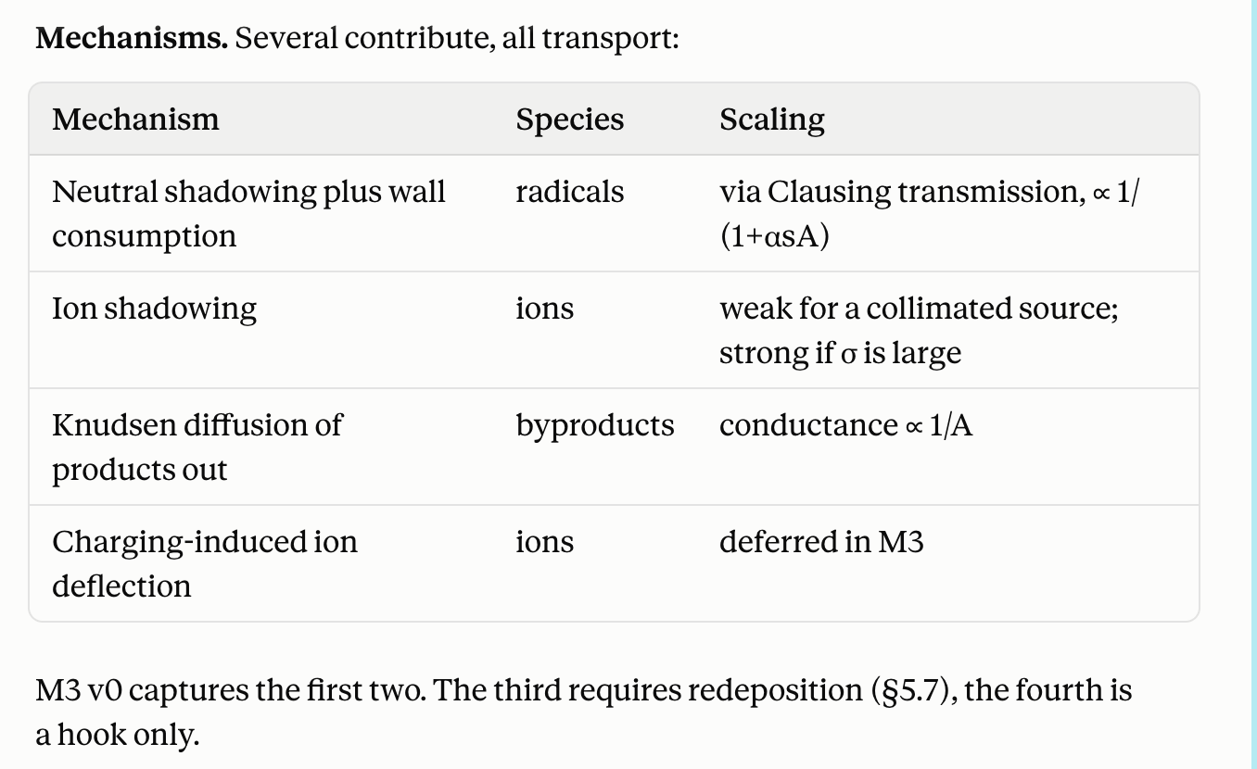
Re-emission distributions
A particle that does not stick departs with some distribution. Three cases cover most of what matters: (depends on how much energy the particle carries relative to the surface it hits)
- Diffuse (cosine) re-emission. f(y, ωᵢ → ωₒ) = (1−s)/π · μₒ. Memoryless: the outgoing direction is independent of the incoming one. Standard for thermalised neutrals.
  - Bulk of what is happening inside a feature
- Specular reflection. f ∝ δ(ωₒ − ℛ(ωᵢ)) where ℛ is mirror reflection about n. Ions at grazing incidence reflect nearly specularly, and this is the dominant mechanism behind sidewall bowing and profile twisting in high-aspect-ratio features.
  - Incoming affects outgoing direction
  - Energetic ions at grazing angles
- Sputtered products. Material removed at y leaves with a distribution peaked about the normal and lands elsewhere — redeposition. This couples the chemistry (how much is removed) to the transport (where it goes), and is the reason M3 and M5 cannot be fully decoupled.
  - Material was removed from the wall and thrown off (AKA nothing arrived/left)
  - Magnitude set by etch rate, not arriving flux
Angular dependence of sticking
sₛ is in general a function of incidence angle. For the polymer precursor in fluorocarbon chemistry this dependence is strong and it is one of the parameters M5 will calibrate. M3 must therefore accept sₛ(y, ωᵢ) as a callable supplied by M5, never hard-code a constant.
- M5 hands off angular dependence to M3
  - Needs to be supplied by M5 since depends on angle, material, coverage

Module 2 — The integral equation

2.1 Deriving the transport equation
3 h · M3 PRD §5.3
We derive the governing equation from particle balance rather than quoting it.
Step 1: flux as an integral over the hemisphere
Let Lₛ(x ← ω) be the arrival rate density at x from direction ω, per unit solid angle and per unit area measured perpendicular to ω. The area element on the surface is foreshortened by μ = ω·n, so
Γₛ(x) = ∫_(H(x)) Lₛ(x ← ω) μ dω (2.1)
- Go direction by direction → add up how much is arriving
  - Direction that hits square-on counts fully
  - Skims → counts near nothing
    - Skimming beam spreads particles over more wall (represented by area element on surface)
Step 2: where the arriving particles came from (actual physics)
Trace the ray backward from x in direction ω. Because Kn ≫ 1 the path is straight (collission-less). Exactly one of two things happens.
- Where did this particle originate from?
If the ray escapes the feature — V(x,ω) = 1 — the particles came from the plasma and Lₛ = Lₛᵘ(ω).
- V determines which case is being followed
- Case 1: escapes the feature (you follow the w of the ray and you can see the sky, without obstruction by other features) → means it came directly from the plasma
If the ray strikes another surface point y = r(x,ω), the particles are whatever y emitted toward x. Writing the emission from y as an integral of its own incoming flux against the scattering distribution:
Lₛ(x ← ω) = V(x,ω) Lₛᵘ(ω) + (1−V(x,ω)) ∫_(H(y)) fₛ(y, ωᵢ → −ω) Lₛ(y ← ωᵢ) μᵢ dωᵢ (2.2)
with y = r(x,ω) and μᵢ = ωᵢ·n(y). Equations (2.1) and (2.2) together are the rendering equation in the form Kajiya wrote it in 1986, specialised to particles.
- Hits a wall → how much was leaving that wall in direction → how much was landing in that wall in the first place?
Step 3: operator form
Define the transport operator 𝒦 acting on functions of (x, ω) by the second term of (2.2). Then
- “Unknown equals the direction part + operation applied to the unknown”
  - 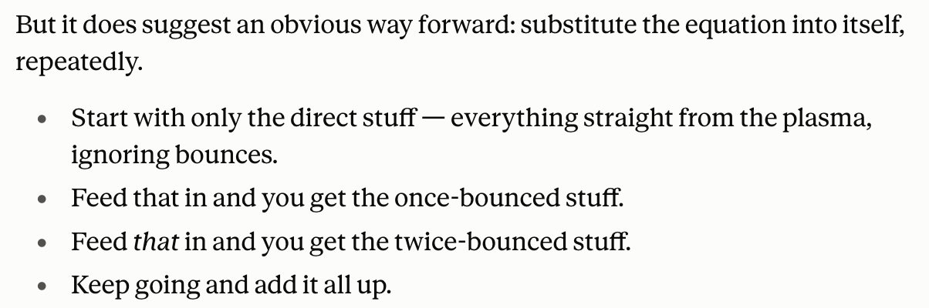
L = Lₑ + 𝒦L (2.3)
where Lₑ is the direct (unscattered) contribution. This is a Fredholm integral equation of the second kind. Formally
L = (ℐ − 𝒦)⁻¹ Lₑ = Σ_(k=0)^(∞) 𝒦ᵏ Lₑ (2.4)
The Neumann series (2.4) has a clean physical reading: the k-th term is the contribution of particles that have bounced exactly k times.
- Non-sticking species is difficult → series takes forever to die (little lost per bounce) → determines how fast the procedure converges

2.2 Convergence of the Neumann series
2 h · M3 PRD §5.3, §7.3
The series converges if and only if the spectral radius ρ(𝒦) < 1. We can bound it physically.
- 2.1 gave us an infinite sum: direct + once + twice +...
  - Does this actually add up to something finite?
  - When can you stop?
Proposition
If the sticking coefficient satisfies sₛ(y,ω) ≥ sₘᵢₙ > 0 uniformly over the surface, then ‖𝒦‖∞ ≤ 1 − sₘᵢₙ and the Neumann series converges geometrically with ratio (1 − sₘᵢₙ).
- Need to solve geometric decay for when it drops below a thousandth → determines when you can truncate)
  - s=0.5 → 10 bounces
  - s= 0.05 → 135 bounces
Proof
Energy conservation at a surface point requires that the total re-emitted flux not exceed the arriving flux minus what sticks:
∫_(H(y)) fₛ(y, ωᵢ → ωₒ) μₒ dωₒ = 1 − sₛ(y, ωᵢ) ≤ 1 − sₘᵢₙ (2.5)
Each application of 𝒦 multiplies the sup-norm by at most this factor, so ‖𝒦ᵏLₑ‖∞ ≤ (1−sₘᵢₙ)ᵏ ‖Lₑ‖∞, and the series is dominated by a geometric series. ∎
The practical consequence
To capture a fraction 1 − ε of the total flux you need
k > log ε / log(1 − sₘᵢₙ) (2.6)
bounces. For s = 0.5 and ε = 10⁻³, k ≈ 10. For s = 0.05 — a weakly sticking polymer precursor — k ≈ 135. This is not an abstraction: low-sticking species require deep path tracing, and the cost of M3 scales accordingly. The same low sticking is what makes those species penetrate deep features, so the expensive case and the physically interesting case coincide.
The degenerate case. If s ≡ 0 anywhere on a closed cavity, ρ(𝒦) = 1 and the series does not converge — particles bounce forever. Physically the cavity is not closed (the mouth is open to the plasma), so escape provides the needed loss. Any implementation must ensure the escape channel is correctly modelled, or a low-sticking run will fail to terminate.

2.3 The deterministic alternative: view factors
3 h · M3 PRD §4.3; checks V29, V30, V33
Before reaching for Monte Carlo, understand the method it replaces, because for shallow features it is better.
Assume purely diffuse re-emission. Then Lₛ(y ← ωᵢ) is independent of direction and the problem reduces to a finite-dimensional linear system. Discretise S into N patches of area Aᵢ. Define the view factor
Fᵢⱼ = (1/Aᵢ) ∫_(Aᵢ) ∫_(Aⱼ) [ μᵢ μⱼ / (π r²) ] V(xᵢ, xⱼ) dAⱼ dAᵢ (2.7)
- “If tile i throws particles off diffusely, what fraction lands on tile j?
  - Depends on distance between tiles, angles, what blocks the line (nothing to do with chemistry or flux)
  - Flux on tile i = direct from plasma + sum of all other tiles sending stuff
    - Each tile sends whatever received - what stuck onto the tile
the fraction of particles leaving patch i diffusely that arrive at patch j. The flux balance is then
Γᵢ = Γᵢ^(direct) + Σⱼ Fⱼᵢ (1 − sⱼ) Γⱼ ⇒ (ℐ − FᵀR)Γ = Γ^(direct) (2.8)
a dense N × N linear solve. Differentiating it is straightforward by implicit differentiation — no discontinuity problem arises, because the discontinuous visibility has already been integrated into the smooth-ish coefficients Fᵢⱼ.
Why M3 does not use this as the primary method

 | View factors / radiosity | Monte Carlo path tracing
Cost | O(N²) to build F, O(N³) or O(N²) iterative to solve | O(Nₛₐₘₚₗₑₛ) independent of geometry complexity
Angular dependence | Fails. Assumes diffuse re-emission. | Handles arbitrary fₛ(ωᵢ → ωₒ) at no extra cost
Specular ions | Cannot represent | Natural
Deep concavity | View factor integrals become nearly singular; accuracy degrades | Unaffected
Differentiation | Easy — implicit differentiation of a linear system | Hard — this is all of Module 5
Noise | None. Deterministic. | O(N⁻¹ᶠ²), and see Module 6

The mission plan specifies path tracing as primary and radiosity as a documented fallback for shallow features. The decisive argument is angular dependence: ion specularity and angle-dependent sticking are first-order effects in the profiles we care about, and radiosity cannot express them at any cost.
- Continue with Monte Carlo
- M5 provides local calculations (needs what arrives at what point)
  - M5 needs to make sure that the closure is smoothed or kinked, at worst
- M2 moves surface given a speed, M3 computes flux given the surface, M5 turns flux into speed

2.4 Redeposition closes a loop
1.5 h · M3 PRD §5.7
Everything above treats the scattering distribution fₛ as given. Product redeposition breaks that. Material removed at y leaves as a source term whose magnitude is set by the etch rate at y, which M5 computes from the flux at y, which is what M3 is trying to compute. The system becomes
Γ = Γ₀[S] + 𝒦Γ + 𝒫(Γ) (2.9)
with 𝒫 the product-emission operator, which is nonlinear because the etch rate is a nonlinear function of flux. This is no longer a Fredholm equation with a Neumann solution; it is a fixed point.
- What broke. Redeposition makes the machine nonlinear. The amount a wall throws off depends on how fast it's etching, and etch rate isn't proportional to flux — it saturates. Double the flux and you don't double the emission.
How to solve it, and how not to differentiate it
Picard iteration — evaluate 𝒫 at the previous iterate, solve the linear transport problem, repeat — converges quickly when redeposition is a small correction, which it usually is. Two or three passes suffice.
- What does this mean? How does this affect the product functioning?
The differentiation is the part worth getting right. Let Γ* satisfy Γ* = 𝒢(Γ*, θ). Do not unroll the iteration. Instead differentiate the fixed-point condition directly:
∂Γ*/∂θ = (ℐ − ∂𝒢/∂Γ)⁻¹ · ∂𝒢/∂θ (2.10)
valid whenever (ℐ − ∂𝒢/∂Γ) is invertible, which it is when the Picard iteration is contractive. The linear solve is applied by the same iteration, so the cost is one extra fixed-point solve rather than a tape proportional to iteration count. Christianson (1994) for the general result; Bai, Kolter & Koltun (NeurIPS 2019) for the autodiff-friendly statement.
Unrolling costs memory linearly in iterations and is numerically fragile near the contraction limit. The PRD forbids it, and the same argument appears in the M7 interface mission for the reactor-scale loading loop — the pattern generalises.
- Is the loop count part of the answer, or is it how you got there?
  - Loop is the model (implicit differentiation)
    - M2 reinitialization → running 5 iterations gets our phi field number
    - No “correct” answer we are creeping to → you want the derivative of the 5 iterations since that is the right answer here
  - Loop is a solver → helps you get to the answer (three runs gets you the spec) → this is our case
    - If we unroll this, we get the derivative of “three passes starting from zero”
Scope in v0. M3 PRD §5.7 excludes redeposition from the first implementation but requires the schema to carry a per-point product emission term from the start. Retrofitting a source term into a shipped transport interface is a rewrite, not a patch. Open question Q4 decides whether M3.8 sits on the critical path.

Module 3 — Monte Carlo estimation

3.1 The estimator and its unbiasedness
2 h · M3 PRD §5.3
We must estimate Γ(x) = ∫_H L(x ← ω) μ dω. Draw ωₖ from a density p(ω) on H with p > 0 wherever the integrand is nonzero, and form
- We can not sample every direction, so we sample a few and infer the total
Γ̂_N = (1/N) Σ_(k=1)^N [ L(x ← ωₖ) μₖ / p(ωₖ) ] (3.1)
Unbiasedness
𝔼[Γ̂_N] = ∫_H [L μ / p] p dω = ∫_H L μ dω = Γ (3.2)
Unbiased for any admissible p. The choice of p affects variance only, not correctness — which is the entire basis of importance sampling.
- Each sample gets divided by how likely you were to pick it
  - Oversampled → discounted
  - Rarely picked → weighted more
- We are only concerned with variance, rather than any systematic bias (i.e., correctness)
Variance
Var[Γ̂_N] = (1/N) ( ∫_H (Lμ)²/p dω − Γ² ) (3.3)
Standard error falls as N⁻¹ᶠ². Halving the error costs four times the work — the fact that governs every design decision in this mission.
- Doing more work → Reducing the error (but scaling doesn’t really make sense here)
  - More samples, stratification, importance sampling, common random numbers — all attack variance. None touches bias.
- Zero variance: sampler’s shape = integrand’s shape
Exercise — optimal importance sampling
Show that (3.3) is minimised by p*(ω) ∝ L(ω)μ, and that this yields zero variance. Explain why this is useless in practice and what it nevertheless tells you about how to choose p. For the direct term, p ∝ μ (cosine-weighted sampling) is the standard practical approximation; derive the inverse-CDF sampler for it.
- Zero variance is useless if every sample tells you the same number
- What I saw / how likely I was to be sent there → evens out (busy = big top and bottom; not busy = small top and bottom)
  - To send samples in proportion to how much it arrives → need to know how much that arrives (becomes a loop)
  - Cosine is a good estimate if the sky itself is close to even → gets worse as its more blocked
- 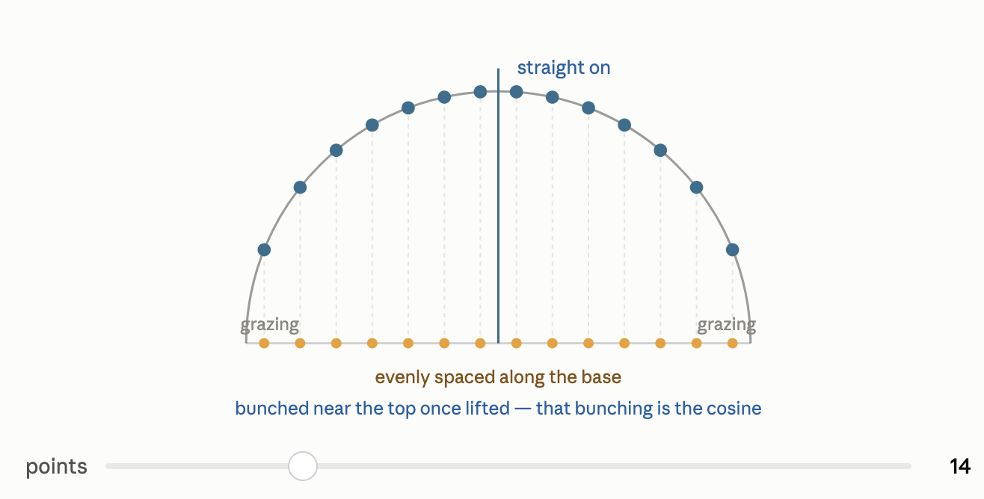

3.2 Path tracing and the recursive estimator
2 h · M3 PRD §5.3, §7.1
Substituting (2.2) Neumann Series into (3.1) recursively gives a path-space estimator: sample a direction, trace the ray, and if it hits a surface, recurse. The estimator for the full Neumann series is
Γ̂ = Σ_k Π_(j=1)^k [ f(ωⱼ₋₁ → ωⱼ) μⱼ / p(ωⱼ) ] Lᵘ(ωₖ₊₁) (3.4)
Each factor in the product is a throughput weight; the path terminates when it escapes to the plasma and collects the source term.
- Source term → source brightness (known amount)
  - Multiply how much survived from each bounce * the source brightness at the end → estimate of single particle’s flux (repeat dozen times and average)
  - Source brightness → how much si coming down from the plasma (or wherever the particle escaped from) → per-direction (not the total)
    - This is actually a boundary condition from M6 @ the wafer plane
    - Ions usually just escape up into the wafer plane (common to go straight up; uncommon for slant), but neutrals are more evenly spread (escape direction from everywhere)
Russian roulette
Truncating the sum at fixed k introduces bias. Russian roulette removes it: at each bounce, continue with probability q and divide the accumulated weight by q. The estimator remains unbiased because
- Do not cut the path deterministically by fixed k
- The trick. Instead of cutting deterministically, flip a coin at each bounce. Kill the path with some probability, or let it live. When it lives, scale up what it carries to make up for all the paths that got killed.
  - Say you kill half. The survivors then count double. Ten paths reach a bounce, five get killed contributing nothing, five survive and count double — the total is still the equivalent of ten. Nothing was lost, on average. (unbiased)
𝔼[contribution] = q · (W/q) + (1−q) · 0 = W (3.5)
Choosing q = 1 − s makes the survival probability the physical non-sticking probability, so paths terminate exactly as particles do. This is both unbiased and physically natural.
Differentiability note. Russian roulette makes the path length a random variable. Under M2 PRD §7.6 this is acceptable — the path length is not a function of θ through a discontinuous branch on a parameter value — but the RNG must be seeded deterministically by step index so that a checkpointed recompute reproduces the same paths. Failure to do this produces an adjoint that differentiates a trajectory that never occurred.
- Test that every parameter produces a nonzero gradient somewhere

3.3 Next-event estimation
2 h · M3 PRD §5.3; §11 forbids omitting it
Naive path tracing finds the source only by chance: a path contributes nothing until a random bounce happens to escape the trench. In a deep feature the escape solid angle is small, so most paths contribute zero and variance is enormous.
- Deep features barely see anything from the sky; lots of zeros that just get absorbed by the walls and very few that actually contribute (high variance)
- You’re not tracing real particles → you’re guessing histories and see if they work out
  - This guessing becomes bad when you’re in a high AR deep trench
    - Some batches might contain no contribution
Next-event estimation splits the integral at each bounce into a direct part, evaluated by explicitly sampling the visible portion of the sky, and an indirect part, continued by sampling. Formally, at each vertex evaluate
Γ_direct(y) = ∫_(H(y)) V(y,ω) Lᵘ(ω) f(ω → ωₒ) μ dω (3.6)
deterministically or with its own dedicated samples, and take the remaining term by recursion with the direct contribution excluded to avoid double counting.
For a trench of aspect ratio A the solid angle subtended by the mouth from the bottom scales as A⁻². Naive sampling therefore wastes a fraction 1 − O(A⁻²) of its samples at the bottom of a deep feature, which is precisely where accuracy matters most. NEE is not an optimisation here; it is the difference between a usable and an unusable estimator.
- Accelerates settling to the true answer faster for high AR features
Exercise
For a 20:1 trench, estimate the fraction of naive paths from the bottom that reach the plasma without a bounce. Then estimate how many samples naive path tracing needs for 1% relative error at the bottom, and compare against NEE.
- 1.4 degrees either side of vertical → weight by cosine → 2.5% of all directions
- In a round hole → becomes 0.06% (worse in 3D)
- Working it through for a 1% target: about 400,000 samples for the trench, 16 million for the hole, counting only the paths that get out unbounced.
  - 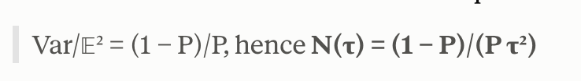

3.4 Stratification and quasi-Monte Carlo
2 h · M3 PRD §5.5
Plain Monte Carlo wastes samples through clustering. Two standard remedies apply directly.
- Stratified sampling. Partition H into M strata and take N/M samples in each. Variance becomes the average of within-stratum variances, which is never larger than the unstratified variance and is much smaller when the integrand varies smoothly across strata.
  - Still random within cells
- Low-discrepancy sequences. Sobol or Halton sequences give error O(N⁻¹ logᵈN) rather than O(N⁻¹ᶠ²) for sufficiently smooth integrands. Our integrand has a discontinuity, so the theoretical rate does not strictly apply, but in practice the improvement is substantial and it is nearly free. Use scrambled Sobol so that randomisation preserves unbiasedness.
  - Lays points down in self-avoiding pattern → every new point goes into biggest remaining gap
- Scrambling
  - Sequences are deterministic
  - Randomize in a way that preserves even spacing (gap-free but also random draw → unbiased argument)
- Loses advantage in jump or kink
Both interact with Module 6’s requirement for correlated sampling across optimiser iterations (pattern needs to be reusable and reproducible), so design them together rather than bolting one on later.
- Objective is to get rid of randomness clumps

Module 4 — Ray–surface intersection on a level set

4.1 Why not extract a mesh
1.5 h · M3 PRD §4.2; M2 PRD §4
The obvious approach is to extract a triangle mesh from φ by marching cubes each timestep, build a bounding volume hierarchy, and trace rays against triangles. This is what a graphics renderer does and what ViennaPS does through Embree.
It is a poor fit here for one reason: the BVH build and the triangle connectivity are discrete structures that change combinatorially as the geometry moves. Differentiating through them is not impossible — the vertex positions are differentiable — but the topology changes are exactly the discontinuities Module 5 is about, and mesh extraction adds a second, independent set of them on top of the physical silhouette discontinuities.

4.2 Sphere tracing
2 h · M3 PRD §5.2; checks V24, V25
Because M2 maintains φ as a signed distance function — that is what reinitialisation is for — a better method is available. Since |φ(x)| is the distance to the nearest surface, a ray at x can advance by |φ(x)| without any possibility of passing through the surface. Iterating,
t₀ = 0, tₖ₊₁ = tₖ + |φ(x₀ + tₖω)| (4.1)
converges to the first intersection. This is sphere tracing (Hart, 1996). It requires no mesh, no acceleration structure, and it is composed entirely of differentiable operations on φ.
Convergence and its failure mode
Convergence is geometric when the ray approaches the surface steeply, and becomes arbitrarily slow at grazing incidence: if the ray is nearly tangent, |φ| stays small while the remaining distance stays large, and the iteration creeps. Practical implementations cap the iteration count.
Fixed iteration count, again. M2 PRD §5.2 forbids data-dependent loop counts in the differentiated path. The same rule applies here: the sphere-tracing loop must run a fixed number of iterations from config, not "until converged". A convergence-based loop makes the computational graph depend on θ and corrupts the gradient in the manner of M2 Lesson 4.1.
- The sensible fix, which the PRD doesn't specify. Don't use marching alone. March a modest number of steps to get near, then switch to a root-finder that closes in fast regardless of angle — a few secant steps will do it. Both counts fixed, so the rule is respected, and the grazing problem largely disappears for a fraction of the cost.
- Hit point is always systematically short, but doesn’t corrupt the gradient
  - The error isn't spread evenly. Steep rays converge in a handful of steps and are essentially exact. Grazing rays barely move and stay wrong. So the error is concentrated entirely at near-tangent incidence — which is the silhouette, which is precisely where Module 5's machinery operates and where every gradient subtlety lives. The one place you'd want accuracy is the one place you don't have it.
- 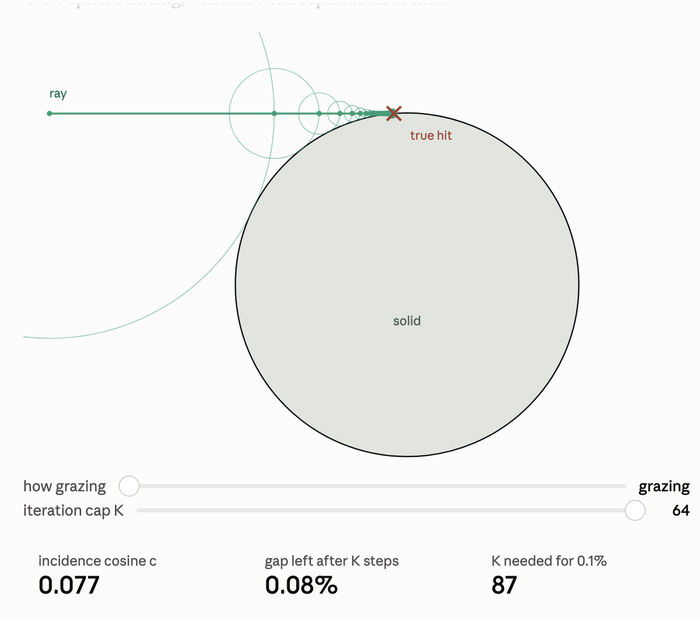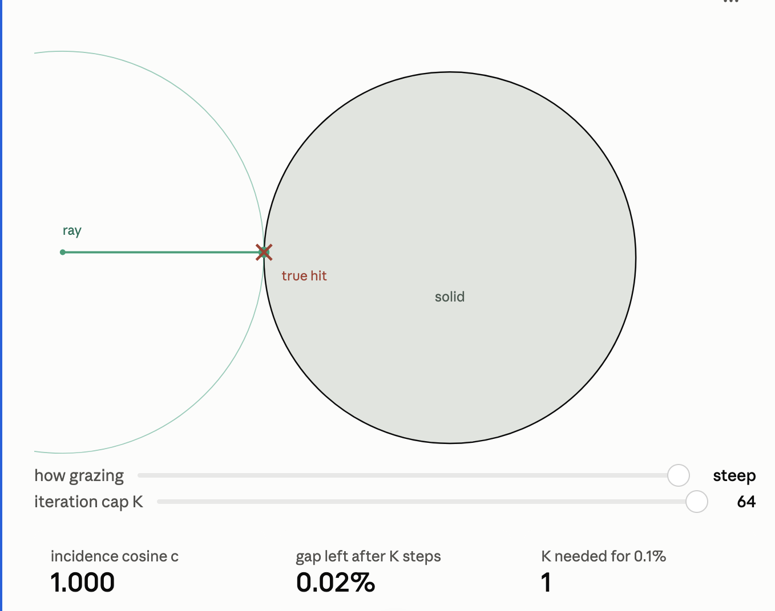

4.3 The derivative of an intersection point
2.5 h · M3 PRD §5.2, §7.2
This derivation is short, central, and explains why Module 5 exists.
Setup
The intersection parameter t satisfies the implicit condition
φ(x₀ + tω; θ) = 0 (4.2)
Derivation
Differentiate (4.2) with respect to θ, holding x₀ and ω fixed, and apply the chain rule:
∇φ · ω (∂t/∂θ) + ∂φ/∂θ = 0
⇒ ∂t/∂θ = − (∂φ/∂θ) / (∇φ · ω) (4.3)
This is the implicit function theorem applied to the ray equation, and it is the correct and exact derivative of the hit point with respect to any parameter the geometry depends on. It costs nothing beyond quantities already available.
Where it breaks, and what that means
The denominator ∇φ·ω vanishes when the ray direction is orthogonal to the surface normal — that is, when the ray is tangent to the surface. The derivative is singular there.
Tangency is exactly the silhouette. A ray grazing the mask corner is the boundary case between hitting and missing, and that is precisely where visibility jumps from 0 to 1. So the implicit-function derivative blows up at exactly the configurations where the pathwise derivative fails to capture the change. These are two views of the same phenomenon, and recognising that they are the same is the conceptual step this module exists to produce.
Exercise
Take φ a plane, φ(x) = x·n̂ − d, with parameter θ = d. Compute ∂t/∂d from (4.3) and verify it against the analytic hit point. Then take φ a sphere of radius R with θ = R, and examine the behaviour of ∂t/∂R as the ray approaches tangency.

Module 5 — Differentiating discontinuous integrals
This module is the technical core of M3 and the reason the mission is flagged as the most likely to overrun. Everything before it is standard, if unfamiliar. This is not.

5.1 The problem, in one line
1 h · M3 PRD §2
We must compute dΓ/dθ where
Γ(θ) = ∫_H g(ω, θ) V(ω, θ) dω (5.1)
and V ∈ {0,1} is visibility. As θ changes, the geometry moves, and the silhouette — the curve on the hemisphere separating "sees the sky" from "sees a wall" — sweeps across directions. V is therefore a discontinuous function of both ω and θ.

5.2 Proof that naive pathwise differentiation is biased
2 h · M3 PRD §2; check V35
Automatic differentiation applied to a Monte Carlo estimator differentiates the sampled integrand. We prove this is wrong with the simplest possible instance.
Counterexample
Let
I(θ) = ∫₀¹ ℋ(x − θ) dx = 1 − θ, θ ∈ (0,1) (5.2)
where ℋ is the Heaviside step. The exact derivative is dI/dθ = −1.
Now form the standard estimator: draw x ∼ U(0,1), take Î = ℋ(x − θ). It is unbiased, since 𝔼[Î] = 1 − θ. Differentiate the estimator pathwise:
∂Î/∂θ = −δ(x − θ) = 0 for almost every x (5.3)
Hence
𝔼[∂Î/∂θ] = 0 ≠ −1 = ∂𝔼[Î]/∂θ (5.4)
The pathwise gradient estimator is biased, and the bias is total: it reports zero sensitivity where the true sensitivity is −1. Note carefully what does not happen. Nothing is infinite, nothing raises an exception, the variance is zero. The estimator confidently returns the wrong answer. ∎
This is the failure mode M3 exists to avoid. An implementation that ray-traces with automatic differentiation and does nothing further will produce gradients that are silently wrong in exactly the geometric configurations that matter — mask edges, corners, silhouettes. It will pass a smoke test on a flat surface and fail on any real feature. The M2 curriculum’s insistence on the Taylor-remainder test is what catches it.

5.3 The correct derivative: the boundary term
3 h · M3 PRD §5.4
The general result is the Leibniz rule for an integral over a parameter-dependent domain, equivalently the Reynolds transport theorem.
Theorem
Let D(θ) ⊆ ℝⁿ be a region whose boundary ∂D(θ) moves with normal velocity vₙ = (∂x/∂θ)·n∂, and let g be continuously differentiable on D. Then
d/dθ ∫_(D(θ)) g(x,θ) dx = ∫_(D(θ)) ∂g/∂θ dx + ∮_(∂D(θ)) g vₙ dS (5.5)
Applied to (5.1)
Partition H into regions where V is constant, separated by the silhouette curve ∂. Inside each region V is constant, so the interior term involves only ∂g/∂θ. Across ∂ the integrand jumps by Δg = g⁺ − g⁻. Therefore
dΓ/dθ = ∫_H V ∂g/∂θ dω + ∮_(∂) Δg · vₙ dℓ (5.6)
The first term is what automatic differentiation computes. The second term — the boundary term — is what it misses, and in the counterexample of §5.2 the first term is zero and the second is everything.
Interpretation
vₙ is the speed at which the silhouette sweeps across the hemisphere as θ changes. Δg is how much the integrand jumps as the silhouette passes. Their product, integrated along the silhouette, is the rate at which solid angle is being converted from occluded to visible. That is physically exactly what happens when a mask edge recedes and a patch of sidewall begins to see more sky.

5.4 Method 1 — edge sampling
1.5 h · M3 PRD §4.4; Li et al. 2018
The most direct approach: estimate the two terms of (5.6) separately. The interior term by ordinary path tracing with autodiff; the boundary term by explicitly finding silhouette edges and sampling along them.
This is Li, Aanjaneya, Durand & Ragan-Kelley (SIGGRAPH Asia 2018), the paper that opened the field. It is correct and it is the easiest to understand.
Why it is not the recommendation
- Silhouette detection is a discrete geometric operation — finding edges where the surface turns away from the viewpoint. On a mesh this is a search over edges; on a level set it is a codimension-one set that must be located numerically.
- The cost is a separate sampling process with its own variance, and silhouette edges are a measure-zero set that must be found rather than stumbled upon.
- Implementation complexity is high and grows with geometric complexity.

5.5 Method 2 — reparameterisation
2 h · M3 PRD §4.4; Loubet et al. 2019
An alternative: change integration variables so that the discontinuity is stationary. Suppose we can find a θ-dependent map T(·, θ) : H → H such that the silhouette in the new coordinates does not move with θ. Substituting ω = T(ω̃, θ),
Γ(θ) = ∫_H g(T(ω̃,θ), θ) V(T(ω̃,θ), θ) |det J_T| dω̃ (5.7)
In the new variables V(T(ω̃,θ),θ) is independent of θ near the discontinuity by construction, so the integrand is differentiable and ordinary pathwise differentiation applies. The condition on T is that its velocity match the silhouette velocity on ∂ — the same condition that will appear in §5.6.
Loubet, Holzschuch & Zwicker (SIGGRAPH Asia 2019). Elegant, and it avoids explicit silhouette detection, but constructing T requires care and the original formulation carries a small bias.

5.6 Method 3 — warped-area sampling, derived
3.5 h · M3 PRD §5.4; Bangaru et al. 2020
The recommended method. It converts the boundary integral into an interior integral using the divergence theorem, so that a single ordinary area-sampling process estimates both terms, without silhouette detection and without bias.
Construction
Let 𝒱(ω) be a vector field on the hemisphere, to be chosen, subject to one requirement:
𝒱(ω) · n∂(ω) = vₙ(ω) for all ω ∈ ∂ (5.8)
that is, on the silhouette the field reproduces the silhouette’s own motion. Elsewhere 𝒱 is free, subject to being differentiable.
Derivation
Let the regions of constant V be D₁, D₂, … with g continuous on each. Apply the divergence theorem on each region:
∮_(∂Dᵢ) g (𝒱 · nᵢ) dℓ = ∫_(Dᵢ) ∇·(g 𝒱) dω (5.9)
Sum over i. On any interior boundary shared by two regions, the outward normals are opposite, so the two surface contributions combine into the jump Δg times the common normal component:
Σᵢ ∮_(∂Dᵢ) g (𝒱·nᵢ) dℓ = ∮_(∂) Δg (𝒱·n∂) dℓ = ∮_(∂) Δg vₙ dℓ (5.10)
where the last equality uses the defining property (5.8). But the left-hand side equals Σᵢ ∫_(Dᵢ) ∇·(g𝒱) dω = ∫_H ∇·(g𝒱) dω. Substituting into (5.6):
dΓ/dθ = ∫_H [ V ∂g/∂θ + ∇·(g 𝒱) ] dω (5.11)
The integrand of (5.11) contains no boundary term and no delta function. It is an ordinary integral over the hemisphere, estimable by the same sampling process already used for the forward pass, and the estimator is unbiased. ∎
Choosing 𝒱
The construction must satisfy (5.8) without knowing where ∂ is. Bangaru et al. build 𝒱 as a weighted average of the boundary velocities of nearby discontinuities, with weights that concentrate as the silhouette is approached — a convolution against a kernel that becomes a delta on ∂. The weights are computed from auxiliary rays, so the cost is a constant factor rather than a separate sampling regime.
Exercise — verify the derivation in 1D
Take the counterexample (5.2). Here H = [0,1], ∂ = {θ}, Δg = −1, vₙ = 1. Construct the simplest admissible 𝒱 (a scalar field on [0,1] equal to 1 at x = θ), evaluate (5.11), and confirm you recover dI/dθ = −1. Then implement both estimators numerically and plot bias versus sample count.

5.7 Method 4 — score-function estimators, and why not
1 h · M3 PRD §4.4, §11
There is a fourth route that requires no geometric machinery at all. If the randomness can be pushed into a density p(ω; θ) that depends on θ, then
d/dθ ∫ f(ω) p(ω;θ) dω = ∫ f(ω) [∂ log p/∂θ] p(ω;θ) dω = 𝔼[f · ∂ log p/∂θ] (5.12)
the score-function or REINFORCE estimator. It is unbiased and it does not care that f is discontinuous, because f is never differentiated.
Why it is rejected
Variance. The score-function estimator’s variance is typically orders of magnitude larger than the pathwise estimator’s, and it does not improve with the smoothness of f. Module 6 establishes that the gradient noise floor must sit below the signal from a 1 nm change in CD; score-function variance at feasible sample counts does not meet that bar. This is the same reason the mission plan rejects voxel Monte Carlo representations for the geometry.

Module 6 — Variance, noise floor and the optimiser

6.1 The gradient noise floor requirement
2 h · M3 PRD §7.4; check V37
M8 will optimise an objective built on CD, depth and sidewall angle to tolerances of order 1 nm and 1°. The gradient estimator must resolve the change in the objective caused by a parameter perturbation that produces a 1 nm CD change. Formally, we require the signal-to-noise ratio of each gradient component to exceed unity:
SNRᵢ = |∂J/∂θᵢ| / √(Var[∂Ĵ/∂θᵢ]) > 1 (6.1)
Since variance falls as 1/N, the required sample count scales as the inverse square of the signal. Halving the CD tolerance quadruples the cost. This is the single most important scaling law in M3 and it should be estimated early, not discovered at integration time.
Exercise
Set up a budget. Estimate ∂CD/∂θ for a representative parameter from a coarse run. Estimate the per-sample variance of the flux estimator at a sidewall point. Solve (6.1) for N. Report the implied wall-clock cost of one gradient evaluation, and compare against the M2 performance gate of 60 s per forward solve.

6.2 Common random numbers
2.5 h · M3 PRD §7.5; M2 PRD §7.6
A stochastic objective creates a problem beyond noise: Ĵ(θ) evaluated twice at the same θ returns different values, so the objective is not a function and finite-difference checks are meaningless.
The fix
Fix the random seed as a function of the sample index rather than drawing fresh randomness. Then for a fixed seed set ξ, the estimator Ĵ(θ; ξ) is a deterministic function of θ. Its expectation over ξ is the true objective, and — away from discontinuities — its derivative is an unbiased estimator of the true derivative:
𝔼_ξ[∇_θ Ĵ(θ;ξ)] = ∇_θ 𝔼_ξ[Ĵ(θ;ξ)] = ∇J(θ) (6.2)
the interchange being justified by dominated convergence when Ĵ is almost surely differentiable in θ — which is exactly what Module 5’s machinery buys us.
This also makes the Taylor-remainder test applicable: with the seed fixed, Ĵ is a deterministic function and the O(h²) residual behaviour must hold. Without common random numbers the Taylor test cannot be run at all, because the noise dominates the residual.
Connection to M2. M2 PRD §7.6 already requires the RNG key to be a deterministic function of step index and a run-level seed, and check V18 verifies bitwise reproduction of the forward trajectory on checkpointed recompute. That requirement was written for M3’s benefit. This is where it is cashed in.

6.3 Stochastic gradients and quasi-Newton methods
2.5 h · M3 PRD §7.4; open question Q6
A genuine architectural tension, worth surfacing before M8 rather than during it.
M8 specifies L-BFGS or a trust-region method. Both build curvature information from differences of successive gradients. L-BFGS in particular forms the pairs
sₖ = θₖ₊₁ − θₖ, yₖ = ∇Jₖ₊₁ − ∇Jₖ (6.3)
and requires the curvature condition sₖᵀyₖ > 0 to maintain a positive-definite approximate Hessian. If ∇J carries noise comparable to its change between iterates, yₖ is dominated by noise, the curvature condition fails or is satisfied spuriously, and the approximate Hessian degrades to garbage. Quasi-Newton methods are not robust to gradient noise in the way first-order stochastic methods are.
The three responses
- Common random numbers plus enough samples. Make the estimator effectively deterministic and pay for it in N. Preferred, and the reason §6.1 matters.
- Increase N as the optimiser converges. Early iterations tolerate noise; late ones do not. Adaptive sample sizing keyed to the gradient norm is standard in stochastic optimisation and is cheap to implement.
- Use a noise-tolerant optimiser. Adam or stochastic trust-region methods tolerate noise but converge more slowly and give worse final accuracy on a smooth problem. A fallback, not a plan.
Raise this with whoever owns M8 before M3 freezes its sampling interface, because the answer determines whether M3 must expose a sample-count knob and a variance estimate alongside each gradient. It should.

6.4 The performance budget, and flux lagging
3 h · M3 PRD §5.8; check V38
M3 is not called once per solve. It is called once per Runge–Kutta stage, so TVD-RK2 over 500 steps means one thousand velocity evaluations. That multiplier changes the cost analysis qualitatively and it invalidates a gate written in the M2 PRD.
The arithmetic

Quantity | Estimate for a 512×128×128 domain
Interface-adjacent cells | ~10⁵
Primary samples per point | 64
Mean path length at s ≈ 0.5 under Russian roulette | ~2 vertices
Rays per velocity evaluation | ~1.3 × 10⁷
Sphere-trace iterations per ray, each a trilinear fetch | ~64
Forward solve, 1000 evaluations | 10² – 10³ s
Adjoint at ~3× | 10³ s and up

M2’s performance gate is a 500-step 3D forward solve in under 60 s. M3 exceeds it by one to two orders of magnitude. This is a design problem, not an optimisation problem, and the PRD raises it as open question Q5 rather than assuming it away.
Flux lagging
Surface flux changes slowly relative to geometry over one timestep. Recompute it every k steps and hold it fixed between recomputes. Because the schedule is fixed and does not depend on θ, the computational graph is unchanged and the gradient remains correct — contrast with the adaptive-timestep failure of M2 Lesson 4.1, where the count itself depended on parameters.
What lagging does change is the physical model, and the size of that change must be measured rather than assumed. Check V38 requires profile error against the k = 1 reference for k ∈ {1, 2, 5, 10, 20}.
The stopping rule. Choose the largest lag whose induced CD and sidewall-angle error sits below the metrology repeatability floor measured in M4. Beyond that point the error is unmeasurable and the extra compute buys nothing. This is the correct way to set a numerical parameter: against an experimentally established noise floor, not against intuition.
Memory, and why remat is mandatory
Reverse mode through 1.3×10⁷ rays × 64 sphere-trace iterations would require a tape of order 10¹⁰ values — tens of gigabytes for a single velocity evaluation, times a thousand evaluations. Storing it is not merely expensive; it is impossible.
The resolution is to checkpoint the entire velocity evaluation and recompute the transport during the backward pass, bounding memory at roughly twice the forward cost. This works if and only if the recomputed transport is bitwise identical to the original, which is exactly what the deterministic seeding of §6.2 guarantees and what M2 check V18 verifies.
Trace the dependency: M2 PRD §7.6 required deterministic RNG keyed by step index. That requirement existed for no visible reason at the time it was written. It exists so that M3 can checkpoint. This is what a well-specified interface buys you — a constraint imposed twenty weeks early that makes an otherwise infeasible mission feasible.

Module 7 — Verification
M2 defined twenty-two checks. M3 needs its own, and the structure carries over: analytic cases first, invariants second, cross-code last, with a machine-readable ledger and a fast tier that runs on every commit.

7.1 Analytic view factors
1.5 h · M3 PRD §8.2; check V26
A small number of configurations have closed-form view factors, and they are the strongest tests available because the answer is exact.
- Two infinite parallel strips of width w separated by h: the crossed-strings formula gives F exactly.
- A disc to a coaxial parallel disc: standard closed form.
- A point above an infinite plane: F = 1 by inspection.
Test the Monte Carlo estimator against each. Relative error must fall as N⁻¹ᶠ² with the expected constant; if it plateaus, the estimator is biased.

7.2 Closure and reciprocity invariants
1.5 h · M3 PRD §8.2; checks V28–V30
Two structural identities hold regardless of geometry and are cheap to check.
Σⱼ Fᵢⱼ = 1 (closure, for an enclosure) (7.1)
Aᵢ Fᵢⱼ = Aⱼ Fⱼᵢ (reciprocity) (7.2)
The furnace test
Enclose the geometry completely, set sticking to zero and re-emission to purely diffuse, and inject a uniform source. At steady state the flux must be exactly uniform over every surface, regardless of geometric complexity. Any deviation is a transport bug. This is the single best whole-system test of a flux solver and it takes an afternoon to set up.

7.3 Gradient verification
1 h · M3 PRD §8.3; checks V31, V32, V35
The M2 suite carries over with one addition. Run the Taylor-remainder test with common random numbers fixed; the O(h²) residual must hold. Then repeat with a naive pathwise gradient (Module 5 disabled) and confirm the test fails. That is the M3 analogue of check V19, and it is the direct experimental confirmation of the bias proved in §5.2.
Also compare against a deterministic radiosity solve on a shallow geometry where radiosity is valid: two independent methods, two independent differentiation routes, one answer.

7.4 Physical validation
1 h · M3 PRD §8.4; checks V39, V40
ARDE is the first physical check that means anything. Simulate etch depth versus aspect ratio at fixed chemistry and compare the shape of the curve against published data. The model was never tuned to it, and the curve emerges from transport alone (Lesson 1.3), so agreement is real evidence rather than a fit.
Faceting angle and sidewall bowing follow, but both depend on M5’s closure as well as M3’s transport, so a disagreement does not localise. Do ARDE first.

Capstone — a differentiable 2D flux solver
Build a 2D differentiable flux solver and couple it to the M2 capstone. Budget ten hours. The result is the first object in this project that is recognisably a process simulator.

Specification
- Geometry: the φ field from the M2 capstone. Rays cast by sphere tracing with a fixed iteration count.
- Two species: an ion with a narrow angular distribution and unity sticking, and a neutral with a cosine distribution and sticking s ∈ (0,1) supplied as a differentiable parameter.
- Transport: path tracing with next-event estimation and Russian roulette with survival probability 1 − s.
- Diffuse re-emission for the neutral; specular reflection for the ion above a grazing-angle threshold, mollified.
- Gradients: warped-area sampling per §5.6. Common random numbers per §6.2.
- Interface: conform exactly to the VelocityModel signature in M2 PRD §5.5, including step_index for deterministic seeding.

Acceptance
- V26 — analytic view factor recovered, error falling as N⁻¹ᶠ² with no plateau. A plateau indicates bias.
- V28 — furnace test: uniform flux to within estimator noise, on a deliberately awkward geometry.
- V31 — Taylor remainder at second order on both a global and a single-point flux objective, common random numbers fixed.
- V35 — the same test FAILS with warp_enabled = False. Ship both plots side by side; this is PRD deliverable 3.
- V39 — coupled to the M2 capstone, the ARDE curve has the correct shape and steepens with increasing sticking coefficient.

The finale
Set a target sidewall angle. Optimise the ion angular spread and the neutral sticking coefficient to hit it, by gradient descent through the full coupled transport-plus-evolution chain.
That is recipe inversion through real transport physics. Everything after it is scale.

What the capstone tells you. The pair of Taylor plots — passing with warped-area sampling, failing without — is the single most valuable artifact this curriculum produces. It is direct experimental proof that the mission’s central technical bet is both necessary and sufficient, obtained at 1/100 scale before committing twenty-two weeks to it.

Reading list

Primary — read in this order
- Kajiya, "The Rendering Equation", SIGGRAPH ’86. Four pages. The origin of equation (2.2). → Module 2
- Li, Aanjaneya, Durand & Ragan-Kelley, "Differentiable Monte Carlo Ray Tracing through Edge Sampling", SIGGRAPH Asia 2018. The paper that opened the field; the clearest statement of the boundary-term problem. → Module 5
- Bangaru, Li & Durand, "Unbiased Warped-Area Sampling for Differentiable Rendering", SIGGRAPH Asia 2020. The recommended method. Derivation in §5.6 follows this. → Module 5
- Loubet, Holzschuch & Zwicker, "Reparameterizing Discontinuous Integrands for Differentiable Rendering", SIGGRAPH Asia 2019. The alternative route. → Module 5

Supporting
- Hart, "Sphere Tracing", The Visual Computer 12 (1996). → Module 4
- Veach, Robust Monte Carlo Methods for Light Transport Simulation (PhD thesis, Stanford 1997). The definitive treatment of variance reduction, NEE and multiple importance sampling. Chapters 2–3 and 9. → Module 3
- Pharr, Jakob & Humphreys, Physically Based Rendering (4th ed.), free online. Reference, not reading. Chapters on sampling and light transport. → Module 3
- Modest, Radiative Heat Transfer. View factors, closure and reciprocity, the furnace test. → Modules 2 and 7
- Nocedal & Wright, Numerical Optimization, ch. 6–7 on quasi-Newton methods and the curvature condition. → Module 6

Process-specific
- Kushner group publications on the Monte Carlo Feature Profile Model. The closest prior art in the semiconductor literature. Not differentiable, which is exactly why it is a useful independent reference.
- ViennaRay documentation. An Embree-based flux solver for exactly this problem. GPL-3.0 — read for understanding only, never copy; observe the clean-room rule.

You are ready for M3 when you can
- Derive equation (2.2) from particle balance on a whiteboard, stating where Kn ≫ 1 is used.
- Prove the Neumann series converges at rate (1 − s) and compute the required bounce count for a given sticking coefficient.
- State and prove the bias of the naive pathwise gradient estimator using the counterexample of §5.2.
- Derive equation (5.11) from the Leibniz rule and the divergence theorem, and state the condition on the warp field.
- Derive ∂t/∂θ for a ray–level-set intersection and explain why it is singular exactly where visibility is discontinuous.
- Explain why ARDE is a transport phenomenon and what that implies about a model that needs an aspect-ratio fudge factor.
- Explain why common random numbers are a prerequisite for the Taylor-remainder test, not an optimisation.
- Derive the implicit-differentiation formula for the redeposition fixed point and say why unrolling is forbidden.
- Reconstruct the §5.8 cost arithmetic and explain why checkpointing the velocity evaluation is mandatory rather than optional.
- Argue for or against warped-area sampling over edge sampling, on grounds other than "the newer paper is better".

Glossary
BRDF / scattering distribution — Bidirectional reflectance distribution function. Here fₛ(y, ωᵢ → ωₒ): the fraction of arriving species s redirected toward ωₒ per unit solid angle.
Clausing factor — Transmission probability of a molecule through a tube in free-molecular flow. The analytic backbone of the ARDE argument in Lesson 1.3.
Common random numbers — Fixing the random seed as a function of sample index so a stochastic estimator becomes a deterministic function of the parameters. Prerequisite for both quasi-Newton optimisation and the Taylor test.
Divergence theorem — ∫_D ∇·F dV = ∮_(∂D) F·n dS. The mechanism that converts the boundary term into an interior integral in §5.6.
Free-molecular flow — Kn ≫ 1. Particles travel ballistically between surface encounters; no gas-phase collisions.
IEADF — Ion energy and angular distribution function. The source term Lₛᵘ(ω), supplied by M6 across the M7 interface.
Knudsen number — Kn = λ/L, mean free path over characteristic length. Kn ≈ 2×10³ at feature scale (Lesson 1.1).
Leibniz / Reynolds transport rule — Differentiation of an integral over a moving domain. Produces the boundary term of equation (5.6).
Neumann series — (ℐ−𝒦)⁻¹ = Σ𝒦ᵏ. Here the k-th term is the contribution of k-times-scattered particles.
Next-event estimation — At each scattering vertex, explicitly sample the source rather than waiting for a random bounce to reach it. Variance reduction, essential in deep features.
Pathwise gradient — Differentiating the sampled integrand. Standard automatic differentiation. Biased when the integrand is discontinuous in the parameter (§5.2).
Russian roulette — Unbiased stochastic path termination: continue with probability q, divide weight by q.
Score-function estimator — REINFORCE. 𝔼[f · ∂log p/∂θ]. Unbiased and discontinuity-tolerant; variance too large for this application (§5.7).
Silhouette — The set of directions at which a ray is tangent to the surface — the boundary between hitting and missing, and the locus of the visibility discontinuity.
Sphere tracing — Ray marching on a signed distance function by stepping |φ| each iteration. Requires φ to be a true SDF, which is what reinitialisation maintains.
Sticking coefficient — sₛ(y,ω): probability an arriving particle is absorbed rather than re-emitted. Controls penetration depth and therefore ARDE.
View factor — Fᵢⱼ: fraction of diffusely emitted flux from patch i that reaches patch j. Basis of the deterministic radiosity alternative.
Warp field — 𝒱(ω) in §5.6. A vector field matching the silhouette velocity on the discontinuity, used to convert the boundary integral into an interior one.

Confidence note. Modules 1–4 and 7 are standard material, stated rigorously but not novel. Module 5 is the transfer of recent graphics results to a domain where they have not been applied, and §5.6 in particular is a derivation reconstructed from the cited paper rather than reproduced from a textbook. Check it independently before building on it. Module 6’s interaction between Monte Carlo gradients and quasi-Newton optimisation is, in my assessment, the most likely source of an unpleasant surprise at M8 integration.

