FRACTAL SEMICONDUCTOR
Mission Plan
Eleven missions across two possible products. Seven are shared; the choice is what you build first, not what you build.

Version 0.3 — two-path structure Date September 2026 Horizon Path A first sellable capability ~w46; full milestone ~w70

Contents

Figure 1 — Two paths, one core
The two products are not alternatives so much as different first steps onto the same platform. Read the capability band at the top first: use case 2 is three capabilities, not one, and only the third needs anything Path A does not already build.
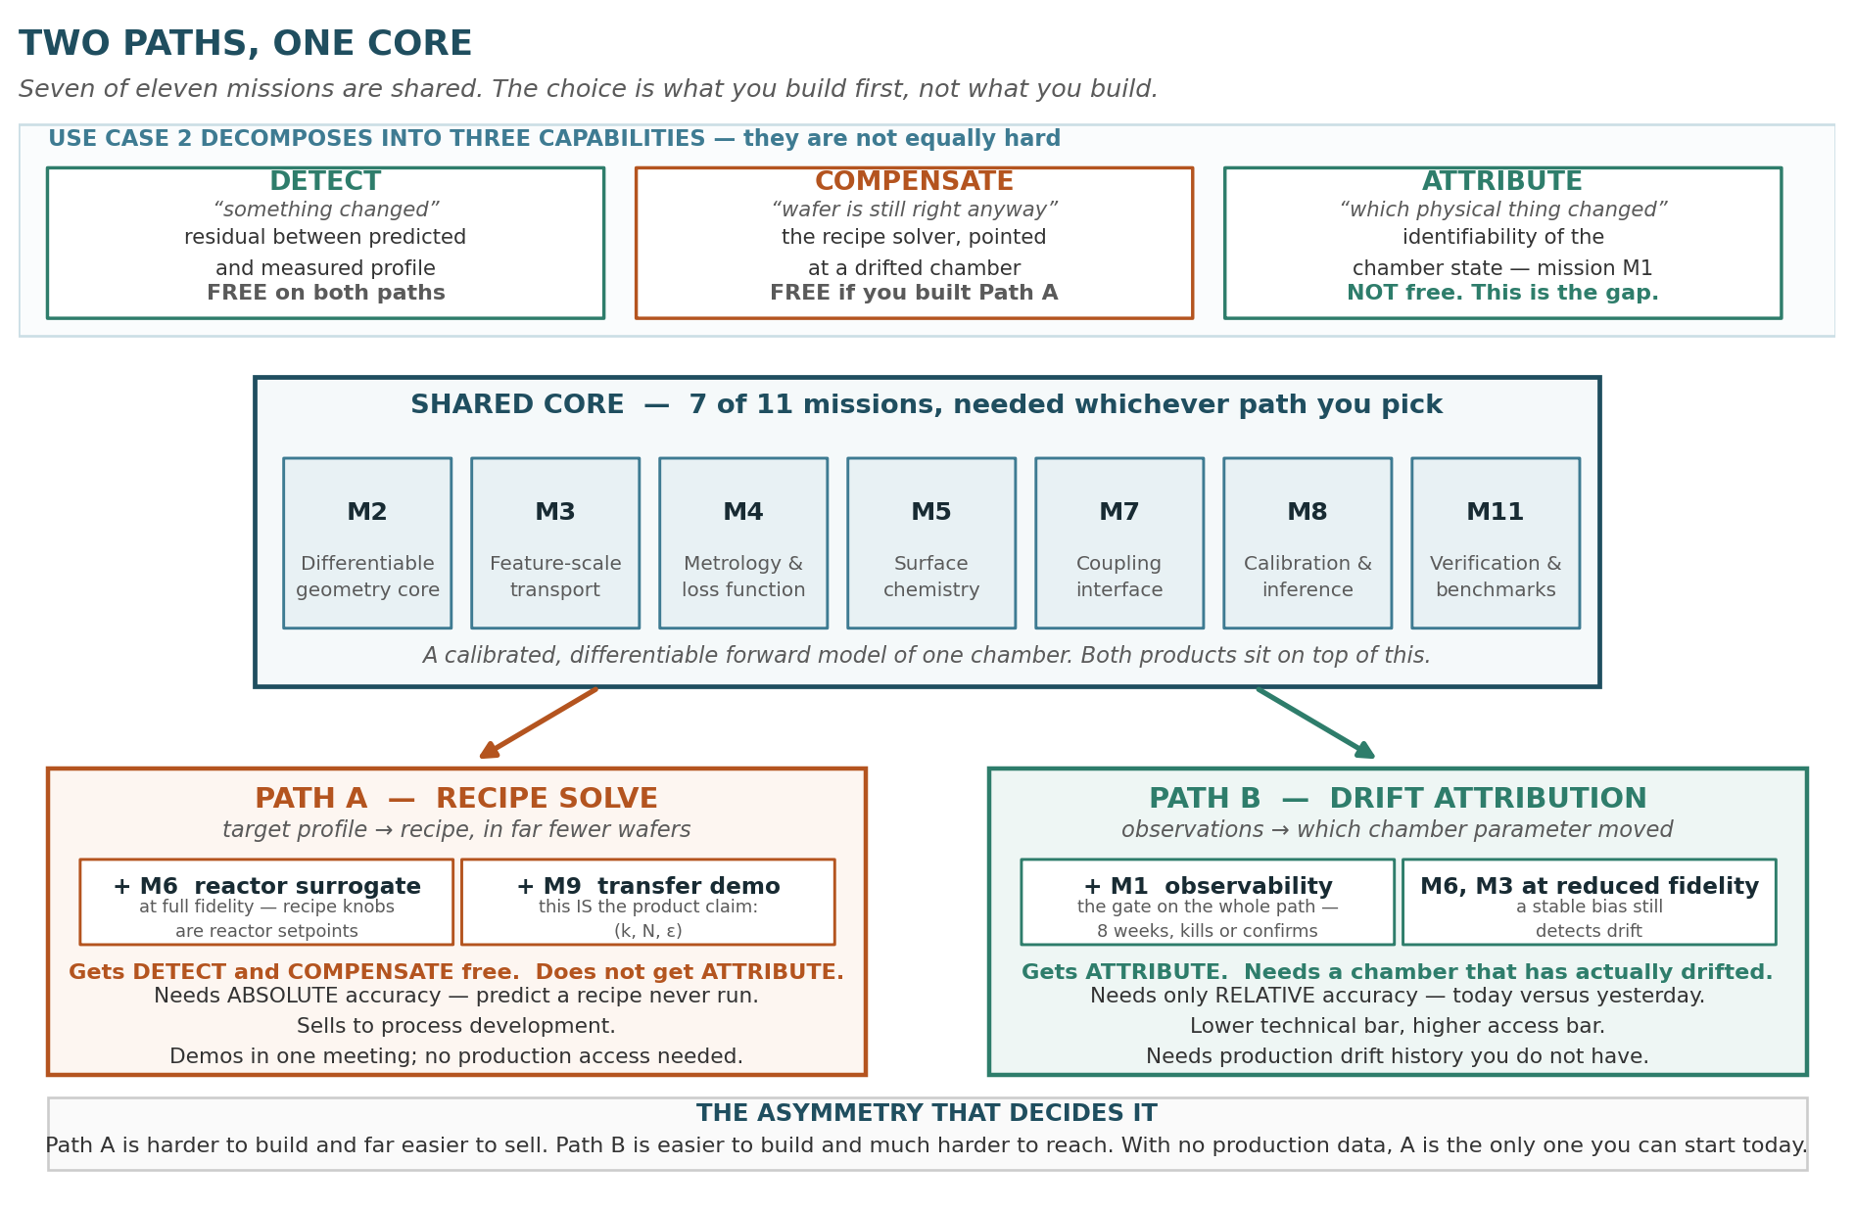

Figure 2 — What the choice actually changes
Same eleven missions, two orderings. The difference is smaller than it feels: M1 moves from week 0 to week 40, M9 changes meaning, and everything else shifts by two weeks. Picking a path buys roughly a quarter, not half the plan.
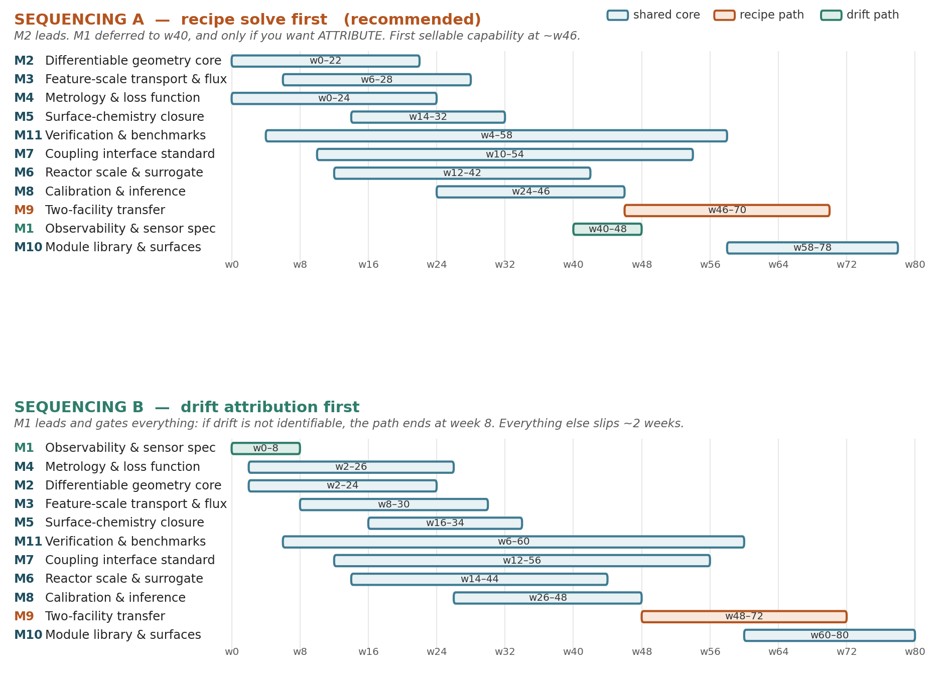

Figure 3 — How the missions compose
One forward chain, one backward pass. A recipe becomes flux at the wafer (M6), crosses the interface (M7), becomes flux at each point inside the trench (M3), becomes a local etch speed (M5), moves the shape (M2), and becomes a number (M4). The adjoint returns the derivative of that number with respect to everything above — and which derivative you read off is which product you have.
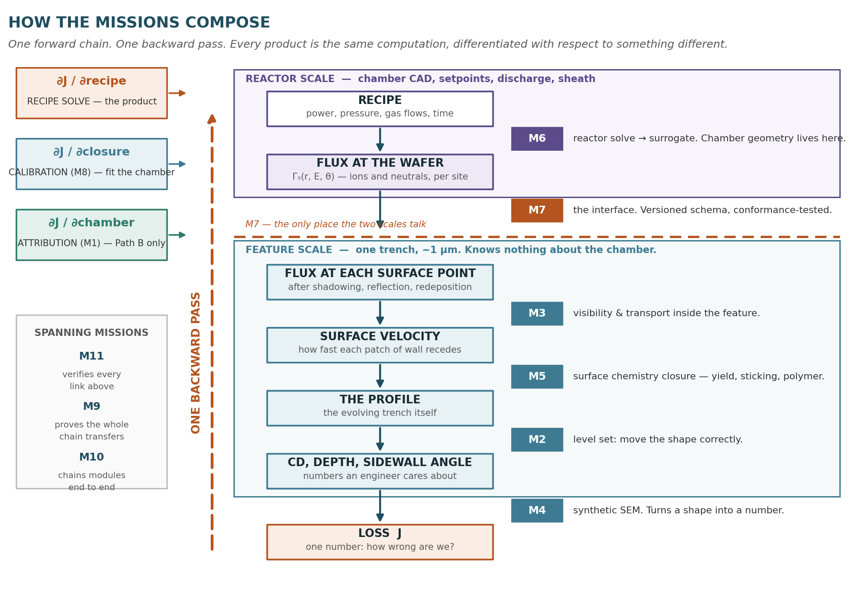

Figure 4 — The finished product
The end state both paths converge on. The coupling interface and the adjoint path are what make this a product rather than a collection of solvers.
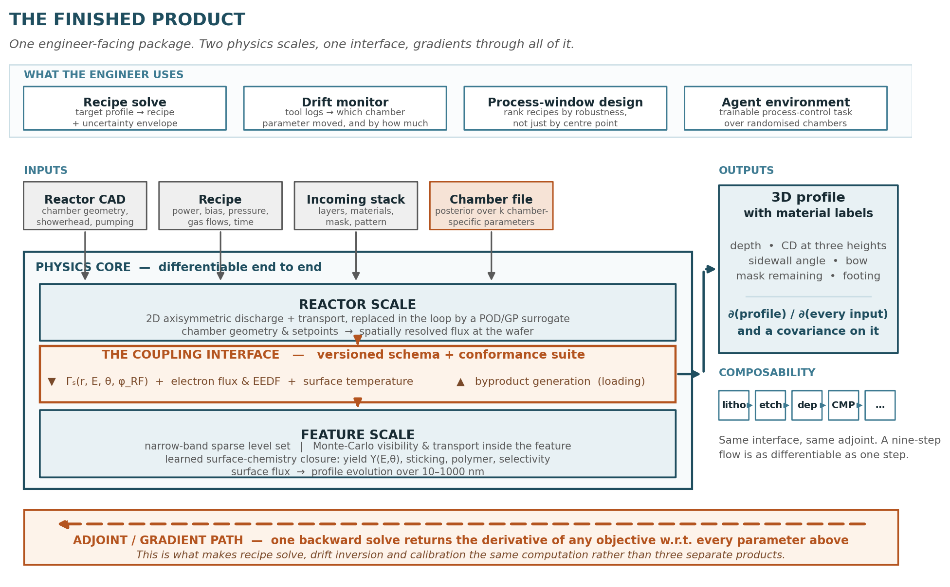

1. Two products, one core
The original brief named two use cases. They share a forward model but they are different inverse problems, and treating them as one thing is what made this plan feel larger than it is.

 | Path A — recipe solve | Path B — drift attribution
The inversion | Chamber state fixed. Invert target profile → recipe. Solving for the input. | Recipe fixed. Invert observations → chamber state. Solving for the model.
Non-uniqueness | Tolerable. If three recipes hit the target, take the most manufacturable one. | Fatal. If two chamber states explain the data, you compensate the wrong knob.
Accuracy needed | Absolute. Predict a recipe never run on this chamber, to a few nanometres. | Relative. Is today different from yesterday? A stable bias still detects drift.
Buyer | Process integration. Discretionary budget, fast feedback. | Yield / manufacturing engineering. Production access, long trust cycle.
Can you start now? | Yes. Academic cleanroom data is sufficient to begin. | Not really. Needs production drift history you do not have.

The recommendation. Build Path A first. The technical work is close to a wash — seven of eleven missions are shared — so the tie is broken commercially: Path A demos in a single meeting, sells to someone with budget, and needs no production access. Path B remains a later expansion into the same accounts, not a separate company. Confidence: moderate. What would change it is a design partner saying drift is their acute pain and process development is not — an empirical question you can answer with conversations rather than code.

1.1 Use case 2 is three capabilities, not one
This is the distinction that makes the choice tractable. "Drift handling" bundles three things of very different difficulty, and Path A delivers two of them without extra work.

Capability | What it needs | Cost on Path A
Detect | A calibrated forward model. Predicted profile stops matching measured profile; the residual is the alarm. | Free. Falls out of the shared core.
Compensate | The recipe solver, pointed at a drifted chamber. You do not need to know why it drifted — only what recipe now hits the target. | Free. Same code, different problem.
Attribute | Identifiability of the chamber state — whether distinct physical causes produce distinguishable observations. Mission M1. | Not free. This is the whole gap.

So Path A already gets most of the operational value of use case 2. Attribution is what you need when compensation runs out of process window, or when you want drift as a leading indicator for scheduling maintenance rather than something to paper over. That is real, and it is the second thing a fab wants, not the first.

1.2 The MVP framing that lowers the bar
Do not sell prediction. Sell experiment selection. The product is not "we predict your wafer perfectly" — it is "we cut your DOE from thirty wafers to five by choosing each next experiment optimally." Run a wafer, measure it, update the model, re-solve, propose the next wafer. The simulator is an informed prior, not an oracle.
That needs accurate gradients — which direction to move — rather than accurate absolutes, and a physics model with imperfect constants can still have qualitatively right derivatives because the physics constrains the shape even where it gets the magnitude wrong. Concretely it drops M9’s target from "2 nm absolute prediction on a held-out recipe" to "the proposed next experiment beats what an expert engineer would have picked." Far more defensible, far easier to demo, and it is how the thing would be deployed anyway.

1.3 Three claims underwrite both paths

# | Claim | Failure mode if false | Broken by | Matters to
C1 | Chamber drift can be attributed to a specific physical cause from instrumentation a fab will actually run. | Attribution collapses to detection. Path B becomes a much smaller product. | M1 | Path B only
C2 | Gradients survive the full forward chain — geometry evolution, visibility, reinitialisation, fixed-point coupling. | Inverse solves converge to plausible-looking wrong answers. Silent, and very expensive to find late. | M2, M3, M7 | Both
C3 | Surface chemistry splits into a chemistry-universal part and a low-dimensional chamber-specific part. | Every chamber needs full recalibration. There is no product, only a consulting practice. | M5, M8, M9 | Both; sharper on A

The one number that matters. C3 reduces to k, the dimension of the chamber-specific parameter vector. Everything commercial follows from it: how many wafers a new customer burns, whether the module library is worth building, what the product can be priced at. M5 proposes k, M8 estimates it, M9 tries to falsify it. This is true on either path.

2. The mission map
Windows below are the Path A ordering (Figure 2, top panel). The Path B ordering shifts most missions two weeks later and moves M1 to week 0.

ID | Mission | Window | Path A | Path B | Done when
M2 | Differentiable geometry core | w0–22 | Critical | Critical | Taylor-remainder test passes
M3 | Feature-scale transport & flux | w6–28 | Critical | Needed, reduced | Unbiased visibility gradients
M4 | Metrology & loss function | w0–24 | Critical | Critical | Repeatability measured; loss recovers known geometry
M5 | Surface-chemistry closure | w14–32 | Critical | Critical | Universal / chamber-specific split declared
M6 | Reactor scale & surrogate | w12–42 | Critical | Needed, reduced | Surrogate within solver noise; <100 ms
M7 | Coupling interface standard | w10–54 | Critical | Critical | Two modules pass one conformance suite
M8 | Calibration & inference stack | w24–46 | Critical | Critical | Held-out prediction inside ε
M9 | Two-facility transfer | w46–70 | Critical — is the claim | Lower priority | (k, N, ε) met in both directions
M11 | Verification & benchmarks | w4–58 | Critical | Critical | Four verification tiers green
M1 | Observability & sensor spec | w40–48 | Deferrable | Critical, first | ≥4 drift modes separable
M10 | Module library & product surfaces | w58–78 | Later | Later | Two-step flow with gradients through the handoff

2.1 What the choice actually changes
Less than it feels. Seven missions are identical on both paths. The divergence is four items:
- M1 moves. Week 0 on Path B, where it gates everything and can end the path in eight weeks. Week 40 on Path A, where it is optional and only buys ATTRIBUTE.
- M9 changes meaning. On Path A the (k, N, ε) triple is the product claim itself. On Path B it matters less, because you calibrate per chamber anyway and relative accuracy is what you are selling.
- M6 and M3 change fidelity, not existence. Path A needs the reactor surrogate at full fidelity because recipe knobs are reactor setpoints. Path B can run cruder, because a stable systematic bias still detects drift perfectly.
- Nothing else moves. Picking a path buys roughly a quarter of the plan, not half. I said otherwise earlier and that was over-promised.

2.2 Concurrency logic
The Path A critical path is M2 → M3 → M8 → M9. Everything else has slack. Protect those four and staff them first; if a resourcing decision is ambiguous, resolve it toward them. On Path B the critical path begins M1 → M8 instead, and M1’s week-8 gate is a genuine kill criterion for the whole product.
- M4 is the most commonly deferred mission and the most commonly regretted. You cannot set ε before measuring metrology repeatability, and you cannot calibrate against images you have not learned to model. It starts at week 0 on Path A.
- M11 is a track of its own because verification is not a phase. It runs continuously from week 4 and gates the solver. A solver never checked against an independent implementation is not a product an engineer will trust, and discovering that at week 58 is not recoverable.
- M7 spans half the plan at low intensity. Mostly design, but it must reach v1 before M8 hardens anything — retrofitting the byproduct return channel or a phase axis into a shipped interface is a rewrite rather than a patch.

2.3 If you only have three people
The plan above assumes roughly four to five technical staff. Under a three-person constraint, drop or defer in this order, and say so out loud rather than quietly stretching every window:
- Defer M6 to a fixed measured IEADF from a single operating point. The feature-scale physics can be calibrated against a constant surface flux; this costs you cross-recipe extrapolation but not the transfer demonstration.
- Defer M10 entirely. Composability is the long-term product, not the proof.
- Reduce M3 to the radiosity fallback for shallow features and pick a first target structure under 10:1 aspect ratio.
- Do not cut M1 or M4. They are the cheapest missions and they set the targets everything else is measured against.

3. The missions

M1 — Observability and sensor specification
WINDOW  w0–08 · 1 person · no GPU | DEPENDS ON  nothing | NEEDED BY  PATH B ONLY — attribution | PATH A STATUS  has slack

Objective
Determine whether chamber drift can be attributed to a specific physical cause using instrumentation a fab will actually run. Differentiability does not buy identifiability; if the state is unobservable, no solver quality repairs it.
Path dependence. This mission exists for ATTRIBUTE and nothing else. On Path B it runs first and its week-8 gate can end the product. On Path A it is deferred to week 40 and is optional — DETECT and COMPENSATE do not need it. If you are on Path A and short of people, this is the first mission to cut.
Work
- Build a deliberately cheap forward model, under one second per profile on a laptop: 0D global plasma balance (Lieberman & Lichtenberg formulation), analytic collisional sheath, 2D level set with a three-species surface model. Accuracy is irrelevant; only the structure of the sensitivities matters.
- Define the chamber-state vector c, roughly ten dimensions: wall recombination coefficient, liner temperature, seasoning-layer thickness, delivered-versus-set RF power, ground-path impedance, throttle conductance, showerhead erosion, chuck helium pressure and wafer temperature offset, focus-ring erosion, per-line MFC offset.
- Define the observable vector y: OES lines and actinometric ratios (Ar 750.4 nm actinometer, F 703.7 nm, CF₂ near 262 nm), V–I probe harmonic amplitude and phase, match capacitor positions, DC self-bias, endpoint-trace shape, blanket monitor rate, and CD / depth / sidewall angle at 9 or 49 sites.
- Compute J = ∂y/∂c by finite differences — c is ~10-D, so FD is adequate and keeps this mission independent of M2. Take the SVD at several operating points.
- Report the null-space directions in named physical terms, not as abstract vectors. "A 4% wall-recombination rise is indistinguishable from a 2 °C liner-temperature drop under this sensor set" is the deliverable; a condition number is not.
- Greedy or convex-relaxation sensor selection, then Fisher information and Cramér–Rao bounds under realistic noise, converting the result into "we detect a 3% shift in X within N wafers at 95% confidence."
Done when
- The Observability Report exists, with a ranked sensor list and detection thresholds stated in wafers.
- At least four candidate drift modes are separable (singular-value ratio under ~100) using instrumentation that ships on a commercial etcher or can be bolted on for under $50k.
Kill / pivot
If separation requires metrology no fab will run in production, narrow use case 2 to drift detection plus compensation under an assumed drift model, and reprice the product accordingly. Better to know in week 8 than month 20.
Imported from
Numerical weather prediction. This is an Observing System Simulation Experiment; the variational machinery is 4D-Var (Le Dimet & Talagrand, Tellus 38A, 1986). Reservoir history matching (Oliver & Chen, Computational Geosciences 15, 2011) is the closer analogue for the sparse-data regime.

M2 — Differentiable geometry core
WINDOW  w2–24 · 1–2 people · 1 GPU | DEPENDS ON  nothing | NEEDED BY  Both paths | PATH A STATUS  CRITICAL PATH

Objective
Three-dimensional interface evolution with a gradient that is verified, not assumed.
Work
- Narrow-band sparse level set. Topology change is automatic (Osher & Sethian 1988; Adalsteinsson & Sethian, J. Comp. Phys. 118, 1995 — the canonical etch/dep/litho paper). Cost scales with surface area: ~10⁷ active cells for 1 µm³ at 1 nm, which is one GPU.
- TVD-RK3 time integration with a Godunov or WENO5 Hamiltonian for the normal-speed term.
- Prototype in JAX on 2D and small 3D domains where the autodiff is trustworthy; port hot kernels to NVIDIA Warp once sparsity dominates. Sparse narrow-band structures fight JAX’s static shape requirements. Expect the port; do not start there.
- Leave the charging hook in: a Poisson solve on the feature domain with surface charge accumulation, dormant until aspect ratio exceeds roughly 20:1 or pulsing enters scope.
The specific hard part: reinitialisation
Standard practice re-imposes the signed-distance property every few steps. That is an implicit, iterative, non-smooth projection. Differentiating through it naively is expensive and noisy; stop-gradienting it is biased. In order of preference: (1) use a formulation that does not need it — a distance-preserving velocity extension or a regularised level set; (2) treat it as an exact projection and derive its adjoint, which is tractable because it solves an Eikonal equation and the adjoint of fast marching is a graph adjoint; (3) reinitialise rarely, checkpoint, and differentiate honestly at 2–3× cost.
Honesty flag. This is an engineering problem, not a physical or computational limit — but it is the single most likely site of silent gradient corruption in the whole system.
Done when
- Taylor-remainder test passes: |J(θ+hδ) − J(θ) − h∇J·δ| falls as O(h²) over at least twenty random directions. A directional finite-difference check alone is not sufficient — it passes on first-order-correct, second-order-wrong gradients.
- A 3D 500 nm trench evolves in under 60 s on one GPU, with the adjoint under 3× the forward pass.
- Gradient tests run in CI on every commit. Non-negotiable: a gradient regression discovered three months later during calibration costs more than the entire test harness.
Imported from
Shape optimisation — Allaire, Jouve & Toader, J. Comp. Phys. 194, 2004, for the level-set adjoint; the dolfin-adjoint community for the Taylor-test discipline.

M3 — Feature-scale transport and flux
WINDOW  w8–30 · 1–2 people · 1 GPU | DEPENDS ON  M2 | NEEDED BY  M8 | PATH A STATUS  CRITICAL PATH

Objective
Unbiased, differentiable flux at every point on the evolving surface, including shadowing, specular and diffuse re-emission, and redeposition inside the feature.
Work
Recognise what this actually is. Flux at a surface point is an integral over the visible hemisphere of the incoming IEADF plus multiple-bounce contributions. That is the rendering equation, and the visibility term is discontinuous. Naive pathwise gradients through visibility are biased — the classic failure that makes inverse rendering silently wrong.
- Adopt Monte Carlo path tracing with next-event estimation, using warped-area sampling for the discontinuity (Bangaru, Li & Durand, SIGGRAPH Asia 2020) or the reparameterisation of Loubet, Holzschuch & Zwicker (SIGGRAPH Asia 2019). The earlier edge-sampling method (Li, Aanjaneya, Durand & Ragan-Kelley, SIGGRAPH Asia 2018) is correct but slower.
- Variance reduction matters more than raw speed: the calibration optimiser in M8 will not converge if the gradient noise floor exceeds the signal from a 1 nm CD difference. Budget for correlated sampling across optimiser iterations.
- Cheaper fallback for shallow features: view-factor / radiosity on the extracted interface mesh. Smooth and easy to differentiate, but scales badly and handles deep concavity poorly beyond two bounces.
- Validate the continuum surface model against offline kinetic Monte Carlo. kMC is not differentiable and is not the core, but it is the right ground truth for roughness statistics and ARDE.
Done when
- Gradient unbiasedness verified on a test geometry with an analytically known view factor.
- A published ARDE curve reproduced; mask-corner faceting and bowing reproduced qualitatively; the analytic limit (unity-yield, perfectly collimated ion etch reproduces the aperture) recovered exactly.
- Gradient noise floor below the level that stalls a trust-region optimiser on a synthetic 1 nm CD target.
Imported from
Differentiable rendering and inverse graphics. This is the largest single import in the plan and, to my knowledge, has no precedent in the semiconductor process-simulation literature — reporting the rendering papers, inferring the transfer.

M4 — Metrology and loss function
WINDOW  w2–26 · 1 person + SEM access | DEPENDS ON  nothing | NEEDED BY  Both paths | PATH A STATUS  has slack

Objective
Turn SEM images into a differentiable objective without a lossy contour-extraction step, and establish the noise floor that defines what ε can honestly be.
Work
- Run the repeat-measurement study first. Measure the same feature many times, across operators and sessions. If SEM repeatability is 2 nm, then ε = 2 nm is not a target, it is noise — and the entire Phase 4 claim needs restating. This is two weeks of work that protects the headline number.
- Build a synthetic-SEM forward model: render the simulated 3D profile with a simple secondary-electron yield model and compare in image space. Analysis by synthesis, rather than fitting to extracted contours.
- Make nuisance parameters explicit and optimise or marginalise them out: per-image tilt, magnification, edge blur, charging offset. Omit them and you will fit chemistry to a stage tilt — a failure that looks exactly like a successful calibration.
- Keep a chamfer or signed-distance-field loss on extracted contours as the documented fallback.
Done when
- Metrology repeatability is measured and reported, and ε has been revised to match it.
- The synthetic-SEM loss recovers a known geometry from real images of a characterised structure to within the measured repeatability.
Imported from
Inverse graphics and analysis-by-synthesis; the same forward-modelling-of-the-instrument discipline used in astronomical photometry, where fitting to catalogues rather than to pixels is a known source of bias.

M5 — Surface-chemistry closure
WINDOW  w16–34 · 1 person | DEPENDS ON  M2, M3 (to test) | NEEDED BY  Both paths | PATH A STATUS  has slack

Objective
Define the closure structure and, critically, propose the split between chemistry-universal and chamber-specific parameters. This mission produces claim C3 in testable form.
Work
- Parameterise physically, not as a free MLP. Ion-assisted yield Y(E) = A(√E − √E_th), the Steinbrüchel (1989) form. Angular dependence f(θ) as a monotone-constrained spline — constrained, because an unconstrained fit will produce a non-physical yield curve that reproduces one dataset and nothing else.
- Per-species neutral sticking with angular dependence for the polymer precursor; polymer deposition as a function of local precursor and ion flux; selectivity to mask and stop layer.
- Target 15–40 parameters. Assign each one to "universal" or "chamber-specific" and write down the physical reason. Chamber-specific should be ≤10.
- Set literature priors on every universal parameter. The priors are what make eight wafers sufficient rather than eighty.
Done when
- A parameter table exists with prior, designation and physical justification for every entry — and the designation was written down before any real data was fitted.
Framing note
This is the "learned closure" position, not the "surrogate" position. Geometry evolution stays first-principles because it is a cheap, well-conditioned, solved PDE and learning it discards a strong inductive bias for nothing. The precedent is Kochkov et al., "Machine learning–accelerated computational fluid dynamics," PNAS 118(21), 2021: a learned closure inside a differentiable solver generalises off-distribution in a way a pure emulator does not.

M6 — Reactor scale and surrogate
WINDOW  w14–44 · 1 person + cloud burst | DEPENDS ON  M1 (informs) | NEEDED BY  Both — reduced for Path B | PATH A STATUS  has slack

Objective
Produce spatially resolved flux at the wafer plane, fast enough to sit inside an optimisation loop — without writing a discharge solver.
Work
Do not build this from scratch. A 2D axisymmetric fluid/hybrid solver in the HPEM lineage (Kushner, J. Phys. D 42, 194013, 2009) is a mature, well-trodden class. Buy, license or collaborate. Writing one costs a year and adds nothing a customer will pay for.
- Sample the setpoint space offline — this is the cloud burst, a few thousand GPU-hours over two weeks, one-time per chamber geometry.
- Reduce the IEADF fields by POD to 20–50 modes. The output is genuinely low-dimensional, which is exactly what makes this block a good surrogate target and the feature scale a bad one.
- Fit the modes with a Gaussian process — the uncertainty estimate enables active learning of where to sample next, which is worth more than raw accuracy when samples are expensive.
- Neural operators (FNO, Li et al. ICLR 2021; DeepONet, Lu et al. Nature Machine Intelligence 3, 2021) become the right tool only when chamber geometry varies continuously. That is the long-term "feed in the reactor CAD" capability, not an M6 requirement.
Done when
- Surrogate error on held-out setpoints is within the reactor solver’s own numerical noise; single evaluation under 100 ms; GP uncertainty is calibrated (nominal 90% intervals contain 90% of held-out truth).
Kill / pivot
If build-versus-buy stalls, fall back to a reduced global-plus-transport model. The surrogate interface is unchanged; only fidelity drops, and the transfer demonstration is still runnable.
Compute. Full 3D PIC of a reactor genuinely needs a cluster. Nothing in this plan requires it. What you need is burst capacity for one-time dataset generation — cloud, not standing iron.

M7 — Coupling interface standard
WINDOW  w12–56 · low intensity, spans | DEPENDS ON  M2, M3, M6 (informs) | NEEDED BY  Both paths | PATH A STATUS  has slack

Objective
Specify, version and test the object through which the two length scales communicate. This, not any individual solver, is what makes a composable module library possible.

Field | Content and rationale
Γₛ(r, E, θ, φ_RF) | Per-species flux, spatially resolved across the wafer, energy- and angle-resolved, and phase-binned in the RF cycle. Phase binning is dormant for CW operation but mandatory the moment pulsing enters scope, and retrofitting a time axis is a rewrite.
Electron flux and EEDF | Required for differential charging in high-aspect-ratio features. Carrying only the ion IEADF is the most common under-specification of this interface.
Surface temperature field | Drives sticking and polymer dynamics; varies across the wafer with chuck zoning.
Byproduct return channel | Etch-product generation rate flowing back up to the reactor model. Stub it to zero in v0 if you must, but it must exist in the schema from the start.

Work
- Write the schema, version it, and build a conformance test suite that any producing or consuming module must pass.
- Two-way coupling: start one-way, then add loading as a Picard fixed-point outer loop, two or three passes.
- Take gradients through the fixed point by implicit differentiation, not by unrolling — unrolling costs memory linearly in iterations and is numerically fragile. See Christianson (1994) on differentiating fixed-point iterations and Bai, Kolter & Koltun (NeurIPS 2019) for the autodiff-friendly statement.
Done when
- Two independently written modules pass the same conformance suite.
- The loading loop converges and its gradients pass the same Taylor test as M2.
Why this is not one-way. The original framing had the scales coupling only through surface flux. Four channels break that: loading (byproduct flux changes the discharge), differential charging, pulsed operation (cycle-averaged IEADF is the wrong object), and internal redeposition. Whether they bite depends on chemistry and aspect ratio — but the schema must be able to express them from v0.

M8 — Calibration and inference stack
WINDOW  w26–48 · 2 people + cleanroom A | DEPENDS ON  M3, M4, M5, M6, M7 | NEEDED BY  M9 | PATH A STATUS  CRITICAL PATH

Objective
Fit one real chamber and produce a posterior rather than a point estimate. Use case 2 needs uncertainty: an unidentified parameter reporting a confident wrong value will drive a compensation move on the wrong knob.
Work
- Design the reticle first. This is the highest-leverage decision in the whole plan. A single test pattern spanning a wide range of CDs, pitches and local pattern densities yields ARDE, macroloading and microloading from one wafer. A well-designed pattern is worth ten wafers with a single CD, and wafer count is the binding constraint.
- Space-filling design (Latin hypercube or Sobol) over 4–6 recipe knobs — source power, bias power, pressure, gas ratio, time — across 20–40 conditions, split into a fit set and a strictly held-out set nobody looks at until the gate is evaluated.
- L-BFGS or trust-region on the adjoint gradient, multi-start from the M5 priors.
- Laplace posterior from the Gauss–Newton Hessian, which the adjoint gives you nearly free.
- Re-run the M1 identifiability machinery on the fitted posterior. If a chamber-specific parameter comes out multimodal, add an observable — M1 tells you which — before adding wafers.
Done when
- Held-out recipes predicted to ≤2 nm CD at three heights, ≤1° sidewall angle, ≤3% depth, ≤5% mask remaining — with ε revised to whatever M4 showed is achievable.
- Every designated chamber-specific parameter has a finite-width, unimodal posterior. Identified, not merely fitted.

M9 — Two-facility transfer
WINDOW  w48–72 · whole team · cleanrooms A and B | DEPENDS ON  M8 | NEEDED BY  PATH A ONLY — the product claim | PATH A STATUS  CRITICAL PATH

Objective
The milestone. As originally written — "demonstrate that a calibrated model transfers" — it was unfalsifiable. Here it is a triple.
Path dependence. On Path A this is the product claim: a customer buys the promise that a model calibrated once transfers to their chamber for N wafers. On Path B it matters less, because you calibrate per chamber anyway and what you sell is relative accuracy over time rather than absolute accuracy across chambers. Under the experiment-selection framing of §1.2, ε can also be restated as "beats an expert’s next-wafer choice" rather than an absolute nanometre target.
Protocol
- Freeze. Physics modules and closure functional forms are locked from M5 and M8. No re-tuning of functional forms at facility B; that would make the demonstration meaningless.
- Refit. Run N wafers at facility B and refit only the k chamber-specific parameters, using the facility-A posterior as the prior.
- Predict. M ≥ 8 held-out recipes, predicted and timestamped before measurement.
- Reverse. Repeat B → A. Asymmetry between directions is diagnostic — it usually means one chamber operates in a regime the closure does not span.

Quantity | Target | Why it is the number that matters
k | ≤ 10 | Chamber-specific parameters refit per chamber. Sets onboarding cost directly.
N | ≤ 8 wafers | Calibration dataset per chamber. The number a customer cares about most.
ε | 2 nm CD, 1° SWA, 3% depth | Prediction error on held-out recipes. Roughly the threshold at which a process engineer trusts a simulation over their own intuition.

These three numbers are simultaneously the product specification, the marketing claim, and the answer to "what does a partner need to know." Treat them as the company’s primary KPI.
Fallback
If a single refit point estimate does not transfer, randomise over the M8 posterior and demonstrate that facility-B truth lies inside the predicted envelope with correct coverage — domain randomisation from robotics sim2real (Tobin et al., IROS 2017). That is a weaker but still commercially useful claim: it supports process-window design and robustness ranking even where it does not support single-shot recipe prediction.

M10 — Module library and product surfaces
WINDOW  w60–80 · ramping team | DEPENDS ON  M7, M9 | NEEDED BY  Both — later | PATH A STATUS  has slack

Work
- Second module: deposition. ALD or CVD conformality reuses the same level set, the same visibility machinery and the same adjoint — only the closure changes. Cheapest possible second module, therefore the right one to prove composability with.
- Flow composition. Output profile of module i is the incoming stack for module i+1; gradients chain automatically. The hard part is not the chain rule, it is the state handoff schema: material identifiers, implant and damage state, residual stress, surface termination. Specify it with the same rigour as M7.
- Product surfaces. Python API; recipe-solve service; drift-attribution monitor consuming tool logs and inline metrology; gym-style environment exposing the simulator as a trainable process-control task.
Done when
- A two-step flow (etch then deposition, or deposition then etch) is solved end-to-end with gradients validated through the handoff.

M11 — Verification and benchmark suite
WINDOW  w6–60 · continuous, ~0.3 FTE | DEPENDS ON  M2, M3 (subjects) | NEEDED BY  Both paths | PATH A STATUS  has slack

Objective
Establish that the solver computes what it claims to compute, independently of whether it matches a wafer. This mission was missing from v0.1 of the plan and that was an error: v0.1 had validation (M8, M9) but almost no verification, and the two are different questions.
Verification asks are we solving the equations right — checked against analytic solutions, method of manufactured solutions, convergence order, and independent implementations. Validation asks are we solving the right equations — checked against wafers. A solver can pass validation on a calibrated chamber while carrying a discretisation bug, because the calibration absorbs it. That model will then fail the moment it is asked to extrapolate, which is precisely what M9 asks of it.
Four tiers, running continuously

Tier | Against what | Tests | Catches
1  from w6 | Mathematics | Method of manufactured solutions on the level-set advection; observed order of convergence; Zalesak disk rotation; analytic view factors; Taylor-remainder test (shared with M2) | Discretisation bugs, wrong boundary conditions, order loss. Cheap, fast, runs in CI on every commit.
2  from w20 | ViennaPS / ViennaLS / ViennaRay | Same geometry, same flux, same surface model — compare profiles. Open source, level-set based, published, from TU Wien. | Implementation errors in the level set and the ray transport. The single highest-value external check available, and it is free.
3  from w32 | A commercial TCAD topography tool | Sentaurus Topography, SEMulator3D or Victory Process on a standard structure, via an academic licence at Georgia Tech or Stanford | Modelling-assumption errors, and it produces the comparison a customer will actually ask for.
4  from w26 | Published experimental data | ARDE curves, bowing, faceting, microloading from the literature — recipes we did not run and cannot tune to | Physics errors. The only tier that is real evidence rather than self-consistency.

Why tier ordering matters. Code-to-code agreement is weak evidence — two codes can share an assumption and both be wrong. Tiers 1–3 exist to catch our bugs. Tier 4 and M9 are what earn an engineer’s trust. Do not let a clean ViennaPS comparison stand in for either.
Done when
- Tier 1 runs in CI on every commit and has never been red for more than one working day.
- Tier 2 agrees with ViennaPS on three standard structures to within a stated tolerance, with every disagreement either explained or logged as an open discrepancy.
- Tier 3 comparison exists on at least one structure, with differences attributed to named modelling assumptions rather than left unexplained.
- Tier 4 reproduces at least two published trends the model was never tuned against.
- A public verification record: every tier, every result, every open discrepancy, dated. This document is what a sceptical customer asks for and what most simulation vendors cannot produce.
On PETSc — recommendation: no, not now
PETSc is a library for large sparse linear and nonlinear systems. Nothing on the critical path needs it. Narrow-band level-set evolution is explicit and local; the visibility integral is Monte Carlo; the calibration solve is a dense problem in 15–40 parameters where L-BFGS is correct. Adding PETSc would import a heavy dependency that fights the GPU-plus-autodiff substrate chosen in M2, since gradients through PETSc solves require a separate adjoint path.
The honest exception: if the feature-scale charging model (deferred in M2, mandatory above roughly 20:1 aspect ratio) needs a large implicit Poisson solve, a sparse solver becomes relevant. Even then, a conjugate-gradient solve written directly in the autodiff substrate is likely to be simpler and differentiable by construction. Revisit only when charging is actually built, and treat the decision as reversible.
On ViennaPS — recommendation: yes, and early
ViennaPS is the closest open-source analogue to what M2 and M3 are building: level-set surface evolution with ray-traced flux for etch and deposition. It is not differentiable, which is exactly why it is a good benchmark — it is an independent implementation of the same forward physics, not a variant of ours. Stand it up at week 20, before M3 is finished, so disagreements surface while the code is still soft.

4. Resourcing

4.1 Roles against missions

Role | Owns | Note
Numerical PDE / adjoint specialist | M2, M3, M7 | The hardest hire, and on Path A the one that gates week 0. If the seat is empty, start with M4 and M11, which need no solver code.
Plasma & surface-chemistry physicist | M5, M6, M1 if run | On Path A this role starts on the closure and the reactor surrogate. On Path B it starts on M1 and owns which drift modes are physically plausible.
ML / inference engineer | M4, M6 surrogate, M8 | Owns the CI gradient-test harness. That harness is infrastructure, not overhead.
Verification (shared, ~0.3 FTE) | M11 | Not a hire. Rotate it, but name an owner each quarter — unowned verification silently stops happening.
Process engineer with fab experience | M8 reticle & DOE, M9 protocol | At least fractional. Without this role the experimental design will be subtly wrong in ways a purely computational team will not catch.

4.2 Compute

Missions | Need | Shape
M1 | Laptop | None. Deliberately.
M2, M3 | 1–2 GPUs, continuous | One workstation or a small rented node. Iteration latency matters more than throughput.
M6 | A few thousand GPU-hours over ~2 weeks | Cloud spot burst for surrogate dataset generation. One-time per chamber geometry.
M8, M9 | 4–8 GPUs, continuous | Multi-start calibration and posterior sampling parallelise trivially.
No standing HPC cluster is required by anything in this plan. Budget for burst, not for iron.

4.3 Facility access and what to ask Sandia / CINT for
M1’s Observability Report is what converts a vague co-development conversation into a scoped ask. Once it exists, request:
- Chamber hours on a tool of the same type as facility A’s, with sensor ports available for a V–I probe and an OES collimator.
- Permission to run a 20–40 condition DOE including deliberately off-nominal conditions — the corners are where closures fail and are therefore the most informative wafers you will run.
- Cross-section SEM capacity with a defined turnaround. This is usually the real bottleneck, not chamber time.
- The identical reticle used at facility A. A different test pattern turns a transfer experiment into a confound.
- Historical tool logs and any documented drift or chamber-mismatch events. Free, and the only realistic source of genuine drift examples for validating M1. Ask early — release takes months.
- Co-authorship on the observability report and the transfer result. Cheap for them, and it makes the validation externally credible in a way an internal claim never will be.

5. Risk register

Risk | Severity | Owned by | Mitigation / kill criterion
Wrong path chosen for the market | High — costs a quarter, not the company | Founders | Answerable with design-partner conversations, not code. Ask two or three fabs which of DETECT/COMPENSATE/ATTRIBUTE they would pay for, before week 8.
Incumbent adds gradients to an existing calibrated solver | Moderate, Path A | Founders | Defensibility is calibration-to-a-specific-chamber, not differentiability. Make k, N and ε the public claim, not the adjoint.
Drift modes not identifiable from fab-realistic sensors | Existential to Path B only | M1 | Tested in 8 weeks on Path B. If it fails, Path B narrows to detect-plus-compensate — which Path A already delivers — and the case for Path A strengthens.
Silent gradient corruption | High, and insidious | M2, M3 | Taylor-remainder tests in CI from week 4. Never accept "the optimiser converges" as evidence of gradient correctness.
Chamber-specific set is not low-dimensional (C3 false) | Existential to the business model | M5, M8, M9 | If k > 25 or N > 20 wafers, the product is a services business. Repitch and reprice; do not stretch the definition of success.
Metrology noise floor exceeds ε | Moderate but corrosive | M4 | Measure repeatability in week 4, before ε is committed to anywhere external.
Academic cleanroom tools unlike production tools | Moderate | M9 | Real, and worth stating plainly to partners. Argues for prioritising the Sandia/CINT relationship and choosing a chemistry and structure that exist in both worlds.
Reactor build-vs-buy stalls | Moderate | M6 | Reduced global-plus-transport fallback. Interface unchanged; fidelity drops.
Charging matters earlier than assumed | Moderate | M2, M7 | Keep the Poisson hook in the architecture. Do not choose a first target structure above ~20:1 aspect ratio.
Solver carries a discretisation bug that calibration absorbs | High — surfaces only under extrapolation | M11 | Four-tier verification running continuously from week 6. A model that validates on a calibrated chamber and fails on transfer is the signature; M11 exists to catch it before M9 does.
Visibility gradient noise stalls calibration | Moderate | M3 | Correlated sampling and variance reduction; radiosity fallback for shallow features. Engineering, not a wall.

6. Glossary
Adjoint method — Computing the gradient of a scalar objective with respect to many parameters by solving one backward equation, at a cost independent of the number of parameters.
ARDE — Aspect-ratio-dependent etching — etch rate falling as features become deeper and narrower.
CD / SWA — Critical dimension (feature width, usually measured at several heights) and sidewall angle.
Closure — A sub-model standing in for physics the governing equations do not resolve, e.g. a surface reaction probability. A learned closure is fitted from data while the surrounding solver stays first-principles.
DeepONet / FNO — Neural-operator architectures that learn mappings between function spaces rather than between vectors — the right tool when geometry or boundary conditions vary continuously.
EEDF / IEADF — Electron energy distribution function; ion energy and angular distribution function — the joint distribution of ion energy and incidence angle at the wafer surface.
HPEM — Hybrid Plasma Equipment Model — the reactor-scale fluid/kinetic hybrid solver lineage from the Kushner group; the de facto reference for this class of simulation.
Identifiability / observability — Whether distinct parameter or state values produce distinguishable observations. If not, the inverse problem has no unique solution regardless of solver quality.
Implicit differentiation — Getting the gradient of a fixed-point or optimisation solution by differentiating its optimality condition, rather than by unrolling the iterations that found it.
Laplace approximation — A Gaussian posterior built from the curvature at the maximum-likelihood point — the cheapest usable uncertainty estimate when the adjoint already provides Hessian-vector products.
Level set — Representing a moving interface as the zero contour of a scalar field, so topology changes happen automatically without explicit surgery.
Loading / microloading — Etch rate depending on total exposed area on the wafer, or on local pattern density, through byproduct and reactant depletion.
Narrow band — Updating only grid points within a few cells of the interface, reducing cost from volume-scaling to surface-scaling.
OES — Optical emission spectroscopy — reading plasma composition from emitted light; the standard non-invasive chamber sensor.
OSSE — Observing System Simulation Experiment — using a simulator to evaluate what a proposed sensor set would let you infer, before buying the sensors.
POD — Proper orthogonal decomposition — PCA applied to simulation fields, compressing a high-dimensional output into a handful of modes.
Taylor-remainder test — The standard verification that an adjoint gradient is correct: the second-order residual must decay as O(h²) under refinement of the step size.
V–I probe — Voltage–current sensor on the RF line; harmonic content is a sensitive and cheap indicator of chamber state.
Warped-area sampling — A technique from differentiable rendering that gives unbiased gradients through visibility discontinuities without explicitly sampling silhouette edges.
4D-Var — Four-dimensional variational data assimilation — adjoint-based fitting of a model’s state to observations spread over a time window. The weather-forecasting ancestor of the drift-inversion problem.

Confidence notes. The path recommendation is held at moderate confidence and rests on commercial reasoning rather than technical — the missions are close to a wash. M2 and M4 are engineering with known methods and I am confident in them as written. M3 is the least conventional mission and the one most likely to overrun, because the differentiable-rendering machinery has not been applied to this problem before. M8’s window assumes cleanroom access is not the bottleneck, which it usually is. M9’s ε is a genuine guess, should be revised the moment M4 reports metrology repeatability, and under the experiment-selection framing may not need to be a nanometre number at all.

