After running the application, it is a spring boot project with java included.

Go to <http://localhost:8083/swagger-ui/>

Input your json

[

{

"name": "Limes"

},

{

"name": "Limes"

}

,

{

"name": "Apples"

}

,

{

"name": "Limes"

}

]

to get the result.

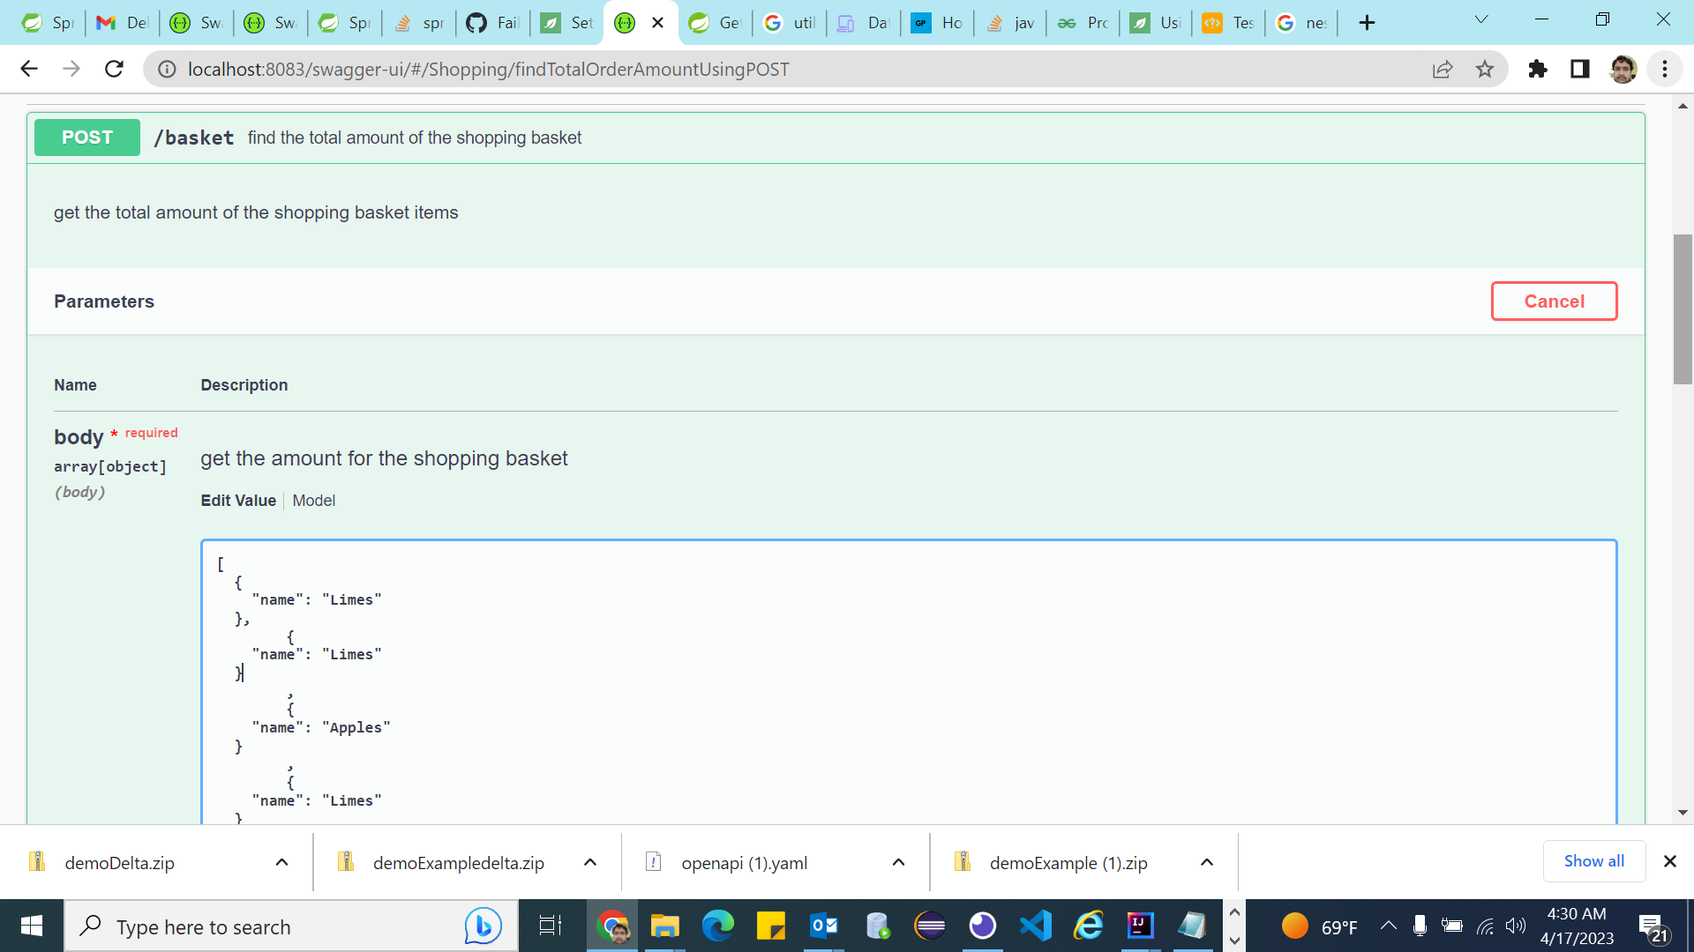

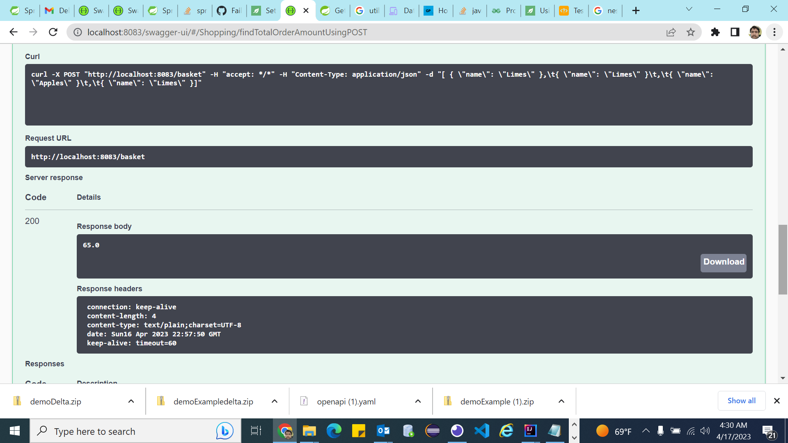

Delivery:

* Open Api definition yaml.
* Source Code