**Manual**:

**Code**:

please run the project as **spring boot application** with the program argument as

**--outreach.notregister=C:/Group_login/715013_hackfac_backend/715013_spring_batch/XL/OutReach_unregistered.xlsx**

**--outreach.register=C:/Group_login/715013_hackfac_backend/715013_spring_batch/XL/OutReach_unregistered.xlsx**

**--outreach.eventsummery=C:/Group_login/715013_hackfac_backend/715013_spring_batch/XL/OutReach_event_summery.xlsx**

**--outreach.eventinfo=C:/Group_login/715013_hackfac_backend/715013_spring_batch/XL/OutReach_event_information.xlsx**

**--outreach.eventpmo=C:/Group_login/715013_hackfac_backend/715013_spring_batch/XL/OutReach_Pmo_details.xlsx**

For different user the configuration would be different.

**Spring profile has been implemented:**

**DOCKER:**

For code deployed to **Docker** please use **dvl** profile presuming that the docker mysql url is

**jdbc:mysql://172.18.2.50:3306/hackfac?useSSL=false**

to run please use VM argument as **dvl**

**-Dspring.profiles.active=dev**

**LOCAL:**

you dont need to configure anything.

**This Satisfy the need of custom configurable XL file location.**

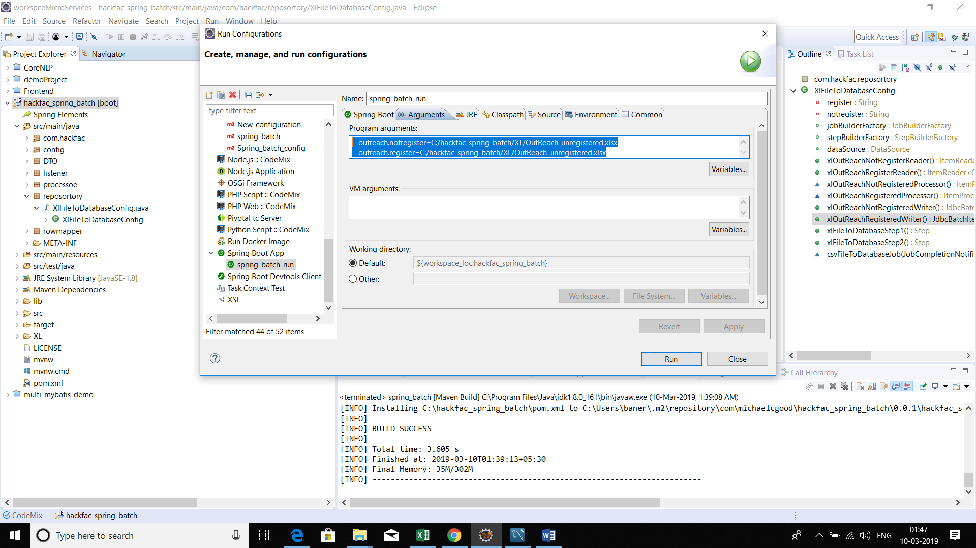

After running the application, you will automatically see the data has been updated to the database

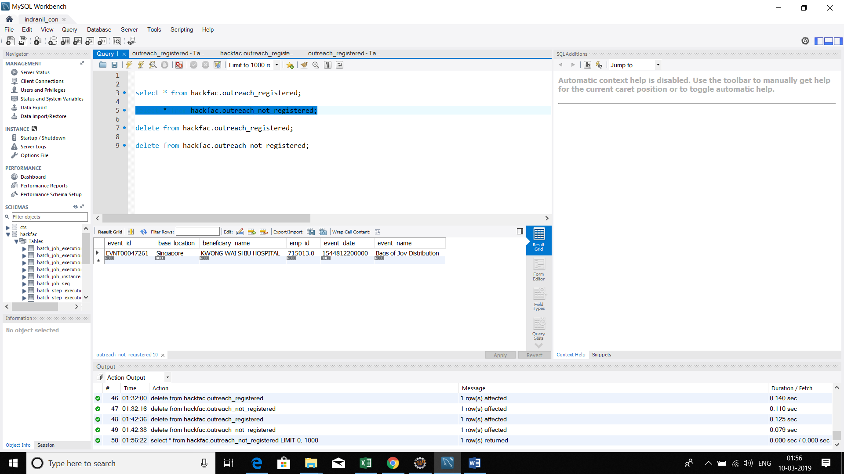

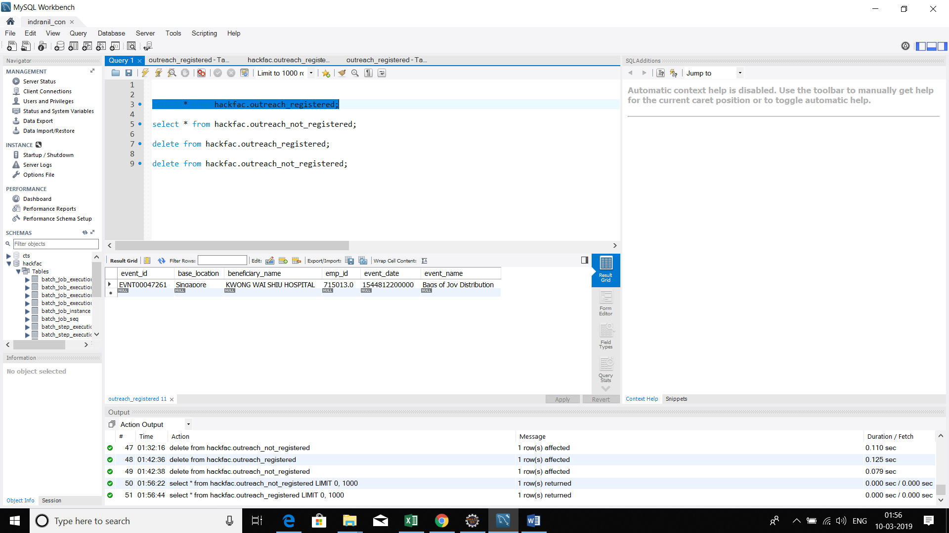

The batch has been auto scheduled with the help of **cron**

@Scheduled(cron="0 30 21 * * 0")

Which means it will be going to execute on every Sunday at 21:30.

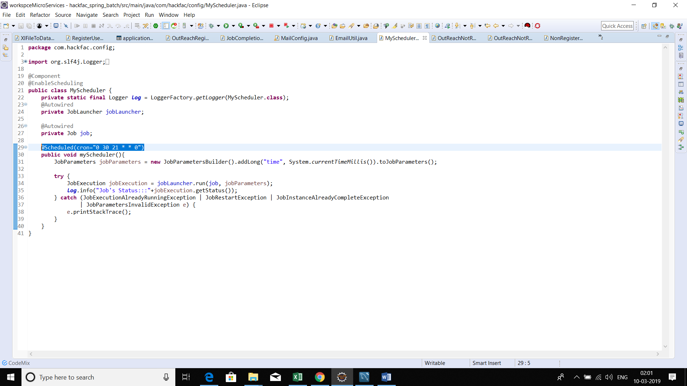

**This satisfy our auto scheduling.**

**WE have used GMAIL SMTP please see the mail is getting triggered but the device is not registered that is why it is not sending the mail.**

**Hope we will not face the same issue with cognizant SMTP.**

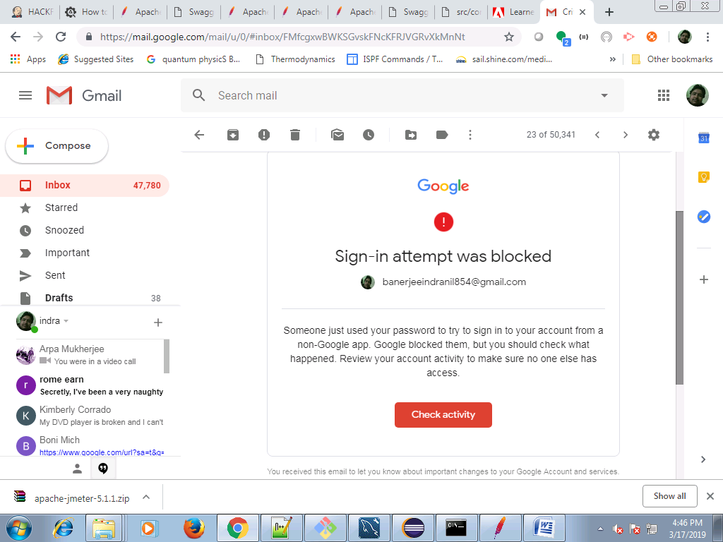

**UNIT TESTING:**

unit testing has been implemented using **mockito/junit** and the code coverage is shown using **eclemma**

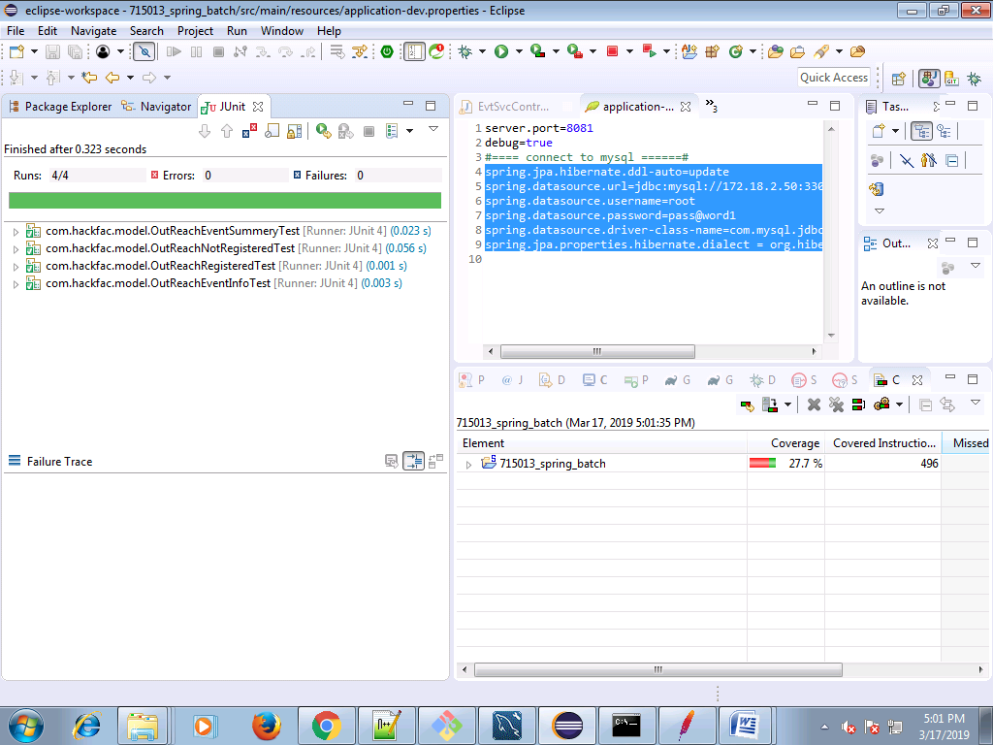

coverage will be increase in later point of time. this is for point of refference.

**CODE QUALITY:**

code quality has been implemented using **sonar lint**

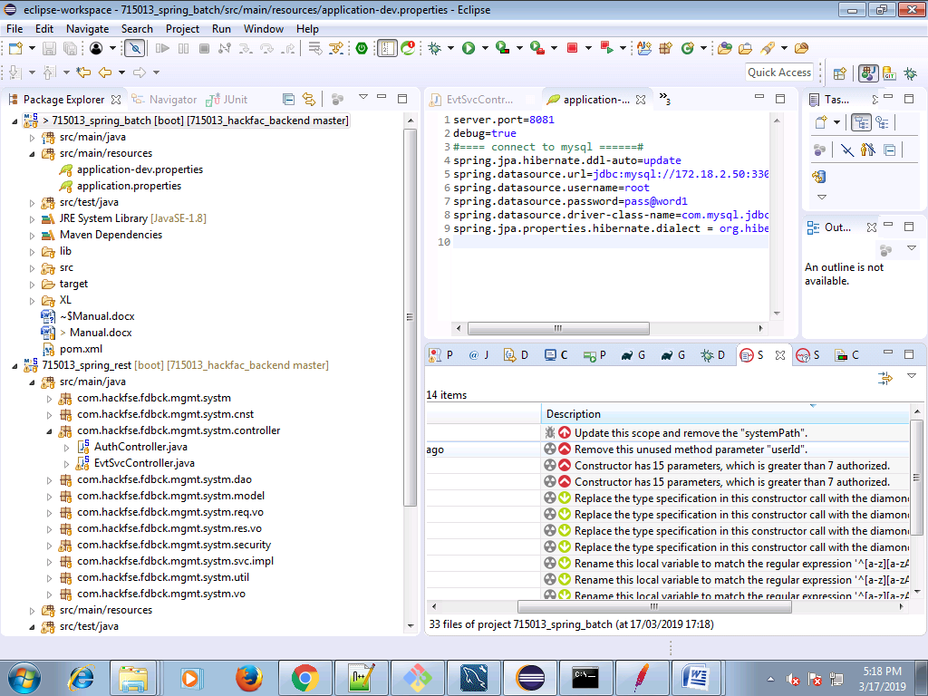

the 4 major issue 2 are for using local lib which can be resolve using nexus which not in scope.

and the other 2 in constractor parameter which can be resolve table normalization We try to keep the table as same as the XL so no need.

**Happy coding.**