**PLEASE GO TO THE GIT LINK**

**http://172.18.2.18/delta_new_blood/715013_hackfac_frontend**

**and clone git@172.18.2.18:delta_new_blood/715013_hackfac_frontend.git**

**ALL the password for the static LDAP is "secret".**

**FOR FRONT END BUILD PLEASE RUN:**

**ng build --configuration=production;**

**in visual code.**

**then got o the backend project 715013_spring_rest and uncomment**

<!-- <plugin>

<artifactId>maven-resources-plugin</artifactId>

<executions>

<execution>

<id>copy-resources</id>

<phase>validate</phase>

<goals>

<goal>copy-resources</goal>

</goals>

<configuration>

<outputDirectory>${basedir}/target/classes/static/</outputDirectory>

<resources>

<resource>

<directory>${basedir}/../715013_hackfac_frontend/dist/FeedbackApp</directory>

</resource>

</resources>

</configuration>

</execution>

</executions>

</plugin> -->

part and build the backend project.

remember before committing please comment this part or else it will fail in jenkins build as it will not find dish folder through this plugin.

it copy what ever content is there inside dish in to spring boot static folder so we can run it using spring boot so we donot hav to deply the angular code in docker the backend docker will going to work.

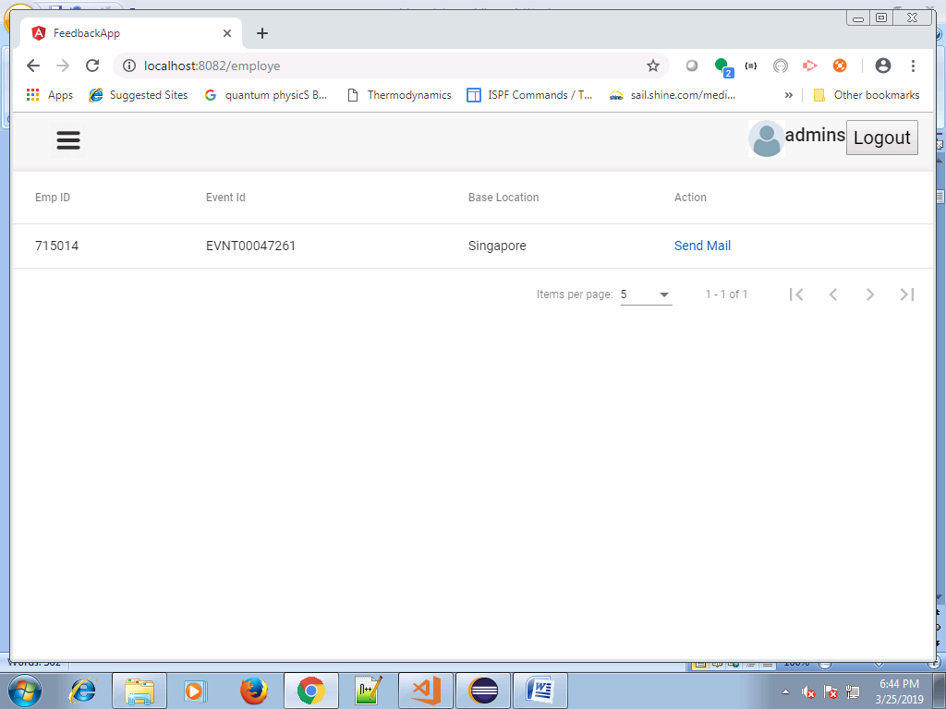

**APPLICATION:**

**http://localhost:4200/home**

|  |  |  |
| --- | --- | --- |
| 715013 | admins |  |
| 715017 | pocs |  |
| 715014 | emps |  |
| 715018 | pmos |  |

this are the user role and password which has been preconfigured in the system as we are **using static ldap config.**

**PLEASE LOGIN AS ADMINS**

**1>**

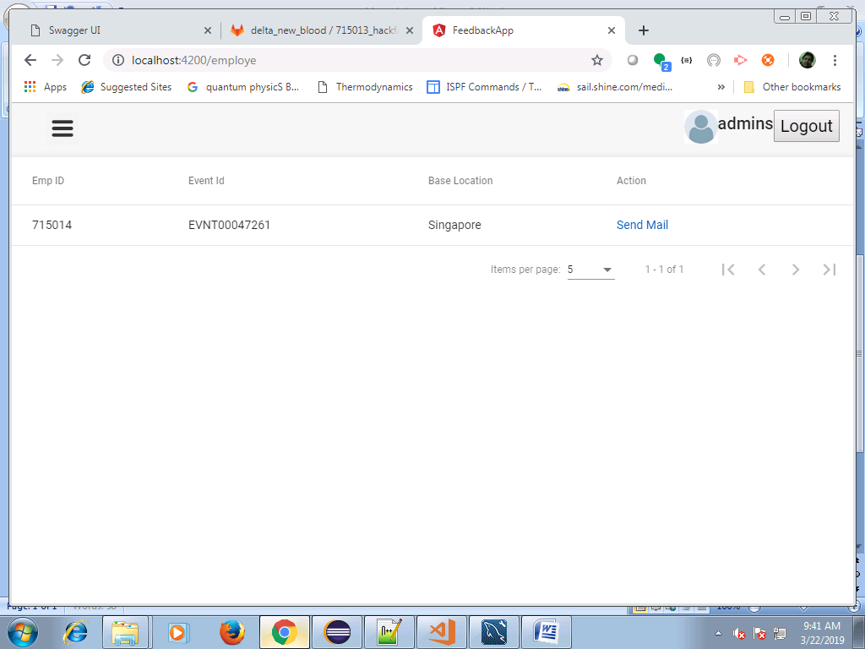

**2>**

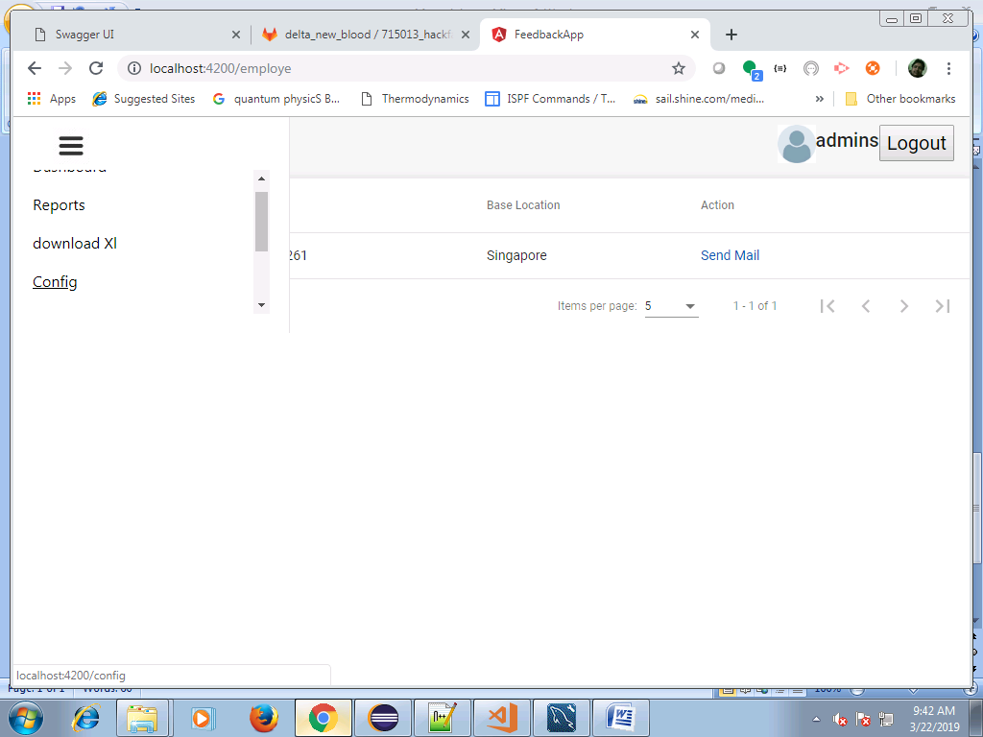

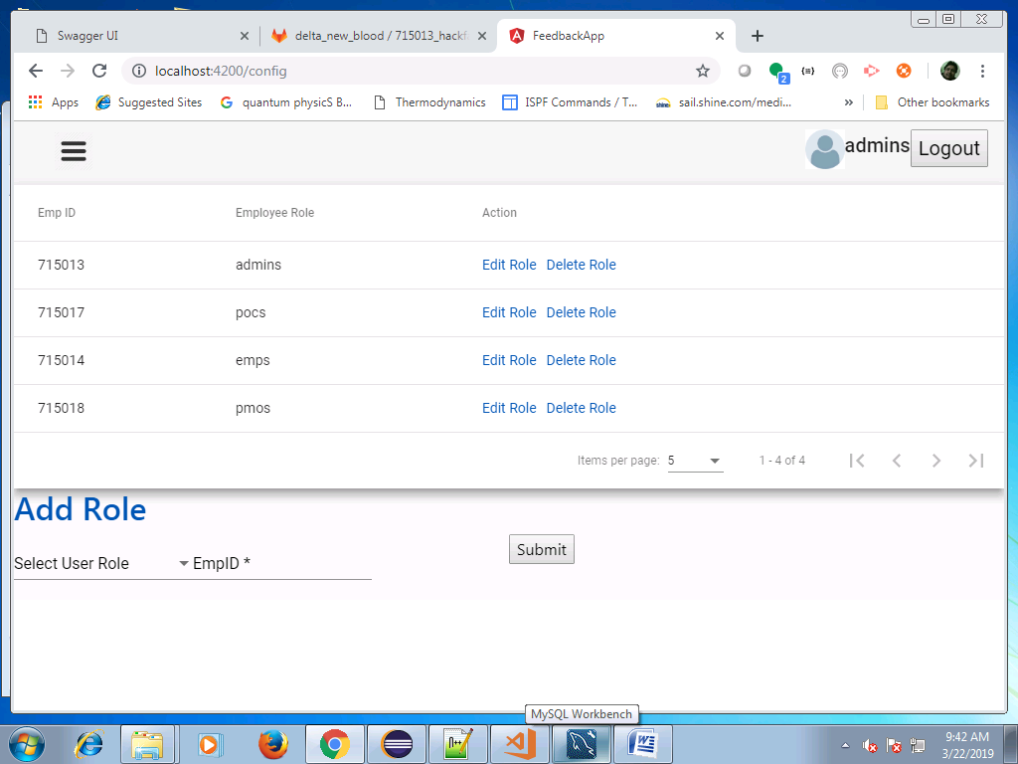

**here you can configure the user role.**

**3>**

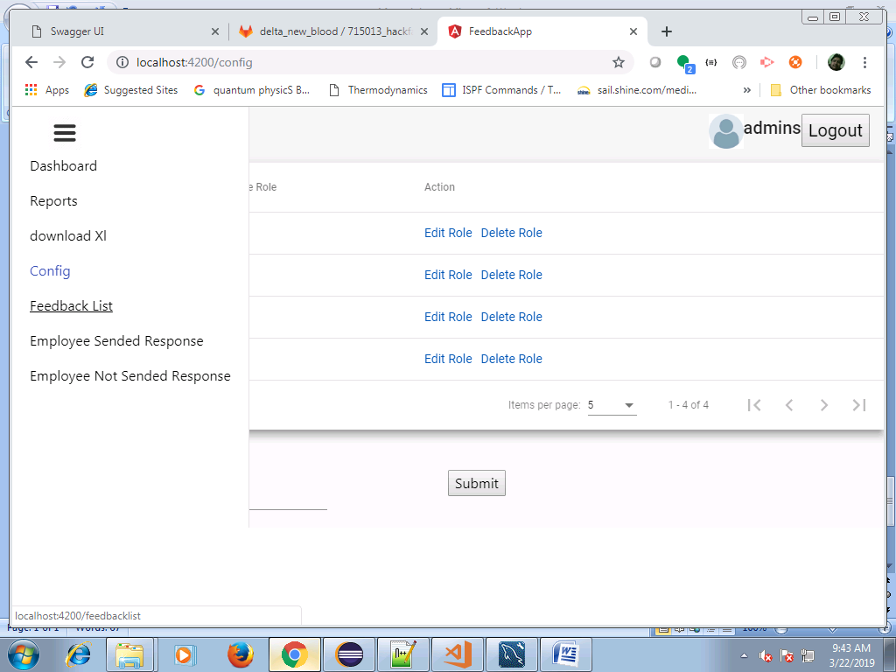

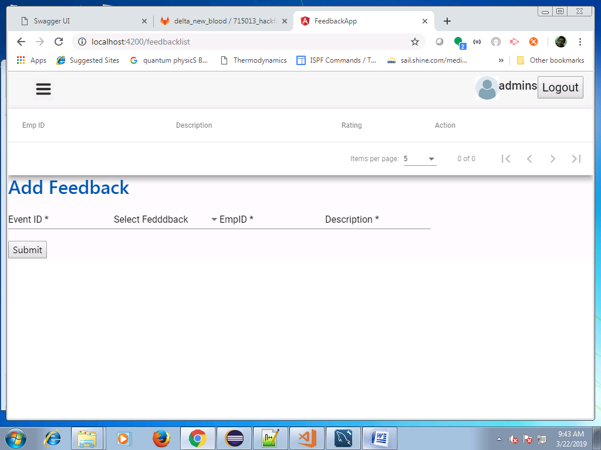

**here you can config feedback.**

**4>**

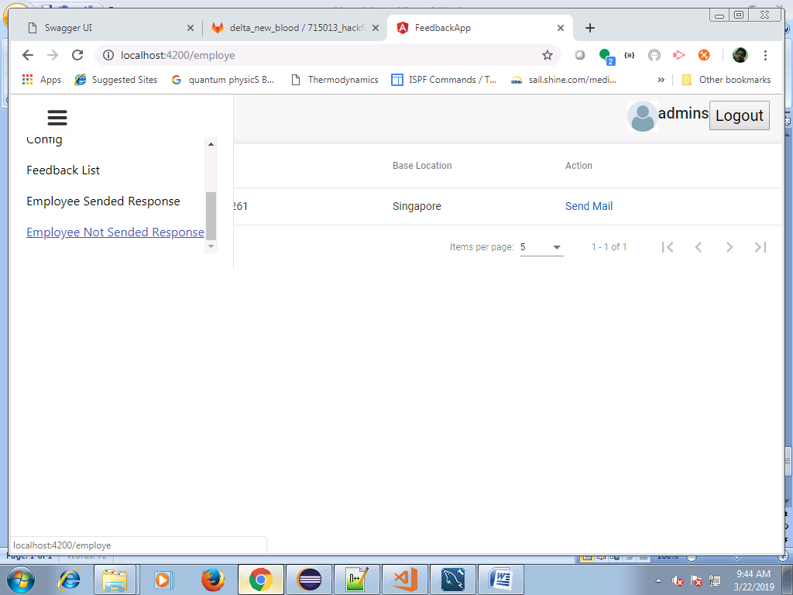

**here you can see who has not sended the response and send mail.**

**5>**

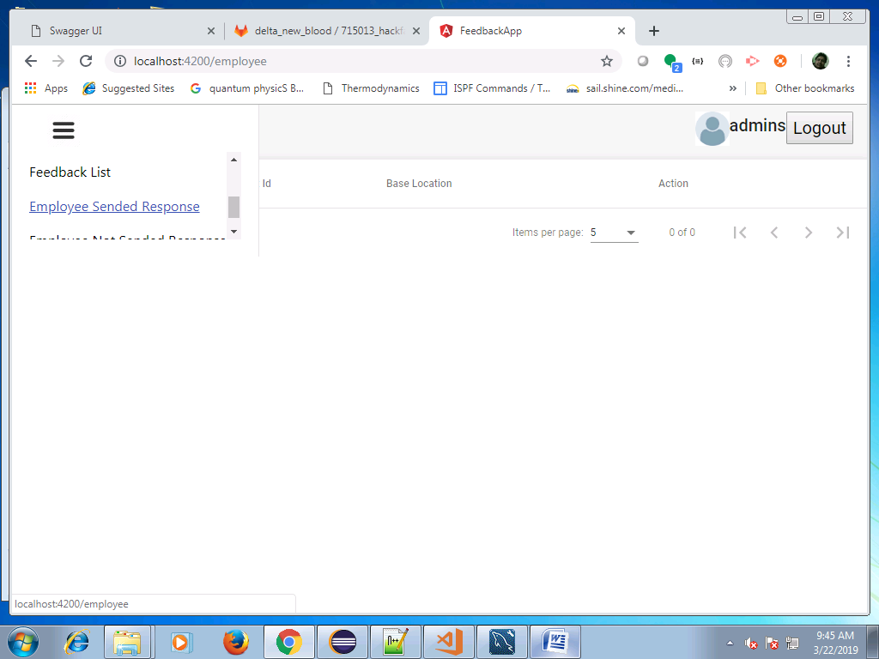

**here you can see all the employee who has already sended the response and send good luck mail**

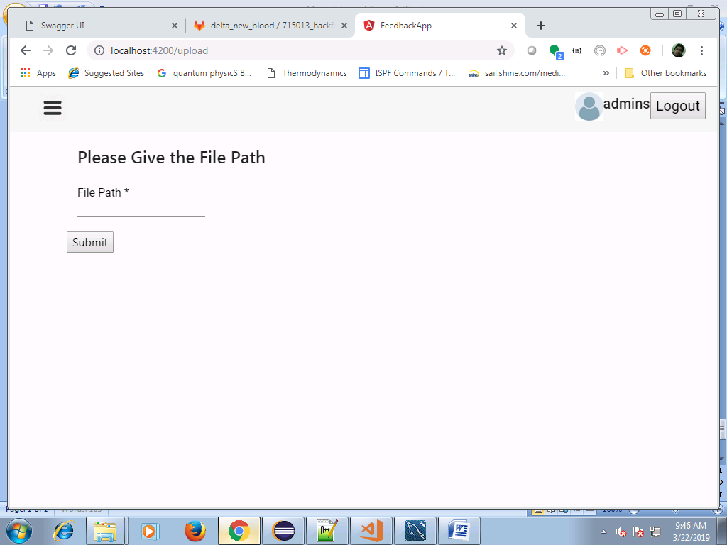

**based on the feed back we can generate XL**

**EXP:git the path like 'C:/Group_login/715013_hackfac_backend/715013_spring_batch/XL'**

**give the path like this and the feed XL will automatically generated in the path**

**6>**

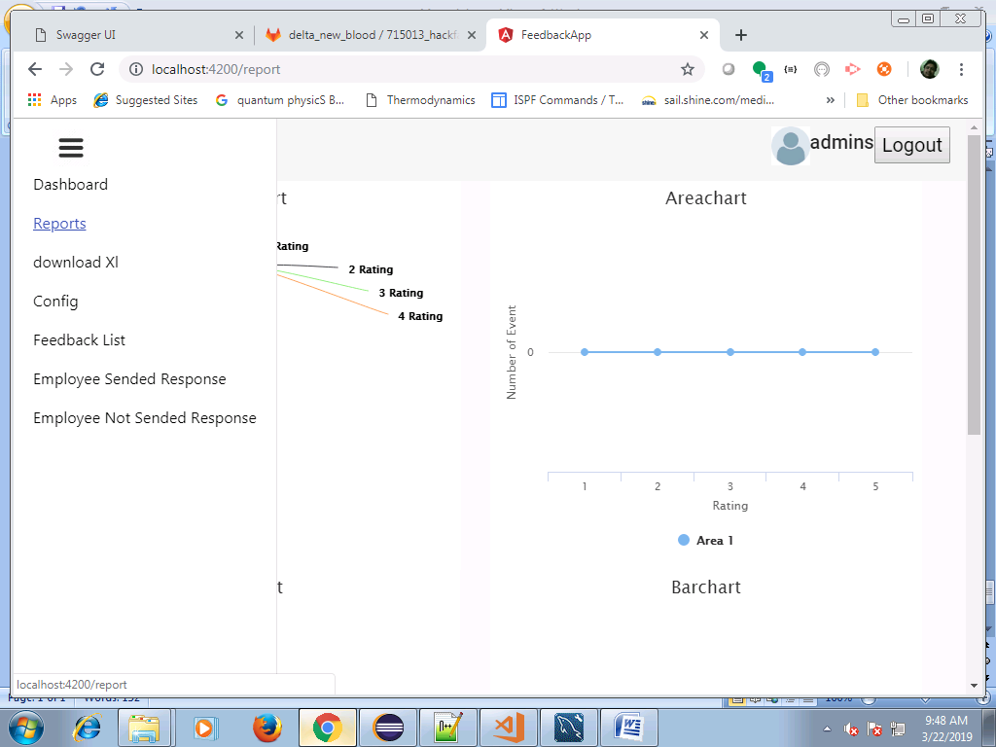

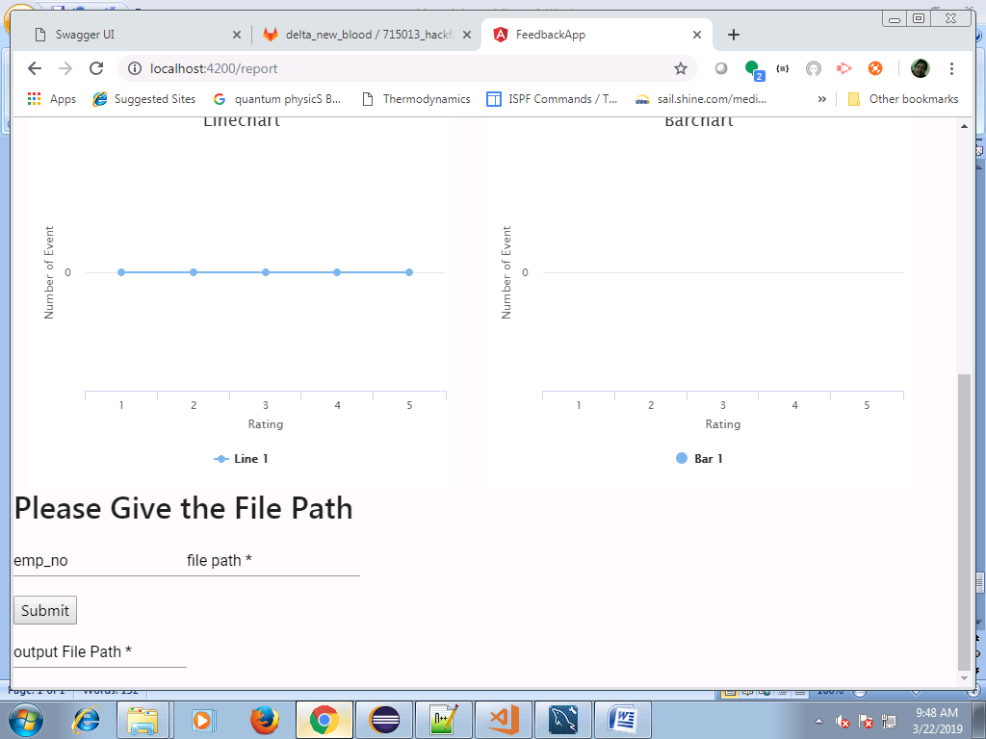

**for admin repot give the same path as previously and the report will be generated.**

**7>**

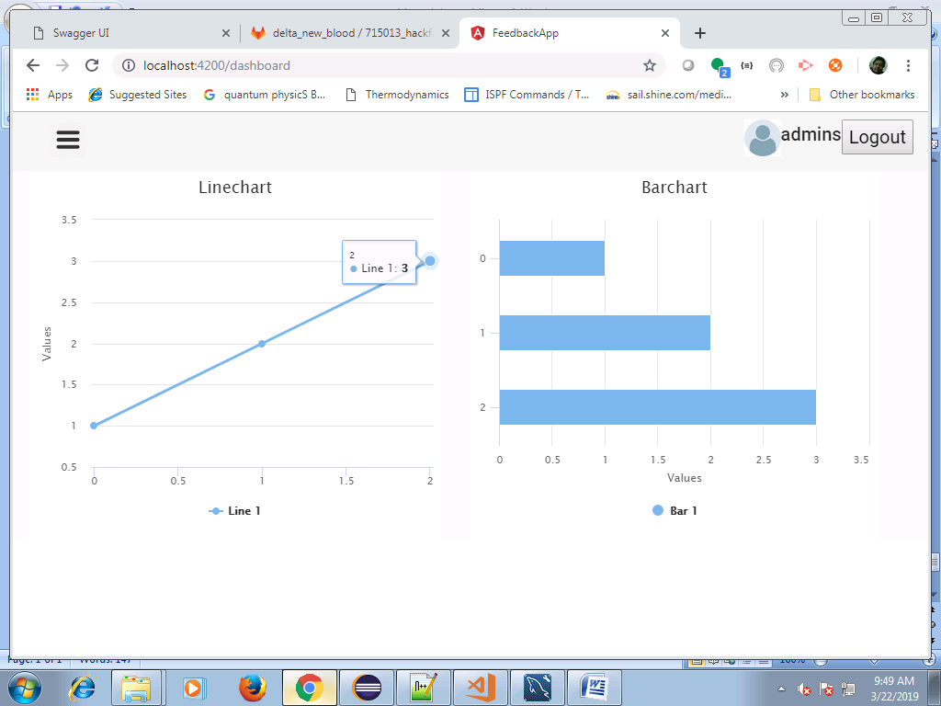

**in the dashbord :you can see the status of the system.**

**PLEASE LOGIN AS PMOS**

**As a PMO the user will be able to do**

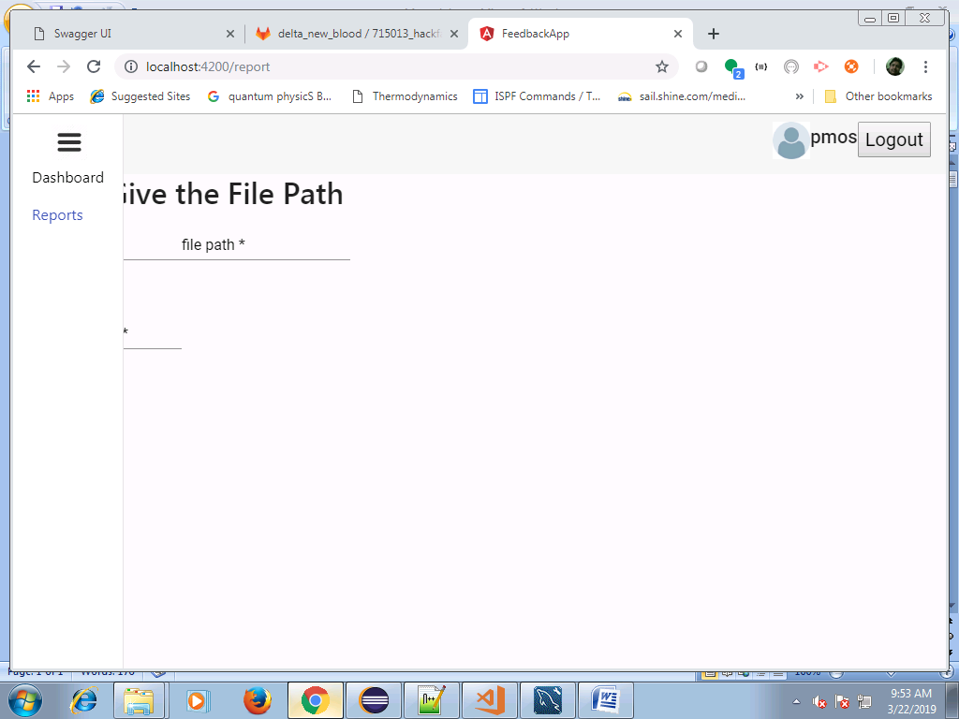

**this two functionality.**

**PLEASE LOGIN AS POCS:**

**AS a POC user will be able to do these functionality**

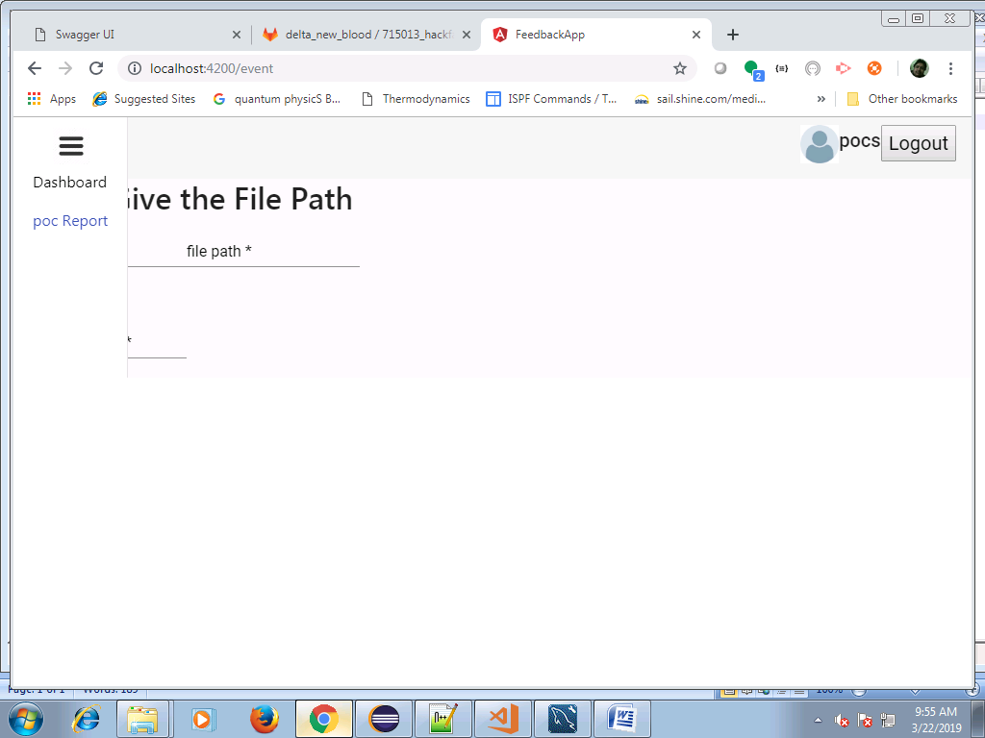

**PLEASE LOGIN AS EMPS**

**if the user is login as EMP (as no mail server is configure we are presuming the userid and password which was suppose to come from the link we are putting manualy)**

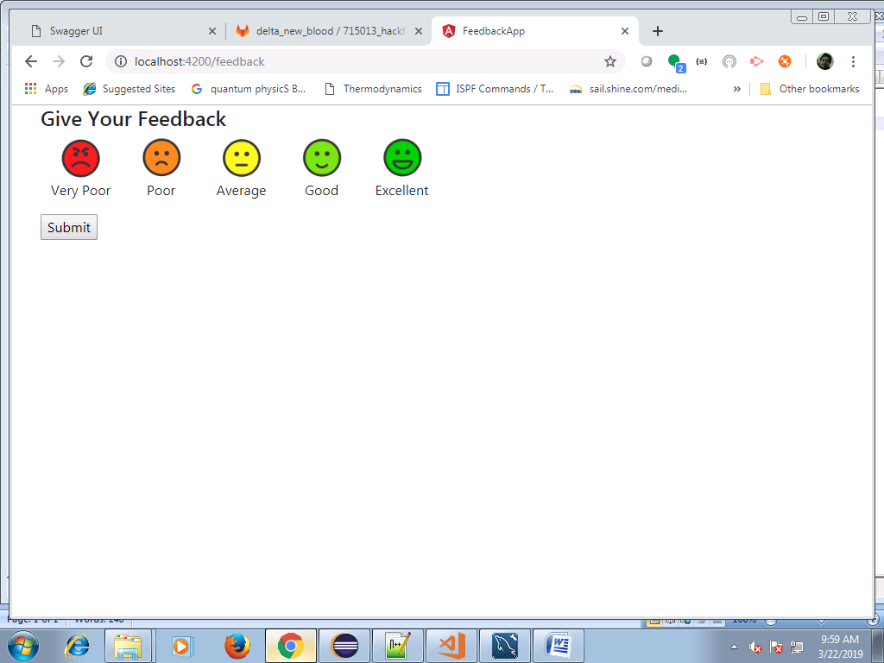

**emp can only send the respons of the event.**

**IT was a great journey leared a lot thanks.**