**Manual**:

**Database:**

Please create a schema with the name of **hackfac** .

Inside the desired connection:

In my case it was

**spring.datasource.url=jdbc:mysql://localhost:3306/hackfac?useSSL=false**

**spring.datasource.username=root**

**spring.datasource.password=root**

The tables will be automatically created based on the POJO.

**Code**:

Please import the project as maven project.

After doing that please **build** the project using **mvn clean build.**

please run the project as **spring boot application** with the program argument as

**--outreach.notregister=C:/hackfac_spring_batch/XL/OutReach_unregistered.xlsx**

**--outreach.register=C:/hackfac_spring_batch/XL/OutReach_unregistered.xlsx**

For different user the configuration would be different.

**This Satisfy the need of custom configurable XL file location.**

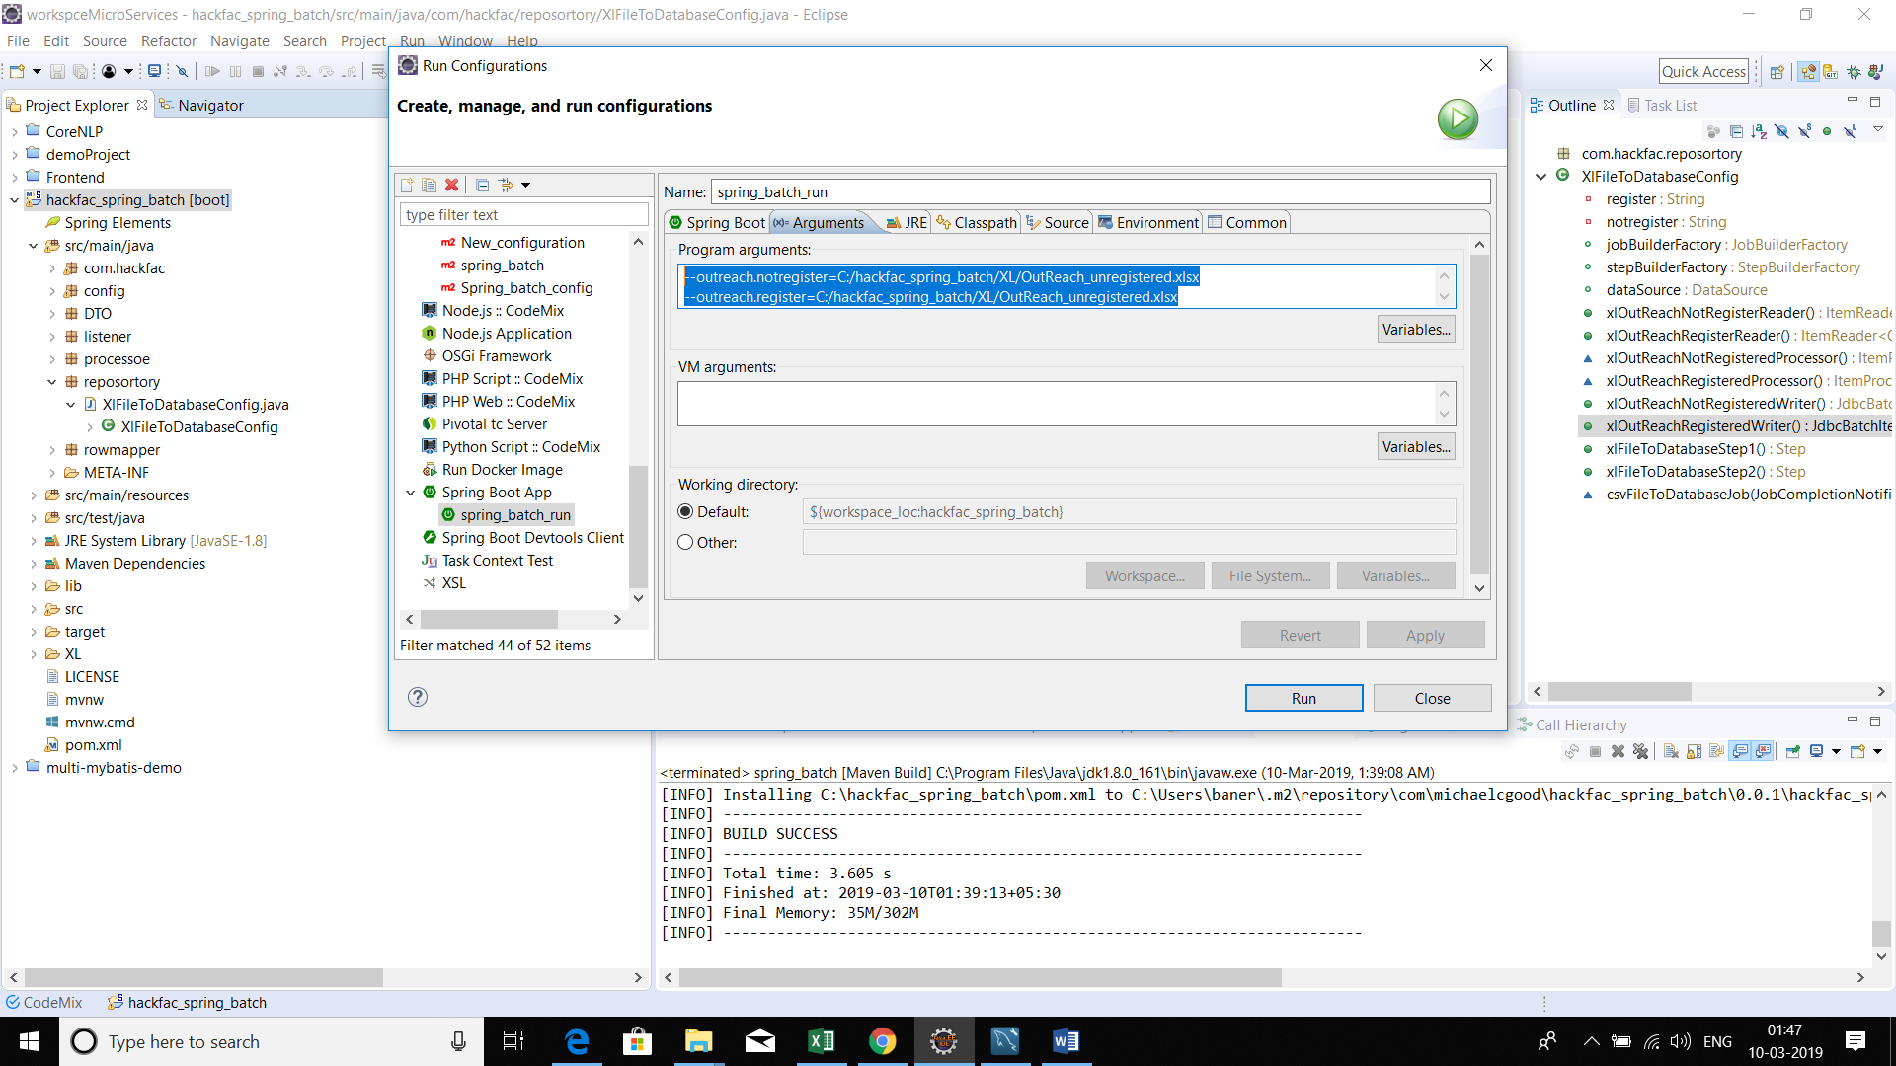

After running the application, you will automatically see the data has been updated to the database

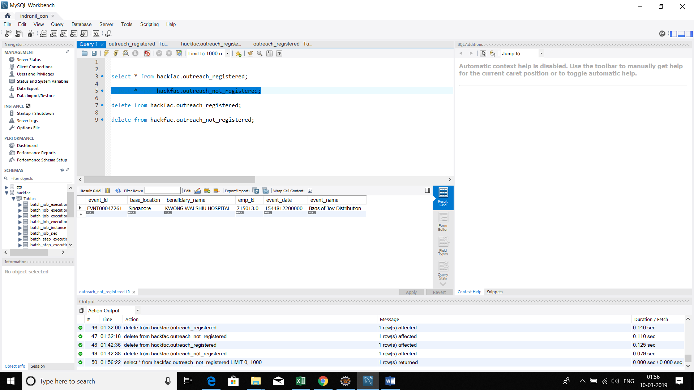

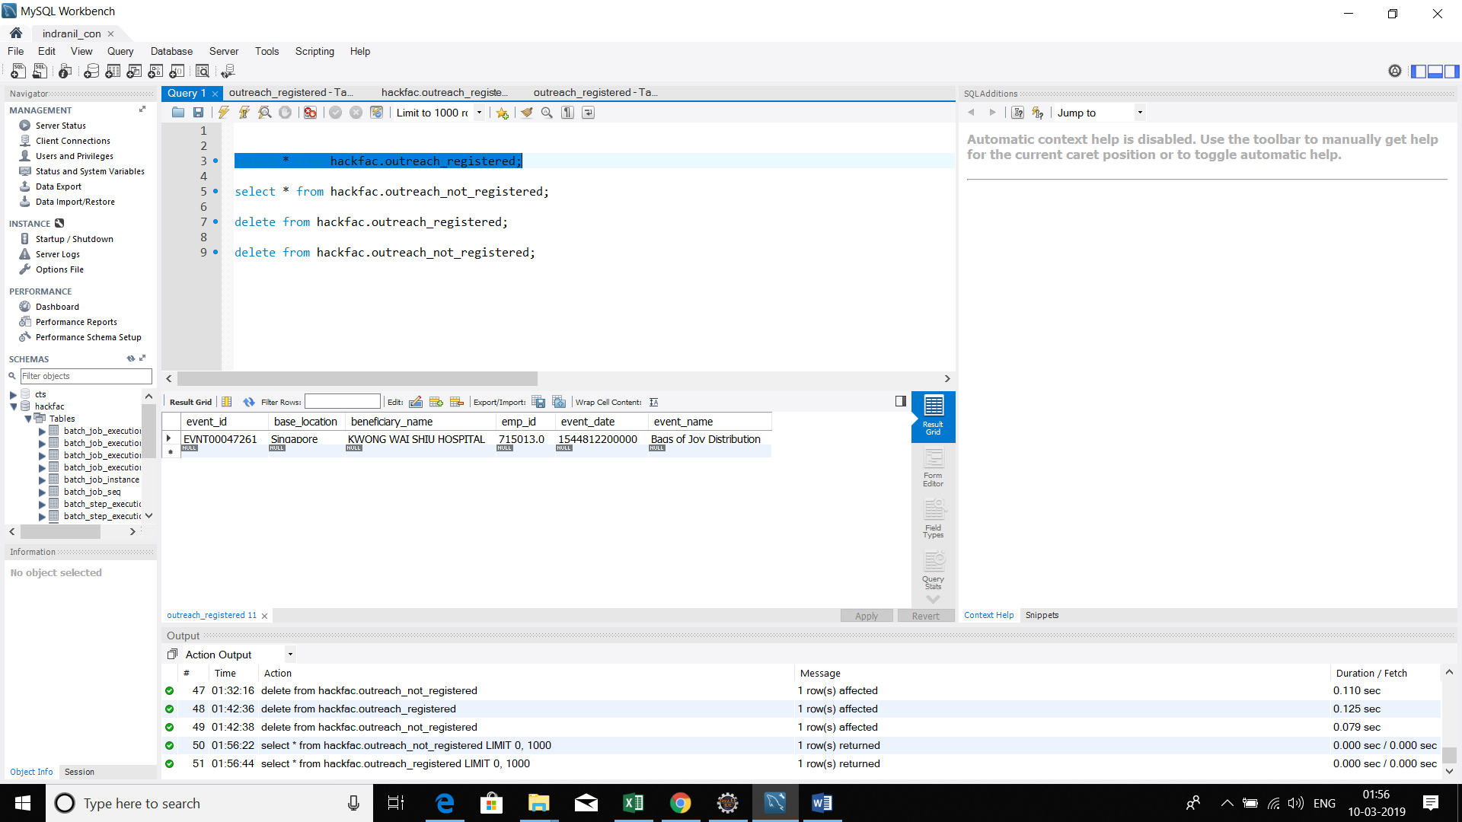

The batch has been auto scheduled with the help of **cron**

@Scheduled(cron="0 30 21 * * 0")

Which means it will be going to execute on every Sunday at 21:30.

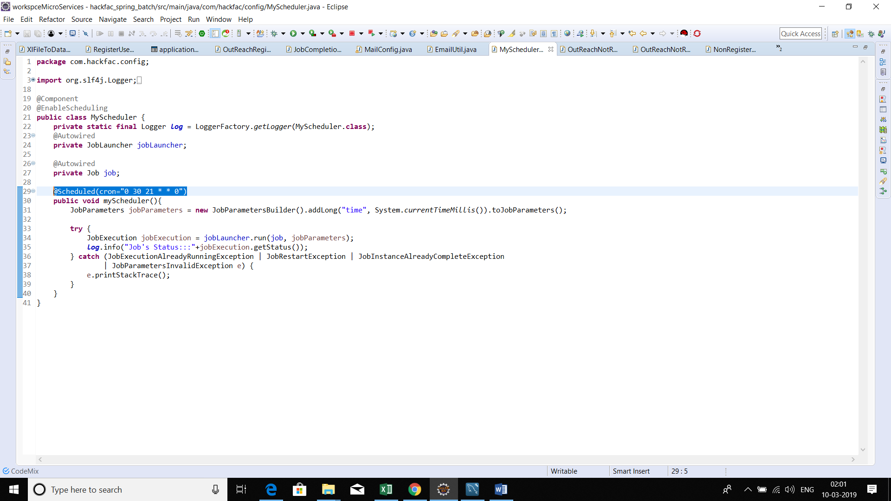

**This satisfy our auto scheduling.**

**We do not have the access to any smtp server for that reason we can not shot the mail right now it is throwing authentication error while configuring with GMAIL (may be something is wrong with the SMTP config).**

**Please provide the relevant config.**

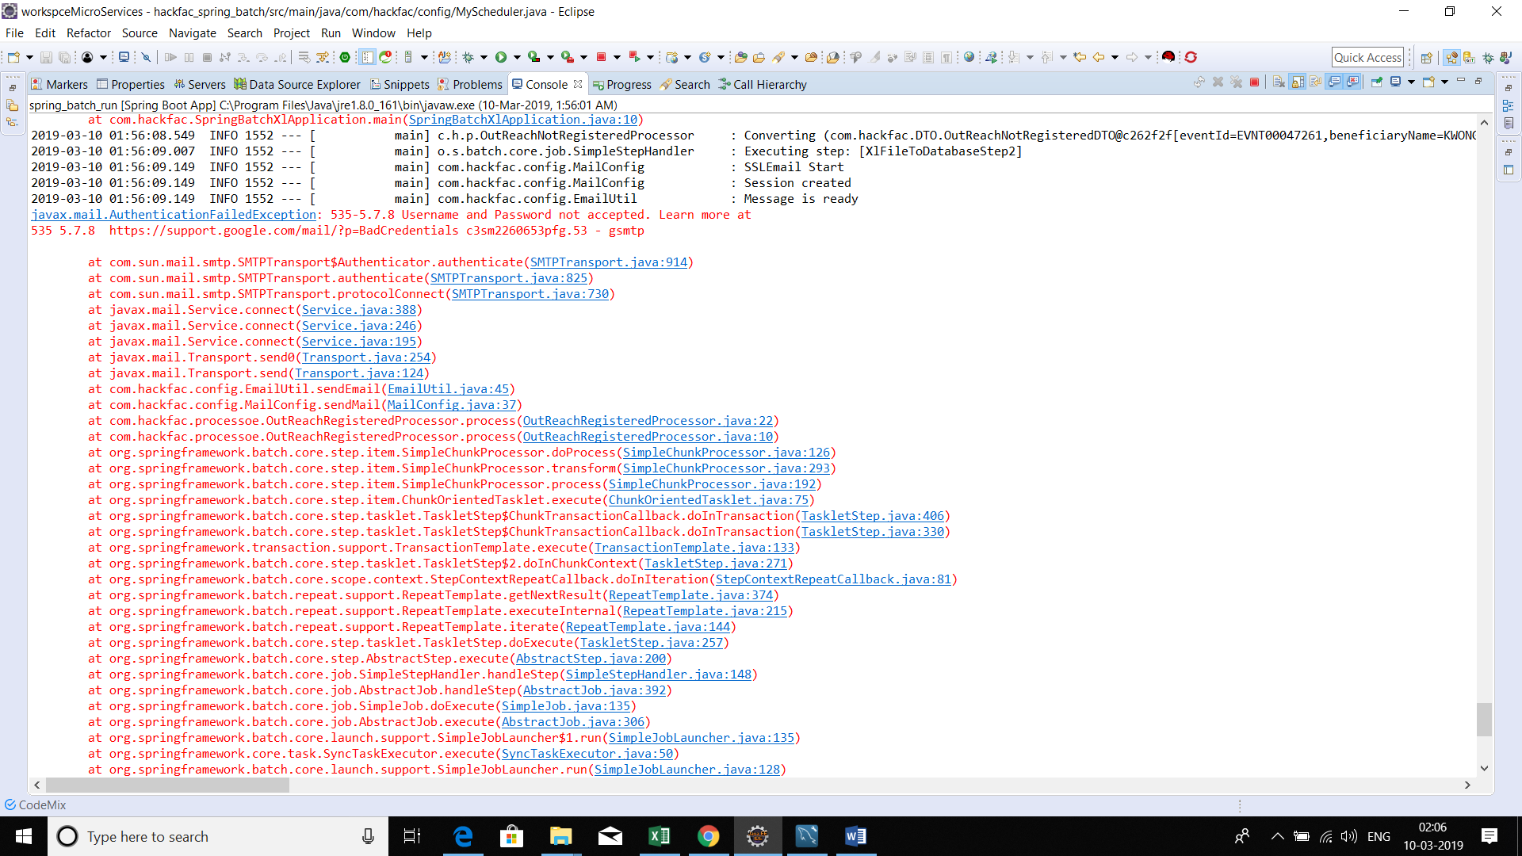

**Happy coding.**