While running Please configure spring profile by adding

-Dspring.profiles.active=local

As VM argument.

After start use

<http://localhost:8080/TEAMDELTA/users/>

url to access the application.

Only admin access has been provided for all rest URL letter point we will decide which REST will have ADMIN or USER access or any other role.

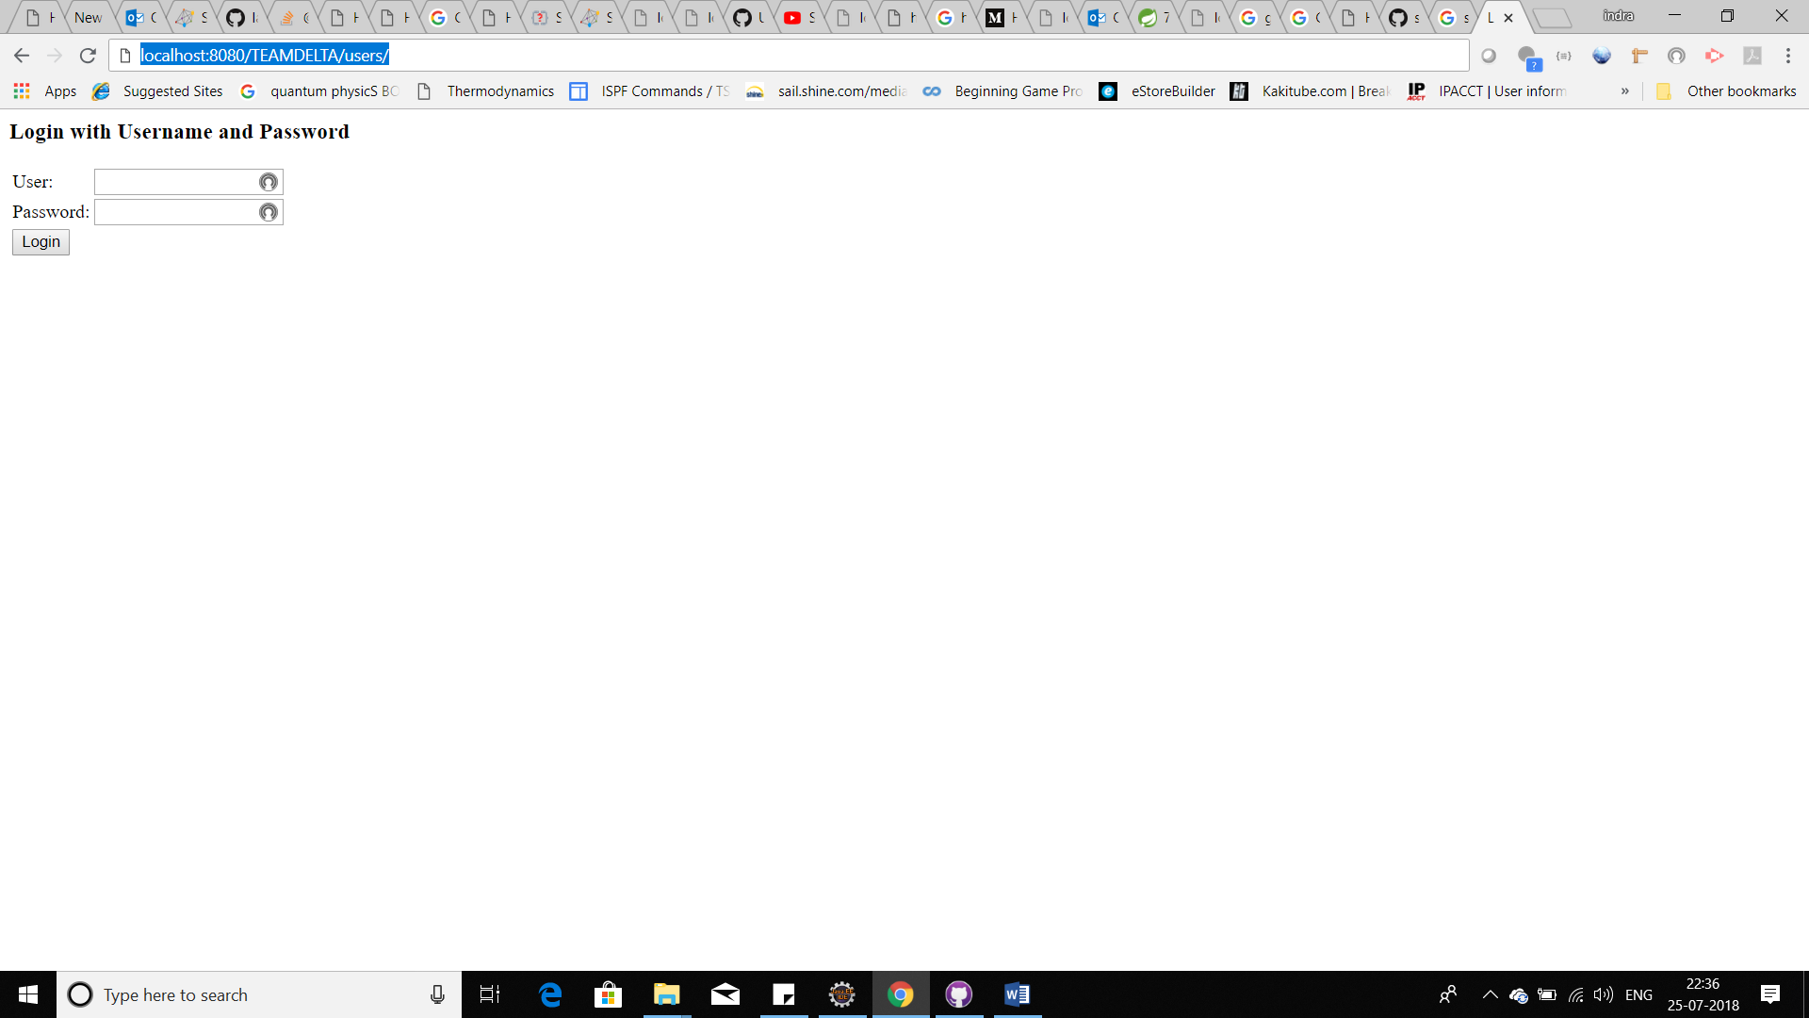

Screen will come please give

User as ‘aaa’ password as ‘aaa’

Then

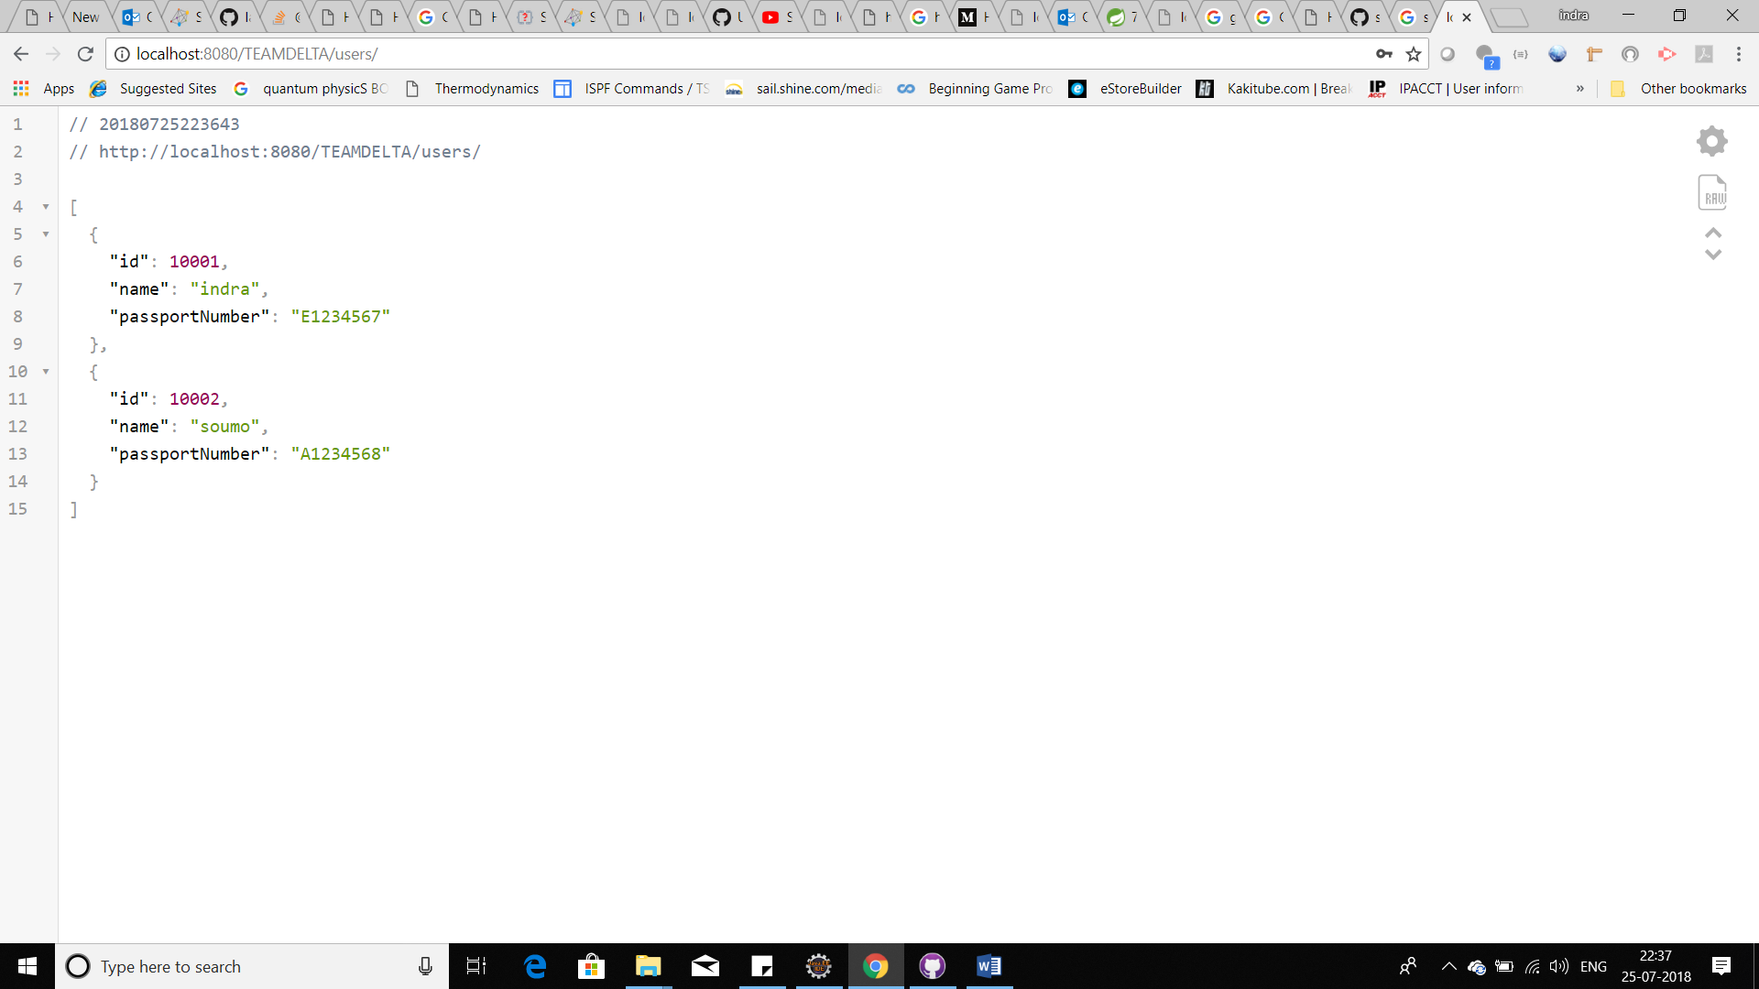

Coding template is done.

* **String security**
* **Hateoas**
* **Transaction management**
* **Swagger**
* **Jpa**
* **H2 as local mysql as prod**
* **Custom exception**

We are left with **logger implementation, business implementation**

**And UI**.

For Swagger URL please go to this

http://localhost:8080/TEAMDELTA/swagger-ui.html