

**UNIVERSITY OF NAIROBI**

SCHOOL OF COMPUTING AND INFORMATICS

**PROJECT DOCUMENTATION**

**ONLINE DAIRY FARMING RECORD MANAGEMENT SYSTEM**

**MUIRURI DENNIS BANGA**

**P15/1475/2012**

**Project Supervisor**

**PROF. ELIJAH OMWENGA**

**Date Submitted**

**24TH APRIL 2014**

# DECLARATION

I, Dennis Banga, hereby declare that this project is my own work, and has to the best of my knowledge, not been submitted to any other institution of higher learning.

Student’s Name DENNIS BANGA MUIRURI .

Registration No: _______ P15/1475/2012_____________________________

Signature __________________________________________________

Date __________________________________________________

This project has been submitted as a partial fulfilment of requirements for the Diploma in Computer Science of the University of Nairobi with my approval as the University Supervisor.

Supervisor’s Name _________PROF.ELIJAH OMWENGA_________________

Signature __________________________________________________

Date __________________________________________________

# ACKNOWLEDGEMENTS

First and foremost I would like to thank the Almighty God for giving me the strength to carry on through this project.

I am particularly thankful to my supervisor, Prof. Elijah Omwenga, who was very instrumental in the conceptualization of the project and has been of great assistance in refining the project throughout its development.

Finally, I would also like to acknowledge my parents for their continual encouragement and support during the project.

Table of Contents

LIST OF ABBREVIATION 3

TABLE OF FIGURES 3

1.0 INTRODUCTION 4

1.1 BACKGROUND 4

1.2 PROBLEM DEFINITION 5

1.3 GOALS 5

1.4 OBJECTIVES 5

1.5 JUSTIFICATION 5

1.6 EXPECTED OUTCOME 6

1.7 ASSUMPTION 6

1.8 PROJECT SCOPE 6

2.0 LITERATURE REVIEW 7

2.1 DAIRY FARMING IN KENYA 7

2.2 RECORDS AND IMPORTANCE OF DAIRY FARMING 7

2.3 EXISTING SYSTEMS 8

2.3.1 AgSquared 8

2.3.2 POCKET DAIRY 9

2.3.3 PIONEER ONLINE RECORD KEEPING SYSTEM 10

2.3.4 eCow 10

3.0 METHODOLOGY 12

3.1 APPROACH 12

3.1.1 REQUIREMENTS SPECIFICATION AND ANALYSIS 12

3.1.2 DESIGN 12

3.1.3 IMPLEMENTATION 13

3.1.4 TESTING AND EVALUATION 13

4.0 SYSTEM ANALYSIS 13

4.1 DATA COLLECTION 13

4.1.1 INFORMAL INTERVIEW 14

4.1.2 OBSERVATION 14

4.1.3 WRITTEN DOCUMENTS AND ONLINE DOCUMENTS 14

4.2 FEASIBILITY ANALYSIS 14

4.2.1 ECONOMICAL FEASIBILITY 14

4.2.2 TECHNOLOGICAL FEASIBILITY 14

4.2.3 SCHEDULE FEASIBILITY 14

4.2.3 TECHNICAL FEASIBILITY 14

4.2.4 SCHEDULE FEASIBILITY14

4.2.5 OPERATIONAL FEASIBILITY 14

4.3.1 FUNCTIONAL REQUIREMENTS 15

4.3.2 NON FUNCTIONAL REQUIREMENTS 15

4.4 SYSTEM ANALYSIS MODELS 15

4.4.1 USE CASE DIAGRAM 16

4.4.2 ENTITY RELATIONAL MODEL 17

5.0 SYSTEM DESIGN 18

5.1 ARCHITECTURAL DESIGN 18

5.2 DATABASE DESIGN 18

5.3 USER INTERFACE DESIGN 18

6.0 RESOURCES 22

6.0 HARDWARE 22

6.0 SOFTWARE 22

6.0 PROJECT WORK PLAN 23

6.1 PROJECT TIMELINE 23

6.2 GANTT CHART 23

7.0 REFERENCES AND BIBILIOGRAPHY 24

**LIST OF ABBREVIATION**

SMS - Short Message Service

MOLD - Ministry Of Livestock Development

USAID - United States Agency for International Development

RAM - Random Access Memory

LAMP - Linux Apache MySQL PHP

GSM - Global Systems for Mobile

PCDART- Personal Computer Direct Access to Records by Telephony.

HTTP-

API-

HTML-

DFD- Data Flow Diagram.

**TABLE OF FIGURES**

Figure 1 –Agsquared site…………………………………………..……………………………………………………....8

Figure 2 – PocketDairy App site …………….…………………………………………………………………………..9

Figure 3 – Pioneer Online Record keeping system site…………………………………….………………….10

Figure 4 – eCow site………………………………………………….…………………………………….………………….11

Figure 5 – Use case Diagram..…………………………………….…………………………………….………………….16

Figure 6 –Entity relational diagram..………………………….…………………………………….………………….17

Figure 7 – Architectural diagram……………………………….…………………………………….………………….18

Figure 8 –Context diagram……………………………………….…………………………………….………………….18

Figure 9 – Level 1 DFD………………………………………………….…………………………………….………………….20

**1.0 INTRODUCTION**

**1.1 BACKGROUND**

Kenya is an agricultural based economy with most of the citizens relying on smallholder agriculture production. Dairy farming been part of the agricultural sector contributes greatly to the economy. It involves rearing of dairy cattle whose main purpose is to produce milk, reproduce to provide replacement cows for the future and most of all provide a means of living for the farmers in the dairy business. It is dominated by small scale farmers. For farmers to effectively and efficiently manage the dairy cattle they need to keep records. These records contain identification, breeding, feeding, production, vaccination, health and financial information. Keeping of records help the farmers to think of their dairy farm as a business.

According to Brannstorm (2008), dairy farming is a complex business that demands accurate records and careful financial management. Unfortunately, farmers normally see record keeping as a mundane task. Muhammad et al (2004) proved that farm record keeping is a key practice to successful farmers and vice versa. A farm record provides timely and consistent information to assist in the management process, keeping track of how many cows he/she has, what their health is and what he/she is feeding them. In addition, obtaining grants and loans from financial institutions for small scale dairy farmers require that you have financial records to show what you have earned and what your expenses are, financial statement to prove that the farm is financial viable.

Most of the small scale dairy farmers don't keep comprehensive records for their cattle and usually use paper records. Paper records have shortcoming as there may be duplication of data thus making it difficult to keep track. In addition, the paper records may be lost meaning the data is lost completely. Analysing handwritten records is tedious, cumbersome and time consuming. Also these records are not always accessible as they are localized. Moreover, many farmers don't know details for good dairy records thus predefined forms will assist farmers and at the same time get to know the details required.

A rise in the record keeping problems using the manual records seeks an alternative way for storage of dairy cattle information and data.

An online platform providing management for the dairy cow records will assist farmers in efficient record storage and thus will help the farmers in decision making, keep memory, assess profitability/ losses and help the farmers in improving the efficiency of the operations. SMS to update the records online using a GSM mobile is easier for the farmers who cannot access the online platform.

**1.2 PROBLEM DEFINITION**

Currently, dairy farmers using the paper records to keep information about their dairy business is ineffective since manual records are prone to errors; inconsistency in recording leading to duplication, analysis is time consuming, losing the records means information and data is lost too, and accessibility is limited. Also most of the farmers being small scale farmers don’t have information about what good dairy record incorporates, thus their records may omit essential details. In addition, it is difficult for dairy farmers to know the financial status of their business whether they are making loss or profits depending on their cost and income.

Therefore, there is need for the online dairy farming management system for keeping records and analysing the financial records of the dairy farmers to enable them to effectively manage their dairy cattle business and easily access the information of their cows.

This system enables recording, analysis and access to records in a manner that is easy and accessible from anywhere. Also the records details are predefined thus capturing relevant information.

**1.3 GOAL**

To come up with an online platform that will provide recording of dairy cows data, storage, analysis of financial data and updates through SMS, and access of the information stored in a formatted way.

**1.4 OBJECTIVES**

In order to achieve the above goal, the objectives to be met include:

1. To provide an online platform that allows dairy farmers to store their dairy records online.
2. To provide an SMS based platform that will allow users to update financial records using SMS.
3. To provide dairy farmers with reports from their online records.
4. To analyse financial and milk records of the dairy business.
5. To provide SMS reminders to the dairy farmers on dairy farming activities.

**1.5 PROJECT JUSTIFICATION**

An online platform that stores dairy cattle information will be beneficial to the farmers, as chances of online records being lost is minimal. In addition, analysing of the financial records of the dairy farming business will be easier on the online records and the farmers will not have to waste time analysing manual records. In online records, duplication is unlikely to arise. It will capture the essential details of good farm records and thus farmers will have good kept records. Having a SMS service for updating and querying from the records will make it easy for the farmers to access the services from their mobile phones. Using the SMS service will be scalable and effective as most farmers own a mobile phone.

Generating reports on their income and expense, hence these reports can be used by financial institutions while appraising the farmers for loans.

Currently in Kenya there is no system that is providing online storage and analysis of financial records of dairy farmers. Therefore, this will be the first system of its kind.

**1.6 ASSUMPTION**

Small scale farmers can be able to access and use Internet services as well as the SMS services.

**EXPECTED OUTCOME**

After successful completion of this project, an online web application will be developed that will enable dairy farmers to sign up, register individual cow details in the system, add records of the cows in the system, provide reports from the records and also update their records. The farmers will also be able to set reminders for their dairy farming activities.

The system will also have a SMS platform that will enable farmers to update their income and expenses records by use of SMS and also be able to query information of their records.

**1.7 PROJECT SCOPE**

The scope of this project is restricted to:

1. Develop an Online platform linked to an SMS gateway.
2. Records kept will be for dairy cattle farming only.
3. SMS platform will be used for updating and querying financial record.

**2.0 LITREATURE REVIEW**

**2.1 DAIRY FARMING IN KENYA**

Dairy farming is type of livestock rearing where cattle are kept for milk production with sole purpose of selling milk to the consumer.

In Kenya dairy industry is dominated by small-scale farmers. It is well-developed in the livestock subsector contributing about 6% GDP, and it is practiced in the medium and high rainfall areas mainly in the central highlands, Rift valley, Eastern and coast lowlands (MOLD, 2006). Majority of the small scale farmers are concentrated in the Central highlands and they own 1-5 cows (USAID, 2008). Also this farmers market their milk either through the formal or the informal market. In the informal market it comprises of direct deliveries to consumer, or through intermediaries such as traders. This channel accounts 85% of the marketed milk and only 15% of the marketed milk flows through the formal market via cooperatives and processors (Thorpe, 2000; USAID, 2008).

The growth of the dairy sub sector has been highly contributed by the high domestic demand for milk and dairy products due to growing population.

**2.2 RECORDS AND IMPORTANCE OF DAIRY RECORDS**

Record keeping is an essential tool to any business and it plays a major role regardless of the size, nature or type of the business, thus a good entrepreneur must be a good record keeper. In the present day, farming operations are becoming more and more business oriented. To remain in business, is not only to become a good producer but also a good financial manager.

To keep track of what is happening on a dairy farm requires some records. Good farm management requires having a good useful set of farm records. Good records do not ensure the farm will be successful; however, success is unlikely without them. To keep records is simply to collect relevant information that can help you as a farmer to take good decisions, keep track of activities, production and important events on a farm.

Farm records are like report cards students receive at school. With a farm report card, farmers can tell how they are managing their operation compared to other producers and they can see their strengths and weakness in their operation. Farm records provide the farmer with data, information and knowledge. Keeping of records should be systematic and simple.

The use of the farm records include:

1. Be used in determining profitability of techniques used in the farm.
2. Used to keep memory on what the farmer did or what happened.
3. Used in decision making to make proper management decisions.
4. Helps the farmer to improve the efficiency of the farm's operations.

**Importance of record keeping in dairy farming:**

1. To keep track of the dairy cattle.
2. Evaluation of livestock for selection
3. Aid in selecting animals with the right characteristics for breeding.
4. Helps in feeding and management.
5. Helps in disease management by keeping track of treatment.
6. To assess profitability or losses.
7. Credit and loan access having financial records.

**The types of records kept in a dairy farm include**:

1. *Identification records* -These are records that identify individual animals e.g. by giving the animals an ear tag, names, tattooing or paints and dyes.
2. *Breeding records*- To provide information about cows such as age at the first service, age at first calving, date of calving, number of services per conception, date/time of insemination of the cows.
3. *Production records*- These are records that indicate the production of the cows, their milk yield.
4. *Feeding records* -To indicate the amount of feed given to the cattle as well as the type of feed.
5. *Health records* – To provide information about health status of the individual cows such as vaccination, dipping/spraying, deworming and treatment.
6. *Financial records*- Provide farmer with information about profitability of his/her farm. Includes expenditure and expenses records.

Online storage of records is whereby the records' data and information are stored in a database and can be accessed on a web platform for updating or viewing.

**2.3 EXISTING RELATED PROJECTS**

**2.3.1Ag Squared**

It is a web-interface program designed to serve the record keeping needs of small farms that is primarily for crop farmers to track field management, labour and equipment use, planting and harvesting schedules, and crop yields. It does not provide recording of dairy farming information. Thus cannot support dairy farmers’ needs by storing their dairy records electronically.

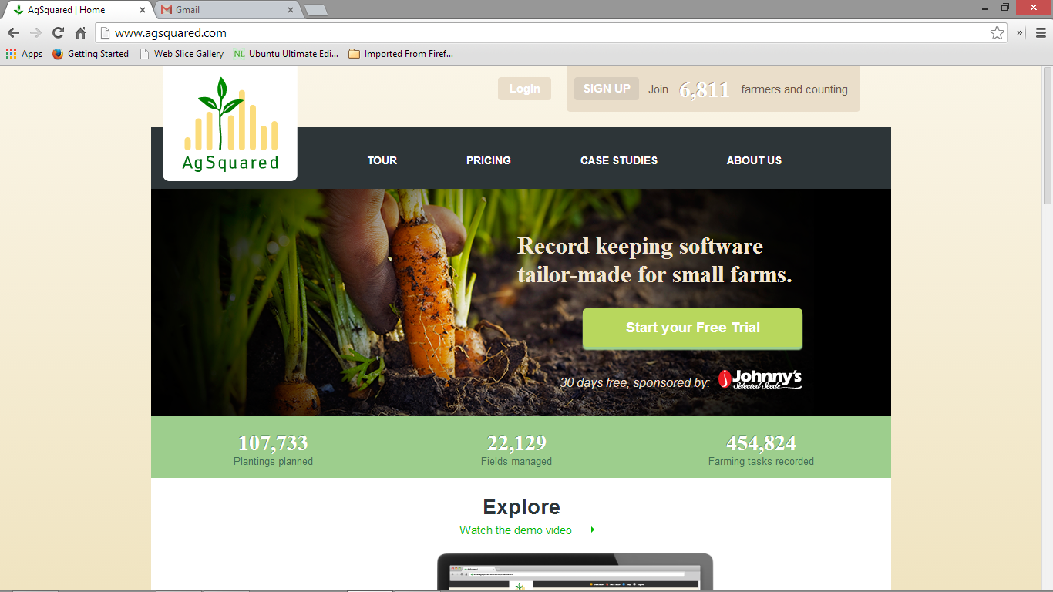

Figure 1- Agsquared site

**2.3.2 Pocket Dairy App**

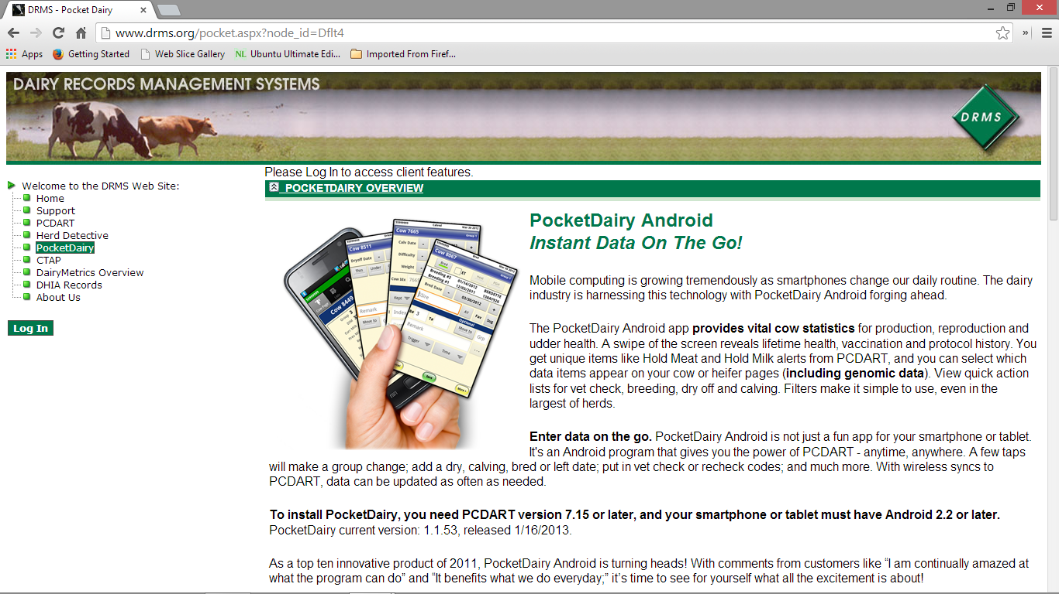

Figure 2- Pocket Dairy App site

It is an android application that provides vital cow statistics for production, reproduction and udder health. It runs in android version 2.2 and above, and has a monthly charge of $10 plus 3cents per cow and $50 start-up fee.

Used for large herds of dairy cows and does not provide financial analysis. Most small scale farmers don't own smartphones as it operates in android platform. In addition, it is expensive to farmers and it will not be viable for Kenyan farmers as most of them are small holder farmers.

Pocket dairy App also uses Radio Frequency Identification (RFID) and the PCDART which is desktop software for management of herds. The PCDART which is PC software and provides management of large herd of cattle as it can be integrate with most on-farm automated milk recording, robotic and heat monitoring systems. This system is not suitable for small scale farmers as the cost of operation is expensive, also due the few number of cows; the system utilization will not be to the fullest.

**2.3.3 Pioneer Online Record Keeping System**

It is an online program that provides recording to field operations regarding crop management.

It does not provide storage of dairy farming records but only deals with records pertaining field crop operations such as planting. It provides storage of field operations only to pioneer farmers. This system will not be usable to dairy farmers to store their records.

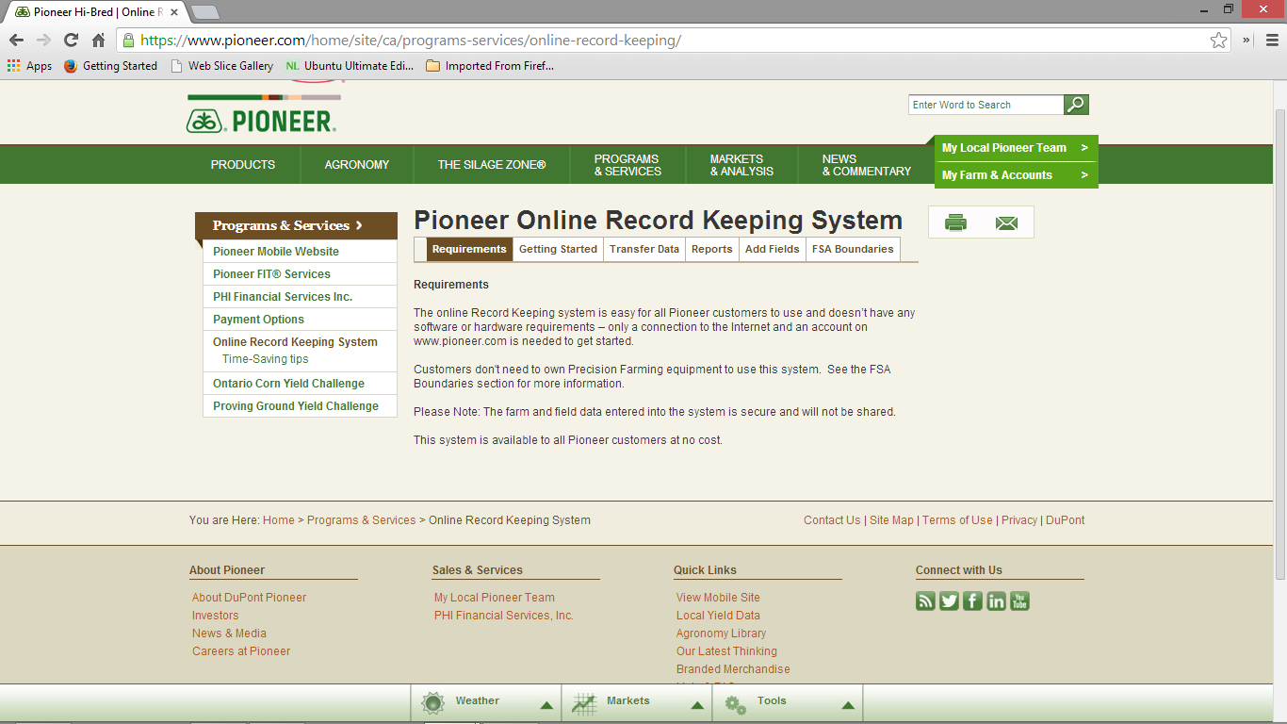

Figure 3- Pioneer Online record Keeping System site

**2.3.4 iCow**

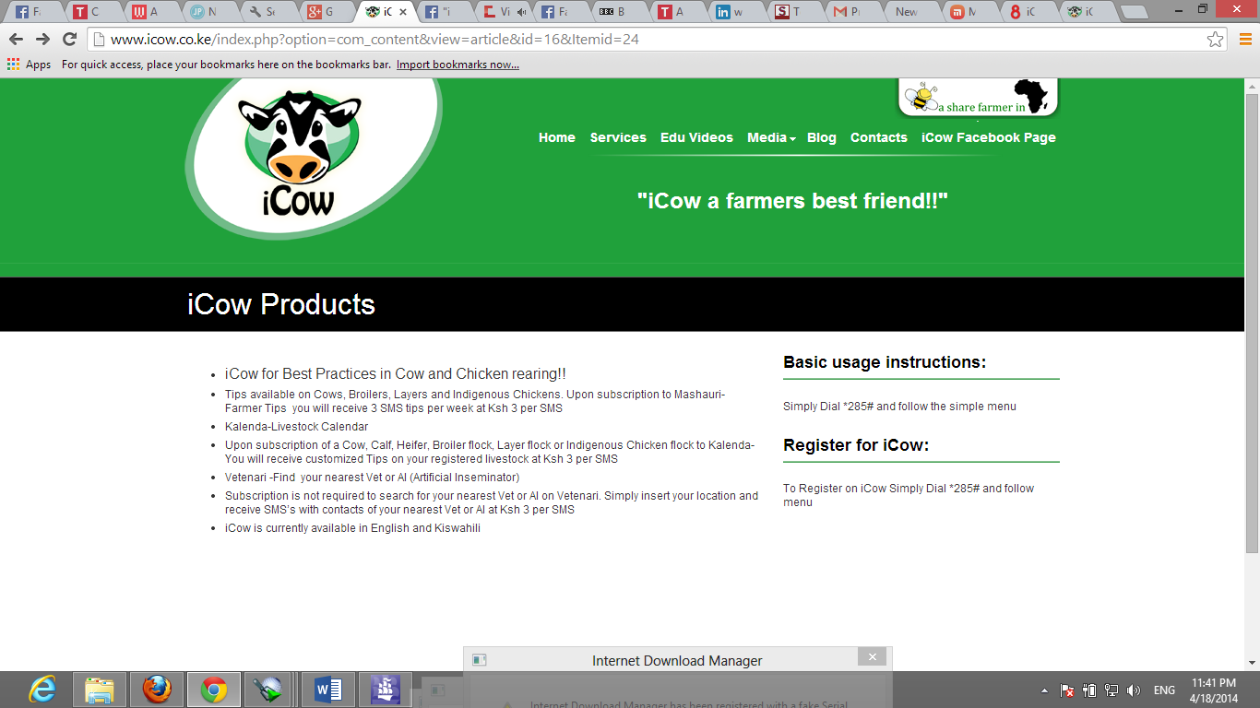

Figure 4- iCow site

iCow is an agricultural information service with a variety product available through subscription service *285# to help farmers improve productivity.

It provides services as Mshauri-Farmers tips where a registered farmer can subscribe tips on cows, broilers, layers and indigenous chickens. In addition, Vetinari, it finds the nearest vet or Artificial Inseminator and Kalenda which is a livestock calendar that monitor your livestock through its growth life and provides tips to the farmer as SMS. The tips include health information service, diet information service, nutrition information service, illness and disease information services and provides record keeping for milk production.

For the Online dairy Farming record management system it provides record keeping services for not only milk records but also calving, insemination, feeding, health, cow detail records. In addition, it provides analysis of the milk production for the cows, provide farmers with a reminder service whereby they can set their activities to be reminded through sms, and provides storage of financial records of the farmer, this includes expense and income and provide analysis. The system can be accessed both online and using the sms service.

**3.0 METHODOLOGY**

## The system was implemented using Modified Waterfall Methodology. This methodology allows adjustments to a set of requirements unlike the pure waterfall methodology. The phase of development are permitted to overlap hence a number of tasks can function concurrently and allows back tracking to incorporate changes in the requirements based on what is learned during development. There is also some flexibility to correct mistakes and make small change realised during the development. This ensured that the system was developed in a systematic and sequential manner.

## 3.1 APPROACH

## 3.1.2 REQUIREMENTS SPECIFICATION AND ANALYSIS

This is a stage of the System development lifecycle which involved collection of information that was relevant for the development of the system and then analysis of the data and information to build a logical model of the system that was used in the design phase. It involved carrying out a feasibility study to determine the operational, economic, schedule and time feasibility of development of the project. The acquisition of data and information of the system requirements involved interviewing farmers, observation and document review. The fact-finding result was used to develop the system logical model that explains the system functionality. Data Flow Diagrams and Entity Relational Diagrams were used to represent the logical model.

**3.1.2 DESIGN**

This stage involved the creation of a physical model that satisfied the entire documented requirement for the system. At this stage, the user interface was designed and the identified necessary outputs, inputs, and processes. In addition, it involved determining the application architecture to transform the logical design into program modules and code.

**3.1.2 IMPLEMENTATION AND CODING**

This stage involved the translation of the developed designs into an actual system using programing language. It being a web application, it was developed using of programming languages: MySQL, PHP, HTML and CSS to achieve both the defined functionalities and user interface requirements.

**3.1.2 TESTING and EVALUATION**

At every stage of development there was validation and verification of the requirements. After completion of development of the system it was be tested to verify it is working in a credible manner. Testing involved both white box test and black box test. In addition, evaluation of the system will be carried out to ensure all functionalities of the system works as desired and produces expected outputs for specified inputs.

**4.0 SYSTEM ANALYSIS**

It involves investigating a system, identifying the problems and using the information recommended to system. Also the understanding of how things are done and checking if the proposed system would be viable. System analysis involves:

1. Data Collection
2. Feasibility Analysis
3. Requirements Analysis
4. System Modelling

**4.1 Data Collection**

Data collection was conducted in few homesteads in Murang’a County which practised dairy farming. It was carried out to collect information from the dairy farmers about the proposed system. The following methods were used for data collection:

1. Informal interview
2. Observation
3. Written Documents and Online Documents.

**4.1.1 Informal Interview.**

Dairy farmers were interviewed to obtain information and their view about the development of the system. In addition, what records they kept for their cattle, access to internet services and if they were able to assess the profitability of their farming.

Findings from the interview:

Most of the farmers kept records on the milk they sold. They wrote it down on an exercise book and cancelled off when they got paid. All the farmers interviewed had mobile phones and could use the sms service. Records on insemination and treatment, they just kept the receipt given by veterinary doctor. They had a challenge when they lost/misplaced the exercise book recorded amount of milk sold. Some had mobile phones which could access Internet services. Some of the farmers had challenges in knowing what profit they got from the farming. They responded positive on having a way they can store their records online.

**4.1.2 Observation**

From observation most of the farmers had average of 2 cows. Their milk production record was shallow, as it just included the amount of milk they had sold. From the receipts given by the veterinary doctors, got information on what the insemination record should contain.

**4.1.3 Written Documents and Online Documents**

Online and written documents were reviewed to get information on what records the dairy farmers should keep and the details of the records.

**4.2 FEASBILLITY ANALYSIS**

Feasibility analysis is the process by which project feasibility is measured. A feasibility study was done to find out whether the proposed system was viable in terms of economic, schedule, technical and operation feasibility.

This is the test of the proposed system in terms of its workability meeting users’ requirements, effective use of resources and cost effectiveness.

**4.2.1 Economic feasibility**

It involves checking whether the system would be affordable to build and maintain. In terms of the resources required; most of the tools are freely available and accessible. Once the system is deployed it has potential of generate income.

**4.2.2 Technological feasibility**

A technological feasibility study revealed that the technology required to develop the system is available and with the increase use of the internet and mobile phones, the system would be able to target a large number of farmers.

**4.2.3 Schedule feasibility**

According to the work schedule of completing this project, approximately 1.5 months has been allocated for the development of the system which is enough time to design, test and evaluate the system successfully.

**4.2.4**  **Technical feasibility**

This study involves checking the availability of hardware, software and personnel for building and running of the system. The proposed system was found to be technically feasible since it would not require staff to operate it and the required hardware and software to design and maintain the system is available.

**4.2.5 Operational Feasibility**

It was necessary to change the current method of storing records by farmers from manual to electronic. The target audience being farmers, having tips and help tools could assist them to easily use the system.

**4.3.1 Functional Requirements**

**Farmer**

1. Unregistered farmers can register.
2. Registered users’ can login in the system.
3. Registered farmers’ to add new cows’ details in the system.
4. Farmer can delete a record or update a record.
5. The farmer can set activities reminders and then get reminders via sms.
6. A farmer can generate reports from the record stored
7. A farmer can view records of his/her cows.
8. The farmer can update income, expense, and milk production records using the SMS service.

**System**

1. The system should interact with the SMS gateway to enable receiving and sending of messages to the users.
2. The system should send login password to the user via SMS.
3. The system should analyse the income and expenses of the farmer and send results via SMS.

**4.3.2 Non-functional requirements.**

1. The system should be secure, only authorized users are allowed to log in and use the system.
2. Efficiency response time performance and page generation speed.
3. The system should be usable, has tips displayed on each page and provide a concise interface for users.
4. The system should be reliable in user input validation.
5. The system should be stable, be available to multiple users who have logged in at the same time and using the system simultaneously.

**4.4 System Analysis Models**

**4.4.1 Use Case Diagrams**

These are diagrams that were used during the analysis phase to identify and split functionality of the system. They are made up ofactors and use cases. Actors represent the various external people or entities that interact with the system.

The use case of the system consists of one actor (farmer):

The activities carried by the farmer include:

1. Registering/ Login
2. Viewing records
3. Adding new cows details.
4. Updating records.
5. Deleting records.
6. Setting reminders.
7. Generating and viewing reports.

USER CASE DIAGRAM

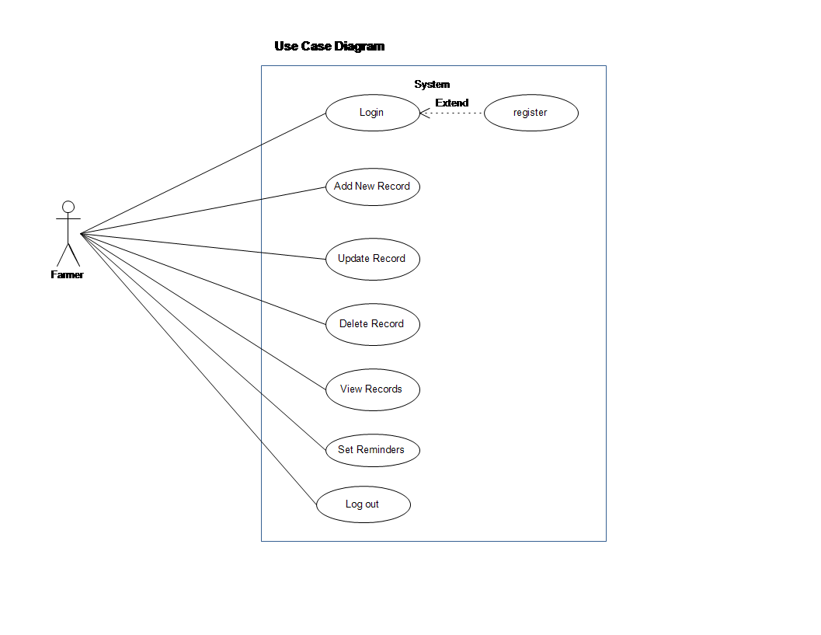

Fig 5. Use case diagram.

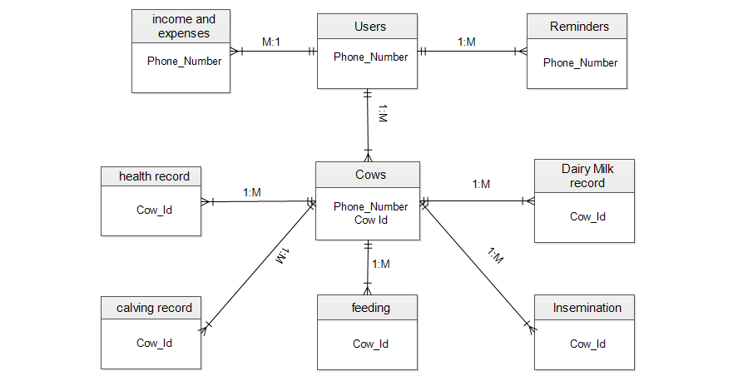

Fig 6. Entity Relationship Diagram

**5.0 SYSTEM DESIGN**

5.1 Architectural Design

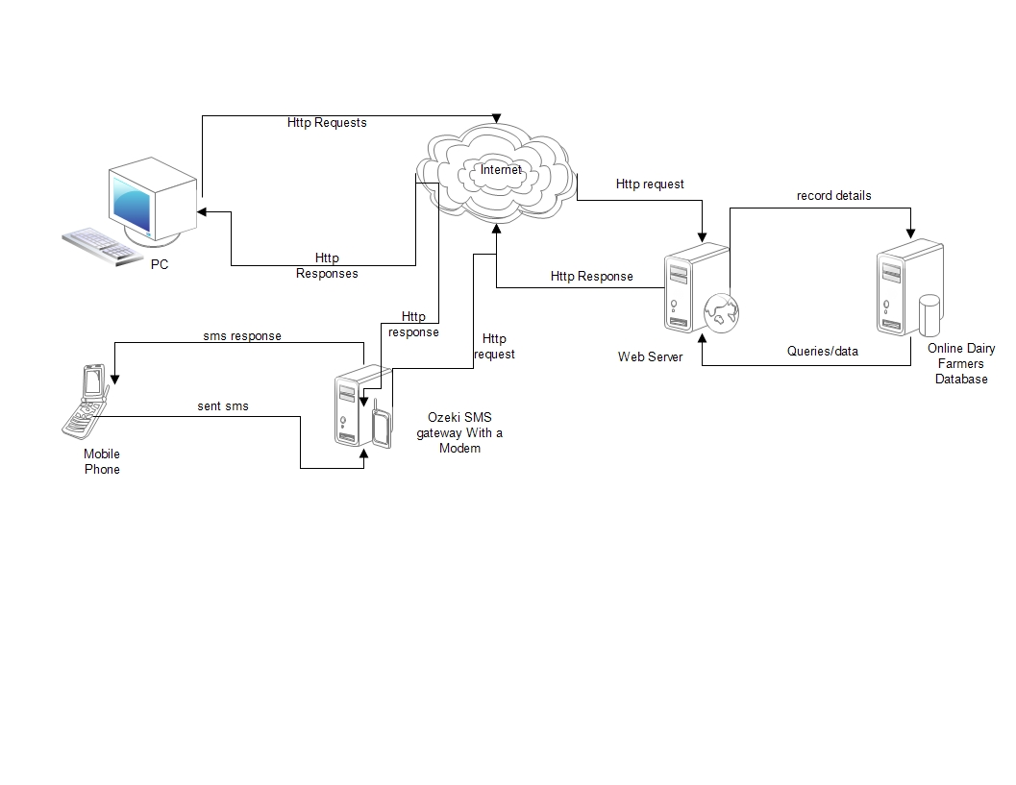

Fig 7. Architectural Design diagram

DATAFLOW DIAGRAMS

**Context Diagram**

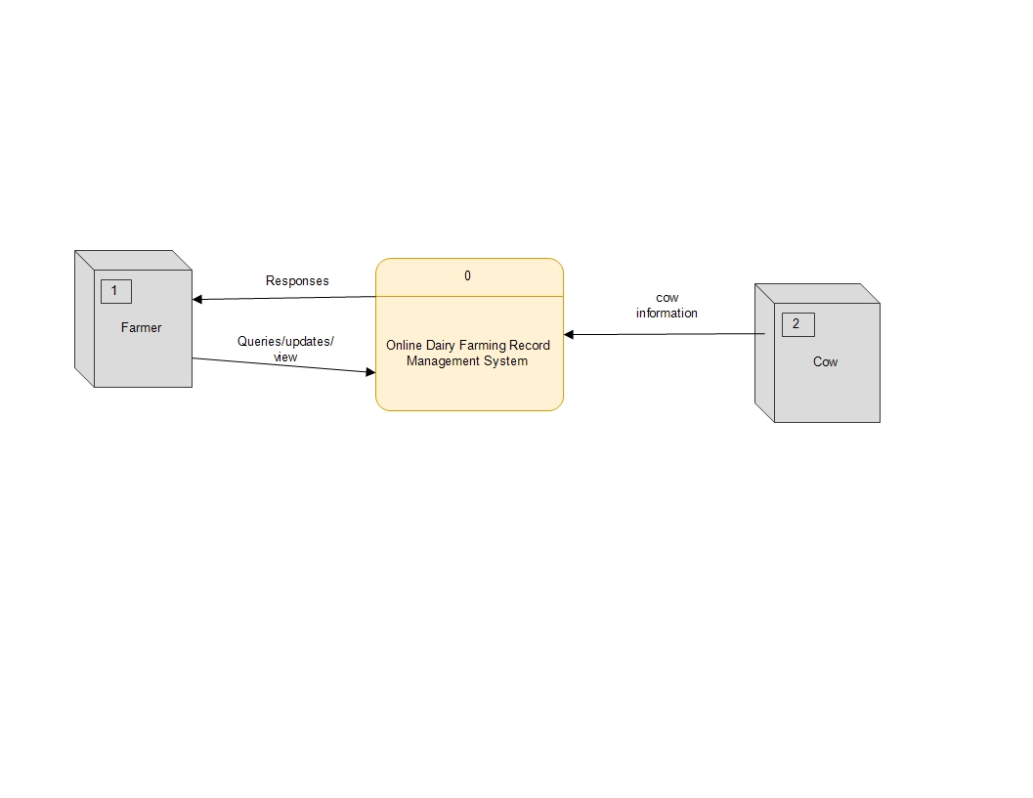

Fig 8. Contex diagram.

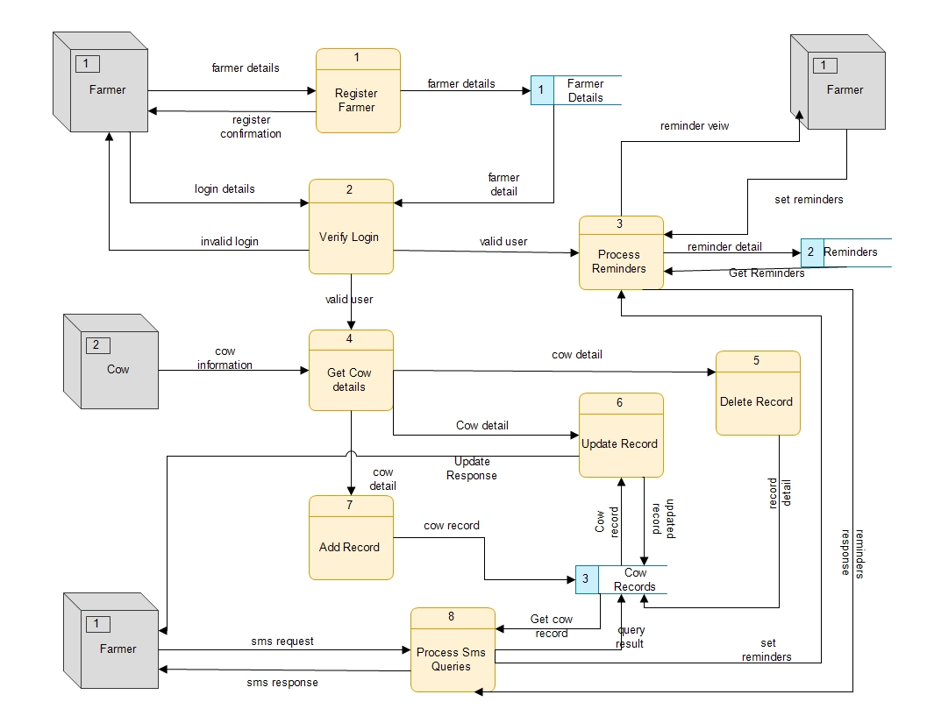

Fig 9 .Level 1 dataflow

**5.2 DATABASE DESIGN**

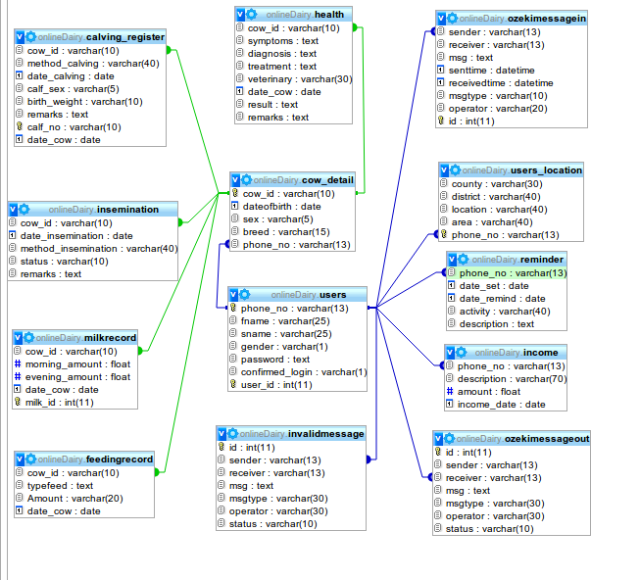

Fig 10. Database diagram

**5.3 USER INTERFACE DESIGN**

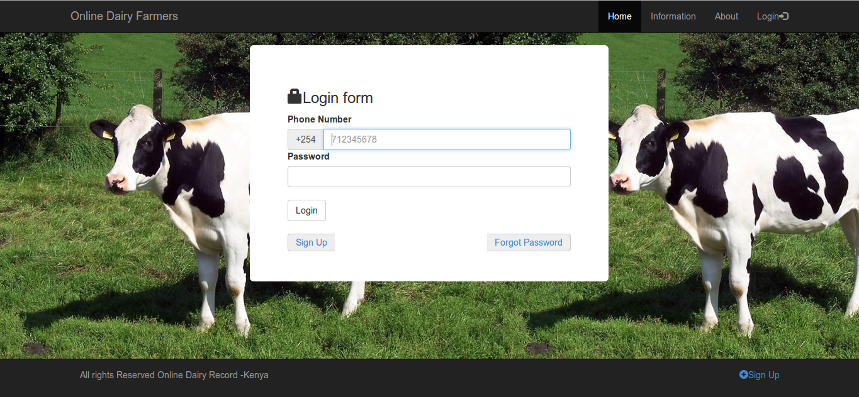

Fig 11. Login page

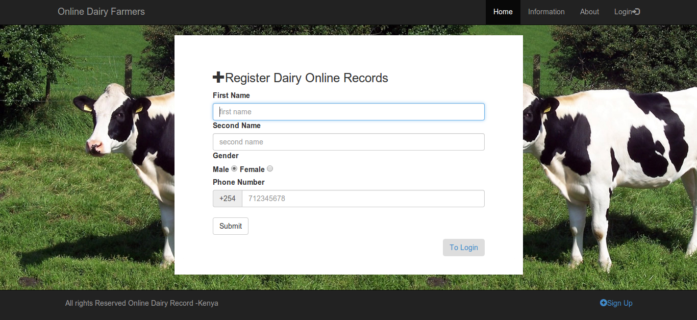

Fig 12. Registration page

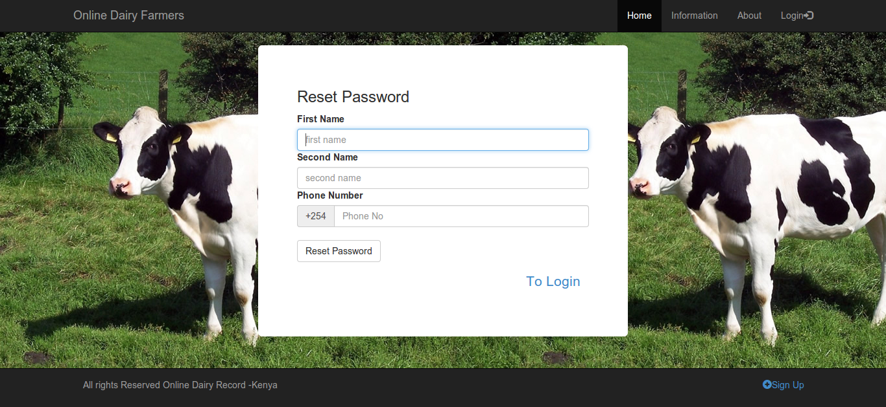

**Fig 13. Reset password page**

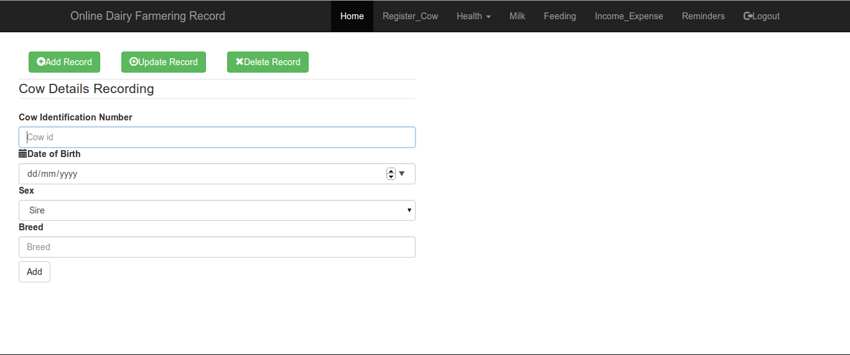

**Fig 14. Add cow record page**

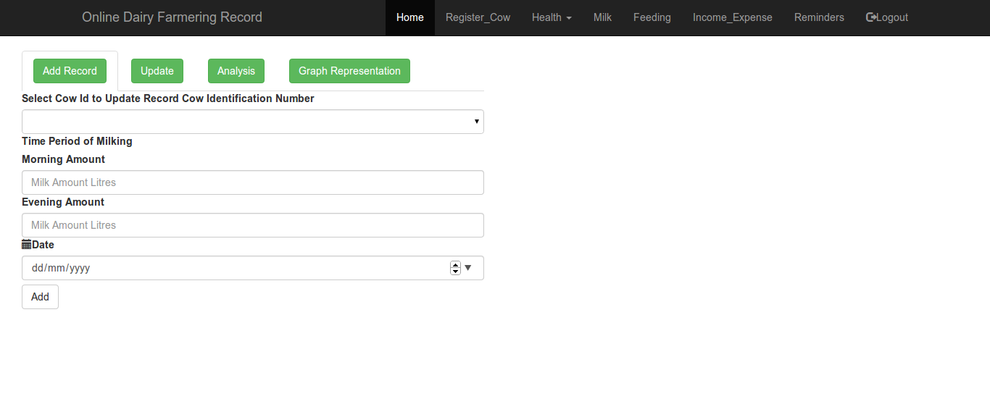

**Fig 15 .Add Milk record page.**

**6.0 SYSTEM IMPLEMENTATION AND TESTING**

**6.1 IMPLEMENTATION**

**6.1.1 RESOURSES**

The system was built using the following hardware and software resources:

|  |  |
| --- | --- |
| **HARDWARE** | DELL 1545, Intel 2 duo, 4.0GB RAM, 320 GB Hard Drive |
|  | Airtel Modem HSPA and Airtel SIM Card |
| **SOFTWARE** |  |
| Operating system | Ubuntu 12.04 LTS |
| Documentation software | Microsoft Office 2013. |
| Back Up | Google Drive |
| Software design Software | Edraw 7.0 |
| LAMP Server | Apache, PHP 5, MySQL |
| Programing Languages | HTML 5, CSS, JavaScript |
| Cron Jobs | Ubuntu Scheduler |

**6.1.2 Choice of Programming Tools, Techniques and Technologies.**

1. **PHP (Server side) CodeIgnitor Framework**

The entire system server side was built on CodeIgnitor PHP framework. It was the choice because of its efficiency and implements PHP Object Oriented Programming paradigm. Also, it uses MVC (Model, View, and Controller) design pattern, which made the system to have a clear structure, easily extensible and maintainable. It has also inbuilt security features that protects from web application attacks such as Cross Side scripting (XSS) and SQL injection.

Benefits of using PHP sever scripting language over other scripting language as Microsoft’s ASP.NET

1. It is open source meaning it the source code is free to download and use. Thus makes the development cost cheaper.
2. It is portable meaning is available for different Operating Systems.
3. It is also interfaces with many databases such as Sybase, MySQL, PostgreSQL and oracle relational database.
4. MySQL

MySQL was the preferred choice because it is very fast, robust relational database management system. It allows one to easily store, search, sort, and retrieve data.

Some of the strengths of using MySQL include the following:

1. MySQL is available freely under an open source license and at a low cost under a commercial license.
2. It is easy to use because most modern databases use structured query language (SQL).
3. MySQL source code can also be downloaded, used and redistributed freely.
4. It is portable and can easily be used in both Windows and UNIX operating systems
5. HTML5, CSS and JavaScript

The client side of the web application was the desktop browser and thus the technologies of choice were HTML5, CSS and JavaScript. JavaScript and JQuery were used because of their speed and their code syntax is precise.

1. SMS Gateway

Ozeki NG SMS gateway was incorporated to the system so as it can provide clients with some of the services offered in the web application through SMS. It was of choice because of robustness and speed in sending and receiving sms. Also the gateway is platform independent and could be linked to the system using HTTP connection.

1. Scheduler-Cron jobs (Ubuntu Application).

Using Cron job, which is a feature configurable in Linux Operating System. It was used for checking activity dates of the reminders daily and then sending the details of the activity to the farmers through sms if the activity date was the day that followed. Scheduling of activity dates using the Scheduler is easy and reliable.

1. Google Charts.

It is an online application programming interface that was used in the system for drawing the line graphs. It was of choice because it is open source, its usage is easy and provides detailed graphical representation of data.

1. Bootstrap

It is a CSS framework that was used in design the client side of the application. It was of choice because it is easy to use and has a lot of formatting features.

1. Google Drive.

It was used throughout the development of the project for backing up of the project files and directories to prevent any anticipated risk of loss of data. It was of choice because it provides 15GB capacity which is free, having a Gmail account.

1. Sublime Text.

It was the editor application that was in coding the system. It was preferred because it open source and provides formatting styles which makes the code readable and easy to debug errors in the code.

**6.1.3 Code Structure & Organization**

1. Use of the Sublime Text Editor

All the code was well structured and formatted following best practices for coding. Notably, indentation and inline commenting was adequately used making the code very readable.

1. The modal, View and Controller Pattern

Because of the MVC design pattern used, my code was mainly arranged within the models, views and controllers folder as stipulated by the framework. The CSS and JavaScript code is orderly arranged in their respective folders too.

**6.1.4 Security Features of the System.**

The system employs various form of securing data. Some of the ways include:

1. CodeIgnitor Inherent Security feature.

There is an inherent security feature that is inbuilt within the framework used to develop this system. This feature mainly prevents the system against SQL injection and XSS which are the most common attacks on web applications. Every input in the system goes through a Form Validation class that validates against the attacks and validates the data. Also at the SQL level, the Database Active Records class cleans the SQL statements first before execution, to prevent SQL injection.

1. Securing Passwords and Validation of the users.

The user passwords are secured by encrypting them using the md5 cryptography algorithm.

There is validation of the user’s mobile phone numbers as the passwords are sent to the users via sms to validate that the phone number they are using is theirs and it’s valid.

**6.1 TESTING**

The testing phase primarily focused on identifying mistakes, errors or bugs in the code and trying to correct them. Testing was done incrementally starting from the most basic components of the system and progressing until the system is tested as a single unit.

The system was tested in three phases:

1. **Unit testing** - This involved testing each and every component that make up the Online dairy Farmers Recording System (ODFRS). Both black box and white box testing were employed.
2. **Integration testing-** When all the modules were developed, they were tested if they communicated together. Testing was done to check whether the Ozeki NG gateway was working together and correctly with the sms handling module of the system.
3. **System testing-** System testing involves testing the system as a whole complete unit. This involved testing the system with all components, to check the functionalities were executing correctly and worked as required.

# 7.0 CONCLUSION AND RECOMMENDATIONS

This chapter focuses on the major achievements of the system, problems encountered during the development process and a description of what can be done to further improve the system.

## 7.1 ACHIEVEMENTS OF THE SYSTEM

The system has been able to meet user requirements and objectives initially set out in the following ways:

1. The system allow farmer to register and be able to store dairy records for cows.
2. The system provides financial analysis of the income and expense data for the farmers. It shows the total expenses, total income and the profit with a specified period of time.
3. The system also provides reports of the data of the records and the farmers can be able to download it in pdf format or excel format.
4. The system enable the farmers to be able to update or query their records via sms. Farmer are can be able to update their milk record, financial record and set reminders via sms. In addition,

Farmer can query easily data of their financial records and milk record via sms.

1. The system is enable user to set a reminder of their activities in the system and be reminded of the activity a day before.

## 7.2 CHALLENGES DURING DEVELOPMENT

There were several constraining factors encountered in the development process of the system despite its completion. These factors included:

1. Some of the features of the system required internet connection to work which made testing in absence of an internet connection difficult e.g. Google charts application interface.
2. A considerable amount of time was spent learning new technologies which delayed the system implementation process. e.g. use the sms gateway and the Google charts api.

## 7.3 RECOMMENDATIONS

The following are suggestions of improving the system in the future:

* They system be fully integrated with Kenya’s CDF databases so as to provide real and accurate information about CDF usage so that monitoring can be done practically.
* The system should have a mobile portal since most users own a mobile phone that is internet enabled and it is easier for them to access the site anywhere on their mobile devices.

## 7.4 CONCLUSION

Despite several challenges faced during the system development process, it is evident that most of the system objectives and user requirements were met. Several ways of improving the system are also available such as mobile-based applications. This shows that there is still more room for improvement and growth of the system in the near future.

## 6.0 RESOURCES

The development and deployment of this web application will require hardware and software

Resources as listed below.

### 6.1 HARDWARE

1. Personal Computer 64 bit
2. Hard Disk 320GB
3. RAM 4GB
4. GSM modem (Airtel).

### SOFTWARE

1. Ozeki SMS Gateway server.
2. Operating System (Linux Ubuntu 12.04)
3. LAMP Server.
4. CodeIgniter, PHP framework.
5. Gantt Project Management software.
6. Sublime Text Editor
7. E-Draw

**7.0 PROJECT WORK PLAN**

## 7.1 Project timeline

To implement the research project proposed, the following project timeline will be observed.

|  |  |  |  |  |
| --- | --- | --- | --- | --- |
|  | **Task** | **Scheduled Begin Date** | **Scheduled End date** | **Duration** |
| 1 | Proposal writing | 17/2/2014 | 23/2/2014 | 4 days |
| 2 | Requirements elicitation and Data Analysis | 24/2/2014 | 28/2/2014 | 5 days |
| 5 | System Design | 1/3/2014 | 6/3/2014 | 5 days |
| 6 | Implementation | 7/3/2014 | 31/3/2014 | 24 days |
| 7 | Testing | 1/4/2014 | 2/4/2014 | 1 days |
| 8 | Documentation | 2/4/2014 | 6/4/2014 | 5 days |

**7.2 GANT CHART**

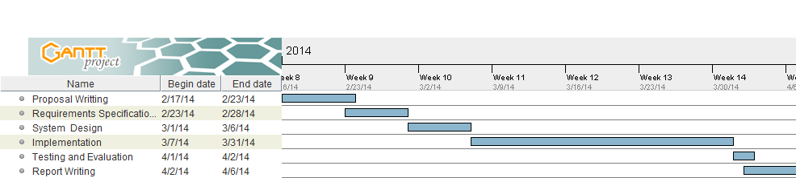

**8.0 REFERENCES AND BIBILIOGRAPHY**

1. Ministry of livestock development. (2006). Annual Report.
2. Ministry of livestock development. (2006). Small holder Farmers Guide to Dairy Farming as a Business.
3. USAID. (2008). Kenya Dairy Sector competitiveness program: Milk shed Assessment and small business organization needs analysis. Land O Lakes/ Fibec limited Report
4. Thorpe W., Muriuki, H. G., Omore, A., Owango, M.O. and Staal, S. (2000). “Dairy Development in Kenya: The past, the present and the future”. Paper presented at the Annual Symposium of the Animal Production Society of Kenya, Nairobi.
5. Moran J.(2009), Business Management For Tropical Farmers. Land Links Press, Colloywood, Australia.
6. Muriuki, H, G. (2003). Milk and Dairy Products, Post-harvest Losses and Food Safety in Sub-Saharan Africa and the Near East, a Review of the Small Scale Dairy Sector – Kenya. Rome, Italy: Food and Agricultural Organization.
7. Brannstorm A.J., (2006). Using Farm Records Effectively For Business & Financial Management. Faculty , UW Centre for Dairy profitability.
8. Muhammad, S., Tegegne, F., Ekanem, E. (2004). Factors Contributing to Success of Small Farm Operations in Tennessee, Institute of Agricultural and Environmental Research Tennessee State University Nashville, Tennessee, Journal of Extension.
9. Tranel, L, F. (2002). Managing Dairy Farm Finances. IOWA State University Cooperative Extension
10. Pakistan’s 1st Online Dairy Farming Guide. [www] <http://www.pakdairyinfo.com/record.htm>. (Accessed on February 02, 2014).
11. AgSquared. [www] <http://www.agsquared.com/> (Accessed on February 14, 2014).
12. Pioneer Online Record Keeping System. [www] <https://www.pioneer.com/home/site/ca/programs-services/online-record-keeping/>. (Accessed on February 14, 2012).
13. Pocket Dairy Android Application. [www] <http://www.drms.org/pocket.aspx> (Accessed on February 14, 2014).
14. iCow. [www]. <http://www.icow.co.ke/>. (Accessed on 12/4/2014)