ECEN 454 – Lab 2: Cadence Custom Layout: Design Rules, Extraction, and Verification

Faizan Bangash
Section 506
TA: Lin Huang
DUE: 18 September 2018
------------------------------------------------ INVERTER ---------------------------------------------------

Schematic:
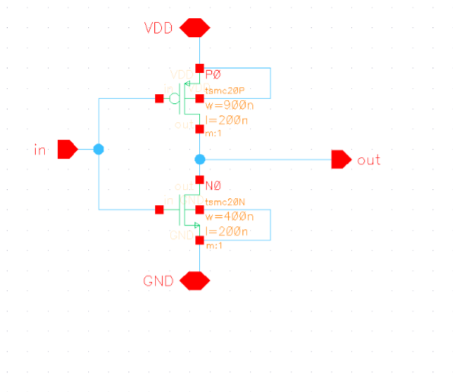

Symbol:
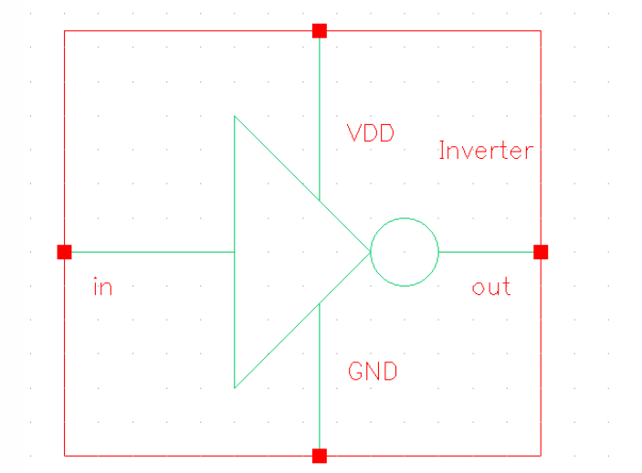

Extraction -
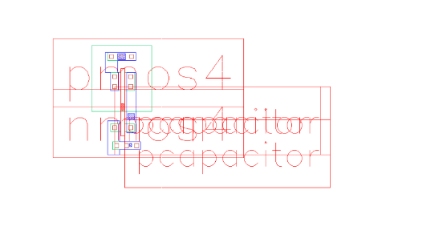

Layout:
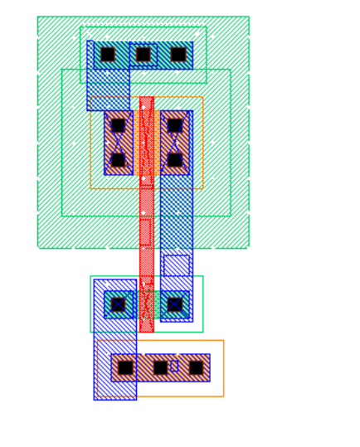

LVS-Output:

@(#)$CDS: LVS version 6.1.7-64b 09/15/2018 15:46 (sjfhw310) $

Command line: /softwares/Linux/cadence/IC617/tools.lnx86/dfII/bin/64bit/LVS -dir /home/ugrads/b/bangashfaizan1/Desktop/ecen-454/lab-1/LVS -l -s -t /home/ugrads/b/bangashfaizan1/Desktop/ecen-454/lab-1/LVS/layout /home/ugrads/b/bangashfaizan1/Desktop/ecen-454/lab-1/LVS/schematic Like matching is enabled.

Net swapping is enabled.

Using terminal names as correspondence points.

Compiling Diva LVS rules...

Net-list summary for

/home/ugrads/b/bangashfaizan1/Desktop/ecen-454/lab-1/LVS/layout/netlist

count

- nets

- terminals

1pmos
- nmos

Net-list summary for

/home/ugrads/b/bangashfaizan1/Desktop/ecen-454/lab-1/LVS/schematic/netlist

count

- nets

- terminals

- pmos

- nmos

Terminal correspondence points

N0 | N2 | GND
N3 | N0 | VDD
N2 | N1 | in
N1 | N3 | out

Devices in the netlist but not in the rules:

pcapacitor

Devices in the rules but not in the netlist:

cap nfet pfet nmos4 pmos4

The net-lists match.
 | layout schematic
 | instances
un-matched |  | 0 | 0
rewired |  | 0 | 0
size errors |  | 0 | 0
pruned |  | 0 | 0
active | 2 | 2
total | 2 | 2
 | nets
un-matched |  | 0 | 0
merged |  | 0 | 0
pruned |  | 0 | 0
active | 4 | 4
total | 4 | 4

 | terminals
un-matched |  | 0 | 0
matched but
different type |  | 0 | 0
total | 4 | 4

Probe files from /home/ugrads/b/bangashfaizan1/Desktop/ecen-454/lab-1/LVS/schematic

devbad.out:

netbad.out:

mergenet.out:

termbad.out:

prunenet.out:

prunedev.out:

audit.out:

Probe files from /home/ugrads/b/bangashfaizan1/Desktop/ecen-454/lab-1/LVS/layout

devbad.out:

netbad.out:

mergenet.out:

termbad.out:

prunenet.out:

prunedev.out:
audit.out:

------------------------------------------------- NAND ----------------------------------------------------
Schematic: 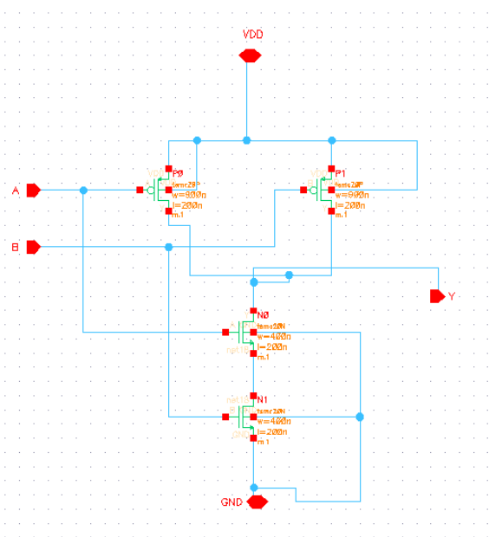

Symbol:
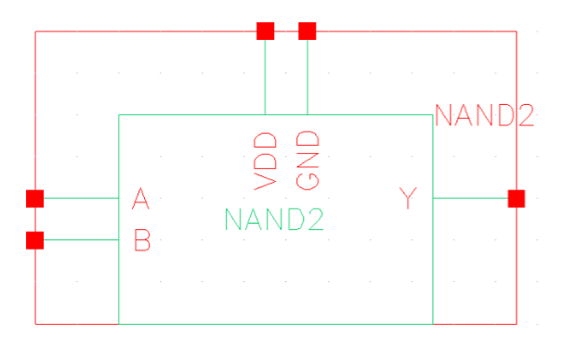
Extraction :
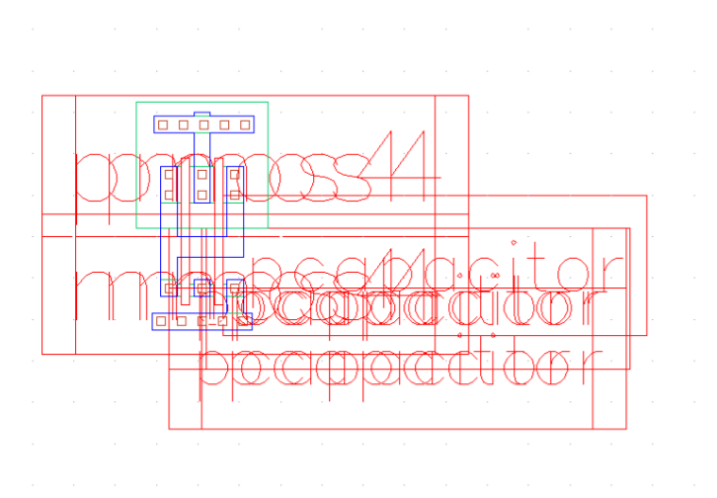
Layout:
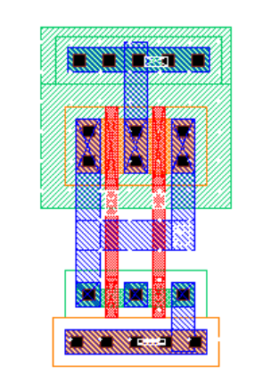
LVS-Output:

@(#)$CDS: LVS version 6.1.7-64b 09/15/2018 19:32 (sjfhw310) $

Command line: /softwares/Linux/cadence/IC617/tools.lnx86/dfII/bin/64bit/LVS -dir /home/ugrads/b/bangashfaizan1/Desktop/ecen-454/lab-1/LVS -l -s -t /home/ugrads/b/bangashfaizan1/Desktop/ecen-454/lab-1/LVS/layout /home/ugrads/b/bangashfaizan1/Desktop/ecen-454/lab-1/LVS/schematic Like matching is enabled.

Net swapping is enabled.

Using terminal names as correspondence points.

Compiling Diva LVS rules...

Net-list summary for

/home/ugrads/b/bangashfaizan1/Desktop/ecen-454/lab-1/LVS/layout/netlist

count

- nets
- terminals

- pmos

- nmos

Net-list summary for

/home/ugrads/b/bangashfaizan1/Desktop/ecen-454/lab-1/LVS/schematic/netlist

count

- nets

- terminals

- pmos

- nmos

Terminal correspondence points

N4 | N5 | A
N3 | N0 | B
N2 | N1 | GND
N5 | N3 | VDD
N1 | N2 | Y

Devices in the netlist but not in the rules:

pcapacitor

Devices in the rules but not in the netlist:

cap nfet pfet nmos4 pmos4

The net-lists match.
 | layout schematic
 | instances
un-matched |  | 0 | 0
rewired |  | 0 | 0
size errors |  | 0 | 0
pruned |  | 0 | 0
active | 4 | 4
total | 4 | 4
 | nets
un-matched |  | 0 | 0
merged |  | 0 | 0

pruned |  | 0 | 0
active | 6 | 6
total | 6 | 6
 | terminals
un-matched |  | 0 | 0
matched but
different type |  | 0 | 0
total | 5 | 5

Probe files from /home/ugrads/b/bangashfaizan1/Desktop/ecen-454/lab-1/LVS/schematic

devbad.out:

netbad.out:

mergenet.out:

termbad.out:

prunenet.out:

prunedev.out:

audit.out:

Probe files from /home/ugrads/b/bangashfaizan1/Desktop/ecen-454/lab-1/LVS/layout

devbad.out:

netbad.out:

mergenet.out:

termbad.out:

prunenet.out:

prunedev.out:

audit.out:
-------------------------------------------------- XOR ----------------------------------------------------

Schematic: 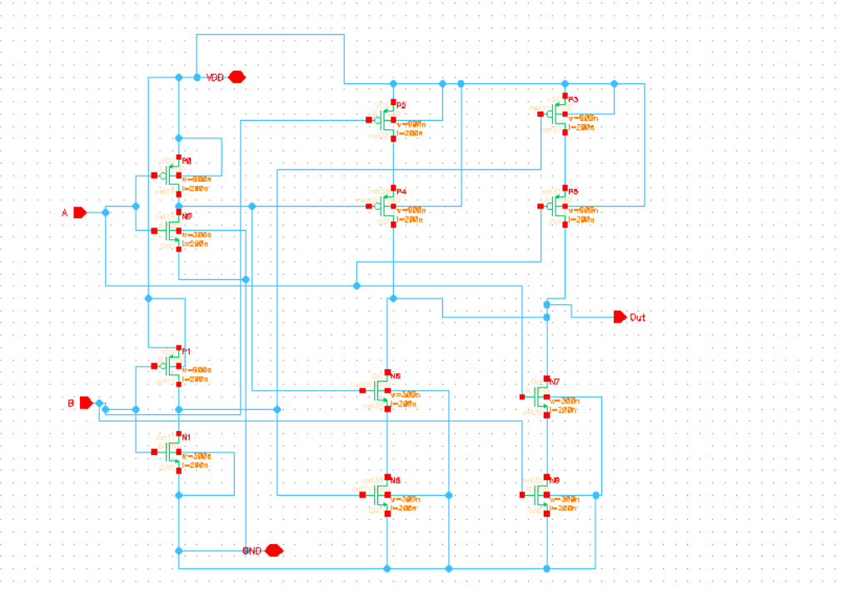

Symbol: 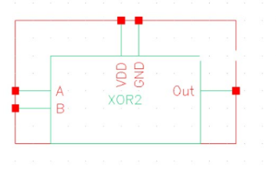

Extractions:
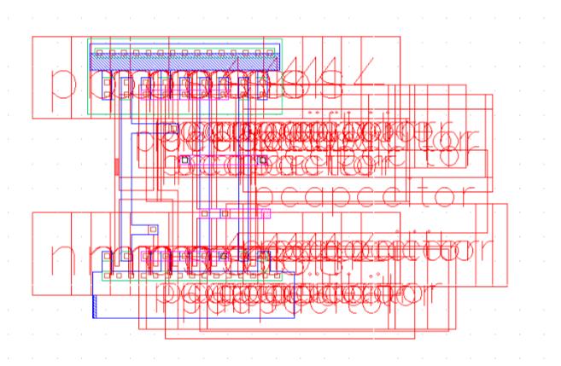
Layout:
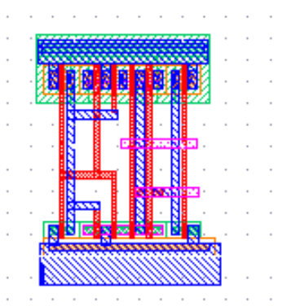
LVS-Output:

@(#)$CDS: LVS version 6.1.7-64b 09/17/2018 16:43 (sjfhw310) $

Command line: /softwares/Linux/cadence/IC617/tools.lnx86/dfII/bin/64bit/LVS -dir /home/ugrads/b/bangashfaizan1/Desktop/ecen-454/lab-1/LVS -l -s -t /home/ugrads/b/bangashfaizan1/Desktop/ecen-454/lab-1/LVS/layout /home/ugrads/b/bangashfaizan1/Desktop/ecen-454/lab-1/LVS/schematic Like matching is enabled.

Net swapping is enabled.

Using terminal names as correspondence points.

Compiling Diva LVS rules...

Net-list summary for

/home/ugrads/b/bangashfaizan1/Desktop/ecen-454/lab-1/LVS/layout/netlist

count

11 nets

- terminals

- pmos

- nmos

Net-list summary for

/home/ugrads/b/bangashfaizan1/Desktop/ecen-454/lab-1/LVS/schematic/netlist

count

11 nets

- terminals

- pmos

- nmos

Terminal correspondence points

N8 | N0 | A
N7 | N3 | B
N6 | N4 | GND
N10 | N6 | VDD
N9 | N10 | out

Devices in the netlist but not in the rules:

pcapacitor

Devices in the rules but not in the netlist:

cap nfet pfet nmos4 pmos4

The net-lists match.
 | layout schematic
 | instances
un-matched |  | 0 | 0
rewired |  | 0 | 0
size errors |  | 0 | 0
pruned |  | 0 | 0
active | 12 | 12

total | 12 | 12
 | nets
un-matched |  | 0 | 0
merged |  | 0 | 0
pruned |  | 0 | 0
active | 11 | 11
total | 11 | 11
 | terminals
un-matched |  | 0 | 0
matched but
different type |  | 0 | 0
total | 5 | 5

Probe files from /home/ugrads/b/bangashfaizan1/Desktop/ecen-454/lab-1/LVS/schematic

devbad.out:

netbad.out:

mergenet.out:

termbad.out:

prunenet.out:

prunedev.out:

audit.out:

Probe files from /home/ugrads/b/bangashfaizan1/Desktop/ecen-454/lab-1/LVS/layout

devbad.out:

netbad.out:
mergenet.out:

termbad.out:

prunenet.out:

prunedev.out:

audit.out:

