**Lab 10: Automatic Place and Route Using SOC Encounter**

Faizan Bangash

Section 506

TA: Lin Huang

DUE: 27 November 2018

encounter.log –

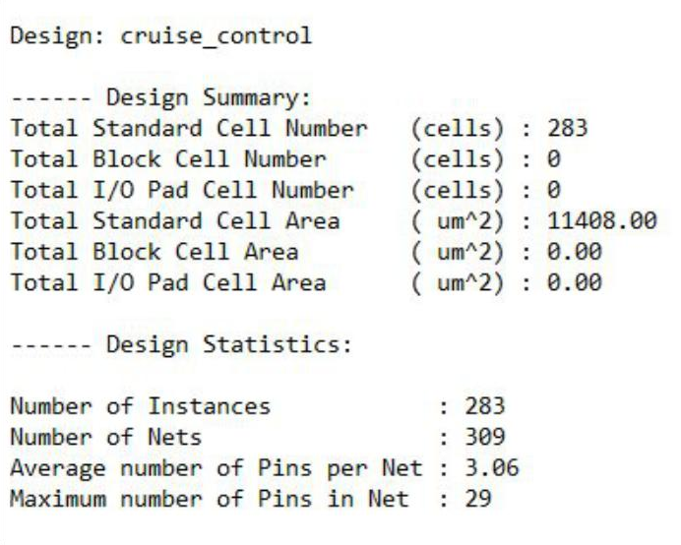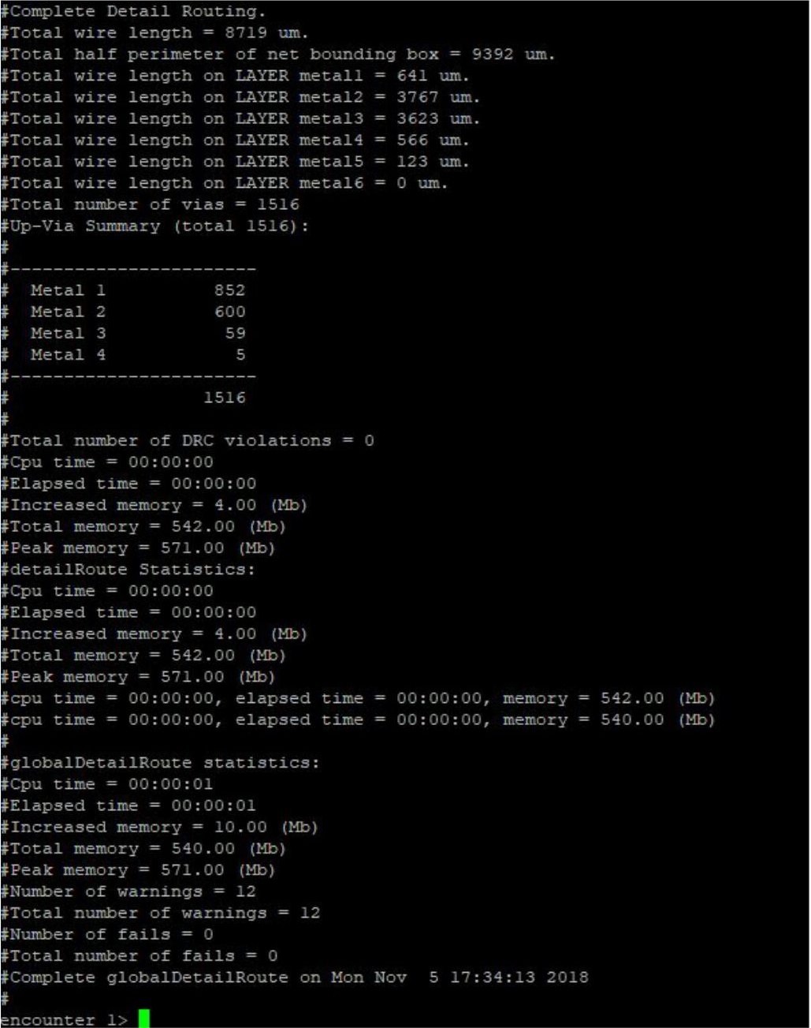

Total Wirelength: 8719 um

Number of Vias: 1516

Number of Standard Cells: 283

