**Lab 3 – Logic Minimization with K-Map**

Faizan Bangash

TA : Saurav Kumar Sahu

ECEN 248 – 302

June 26th, 2018.

**Objectives** –

In this lab, I used a breadboard to model the output productivity of a farm based on the four types of animals. I also learned how to simplify a truth table with k-maps to get a Boolean equation and use that to create a circuit. In doing so, I developed comprehensive understanding of how breadboard circuits work, as well as became familiar with the 8-digit output generator and DIP switches. This lab is a prime example of how digital circuits may be used to model real-world applications.

**Design –**

For part 1 of the lab, I modelled our breadboards after the given circuit diagram:

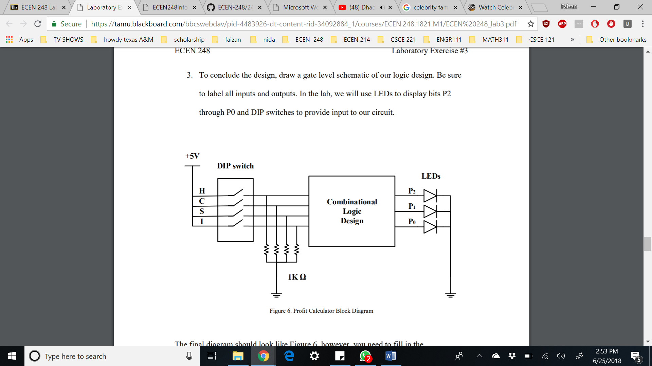

In part 1 of the lab, the circuit lit up each LED based on the input given at the DIP switch. I used the XOR, AND, OR, and INV gates to create the profit logic.

In part 2 of the lab, we used a binary decoder and a seven-segment display to assist in showing the profit from the farmer’s farm.

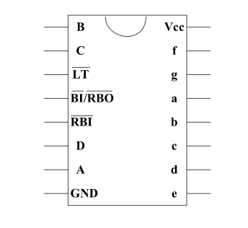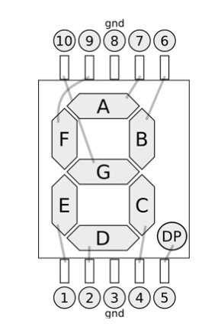

For part 2 of the lab, my breadboard was modelled based on this given circuit diagram:

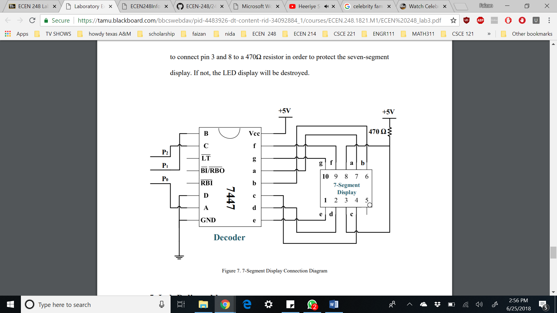

From here, I set up the profit logic to output P2 P1 or P0 depending on the current input and then I connected the input we got from P2, P1 and P0 to the decoder and seven-segment display.

**Results –**

In the lab, I successfully got the proper values with the valid and possible inputs. The outputs match outputs I expected.

|  |  |  |  |  |  |  |  |
| --- | --- | --- | --- | --- | --- | --- | --- |
| **H** | **C** | **S** | **I** | **P2** | **P1** | **P0** | **Output** |
| 0 | 0 | 0 | 0 | 0 | 0 | 0 | 0 |
| 0 | 0 | 0 | 1 | 0 | 0 | 1 | 1 |
| 0 | 0 | 1 | 0 | 0 | 1 | 0 | 2 |
| 0 | 0 | 1 | 1 | 0 | 1 | 1 | 3 |
| 0 | 1 | 0 | 0 | 1 | 0 | 0 | 4 |
| 0 | 1 | 0 | 1 | 0 | 1 | 1 | 3 |
| 0 | 1 | 1 | 0 | 1 | 1 | 1 | 7 |
| 0 | 1 | 1 | 1 | 0 | 1 | 1 | X |
| 0 | 0 | 0 | 0 | 0 | 1 | 1 | 3 |
| 1 | 0 | 0 | 1 | 0 | 1 | 1 | 3 |
| 1 | 0 | 1 | 0 | 1 | 0 | 1 | 5 |
| 1 | 0 | 1 | 1 | 1 | 0 | 1 | X |
| 1 | 1 | 0 | 0 | 1 | 1 | 1 | 7 |
| 1 | 1 | 0 | 1 | 0 | 1 | 1 | X |
| 1 | 1 | 1 | 0 | 1 | 0 | 1 | X |
| 1 | 1 | 1 | 1 | 1 | 1 | 1 | X |

Some of the outputs have a X for certain inputs because that input is impossible to get with the restrictions placed on the farmer. Even though the circuit outputs certain values for these inputs, it is not possible to do them in real life. The most efficient way John can maximize production is to raise cows and sheep, or cows and hogs. Their cumulative total comes to 7 production units.

**Conclusion –**

In this lab, I was able to take a complex situation and minimize it down to simple equations to create a combinational logic to represent profit of a farm. I also got more experience with an increased number of wires. learned how to manage a board with a lot going on and learned how important secure connections are. This lab taught me the real-world application of basic circuit design, as well as I familiarized myself with DIP switches and seven-digit display.

**Questions –**

1. **What values does your circuit output for the “don’t cares” and why?**

Outputs with overflow were the don’t cares. When we add Boolean numbers past their maximum capacity, and don’t have a way to store carries, we don’t care about them by default because they don’t display accurate data.