**ECEN 325 LAB 2**

**Faizan Bangash**

**Section 504**

**09-19-2018**

**Calculations –**

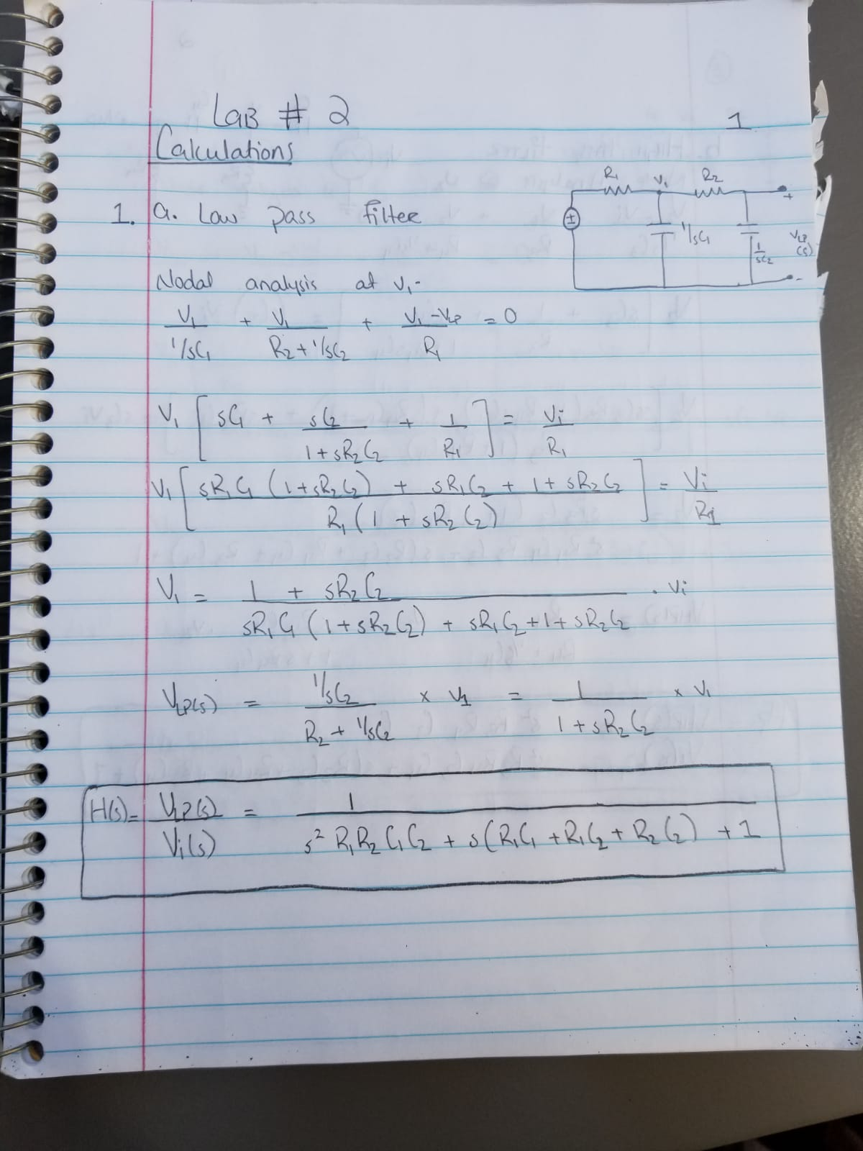

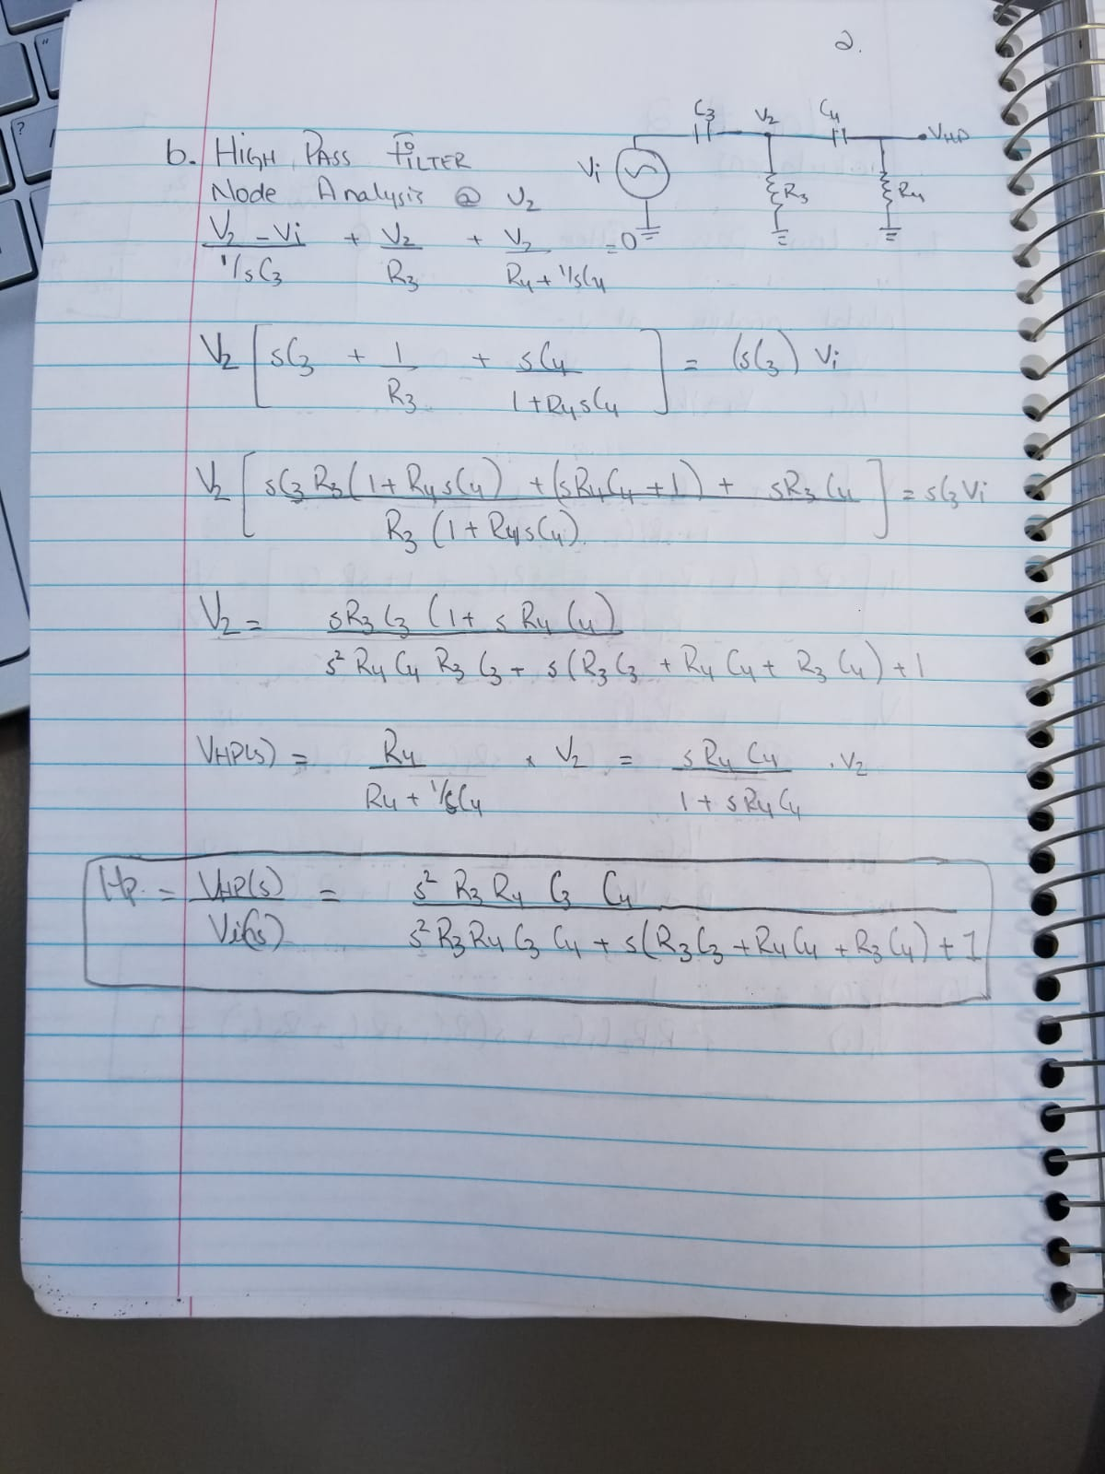

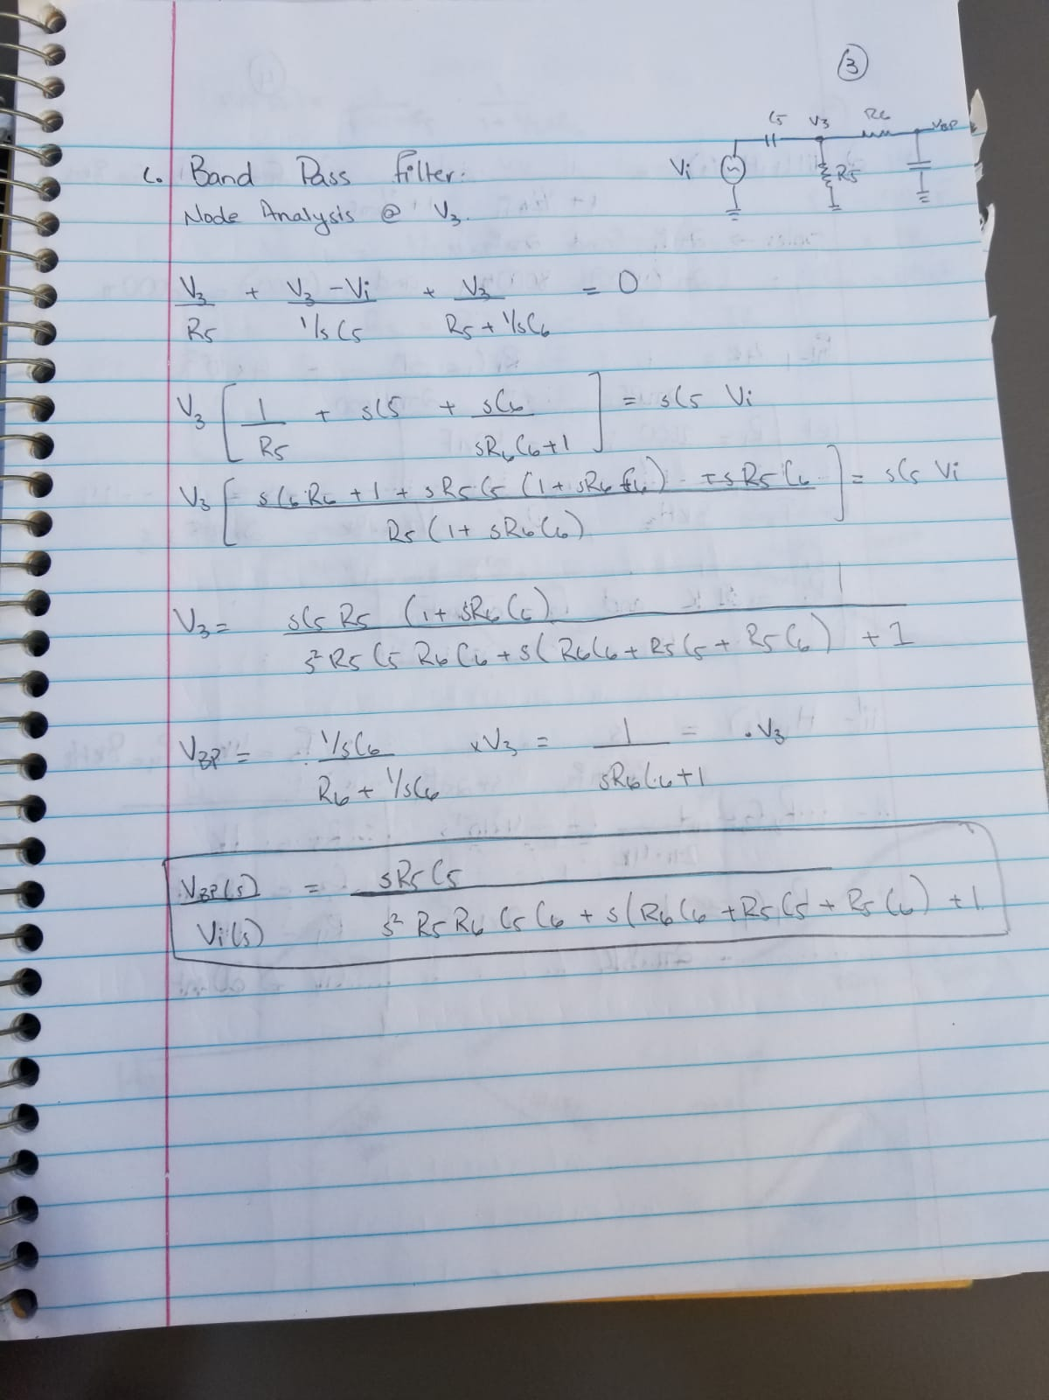

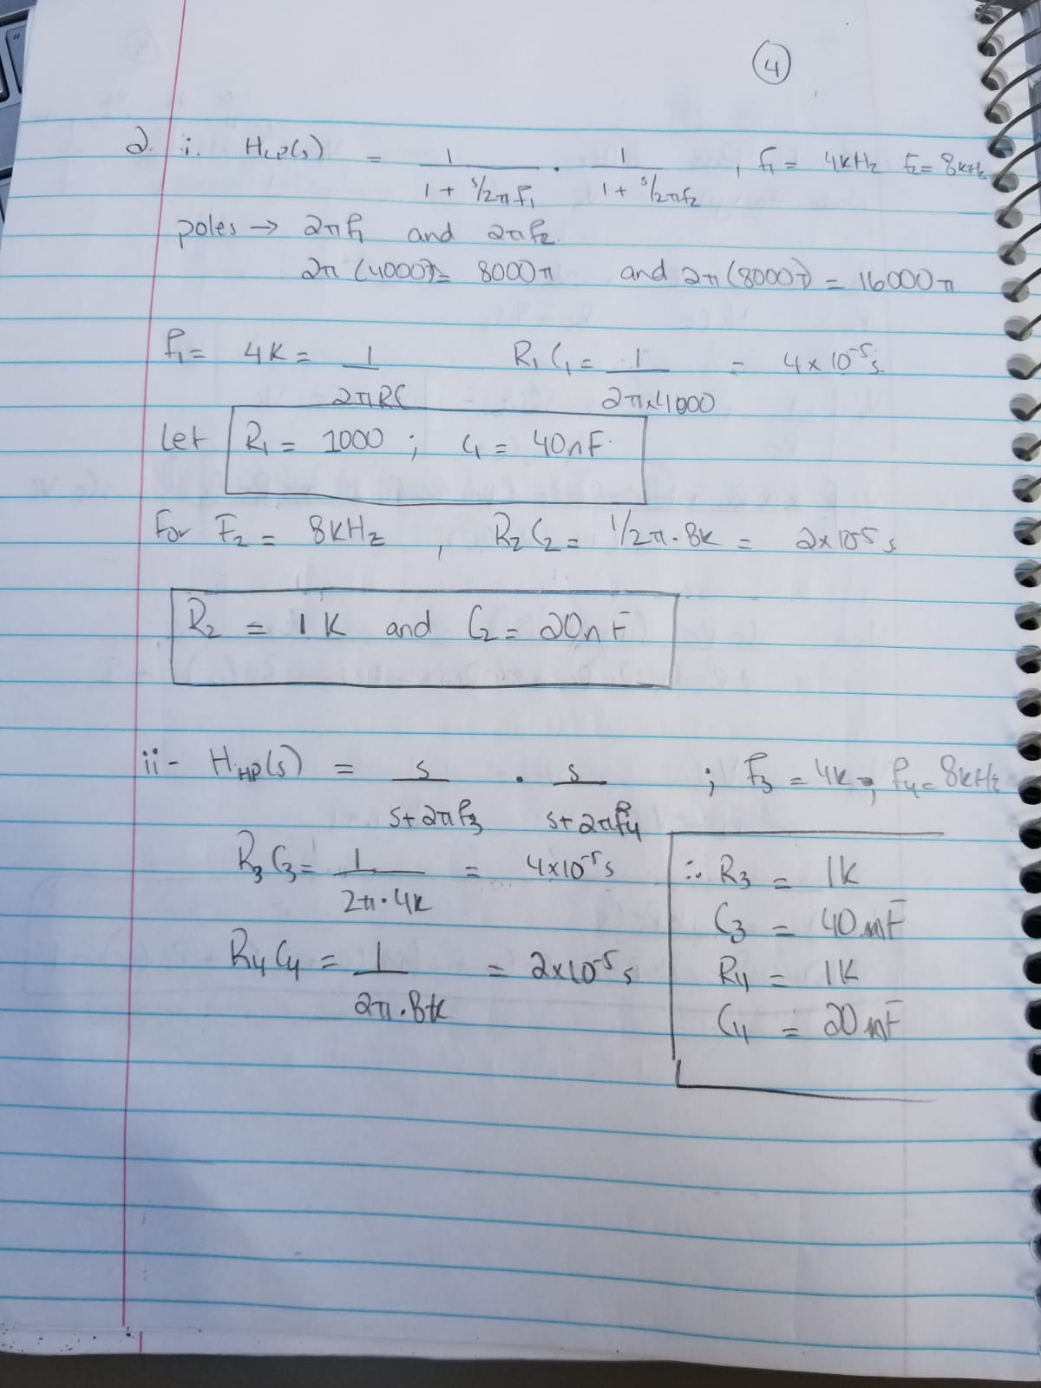

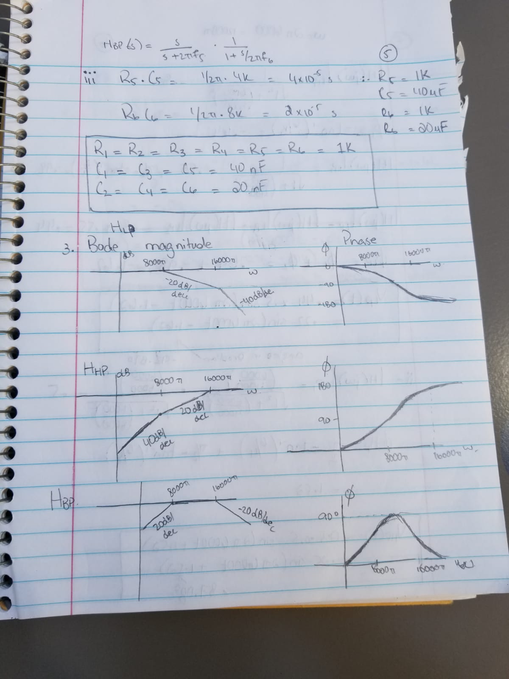

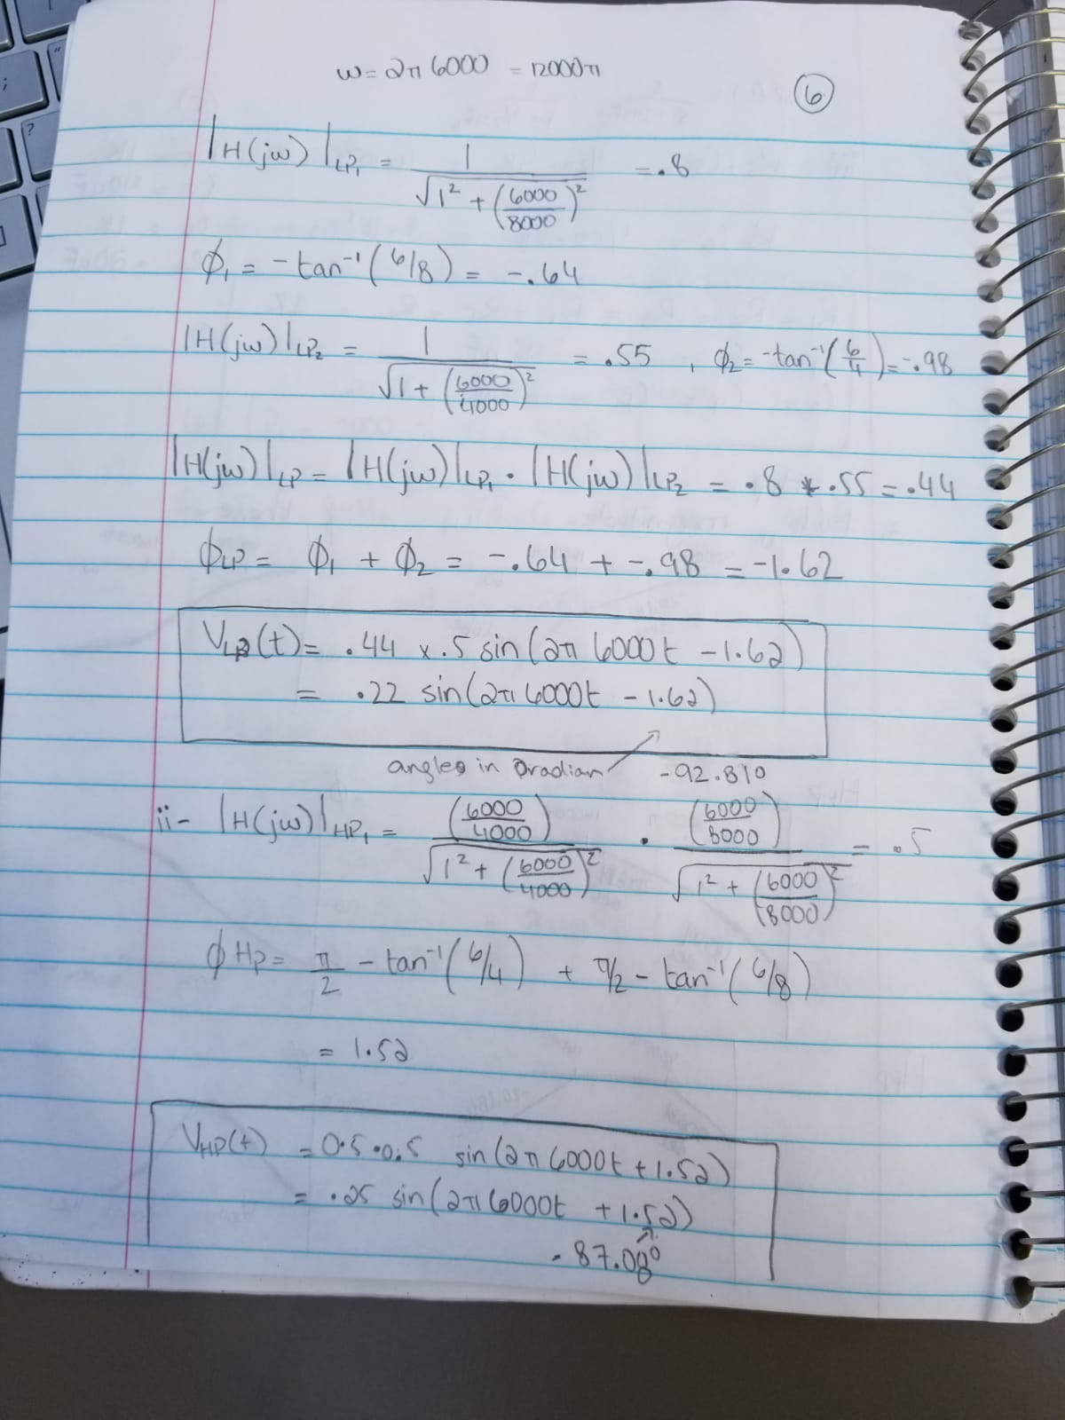

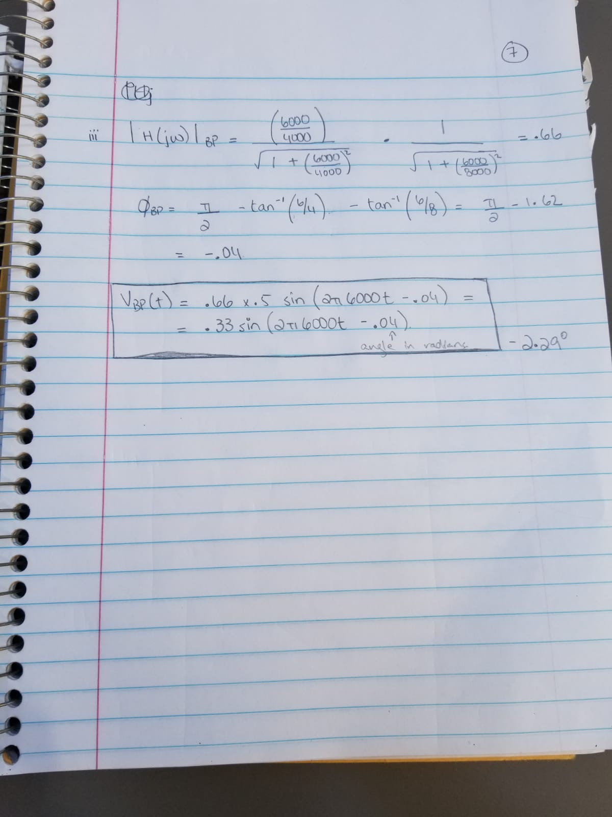

**Simulations –**

Low Pass Filter

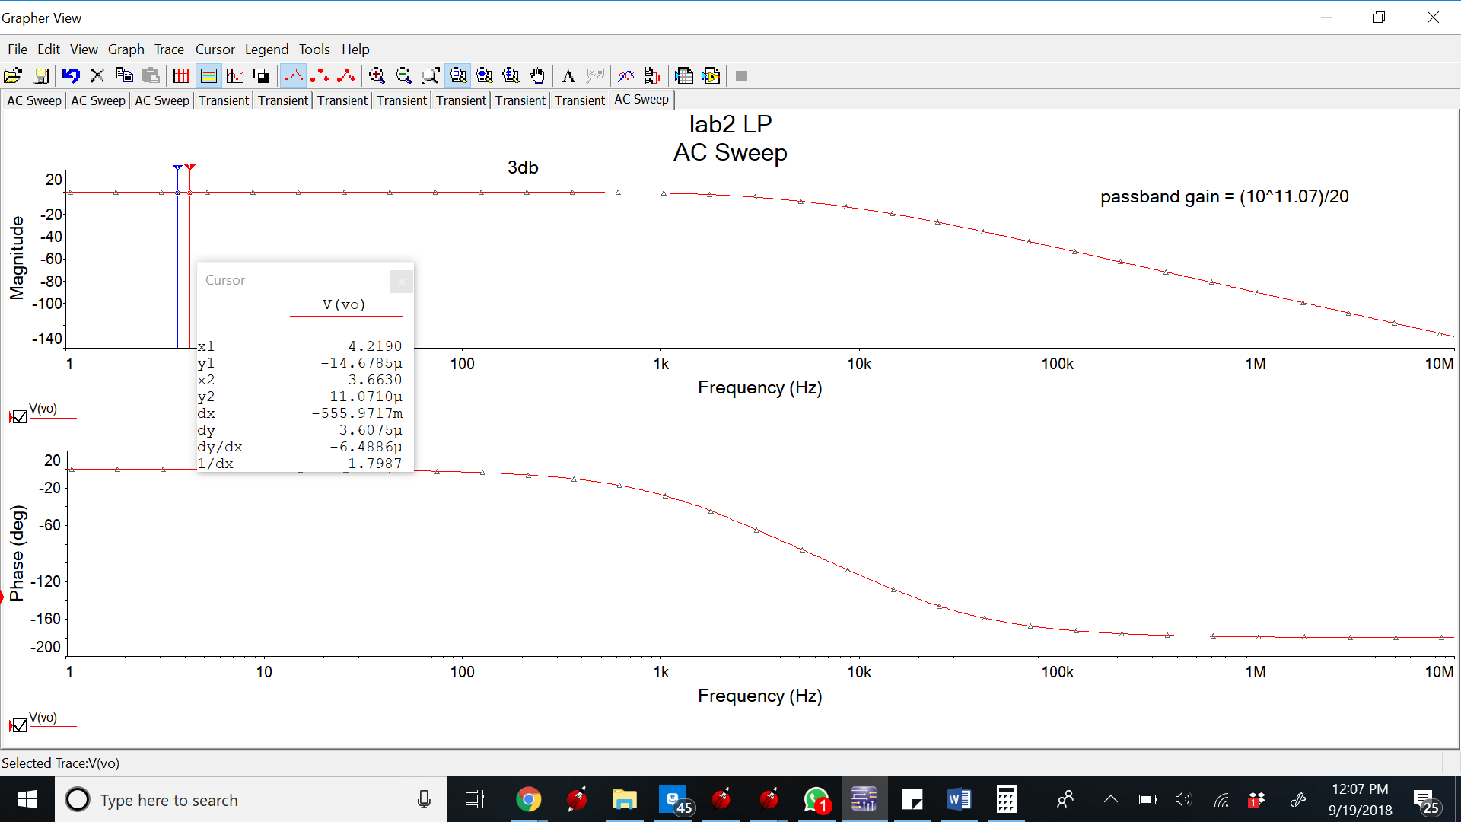

3db Frequency

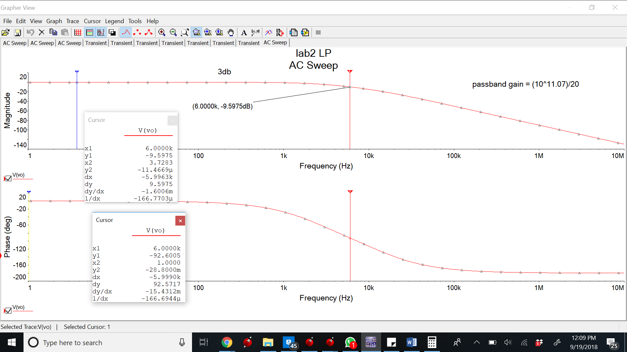

Magnitude and Phase angle at 6kHz

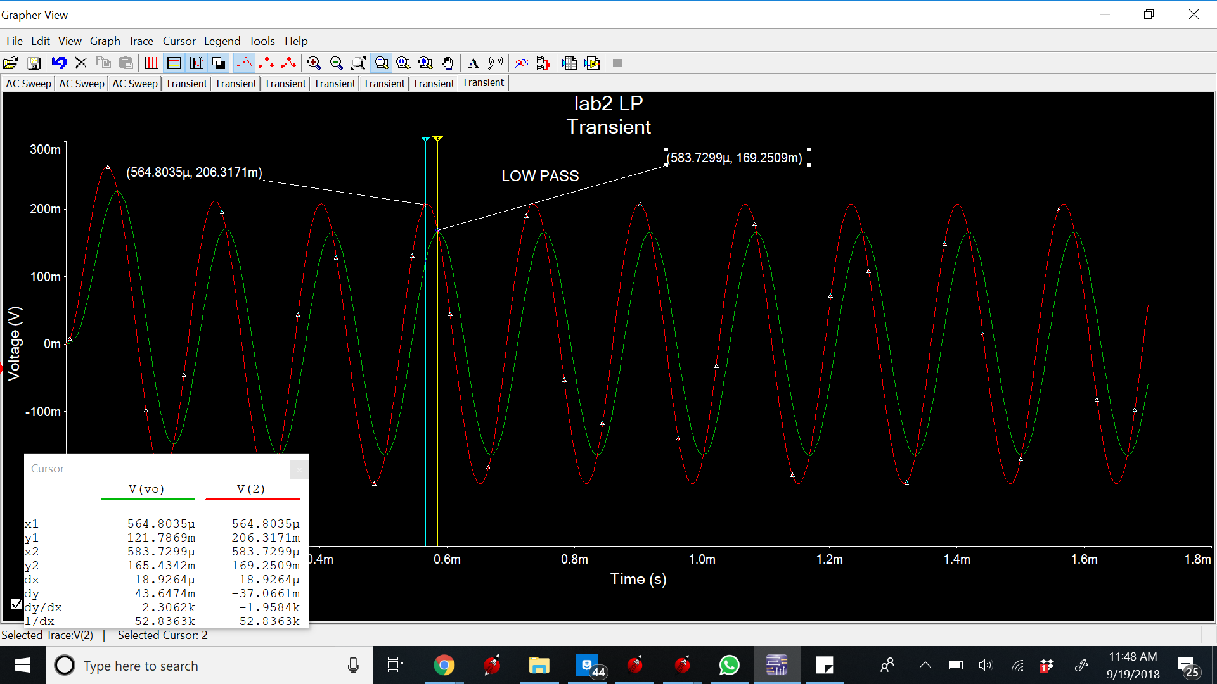

Low Pass Transient

**High Pass Filter**

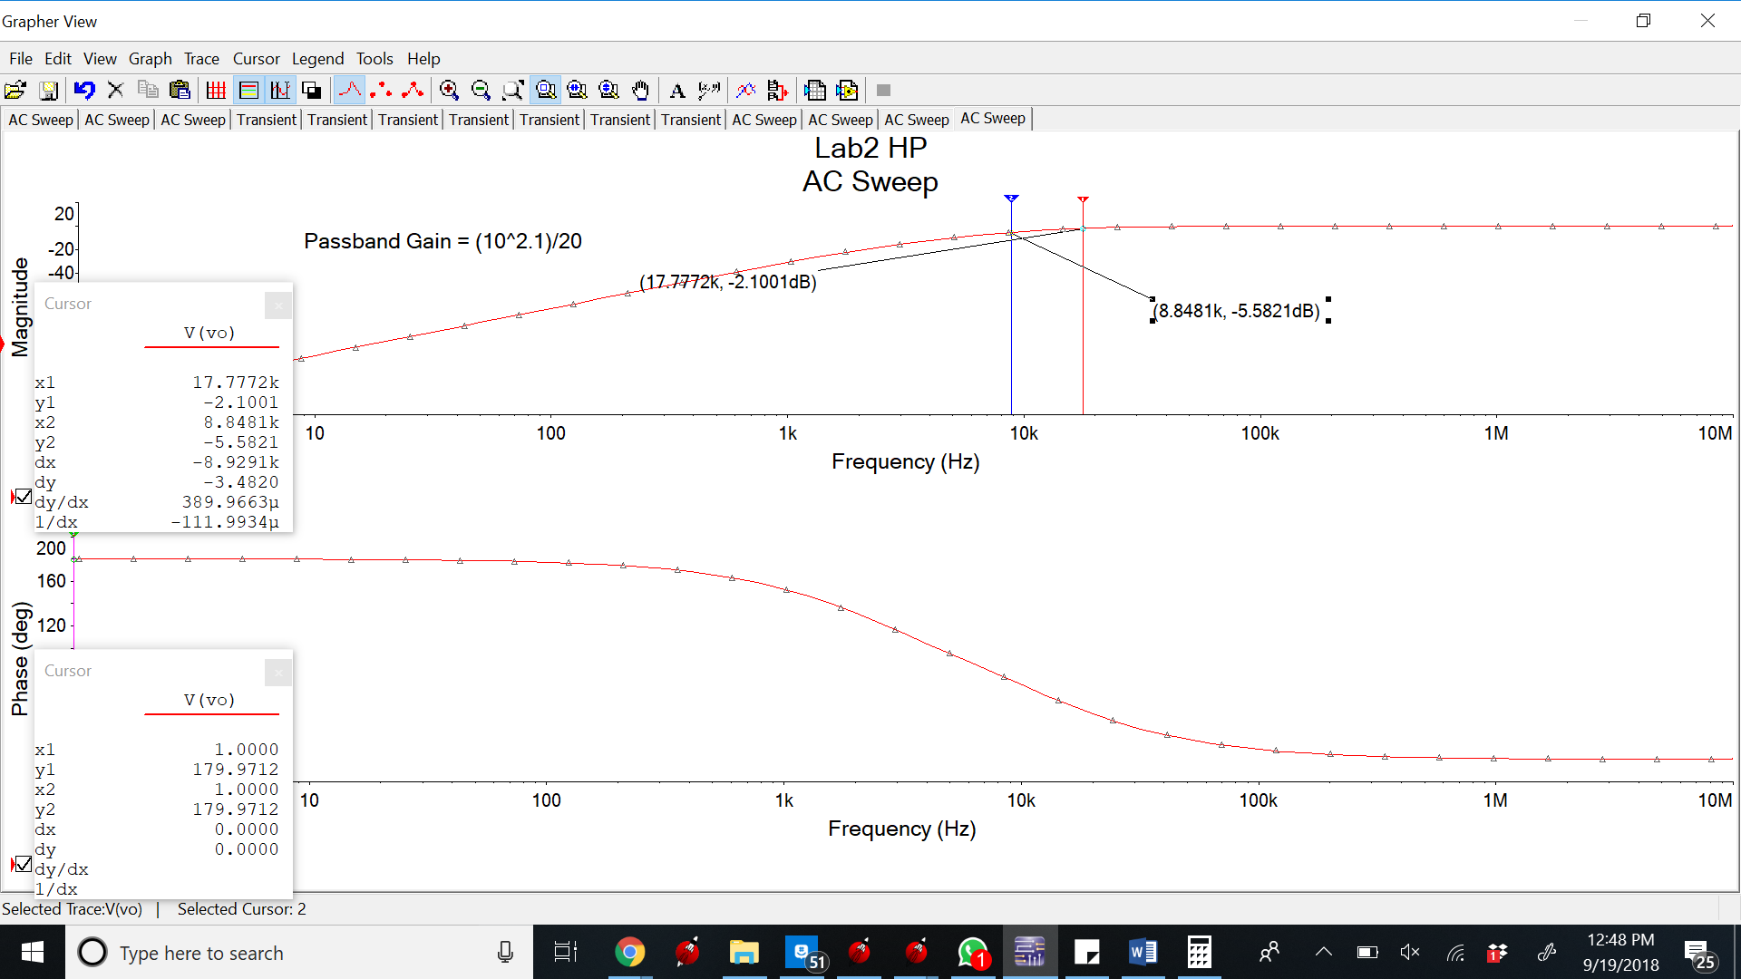

Passband Gain = (10^2.1/20)

3dB frequency and Passband Gain

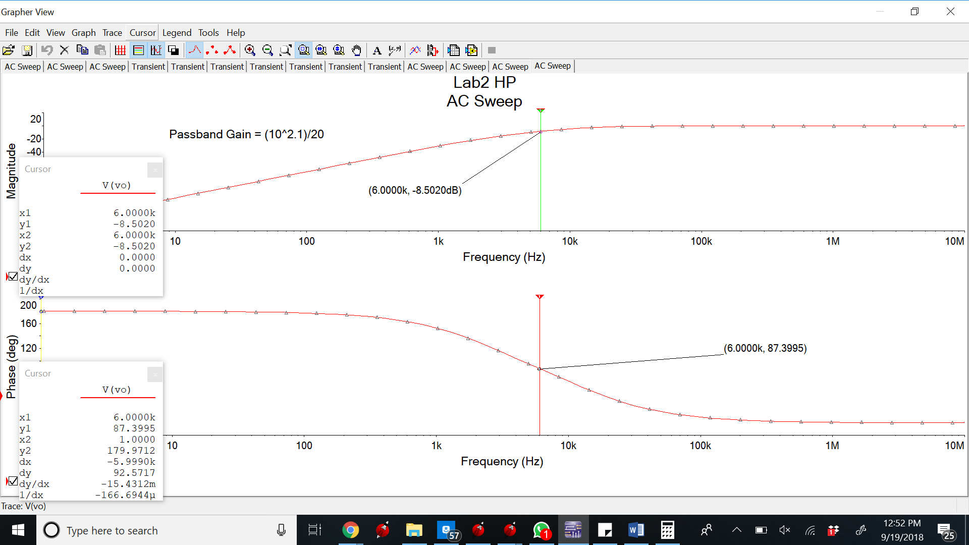

Magnitude and Phase angle at 6kHz frequency

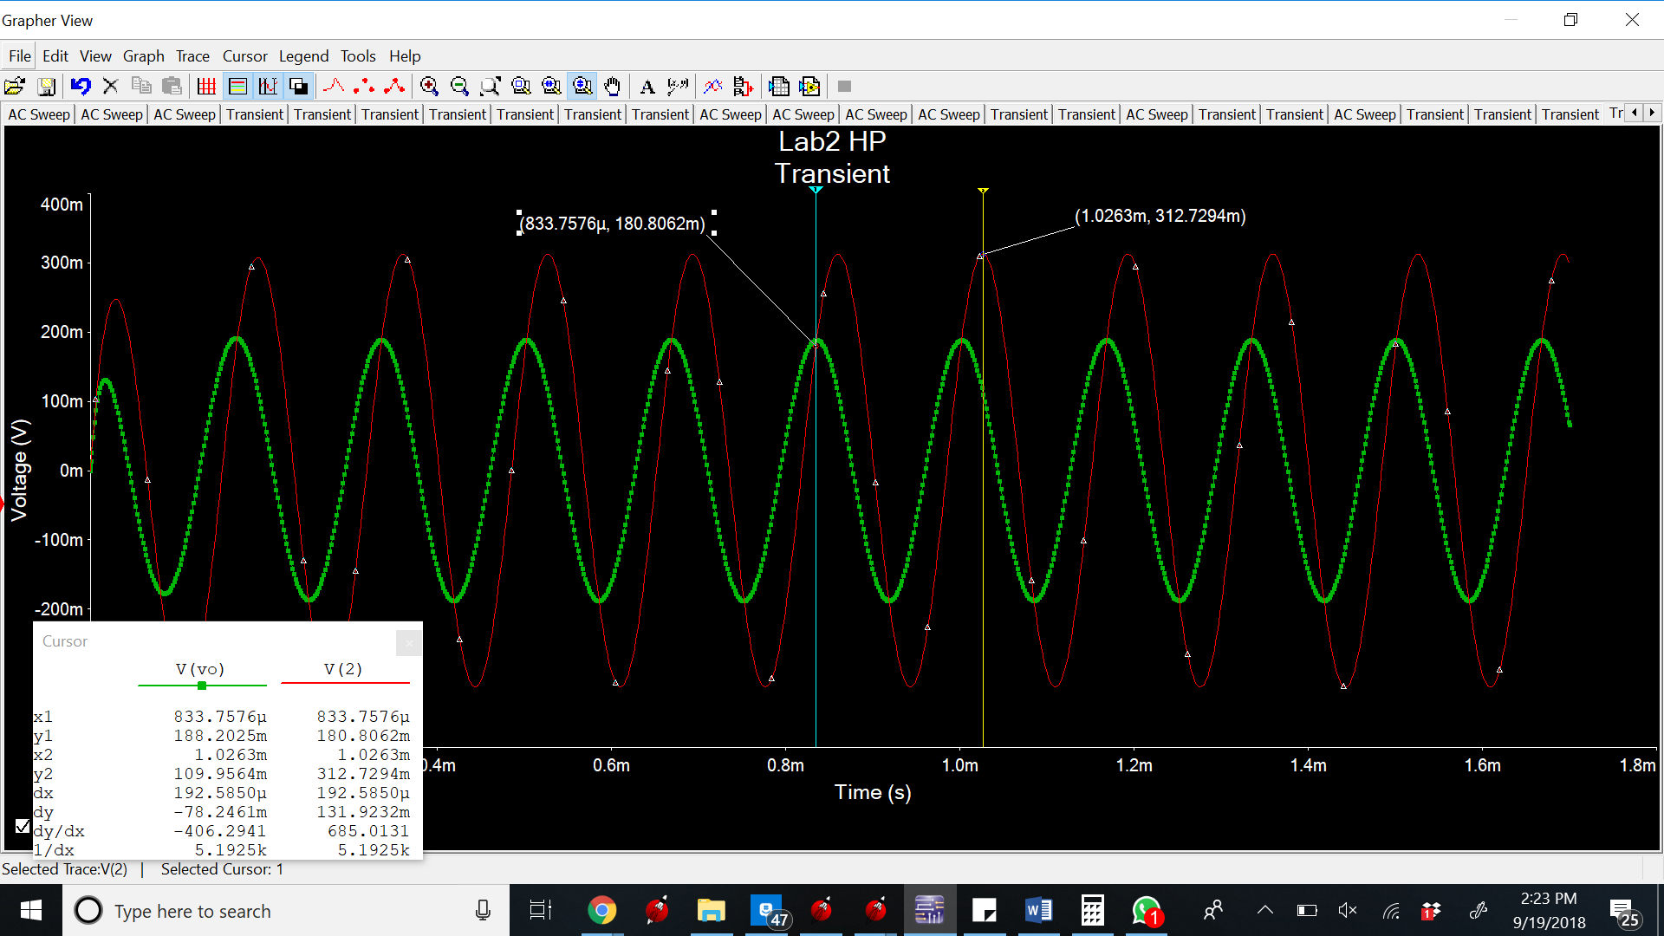

Transient

**BandPass Filter**

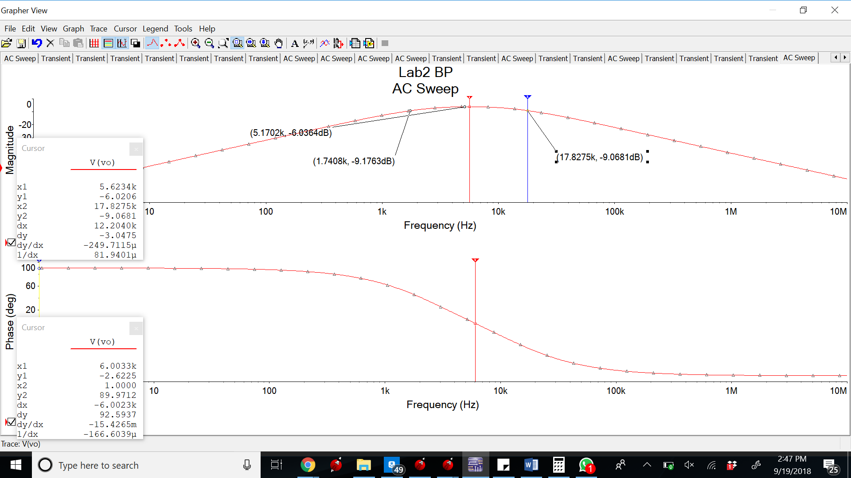

3dB frequency

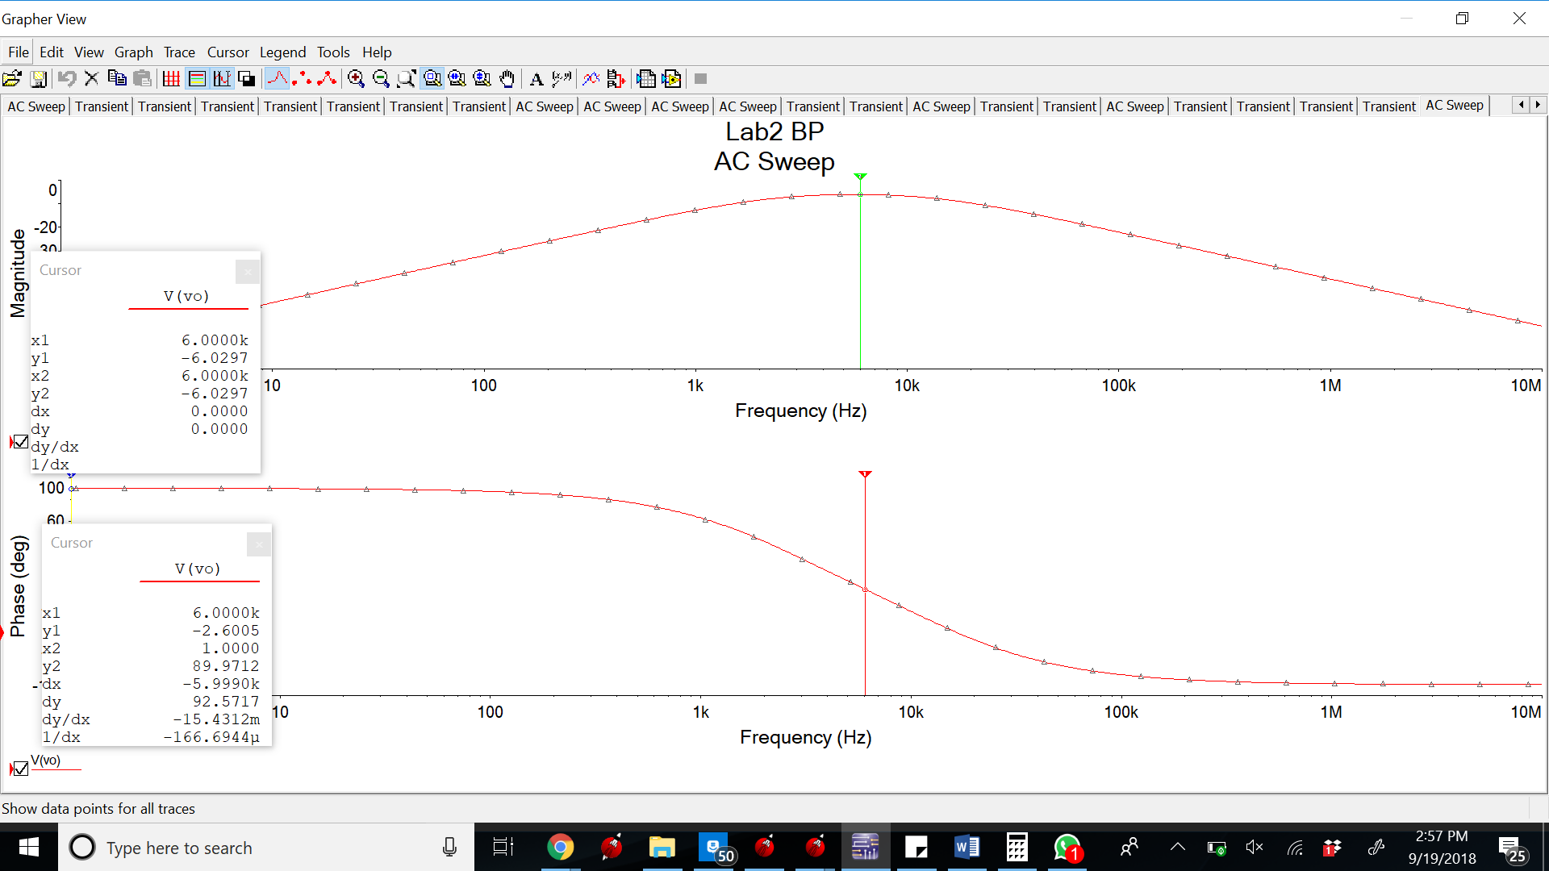

Magnitude and frequency at 6kHz

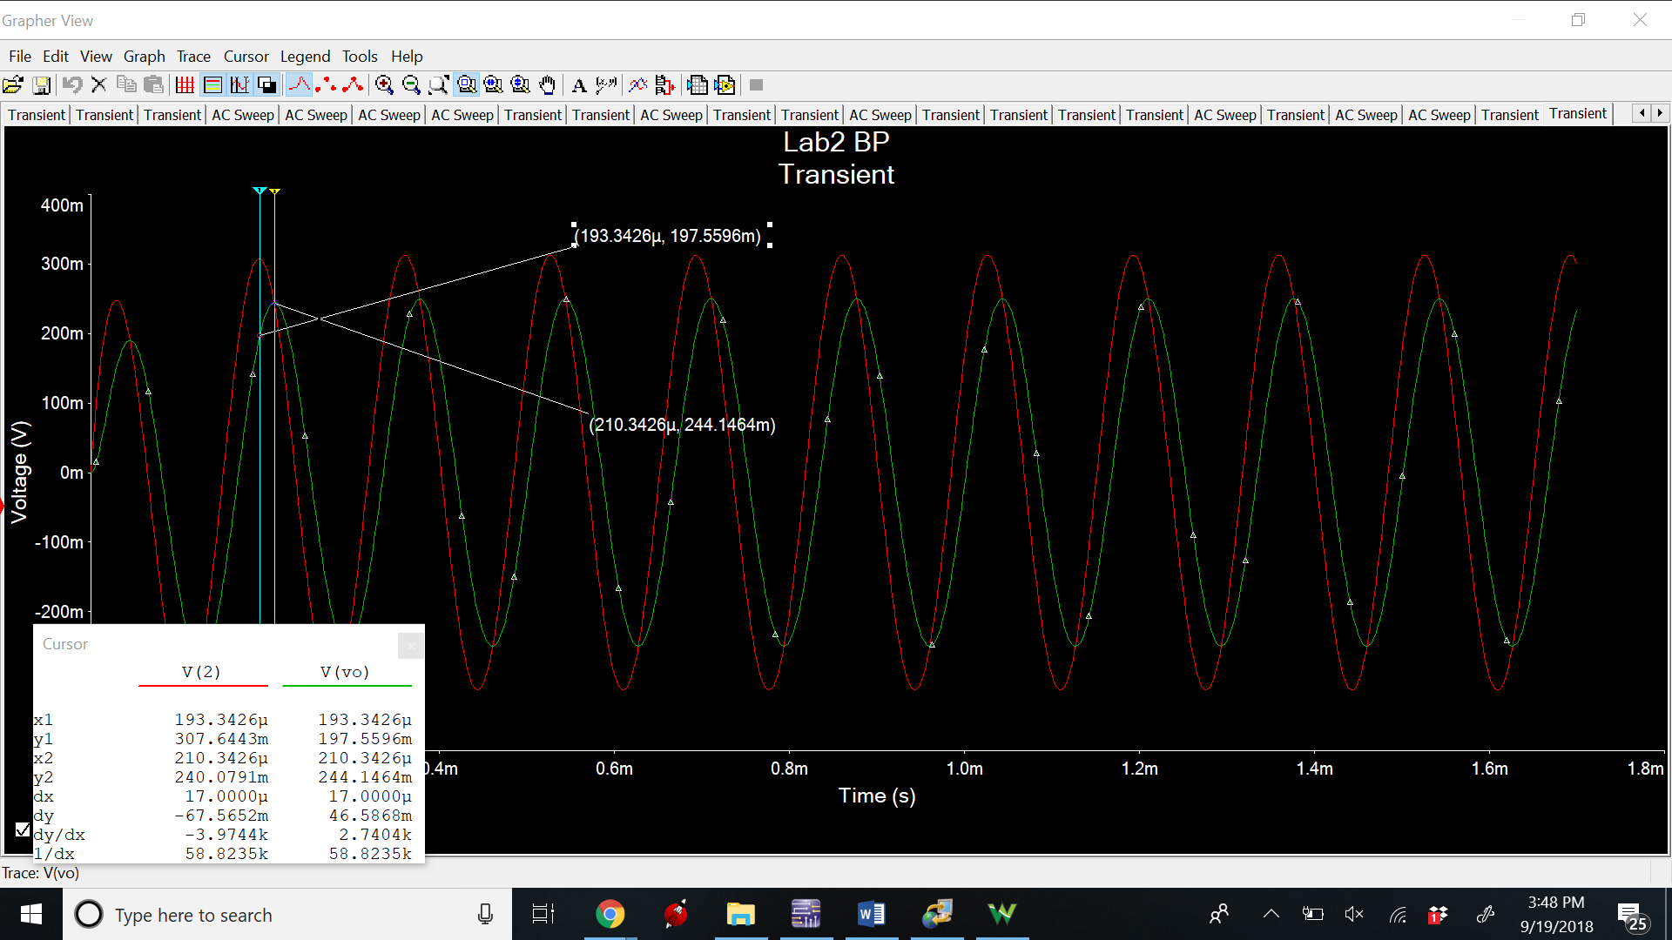

Transient

**Measurements**

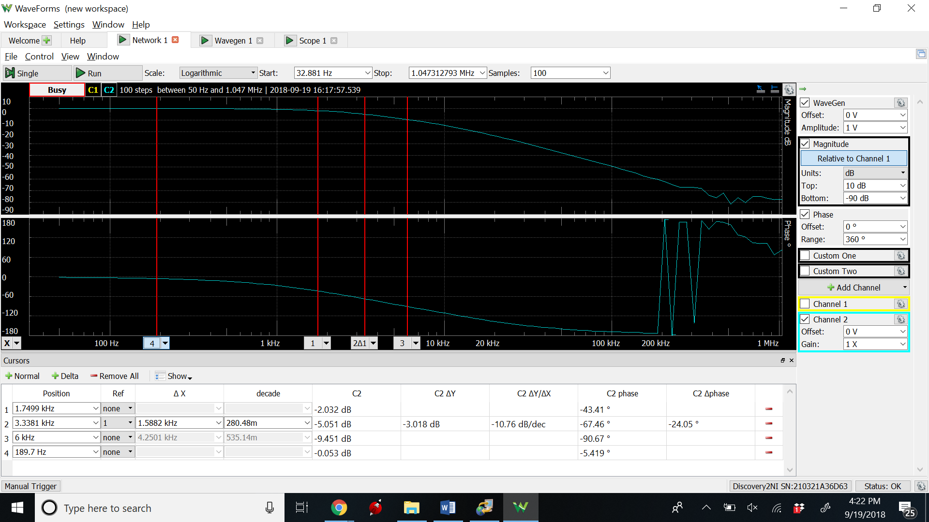

**3db Low pass**

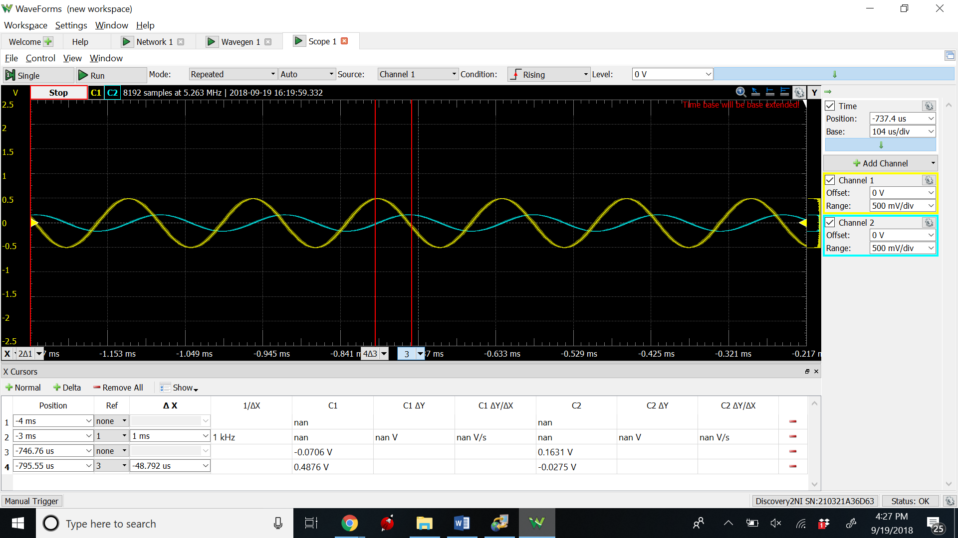

Magnitude of input and output at 6kHz

**High Pass-**

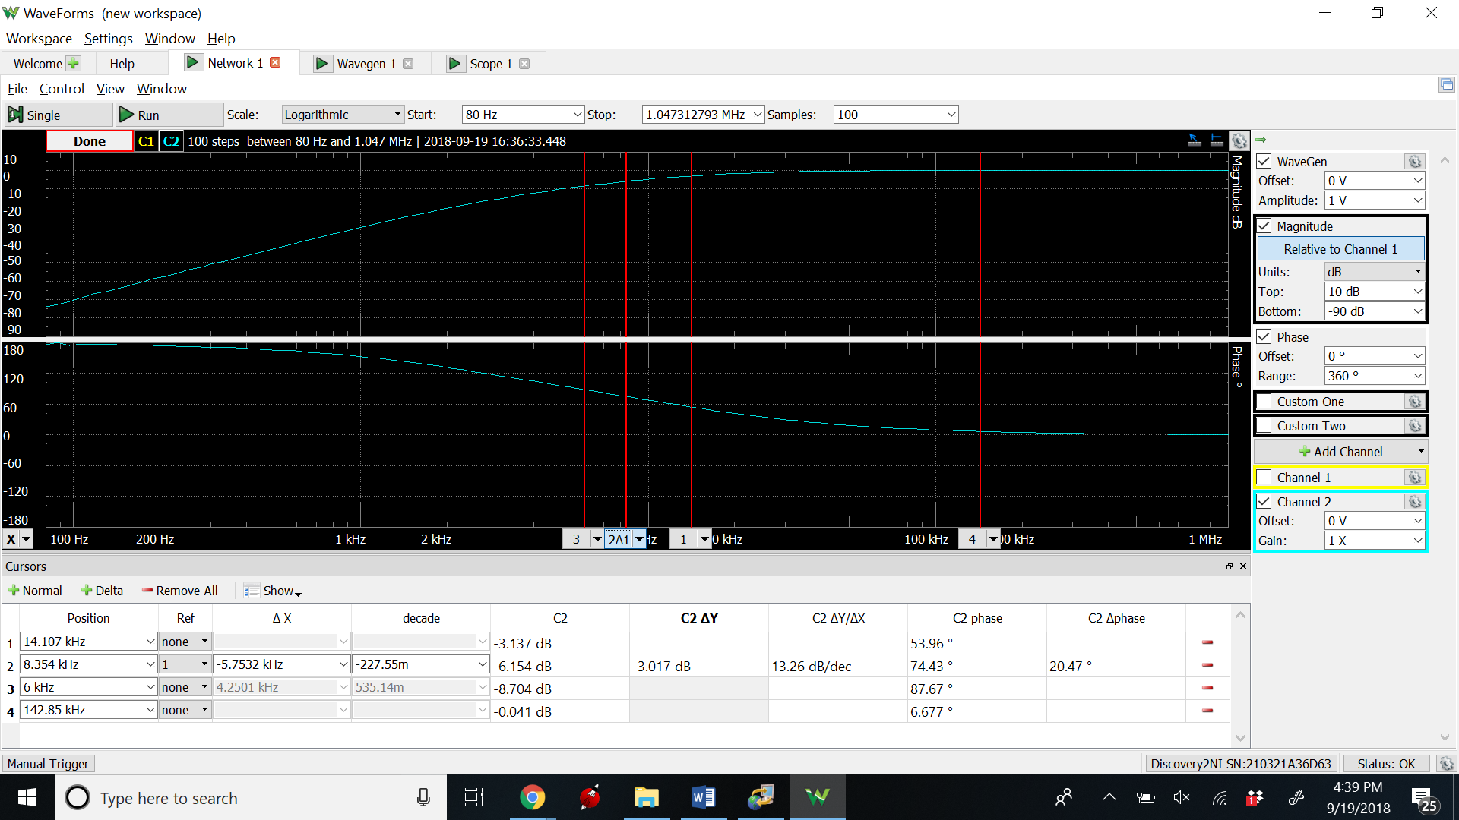

3dB frequency

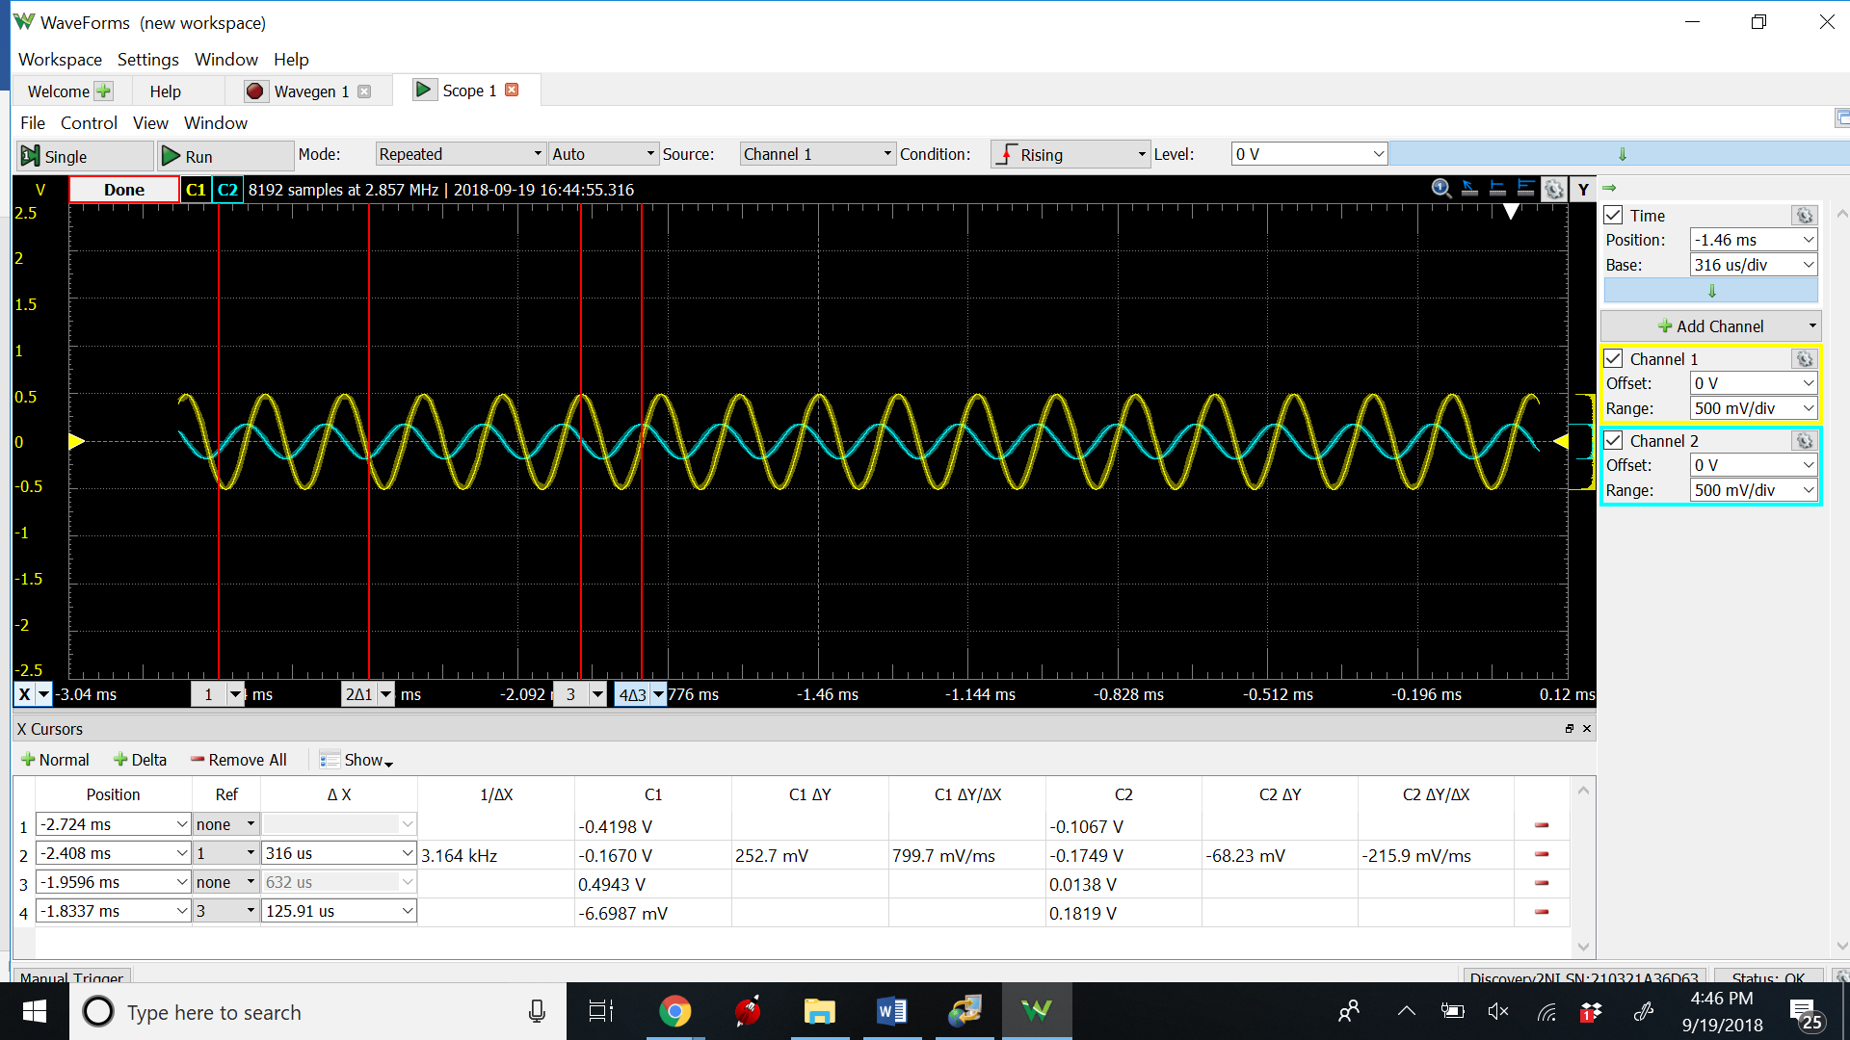

**Bandpass Filter**

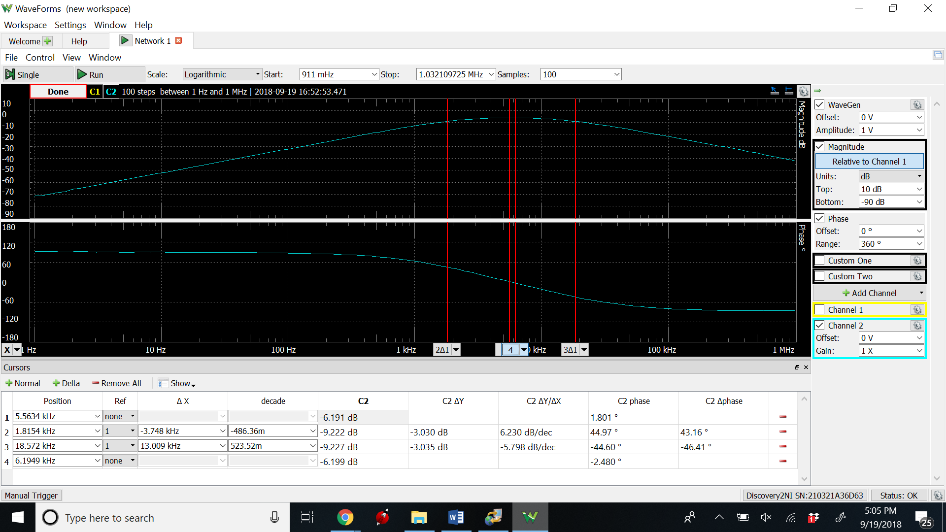

3dB frequency

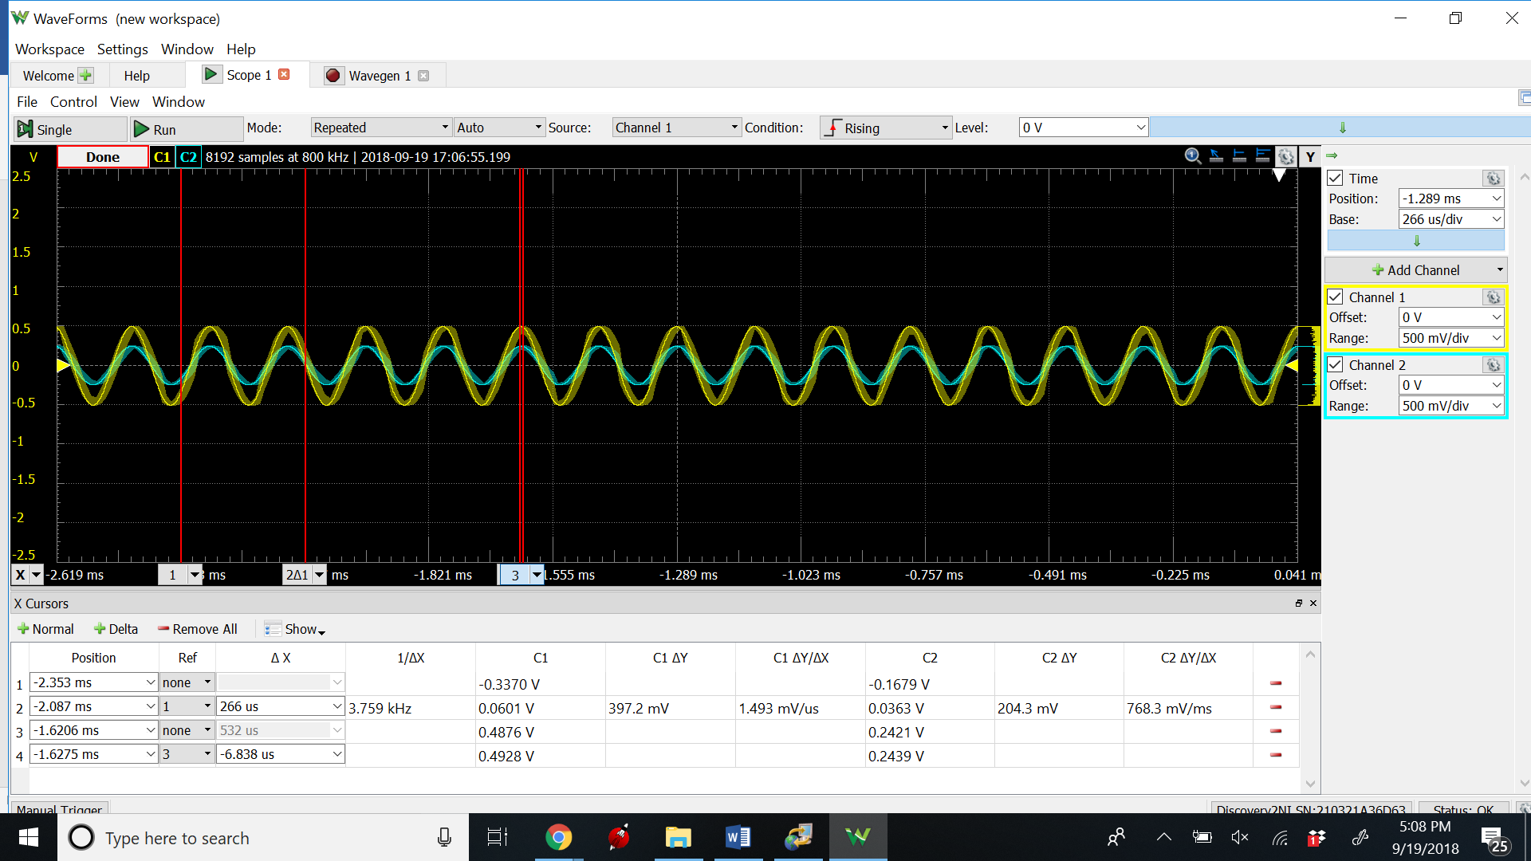

Magnitude and phase at 6kHz

**DATA**

**Calculation**

|  |  |  |  |
| --- | --- | --- | --- |
|  | **Magnitude** | **Frequency** | **Phase Angle(degrees)** |
| **Low Pass filter** | .22V | 6000Hz | -92.81 |
| **High Pass Filter** | .25V | 6000Hz | 87.08 |
| **Band Pass Filter** | .33V | 6000Hz | -2.29 |

**Simulation**

|  |  |  |  |  |
| --- | --- | --- | --- | --- |
|  | **3-db Frequency** | **Passband gains** | **Magnitude at 6kHz (dB)** | **Phase at 6kHz** |
| **Low Pass Filter** | 4.2190 kHz | .999 | -9.5975 | -92.6005o |
| **High Pass Filter** | 8.8481 kHz | .99 | -8.5020 | 87.3995 |
| **Band Pass Filter** | 1.7048kHz,17.8275kHz | .48 | -6.0297 | -2.6005o |

|  |  |  |  |
| --- | --- | --- | --- |
|  | **Magnitude (Input)V** | **Magnitude (Output)V** | **Phase Difference** |
| **Low Pass Filter** | 206.3171m | 169.25m | 40.8809o |
| **High Pass Filter** | 312.7294m | 180.806m | 88.923 |
| **Band Pass Filter** | 179.3217m | 177.4225m | 47.7359o |

**Phase Difference** –

T = 1/f = 1/6000 = .000166667

Vo – V1 = delta t;

((Delta t) * (360))/T

**Measurement –**

|  |  |  |  |  |
| --- | --- | --- | --- | --- |
|  | **3-db Frequency** | **Passband gains** | **Magnitude at 6kHz** | **Phase at 6kHz (angle)** |
| **Low Pass Filter** | 3.3381kHz | -.053dB | -9.451 dB | -90.67 |
| **High Pass Filter** | 8.354 kHz | -.041 dB | -8.704 dB | 87.67 |
| **Band Pass Filter** | 1.8154 , 18.572 kHz | -6.199 dB | -6.141 dB | -1.088 |

|  |  |  |  |
| --- | --- | --- | --- |
|  | **Magnitude (Input)** | **Magnitude (Output)** | **Phase Difference** |
| **Low Pass Filter** | .4876 V | .1631 V | 105.391 |
| **High Pass Filter** | .1819 V | .4943 V | 92.18 |
| **Band Pass Filter** | .4876 V | .2439 V | -1.378 |

**Phase Difference** –

T = 1/f = 1/6000 = .000166667

Vo – V1 = delta t;

((Delta t) * (360))/T

Conclusion –

Simulation Plots:

The difference between my calculations and my simulations was negligible. My values for both were pretty much the same. The voltages and phase angles matched up. My simulations were very similar to my experiments. However, there were slight difference in the values that I got. These can be attributed to unknown resistances in the wires, the breadboard, and the sensitivity of the Analog Discovery. It is also important to note that my resistance values were not exactly the same as my calculated component values. This is because it is impossible to get those exact resistances with the components that I have available.

As for justifying the component values that I used even though the transfer function can be achieved with different values, I went for simplicity of setup. I started by setting my capacitance values when solving for my component values. However, what I found is that different capacitance value result is very, very different resistance values. Some resistances were impossibly small and I didn’t have the resistors necessary and some resistances were massive, leading to the same problem. To that end, I went with values that I not only had components for, but I also went for values that I could easily set up with only 2-4 resistors for the whole circuit.