**Lab 4: Operational Amplifiers – Part 2**

Faizan Bangash

Ecen 325-504

Date: 3rd October 2018

**Calculations**

1. Summing amplifier

R3 = 15kΩ

R3 = R1

**R1 = 15kΩ**

R3 / R2 = 2

**R2 = 7.5kΩ**

1. Differential amplifier

R2 = R3 = R4 = 10kΩ

R2 / R1 = 1

**R1 = 10kΩ**

1. Instrumentation amplifier

Rgain = 1kΩ

3 = 1 + 2R/Rgain

**R = 1kΩ**

1. Summing amplifier

Differential amplifier

Instrumental amplifier

**Simulations**

Summing amplifier

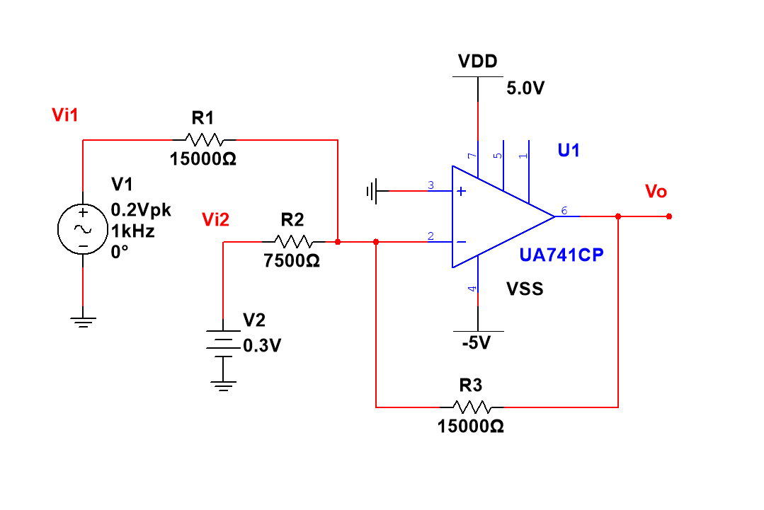

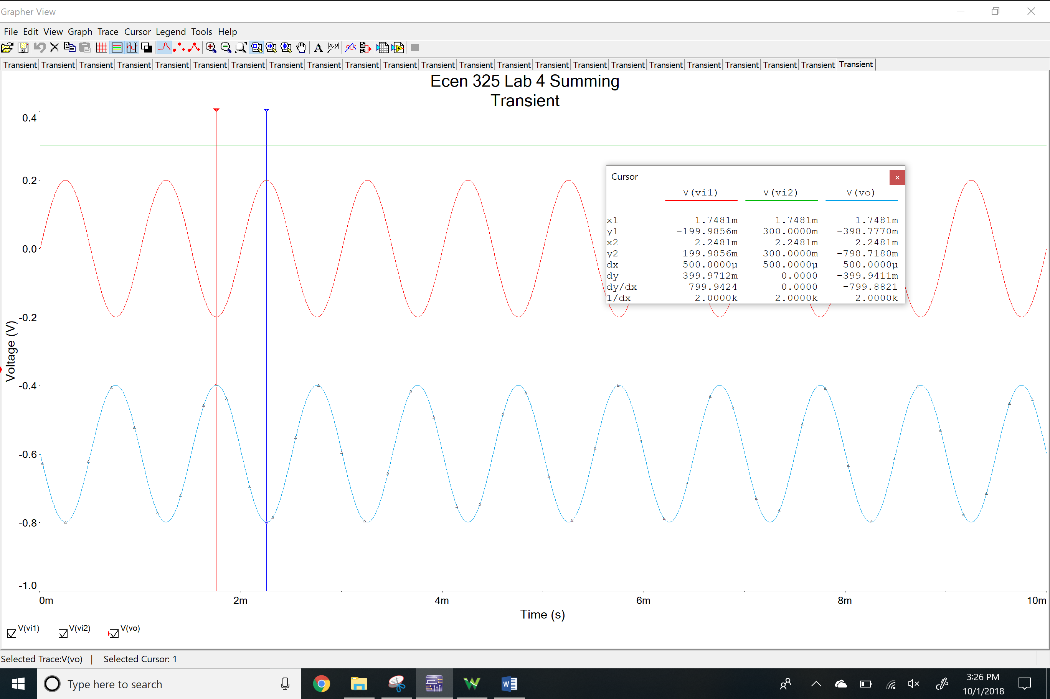

Differential amplifier

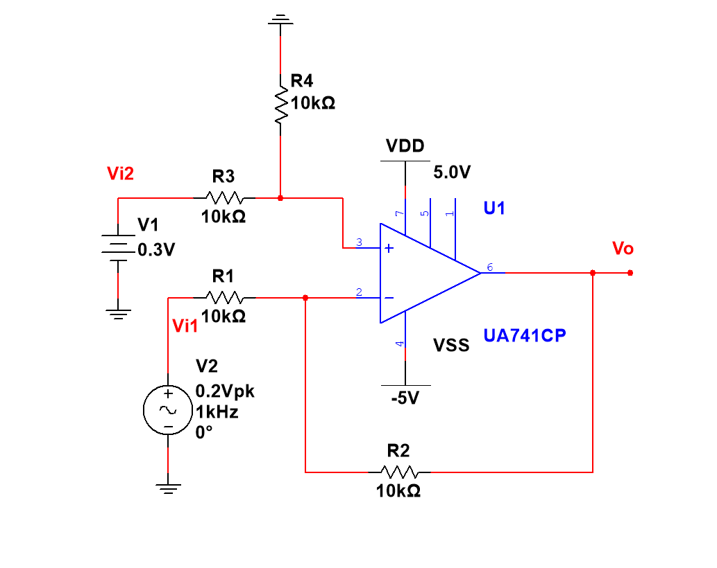

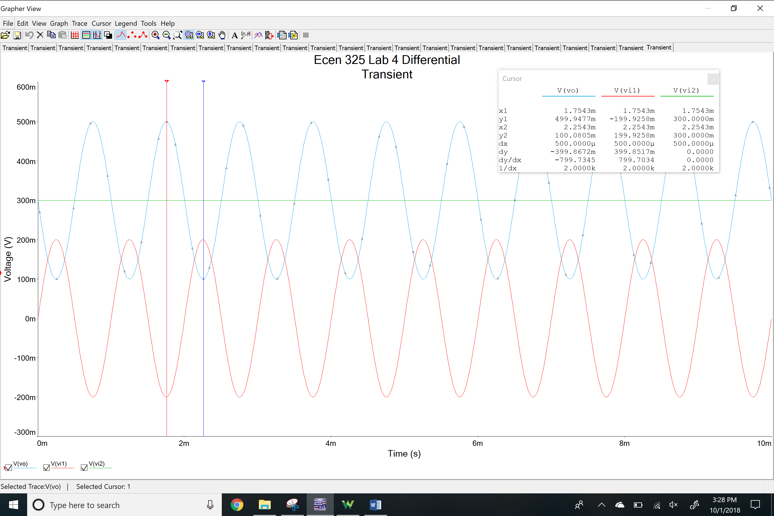

Instrumentation amplifier

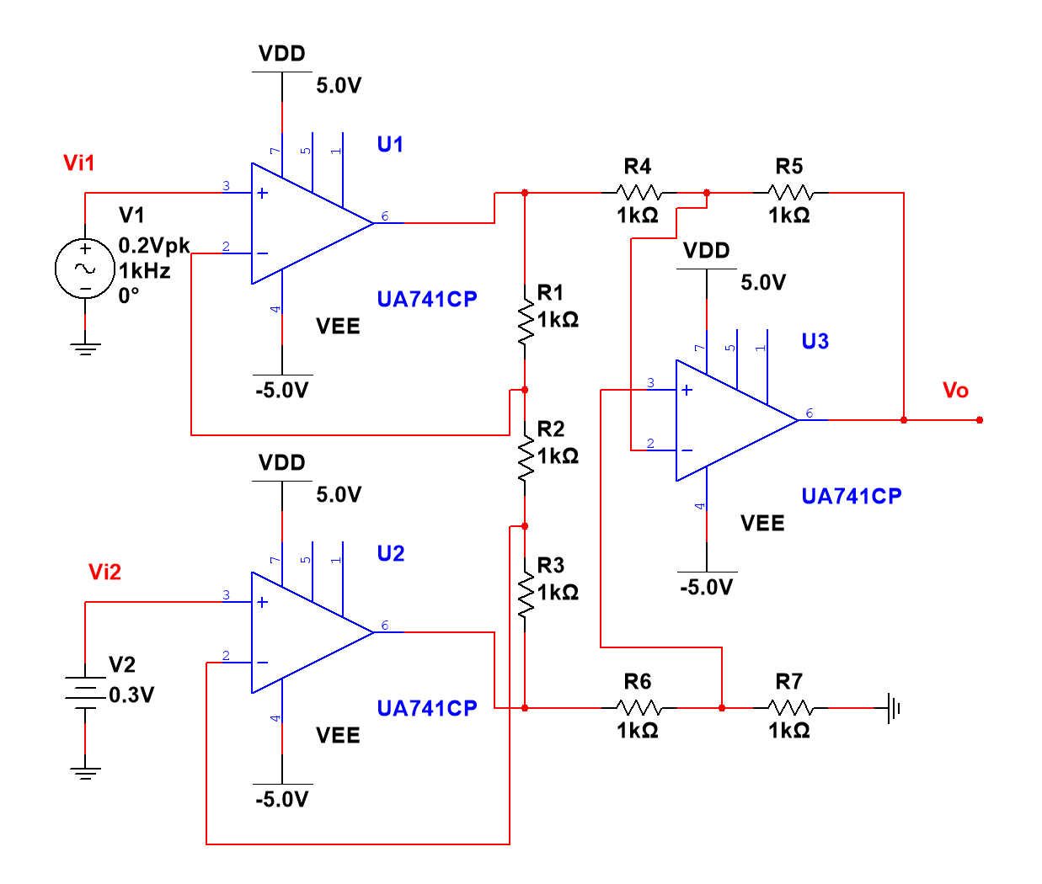

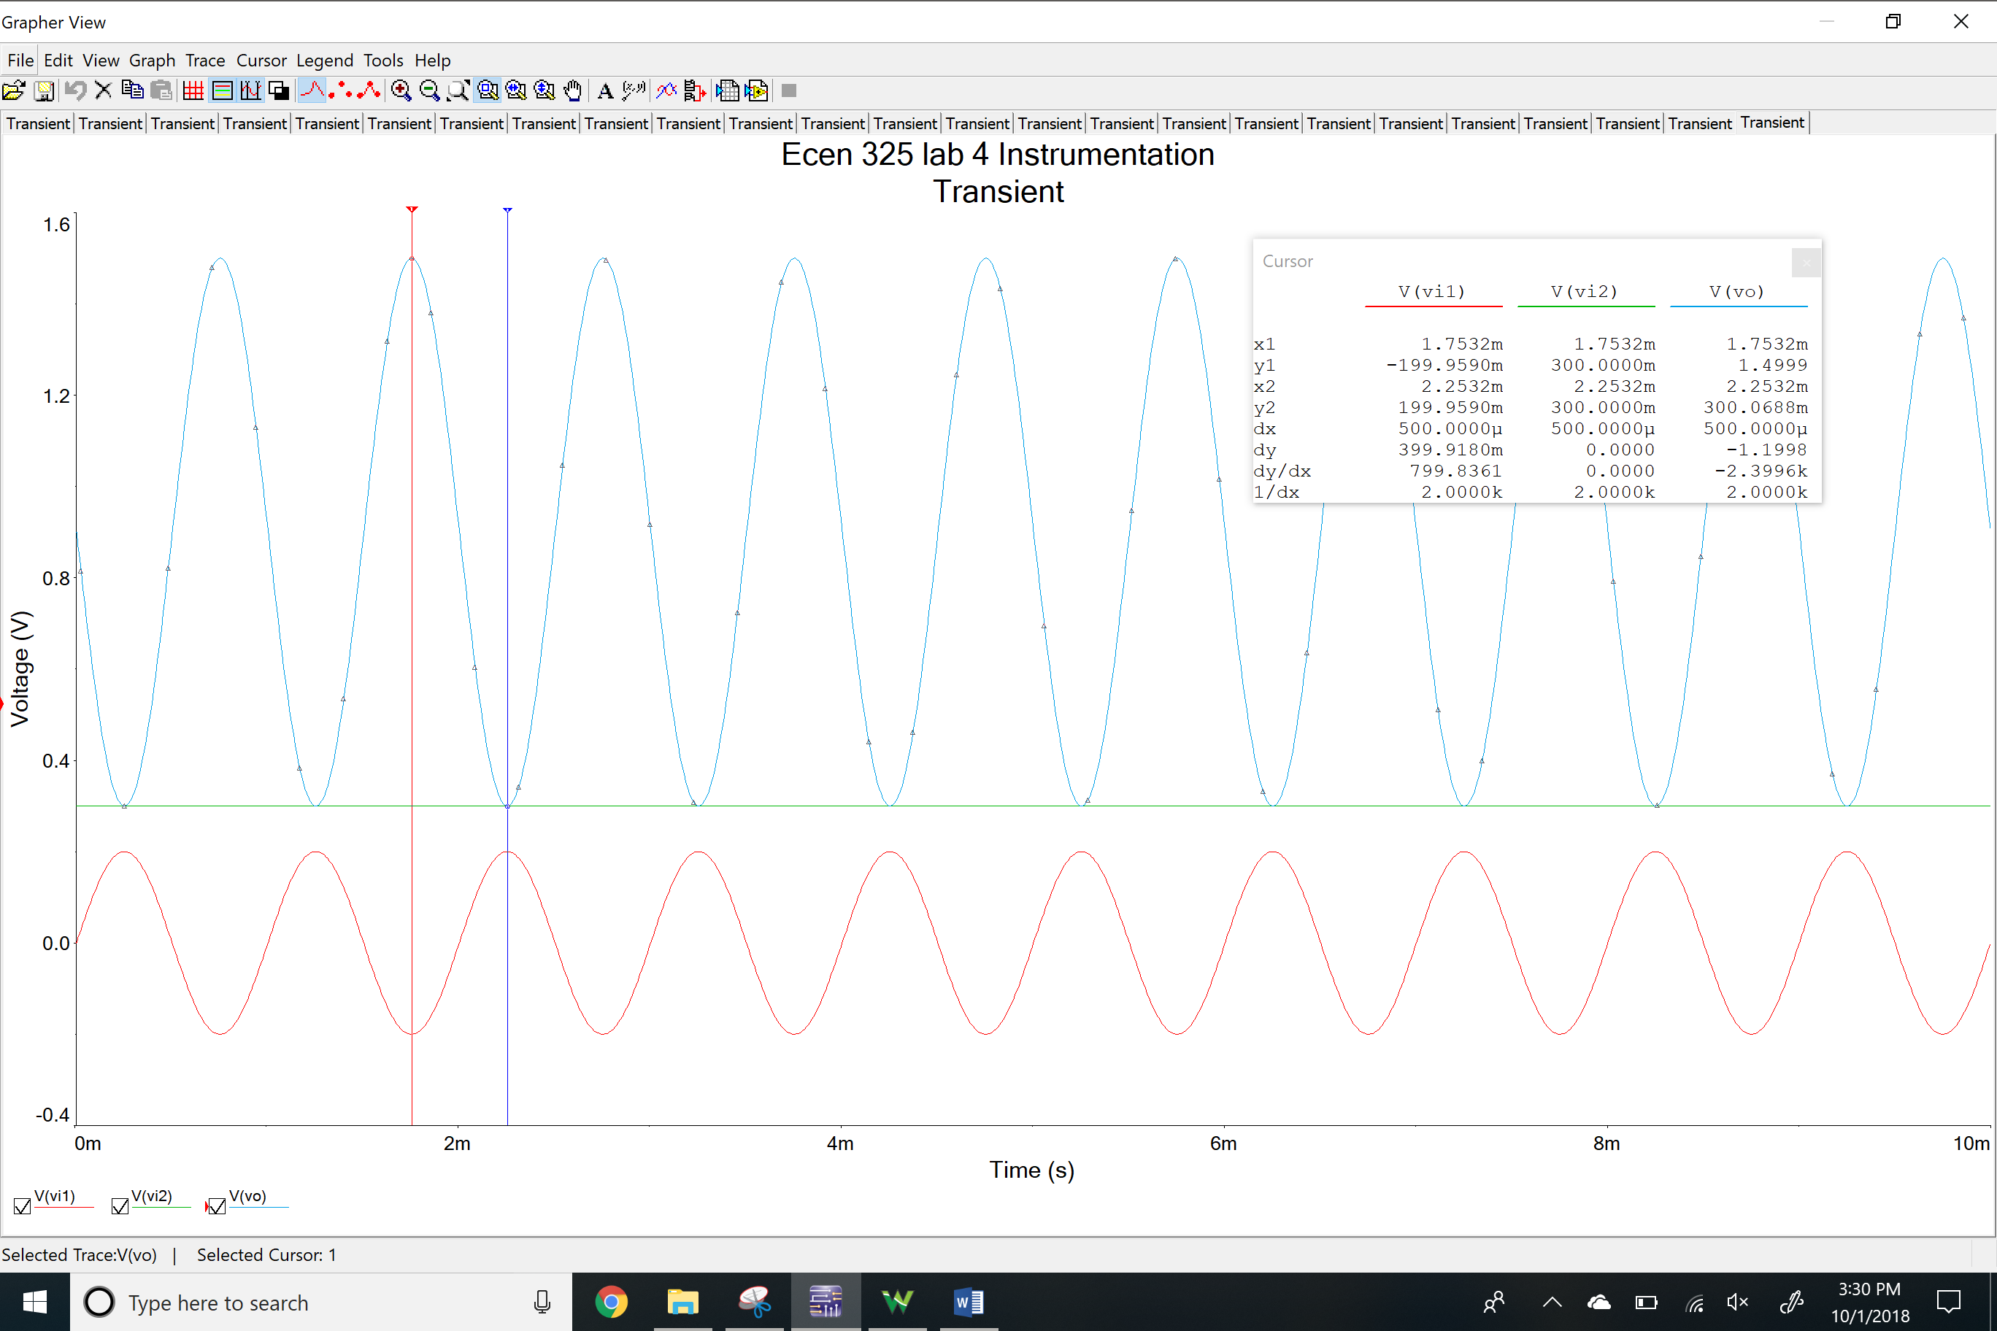

**Measurements**

Summing amplifier

Time-domain waveform

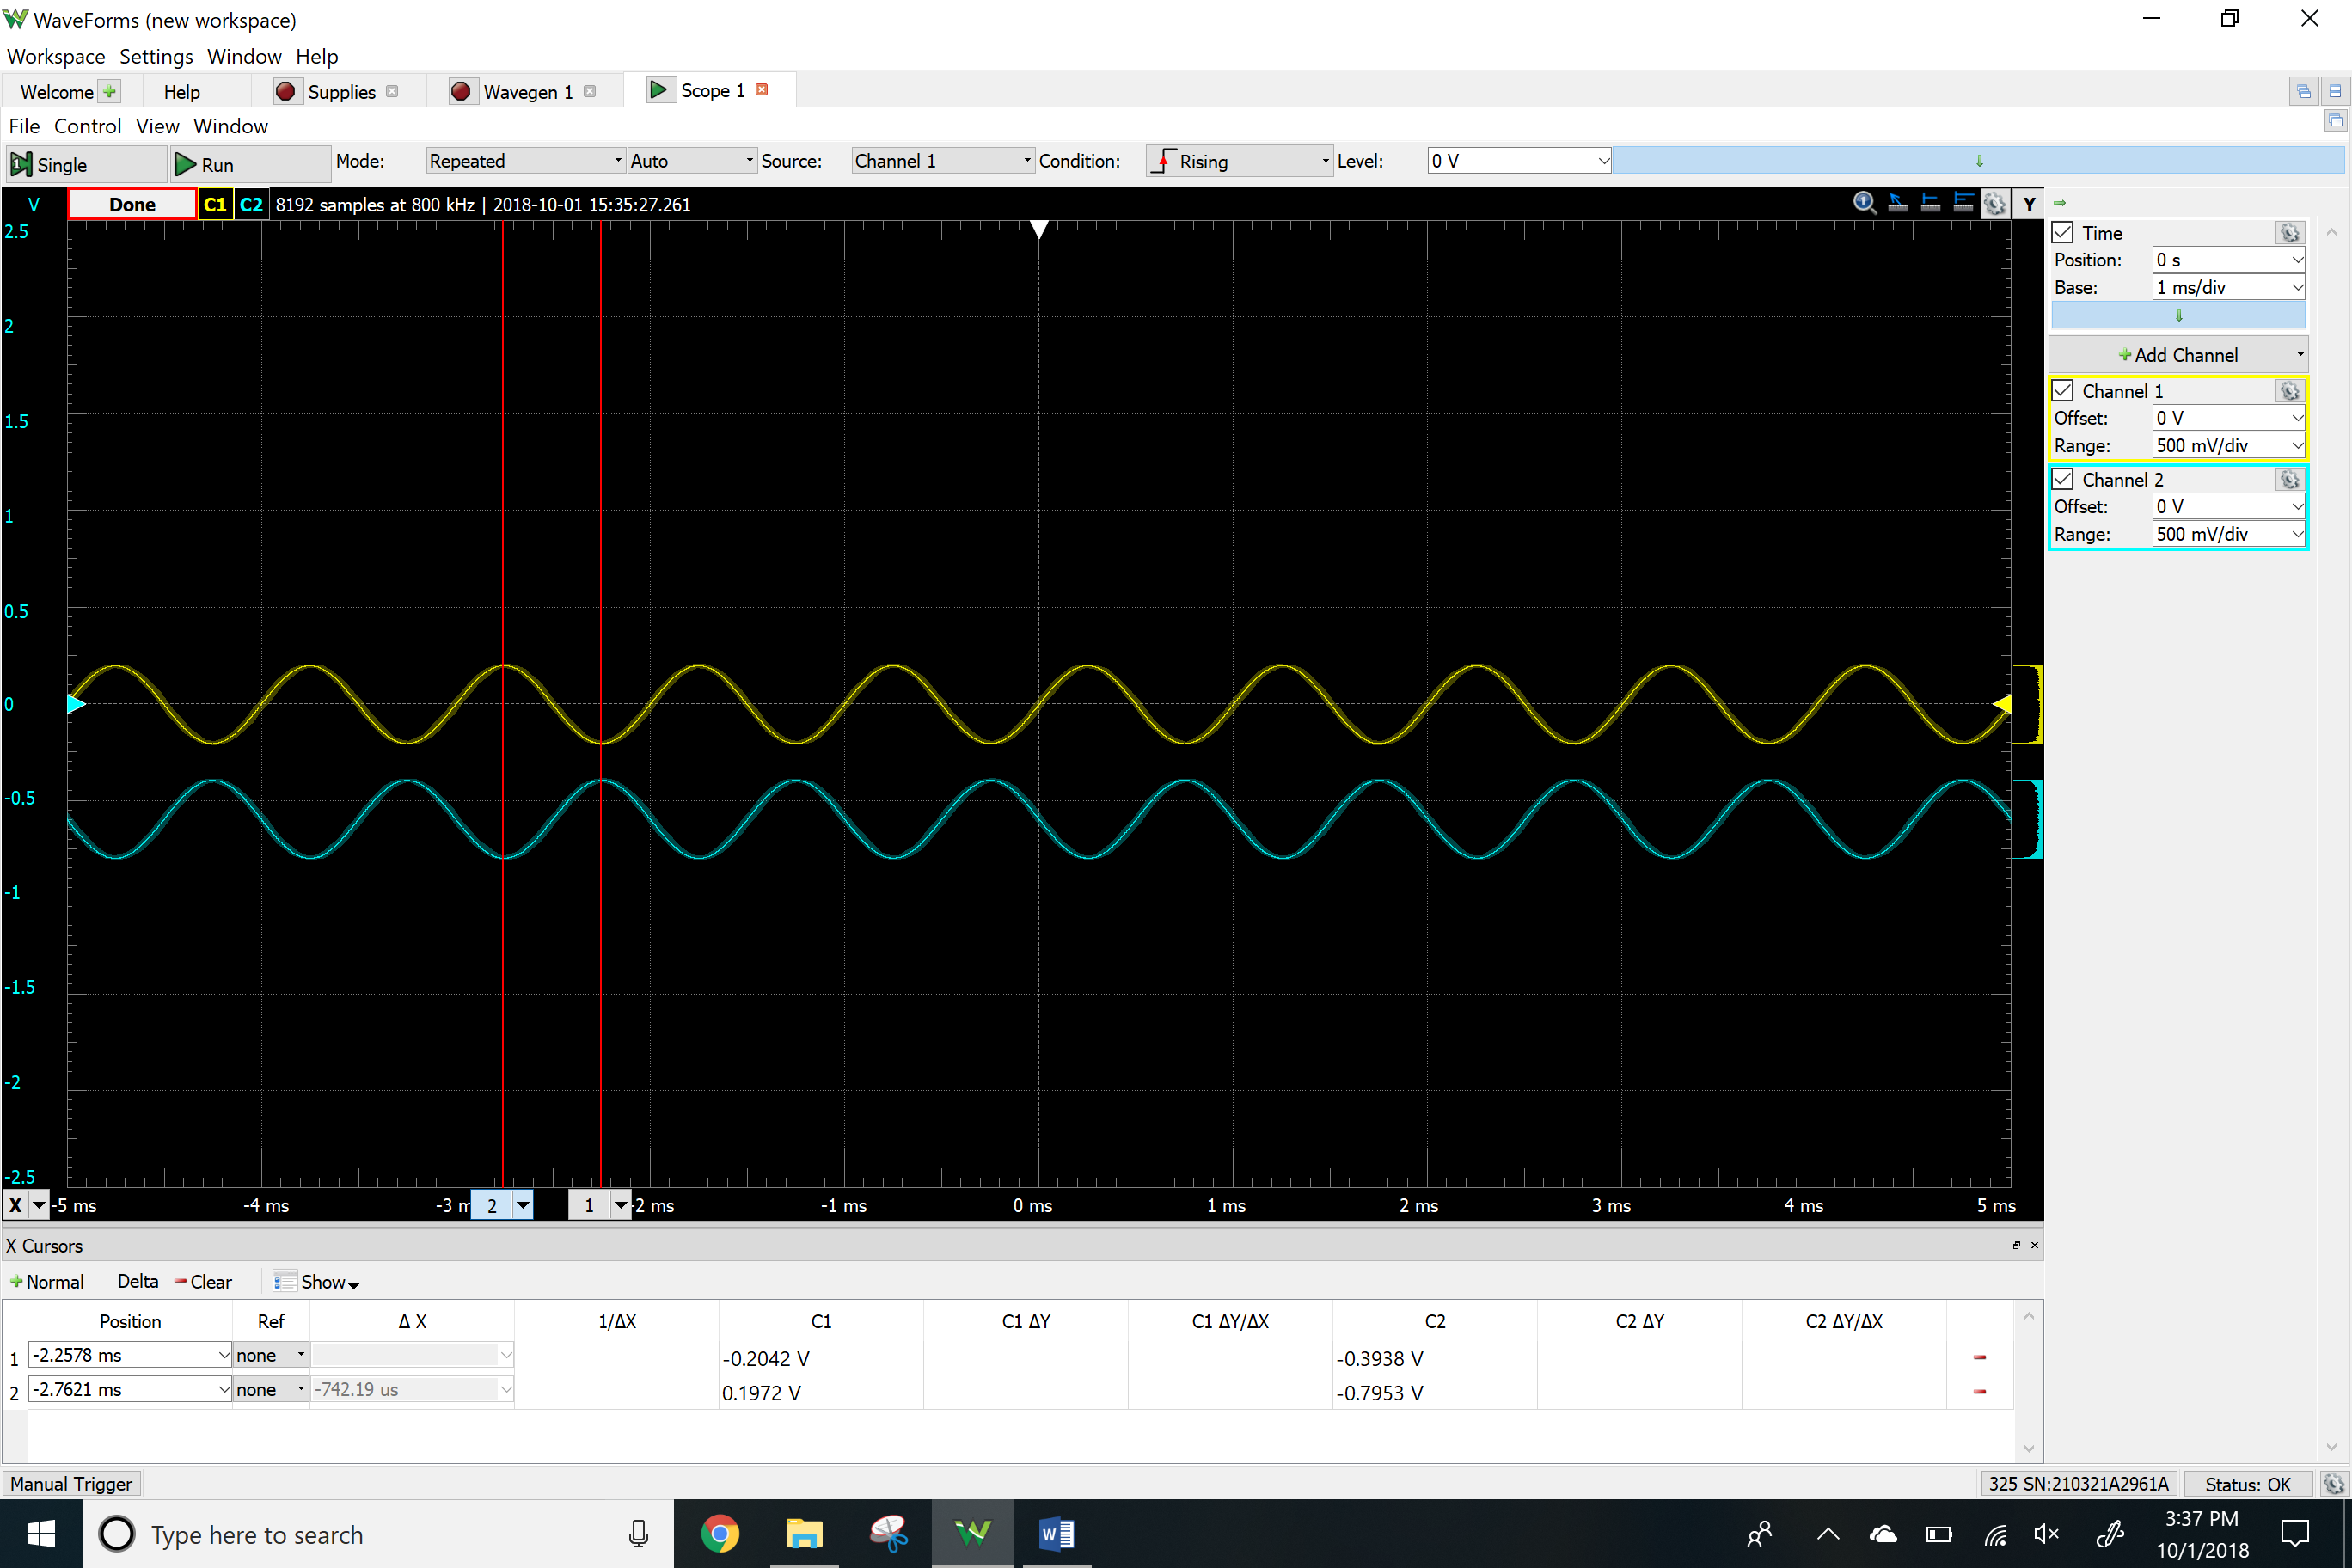

Clipping

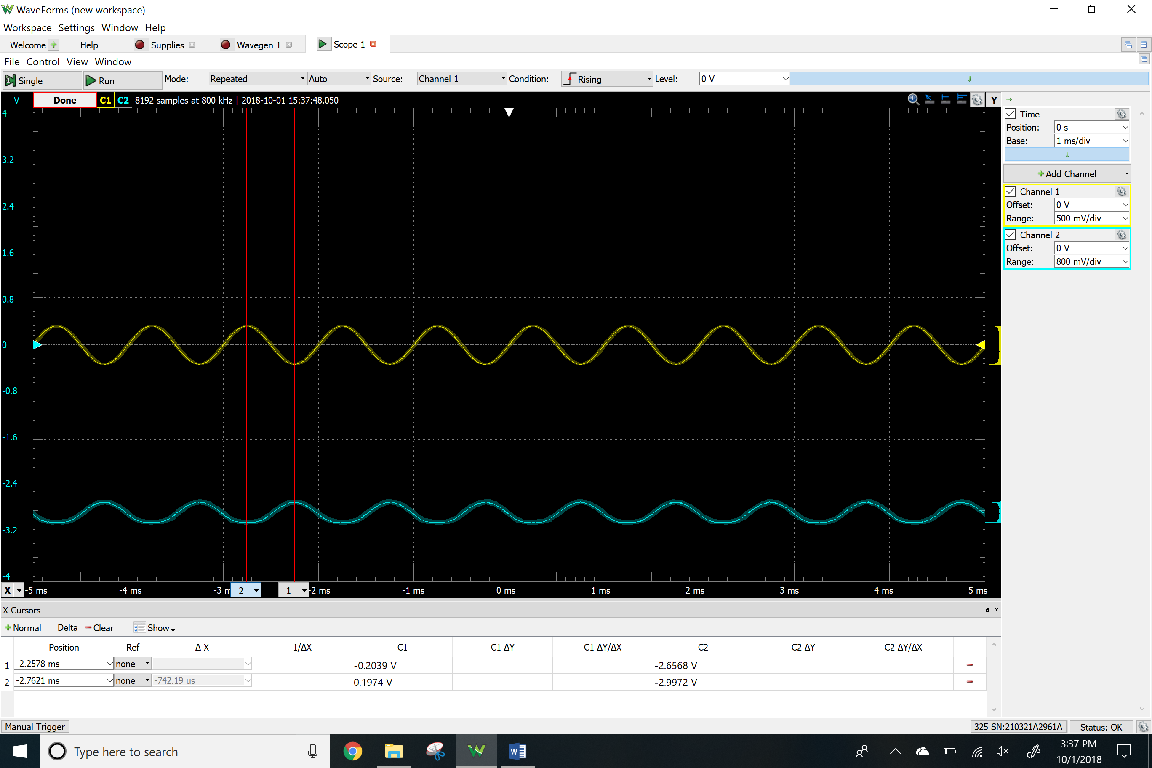

Differential amplifier

Time-domain waveform

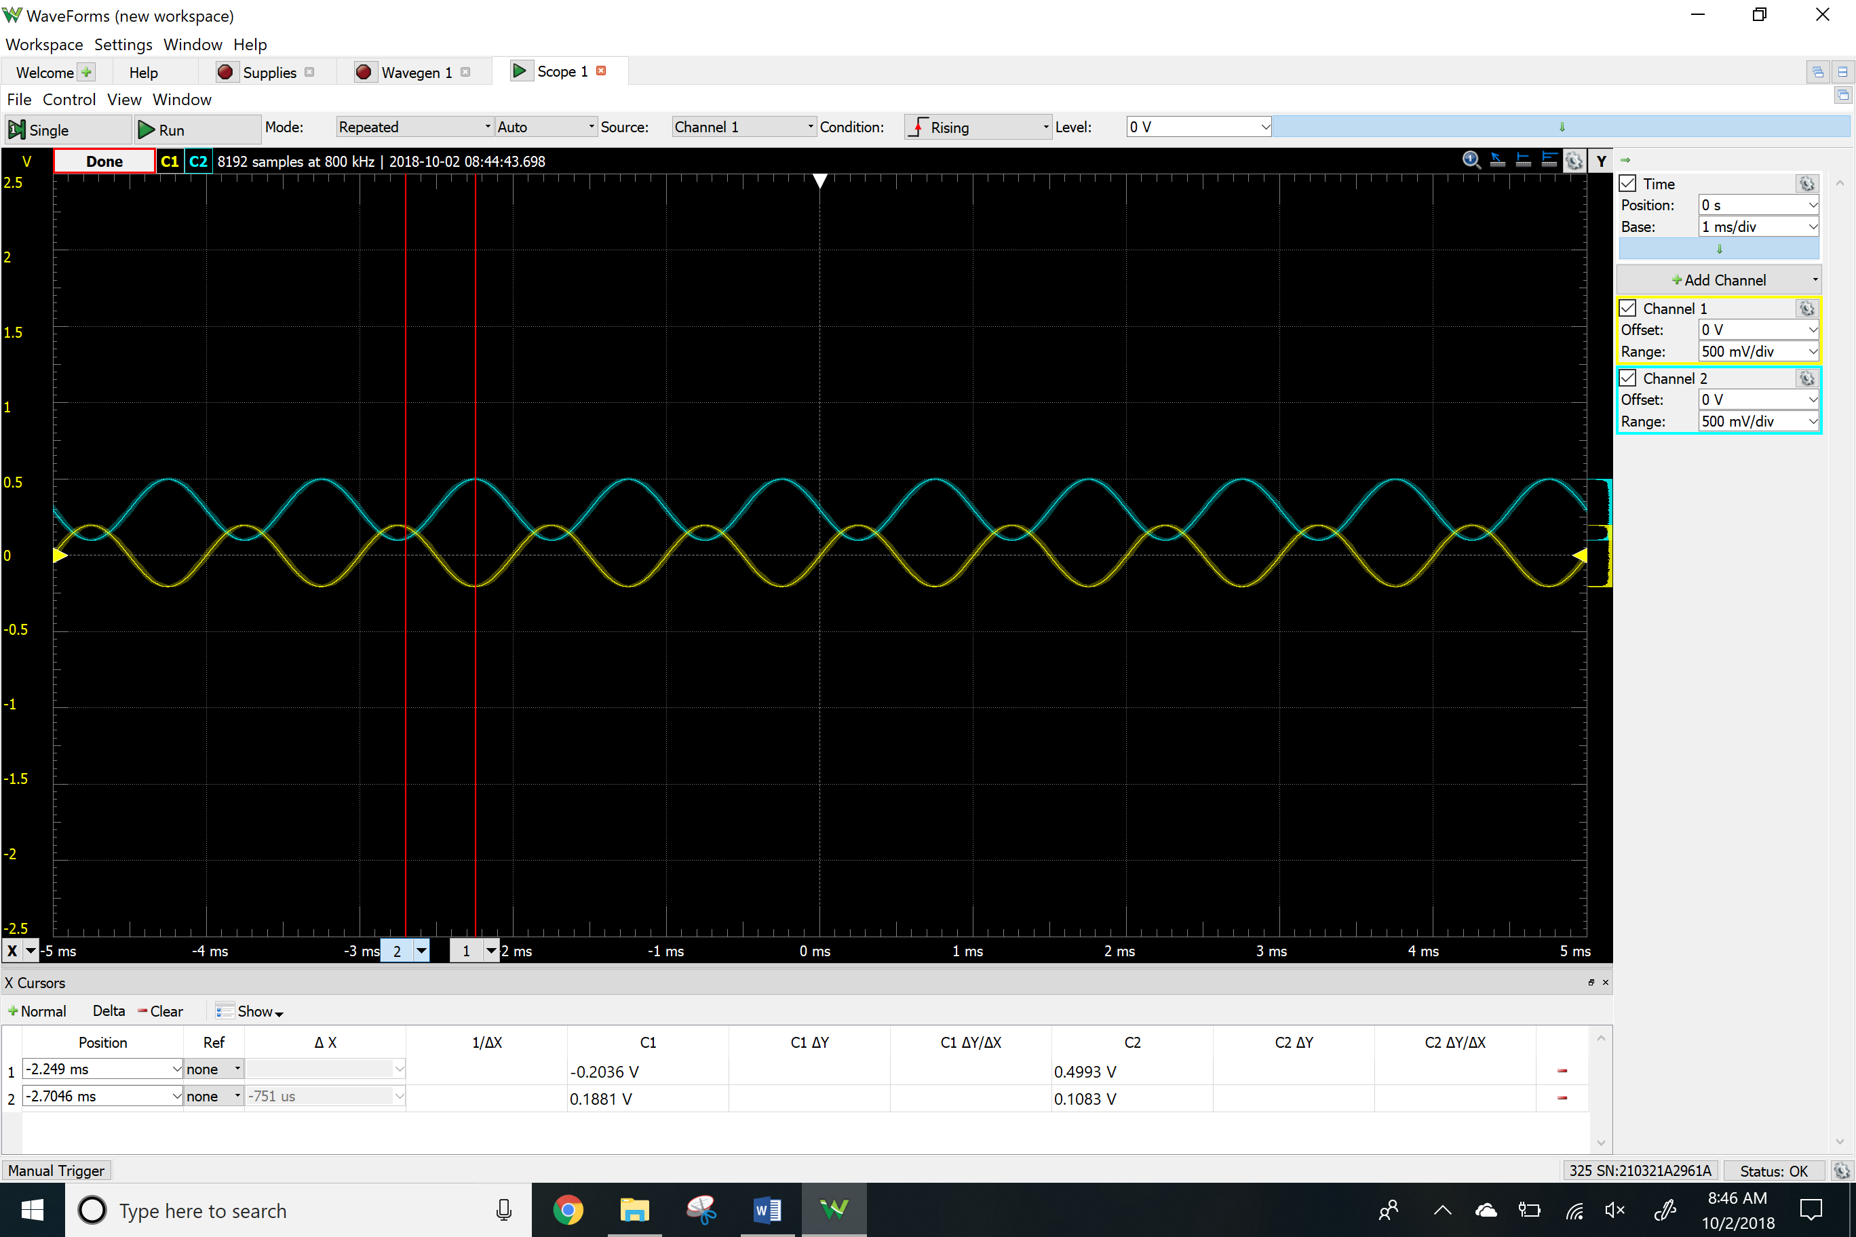

ADM

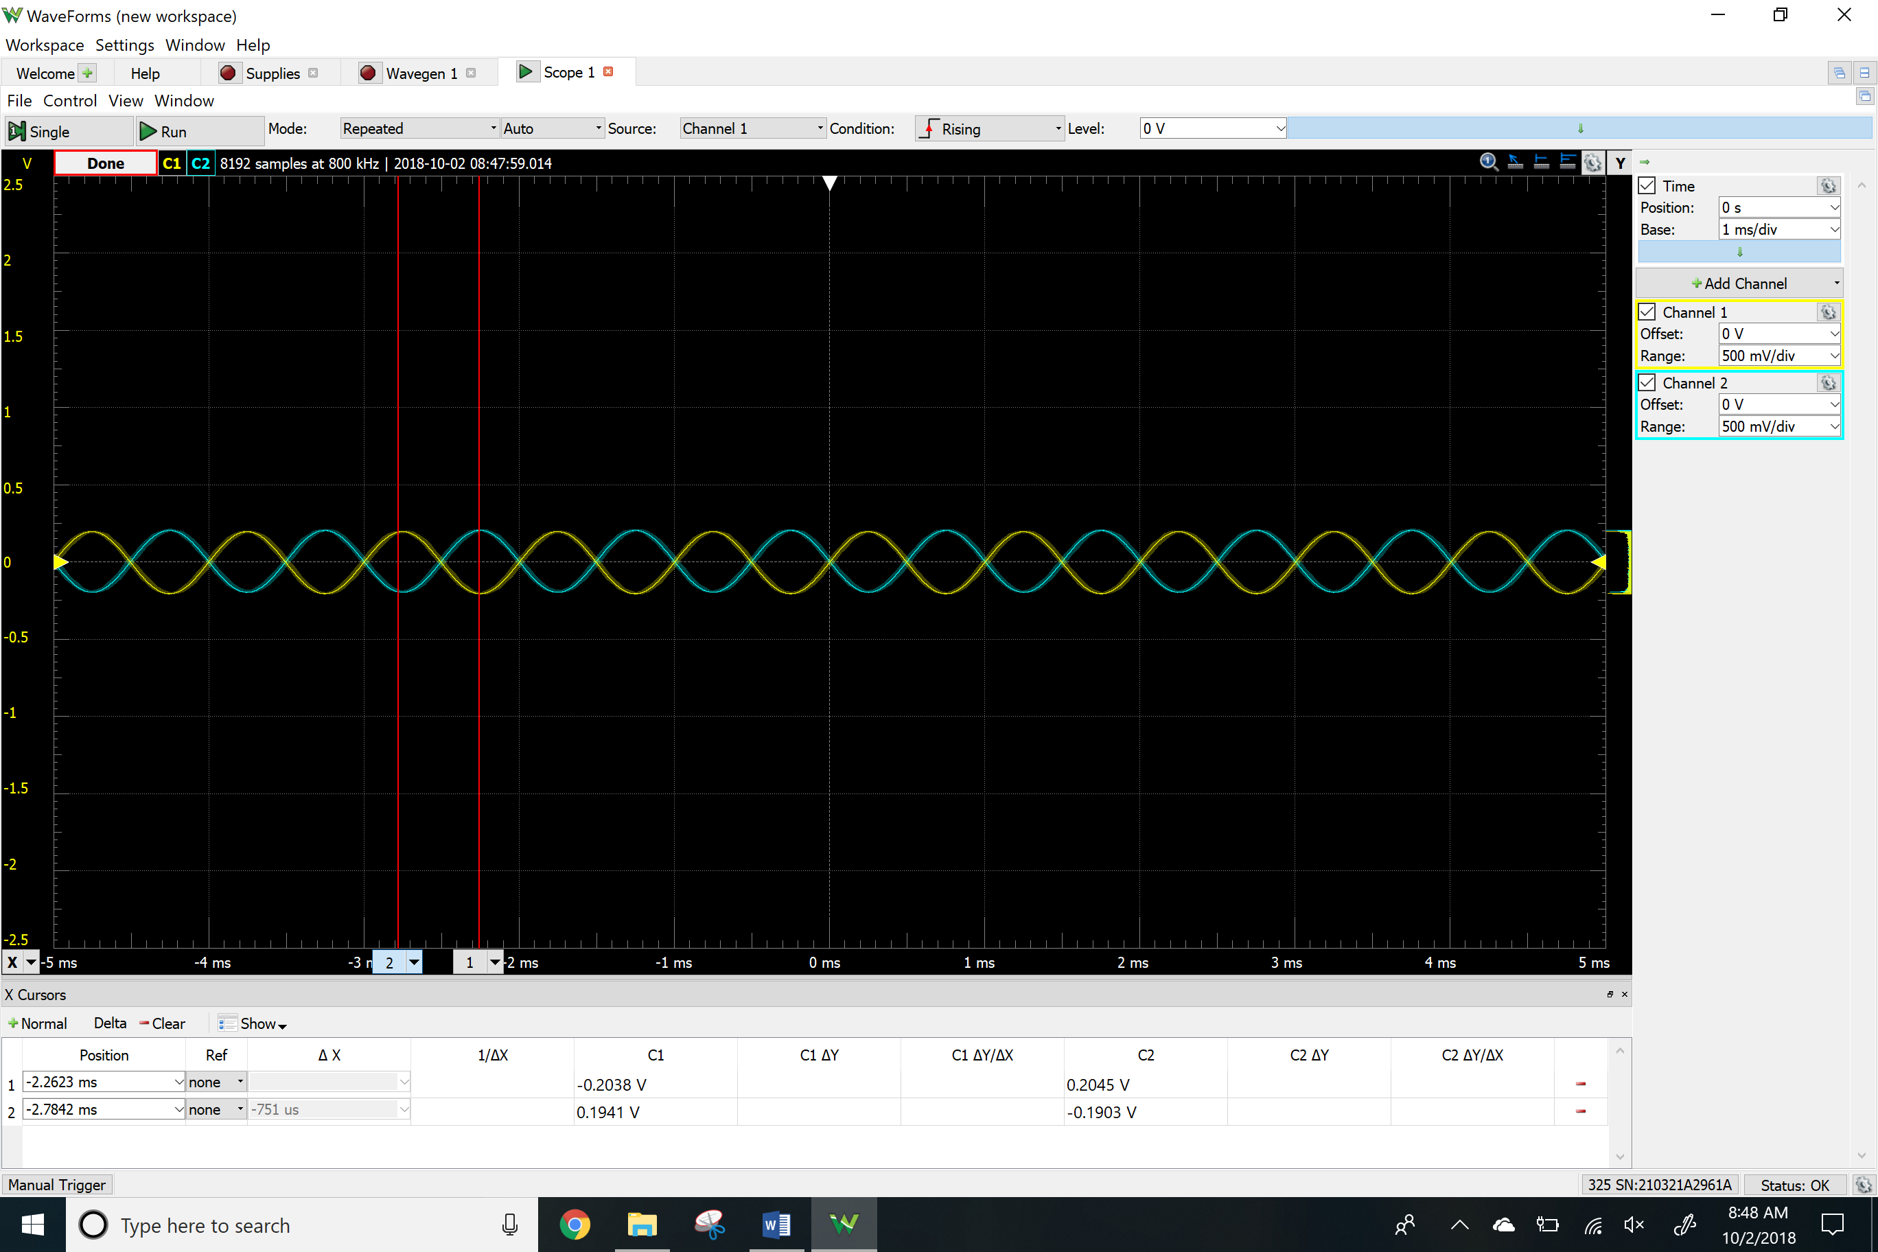

ACM

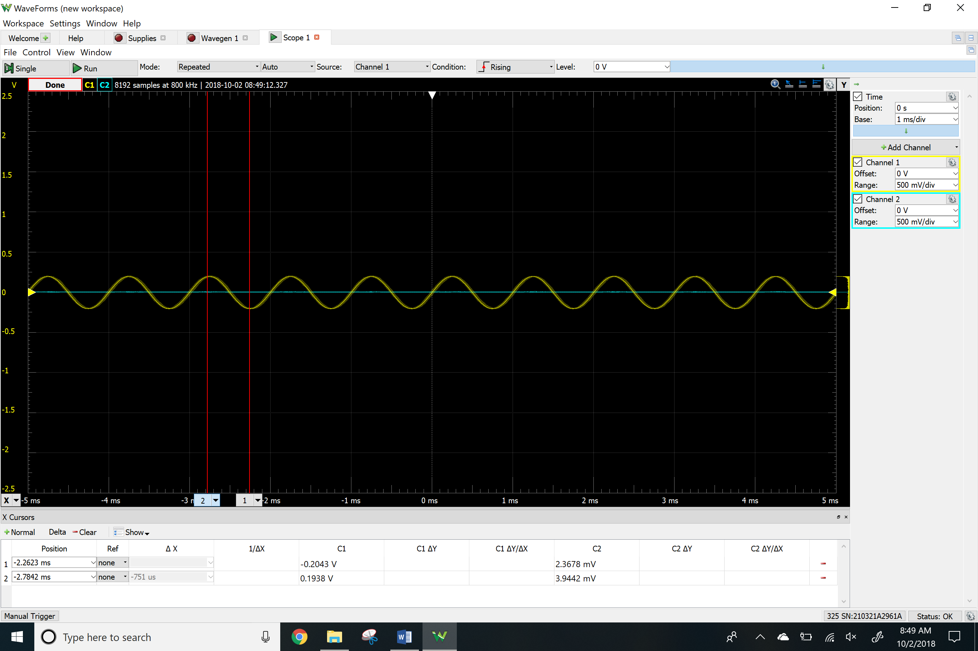

Instrumentation amplifier

Time-domain waveform

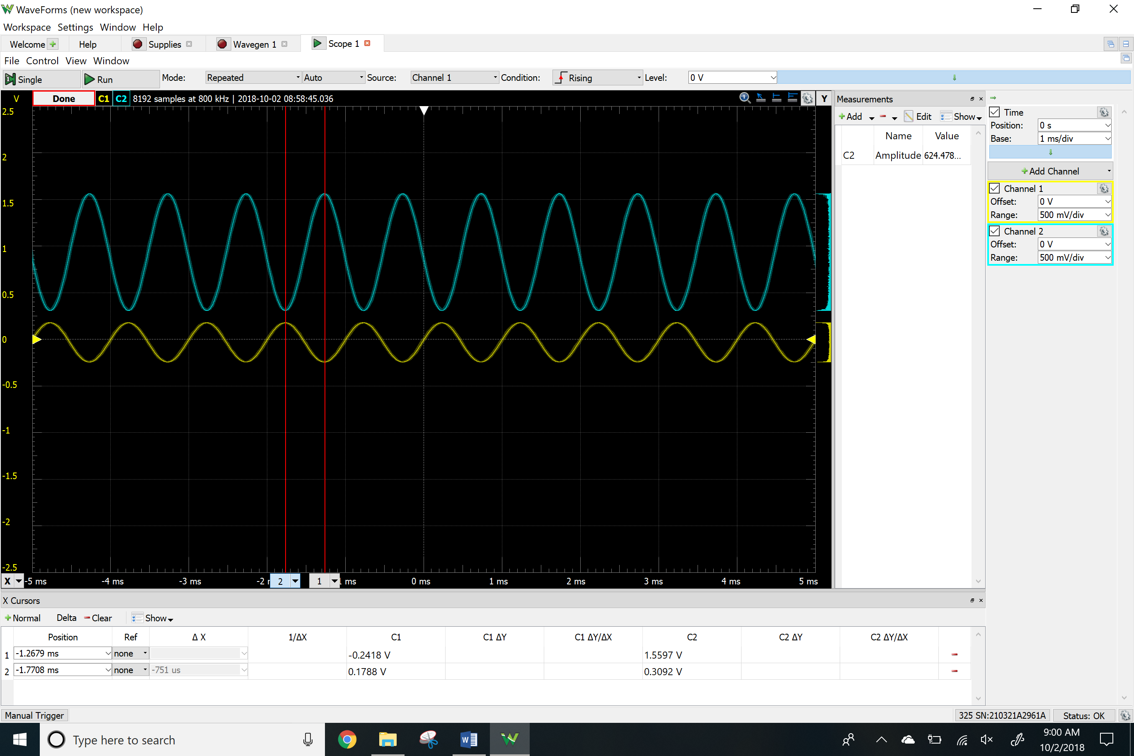

**Results**

Calculated

|  |  |
| --- | --- |
|  | Summing |
| Vi1 | 0.2 V @ 1kHz |
| Vi2 | 0.3 V |
| Vo | -0.2sin(2π1000t)-0.6 V |

|  |  |
| --- | --- |
|  | Differential |
| Vi1 | 0.2 V @ 1kHz |
| Vi2 | 0.3 V |
| Vo | 0.3-0.2sin(2π1000t) V |

|  |  |
| --- | --- |
|  | Instrumentation |
| Vi1 | 0.2 V @ 1kHz |
| Vi2 | 0.3 V |
| Vo | 0.9-0.6sin(2π1000t) V |

Simulated

|  |  |  |  |
| --- | --- | --- | --- |
|  | Summing | Differential | Instrumentation |
| Vi1 | 0.2 V @ 1kHz | 0.2 V @ 1kHz | 0.2 V @ 1kHz |
| Vi2 | 0.3 V | 0.3 V | 0.3 V |
| Vo | 0.199 V | 0.199 V | 0.599 V |

Measured

|  |  |  |  |
| --- | --- | --- | --- |
|  | Summing | Differential | Instrumentation |
| Vi1 | 0.2 V @ 1kHz | 0.2 V @ 1kHz | 0.2 V @ 1kHz |
| Vi2 | 0.3 V | 0.3 V | 0.3 V |
| Vo | 0.200 V | 0.195 V | 0.625 V |
| ADM | - | 1 V | - |
| ACM | - | 0 V | - |
| CMRR | - | 0 V | - |
| Clipping Point | ~1.4 V | - | - |

**Conclusion**

Differences between calculated and simulated results:

There were no differences between the calculated and simulated results.

Differences between all of the results:

Unsurprisingly, the differences between all of the results, from the calculated, simulated and experimental, were negligible. I calculated the common mode rejection ration. This ratio helps us design circuit that are affected by minimum amount of noise. Any differences between the simulated and experimental can be attributed to unaccounted resistances in the breadboard and to resistance values not being exactly as calculated due to not having the proper resistors.