**Lab 6: Diodes**

Faizan Bangash

Ecen 325-504

October 17, 2018

**Calculations**

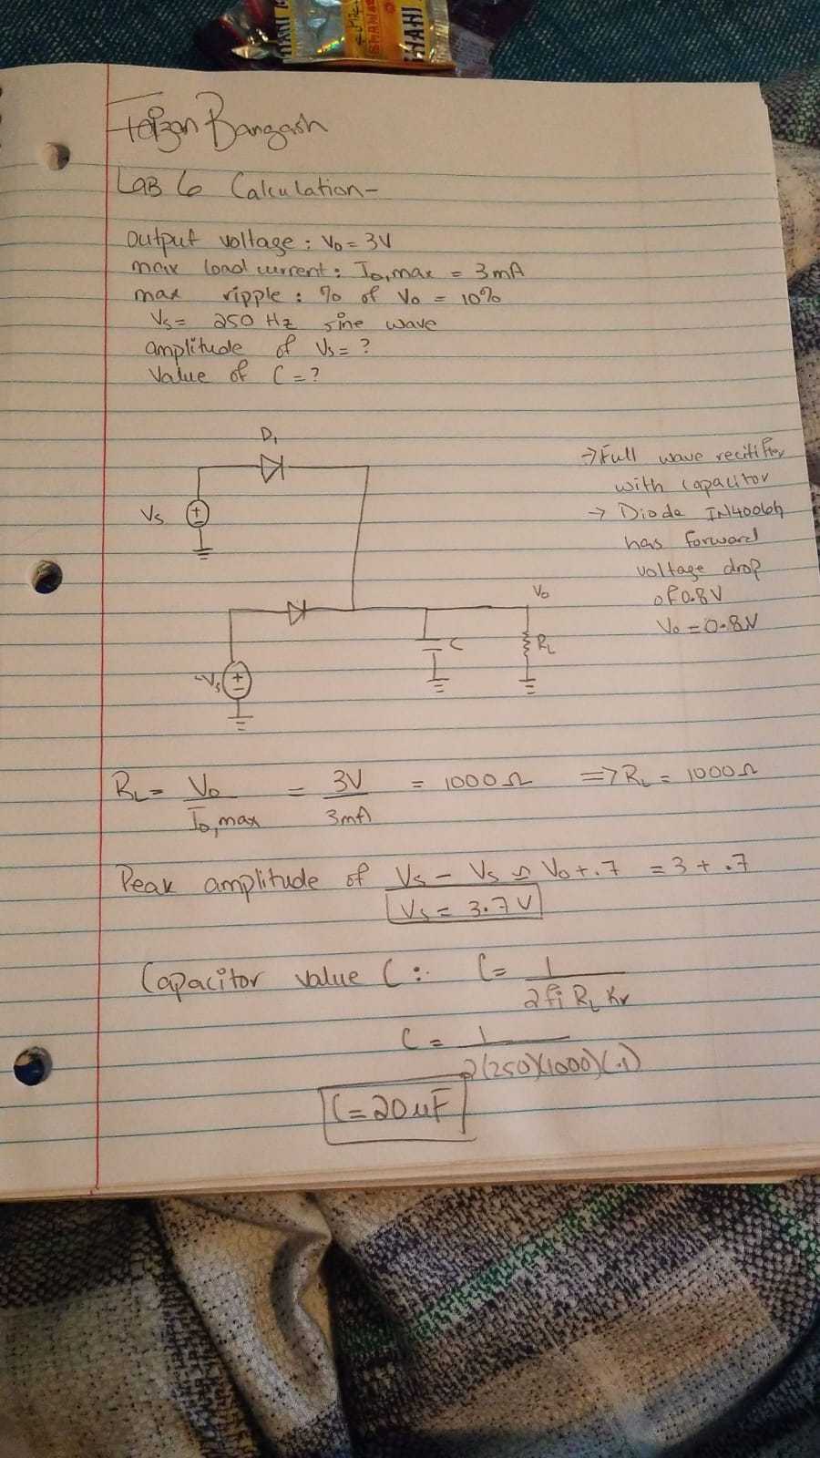

**Simulation**

Diode Test Circuit for I-V Characteristic

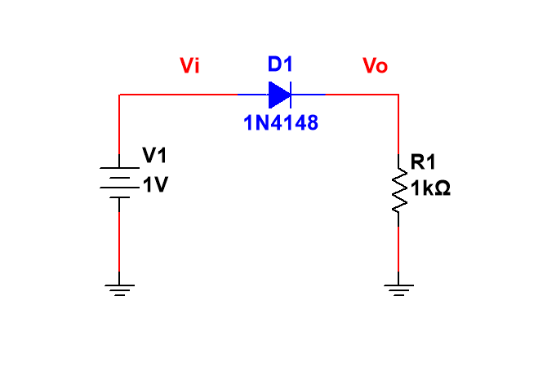

DC sweep

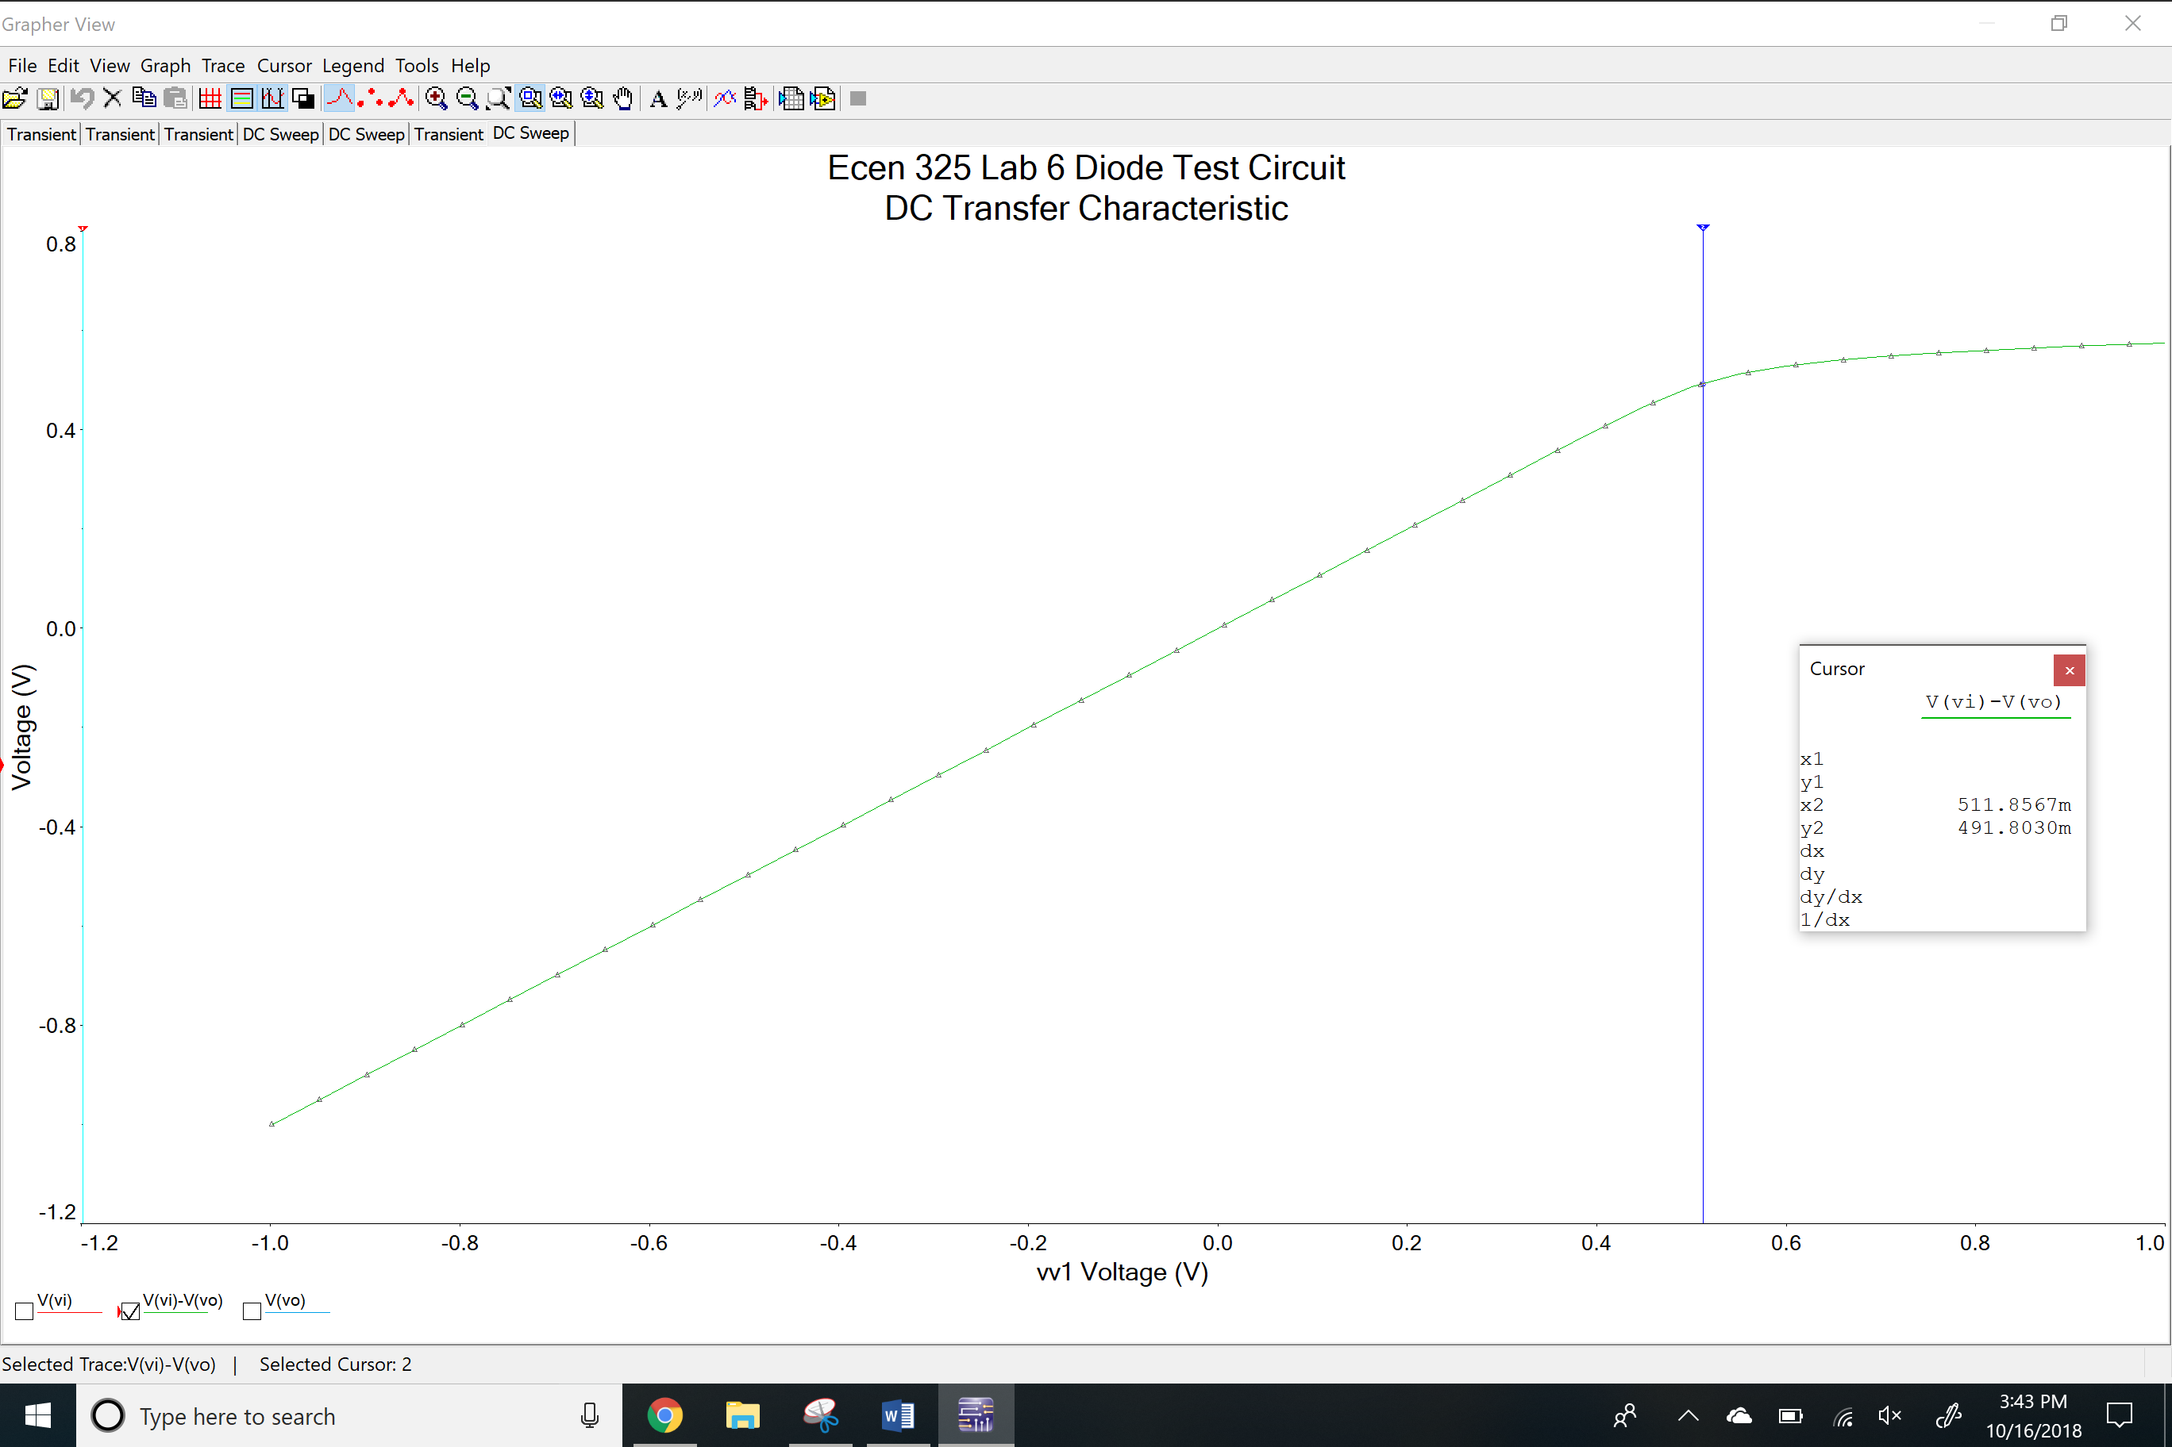

Id vs Vd Plot for simulation values

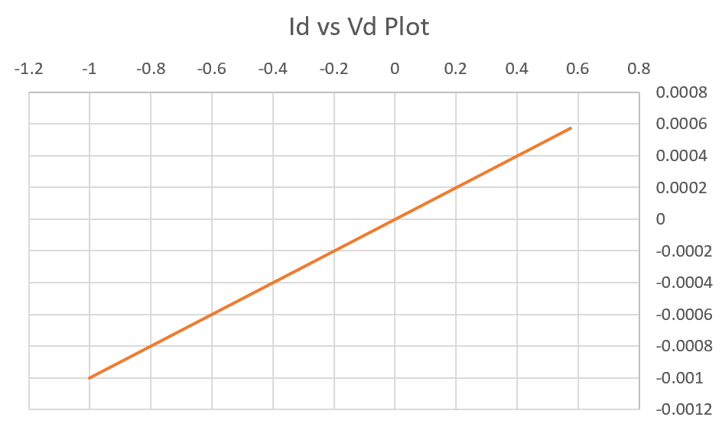

Power supply circuit

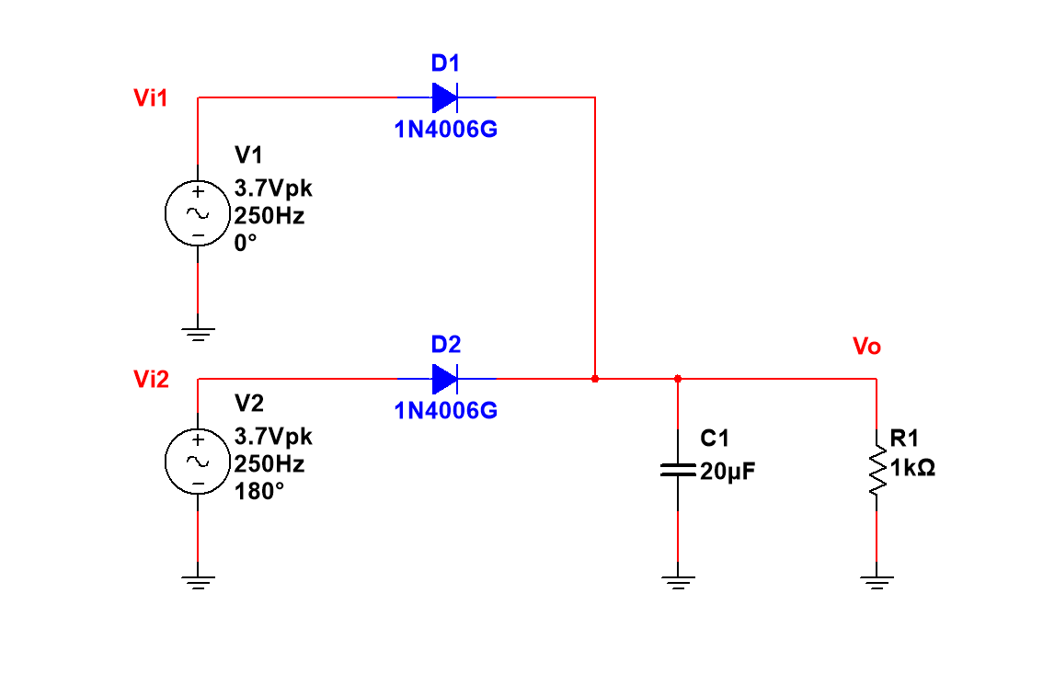

Time-domain waveform for power supply circuit

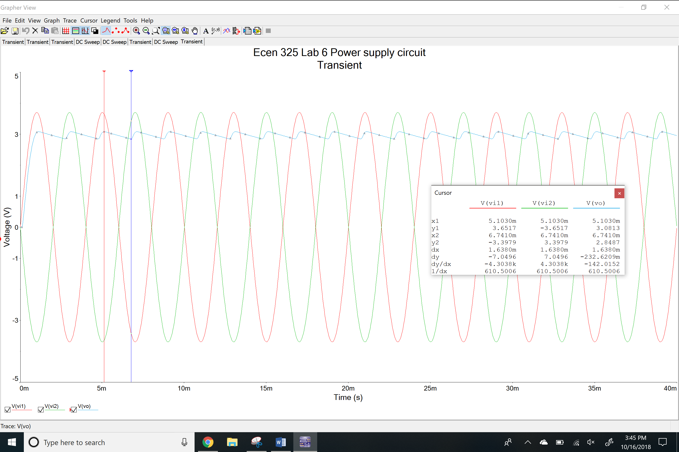

Peak current on diode and load resistor

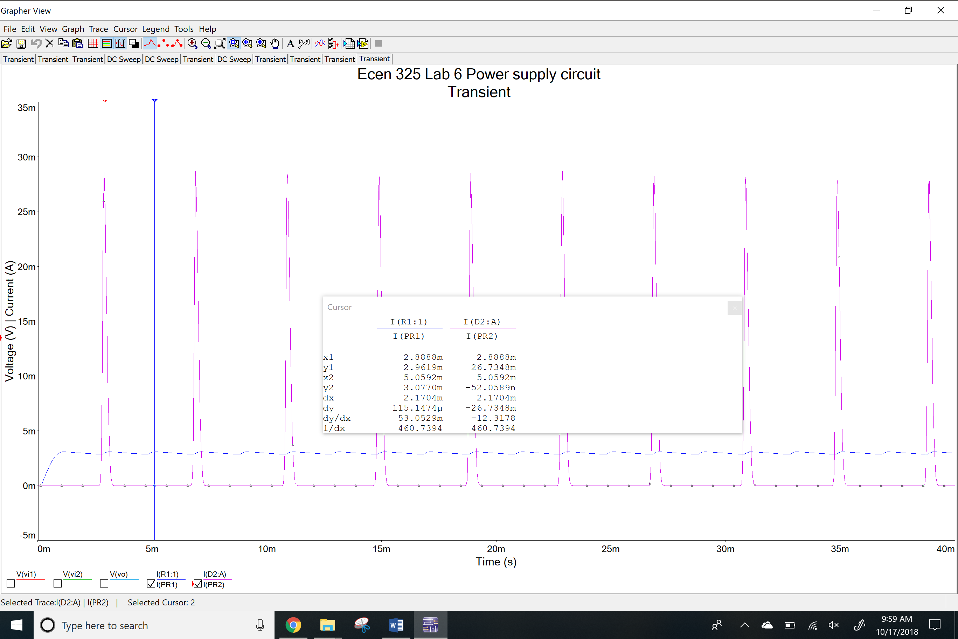

**Measurements**

Diode Test Circuit for I-V Characteristic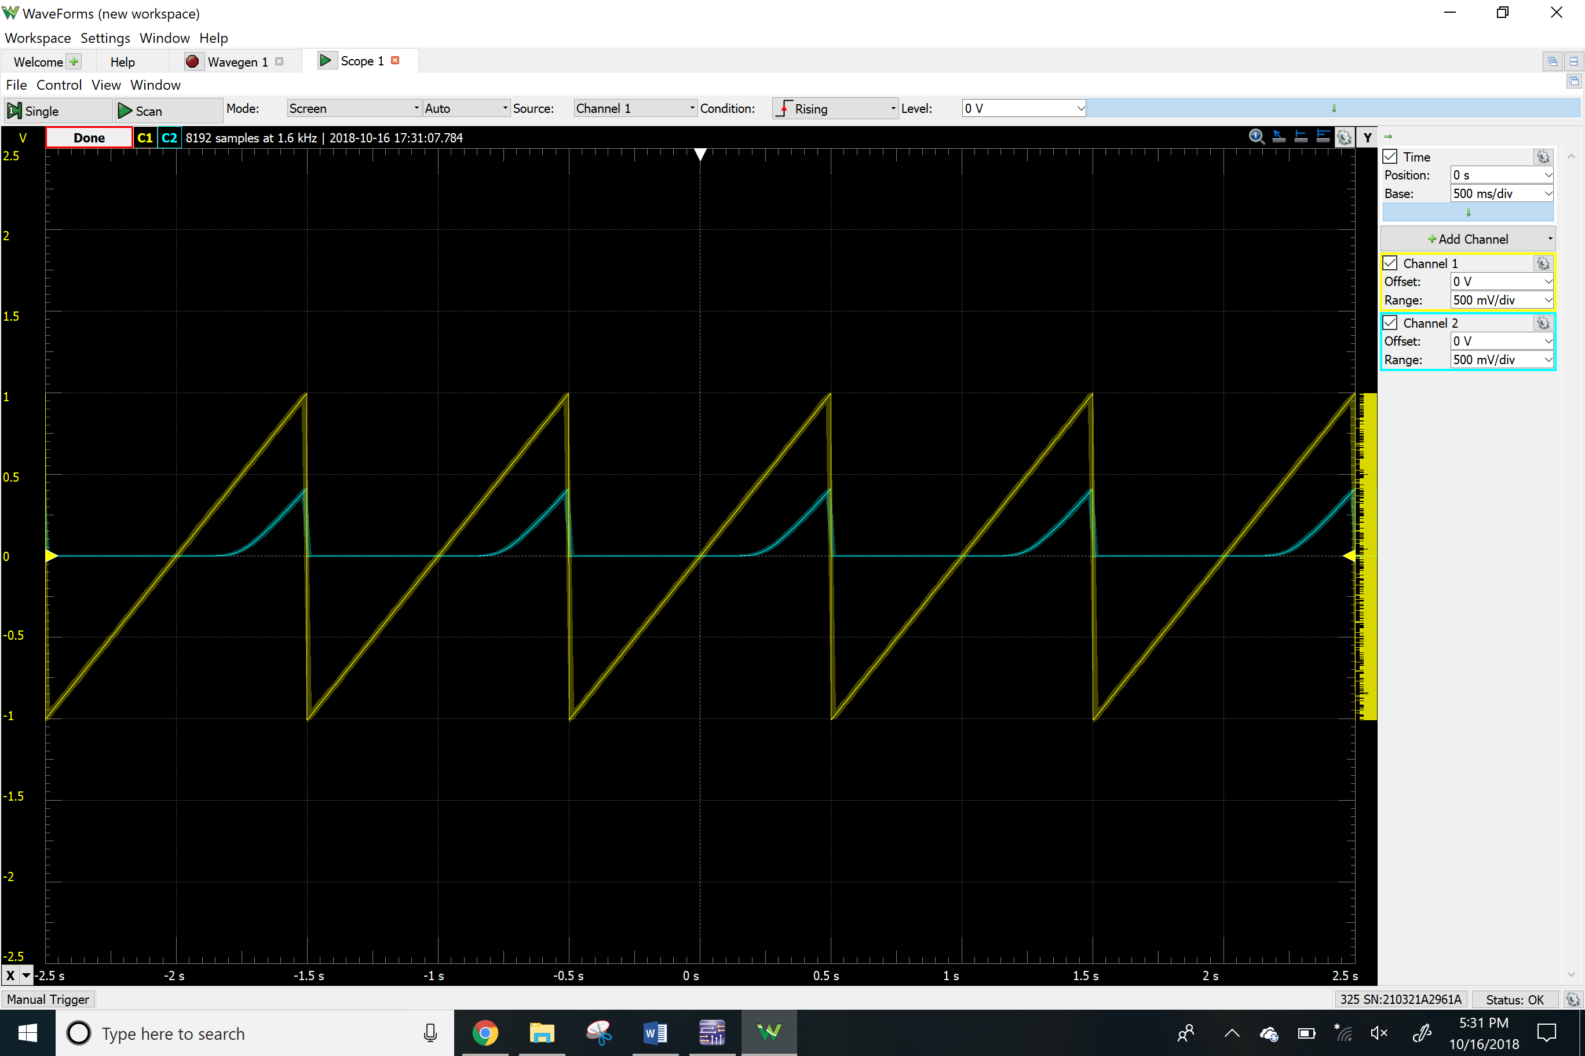

Id vs Vd Plot for measurement values

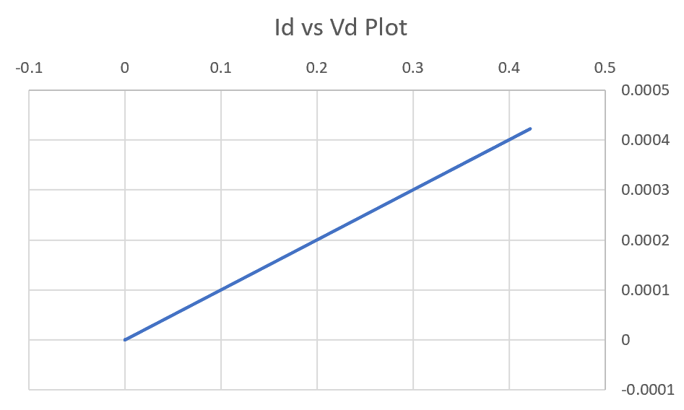

Time-domain waveform for Power supply circuit

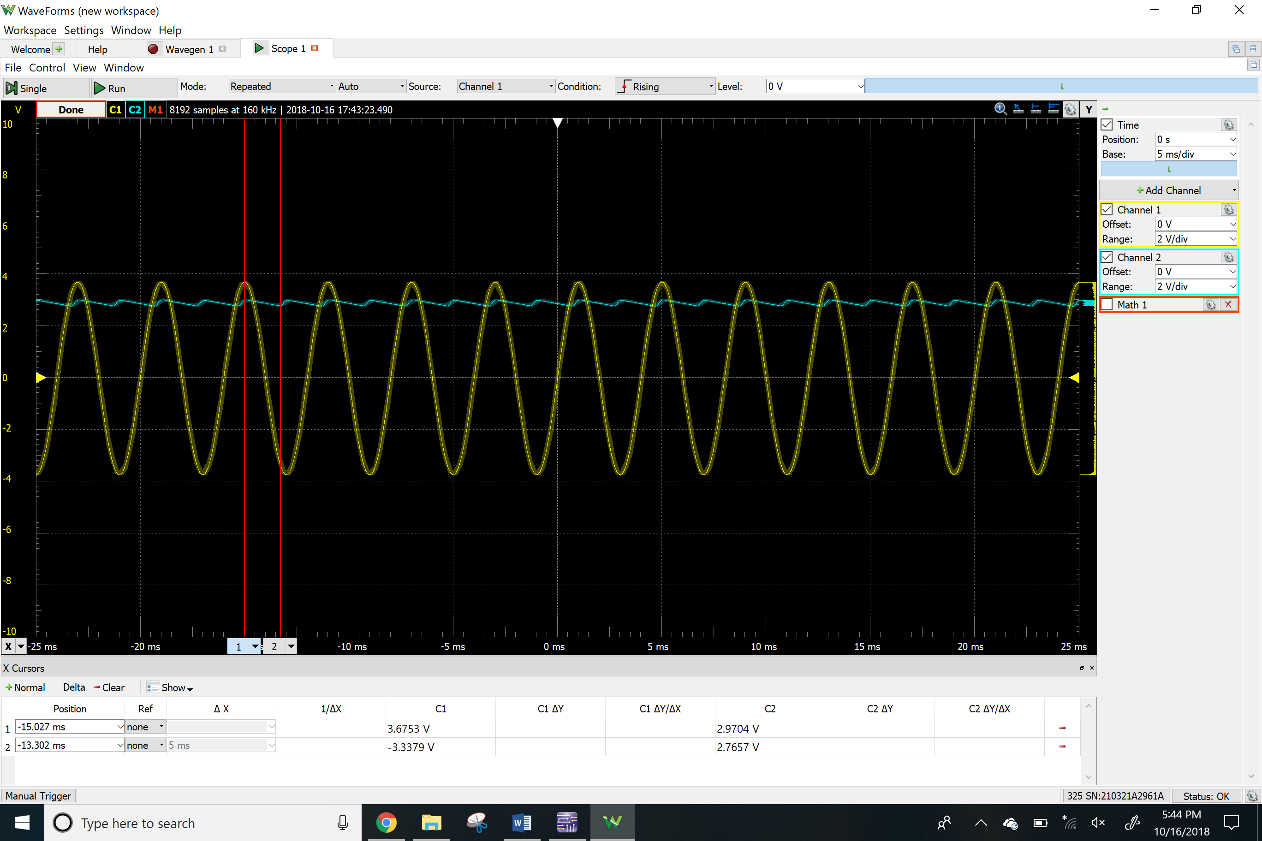

**Results**

Calculated

|  |  |
| --- | --- |
| Vs | 3.7 V |
| C | 20 uF |

Simulated

|  |  |
| --- | --- |
| Peak output voltage | 3.0813 V |
| Maximum ripple | 0.2326 V |
| Peak current on diode | 26.7348 mA |
| Peak current on load resistor | 3.0770 mA |

Measured

|  |  |
| --- | --- |
| Peak output voltage | 2.9704 V |
| Maximum ripple | 0.2047 V |

**Conclusion**

The purpose of this lab was to learn about the basic concepts and characteristic of diodes. In first part, I tested diode circuit and obtain the I-V characteristic for it. The I-V characteristic allows us to visualize how the current flows in the circuits with diode. In the second part, I built a power supply circuit with a capacitor to bring the current close to being steady and also were able to measure the maximum ripple.