1.1

$x_{1}=4,x_{2}=1,x_{3}=9,z=2$

1.2

$x_{1}=0.25,x_{2}=0,x_{3}=0,x_{4}=-0.25,z=1.25$

1.8

设 $x_{n+1}=max{\{q}_{i}x_{i}\}$,则模型二可线性化为

$$\left\{\begin{aligned}q_{i}x_{i}≤x_{n+1} \\ {\sum_{i=0}^{n}{\left(r_{i}-p_{i}\right)x_{i}≥k_{M}} \atop \sum_{i=0}^{n}{\left(1+p_{i}\right)x_{i}=M}} \\ x_{i}≥0\end{aligned}\right.$$

取 $M=1$,代入已知数据得到如下模型

$minx_{5}$

$s.t\left\{\begin{aligned}0.025x_{1}-x_{5}≤0 \\ 0.025x_{2}-x_{5}≤0 \\ \begin{matrix}0.025x_{3}-x_{5}≤0 \\ 0.025x_{4}-x_{5}≤0 \\ \begin{matrix}-0.05x_{0}-0.27x_{1}-0.19x_{2}-0.185x_{3}-0.185x_{4}≤-k \\ x_{0}+1.01x_{1}+1.02x_{2}+1.045x_{3}+1.065x_{4}=1 \\ x_{i}≥0\end{matrix}\end{matrix}\end{aligned}\right.$

将 $k$ 赋值为0.05，以0.005步长迭代，收益 $Q$ 与风险 $V$ 的关系见图1.1，从图中可以看到收益在0.21之后，风险增长率较大，所以为了规避风险，将收益定在0.21.

当收益 $Q=0.2055$ 时， $x_{0}=0,x_{1}=0.3089,x_{2}=0.5148,x_{3}=0.1404,x_{4}=0.0152$，最小风险为0.0077

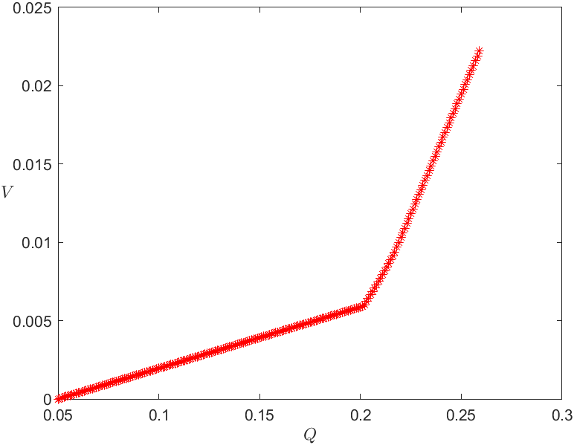

代码：

1.1

|  |
| --- |
| f=[3;-1;-1];  a=[1,-2,1;4,-1,-2];b=[11;-3];  aeq=[-2,0,1];beq=1;  [x,y]=linprog(-f,a,b,aeq,beq,zeros(3,1));  y=-y  x |

1.2

|  |
| --- |
| f=1:4;  c=[f;f];  aeq=[1,-1,-1,1;1,-1,1,-3;1,-1,-2,3];  beq= [0,1,-1/2];  aeq= [aeq,-aeq];  [uv,val]=linprog (c,[],[],aeq,beq,zeros(8,1));  val  x=uv(1:4)-uv(5:end) |

1.8

|  |
| --- |
| prob=optimproblem;  x=optimvar("x",6,"LowerBound",0);  r=[0.05,0.28,0.21,0.23,0.25]; %收益率  p=[0,0.01,0.02,0.045,0.065];%交揭费率  q=[0.025;0.015;0.055;0.026];%风险损失率  prob.Objective=x(6);k=0.05;  V=[];%风险初始化  Q=[];%净收益初值化  X=[];%最优解的初始化  while k<0.26  prob.Constraints.con1 = [q.*x(2:5)<=x(6)  (p-r)*x(1:end-1)<=-k];  prob.Constraints.con2=(1+p)*x(1:end-1)==1;  [sol,fval]= solve(prob);xx=sol.x;  V=[V,max(q.*xx(2:end-1))];X=[X;xx'];  Q=[Q,(r-p)*xx(1:end-1)];k=k+0.001;  end  plot(Q,V,'*r')  xlabel('$Q$','Interpreter','Latex')  ylabel('$V$','Interpreter','Latex','rotation',0)  ind = find(Q>=0.21,1);  sx= X(ind,1:end-1),v=V(ind) |