2.2

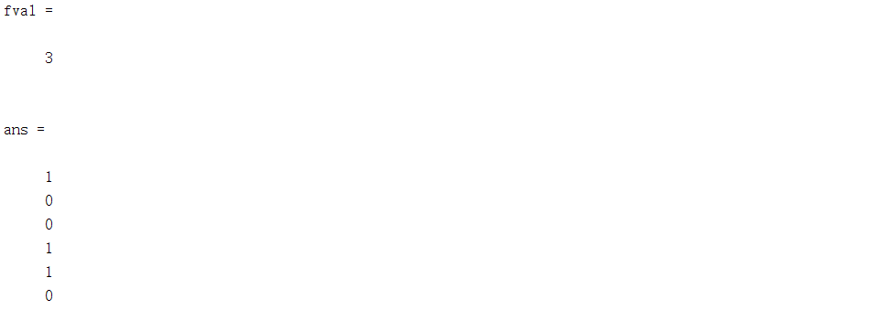

在 $B_{1},B_{4},B_{5}$ 建校

2.8

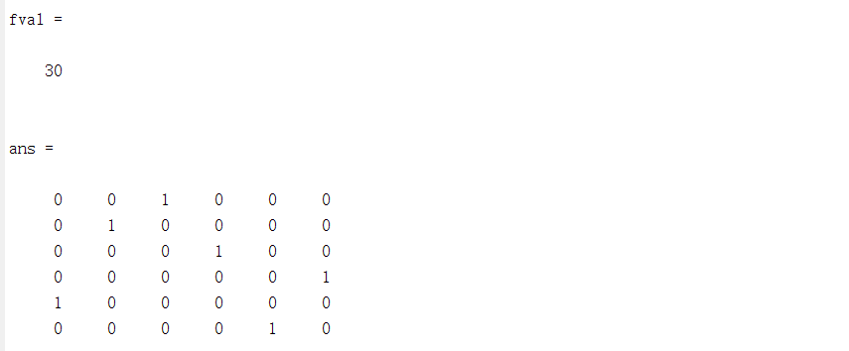

第5人干第一项工作，第2人干第二项，第1人干第三项，第3人干第四项，第6人干第五项，第4人干第六项，总共用时30

3.1

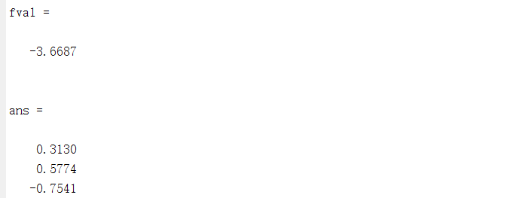

最小值为-3.6687

3.2

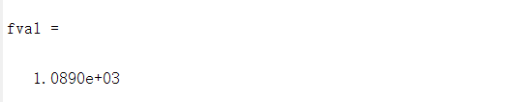

满足条件的最小数为1089

代码：

2.2

|  |
| --- |
| %2.2  prob = optimproblem;  x = optimvar('x',6,'Type','integer','LowerBound',0,'UpperBound',1);  prob.Objective=sum(x);  cons=[x(1)+x(2)+x(3)>=1  x(2)+x(4)>=1  x(3)+x(5)>=1  x(4)+x(6)>=1  x(5)+x(6)>=1  x(1)>=1  x(2)+x(4)+x(6)>=1];  prob.Constraints.cons = cons;  [sol,fval] = solve(prob)  sol.x |

2.8

|  |
| --- |
| %2.8  prob = optimproblem;  c = [6,7,5,8,9,10  6,3,7,9,3,8  8,11,12,6,7,9  9,7,5,4,7,6  5,8,9,6,10,7  9,8,7,6,5,9];  x=optimvar('x',6,6,'Type','integer','LowerBound',0,'upperBound',1);  prob.Objective = sum(sum(c.*x));  prob.Constraints.con = [sum(x,2)==1; sum(x,1)'==1];  [sol,fval] = solve(prob)  sol.x |

3.1

|  |
| --- |
| %3.1  prob = optimproblem;  A = [1,4,5;4,2,6;5,6,3];  x = optimvar('x',3);  prob.Objective=x'*A*x;  prob.Constraints.con = sum(x.^2)==1;  x0.x = rand(3,1) ;  [sol,fval] = solve(prob,x0)  sol.x |

3.2

|  |
| --- |
| %3.2  prob = optimproblem("ObjectiveSense","minimize");  x = optimvar('x',"Type","integer","LowerBound",0);  y = optimvar('y',1,8,"Type","integer","LowerBound",0);  c = [2:9];m = [1,0,1,4,3,4,1,0];  prob.Objective = x;  prob.Constraints.con = x-c.*y==m;  [sol,fval] = solve(prob)  sol.x |