4.9

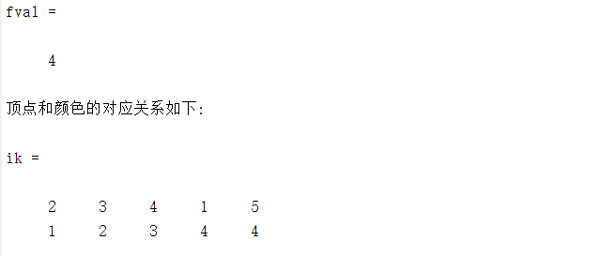

需要四个考场才能满足条件，第2,3,4个人各自在一间教室，第1和第5个人在一间教室

代码

|  |
| --- |
| E=[1,2;1,3;1,4;2,3;2,4;2,5;3,4;3,5];  G=graph(E(:,1),E(:,2));  plot(G)  w = full(adjacency(G))  deg = sum(w)  K = max(deg)  n=size(w,1);  prob = optimproblem("ObjectiveSense","min");  x = optimvar('x',n,K+1,'Type','integer','LowerBound',0,'UpperBound',1);  y = optimvar('y');  prob.Objective = y;  prob.Constraints.con1 = sum(x,2)==1;  prob.Constraints.con2 = x(E(:,1),:)+x(E(:,2),:)<=1;  prob.Constraints.con3 = x*[1:K+1]'<=y;  [sol, fval] = solve(prob)  [i,k] = find(sol.x);  fprintf ('顶点和颜色的对应关系如下:\n')  ik = [i';k'] |