5.4

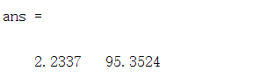

$a,b$ 的估计分别为2.2337,95.3524

代码

|  |
| --- |
| p = [36.9,46.7,63.7,77.8,84.0,87.5];  theta = [181,197,235,270,283,292];  polyfit(p,theta,1) |