6.4

解曲线如图所示

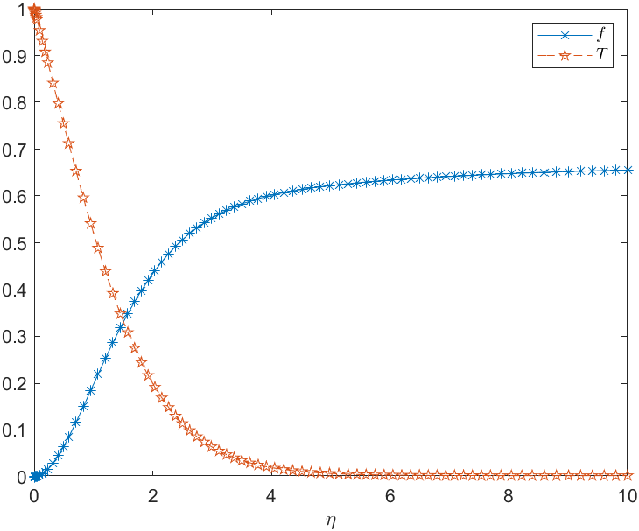

代码

|  |
| --- |
| f=@(t,y)[y(2);y(3);-3*y(1)*y(3)+2*y(2)^2-y(4);y(5);-2.1 *y(1)*y(5)];  y0=[0;0;0.68;1;-0.5];[t,s]=ode45(f,[0,10],y0)  plot(t,s(:,1),'*-',t,s(:,4),'--p')  legend({'$f$','$T$'},'Interpreter','Latex')  xlabel ('$ \eta$','Interpreter','latex' ) |