**云南大学数学与统计学院**

**上机实验报告 （ 3 ）**

|  |  |  |  |  |  |  |  |  |  |  |  |  |  |
| --- | --- | --- | --- | --- | --- | --- | --- | --- | --- | --- | --- | --- | --- |
| **实验课程名** | | | 运筹学实验 | | | | | | | **成绩** | |  | |
| **学号** |  | | **姓名** | **枫叶** | | **专业** | | **统计学** | **年级** | | **2021级** | | |
| **实验项目名称** | | | 用R软件求解运输问题 | | | **日期** | | **2023.4.17** | **实验时间** | | | | **2023.4.17** |
| **指导教师** | | 潘东东 | | | **实验地址（室）** | |  | | | | | | |
| **教师评语** | |  | | | | | | | | | | | |

**一、目的**

学会在R软件下求解运输问题(教材117页 例4-5)

**二、实验内容**

在R中调用lpSovle包中的核心函数lp.transport求解运输问题，并与Rglpk包的核心函数Rglpk_solve_LP所得的结果进行对比。

**三、使用环境**

R

**四、实验步骤**

**1、数据准备：**

**无**

**2、程序实验：**

（1）lp.transport

library(lpSolve)

cost.mat <- matrix(c(6,2,6,7,4,2,5,9,

                     4,9,5,3,8,5,8,2,

                     5,2,1,9,7,4,3,3,

                     7,6,7,3,9,2,7,1,

                     2,3,9,5,7,2,6,5,

                     5,5,2,2,8,1,4,4),byrow = T,ncol = 8)

direction <- "min"

row.signs <- c("<=","<=","<=","<=","<=","<=")

row.rhs <- c(60,55,51,43,41,52)

col.signs <- c(">=",">=",">=",">=",">=",">=",">=",">=")

col.rhs <- c(35,37,22,32,41,32,43,38)

lp.transport(cost.mat, direction, row.signs, row.rhs, col.signs, col.rhs)

lp.transport(cost.mat, direction, row.signs, row.rhs, col.signs, col.rhs)$solution

（2）Rglpk_solve_LP

library(Rglpk)

obj = c(6,2,6,7,4,2,5,9,

        4,9,5,3,8,5,8,2,

        5,2,1,9,7,4,3,3,

        7,6,7,3,9,2,7,1,

        2,3,9,5,7,2,6,5,

        5,5,2,2,8,1,4,4)

mat = matrix(c(1,1,1,1,1,1,1,1,0,0,0,0,0,0,0,0,0,0,0,0,0,0,0,0,0,0,0,0,0,0,0,0,0,0,0,0,0,0,0,0,0,0,0,0,0,0,0,0,

               0,0,0,0,0,0,0,0,1,1,1,1,1,1,1,1,0,0,0,0,0,0,0,0,0,0,0,0,0,0,0,0,0,0,0,0,0,0,0,0,0,0,0,0,0,0,0,0,

               0,0,0,0,0,0,0,0,0,0,0,0,0,0,0,0,1,1,1,1,1,1,1,1,0,0,0,0,0,0,0,0,0,0,0,0,0,0,0,0,0,0,0,0,0,0,0,0,

               0,0,0,0,0,0,0,0,0,0,0,0,0,0,0,0,0,0,0,0,0,0,0,0,1,1,1,1,1,1,1,1,0,0,0,0,0,0,0,0,0,0,0,0,0,0,0,0,

               0,0,0,0,0,0,0,0,0,0,0,0,0,0,0,0,0,0,0,0,0,0,0,0,0,0,0,0,0,0,0,0,1,1,1,1,1,1,1,1,0,0,0,0,0,0,0,0,

               0,0,0,0,0,0,0,0,0,0,0,0,0,0,0,0,0,0,0,0,0,0,0,0,0,0,0,0,0,0,0,0,0,0,0,0,0,0,0,0,1,1,1,1,1,1,1,1,

               1,0,0,0,0,0,0,0,1,0,0,0,0,0,0,0,1,0,0,0,0,0,0,0,1,0,0,0,0,0,0,0,1,0,0,0,0,0,0,0,1,0,0,0,0,0,0,0,

               0,1,0,0,0,0,0,0,0,1,0,0,0,0,0,0,0,1,0,0,0,0,0,0,0,1,0,0,0,0,0,0,0,1,0,0,0,0,0,0,0,1,0,0,0,0,0,0,

               0,0,1,0,0,0,0,0,0,0,1,0,0,0,0,0,0,0,1,0,0,0,0,0,0,0,1,0,0,0,0,0,0,0,1,0,0,0,0,0,0,0,1,0,0,0,0,0,

               0,0,0,1,0,0,0,0,0,0,0,1,0,0,0,0,0,0,0,1,0,0,0,0,0,0,0,1,0,0,0,0,0,0,0,1,0,0,0,0,0,0,0,1,0,0,0,0,

               0,0,0,0,1,0,0,0,0,0,0,0,1,0,0,0,0,0,0,0,1,0,0,0,0,0,0,0,1,0,0,0,0,0,0,0,1,0,0,0,0,0,0,0,1,0,0,0,

               0,0,0,0,0,1,0,0,0,0,0,0,0,1,0,0,0,0,0,0,0,1,0,0,0,0,0,0,0,1,0,0,0,0,0,0,0,1,0,0,0,0,0,0,0,1,0,0,

               0,0,0,0,0,0,1,0,0,0,0,0,0,0,1,0,0,0,0,0,0,0,1,0,0,0,0,0,0,0,1,0,0,0,0,0,0,0,1,0,0,0,0,0,0,0,1,0,

               0,0,0,0,0,0,0,1,0,0,0,0,0,0,0,1,0,0,0,0,0,0,0,1,0,0,0,0,0,0,0,1,0,0,0,0,0,0,0,1,0,0,0,0,0,0,0,1),

               ncol = 48, byrow = T)

dir = c("<=", "<=", "<=", "<=", "<=","<=",

        ">=", ">=", ">=",">=",">=",">=",">=",">=")

rhs = c(60,55,51,43,41,52,

        35,37,22,32,41,32,43,38)

max = F

Rglpk_solve_LP(obj, mat, dir, rhs, max)

**3、程序结果（截屏）：**

（1）lp.transport

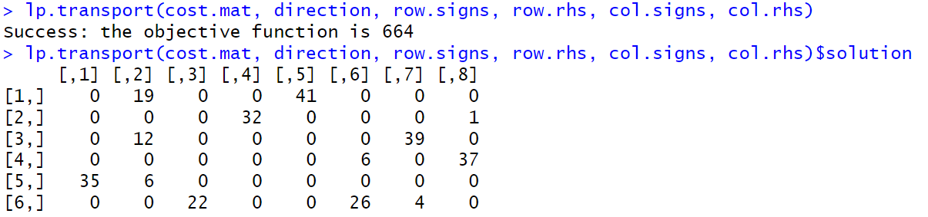

（2）Rglpk_solve_LP

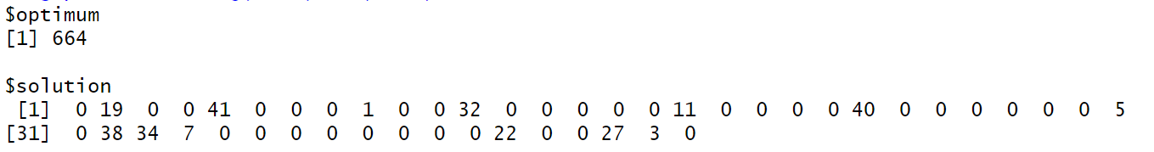

**五、实验结果及分析**

求解出的结果一致，但lp.transport函数显然要比Rglpk_solve_LP更为便捷