## 加载包

library(dplyr)  
library(purrr)  
library(ggplot2)

## 第一题

poisson_gen <- function(n=1,lambda=10,maxtime=10,set_seed=NA){  
 maxperson <- 2*lambda*maxtime  
 if(!is.na(set_seed)) set.seed(set_seed)  
 data.frame(id = n,  
 Time = rexp(maxperson,lambda) %>% cumsum(),  
 goals = 1:maxperson) %>%  
 filter(Time <= maxtime)  
}  
data <- poisson_gen(1,0.1,100,429) %>%  
 filter(goals<=6)  
a <- data$Time;b <- data$goals #如果是ggplot2就不用中间变量了  
plot(0, type="n", xlim=c(0, max(a)+1), ylim=c(0, max(b)+1), xlab="分钟", ylab="进球数")  
for (i in 1:(length(a)-1)) {  
 segments(x0=a[i], y0=b[i], x1=a[i+1], y1=b[i], lwd=2)  
 points(a[i], b[i], pch=16, col="black", cex=0.75) # 实心点  
 points(a[i+1], b[i], pch=1, col="black", cex=0.75) # 空心点  
}  
points(a[6],6,pch=16, cex=0.75)

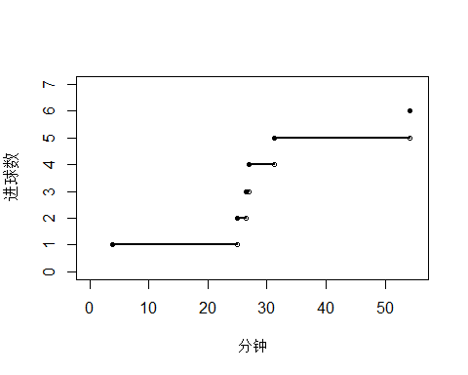

## 第二题

set.seed(429)  
t=60  
U1 <- rpois(1,5) %>%  
 runif(0,60) %>%  
 sort()  
a <- U1;b <- 1:length(U1)  
plot(0, type="n", xlim=c(0, max(a)+1), ylim=c(0, max(b)+1), xlab="分钟", ylab="进球数")  
for (i in 1:(length(a)-1)) {  
 segments(x0=a[i], y0=b[i], x1=a[i+1], y1=b[i], lwd=2)  
 points(a[i], b[i], pch=16, col="black", cex=0.75) # 实心点  
 points(a[i+1], b[i], pch=1, col="black", cex=0.75) # 空心点  
}  
points(a[6],6,pch=16, cex=0.75)

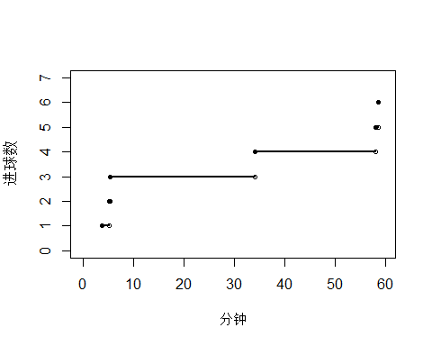

## 第三题

first_time <- rexp(1000,1/10+1/12)  
mean(first_time)

## [1] 5.157331

ggplot(data.frame(time=first_time),aes(x=time)) +  
 geom_histogram(aes(y=after_stat(density)),fill="lightblue",bins = 100) +  
 stat_function(fun = function(x) dexp(x, rate = 1/10+1/12)) +  
 xlab("第一次进球的时间") +  
 theme_bw()

