## 加载包

library(dplyr)  
library(ggplot2)

## 第一题

winer_view <- function(sigma){  
 data.frame(t=seq(0,1,0.0001),  
 x=c(0,cumsum(rnorm(10000,1*0.0001*sigma^2)))) %>%  
 ggplot() +  
 geom_line(aes(x=t,y=x)) +  
 labs(title = bquote(sigma==.(sigma))) +  
 theme_bw()  
}  
winer_view(1)

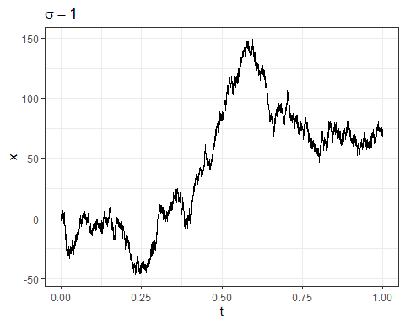

winer_view(1.5)

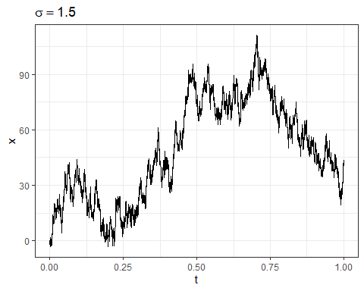

winer_view(2)

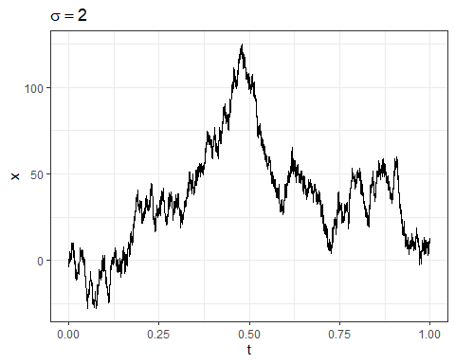

## 第二题

易知 $F_{n}\left(t\right)=e^{−nλ}\sum_{k=0}^{⌊t⌋}{\frac{{\left(nλ\right)}^{k}}{k!}}$，则可构造如下函数

F_n <- function(t,n,lambda=2){  
 t <- floor(t);lambda <- n*lambda  
 exp(-lambda)*sum(lambda^(0:t)/factorial(0:t))  
}  
P_n <- function(t,n){  
 F_n(t,n)-F_n(t,n+1)  
}  
P_data <- data.frame(t=rep(5,5),  
 n=seq(0,8,2)) %>%  
 rowwise() %>%  
 mutate(p=P_n(t,n))  
P_data

## # A tibble: 5 × 3  
## # Rowwise:   
## t n p  
## <dbl> <dbl> <dbl>  
## 1 5 0 0.0166   
## 2 5 2 0.339   
## 3 5 4 0.124   
## 4 5 6 0.0148   
## 5 5 8 0.00106

## 第三题

P <- matrix(c(1/2,1/4,0,1/2,1/2,3/4,0,1/4,1/4),nrow = 3)  
P2 <- P%*%P  
P2

## [,1] [,2] [,3]  
## [1,] 0.3750 0.5000 0.1250  
## [2,] 0.2500 0.5625 0.1875  
## [3,] 0.1875 0.5625 0.2500

rep(1/3,3) %*% P2

## [,1] [,2] [,3]  
## [1,] 0.2708333 0.5416667 0.1875