BAO CAO CUOI KY
DE TAI 1: SONG SONG HOA NHAN MA TRAN KICH THUOC LON
Hoc phan: Tinh toan hieu nang cao (High Performance Computing)
Nhom thuc hien: chua cap nhat ten 3 thanh vien

1. Co so ly thuyet va phan tich thuat toan
Gioi thieu bai toan: de tai thuc hien phep nhan ma tran kich thuoc lon, xay dung chuong trinh tuan tu va chuong trinh song song bang MPI/OpenMPI, sau do danh gia kha nang tang toc khi thay doi so process va so node.
Bai toan de tai 1 la nhan hai ma tran chu nhat kich thuoc lon C = A x B. Voi A co kich thuoc M x K va B co kich thuoc K x N, ket qua C co kich thuoc M x N. Moi phan tu C[i,j] duoc tinh bang tong A[i,t] * B[t,j] voi t tu 0 den K-1.
Thuat toan tuan tu co ba vong lap long nhau nen do phuc tap tinh toan la O(M x K x N). So phep toan dau cham dong ly thuyet xap xi 2 x M x K x N FLOP.
Variant | Vai tro | Ghi chu
seq | Baseline tuan tu | De giai thich cong thuc O(M x K x N).
seq_tiled | Baseline tuan tu toi uu cache | Dung tile de tang locality bo nho.
mpi | Ban song song MPI | Chia hang A, broadcast B, gather C.
mpi_tiled | Ban song song MPI toi uu cache | Khuyen nghi dung cho benchmark chinh.
mpi_2d | Ban MPI chia luoi 2D | Scatter block hang A va block cot B da transpose theo matrix-v2.

2. Thiet ke giai phap song song bang MPI/OpenMPI
Chuong trinh dung pure MPI, khong dung OpenMP. Cac bien the mpi/mpi_tiled chia cac hang cua A bang MPI_Scatterv, broadcast toan bo B bang MPI_Bcast, moi process tinh mot khoi hang cua C, sau do rank 0 gom ket qua bang MPI_Gatherv. Bien the mpi_2d dung luoi process 2 chieu, scatter block hang A va block cot B da transpose, moi process tinh mot block C.
Thanh phan | Thiet ke don gian
Phan chia du lieu | Chia theo hang; cac process nhan so hang gan bang nhau.
Tinh local | Nhan basic/tiled tren phan hang, hoac nhan block voi B transpose trong mpi_2d.
Input dong | Demo interactive cho nhap N/variant/seed; sai thi bao loi va nhap lai.
Kiem soat RAM | Uoc luong RAM truoc khi chay va tu choi cau hinh vuot nguong.
Core/process | threads_per_process = 1; danh gia mapping/binding bang OpenMPI.

3. Cai dat chuong trinh
De giu code de doc va de demo, phan thuat toan nam trong src/matrix_hpc.c, phan CLI/benchmark/evidence nam trong src/benchmark.c. Makefile build bang mpicc voi -O3.
Hang muc | Trang thai
Ma nguon | src/matrix_hpc.c, src/benchmark.c, src/matrix_hpc.h
Build | make tao build/matrix_hpc
Demo | scripts/demo.sh hoi so process truoc roi chay mpirun
Benchmark 1 may | scripts/run_benchmark.sh
Benchmark 3 may that | scripts/run_multinode.sh, can config/hosts
Evidence | raw_runs.csv, summary.csv, checksums.csv, sample CSV
File/script | Muc dich
scripts/run_local_pipeline.sh | Chay benchmark local, tao chart, kiem checksum, tao Word report.
scripts/run_multinode.sh | Chay benchmark 1/2/3 node khi co 3 may that.
scripts/check_local_env.sh | Kiem tra GCC, OpenMPI, Python va python-docx.
docs/INSTALL_FOR_TEAMMATES.md | Huong dan clone, cai moi truong va chuan bi 3 may.
docs/SUBMISSION_CHECKLIST.md | Checklist artifact truoc khi nop.

4. Ket qua thuc nghiem va danh gia hieu nang
Chi so bat buoc gom Execution Time, Speedup S(p)=T(1)/T(p), Parallel Efficiency E(p)=S(p)/p. Bao cao cung ghi them Amdahl serial fraction va Amdahl max speedup de giai thich gioi han tang toc.
Cau hinh yeu cau | Trang thai
Process sweep | Can chay 1,2,4,8 va 16 neu tai nguyen cho phep.
Node sweep | Can chay 1,2,3 node tren 3 may Linux rieng biet.
Repeat | 5 lan moi cau hinh de giam nhieu.
Kich thuoc MxKxN | Khuyen nghi 2048x2048x2048, 4096x4096x4096; thu shape chu nhat neu can demo M,K,N khac nhau.
Thong tin moi truong | Gia tri can cap nhat
May chinh | Cap nhat CPU/RAM/OS sau khi benchmark local.
May worker 1 | Cap nhat CPU/RAM/OS khi co may that.
May worker 2 | Cap nhat CPU/RAM/OS khi co may that.
Mang | Cung LAN/Wi-Fi, SSH tu may chinh sang worker.
Compiler/MPI | GCC + OpenMPI, lay version tu scripts/check_local_env.sh.
variant | M | K | N | P | nodes | avg(s) | min(s) | speedup | eff | Amdahl serial | Amdahl max
mpi | 64 | 48 | 32 | 1 | 1 | 0.000166863 | 0.000166863 | 1.000000 | 1.000000
mpi | 64 | 48 | 32 | 2 | 1 | 0.000247782 | 0.000247782 | 0.673427 | 0.336713 | 1.000000 | 1.000000
mpi | 64 | 48 | 32 | 4 | 1 | 0.000159197 | 0.000159197 | 1.048154 | 0.262039 | 0.938744 | 1.065253
mpi_2d | 64 | 48 | 32 | 1 | 1 | 0.000166455 | 0.000166455 | 1.000000 | 1.000000
mpi_2d | 64 | 48 | 32 | 2 | 1 | 0.000313020 | 0.000313020 | 0.531771 | 0.265886 | 1.000000 | 1.000000
mpi_2d | 64 | 48 | 32 | 4 | 1 | 0.000405086 | 0.000405086 | 0.410913 | 0.102728 | 1.000000 | 1.000000
mpi_tiled | 64 | 48 | 32 | 1 | 1 | 0.000136678 | 0.000136678 | 1.000000 | 1.000000
mpi_tiled | 64 | 48 | 32 | 2 | 1 | 0.000122975 | 0.000122975 | 1.111429 | 0.555715 | 0.799485 | 1.250805
mpi_tiled | 64 | 48 | 32 | 4 | 1 | 0.000307888 | 0.000307888 | 0.443921 | 0.110980 | 1.000000 | 1.000000
seq | 64 | 48 | 32 | 1 | 1 | 0.000128534 | 0.000128534 | 1.000000 | 1.000000
seq_tiled | 64 | 48 | 32 | 1 | 1 | 0.000100208 | 0.000100208 | 1.000000 | 1.000000

Bieu do Execution Time, Speedup, Efficiency
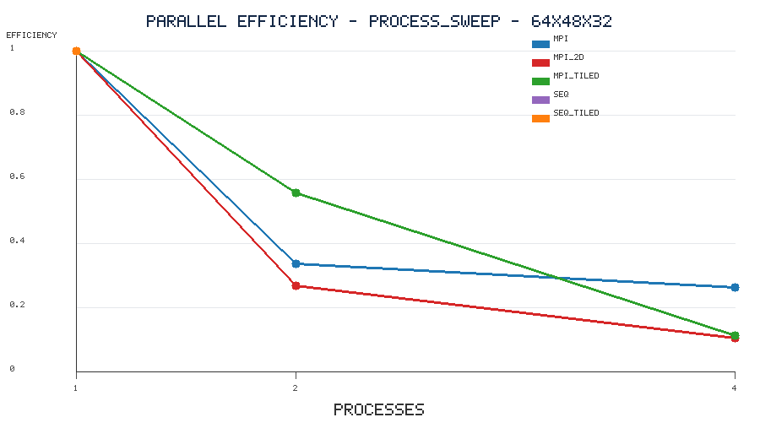
process_sweep_MKN64x48x32_efficiency
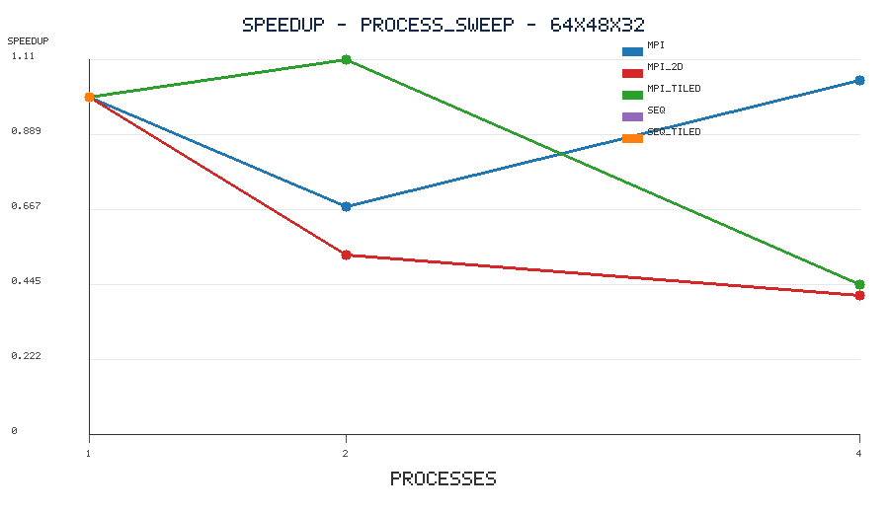
process_sweep_MKN64x48x32_speedup
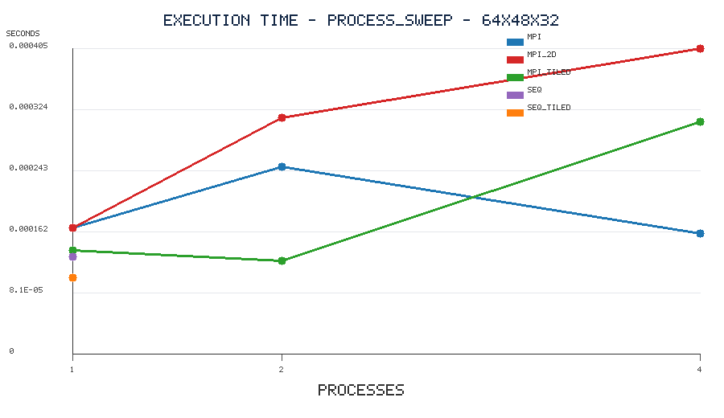
process_sweep_MKN64x48x32_time_min_sec

Evidence checksum
variant | M | K | N | processes | nodes | status
mpi | 64 | 48 | 32 | 1 | 1 | OK
mpi | 64 | 48 | 32 | 2 | 1 | OK
mpi | 64 | 48 | 32 | 4 | 1 | OK
mpi_2d | 64 | 48 | 32 | 1 | 1 | OK
mpi_2d | 64 | 48 | 32 | 2 | 1 | OK
mpi_2d | 64 | 48 | 32 | 4 | 1 | OK
mpi_tiled | 64 | 48 | 32 | 1 | 1 | OK
mpi_tiled | 64 | 48 | 32 | 2 | 1 | OK

5. Ket luan va phu luc nop bai
Do an da xay dung chuong trinh C + MPI gon, de giai thich, co ban tuan tu, ban song song, benchmark script va evidence checksum/sample. Cac ket qua 3 node se duoc cap nhat sau khi co du 3 may Linux that trong cung LAN/Wi-Fi.

Phu luc: lenh chay mau
SHAPES="2048x2048x2048 4096x4096x4096" NP_LIST="1 2 4 8" bash scripts/run_benchmark.sh
Neu cluster du tai nguyen, co the them 16 vao NP_LIST.
HOSTFILE=config/hosts SHAPES="2048x2048x2048 4096x4096x4096" NODES_LIST="1 2 3" PPN=4 bash scripts/run_multinode.sh

