Introduction to Mathing in R Practice

Jim Bang

## Solving a System of Equations: Supply and Demand

Given the following (inverse) supply and demand functions:

$$P=\frac{10}{Q_{d}}$$

$$P=Q_{s}^{2}$$

### Numerical Solution

library(nleqslv)

## Warning: package 'nleqslv' was built under R version 4.2.2

market <- function(x) {  
 supply <- x[1] ^ 2 - x[2]  
 demand <- 10 / x[1] - x[2]  
 return(c(supply, demand))  
}  
equilibrium <- nleqslv(c(2, 2), market)$x

$$\left(2.1544347,4.6415888\right)$$

### Graph of the Solution

curve(10/x,  
 from = 0 ,  
 to = 5,  
 col = 'blue',  
 ylim = c(0, 10),   
 xlab = 'Quantity',   
 ylab = 'Price')  
curve(x^2, col = 'darkorange', add = TRUE)  
segments(x0 = 0, y0 = equilibrium[2], x1 = equilibrium[1], y1 = equilibrium[2])  
segments(x0 = equilibrium[1], y0 = 0, x1 = equilibrium[1], y1 = equilibrium[2])

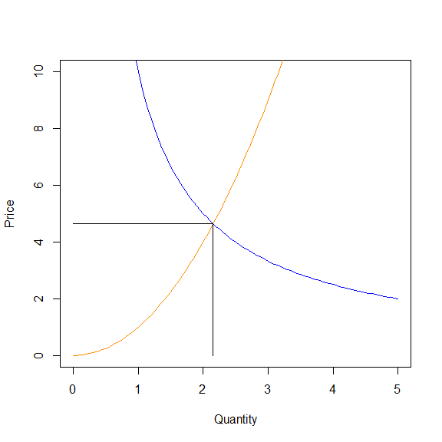

### Analytical Solution

library(Ryacas)

## Warning: package 'Ryacas' was built under R version 4.2.2

##   
## Attaching package: 'Ryacas'

## The following object is masked from 'package:stats':  
##   
## integrate

## The following objects are masked from 'package:base':  
##   
## %*%, det, diag, diag<-, lower.tri, upper.tri

demandInverse <- ysym('10/Q')  
supplyInverse <- ysym('Q^2')  
Qstar <- solve(demandInverse, supplyInverse, 'Q')[[1]] |>   
 y_rmvars()   
Pstar <- with_value(demandInverse, 'Q', Qstar)

$$\left(\sqrt[3]{10},\frac{10}{\sqrt[3]{10}}\right)$$