The code of the full adder is based on the one bit full adder discussed in the text book.

module full_adder(x,y,c_in,s,c_out);

input x,y;
input c_in;
output s;
output c_out;

wire a0, a1;
wire a2;

xor xor1(a0,x,y);
and and1(a1,x,y);
xor xor2(s,a0,c_in);
and and2(a2,a0,c_in);
or or3(c_out,a2,a1);

endmodule

Using iVerilog, the full_adder.v file is simulated with the following testbench code.

module adder_tb;

reg x,y,c_in;
wire s,c_out;

full_adder uut(x,y,c_in,s,c_out);

initial begin
// iVerilog (compiler and simulator) specific code.
// to indicate saving of wave forms for later review.
$dumpfile("adder_tb.dump");
$dumpvars;

// the hash symbol (#) indicates a jump of
// n units time indicated by the number that follows it.

x=0; y=0; c_in=0;
#10 $display("x=%b, y=%b, c_in=%b, s=%b, c_out=%b",x,y,c_in,s,c_out);

x=0; y=0; c_in=1;
#10 $display("x=%b, y=%b, c_in=%b, s=%b, c_out=%b",x,y,c_in,s,c_out);

x=0; y=1; c_in=0;
#10 $display("x=%b, y=%b, c_in=%b, s=%b, c_out=%b",x,y,c_in,s,c_out);

x=0; y=1; c_in=1;
#10 $display("x=%b, y=%b, c_in=%b, s=%b, c_out=%b",x,y,c_in,s,c_out);

x=1; y=0; c_in=0;
#10 $display("x=%b, y=%b, c_in=%b, s=%b, c_out=%b",x,y,c_in,s,c_out);

x=1; y=0; c_in=1;
#10 $display("x=%b, y=%b, c_in=%b, s=%b, c_out=%b",x,y,c_in,s,c_out);

x=1; y=1; c_in=0;
#10 $display("x=%b, y=%b, c_in=%b, s=%b, c_out=%b",x,y,c_in,s,c_out);

x=1; y=1; c_in=1;
#10 $display("x=%b, y=%b, c_in=%b, s=%b, c_out=%b",x,y,c_in,s,c_out);
end
endmodule

Each test step is separated by 10 cycles as indicated by the number after the hash (#) symbol.

However the lines dumpfile and dumpvars are added to inform iVerilog that the waveforms are to be dumped for later review. The waveforms are shown in the following figure.

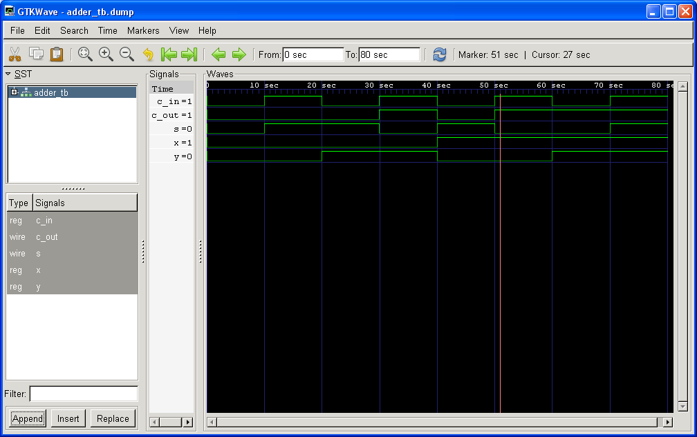

Activity 2

The

