MINDANAO STATE UNIVERSITY – ILIGAN INSTITUTE OF TECHNOLOGY
College of Engineering
Department of Electrical, Electronics and Computer Engineering

EE 177 - LOGIC CIRCUITS AND DIGITAL ELECTRONICS
Name: Johannah Mae D. Abestano Class Schedule: Monday 1:30 – 4:30 PM Date: 10-24-11

LAB ACTIVITY
SIMPSONS SENSOR

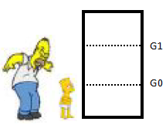
Marge wants to install an alarm that triggers as soon as somebody enters the kitchen. The alarm should have several alert levels.

LEVEL 0: neither Homer nor Bart is in the Kitchen
LEVEL 1: Bart but not Homer is in the Kitchen
LEVEL 2: Homer but not Bart is in the Kitchen
LEVEL 3: Homer and Bart are in the Kitchen

To detect who enters or leaves the Kitchen 2 sensors G1 and G0 are installed in the door frame as depicted. The sensors emit a ‘1’ as soon as their reflection is interrupted. If Bart enters the Kitchen only G0 will emit a ‘1’. Homer is always leaning forward when he is entering the kitchen, and, thus, G1 will always be interrupted before G0. Once they have decided to go into the Kitchen they’ll go through the door. However, if they are in the Kitchen they always can leave, e.g., LEVEL 3 changes to LEVEL 2. The size of homers hips and belly prevent them from entering the kitchen simultaneously. The clock frequency is 1 MHz.

EXPECTED BEHAVIOR
The following are the expected simulation results. These are the same outputs produced by a simulation of the Verilog code that follows.

Bart Enters: LEVEL = 1
Bart Leaves: LEVEL = 0
Homer Enters: LEVEL = 2
Homer Leaves: LEVEL = 0
Homer Enters: LEVEL = 2
But this time, both G1 and G0 are emitting 1
after an initial G0 of 1. Which basically means
head first, then both his head and lower body is
being detected by the sensor as he's entering
Homer Leaves: LEVEL = 0
But this time, both G1 and G0 are emitting 1
after an initial G0 of 1. Which basically means
head first, then both his head and lower body is
being detected by the sensor as he's exiting
Bart Enters: LEVEL = 1
Homer Enters: LEVEL = 3
Homer Leaves: LEVEL = 1
Homer Enters: LEVEL = 3
Bart Leaves: LEVEL = 2
Bart Enters: LEVEL = 3
Homer Leaves: LEVEL = 1
Bart Leaves: LEVEL = 0
This shows the reset capability.
Homer Enters: LEVEL = 2
The device's reset is pressed.
The device's reset is unpressed.
Current LEVEL: LEVEL = 2
Homer Enters: LEVEL = 0
Homer Leaves: LEVEL = 2
End of simulation: LEVEL = 2

SOLUTION
The following conventions are assumed and a state diagram is developed based on them.
FORMAT
[INPUT]/[OUTPUT] // The output is in Binary, it’s decimal form would be the LEVEL

INPUT DEFINITION
[INPUT] = [G1][G0]
BART ENTERS => [G0] = 1
HOMER ENTERS => [G1] = 1 THEN [G0] = 1

OUTPUT DEFINITION
[OUTPUT] =>
00 = LEVEL 0 => NONE => // neither Homer nor Bart is in the Kitchen
01 = LEVEL 1 => BART => // Bart but not Homer is in the Kitchen
10 = LEVEL 2 => HOMER => // Homer but not Bart is in the Kitchen
11 = LEVEL 3 => BOTH => // Homer and Bart are in the Kitchen

The state machine below shows the behavior of the circuit.

01/01
01/11
01/00

01/10
11/01
11/11
11/10
11/00
00

10

11

01

DISCUSSION

A simple trace of the state diagram can go as follows.

1.) Initially, at state 00 or Level 0, the input is 01, indicating Bart entered the room. The new state would then be 01 with a Level of 1.
2.) If Bart decides to go out, the sensor output would be 01 and the state will go back to 00 or Level 0.
3.) If at state 00, Homer enters the room, the sensor will read 11, and the new state would be 10 or a Level of 2.
4.) If Homer decides to get out of the room then the sensors would output 11, and the next state would be back to 00 or Level 0.

The following is the state Table for the diagram:
INDEX | PRESENT STATE |  | SENSOR INPUTS |  | NEXT STATE
INDEX | S1 | S0 | G1 | G0 | S1 | S0
0 | 0 | 0 | 0 | 0 | 0 | 0
1 | 0 | 0 | 0 | 1 | 0 | 1
2 | 0 | 0 | 1 | 0 | X | X
3 | 0 | 0 | 1 | 1 | 1 | 0
4 | 0 | 1 | 0 | 0 | 0 | 1
5 | 0 | 1 | 0 | 1 | 0 | 0
6 | 0 | 1 | 1 | 0 | X | X
7 | 0 | 1 | 1 | 1 | 1 | 1
8 | 1 | 0 | 0 | 0 | 1 | 0
9 | 1 | 0 | 0 | 1 | 1 | 1
10 | 1 | 0 | 1 | 0 | X | X
11 | 1 | 0 | 1 | 1 | 0 | 0
12 | 1 | 1 | 0 | 0 | 1 | 1
13 | 1 | 1 | 0 | 1 | 1 | 0
14 | 1 | 1 | 1 | 0 | X | X
15 | 1 | 1 | 1 | 1 | 0 | 1
K-MAP VAR | d | c | b | a | F | G

Using Karnough Mapping technique we can evaluate the correct algebraic equations to produce the outputs using the Present State and Sensor Inputs.

KARNOUGH MAPPING

(Refer to the table from the previous page to see the K-MAP Variables and their corresponding Circuit values. K-MAP VAR)

For S1: F(d,c,b,a) = bd' + b'd
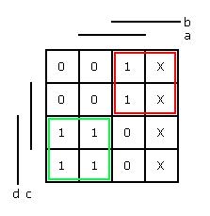

For S0: G(d,c,b,a) = ab'c' + a'c + bc
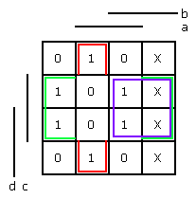
The states S0 and S1 therefore can be plotted with the following Boolean algebras.
S0 = (G₀ && !G₁ && !S0) || (!G0 && S0) || (G1 && S0)
S1 = (G1 && S1) || (!G1 && S1)

THE MORE ELABORATE STATE DIAGRAM
The state diagram shown from the previous page was based on a more elaborate diagram shown as follows.
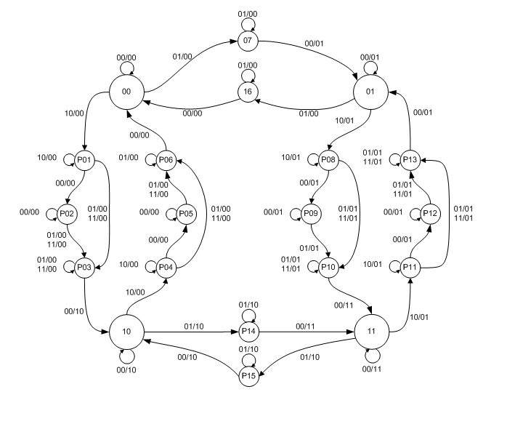
The state diagram is based on the conventions stated on Page 2. The Microsoft Visio file is available here. The small circles are mini states used as transition states among the four big circles which are the main states. Note this is a Mealy Machine.

TRACE DISCUSSION

1.) Initially starting at state 00 (the big circle with two zeroes) if the sensor inputs are 01 or 0 from G1 and 1 from G0, then it means that Bart at the door about to enter the room. The next state is P07. He has not entered yet. The moment where he is still entering is taken care by the loop at P07.

2.) If the sensor indicates a signal of 00 or 0 from G1 and G0 is 0, then it means he has entered already. Then it will proceed to the main state 01, while outputting 01 which indicates a LEVEL 1 in binary.

3.) Inside the room, if for example nobody’s at the door, then the loop at Main State 01 will make sure the output remains at 01 even though the inputs by the sensor are 00, because at the moment Bart entered the room, the level should be 01 or 1.

4.) If for example Homer enters the room then the sensor would input a reading of 10 initially then 01 afterwards. You can follow line from Main State 01 to P08. The loop at P08 makes sure Homer’s head can still pass the door. After his head, either the sensors will output 00 for a moment or 10 immediately, it will proceed to P10. At P10, if the sensor inputs are 00, then this means no one’s at the door and Homer has finally entered the room. The state will then be 11 indicating an output Level of 3.

5.) If Bart leaves at Main State 11, then the inputs from the sensors would be 01 indicating 0 for G1, and 1 for G0. The new state would be at P15, after finishing receiving inputs of 01, 00 will follow indicating no one is at the door, which means Bart is already out. The new state would be 10 or an output Level of 2.

VERILOG IMPLEMENTATION

The Verilog code is for the main is posted at Appendix A at Page 9 and the Xilinx ISE 13.2 Project is also available for download as attached with this email. The main module at Appendix A is the Verilog representation of the FSM diagram at Page 5.

TESTING

The test bench code is included in this document at Appendix B on Page 16. The code can also be downloaded along with the main module as attached with this email.

OUTPUT

The output for the simulation of this test bench was shown on the second page of this document. The following images are wave views. The following snapshot is taken near the start of the simulation.

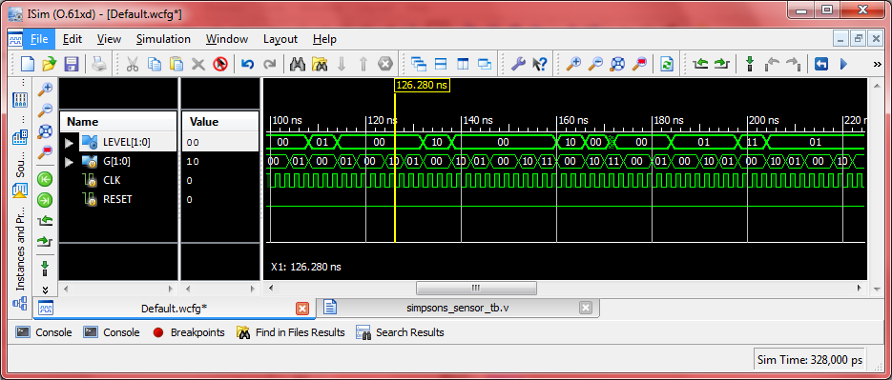

The following image is taken near the end of the simulation. The initial part is a LEVEL of 00. Then when G became 1 (sensor sending data that Bart is at the door), afterwards, the LEVEL became 01 indicating Bart is already inside. When the sensor became 1 again, the Level changed to 0 after it, indicating Bart is already outside of the kitchen.

Then, the sensor indicated 10, after that 01, which indicates the behavior of the sensor when Homer is at the door. After this pattern, the Level is at 10 which means Homer is already inside the Kitchen.

The sensor emits 10 again, and 01 afterwards, this means Homer is exiting the Kitchen. The Level is now at value 00.

After a brief moment, the sensor indicated 10 again, then this time 11, which may mean Homer’s upper body, was blocking the sensor then the lower body plus the upper body blocked the sensor. After this pattern Homer is in the Kitchen again and the Level is 10 again. Homer again exited the room in the same fashion, yielding Level of 0 again.

The wave forms then continues to show the behavior depicted on the FSM at page 5.

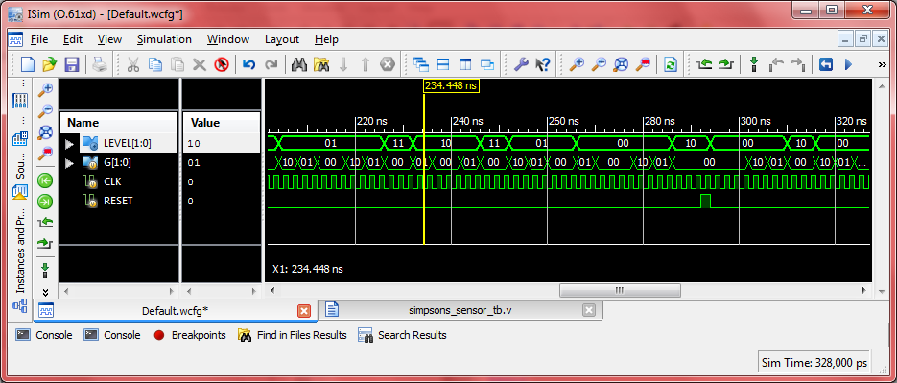

You can observe the Reset switch being flicked in a moment, therefore resetting the current Level to 0.

APPENDIX A

The following code listing is for simpsons_sensor.v, the Main Module for the project.

`timescale 1ns / 1ps

module simpsons_sensor(
input wire [1:0] G,
input wire CLK,
input wire RESET,
output reg [1:0] LEVEL
);
// VARS
reg [5:0] STATE = 0;

// STATES
parameter NONE = 0;
parameter BART = 1;
parameter HOMER = 2;
parameter BOTH = 3;

// MINI-STATES
parameter P01 = 4;
parameter P02 = 5;
parameter P03 = 6;
parameter P04 = 7;
parameter P05 = 8;
parameter P06 = 9;
parameter P07 = 10;
parameter P08 = 11;
parameter P09 = 12;
parameter P10 = 13;
parameter P11 = 14;
parameter P12 = 15;
parameter P13 = 16;
parameter P14 = 17;
parameter P15 = 18;
parameter P16 = 19;

always @ (posedge CLK or negedge CLK)
begin
if (RESET == 1) begin
STATE = 0;
end else begin
case (STATE)
NONE: begin
case (G)
0: begin
STATE <= NONE;
LEVEL <= NONE;
end
1: begin
STATE <= P07;
LEVEL <= NONE;
end
2: begin
STATE <= P01;
LEVEL <= NONE;
end
3: begin // UNDEFINED
STATE <= NONE;
LEVEL <= NONE;
end
endcase
end
BART: begin
case (G)
0: begin
STATE <= BART;
LEVEL <= BART;
end
1: begin
STATE <= P16;
LEVEL <= NONE;
end
2: begin
STATE <= P08;
LEVEL <= BART;
end
3: begin // UNDEFINED
STATE <= NONE;
LEVEL <= NONE;
end
endcase
end
HOMER: begin
case (G)
0: begin
STATE <= HOMER;
LEVEL <= HOMER;
end
1: begin
STATE <= P14;
LEVEL <= HOMER;
end
2: begin
STATE <= P04;
LEVEL <= NONE;
end
3: begin // UNDEFINED
STATE <= NONE;
LEVEL <= NONE;
end
endcase
end
BOTH: begin
case (G)
0: begin
STATE <= BOTH;
LEVEL <= BOTH;
end
1: begin
STATE <= P15;
LEVEL <= HOMER;
end
2: begin
STATE <= P11;
LEVEL <= BART;
end
3: begin // UNDEFINED
STATE <= NONE;
LEVEL <= NONE;
end
endcase
end
P01: begin
case (G)
0: begin
STATE <= P02;
LEVEL <= NONE;
end
1: begin
STATE <= P03;
LEVEL <= NONE;
end
2: begin
STATE <= P01;
LEVEL <= NONE;
end
3: begin
STATE <= P03;
LEVEL <= NONE;
end
endcase
end
P02: begin
case (G)
0: begin
STATE <= P02;
LEVEL <= NONE;
end
1: begin
STATE <= P03;
LEVEL <= NONE;
end
2: begin // UNDEFINED
STATE <= NONE;
LEVEL <= NONE;
end
3: begin
STATE <= P03;
LEVEL <= NONE;
end
endcase
end
P03: begin
case (G)
0: begin
STATE <= HOMER;
LEVEL <= HOMER;
end
1: begin
STATE <= P03;
LEVEL <= NONE;
end
2: begin // UNDEFINED
STATE <= NONE;
LEVEL <= NONE;
end
3: begin
STATE <= P03;
LEVEL <= NONE;
end
endcase
end
P04: begin
case (G)
0: begin
STATE <= P05;
LEVEL <= NONE;
end
1: begin
STATE <= P06;
LEVEL <= NONE;
end
2: begin
STATE <= P04;
LEVEL <= NONE;
end
3: begin
STATE <= P06;
LEVEL <= NONE;
end
endcase
end
P05: begin
case (G)
0: begin
STATE <= P05;
LEVEL <= NONE;
end
1: begin
STATE <= P06;
LEVEL <= NONE;
end
2: begin
STATE <= HOMER;
LEVEL <= HOMER;
end
3: begin
STATE <= P06;
LEVEL <= NONE;
end
endcase
end
P06: begin
case (G)
0: begin
STATE <= NONE;
LEVEL <= NONE;
end
1: begin
STATE <= P06;
LEVEL <= NONE;
end
2: begin // UNDEFINED
STATE <= HOMER;
LEVEL <= HOMER;
end
3: begin // UNDEFINED
STATE <= HOMER;
LEVEL <= HOMER;
end
endcase
end
P07: begin
case (G)
0: begin
STATE <= BART;
LEVEL <= BART;
end
1: begin
STATE <= P07;
LEVEL <= NONE;
end
2: begin // UNDEFINED
STATE <= NONE;
LEVEL <= NONE;
end
3: begin // UNDEFINED
STATE <= NONE;
LEVEL <= NONE;
end
endcase
end
P08: begin
case (G)
0: begin
STATE <= P09;
LEVEL <= BART;
end
1: begin
STATE <= P10;
LEVEL <= BART;
end
2: begin // UNDEFINED
STATE <= P08;
LEVEL <= BART;
end
3: begin // UNDEFINED
STATE <= P10;
LEVEL <= BART;
end
endcase
end
P09: begin
case (G)
0: begin
STATE <= P09;
LEVEL <= BART;
end
1: begin
STATE <= P10;
LEVEL <= BART;
end
2: begin // UNDEFINED
STATE <= BART;
LEVEL <= BART;
end
3: begin // UNDEFINED
STATE <= BART;
LEVEL <= BART;
end
endcase
end
P10: begin
case (G)
0: begin
STATE <= BOTH;
LEVEL <= BOTH;
end
1: begin
STATE <= P10;
LEVEL <= BART;
end
2: begin // UNDEFINED
STATE <= BART;
LEVEL <= BART;
end
3: begin
STATE <= P10;
LEVEL <= BART;
end
endcase
end
P11: begin
case (G)
0: begin
STATE <= P12;
LEVEL <= BART;
end
1: begin
STATE <= P13;
LEVEL <= BART;
end
2: begin
STATE <= P11;
LEVEL <= BART;
end
3: begin
STATE <= P13;
LEVEL <= BART;
end
endcase
end
P12: begin
case (G)
0: begin
STATE <= P12;
LEVEL <= BART;
end
1: begin
STATE <= P13;
LEVEL <= BART;
end
2: begin // UNDEFINED
STATE <= BOTH;
LEVEL <= BOTH;
end
3: begin
STATE <= P13;
LEVEL <= BART;
end
endcase
end
P13: begin
case (G)
0: begin
STATE <= BART;
LEVEL <= BART;
end
1: begin
STATE <= P13;
LEVEL <= BART;
end
2: begin // UNDEFINED
STATE <= BOTH;
LEVEL <= BOTH;
end
3: begin
STATE <= P13;
LEVEL <= BART;
end
endcase
end
P14: begin
case (G)
0: begin
STATE <= BOTH;
LEVEL <= BOTH;
end
1: begin
STATE <= P14;
LEVEL <= HOMER;
end
2: begin // UNDEFINED
STATE <= HOMER;
LEVEL <= HOMER;
end
3: begin // UNDEFINED
STATE <= HOMER;
LEVEL <= HOMER;
end
endcase
end
P15: begin
case (G)
0: begin
STATE <= HOMER;
LEVEL <= HOMER;
end
1: begin
STATE <= P15;
LEVEL <= HOMER;
end
2: begin // UNDEFINED
STATE <= HOMER;
LEVEL <= HOMER;
end
3: begin // UNDEFINED
STATE <= HOMER;
LEVEL <= HOMER;
end
endcase
end
P16: begin
case (G)
0: begin
STATE <= NONE;
LEVEL <= NONE;
end
1: begin
STATE <= P16;
LEVEL <= NONE;
end
2: begin // UNDEFINED
STATE <= BART;
LEVEL <= BART;
end
3: begin // UNDEFINED
STATE <= BART;
LEVEL <= BART;
end
endcase
end
endcase
end
end
endmodule

End of code listing for main module.

APPENDIX B

`timescale 1ns / 1ps

module simpsons_sensor_tb;

// Inputs
reg [1:0] G;
reg CLK;
reg RESET;

// Outputs
wire [1:0] LEVEL;

// Parameters

// Signal indicating no one is at the door. Either they have finished getting in
// or just got out. Separates different signals from each other. Then both G1 and
// G0 are 0.
parameter NONE = 0;

// Happens when Bart passes OR after a A binary 10 signal from G which indates Homer's
// lower body is beginning to block the sensors passing through the door.
parameter G0_SENSOR_LOWER = 1;

// Happens when G1 is equals 1 or G = 2 also indicates that the head / upper body of
// Homer is already passing through the door.
parameter G1_SENSOR_ELEVATED = 2;

// Happens when both Homer's Upper and Lower Body are blocking the sensor. Which means,
// It is still homer who is passing through the door.
parameter G3_SENSOR_BOTH = 3;

// Instantiate the Unit Under Test (UUT)
simpsons_sensor uut (
.G(G),
.CLK(CLK),
.RESET(RESET),
.LEVEL(LEVEL)
);

initial begin
// Initialize Inputs
G = 0;
CLK = 0;
RESET = 0;

// Wait 100 ns for global reset to finish
#100;

// Stimulus Begin
// Sulod si Bart
#4 G = G0_SENSOR_LOWER;
#4 G = NONE; // Signal separator. Successfull pass of Bart.
#2 $display ("Bart Enters: LEVEL = %d", LEVEL);

// Gawas si Bart
#4 G = G0_SENSOR_LOWER;
#4 G = NONE; // Signal separator. Successfull exit of Bart.
#2 $display ("Bart Leaves: LEVEL = %d", LEVEL);

// Sulod si Homer
#4 G = G1_SENSOR_ELEVATED; // Homers upper body.
#4 G = G0_SENSOR_LOWER; // Homers lower body.
#4 G = NONE; // Homer successfully passed through.
#2 $display ("Homer Enters: LEVEL = %d", LEVEL);

// Gawas si Homer
#4 G = G1_SENSOR_ELEVATED; // Homers upper body.
#4 G = G0_SENSOR_LOWER; // Homers lower body.
#4 G = NONE; // Homer successfully passed through.
#2 $display ("Homer Leaves: LEVEL = %d", LEVEL);

// Sulod si Homer but this time
#4 G = G1_SENSOR_ELEVATED; // Homers upper body.
#4 G = G3_SENSOR_BOTH; // Both upper and lower body.
#4 G = NONE; // Homer successfully passed through.
#2 $display ("Homer Enters: LEVEL = %d", LEVEL);
$display ("But this time, both G1 and G0 are emitting 1");
$display ("after an initial G0 of 1. Which basically means");
$display ("head first, then both his head and lower body is");
$display ("being detected by the sensor as he's entering");

// Gawas si Homer
#4 G = G1_SENSOR_ELEVATED; // Homers upper body.
#4 G = G3_SENSOR_BOTH; // Both upper and lower body.
#4 G = NONE; // Homer successfully passed through.
#2 $display ("Homer Leaves: LEVEL = %d", LEVEL);
$display ("But this time, both G1 and G0 are emitting 1");
$display ("after an initial G0 of 1. Which basically means");
$display ("head first, then both his head and lower body is");
$display ("being detected by the sensor as he's exiting");

// Sulod si Bart
#4 G = G0_SENSOR_LOWER;
#4 G = NONE;
#2 $display ("Bart Enters: LEVEL = %d", LEVEL);

// Sulod si Homer
#4 G = G1_SENSOR_ELEVATED;
#4 G = G0_SENSOR_LOWER;
#4 G = NONE;
#2 $display ("Homer Enters: LEVEL = %d", LEVEL);

// Gawas si Homer
#4 G = G1_SENSOR_ELEVATED;
#4 G = G0_SENSOR_LOWER;
#4 G = NONE;
#2 $display ("Homer Leaves: LEVEL = %d", LEVEL);

// Sulod si Homer
#4 G = G1_SENSOR_ELEVATED;
#4 G = G0_SENSOR_LOWER;
#4 G = NONE;
#2 $display ("Homer Enters: LEVEL = %d", LEVEL);

// Gawas si Bart
#4 G = G0_SENSOR_LOWER;
#4 G = NONE;
#2 $display ("Bart Leaves: LEVEL = %d", LEVEL);

// Sulod si Bart
#4 G = G0_SENSOR_LOWER;
#4 G = NONE;
#2 $display ("Bart Enters: LEVEL = %d", LEVEL);

// Gawas si Homer
#4 G = G1_SENSOR_ELEVATED;
#4 G = G0_SENSOR_LOWER;
#4 G = NONE;
#2 $display ("Homer Leaves: LEVEL = %d", LEVEL);

// Gawas si Bart
#4 G = G0_SENSOR_LOWER;
#4 G = NONE;
#2 $display ("Bart Leaves: LEVEL = %d", LEVEL);

#2 $display ("This shows the reset capability.");
// Sulod si Homer
#4 G = G1_SENSOR_ELEVATED;
#4 G = G0_SENSOR_LOWER;
#4 G = NONE;
#2 $display ("Homer Enters: LEVEL = %d", LEVEL);

#2 $display ("The device's reset is pressed.");
#2 RESET = 1;
#2 RESET = 0;
#2 $display ("The device's reset is unpressed.");
#2 $display ("Current LEVEL: LEVEL = %d", LEVEL);

// Sulod si Homer
#4 G = G1_SENSOR_ELEVATED;
#4 G = G0_SENSOR_LOWER;
#4 G = NONE;
#2 $display ("Homer Enters: LEVEL = %d", LEVEL);

// Gawas si Homer
#4 G = G1_SENSOR_ELEVATED;
#4 G = G0_SENSOR_LOWER;
#4 G = NONE;
#2 $display ("Homer Leaves: LEVEL = %d", LEVEL);

#2 $display ("End of simulation: LEVEL = %d", LEVEL);

$finish;
end

// Clock Generator
always begin
#1 CLK = !CLK;
end

endmodule

End of code listing for test bench.

