Gil Michael E. Regalado BS-ECE IV

**CVSL Activity**

**Cascode Voltage Switch Logic** or differential cascode voltage switch logic improves switching times of logic circuits by employing positive feedback.

In this exercise we consider the implementation of, $Z=\overline{A}+BC$. This will produce a differential opposite of $\overline{Z}=\overline{\overline{A}+BC}$. The following figure shows the circuit diagram. A SPICE script will be created and simulated using 0.18u architecture with 1.8V VDD and logic High.

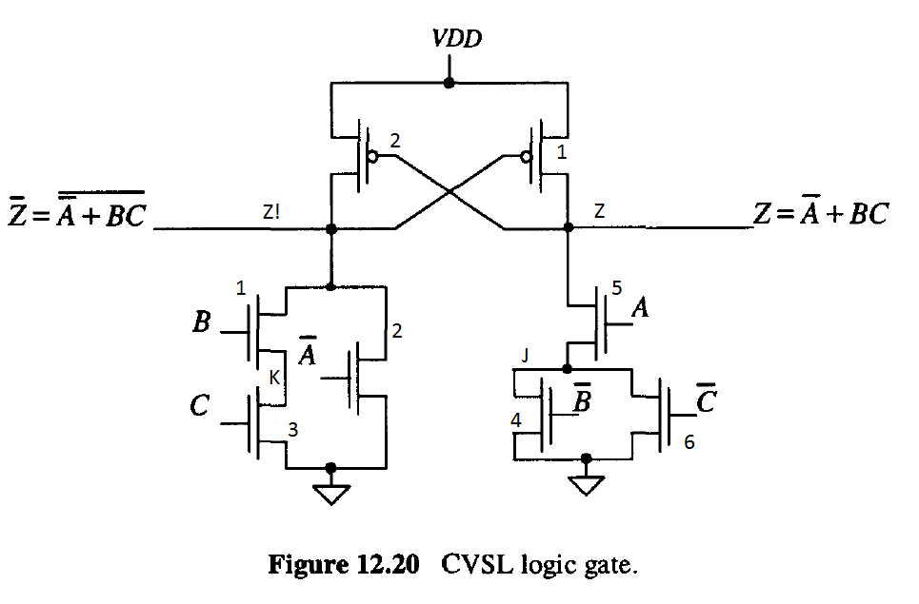

It has the following truth table.

|  |  |  |  |  |
| --- | --- | --- | --- | --- |
| A | B | C | Z | Z! |
| 0 | 0 | 0 | 1 | 0 |
| 1 | 0 | 0 | 0 | 1 |
| 0 | 1 | 0 | 1 | 0 |
| 1 | 1 | 0 | 0 | 1 |
| 0 | 0 | 1 | 1 | 0 |
| 1 | 0 | 1 | 0 | 1 |
| 0 | 1 | 1 | 1 | 0 |
| 1 | 1 | 1 | 1 | 0 |

The following is the spice script:

|  |
| --- |
| CVSL  .PARAM LMIN=0.18u  .PARAM WFACTOR=1.5  .PARAM WMIN='LMIN*WFACTOR'  .lib "C:\synopsys\rf018.l" TT  .global vdd  .option post  Cout_z Z 0 100f  Cout_!z Z! 0 100f  Vdd vdd 0 1.8  Vin_a in_a 0 pulse (1.8 0 1.0p 0 0 200n 400n)  Vin_b in_b 0 pulse (1.8 0 1.0p 0 0 400n 800n)  Vin_c in_c 0 pulse (1.8 0 1.0p 0 0 800n 1600n)  Vin_!a in_!a 0 pulse (0 1.8 1.0p 0 0 200n 400n)  Vin_!b in_!b 0 pulse (0 1.8 1.0p 0 0 400n 800n)  Vin_!c in_!c 0 pulse (0 1.8 1.0p 0 0 800n 1600n)  X_cvsl in_a in_b in_c in_!a in_!b in_!c Z Z! cvsl  .subckt cvsl in_a in_b in_c in_!a in_!b in_!c Z Z!  MN1 Z! in_b K 0 nch l=LMIN w='WMIN*2'  MN2 Z! in_!a 0 0 nch l=LMIN w=WMIN  MN3 K in_c 0 0 nch l=LMIN w='WMIN*2'    MN4 J in_!b 0 0 nch l=LMIN w=WMIN  MN5 Z in_a J 0 nch l=LMIN w='WMIN*2'  MN6 J in_!c 0 0 nch l=LMIN w=WMIN    MP1 Z Z! vdd vdd pch l=LMIN w='WMIN*1'  MP2 Z! Z vdd vdd pch l=LMIN w='WMIN*1'  .ends  .op  .tran 1p 1600n  .end |

Using Cosmoscope the simulation results are shown:

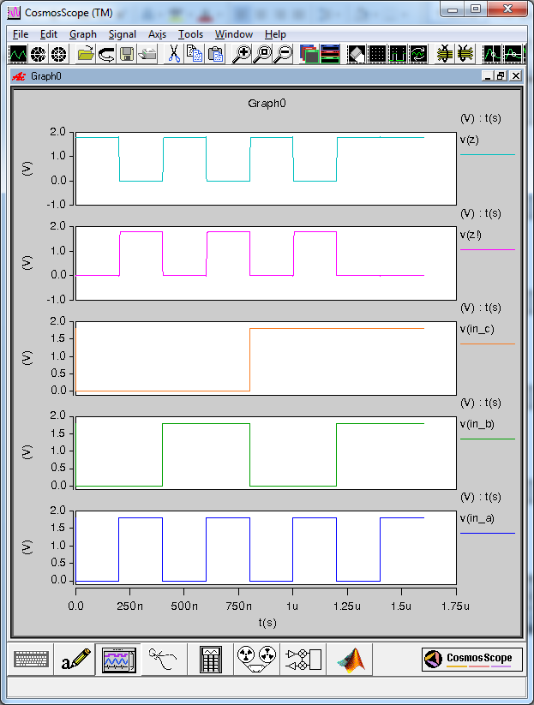

If we Zoon a little bit we can see the transition of the logic from 0 to 1.8V

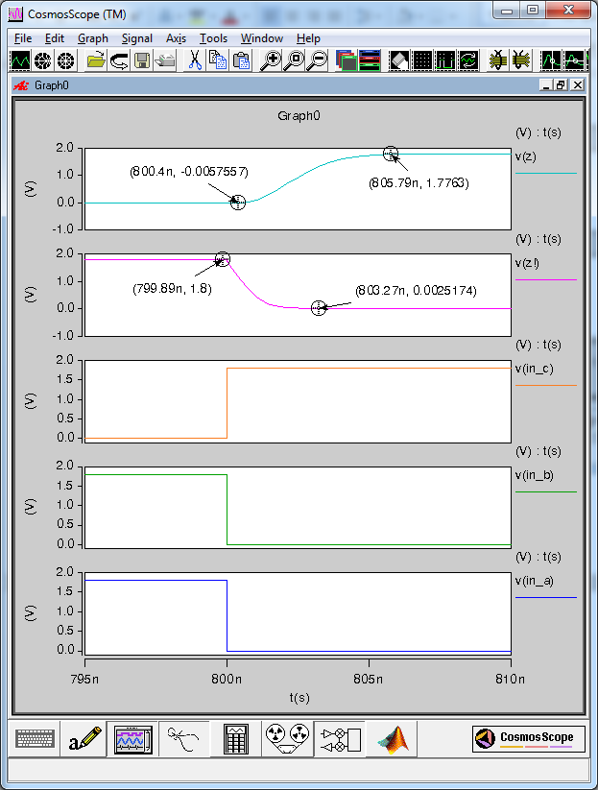

We have determined that the response time for this logic circuit is around:

$$805.79n-800.4n=5.39n$$

