**GIL MICHAEL E. REGALADO BS ECE IV - EE 272**

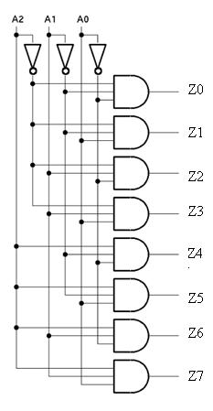**3-8 DECODER**

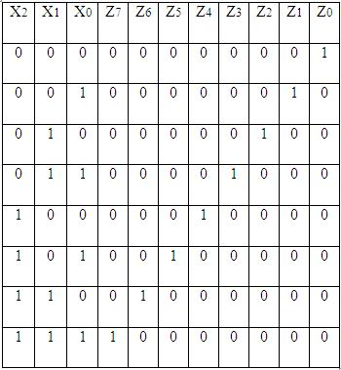

Table 2: Truth Table of 3:8 decoder

It uses all AND gates, and therefore, the outputs are active- high. For active- low outputs, NAND gates are used. It has 3 input lines and 8 output lines. It is also called as binary to octal decoder it takes a 3-bit binary input code and activates one of the 8(octal) outputs corresponding to that code.

**REQUIRED SUB CIRCUITS**

|  |
| --- |
| ****** SUBCIRCUIT DEFINITION: INVERTER  .subckt not ndd nss in out  MN1 out in nss nss nch l='1*LMIN' w='2*LMIN'  MP2 out in ndd ndd pch l='1*LMIN' w='6*LMIN'  .ends |

|  |
| --- |
| ****** SUBCIRCUIT DEFINITION: 3 INPUT NAND  .subckt nand3 dd ss a b c out  MN1 out a ab ss nch l='1*LMIN' w='2*LMIN'  MN2 ab b bc ss nch l='1*LMIN' w='2*LMIN'  MN3 bc c ss ss nch l='1*LMIN' w='2*LMIN'    MP1 out a dd dd pch l='1*LMIN' w='6*LMIN'  MP2 out b dd dd pch l='1*LMIN' w='6*LMIN'  MP3 out c dd dd pch l='1*LMIN' w='6*LMIN'  .ends |

|  |
| --- |
| ****** SUBCIRCUIT DEFINITION: 3-8 DECODER  .include NAND3.SP  .include NOT.SP  .subckt decoder dd ss a0 a1 a2 z0 z1 z2 z3 z4 z5 z6 z7  Xnot0 dd ss a0 not_a0 not  Xnot1 dd ss a1 not_a1 not  Xnot2 dd ss a2 not_a2 not  Xnot_z0 dd ss not_z0 z0 not  Xnot_z1 dd ss not_z1 z1 not  Xnot_z2 dd ss not_z2 z2 not  Xnot_z3 dd ss not_z3 z3 not  Xnot_z4 dd ss not_z4 z4 not  Xnot_z5 dd ss not_z5 z5 not  Xnot_z6 dd ss not_z6 z6 not  Xnot_z7 dd ss not_z7 z7 not  Xnand3_0 dd ss not_a0 not_a1 not_a2 not_z0 nand3  Xnand3_1 dd ss a0 not_a1 not_a2 not_z1 nand3  Xnand3_2 dd ss not_a0 a1 not_a2 not_z2 nand3  Xnand3_3 dd ss a0 a1 not_a2 not_z3 nand3  Xnand3_4 dd ss not_a0 not_a1 a2 not_z4 nand3  Xnand3_5 dd ss a0 not_a1 a2 not_z5 nand3  Xnand3_6 dd ss not_a0 a1 a2 not_z6 nand3  Xnand3_7 dd ss a0 a1 a2 not_z7 nand3  .ends |

**TEST BENCH CODE**

|  |
| --- |
| 3-8 DECODER TEST BENCH  ****** REFERENCE: http://coep.vlab.co.in/?sub=28&brch=81&sim=609&cnt=1  ****** SIMULATION PARAMETERS  .PARAM LMIN=0.18u  .PARAM PVDD=1.8  * Input transition time.  .PARAM TRAN_TIME=0.25n  ****** ANALYSIS OPTIONS  .option post  .op  .tran 1e-15 '32n + (8*TRAN_TIME)'  ****** STIMULI  Vdd ndd 0 PVDD  Va0 in_a0 0 pulse (PVDD 0 0 TRAN_TIME TRAN_TIME 2n 4n)  Va1 in_a1 0 pulse (PVDD 0 0 TRAN_TIME TRAN_TIME 4n 8n)  Va2 in_a2 0 pulse (PVDD 0 0 TRAN_TIME TRAN_TIME 8n 16n)  ****** TEST BENCH CIRCUIT  Cz0 out_z0 ss 0.01f  Cz1 out_z1 ss 0.01f  Cz2 out_z2 ss 0.01f  Cz3 out_z3 ss 0.01f  Cz4 out_z4 ss 0.01f  Cz5 out_z5 ss 0.01f  Cz6 out_z6 ss 0.01f  Cz7 out_z7 ss 0.01f  Xdecoder ndd 0 in_a0 in_a1 in_a2 out_z0 out_z1 out_z2 out_z3 out_z4 out_z5 out_z6 out_z7 decoder  ****** LOAD EXTERNAL FILES  .lib C:\synopsys\rf018.l TT  .include DECODER38.SP  .end |

**SIMULATION RESULTS**

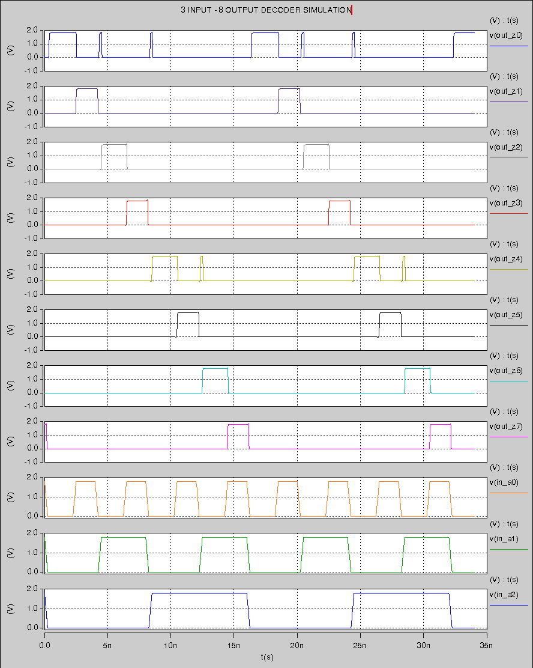

**USING COSMOSCOPE DIGITAL APPROXIMATION**

