**GIL MICHAEL E. REGALADO BS-ECE IV**

**DOMNIO LOGIC AND 2-INPUTS**

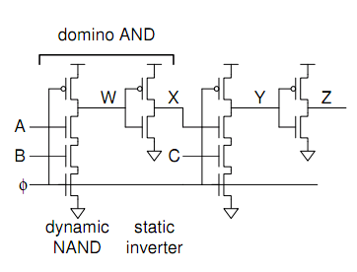

MN4

MP2

MN3

MN2

MN1

MP1

**SIMULATION RESULTS**

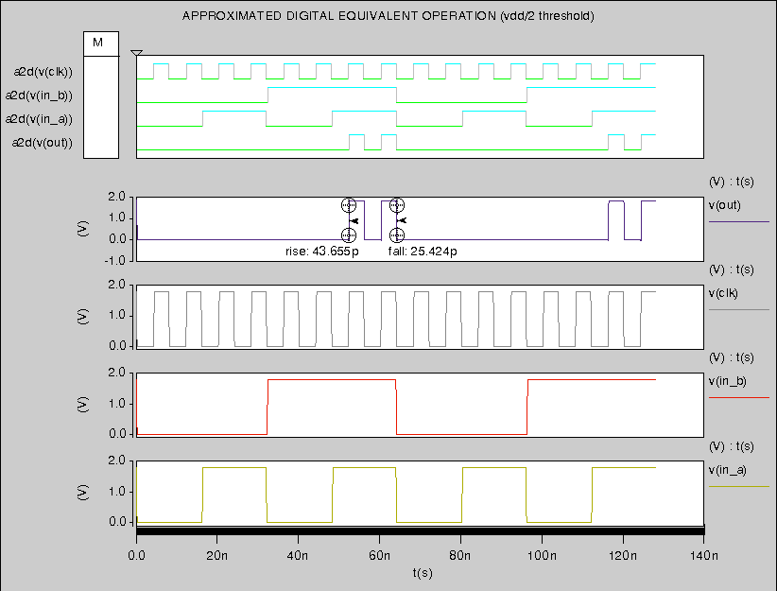

ZOOM

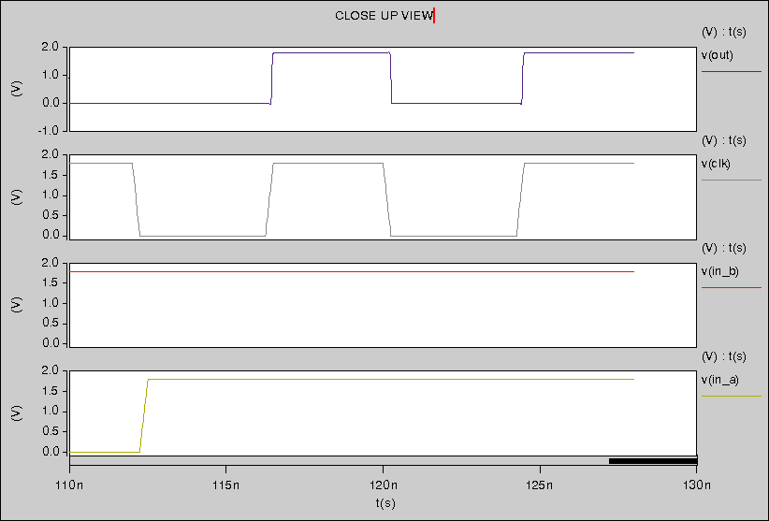

**TEST BENCH AND SCHEMATIC SUBCKT**

|  |
| --- |
| 2 INPUT DYNAMIC AND  ****** PARAMETER DEFINITION  .PARAM LMIN=0.18u  .PARAM PVDD=1.8  ****** ANALYSIS PARAMTERS  .option post  .op  .tran 1e-15 '128n'  ****** STIMULI  Vdd ndd 0 PVDD  Vin_a in_a 0 pulse (PVDD 0 0 0.25n 0.25n 16n 32n)  Vin_b in_b 0 pulse (PVDD 0 0 0.25n 0.25n 32n 64n)  Vclk clk 0 pulse (PVDD 0 0 0.25n 0.25n 4n 8n)  ****** MAIN CIRCUIT  Cout out 0 0.01f  X_domino_and ndd 0 clk in_a in_b out domino_and  ****** DOMINO AND 2 INPUT SUB CIRCUIT  .subckt domino_and dd ss clk a b out  *** main ckt  MP1 w clk dd dd pch l=LMIN w='2*LMIN'  MN1 w a ab ss nch l=LMIN w='2*LMIN'  MN2 ab b b_clk ss nch l=LMIN w='2*LMIN'  MN3 b_clk clk ss ss nch l=LMIN w='2*LMIN'  *** nand  MP2 out w dd dd pch l=LMIN w='2*LMIN'  MN4 out w ss ss nch l=LMIN w='2*LMIN'  .ends  ****** LIBRARY  .prot  .lib "C:\synopsys\rf018.l" TT  .unprot  .end |