**GIL MICHAEL E. REGALADO BS ECE IV - EE 272**

**8-3 ENCODER**

An encoder is a combinational circuit that performs the inverse operation of a decoder. If a device output code has fewer bits than the input code has, the device is usually called an encoder. e.g. 2n-to-n, priority encoders.

The simplest encoder is a 2n-to-n binary encoder, where it has only one of 2n inputs = 1 and the output is the n-bit binary number corresponding to the active input.

Octal-to-Binary take 8 inputs and provides 3 outputs, thus doing the opposite of what the 3-to-8 decoder does. At any one time, only one input line has a value of 1. The figure below shows the truth table of an Octal-to-binary encoder.

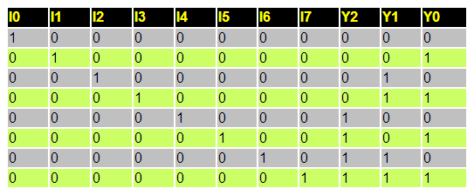

**Truth Table**

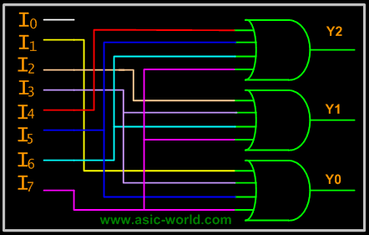

**Circuit Diagram**

**REQUIRED SUB CIRCUITS**

|  |
| --- |
| ****** SUBCIRCUIT DEFINITION: INVERTER  .subckt not ndd nss in out  MN1 out in nss nss nch l='1*LMIN' w='2*LMIN'  MP2 out in ndd ndd pch l='1*LMIN' w='6*LMIN'  .ends |

|  |
| --- |
| ****** SUBCIRCUIT DEFINITION: 4 INPUT NOR  .subckt nor4 dd ss a b c d out  MPA ab a dd dd pch l='1*LMIN' w='6*LMIN'  MPB bc b ab dd pch l='1*LMIN' w='6*LMIN'  MPC cd c bc dd pch l='1*LMIN' w='6*LMIN'  MPD out d cd dd pch l='1*LMIN' w='6*LMIN'    MNA out a ss ss nch l='1*LMIN' w='2*LMIN'  MNB out b ss ss nch l='1*LMIN' w='2*LMIN'  MNC out c ss ss nch l='1*LMIN' w='2*LMIN'  MND out d ss ss nch l='1*LMIN' w='2*LMIN'    .ends |

|  |
| --- |
| ****** SUBCIRCUIT DEFINITION: 8-3 ENCODER  .include NOR4.SP  .include NOT.SP  .subckt encoder dd ss a0 a1 a2 a3 a4 a5 a6 a7 z0 z1 z2  Xnor4_0 dd ss a1 a3 a5 a7 not_z0 nor4  Xnor4_1 dd ss a2 a3 a6 a7 not_z1 nor4  Xnor4_2 dd ss a4 a5 a6 a7 not_z2 nor4  Xnot_z0 dd ss not_z0 z0 not  Xnot_z1 dd ss not_z1 z1 not  Xnot_z2 dd ss not_z2 z2 not  .ends |

**TEST BENCH**

|  |
| --- |
| encoder 8-3  *http://www.asic-world.com/digital/combo3.html  ****** SIMULATION PARAMETERS  .PARAM LMIN=0.18u  .PARAM PVDD=1.8  * Input transition time.  .PARAM TRAN_TIME=0.25n  .PARAM MINTIME=2n  ****** ANALYSIS OPTIONS  .option post  .op  .tran 1e-15 'MINTIME*9'  ****** STIMULI  Vdd ndd 0 PVDD  Va0 in_a0 0 pulse ( 0 PVDD 0 TRAN_TIME TRAN_TIME MINTIME 'MINTIME*8')  Va1 in_a1 0 pulse ( 0 PVDD 'MINTIME*1' TRAN_TIME TRAN_TIME MINTIME 'MINTIME*8')  Va2 in_a2 0 pulse ( 0 PVDD 'MINTIME*2' TRAN_TIME TRAN_TIME MINTIME 'MINTIME*8')  Va3 in_a3 0 pulse ( 0 PVDD 'MINTIME*3' TRAN_TIME TRAN_TIME MINTIME 'MINTIME*8')  Va4 in_a4 0 pulse ( 0 PVDD 'MINTIME*4' TRAN_TIME TRAN_TIME MINTIME 'MINTIME*8')  Va5 in_a5 0 pulse ( 0 PVDD 'MINTIME*5' TRAN_TIME TRAN_TIME MINTIME 'MINTIME*8')  Va6 in_a6 0 pulse ( 0 PVDD 'MINTIME*6' TRAN_TIME TRAN_TIME MINTIME 'MINTIME*8')  Va7 in_a7 0 pulse ( 0 PVDD 'MINTIME*7' TRAN_TIME TRAN_TIME MINTIME 'MINTIME*8')  ****** TEST BENCH CIRCUIT  Cz0 out_z0 ss 0.01f  Cz1 out_z1 ss 0.01f  Cz2 out_z2 ss 0.01f  Xencoder ndd 0 in_a0 in_a1 in_a2 in_a3 in_a4 in_a5 in_a6 in_a7 out_z0 out_z1 out_z2 encoder  ****** LOAD EXTERNAL FILES  .lib C:\synopsys\rf018.l TT  .include ENCODER38.SP  .end |

**SIMULATION RESULT**

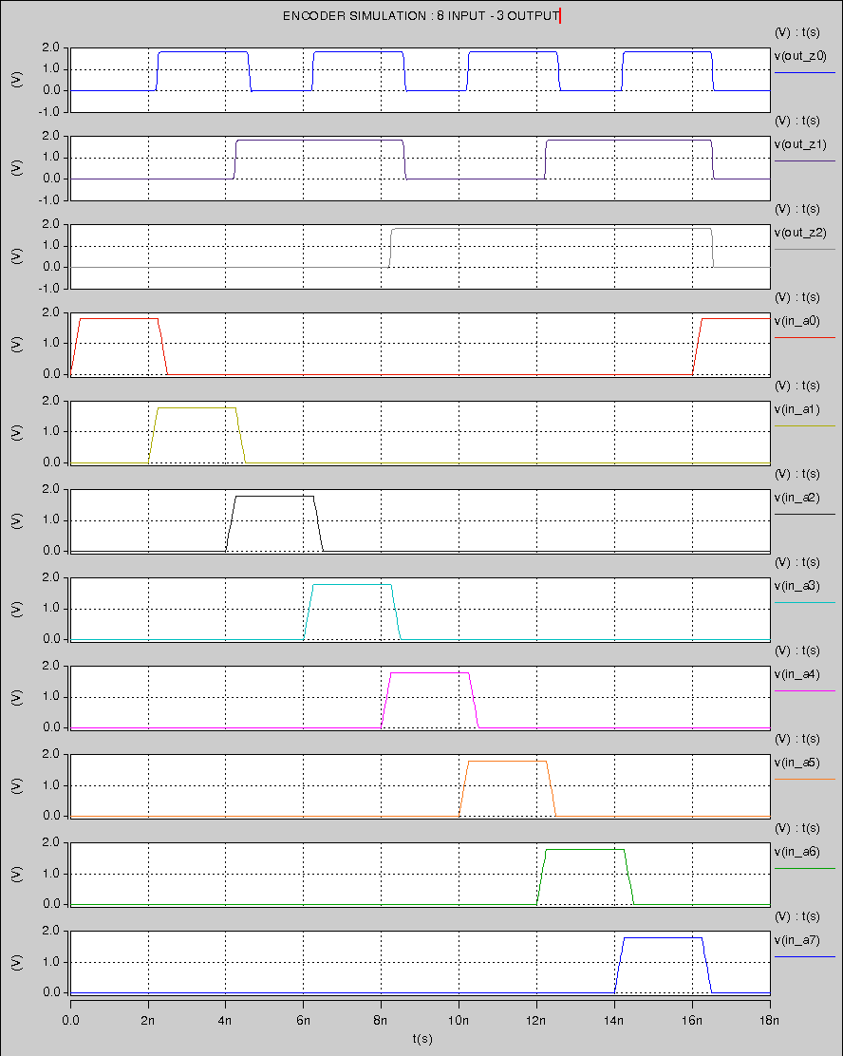

**SIMULATION RESULT WITH RISE TIME AND FALL TIME**

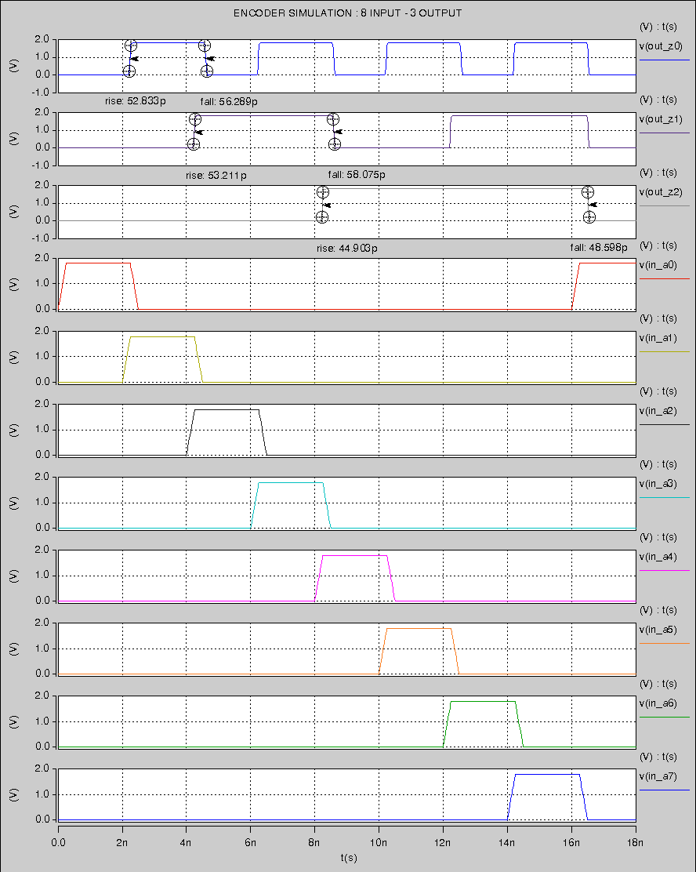

**SIMULATION RESULT / APPROXIMATED DIGITAL VALUES USING COSMOSCOPE**

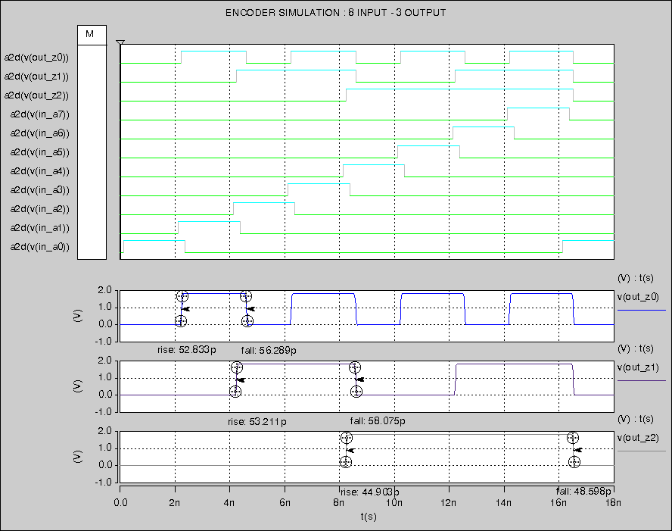

**SIMULATION RESULT – CLOSE UP VIEW ON OUTPUT**

