**GIL MICHAEL E. REGALADO BS ECE IV - EE 272**

CMOS INVERTER GATE SIMULATION

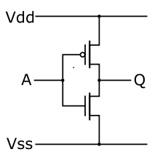

|  |
| --- |
| ****** FILENAME: inverter.cir  ****** SUBCIRCUIT DEFINITION: INVERTER  .subckt inverter dd ss in out  MN1 out in ss ss nch l='1*LMIN' w='2*LMIN'  MP2 out in dd dd pch l='1*LMIN' w='3*LMIN'  .ends |

|  |
| --- |
| ****** FILENAME: inverter_tb.sp  ****** INVERTER TEST BENCH  ****** SIMULATION PARAMETERS  .PARAM LMIN=0.18u  .PARAM PVDD=1.8  .PARAM TRAN_TIME=0.25n  ****** ANALYSIS OPTIONS  .option post  .op  .tran 1e-15 8n  ****** STIMULI  Vdd ndd 0 PVDD  Vin in_x 0 pulse (PVDD 0 0 TRAN_TIME TRAN_TIME 2n 4n)  ****** TEST BENCH CIRCUIT  X_inverter ndd 0 in_x out_z inverter  Cout out_z 0 0.01f  ****** LOAD EXTERNAL FILES  .prot  .lib "C:\synopsys\rf018.l" TT  .include "inverter.cir"  .unprot  .end |

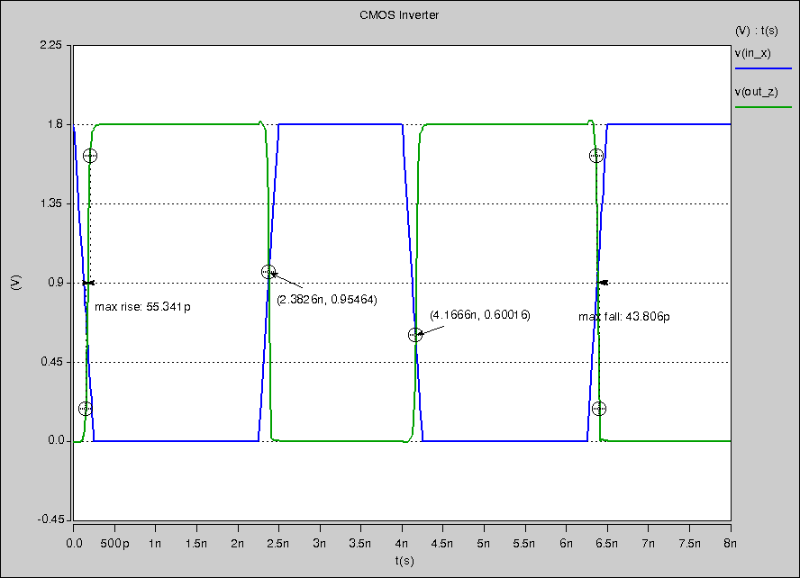

Rise Time: 55.341 ps

Fall Time: 43.806 ps

Input Rise Time Cross Over: 0.95464 Volts

Input Fall Time Cross Over: 0.6 Volts