**GIL MICHAEL E. REGALADO BS ECE IV - EE 272**

**4-1 MULTIPLEXER**

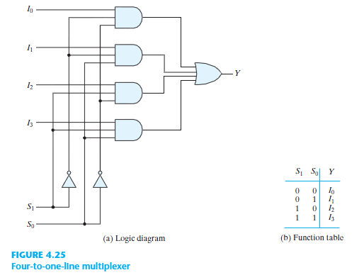

**REQUIRED SUB CIRCUITS**

|  |
| --- |
| ****** SUBCIRCUIT DEFINITION: 3 INPUT NAND  .subckt nand3 dd ss a b c out  MN1 out a ab ss nch l='1*LMIN' w='2*LMIN'  MN2 ab b bc ss nch l='1*LMIN' w='2*LMIN'  MN3 bc c ss ss nch l='1*LMIN' w='2*LMIN'  MP1 out a dd dd pch l='1*LMIN' w='6*LMIN'  MP2 out b dd dd pch l='1*LMIN' w='6*LMIN'  MP3 out c dd dd pch l='1*LMIN' w='6*LMIN'  .ends |

|  |
| --- |
| ****** SUBCIRCUIT DEFINITION: 4 INPUT NOR  .subckt nor4 dd ss a b c d out  MPA ab a dd dd pch l='1*LMIN' w='6*LMIN'  MPB bc b ab dd pch l='1*LMIN' w='6*LMIN'  MPC cd c bc dd pch l='1*LMIN' w='6*LMIN'  MPD out d cd dd pch l='1*LMIN' w='6*LMIN'  MNA out a ss ss nch l='1*LMIN' w='2*LMIN'  MNB out b ss ss nch l='1*LMIN' w='2*LMIN'  MNC out c ss ss nch l='1*LMIN' w='2*LMIN'  MND out d ss ss nch l='1*LMIN' w='2*LMIN'    .ends |

|  |
| --- |
| ****** SUBCIRCUIT DEFINITION: INVERTER  .subckt not ndd nss in out  MN1 out in nss nss nch l='1*LMIN' w='2*LMIN'  MP2 out in ndd ndd pch l='1*LMIN' w='6*LMIN'  .ends |

|  |
| --- |
| ****** SUBCIRCUIT DEFINITION: 4-1 MULTIPLEXER  .include NOT.SP  .include NOR4.SP  .include NAND3.SP  .subckt mux dd ss a0 a1 a2 a3 s0 s1 z  Xnand3_a0 dd ss a0 not_s1 not_s0 n0 nand3  Xnand3_a1 dd ss a1 not_s1 s0 n1 nand3  Xnand3_a2 dd ss a2 s1 not_s0 n2 nand3  Xnand3_a3 dd ss a3 s1 s0 n3 nand3  xnot_n0 dd ss n0 not_n0 not  xnot_n1 dd ss n1 not_n1 not  xnot_n2 dd ss n2 not_n2 not  xnot_n3 dd ss n3 not_n3 not  xnot_s0 dd ss s0 not_s0 not  xnot_s1 dd ss s1 not_s1 not  xnor4 dd ss not_n0 not_n1 not_n2 not_n3 not_z nor4    xnot_z0 dd ss not_z z not  .ends |

**TEST BENCH CIRCUIT**

|  |
| --- |
| 4 TO 1 MULTIPLEXER  ****** REFERENCE:  ****** http://www.asic-world.com/digital/combo3.html  ****** SIMULATION PARAMETERS  .PARAM LMIN=0.18u  .PARAM PVDD=1.8  * Input transition time.  .PARAM TRAN_TIME=0.25n  .PARAM MINTIME=2n  ****** ANALYSIS OPTIONS  .option post  .op  .tran 1e-15 128n  ****** STIMULI  Vdd ndd 0 PVDD  Va0 in_a0 0 pulse (PVDD 0 0 TRAN_TIME TRAN_TIME 2n 4n)  Va1 in_a1 0 pulse (PVDD 0 0 TRAN_TIME TRAN_TIME 4n 8n)  Va2 in_a2 0 pulse (PVDD 0 0 TRAN_TIME TRAN_TIME 8n 16n)  Va3 in_a3 0 pulse (PVDD 0 0 TRAN_TIME TRAN_TIME 16n 32n)  Vs0 in_s0 0 pulse (PVDD 0 0 TRAN_TIME TRAN_TIME 32n 64n)  Vs1 in_s1 0 pulse (PVDD 0 0 TRAN_TIME TRAN_TIME 64n 128n)  ****** TEST BENCH CIRCUIT  Cz0 out_z ss 0.01f  Xmux ndd 0 in_a0 in_a1 in_a2 in_a3 in_s0 in_s1 out_z mux  ****** LOAD EXTERNAL FILES  .lib C:\synopsys\rf018.l TT  .include MUX.SP  .end |

**SIMULATION RESULT**

