**GIL MICHAEL E. REGALADO BS ECE IV EE 272**

**LABORATORY NAND DEMORGAN**

**NAND 2 INPUT**

SCHEMATIC

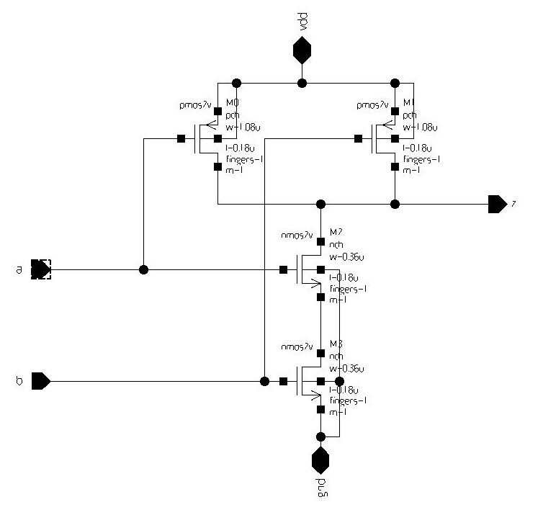

TEST BENCH

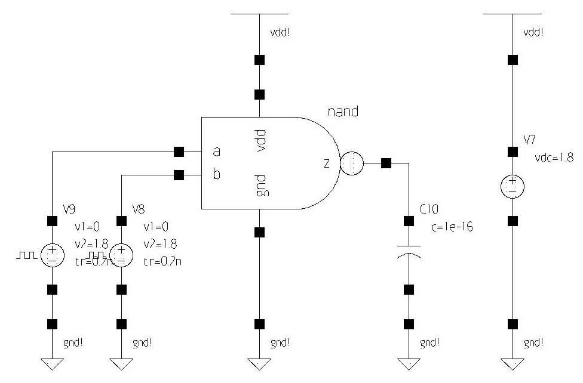

SIMULATION

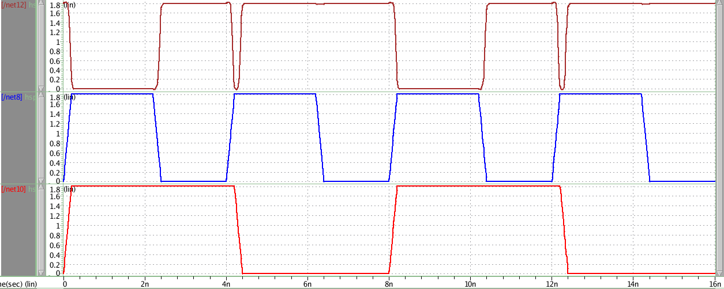

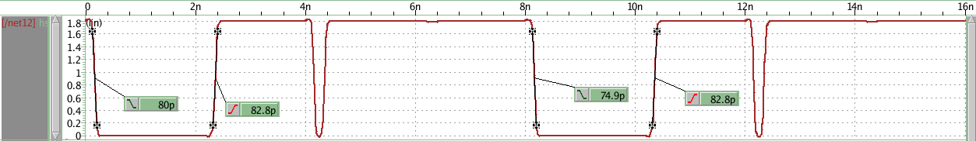

**NAND 3 INPUT**

SCHEMATIC

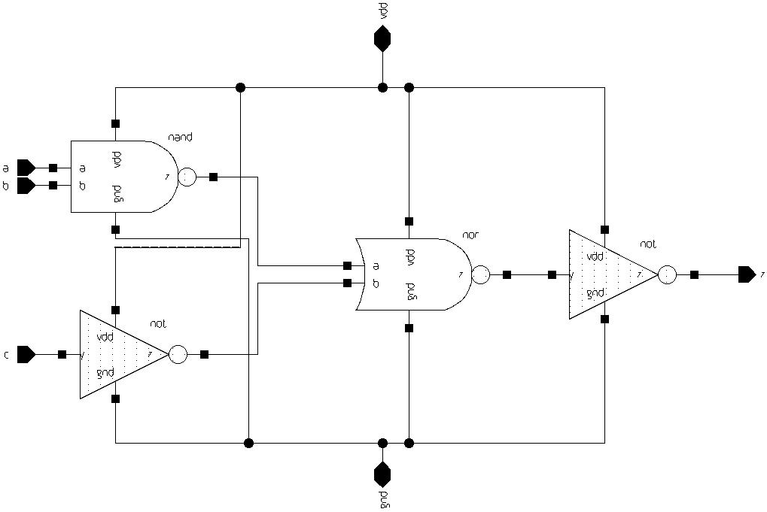

TEST BENCH

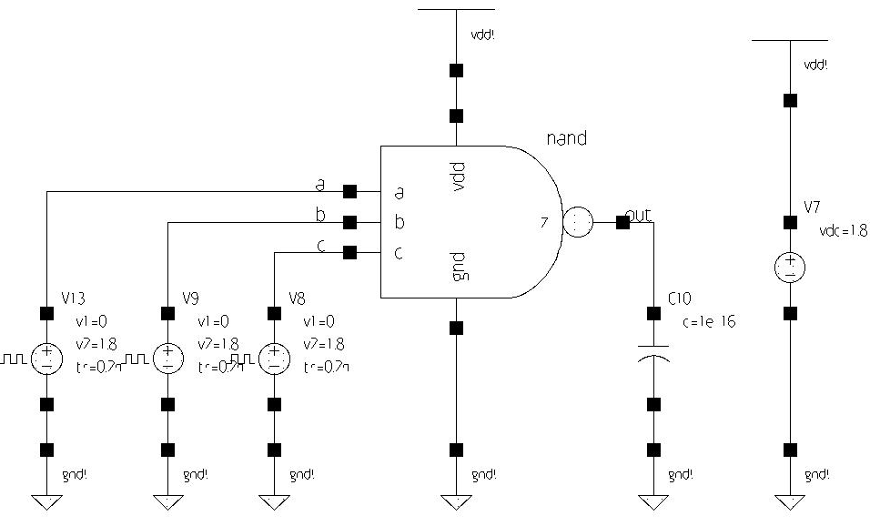

SIMULATION

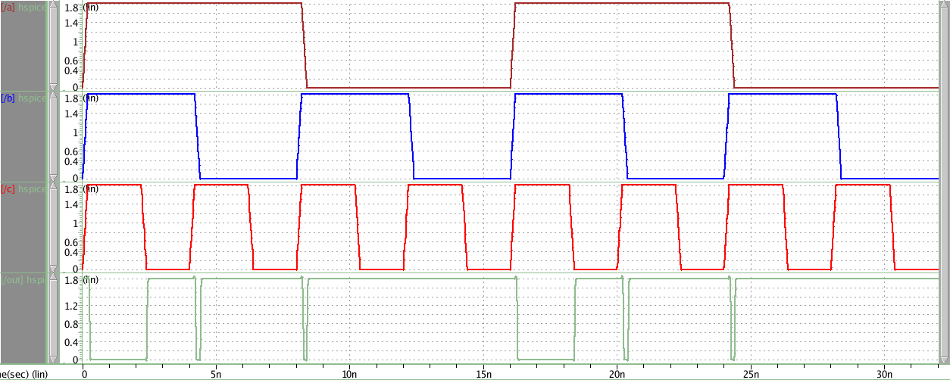

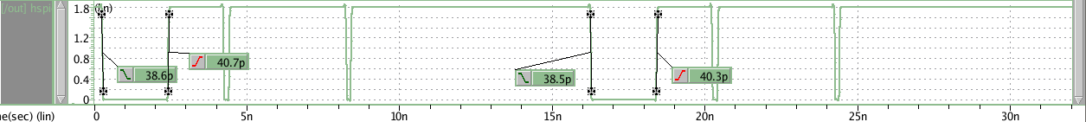

**NAND 4 INPUT**

SCHEMATIC

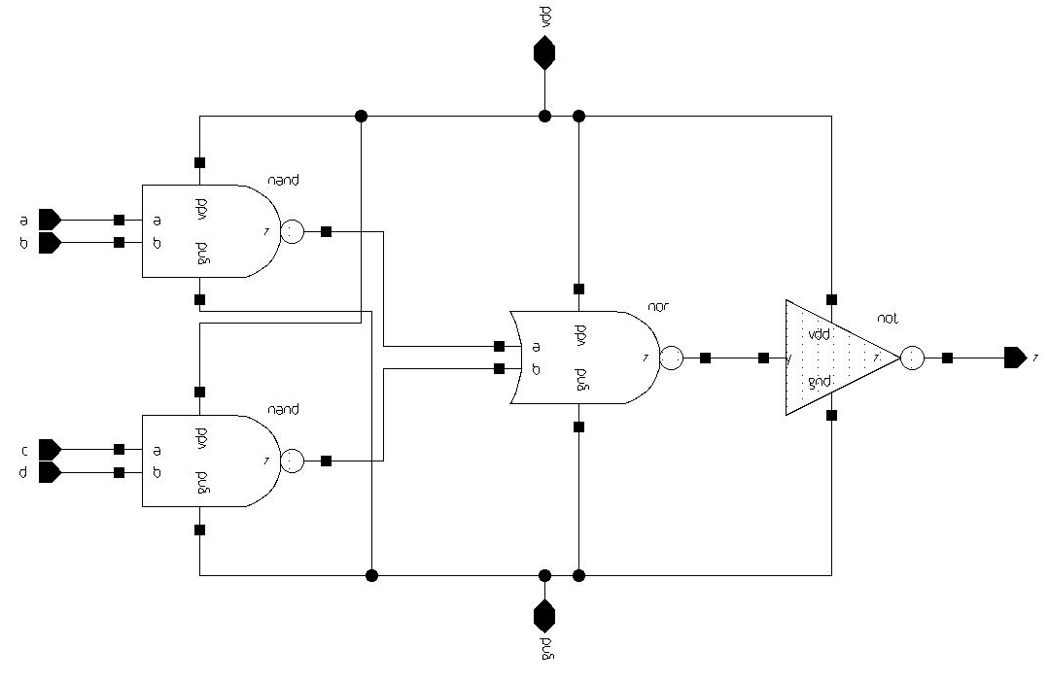

TEST BENCH

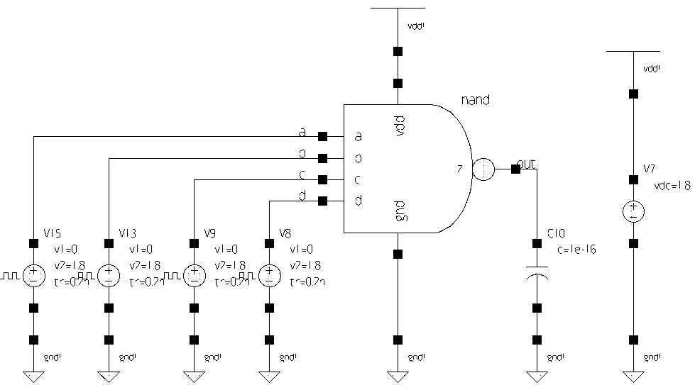

SIMULATION

