**GIL MICHAEL E. REGALADO BS ECE IV EE 272**

**LABORATORY NOR DEMORGAN**

**NOR 2 INPUT**

SCHEMATIC

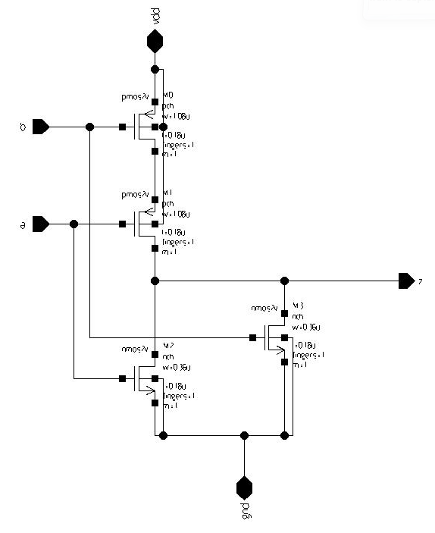

TEST BENCH

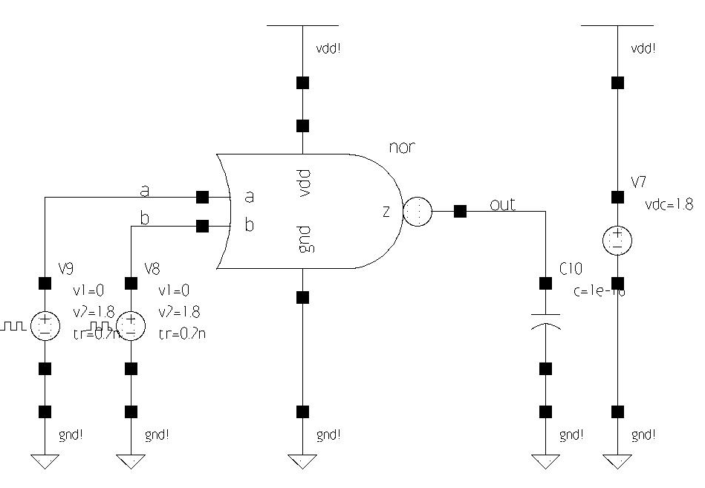

SIMULATION

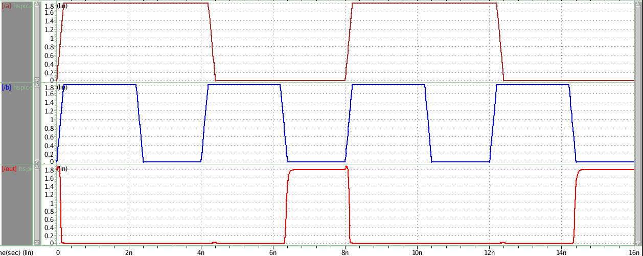

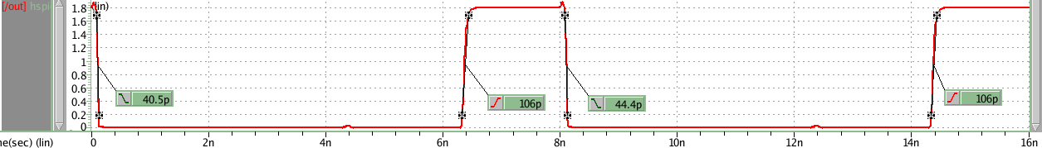

**NOR 3 INPUT**

SCHEMATIC

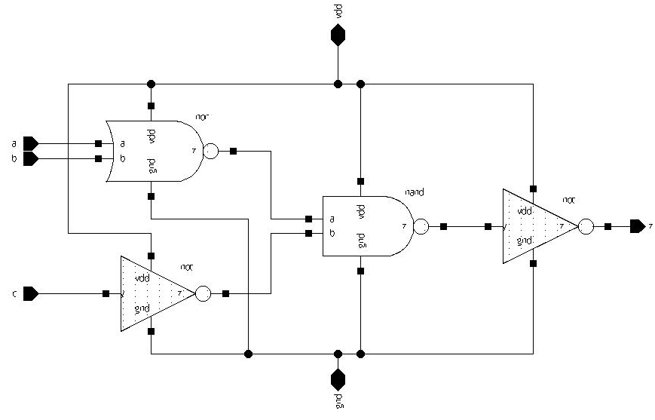

TEST BENCH

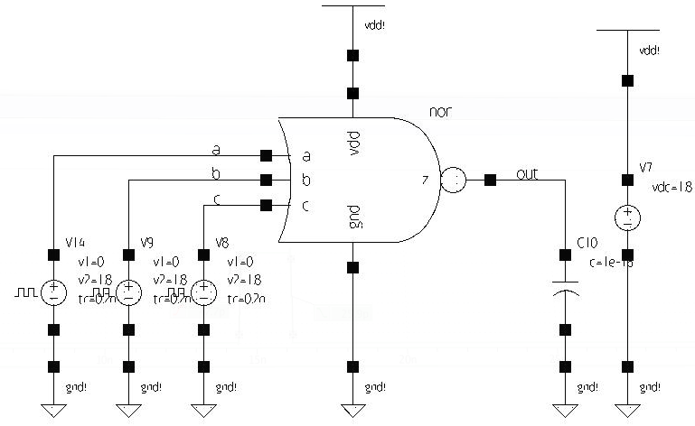

SIMULATION

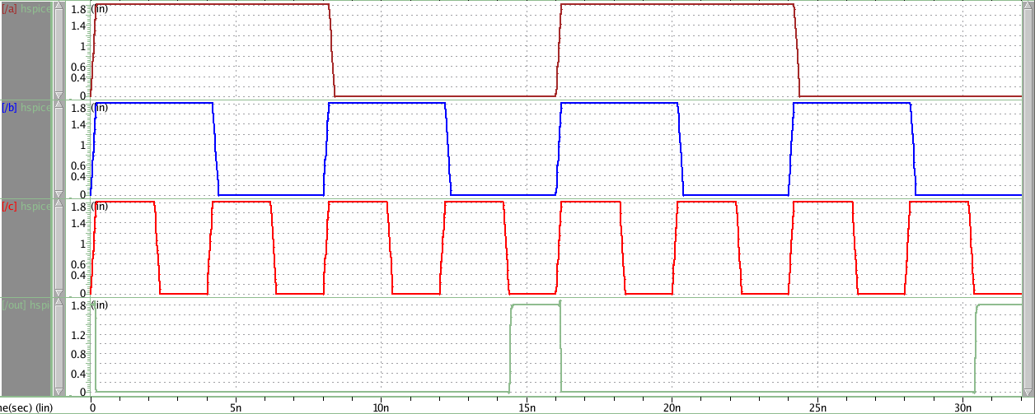

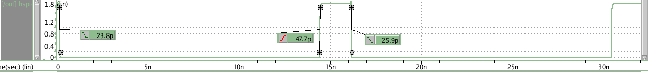

**NOR 4 INPUT**

SCHEMATIC

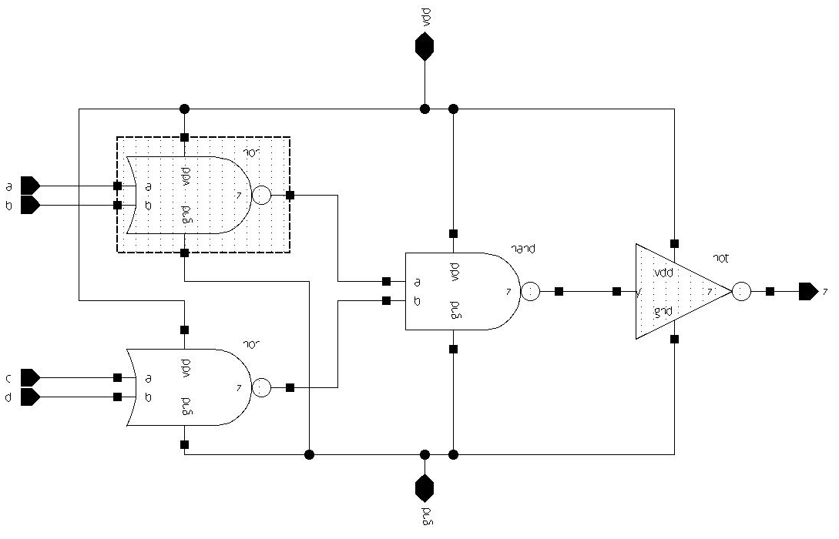

TEST BENCH

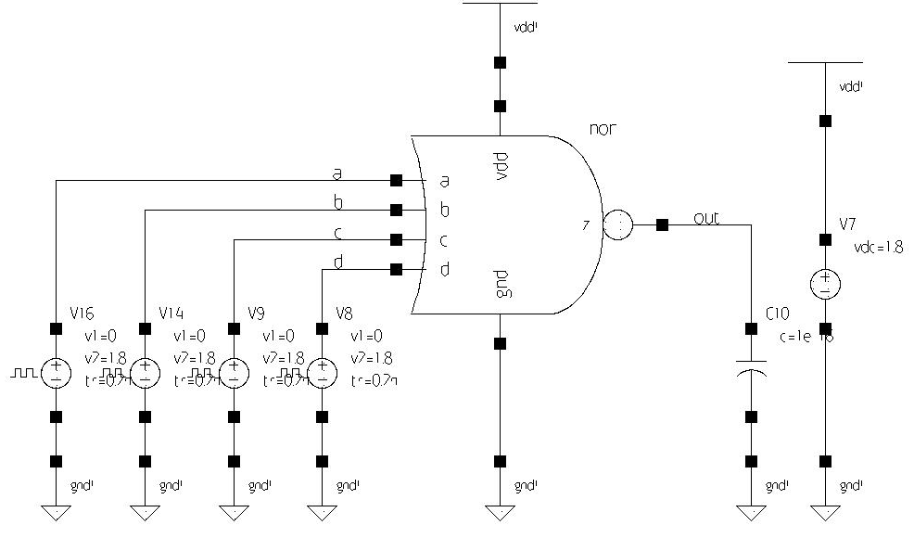

SIMULATION

